Human Granulocytic Anaplasmosis (HGA) Surveillance in Massachusetts, 2011
Massachusetts Department of Public Health
2011 Surveillance Highlights

- 140 confirmed cases of HGA were reported in Massachusetts in 2011, representing approximately a two-fold increase over the number of cases reported in 2010.

- Regions with the highest incidence included southern Berkshire County, as well as Cape Cod and the Islands of Nantucket and Martha’s Vineyard.

- The highest number of confirmed cases occurred in June and July. Only 46% of confirmed cases reported that they had a recent tick bite.

- The average age for a confirmed HGA case was 58 years and 48% were male.

- 29% of confirmed cases were hospitalized. The average age for a confirmed case who was hospitalized was 66 years.

- The most common symptoms reported in confirmed cases included fever (95%), malaise (81%), and myalgia [muscle aches] (75%).

- For more information about HGA and other tick-borne diseases, including things you can do to keep you and your loved ones safe, please visit www.mass.gov/dph/tick.

The map below illustrates HGA incidence rates per 100,000 by city and town of residence in Massachusetts from 2007-2011. Areas of highest incidence include southern Berkshire County, and Cape Cod and the Islands. There was an isolated area of high incidence in Norfolk County. No confirmed cases of HGA were reported from Franklin, Hampshire, or Suffolk Counties in 2011.
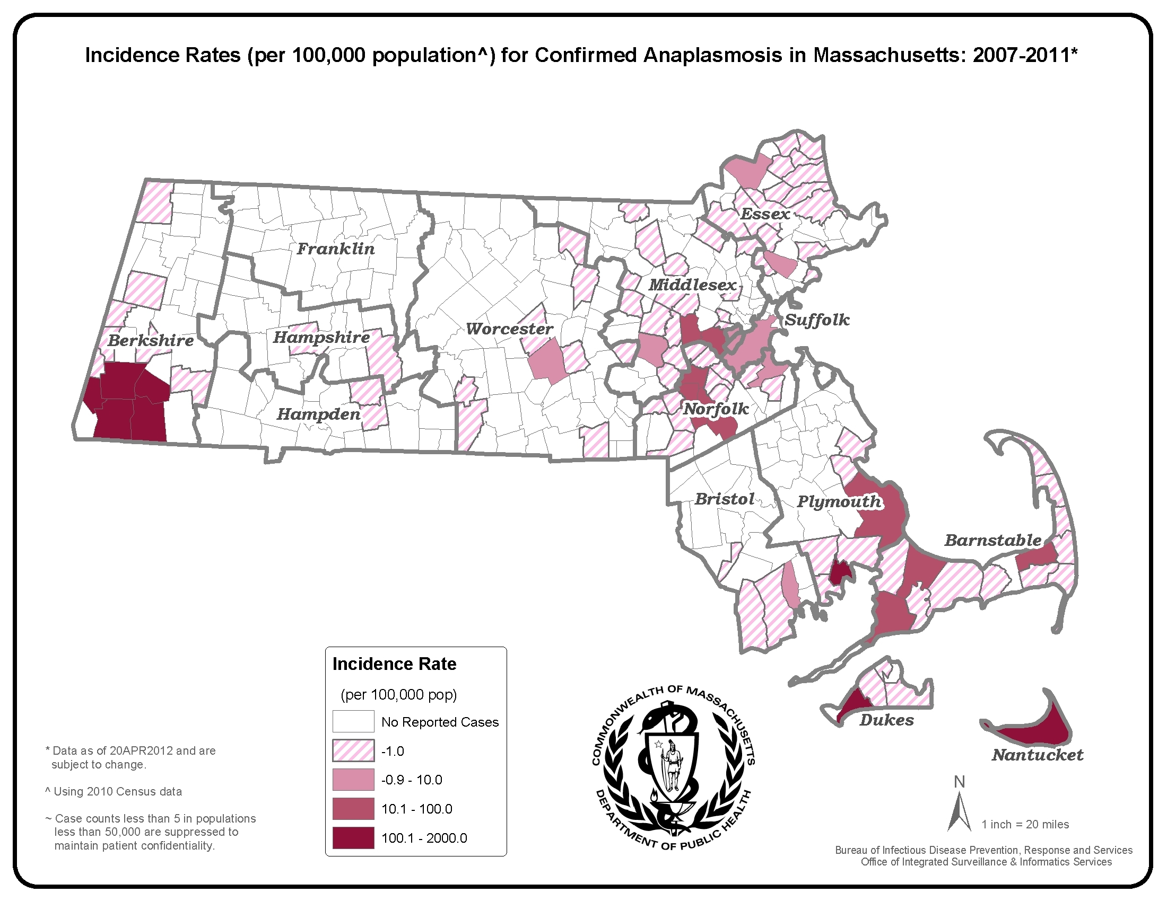
County | 2011 Confirmed Cases (#) | 2011  Incidence Rate (per 100,000)
Cape Cod & Islands* | 31 | 12.78
Berkshire | 30 | 22.86
Bristol | 3 | 0.55
Essex | 7 | 0.94
Franklin | 0 | 0.00
Hampden | 3 | 0.65
Hampshire | 0 | 0.00
Middlesex | 21 | 1.40
Norfolk | 20 | 2.98
Plymouth | 18 | 3.64
Suffolk | 0 | 0.00
Worcester | 7 | 0.88
State Total | 140 | 2.14
*Statistics for Barnstable, Dukes and
Nantucket counties are combined in
accordance with confidentiality guidelines

Figure 1.

Figure 2.

Figure 3.

