Human Granulocytic Anaplasmosis (HGA) Surveillance in Massachusetts, 2012
Massachusetts Department of Public Health (MDPH)

Investigation of suspect cases of HGA, and the collection of clinical and exposure data by local public health, enables MDPH to analyze trends and provide this surveillance summary.
2012 Surveillance Highlights

- 237 confirmed cases of HGA were reported in Massachusetts in 2012, representing a 60% increase over the number of cases reported in 2011.

- Regions with the highest incidence included southern Berkshire County, as well as Cape Cod and the Islands of Nantucket and Martha’s Vineyard. Several counties, including Middlesex, Norfolk, and Worcester had incidence rates that substantially increased from 2011, suggesting newly emerging areas of concern for HGA.

- The highest number of confirmed cases occurred in May, June, and July. Only 44% of confirmed cases reported that they had a recent tick bite.

- 58% of confirmed cases were over 60 years of age. Incidence rates are highest in those over 60. 50% of all cases were male.

- 42% of confirmed cases were hospitalized. The average age for a hospitalized confirmed case was 68 years. At least 4 cases died.

- The most common symptoms reported in confirmed cases included fever (98%), myalgia [muscle aches] (80%), and malaise (76%).

- For more information about HGA and other tick-borne diseases, including things you can do to keep you and your loved ones safe, please visit www.mass.gov/dph/tick.

The map below illustrates HGA incidence rates per 100,000 by city and town of residence in Massachusetts from 2008-2012. Areas of highest incidence include southern Berkshire County, Southeastern Massachusetts, and Cape Cod and the Islands. Southern Middlesex County and Norfolk County both had isolated areas of elevated incidence. Confirmed HGA cases were found in every county in Massachusetts in 2012.
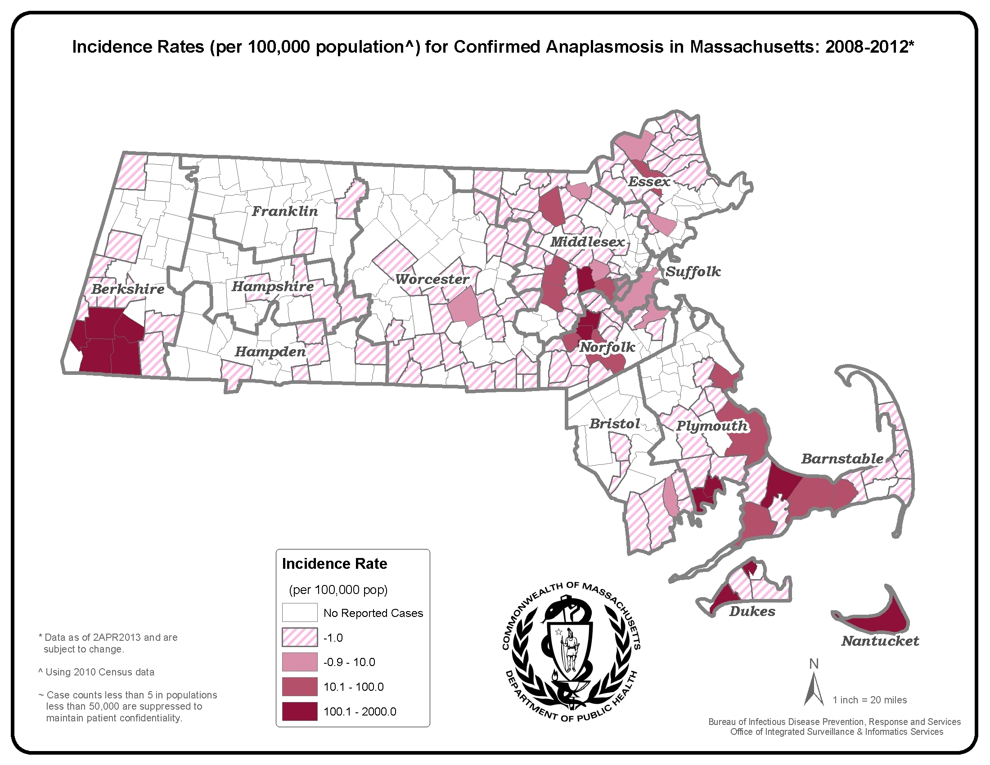
County | 2012 Confirmed Cases (#) | 2012  Incidence Rate (per 100,000)
Cape Cod & Islands* | 43 | 17.73
Berkshire | 30 | 22.86
Bristol | 8 | 1.46
Essex | 7 | 1.88
Franklin | 3 | 4.20
Hampden | 3 | 0.65
Hampshire | 3 | 1.90
Middlesex | 51 | 3.39
Norfolk | 30 | 4.47
Plymouth | 25 | 5.05
Suffolk | 4 | 0.55
Worcester | 23 | 2.88
State Total | 237 | 3.62
*Statistics for Barnstable, Dukes and
Nantucket counties are combined in
accordance with confidentiality guidelines

Figure 1.

Figure 2.
n= 237

Figure 3.

