Human Granulocytic Anaplasmosis (HGA) Surveillance in Massachusetts, 2013
Massachusetts Department of Public Health (MDPH)

Investigation of suspect cases of HGA, and the collection of clinical and exposure data by local public health enables MDPH to analyze trends and provide this surveillance summary.
2013 Surveillance Highlights

- 329 confirmed and probable cases of HGA were reported in Massachusetts in 2013, about the same number of cases as was reported in 2012. Overall 990 suspect cases were investigated.

- Regions with the highest incidence included southern Berkshire County, as well as Cape Cod and the Islands of Nantucket and Martha’s Vineyard.

- The highest number of confirmed cases occurred in May, June, and July. Only 34% of confirmed cases reported that they had a recent tick bite.

- People over the age of 60 years continue to be at greatest risk for clinical disease (48% of patients identified with HGA are over 60) and half (49%) of all cases were male.

- One out of three patients with HGA (34%) was hospitalized. The average age of hospitalized cases was 63 years. There was at least one fatality.

- The most common symptoms reported in confirmed or probable cases included fever (97%), malaise (81%), and muscle aches and pain (72%).

- For more information about HGA and other tick-borne diseases, including things you can do to keep you and your loved ones safe, please visit www.mass.gov/dph/tick.

The map below illustrates HGA incidence rates per 100,000 by city and town of residence in Massachusetts from 2009-2013. Areas of highest incidence include southern Berkshire County, Southeastern Massachusetts, and Cape Cod and the Islands. Southern Middlesex County and Norfolk County both had isolated areas of elevated incidence. All counties reported cases of HGA in 2013.
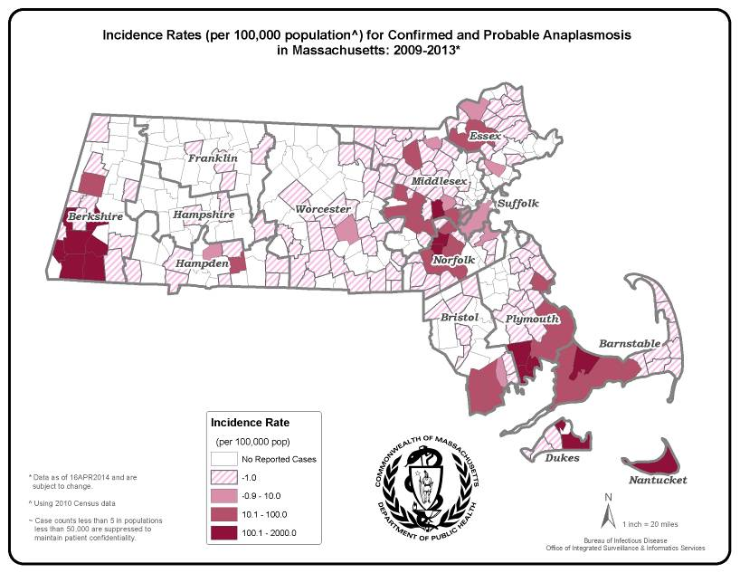
County | 2013 Cases  Confirmed and Probable | 2013  Incidence Rate per 100,000
Berkshire | 55 | 41.91
Bristol | 16 | 2.92
Cape Cod & Islands* | 37 | 15.25
Essex | 27 | 3.63
Franklin | 6 | 8.41
Hampden | 7 | 1.51
Hampshire | 2 | 1.27
Middlesex | 67 | 4.46
Norfolk | 43 | 6.41
Plymouth | 45 | 9.09
Suffolk | 11 | 1.52
Worcester | 13 | 1.63
State Total | 329 | 5.0
*Statistics for Barnstable, Dukes and
Nantucket counties are combined in
accordance with confidentiality guidelines

Figure 1.

Figure 2.

Figure 3.

