Human Granulocytic Anaplasmosis (HGA) Surveillance in Massachusetts, 2015
Massachusetts Department of Public Health (MDPH)

Investigation of suspect cases of HGA, and the collection of clinical and exposure data by local public health enables MDPH to analyze trends and provide this surveillance summary.
2015 Surveillance Highlights

- 763 confirmed and probable cases of HGA were reported in Massachusetts in 2015, a 26% increase over 2014. Overall 1,476 suspect cases of HGA were investigated.

- Statewide, HGA incidence increased from 9.2 to 11.7 cases per 100,000 residents. The counties with the highest incidence continue to be Barnstable, Berkshire, Dukes, Nantucket and Plymouth. Berkshire County had the greatest change in incidence, from 60.2 to 112.0 cases per 100,000 residents.

- The majority of cases occurred in May, June, and July, with only 36% of cases reporting awareness of a recent tick bite.

- People aged 60 years and over continue to be at greatest risk for clinical disease (54% of patients identified with HGA were 60 or over) and 62% of all cases were male.

- One out of three patients with HGA (33%) was hospitalized. The symptoms most commonly reported included fever (93%), malaise (68%), and muscle aches and pain (61%). There were no known fatalities.

- For more information about HGA and other tick-borne diseases, including things you can do to keep you and your loved ones safe, please visit www.mass.gov/dph/tick.

The map below illustrates HGA incidence rates per 100,000 population by city and town of residence in Massachusetts from 2011-2015. Areas of highest incidence include southern Berkshire County, Southeastern Massachusetts, Cape Cod and the Islands. Many locations within Middlesex, Norfolk and Essex Counties also had areas of elevated incidence.

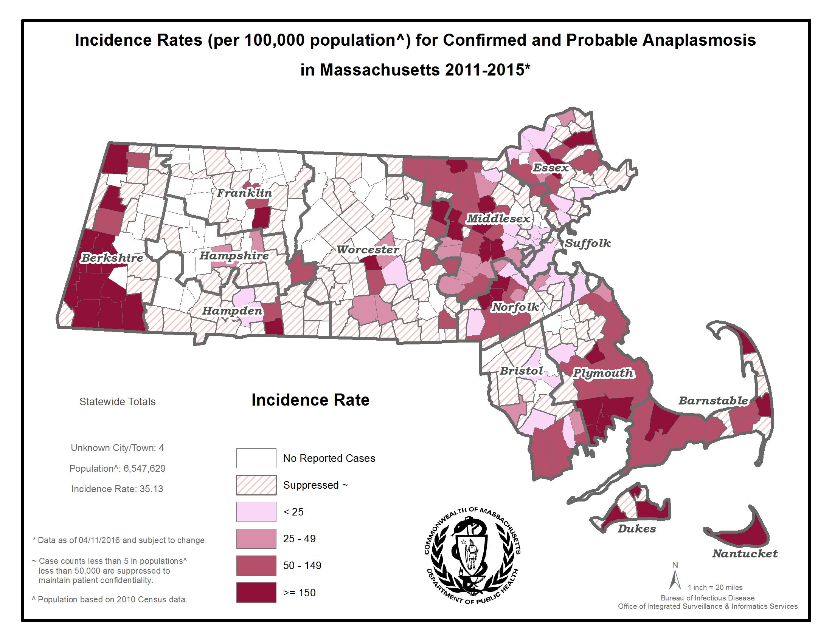
County | 2015 Cases  Confirmed and Probable | 2015  Incidence Rate per 100,000
Barnstable | 55 | 25.5
Berkshire | 147 | 112.0
Bristol | 46 | 8.4
Dukes | 7 | 42.3
Essex | 38 | 5.1
Franklin | 11 | 15.4
Hampden | 12 | 2.6
Hampshire | 28 | 17.7
Middlesex | 168 | 11.2
Nantucket | 8 | 78.6
Norfolk | 63 | 9.4
Plymouth | 103 | 20.8
Suffolk | 14 | 1.9
Worcester | 63 | 7.9
State Total | 763 | 11.7
Figure 1.
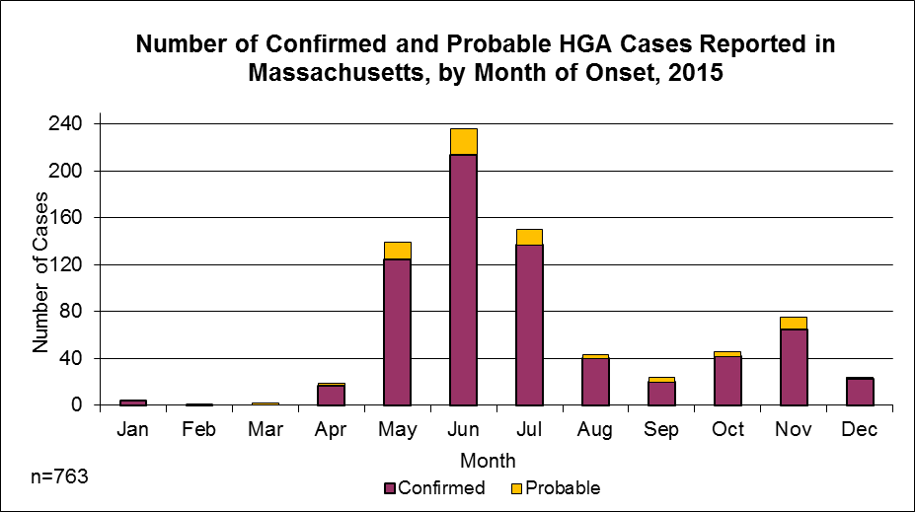

Figure 2. 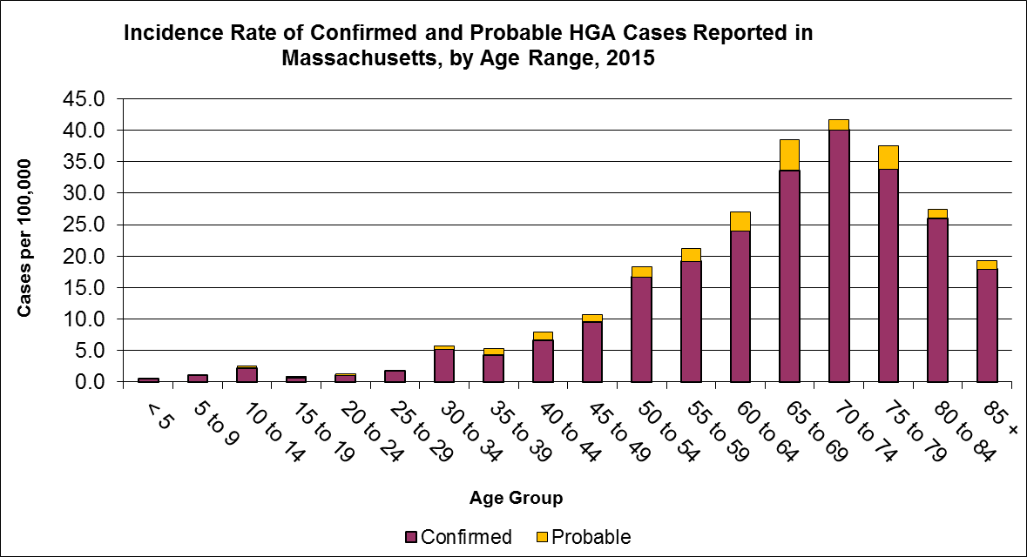

Figure 3.
