Human Granulocytic Anaplasmosis (HGA) Surveillance in Massachusetts, 2016
Massachusetts Department of Public Health (MDPH)

Investigation of suspect cases of HGA, and the collection of clinical and exposure data by local public health enables MDPH to analyze trends and provide this surveillance summary.
2016 Surveillance Highlights

- 828 confirmed and probable cases of HGA were reported in Massachusetts in 2016, an 8% increase over 2015. Overall 1,624 suspect cases of HGA were investigated.

- Statewide, HGA incidence increased from 11.7 to 12.7 cases per 100,000 residents. The counties with the highest incidence continue to be Barnstable, Berkshire, Dukes, Nantucket and Plymouth. Dukes County had the greatest change in incidence, from 42.3 to 90.7 cases per 100,000 residents.

- The majority of cases occurred in May, June, and July, with only 38% of cases reporting awareness of a recent tick bite.

- People aged 60 years and over continue to be at greatest risk for clinical disease (54% of patients identified with HGA were 60 or over) and 54% of all cases were male.

- One out of three patients with HGA (34%) was hospitalized. The symptoms most commonly reported included fever (93%), malaise (70%), and muscle aches and pain (64%). There were two fatalities.

- For more information about HGA and other tick-borne diseases, including things you can do to keep you and your loved ones safe, please visit www.mass.gov/dph/tick.

The map below illustrates HGA incidence rates per 100,000 population by city and town of residence in Massachusetts from 2011-2016. Areas of highest incidence include southern and western Berkshire County, Southeastern Massachusetts, Cape Cod and the Islands. Many locations within Central Essex, Norfolk and Middlesex Counties also had areas of elevated incidence.

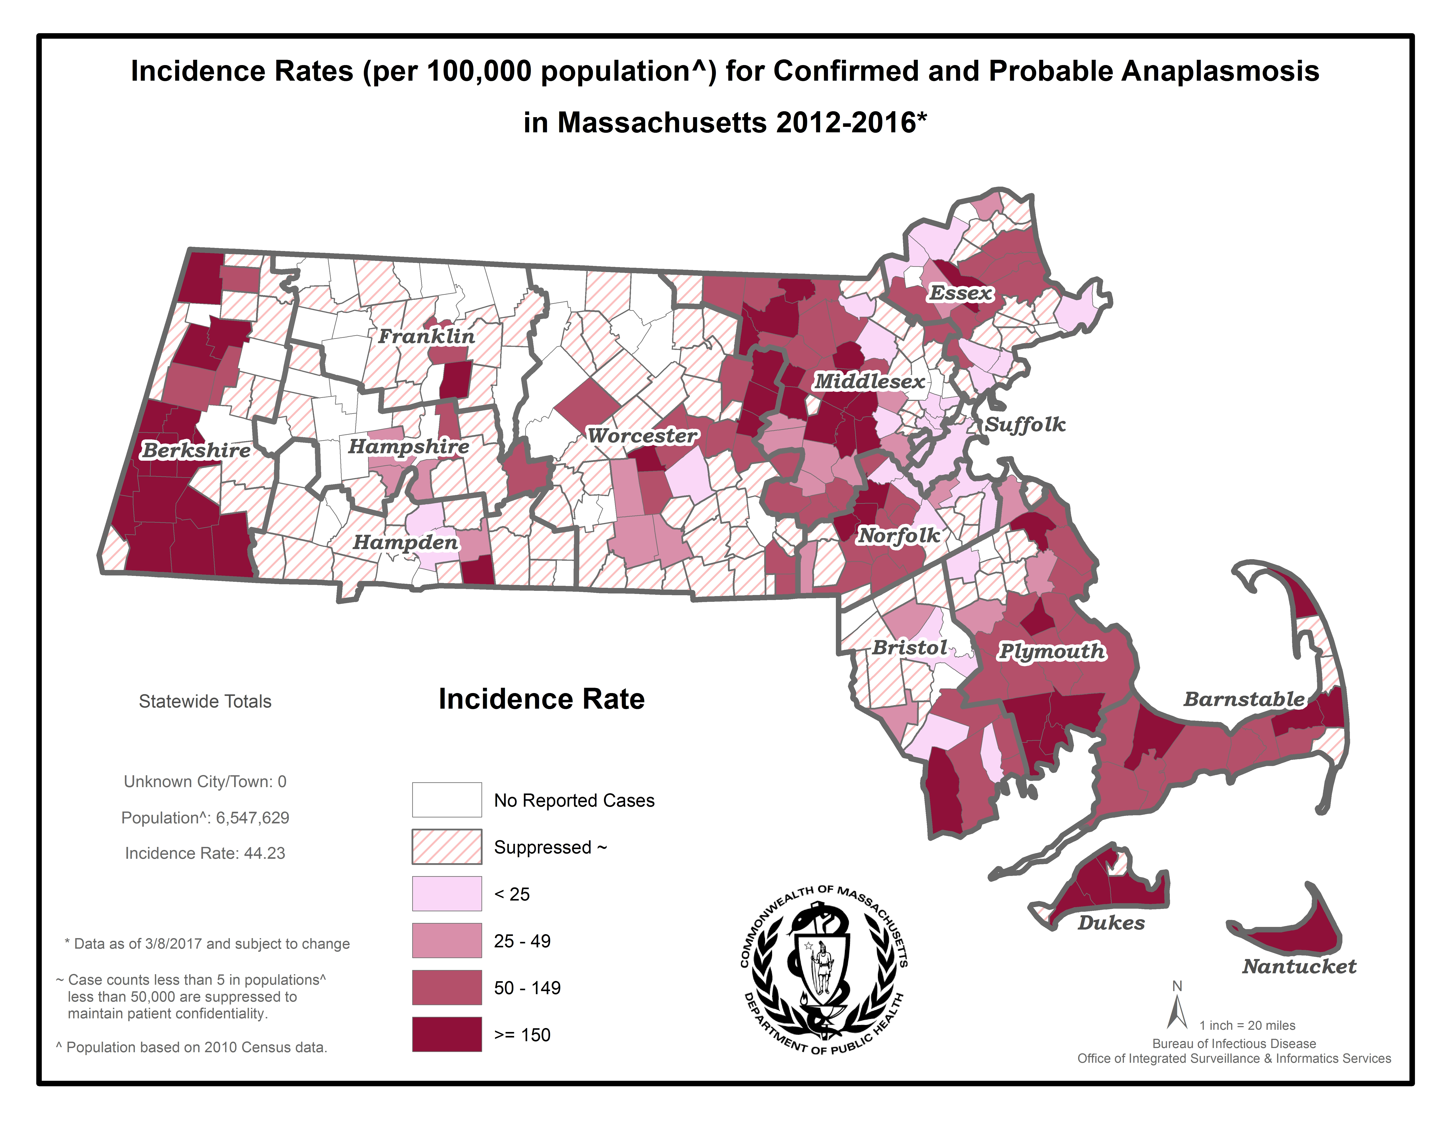
County | 2016 Cases  Confirmed and Probable | 2016  Incidence Rate per 100,000
Barnstable | 68 | 31.5
Berkshire | 87 | 66.3
Bristol | 69 | 12.6
Dukes | 15 | 90.7
Essex | 48 | 6.5
Franklin | 10 | 14.0
Hampden | 9 | 1.9
Hampshire | 19 | 12.0
Middlesex | 176 | 11.7
Nantucket | 10 | 98.3
Norfolk | 55 | 8.2
Plymouth | 162 | 32.7
Suffolk | 12 | 1.7
Worcester | 88 | 7.9
State Total | 828 | 12.7
Figure 1.
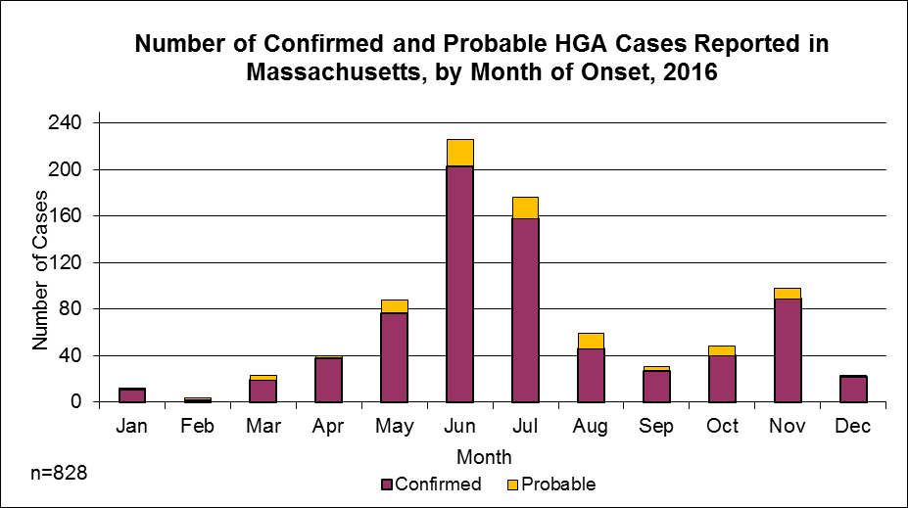

Figure 2.
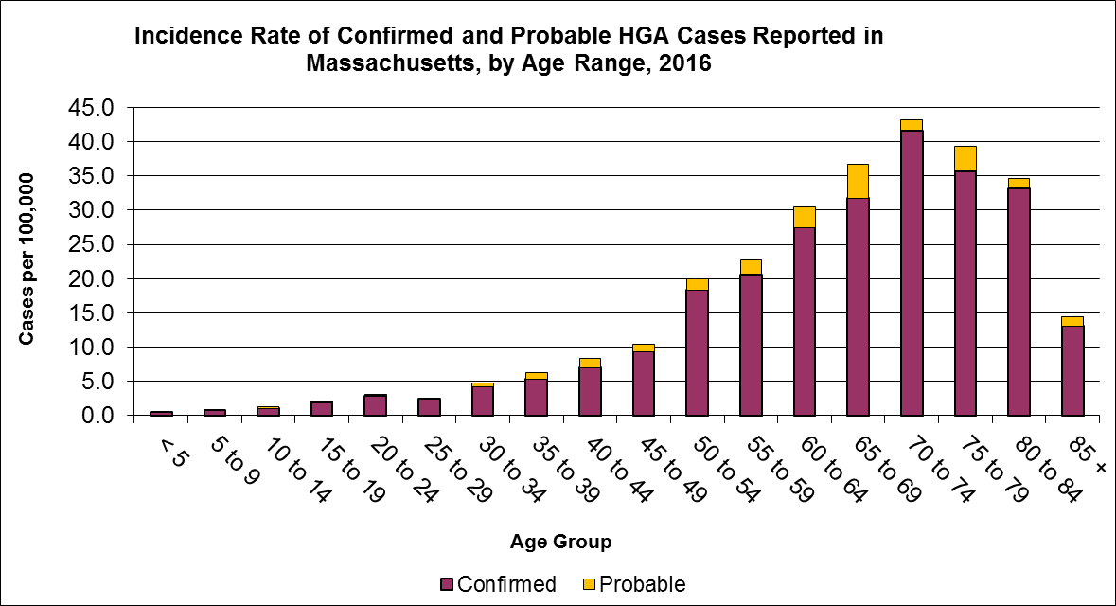
Figure 3.
