Bureau of Infectious Disease and Laboratory Sciences
Massachusetts State Public Health Laboratory
305 South St.
Jamaica Plain, MA 02130

Human Granulocytic Anaplasmosis (HGA) Surveillance in Massachusetts, 2018
2018 Surveillance Highlights

- 656 confirmed and probable cases of HGA were reported in Massachusetts in 2018. Overall 1,919 suspect cases of HGA were investigated. PCR and microscopy laboratory test results indicate current infection, even in individuals not captured in case counts (Figure 3).

- Statewide, HGA incidence decreased from 18.4 to 10.0 cases per 100,000 residents. The counties with the highest incidence were Barnstable, Berkshire, Dukes, Franklin, Nantucket and Plymouth. Berkshire County had the greatest change in incidence, from 133.4 to 69.3 cases per 100,000 residents.

- The majority of cases occurred in May, June, and July, with only 40% of cases reporting awareness of a recent tick bite.

- People aged 60 years and over continue to be at greatest risk for clinical disease (51% of patients identified with HGA were 60 or over) and 62% of all cases were male.

- Approximately one out of four patients with HGA (26%) was hospitalized. The symptoms most commonly reported included fever (99%), malaise (73%), and muscle aches and pain (72%).

- For more information about HGA and other tick-borne diseases, please visit www.mass.gov/dph/tick.

County | 2018 Cases  Confirmed and Probable | 2018  Incidence Rate per 100,000
Barnstable | 43 | 19.9
Berkshire | 91 | 69.3
Bristol | 47 | 8.6
Dukes & Nantucket | 4 | 15.0
Essex | 39 | 5.2
Franklin | 14 | 19.6
Hampden | 13 | 2.8
Hampshire | 14 | 8.9
Middlesex | 147 | 9.8
Norfolk | 45 | 6.7
Plymouth | 116 | 23.4
Suffolk | 4 | 0.6
Worcester | 79 | 9.9
State Total | 656 | 10.0
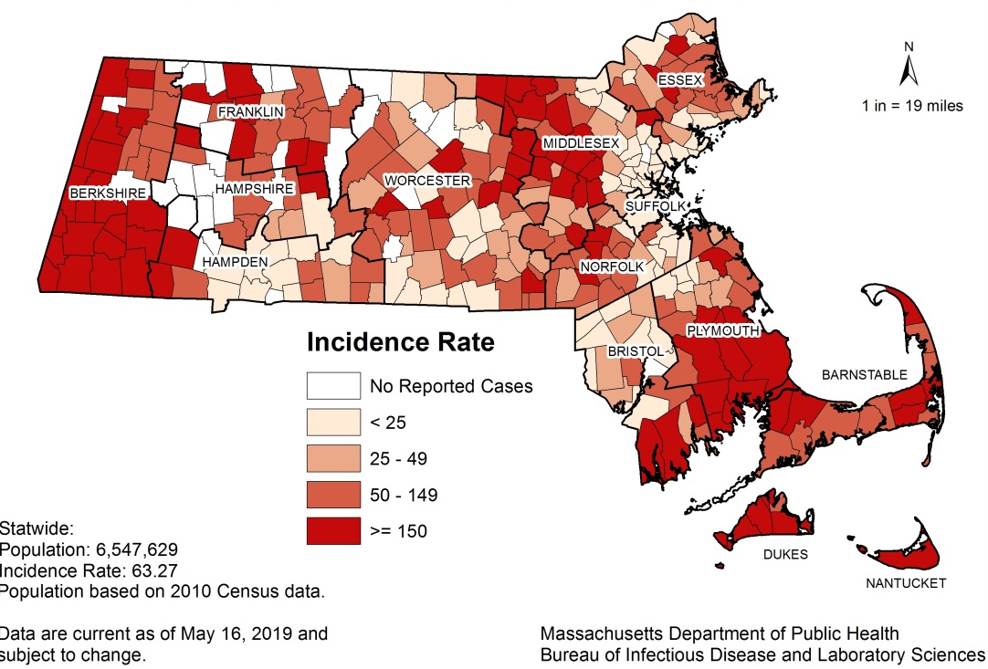
Map 1: Five-year HGA incidence rates per 100,000 population by city or town of residence, Massachusetts, 2014-2018.

Table 1: HGA counts and incidence rates per 100,000 population by county of residence, Massachusetts, 2018.

Figure 1. Number of confirmed and probable HGA cases by month of symptom onset, Massachusetts, 2018.
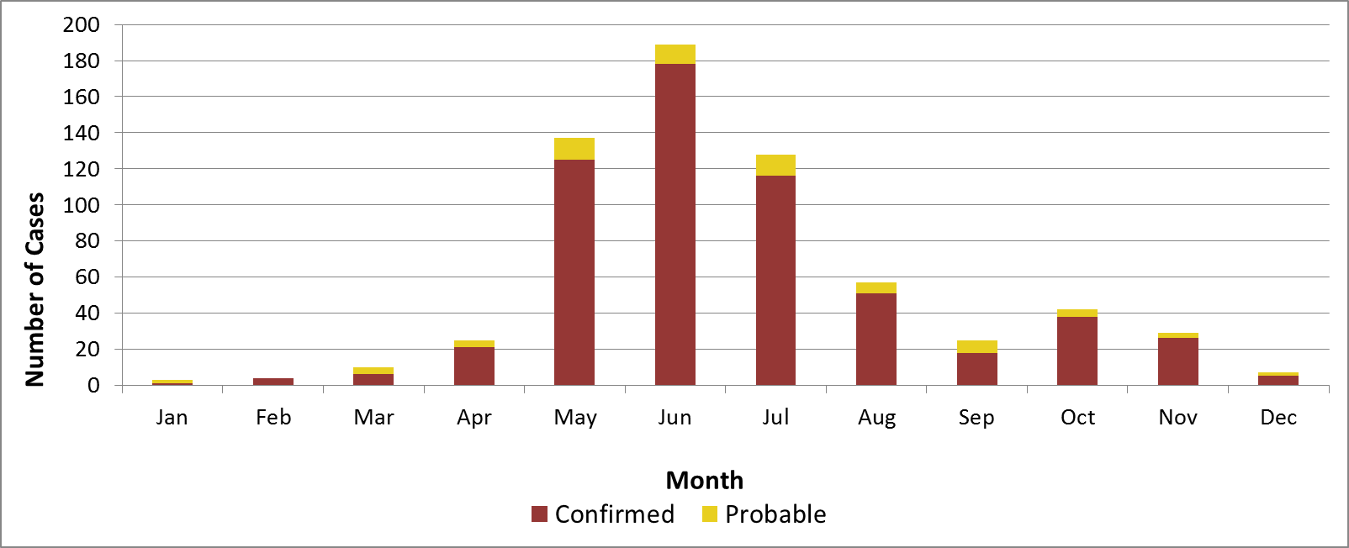

Figure 2. Rate (per 100,000 population) of confirmed and probable HGA cases by age group, Massachusetts, 2018
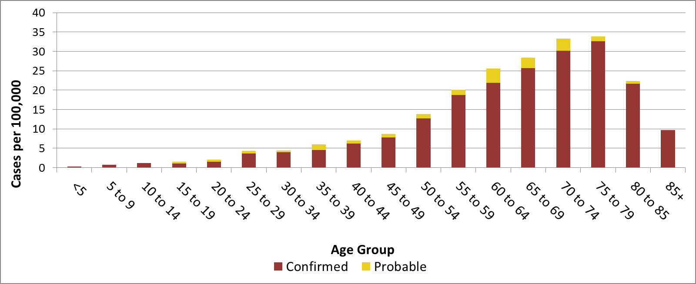

Figure 3. Number of confirmed and probable HGA cases by year, Massachusetts, 2014-2018
