Background/Introduction

INDOOR AIR QUALITY ASSESSMENT

Seekonk Human Services Department
320 Pleasant Street
Seekonk, MA

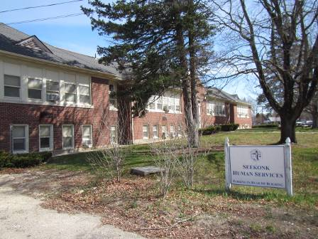

Prepared by:
Massachusetts Department of Public Health
Bureau of Environmental Health
Indoor Air Quality Program
June 2015
In response to a request by Mr. Robert Lamoureux, Superintendent, Seekonk Public Works, the Massachusetts Department of Public Health (MDPH), Bureau of Environmental Health (BEH) provided assistance and consultation regarding indoor air quality (IAQ) concerns at the Seekonk Human Services (SHS) office located at 320 Pleasant Street, Seekonk, MA. On April 16, 2015, Cory Holmes, Environmental Analyst/Regional Inspector in BEH’s IAQ Program visited the SHS to conduct an IAQ assessment.
The SHS is located on the 2nd floor of the former Pleasant Street School, which is a two-story red brick building constructed in the early 1940s. The building has undergone interior renovations over the years to accommodate town offices. The SHS space consists of subdivided areas within one large room, separated by partial (3/4 height walls) to create office space. Windows are openable, with the exception of those with portable air conditioners (ACs) installed.

Methods
Air tests for carbon monoxide, carbon dioxide, temperature and relative humidity were conducted with the TSI, Q-Trak, IAQ Monitor, Model 7565. Air tests for airborne particle matter with a diameter less than 2.5 micrometers were taken with the TSI, DUSTTRAK™ Aerosol Monitor Model 8532. BEH/IAQ staff also performed a visual inspection of building materials for water damage and/or microbial growth. Moisture testing of water-damaged wood was conducted using a Delmhorst BD-2100 moisture meter.

Results
The SHS has a staff of 8 employees and volunteers and is visited by clients/members of the public daily. Tests were taken during normal operations and results appear in Table 1.

Discussion

Ventilation
It can be seen from Table 1 that carbon dioxide levels were above 800 parts per million (ppm) in all areas surveyed at the time of the assessment, indicating a lack of air exchange. It is important to note that the building was originally designed to provide mechanical ventilation through the use of unit ventilators (univents), which have largely been abandoned (Picture 1). Although coils within the univents provide heat, the motors which draw in outside air are not operational.
A univent draws air from the outdoors through a fresh air intake located on the exterior wall of the building (Picture 2) and returns air through an air intake located at the base of the unit. Fresh and return air are mixed, filtered, heated and provided through an air diffuser located in the top of the unit (Figure 1). Due to the age of the units at the SHS, the amount of fresh air must be adjusted by hand, using a knob attached to a louver inside the unit. Without motors to draw in outside air, fresh air being brought in by these units is limited to convection due to heating, and incidental air penetration (drafts).
It is also important to note that the univents are original to the building’s construction, which makes them over 70 years old. Efficient function of equipment of this age is difficult to maintain, since compatible replacement parts are often unavailable. According to the American Society of Heating, Refrigeration and Air-Conditioning Engineering (ASHRAE), the service life for a unit heater, hot water or steam is 20 years, assuming routine maintenance of the equipment (ASHRAE, 1991). Despite attempts to maintain the equipment, the optimal operational lifespan of this equipment has been exceeded.
Exhaust ventilation was designed to be provided by vents located in closets (Picture 3). These exhausts were not drawing air at the time of the assessment. Without supply and exhaust ventilation, pollutants can build up and lead to IAQ and comfort complaints.
To maximize air exchange, the MDPH recommends that both supply and exhaust ventilation operate continuously during periods of occupancy. In order to have proper ventilation with a mechanical supply and exhaust system, the systems must be balanced to provide an adequate amount of fresh air to the interior of a room while removing stale air from the room. It is recommended that heating, ventilating and air conditioning (HVAC) systems be re-balanced every five years to ensure adequate air systems function (SMACNA, 1994). In their current condition, the systems cannot be balanced.
Minimum design ventilation rates are mandated by the Massachusetts State Building Code (MSBC). Until 2011, the minimum ventilation rate in Massachusetts was higher for both occupied office spaces and general classrooms, with similar requirements for other occupied spaces (BOCA, 1993). The current version of the MSBC, promulgated in 2011 by the State Board of Building Regulations and Standards (SBBRS), adopted the 2009 International Mechanical Code (IMC) to set minimum ventilation rates. Please note that the MSBC is a minimum standard that is not health-based. At lower rates of cubic feet per minute (cfm) per occupant of fresh air, carbon dioxide levels would be expected to rise significantly. A ventilation rate of 20 cfm per occupant of fresh air provides optimal air exchange resulting in carbon dioxide levels at or below 800 ppm in the indoor environment in each area measured. MDPH recommends that carbon dioxide levels be maintained at 800 ppm or below. This is because most environmental and occupational health scientists involved with research on IAQ and health effects have documented significant increases in indoor air quality complaints and/or health effects when carbon dioxide levels rise above the MDPH guidelines of 800 ppm for schools, office buildings and other occupied spaces (Sundell et al., 2011). The ventilation must be on at all times that the room is occupied. Providing adequate fresh air ventilation with open windows and maintaining the temperature in the comfort range during the cold weather season is impractical. Mechanical ventilation is usually required to provide adequate fresh air ventilation.
Carbon dioxide is not a problem in and of itself. It is used as an indicator of the adequacy of the fresh air ventilation. As carbon dioxide levels rise, it indicates that the ventilating system is malfunctioning or the design occupancy of the room is being exceeded. When this happens, a buildup of common indoor air pollutants can occur, leading to discomfort or health complaints. The Occupational Safety and Health Administration (OSHA) standard for carbon dioxide is 5,000 parts per million parts of air (ppm). Workers may be exposed to this level for 40 hours/week, based on a time-weighted average (OSHA, 1997).
The MDPH uses a guideline of 800 ppm for publicly occupied buildings. A guideline of 600 ppm or less is preferred in schools due to the fact that the majority of occupants are young and considered to be a more sensitive population in the evaluation of environmental health status. Inadequate ventilation and/or elevated temperatures are major causes of complaints such as respiratory, eye, nose and throat irritation, lethargy and headaches. For more information concerning carbon dioxide, consult Appendix A.
Indoor temperature measurements the day of the assessment ranged from 70 °F to 71 °F (Table 1), which were within to the MDPH recommended comfort range. The MDPH recommends that indoor air temperatures be maintained in a range of 70 °F to 78 °F in order to provide for the comfort of building occupants. Temperature control complaints were expressed in Ms. DosSantos’s office, mainly reported as cold drafts from the abandoned univent. This may indicate that the louvers, even in their “shut” position may not be sufficient to seal out drafts during the winter/windy conditions. In addition, Ms. DosSantos’s office is small and her desk is located in close proximity to the unit. In many cases concerning indoor air quality, fluctuations of temperature in occupied spaces are typically experienced, even in a building with an adequate fresh air supply.
The relative humidity measured in the building during the assessment ranged from 24 to 25 percent, which was below the MDPH recommended comfort range in all areas surveyed (Table 1). The MDPH recommends a comfort range of 40 to 60 percent for indoor air relative humidity. Relative humidity levels in the building would be expected to drop during the winter months due to heating. The sensation of dryness and irritation is common in a low relative humidity environment. Low relative humidity is a very common problem during the heating season in the northeast part of the United States.

Microbial/Moisture Concerns
A few water-damaged ceiling tiles were observed in the main office area (Picture 4; Table 1), indicating current/historic roof leaks, plumbing leaks or other water infiltration. Water-damaged ceiling tiles can provide a source of mold and should be replaced after a water leak is discovered and repaired.
The wooden windowsill beneath the AC in Ms. DosSantos’s office exhibited peeling paint and water damage. Although moisture testing at the time of the assessment deemed the wood dry, it is recommended that the windowsill be cleaned/refinished or replaced and that the seal around the AC be made as watertight as possible.

Other IAQ Evaluations
Indoor air quality can be negatively influenced by the presence of respiratory irritants, such as products of combustion. The process of combustion produces a number of pollutants. Common combustion emissions include carbon monoxide, carbon dioxide, water vapor and smoke (fine airborne particle material). Of these materials, exposure to carbon monoxide and particulate matter with a diameter of 2.5 micrometers (μm) or less (PM2.5) can produce immediate, acute health effects upon exposure. To determine whether combustion products were present in the indoor environment, BEH/IAQ staff obtained measurements for carbon monoxide and PM2.5.

Carbon Monoxide
Carbon monoxide is a by-product of incomplete combustion of organic matter (e.g., gasoline, wood and tobacco). Exposure to carbon monoxide can produce immediate and acute health effects. Several air quality standards have been established to address carbon monoxide and prevent symptoms from exposure to these substances. The MDPH established a corrective action level concerning carbon monoxide in ice skating rinks that use fossil-fueled ice resurfacing equipment. If an operator of an indoor ice rink measures a carbon monoxide level over 30 ppm, taken 20 minutes after resurfacing within a rink, that operator must take actions to reduce carbon monoxide levels (MDPH, 1997).
The American Society of Heating Refrigeration and Air-Conditioning Engineers (ASHRAE) has adopted the National Ambient Air Quality Standards (NAAQS) as one set of criteria for assessing indoor air quality and monitoring of fresh air introduced by HVAC systems (ASHRAE, 1989). The NAAQS are standards established by the US EPA to protect the public health from six criteria pollutants, including carbon monoxide and particulate matter (US EPA, 2006). As recommended by ASHRAE, pollutant levels of fresh air introduced to a building should not exceed the NAAQS levels (ASHRAE, 1989). The NAAQS were adopted by reference in the Building Officials & Code Administrators (BOCA) National Mechanical Code of 1993 (BOCA, 1993), which is now an HVAC standard included in the Massachusetts State Building Code (SBBRS, 2011). According to the NAAQS, carbon monoxide levels in outdoor air should not exceed 9 ppm in an eight-hour average (US EPA, 2006).
Carbon monoxide should not be present in a typical, indoor environment. If it is present, indoor carbon monoxide levels should be less than or equal to outdoor levels. On the day of the assessment, outdoor carbon monoxide concentrations were non-detect (ND) (Table 1). No measurable levels of carbon monoxide were detected inside the building (Table 1).

Particulate Matter
The US EPA has established NAAQS limits for exposure to particulate matter. Particulate matter includes airborne solids that can be irritating to the eyes, nose and throat. The NAAQS originally established exposure limits to PM with a diameter of 10 μm or less (PM10). In 1997, US EPA established a more protective standard for fine airborne particulate matter with a diameter of 2.5 μm or less (PM2.5). This more stringent PM2.5 standard requires outdoor air particle levels be maintained below 35 μg/m³ over a 24-hour average (US EPA, 2006). Although both the ASHRAE standard and BOCA Code adopted the PM10 standard for evaluating air quality, MDPH uses the more protective PM2.5 standard for evaluating airborne PM concentrations in the indoor environment.
Outdoor PM2.5 concentrations were measured at 7 μg/m³ (Table 1). PM2.5 levels measured in the building ranged from 9 to 11 μg/m³ (Table 1), which were below the NAAQS PM2.5 level of 35 μg/m³. Frequently, indoor air levels of particulate matter (including PM2.5) can be at higher levels than those measured outdoors. A number of activities that occur indoors and/or mechanical devices can generate particulate matter during normal operations. Sources of indoor airborne particulate matter may include but are not limited to particles generated during the operation of fan belts in the HVAC system, use of stoves and/or microwave ovens in kitchen areas; use of photocopiers, fax machines and computer printing devices; operation of an ordinary vacuum cleaner and heavy foot traffic indoors.

Other Conditions
Other conditions that can affect IAQ were observed during the assessment. In some areas items were on floors, windowsills, tabletops, counters, bookcases and desks, which provide a source for dusts to accumulate. These items (e.g., papers, folders, boxes) make it difficult for custodial staff to clean. Items should be relocated and/or be cleaned periodically to avoid excessive dust build up. In addition, dust and debris can accumulate on flat surfaces (e.g., desktops, shelving and carpets) in occupied areas and subsequently be re-aerosolized causing further irritation. Dirt, dust and debris was also observed in the interior of the univent, which can be aerosolized if uncontrolled drafts are forced through it.
Finally, offices contain wall-to-wall carpeting that appeared to be in good condition. The Institute of Inspection, Cleaning and Restoration Certification (IICRC), recommends that carpeting be cleaned annually (or semi-annually in soiled high traffic areas) (IICRC, 2012).

Conclusions/Recommendations
In view of the findings at the time of the visit, the following recommendations are provided.
- Consider relocating Ms. DosSantos’s work space away from the univent.
- If original function of univents is not to be restored consider sealing fresh air intakes to prevent uncontrolled drafts and aerosolization of dust/debris.
- Consider replacing vintage univents with modern units.
- Reactivate exhaust vents in closets, make repairs as needed.
- Occupants are encouraged to open windows (weather permitting) where operable, to temper rooms and provide fresh air. Care should be taken to ensure windows are properly closed at night and on weekends to avoid the freezing of pipes and potential flooding.
- For buildings in New England, periods of low relative humidity during the winter are often unavoidable. Therefore, scrupulous cleaning practices should be adopted to minimize common indoor air contaminants whose irritant effects can be enhanced when the relative humidity is low. To control dusts, a high efficiency particulate arrestance (HEPA) filter equipped vacuum cleaner in conjunction with wet wiping of all surfaces is recommended. Avoid the use of feather dusters. Drinking water during the day can help ease some symptoms associated with a dry environment (throat and sinus irritations).
- Particular attention should be paid to thoroughly clean in/around univent and surrounding surfaces (e.g., windowsills, floor) as needed.
- Clean/refinish or replace windowsill below AC in Ms. DosSantos’s office. Ensure AC is installed as airtight as possible to prevent drafts and/or water infiltration around unit.
- Ensure roof/plumbing leaks are repaired and replace any remaining water-damaged ceiling tiles and other building materials. Disinfect areas of water leaks with an appropriate antimicrobial, as needed.
- Relocate or consider reducing the amount of materials stored in work areas to allow for more thorough cleaning. Clean items regularly with a wet cloth or sponge to prevent excessive dust build-up.
- Clean carpeting annually or semi-annually in soiled high traffic areas as per the recommendations of the Institute of Inspection, Cleaning and Restoration Certification (IICRC, 2012).
- Refer to resource manual and other related indoor air quality documents located on the MDPH’s website for further building-wide evaluations and advice on maintaining public buildings. These documents are available at: http://mass.gov/dph/iaq.

References
ASHRAE. 1989. Ventilation for Acceptable Indoor Air Quality. American Society of Heating, Refrigeration and Air Conditioning Engineers. ANSI/ASHRAE 62-1989.
ASHRAE. 1991. ASHRAE Applications Handbook, Chapter 33 “Owning and Operating Costs”. American Society of Heating, Refrigeration and Air Conditioning Engineers, Atlanta, GA.
BOCA. 1993. The BOCA National Mechanical Code/1993. 8th ed. Building Officials and Code Administrators International, Inc., Country Club Hill, IL.
IICRC. 2012. Carpet Cleaning FAQ 4 Institute of Inspection, Cleaning and Restoration Certification. Institute of Inspection Cleaning and Restoration, Vancouver, WA.
MDPH. 1997. Requirements to Maintain Air Quality in Indoor Skating Rinks (State Sanitary Code, Chapter XI). 105 CMR 675.000. Massachusetts Department of Public Health, Boston, MA.
OSHA. 1997. Limits for Air Contaminants. Occupational Safety and Health Administration. Code of Federal Regulations. 29 C.F.R 1910.1000 Table Z-1-A.
SBBRS. 2011. Mechanical Ventilation. State Board of Building Regulations and Standards. Code of Massachusetts Regulations, 8th edition. 780 CMR 1209.0
SMACNA. 1994. HVAC Systems Commissioning Manual. 1st ed. Sheet Metal and Air Conditioning Contractors’ National Association, Inc., Chantilly, VA.
Sundell. 2011. Sundell, J., H. Levin, W. W. Nazaroff, W. S. Cain, W. J. Fisk, D. T. Grimsrud, F. Gyntelberg, Y. Li, A. K. Persily, A. C. Pickering, J. M. Samet, J. D. Spengler, S. T. Taylor, and C. J. Weschler. Ventilation rates and health: multidisciplinary review of the scientific literature. Indoor Air, Volume 21: pp 191–204.
US EPA. 2006. National Ambient Air Quality Standards (NAAQS). US Environmental Protection Agency, Office of Air Quality Planning and Standards, Washington, DC. http://www.epa.gov/air/criteria.html.
Picture 1
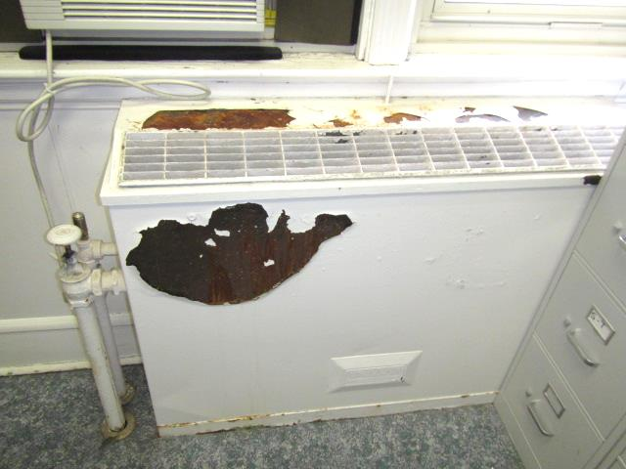
Early 1940s univent, note peeling paint
Picture 2
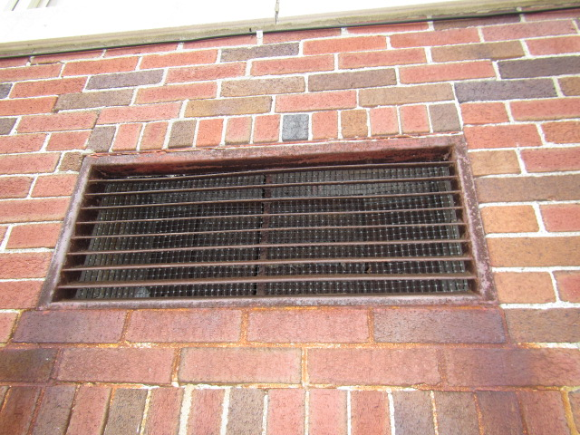
Fresh air intake for univent
Picture 3
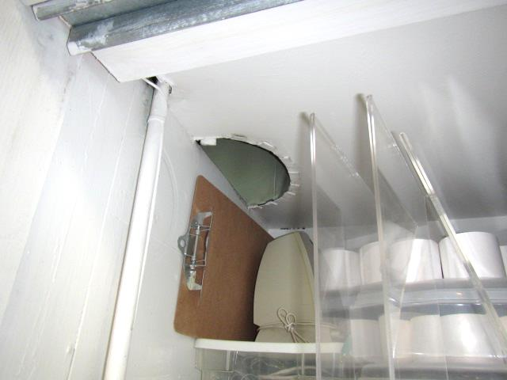
Exhaust vent (arrow) located in ceiling of closet
Picture 4
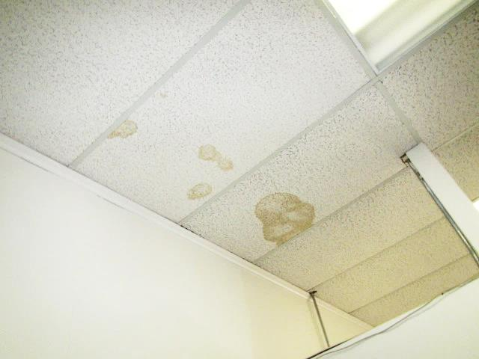
Water-damaged ceiling tiles
Picture 5
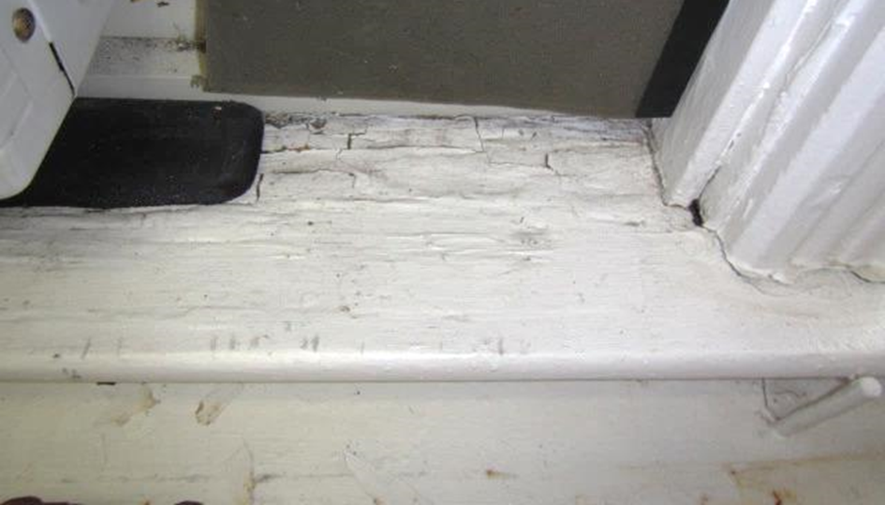
Water-damaged/peeling paint on wooden windowsill

Location | Carbon  Dioxide  (ppm) | Carbon Monoxide  (ppm) | Temp  (°F) | Relative  Humidity  (%) | PM2.5  (µg/ m³) | Occupants  in Room | Windows  Openable | Ventilation |  | Remarks
 |  |  |  |  |  |  |  | Supply | Exhaust
Background | 414 | ND | 62 | 17 | 7 |  |  |  |  | Warm, sunny, light breeze
DosSantos Office | 1060 | ND | 70 | 25 | 9 | 1 | Y | N | N | Vintage UV-peeling paint/fan not operating, window AC, water damage to wooden window sill-dry/normal moisture content, dirt/dust/debris on flat surfaces and UV
Brickley Office | 966 | ND | 71 | 25 | 11 | 0 | Y | N | N
Main Office Area (Left) | 988 | ND | 71 | 25 | 11 | 0 | N | N | N | Fan in wall for ventilation
Main Office Area (Right) | 1010 | ND | 71 | 25 | 9 | 4 | N | N | N
Huck Office | 955 | ND | 71 | 24 | 9 | 0 | Y | N | N | Window AC

The service life is the median time during which a particular system or component of …[an HVAC]… system remains in its original service application and then is replaced. Replacement may occur for any reason, including, but not limited to, failure, general obsolescence, reduced reliability, excessive maintenance cost, and changed system requirements due to such influences as building characteristics or energy prices (ASHRAE, 1991).

