INDOOR AIR QUALITY ASSESSMENT

Hurley Building, 2nd floor
Executive Office of Labor and Workforce Development
19 Staniford Street
Boston, MA

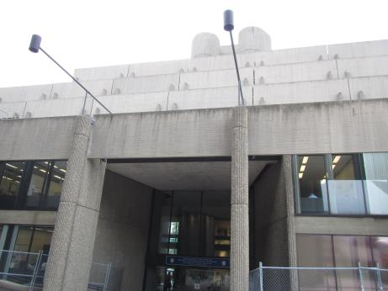

Prepared by:
Massachusetts Department of Public Health
Bureau of Environmental Health
Indoor Air Quality Program
November 2016

Background
Building: | Hurley Building  Division of Unemployment Assistance  2nd Floor
Address: | 19 Staniford Street Boston, MA
Assessment Requested by: | Harris Magloire, Facilities/Operations Management, Executive Office of Labor and Workforce Development
Reason for Request: | General Indoor Air Quality (IAQ) concerns
Date of Assessment: | September 28, 2016
Massachusetts Department of Public Health/Bureau of Environmental Health (MDPH/BEH) Staff Conducting Assessment: | Jason Dustin, Environmental Analyst/Inspector, IAQ Program
Building Description: | Multi-story, flat-roofed concrete building
Building Population: | Approximately 21 employees in area tested
Windows: | Openable

Methods
Please refer to the IAQ Manual for methods, sampling procedures, and interpretation of results (MDPH, 2015).

IAQ Testing Results
The following is a summary of indoor air testing results (Table 1).
- Carbon dioxide levels were below 800 parts per million (ppm) in all areas assessed, indicating adequate fresh air in the space.
- Temperature was within or just below the recommended range of 70°F to 78°F in all areas assessed.
- Relative humidity was within the recommended range of 40% to 60% in all areas assessed.
- Carbon monoxide levels were non-detectable (ND) in all indoor areas assessed.
- Fine particulate matter (PM2.5) concentrations measured were below the National Ambient Air Quality Standard (NAAQS) level of 35 μg/m³ in all areas assessed.
- Total Volatile Organic Compounds (TVOCs) were ND in all areas assessed.

Ventilation
This assessment was limited to a portion of the second floor. The area consists of a large open work space with carpeting and cubicles. It can be seen from Table 1 that carbon dioxide levels were below 800 parts per million (ppm) in all areas surveyed indicating adequate ventilation. Mechanical ventilation is provided by air handling units (AHUs) ducted to induction units located along the base of windows (Picture 1).

Microbial/Moisture Concerns
BEH/IAQ staff noted a water cooler and two refrigerators located on top of carpeting in the break room. Water staining was also evident in this area due to previous spills (Picture 2). Chronic moistening of carpet can lead to microbial growth. Water coolers and refrigerators should be placed on waterproof mats or in an area that is tiled.
Temporary drip pans were noted below induction units (Picture 3). These pans were reportedly placed below these units as a precautionary measure. No water was found collecting in the pans. These pans should be emptied and cleaned periodically should they begin to collect water in humid months. Humidity control at the AHU and monitoring cooling water temperature/dew point are especially important to avoid excess condensation from forming at the induction units. It was reported that this concern is being appropriately addressed by facility staff.

Other IAQ Evaluations
Exposure to low levels of TVOCs may produce eye, nose, throat, and/or respiratory irritation in some sensitive individuals. To determine if VOCs were present, BEH/IAQ staff measured TVOC levels within the office suite. TVOC levels were ND at the time of assessment. BEH/IAQ staff also examined rooms for products containing VOCs. BEH/IAQ staff noted hand sanitizers, fragrances, and dry erase materials in use within the office. All of these products have the potential to be irritants to the eyes, nose, throat, and respiratory system of sensitive individuals.
The second floor office area inspected is carpeted. Carpets should be cleaned annually (or semi-annually in soiled/high traffic areas) in accordance with Institute of Inspection, Cleaning and Restoration Certification (IICRC) recommendations, (IICRC, 2012). Facilities staff reported that there is a regular program in place for high efficiency particulate arrestance (HEPA) vacuuming and carpet cleaning.
The break room did not appear to be equipped with direct local exhaust. MDPH typically recommends having local exhaust in these areas to remove moisture, odors and particulate matter due to cooking activities.
Plants were observed in several areas (Table 1). Plants, soil, and drip pans can serve as sources of mold/bacterial growth. Plants should be properly maintained, over-watering of plants should be avoided, and drip pans should be inspected periodically for mold growth.

Conclusions/Recommendations
Based on observations at the time of assessment, the following is recommended:
- Place a waterproof mat under water coolers and refrigerators. Alternatively, consider removing carpeting and installing tile in the break room.
- Eliminate/reduce the use of hand sanitizers, fragrances, and dry erase materials in use within the office since all of these products have the potential to be irritants to the eyes, nose, throat, and respiratory system of sensitive individuals.
- Plants should be properly maintained, over-watering of plants should be avoided, and drip pans should be inspected periodically for mold growth.
- Continue to monitor the temporary drip pans under the induction units, especially in humid weather. These pans should be emptied and cleaned periodically should they begin to collect water. Humidity control at the AHU and cooling water temperature/dew point should continue to be carefully monitored to avoid condensation issues.
- Carpets should continue to be cleaned annually (or semi-annually in soiled/high traffic areas) in accordance with Institute of Inspection, Cleaning and Restoration Certification (IICRC) recommendations, (IICRC, 2012).
- Consider installing direct local exhaust in the break room to remove moisture, odors, and particulate matter from cooking activities. Additional HVAC balancing may be required to account for any pressure differentials created if alterations are made.
- For buildings in New England, periods of low relative humidity during the winter are often unavoidable. Therefore, scrupulous cleaning practices should be adopted to minimize common indoor air contaminants whose irritant effects can be enhanced when the relative humidity is low. To control for dusts, a HEPA filter equipped vacuum cleaner in conjunction with wet wiping of all surfaces is recommended. Avoid the use of feather dusters. Drinking water during the day can help ease some symptoms associated with a dry environment (throat and sinus irritations).
- Refer to resource manual and other related IAQ documents located on the MDPH’s website for further building-wide evaluations and advice on maintaining public buildings. These documents are available at: http://mass.gov/dph/iaq.

References
IICRC. 2012. Institute of Inspection, Cleaning and Restoration Certification. Carpet Cleaning: FAQ. Retrieved from http://www.iicrc.org/consumers/care/carpet-cleaning.
MDPH. 2015. Massachusetts Department of Public Health. Indoor Air Quality Manual: Chapters I-III. Available at: http://www.mass.gov/eohhs/gov/departments/dph/programs/environmental-health/exposure-topics/iaq/iaq-manual/.
Picture 1
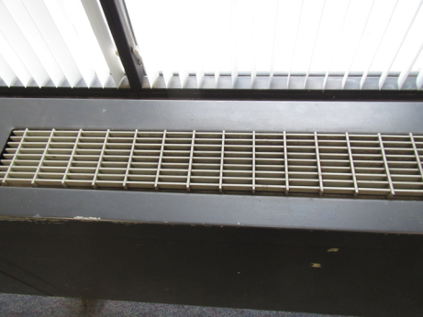
Induction unit
Picture 2
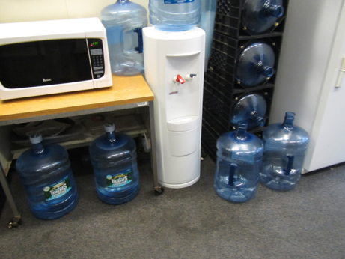
Water cooler and refrigerator on carpeting (note stains on carpet)
Picture 3
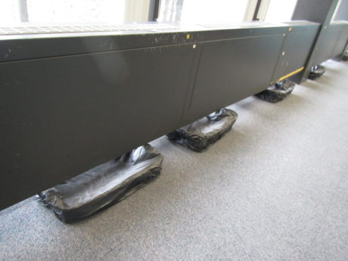
Temporary drip pans beneath induction units

Location | Carbon  Dioxide  (ppm) | Carbon Monoxide  (ppm) | Temp  (°F) | Relative  Humidity  (%) | PM2.5  (µg/m³) | TVOCs  (ppm) | Occupants  in Room | Windows  Openable | Ventilation |  | Remarks
 |  |  |  |  |  |  |  |  | Supply | Exhaust
Background | 353 | ND | 63 | 62 | 13 | ND | - | - | - | - | Overcast, windy, slight drizzle
Future office (across from 207T) | 478 | ND | 68 | 60 | 6 | ND | 3 | N | Y | Y | Carpet, induction units
Staniford side-midway | 496 | ND | 70 | 59 | 6 | ND | 5 | N | Y | Y | Plants, HS
Staniford side-outside new stairway area | 514 | ND | 70 | 57 | 4 | ND | 2 | N | Y | Y
Plaza side- rear | 514 | ND | 71 | 56 | 4 | ND | 5 | N | Y | Y | Plants, HS
Plaza side- front | 467 | ND | 70 | 56 | 3 | ND | 3 | N | Y | Y
Break Room | 487 | ND | 69 | 57 | 3 | ND | 3 | N | Y | Y | Cooler and refrigerators on carpeting, carpet stained, no local exhaust

