INDOOR AIR QUALITY ASSESSMENT

Executive Office of Labor and Workforce Development
Hurley Building
19 Staniford Street 5th floor
Boston, Massachusetts

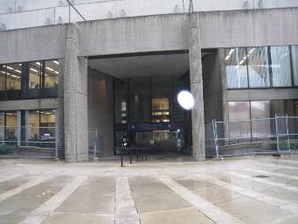

Prepared by:
Massachusetts Department of Public Health
Bureau of Environmental Health
Indoor Air Quality Program
November 2015

Background
Building: | Executive Office of Labor and Workforce Development Offices (EOLWD)
Address: | Hurley Building, 18 Staniford Street, Boston (5th floor)
Assessment Requested by: | Tom Waye  Secretariat Human Resources Director
Date of Assessment: | October 26, 2015
Bureau of Environmental Health/Indoor Air Quality (BEH/IAQ) Program Staff Conducting Assessment: | Michael Feeney, Director  Ruth Alfasso, Environmental Engineer/Inspector
Date of Building Construction: | 1960s
Reason for Request: | Respiratory concerns/general assessment

Building Description
The EOLWD space is located on the 5th floor of a multi- story concrete building with a complex shape, including curved walls in many places. The building has a flat roof. The space contains offices, conference rooms, open cubicle areas, and storage rooms. Windows are not openable.

Results and Discussion
This space is occupied by approximately 75 employees. Test results are presented in Table 1. Methods and indoor air related sampling information can be found in the IAQ Manual and Appendices for IAQ Reports, which can be found at:
http://www.mass.gov/eohhs/gov/departments/dph/programs/environmental-health/exposure-topics/iaq/iaq-rpts/general-appendices-for-iaq-reports.html

Ventilation
It can be seen from Table 1 that carbon dioxide levels were below 800 parts per million (ppm) in all areas surveyed indicating adequate ventilation throughout the 5th floor. Mechanical ventilation is provided by air handling units (AHUs). Ducts carry air from the AHUs to offices and distribute tempered air via supply vents (Picture 1). Additional air circulation is provided by induction units located along the base of windows (Picture 2). Return air is drawn into ceiling-mounted vents and brought back to AHUs.
Of note are the components of the ventilation system in this area compared to other locations on the floor. HVAC fresh air supply vents and exhaust vents in the ceiling above the EOLWD space (Picture 3) are different configuration than those on the remainder of the floor (Picture 4). This difference in configuration likely indicated that this section of the HVAC system was added after the original construction of the building. It is likely that the area occupied by EOLWD was originally open space, with the induction units intended as the source of fresh air for the section of the building. At some point after the original construction of the building, private offices walls were installed in the EOLWD area. The HVAC system shown in Picture 3 was installed to provide fresh air for the non-office areas of the EOLWD space.
To maximize air exchange, the Massachusetts Department of Public Health (MDPH) recommends that both supply and exhaust ventilation operate continuously during periods of occupancy. The MDPH recommends that thermostats be set to the fan “on” setting during occupied hours to provide a continuous source of fresh air and filtration.
Supply and exhaust vents had a variety of appearances and in some cases determining if a vent provided supply or exhaust was difficult, especially since some vents produced no air movement, in or out of the vent. Because little or no exhaust ventilation appeared to be operating in the EOLWD space on the day of the visit, occupant-generated pollutants and odors could build up in the space.
Occupants reported that at times the odor of marijuana and cigarette smoke could be detected in the space. These odors were reportedly intermittent and not present at the time of the assessment. This would suggest that the air intakes for portions of this office space are located either at ground level or in an area where people congregate. Examining plans for the ventilation system for these offices, especially as-built plans, would be helpful in determining what can be done to improve perceived air circulation, increase exhaust, and eliminate sources of contaminants like marijuana/cigarette smoke. For example, if air intakes are located near publically accessible outside areas, the systems attached to them may need additional filtration to remove particulates and associated odors.

Temperature and Relative Humidity
Indoor temperature measurements ranged from 71°F to 76°F (Table 1), which were within the MDPH recommended comfort range. The MDPH recommends that indoor air temperatures be maintained in a range of 70°F to 78°F in order to provide for the comfort of building occupants.
Indoor relative humidity (RH) ranged from 20 to 28 percent (Table 1), which were all below the MDPH comfort range in some areas. The MDPH recommends a comfort range of 40 to 60 percent for indoor air relative humidity. Relative humidity levels in the building would be expected to drop during winter months due to heating. The sensation of dryness and irritation is common in a low relative humidity environment. Low relative humidity is a very common problem during the heating season in the northeast part of the United States.

Microbial/Moisture Concerns
Water-damaged ceiling tiles were observed in some areas (Picture 4 Table 1). In one area, a wall had water staining (Picture 5). The US Environmental Protection Agency (US EPA) and the American Conference of Governmental Industrial Hygienists (ACGIH) recommend that porous materials (e.g., carpeting, gypsum wallboard) be dried with fans and heating within 24 to 48 hours of becoming wet (US EPA, 2001; ACGIH, 1989). If not dried within this time frame, mold growth may occur. Once mold has colonized porous materials, they are difficult to clean and should be removed. The source of the leak above the ceiling tiles should be repaired and the water-damaged ceiling tiles should be removed and replaced.
Plants were observed in many areas, including on induction units (Pictures 2 and 6; Table 1). Plants can be a source of pollen and mold, which can be respiratory irritants to some individuals. Plants should be kept away from sources of airflow which may distribute particles, pollen, mold and odors. Plants should be properly maintained, over-watering of plants should be avoided and drip pans should be inspected periodically for mold growth and cleaned or replaced as necessary.
Water dispensing equipment and small refrigerators were observed in carpeted areas (Picture 7; Table 1). Spills or leaks from this equipment can moisten carpet and lead to microbial growth and carpet degradation.

Other IAQ Evaluations
Indoor air quality can be negatively influenced by the presence of respiratory irritants, such as products of combustion. The process of combustion produces a number of pollutants. Common combustion emissions include carbon monoxide, carbon dioxide, water vapor, and smoke (fine airborne particle material). Of these materials, exposure to carbon monoxide and particulate matter with a diameter of 2.5 micrometers (μm) or less (PM2.5) can produce immediate, acute health effects upon exposure. To determine whether combustion products were present in the indoor environment, BEH/IAQ staff obtained measurements for carbon monoxide and PM2.5

Carbon Monoxide
Carbon monoxide should not be present in a typical, indoor environment. If it is present, indoor carbon monoxide levels should be less than or equal to outdoor levels. Carbon monoxide levels outdoors were measured at 1.6 ppm. Low levels of carbon monoxide of 1 ppm or less were detected inside the building during the assessment.

Particulate Matter
Outdoor PM2.5 concentrations were measured at 11 μg/m³ (Table 1), which were below the NAAQS limit of 35 μg/m³. Indoor PM2.5 levels ranged from 4 to 23 μg/m³ (Table 1), which were also below the NAAQS PM2.5 level of 35 μg/m³. Frequently, indoor air levels of particulate matter (including PM2.5) can be at higher levels than those measured outdoors.

Volatile Organic Compounds (VOCs)
Exposure to low levels of total VOCs (TVOCs) may produce eye, nose, throat and/or respiratory irritation in some sensitive individuals. In order to determine if VOCs were present, BEH/IAQ staff examined rooms for products containing VOCs. BEH/IAQ staff noted air fresheners, hand sanitizer, cleaners (Picture 8) and dry erase materials in use within the space (Table 1). All of these have the potential to be irritants to the eyes, nose, throat and respiratory system of sensitive individuals.

Other Concerns
Other conditions that can affect IAQ were observed during the assessment. Some personal fans and supply vents were observed to be dusty (Picture 9). Dust on these items can be reaerosolized and cause irritation or odors.
In some areas, accumulation of items, including papers, boxes, and personal items, were stored on floors desks, tables, and counters. Large numbers of items provide a source for dusts to accumulate. These items make it difficult for custodial staff to clean. In addition, in some areas, items were observed on the top of induction units (Picture 2), which will prevent them from circulating air. Items should be relocated and/or cleaned periodically to avoid excessive dust build up.
Food preparation areas were located in several parts of the space, including in an open area central to many offices. Food preparation equipment can be a source of odors and particulates, especially if appliances are not kept clean and in good repair. The lack of effective exhaust ventilation will increase the potential for food/cooking/smoke odors to penetrate occupied areas. Food can also be attractive to pests.

Conclusions/Recommendations
In view of the findings at the time of the visit, the following recommendations are made:
- Continue to operate all HVAC systems on the “on” setting to provide continuous airflow/filtration during occupied hours.
- Investigate the current design of the HVAC ducts to determine where fresh air supplies for various areas are located and how the system is designed to operate. Determine source of marijuana smoke odor and use access controls and/or increased filtration to eliminate the sources.
- Determine function of exhaust/return systems for the area and repair or modify to provide additional removal of stale air and odors.
- Consider having the HVAC systems for this area balanced to ensure appropriate flow of fresh and exhaust air over the entire space. Balancing of such system should be performed every 5 years.
- For buildings in New England, periods of low relative humidity during the winter are often unavoidable. Therefore, scrupulous cleaning practices should be adopted to minimize common indoor air contaminants whose irritant effects can be enhanced when the relative humidity is low. To control for dusts, a high efficiency particulate arrestance (HEPA) filter equipped vacuum cleaner in conjunction with wet wiping of all surfaces is recommended. Avoid the use of feather dusters. Drinking water during the day can help ease some symptoms associated with a dry environment (throat and sinus irritations).
- Replace water-damaged ceiling tiles once the source of the leak is discovered and repaired.
- Clean the water-stained wall shown in Picture 4 and check above the ceiling tile system in this area for additional water damage.
- Consider placing water dispensers/small refrigerators in non-carpeted areas or place a waterproof mat underneath them.
- Maintain indoor plants, use non-porous drips pans, prevent overwatering and refrain from placing them near ventilation equipment.
- Reduce the use of items containing VOCs including scented cleaners, air fresheners, dry erase materials and hand sanitizer.
- Clean surfaces, carpets and vents on a preventative maintenance schedule.
- Store items in an organized manner and move them to clean periodically to prevent a buildup of dust.
- Consider moving food preparation areas to non-carpeted, enclosed spaces with exhaust ventilation. Keep all food preparation areas and equipment clean to prevent odors, smoke and pests.
- Refer to resource manuals and other related indoor air quality documents for further building-wide evaluations and advice on maintaining public buildings. These materials are located on the MDPH’s website: http://mass.gov/dph/iaq.

References
ACGIH. 1989. Guidelines for the Assessment of Bioaerosols in the Indoor Environment. American Conference of Governmental Industrial Hygienists, Cincinnati, OH.
US EPA. 2001. Mold Remediation in Schools and Commercial Buildings. US Environmental Protection Agency, Office of Air and Radiation, Indoor Environments Division, Washington, DC. EPA 402-K-01-001. March 2001.
Picture 1
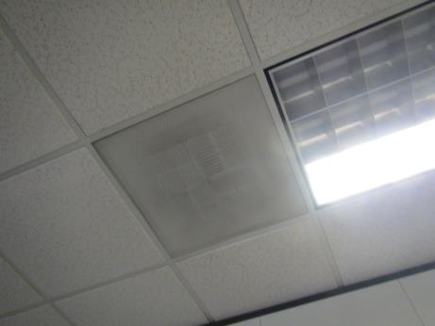
Supply vent
Picture 2
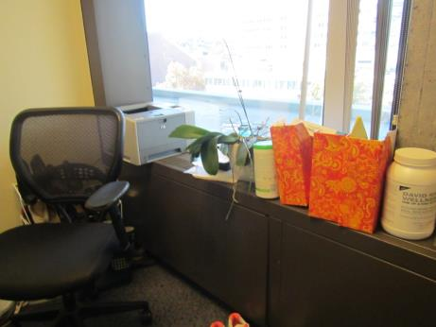
Induction unit with items/plants on it
Picture 3
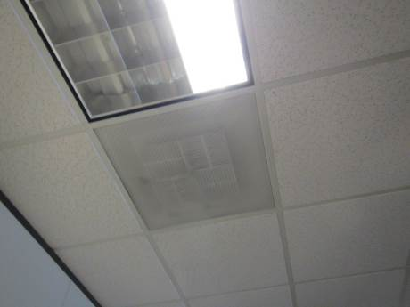

Picture 4
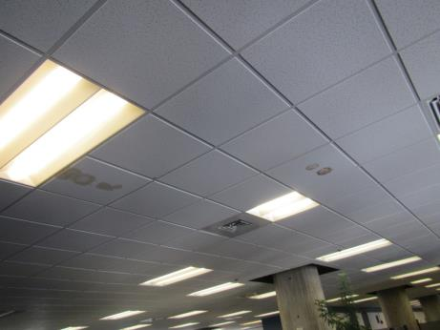
Fresh Air Supply and water-damaged ceiling tiles
Picture 5
Water staining on wall
Picture 6
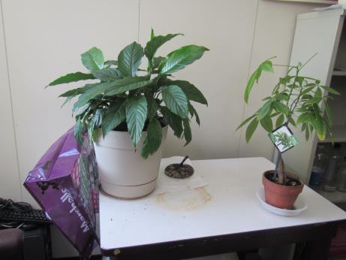
Plants and water damage/stains on table
Picture 7
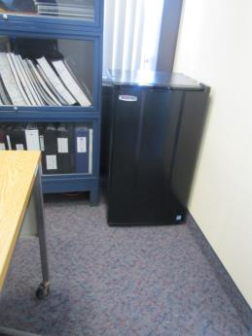
Refrigerator on carpet
Picture 8
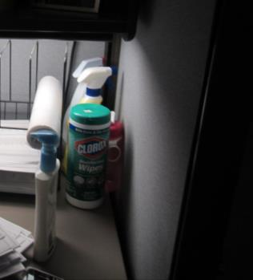
Cleaning products
Picture 9
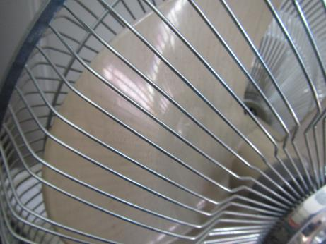
Dusty personal fan

Location | Carbon  Dioxide  (ppm) | Carbon Monoxide  (ppm) | Temp  (°F) | Relative  Humidity  (%) | PM2.5  (µg/m³) | Occupants  in Room | Windows  Openable | Ventilation |  |  | Remarks
 |  |  |  |  |  |  |  | Intake | Exhaust
Background outside | 415 | 1.6 | 57 | 21 | 11
Nursing mothers room | 564 | 0.9 | 72 | 28 | 13 | 3 | N | Y |  |  | Induction unit, PF (dusty), plants with damage underneath, fridge on carpet, shredder
Makros | 650 | 1 | 72 | 25 | 11 | 0 | N | Y |  |  | Induction unit, PF
Cooks (cubes) | 590 | 1 | 72 | 25 | 23 | 1 | N | Y |  |  | AP
Lark-Harvey (cubes) | 633 | 1 | 72 | 24 | 18 | 1 | N | Y |  |  | PF, plants, items including plush and cloth, CP
Quershen | 603 | 1 | 74 | 24 | 15 | 0 | N | Y |  |  | Stained wall, PFs, food
Beard (cubes) | 569 | 0.8 | 74 | 23 | 12 | 0 | N | Y |  |  | Area rug, CP, HS, PF, plants in hallway and microwave and fridge
Fontain (cubes) | 549 | 0.8 | 73 | 23 | 10 | 0 | N | Y |  |  | HS
Stanton | 558 | 0.8 | 73 | 23 | 6 | 1 | N | Y |  |  | Plants on induction unit
Auditing (cubes) | 569 | 0.7 | 74 | 24 | 17 | 3 | N | Y |  |  | WD CT, plant, DEM
External Auditing | 572 | 0.8 | 74 | 23 | 8 | 1 | N | Y |  |  | DEM
Women’s restroom |  |  |  |  |  |  | N | Y |  | Y
Lentini | 554 | 0.8 | 74 | 23 | 8 | 1 | N | Y |  | Y | WD CT, items on induction unit, mint odor
Rousseau | 578 | 0.7 | 75 | 22 | 8 | 1 | N | Y |  | Y | PF on
Boyd | 529 | 0.7 | 75 | 21 | 9 | 0 | N | Y |  | Y | PF, DEM
Ristoccia (cubes) | 563 | 0.7 | 76 | 21 | 11 | 1 | N | Y |  | Y
Lazar (cubes) | 568 | 0.7 | 76 | 22 | 8 | 4 | N | Y |  | Y | Plants
Mortuza | 586 | 0.7 | 76 | 22 | 7 | 1 | N | Y |  | Y | PF, DEM
Peña | 577 | 0.8 | 76 | 21 | 7 | 3 | N | Y |  | Y
Kwan (cubes) | 565 | 0.8 | 75 | 22 | 8 | 2 | N | Y |  | Y | Many plants, WD CT
Granberry (cubed) | 558 | 0.9 | 75 | 22 | 11 | 2 | N | Y |  | Y
Fouster | 580 | 0.7 | 75 | 22 | 10 | 1 | N | Y |  | Y | Items on induction unit, DEM
MDF room |  |  |  |  |  |  | N | Y |  | N | Duct hanging down from ceiling
Breakroom |  |  |  |  |  |  | N | Y |  | Y | Water cooler and fridge on carpet, microwave, toaster
Arnold | 577 | 0.7 | 75 | 22 | 7 | 1 | N | Y |  | Y | DEM, CP, AI
Haynes (cubes) | 597 | 0.7 | 75 | 22 | 8 | 2 | N | Y |  | Y | WD CT, reports of leaks
Dresser (cubed) | 560 | 0.7 | 75 | 22 | 7 | 0 | N | Y |  | Y
Mahoney | 617 | 0.7 | 74 | 22 | 10 | 1 | N | Y |  | Y | DEM
Finneran (cubes) | 584 | 0.9 | 75 | 22 | 7 | 2 | N | Y |  | Y
Nocera | 588 | 0.7 | 75 | 22 | 7 | 3 | N | Y |  | Y | DEM, plants, PF, fridge on carpet
Sullivan | 576 | 0.7 | 75 | 21 | 15 | 0 | N | Y |  | Y | WD CT, items on induction unit
Moran (cubes) | 555 | 0.7 | 75 | 21 | 8 | 3 | N | Y |  | N | WD CT, plants
Pepin | 538 | 0.7 | 75 | 21 | 7 | 0 | N | Y |  | N | DO, plant, PF, DEM, items on induction unit
Sein (cubes) | 535 | 0.7 | 75 | 21 | 8 | 0 | N | Y |  | N | Plants, AI
Souza | 538 | 0.7 | 75 | 21 | 6 | 1 | N | Y |  | N | Plants, PF
Auvil | 614 | 0.7 | 75 | 22 | 7 | 1 | N | N |  | N | Door in window area, induction unit on, DEM
Yung (cubes) | 528 | 0.7 | 74 | 22 | 11 | 3 | N | Y |  | Y | Plants
Jose (cubes) | 565 | 0.7 | 74 | 22 | 7 | 2 | N | Y |  | Y | PF, plants
Ford | 540 | 0.7 | 74 | 21 | 7 | 0 | N | Y |  | Y | Induction unit on, DEM
Defina | 608 | 0.7 | 74 | 23 | 6 | 2 | N | Y |  | Y | DEM
Mackall II | 622 | 0.7 | 75 | 22 | 7 | 1 | N | Y |  | Y | Plant, PF
Secretary to Marlow | 628 | 0.7 | 75 | 22 | 6 | 1 | N | Y |  | Y | Plant on induction unit
Marlow | 499 | 0.7 | 74 | 20 | 5 | 0 | N | Y |  | Y | Fridge on carpet, microwave
Mcgonagal | 574 | 0.7 | 74 | 22 | 6 | 1 | N | Y |  | Y | WD CTs, plant
Conference | 596 | 0.6 | 74 | 22 | 6 | 5 | N | N |  | Y | DO, plant, HS
Sterns (cubes) | 515 | 0.7 | 73 | 22 | 5 | 0 | N | Y |  | Y | PF, plants
Pallazola | 504 | 0.7 | 73 | 21 | 5 | 1 | N | Y |  | Y | Flowers
Henkel | 553 | 0.7 | 73 | 22 | 5 | 1 | N | Y |  | Y | PF –on, mints, plants, DO
Breakroom | 471 | 0.7 | 73 | 21 | 4 | 0 | N | Y |  | Y | WC and fridge on carpet, CP
Vacant office | 487 | 0.7 | 71 | 21 | 5 | 0 | N | Y |  | Y | Plant on induction unit
Waye | 693 | 0.7 | 71 | 22 | 8 | 0 | N | Y |  | Y | PF, perfume odor, DEM
Receptionist | 501 | 0.7 | 71 | 22 | 5 | 1 | N | Y |  | Y
Copy room |  |  |  |  |  |  | N | N |  | Y

