# Background

**INDOOR AIR QUALITY ASSESSMENT**

**Dr. Kevin M. Hurley Middle School**

**Room 105**

**650 Newman Ave.**

**Seekonk, MA**

Exterior view of
Dr. Kevin M. Hurley Middle School
650 Newman Ave.
Seekonk, MA


Prepared by:

Massachusetts Department of Public Health

Bureau of Climate and Environmental Health

Division of Environmental Health Regulations and Standards

April 2025

|  |  |
| --- | --- |
| Building: | Dr. Kevin M. Hurley Middle School |
| Address: | 650 Newman Avenue, Seekonk, MA |
| Assessment Requested by: | Jim Roy, Facilities Director, Seekonk Public Schools (SPS) |
| Date of Assessment: | April 3, 2025 |
| **Reason for Request:** | Staff concerns about mold growth in classroom 105 |
| Massachusetts Department of Public Health/Bureau of Climate and Environmental Health/Division of Environmental Health Regulations and Standards (MDPH/BCEH/EHRS) Staff Conducting Assessment: | Cory Holmes, Senior Advisor for Indoor Air Quality Inspections, Audits, Outreach and Training |
| Building Description: | Room 105 is an interior classroom with no windows that has a suspended ceiling tile system, vinyl floor tiles, and a combination of cinder block, gypsum, and cement board walls. |

# Methods

Please refer to the IAQ Manual for methods, sampling procedures, and interpretation of results (MDPH, 2015). The following is a summary of indoor air testing results. BCEH/IAQ staff also conducted moisture testing of building materials (ceiling tiles and gypsum walls), performed visual inspection for water damage and/or microbial growth, and examined the space for the presence of odors or other environmental concerns within the classroom and above the ceiling tile system.

# Air Testing Results

| **Media sampled** | | **MDPH Guideline/**  **Comparison Value** | | **Measured Range** | | | **Comments** | |
| --- | --- | --- | --- | --- | --- | --- | --- | --- |
| **Outdoors/**  **Background** | | **Rm 105** |
| Carbon Dioxide (CO2) | | < 800 parts per million (ppm) is preferred | | 448 | | 681 |  | |
| Total Volatile Organic Compounds (TVOCs) | | Equal to or below background level measured | | ND | | ND | No odors detected | |
| Carbon Monoxide (CO) | | Non-detectable (ND) or equal to or below background level measured | | ND | | ND |  | |
| Particulate Matter 2.5 (PM2.5) | | US EPA National Ambient Air Quality Standards (NAAQS) 35 μg/m3 or less | | 4 | | ND |  | |
| Temperature | | 70 to 78ºF | | 49 | | 70 | Within MDPH comfort guidelines | |
| Relative Humidity (RH) | | 40% to 60% | | 100% | | 42% | Within MDPH comfort guidelines | |
| Moisture Testing | | Normal = dry | |  | | All building materials found dry at time of assessment, no visible water damage, leaks or staining | Ceiling tiles  Gypsum wallboard | |
| ppm = parts per million | µg/m3 = microgram per cubic meter | | ND = non-detectable | |  | | |

# Discussion and Observations

### Ventilation

Fresh air for the room is supplied by a rooftop air handling unit (AHU) that was installed within the last few years (Picture 1). The building uses ducted supply vents and a ducted return system (Pictures 2 and 3).

Rooftop AHUs are equipped with filters. The MDPH recommends pleated filters with a Minimum Efficiency Reporting Value (MERV) of 8 or higher, which are adequate in filtering out pollen and *mold spores* (ASHRAE, 2012). Filters should also be changed two to four times a year, or per the manufacturer’s recommendations. It was reported by Mr. Roy that filters installed at HMS are MERV 8 (Picture 4) and are changed four times a year. However, when DPH staff inspected the rooftop unit, they also had an *additional* MERV 10 filter installed (Picture 5), which will *more effectively* remove smaller particles.

### Visual observations and moisture testing

At the time of assessment, the room was found clean with little clutter and well-kept by the occupant. No musty odors, visible mold, water-damaged, or moist materials were observed. The room did not contain a sink or any plumbing. During the assessment, classroom furniture and other items against the walls were moved to observe conditions behind them and no water damage or visible mold was observed.

As a proactive measure, DPH staff conducted moisture measurements of gypsum wallboard to make sure there was no hidden moisture present; all sections of wall were dry at the time of assessment. It is also important to note that many of the materials in the room are mold-resistant. Although all the walls appeared the same:

* the south wall is made of gypsum wallboard (Picture 6)
* the east and north walls are constructed of cement board (Pictures 6 and 7), and
* the west wall is concrete block and glass (Picture 7)

Flooring in the room was non-porous vinyl tile (Picture 8), therefore no wall-to-wall nor area carpets were present that could provide a mold growth medium or source of other odors. In addition, ceiling tiles in all four quadrants and center of the room were removed to examine the ceiling plenum, which was found dry, with no visible mold or associated odors. No porous materials that could grow mold were observed above the ceiling, which consisted of concrete and metal ductwork (Picture 9).

Also noted in the room was a high-efficiency particulate arrestance (HEPA) air purifier (Picture 10). HEPA units remove up to 99% of airborne contaminants as small as 0.1 microns, including viruses and mold spores. It also had an activated carbon filter that removes chemicals, gases, and odors (Picture 11). All air purifiers should be cleaned and maintained in accordance with manufacturers’ instructions. The filter on this unit was checked and had some dust/debris buildup (Picture 12). Finally, occupants should ensure that when in use, the HEPA filter is not directly against the wall, to properly vent the back of the unit (Picture 13).

# Recommendations

In view of the findings at the time of assessment, the following recommendations are made:

1. Continue to operate the HVAC system in continuous mode to provide air exchange and filtration.
2. Continue to change filters for HVAC equipment 2-4 times a year or as per the manufacture’s recommendations, using Minimum Efficiency Reporting Value (MERV) 8-rated filters, or the highest rating the building’s ventilation system can accommodate to improve air filtration as much as possible without significantly reducing airflow.
3. Move furniture such as bookcases and file cabinets at least 1 inch from walls to create airflow and prevent trapping moisture that can lead to mold growth.
4. Operate the HEPA air purifier during occupancy. Ensure filters are cleaned/changed as per the manufacturers’ recommendations or more frequently if needed.

# References

ASHRAE. 2012. American Society of Heating, Refrigeration and Air Conditioning Engineers (ASHRAE) Standard 52.2-2012 -- Method of Testing General Ventilation Air-Cleaning Devices for Removal Efficiency by Particle Size (ANSI Approved).

MDPH. 2015. Massachusetts Department of Public Health. “Indoor Air Quality Manual: Chapters I-III”. Available at: [Indoor air quality – manual and appendices | Mass.gov](https://www.mass.gov/lists/indoor-air-quality-manual-and-appendices)

**Picture 1**

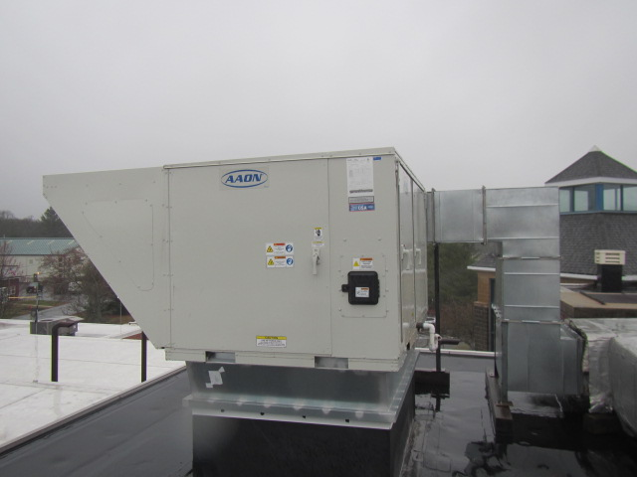

**Rooftop air handling unit (AHU)**

**Picture 2**

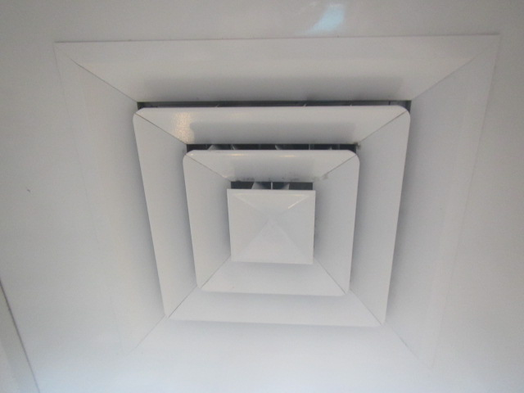

**Ceiling-mounted supply vent**

**Picture 3**

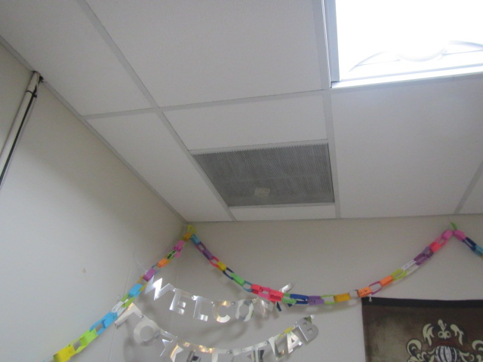

**Ceiling-mounted return vent**

**Picture 4**

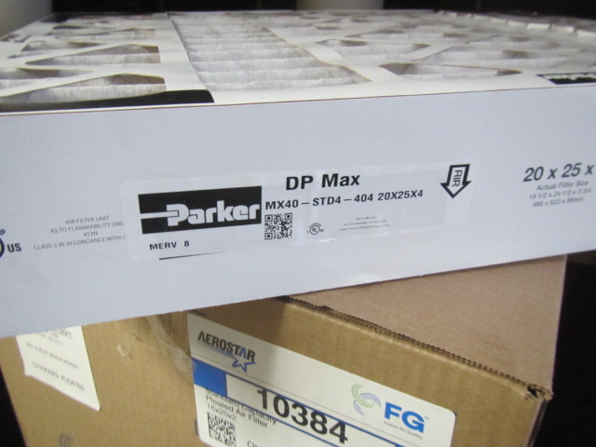

**Four-inch MERV 8 (arrow) box filters installed in rooftop AHU**

**Picture 5**

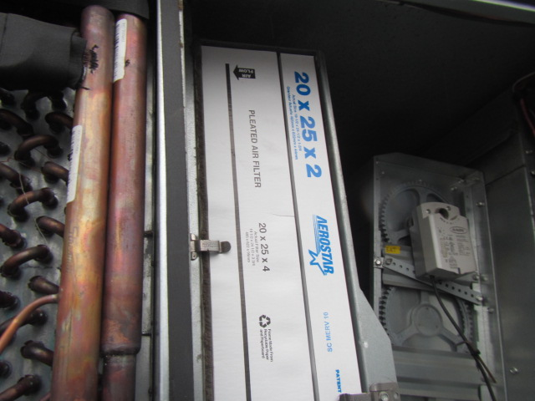

**Four-inch MERV 8 and two-inch MERV 10 (arrow) installed in rooftop AHU**

**Picture 6**

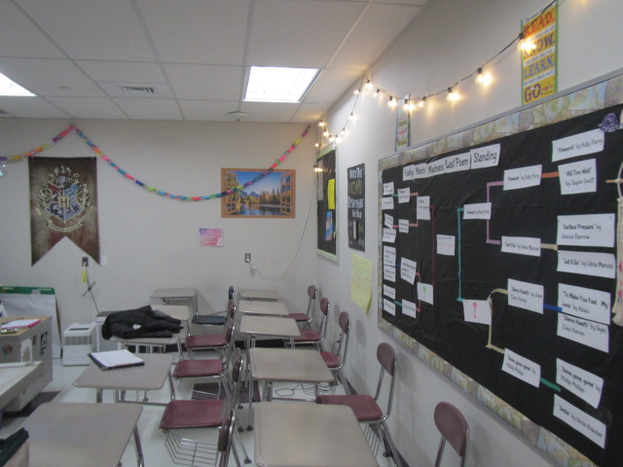

**East wall (left) made of cement board and South wall (right) made of gypsum wallboard**

**Picture 7**

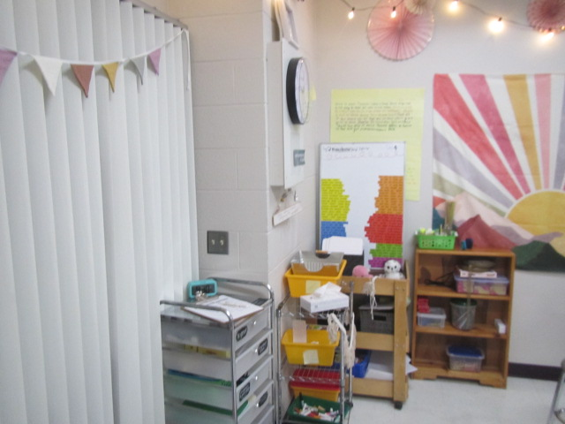

**West wall (left) made of concrete and glass framed windows and the North wall (right) made of cement board**

**Picture 8**

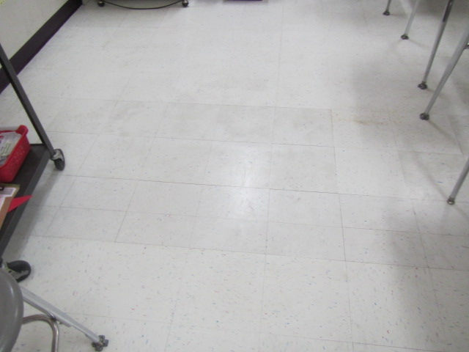

**Vinyl floor tiles**

**Picture 9**

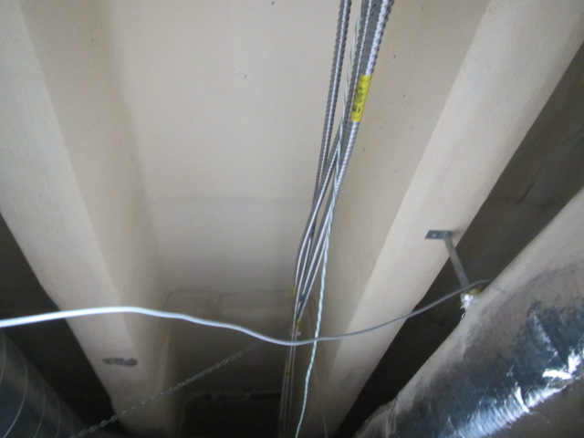

**Concrete above ceiling tiles**

**Picture 10**

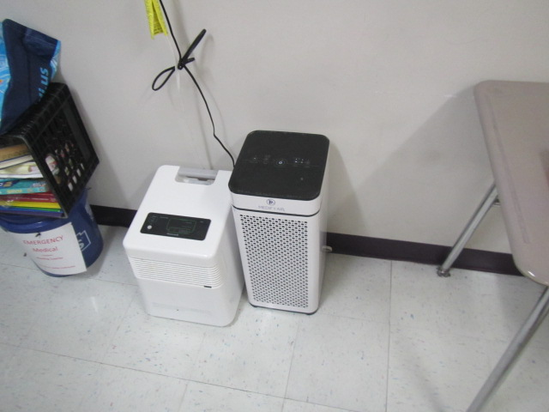

**HEPA filtration unit**

**Picture 11**

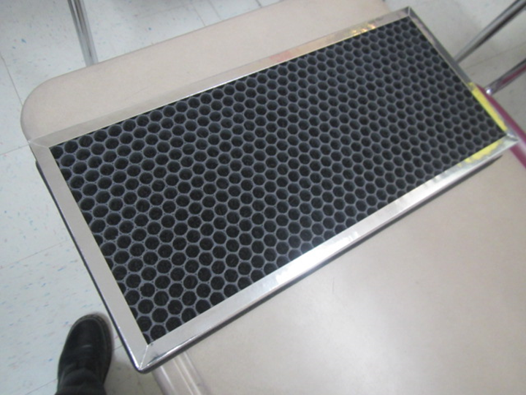

**Carbon filter for HEPA filtration unit**

**Picture 12**

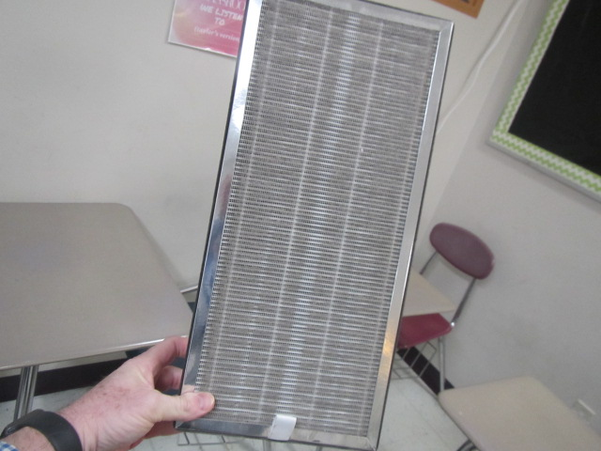

**Dust/debris buildup on HEPA filter**

**Picture 13**

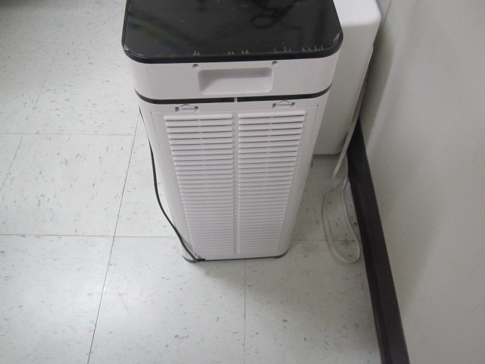

**Vent on the back of HEPA filtration unit**