INDOOR AIR QUALITY ASSESSMENT

Massachusetts Department of Children and Families
500 Main Street
Hyannis, Massachusetts

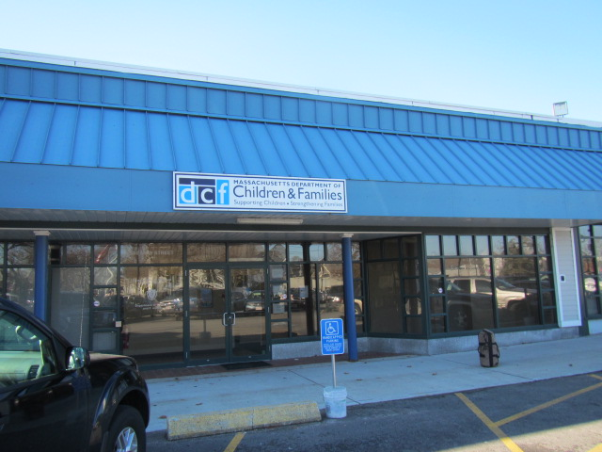

Prepared by:
Massachusetts Department of Public Health
Bureau of Environmental Health
Indoor Air Quality Program
January 2017

Executive Summary
The building needs to have its fresh air supply adjusted and have water-damaged materials located in the ceiling plenum remediated.

Background
Building: | Massachusetts Department of Children and Families (DCF)
Address: | 500 Main Street, Hyannis, MA
Assessment Requested by: | Executive Office of Health and Human Services (EOHHS)
Reason for Request: | General indoor air quality (IAQ) assessment, respiratory issues and mold concerns.
Date of Assessment: | December 23, 2016
Massachusetts Department of Public Health/Bureau of Environmental Health (MDPH/BEH) Staff Conducting Assessment: | Cory Holmes, Environmental Analyst/Inspector, IAQ Program
Building Description: | This building was fully renovated in 2010 and has been occupied by state offices since then. The DCF occupies a section of the main floor (off Main Street) and office/storage space in the finished basement.
Windows: | There are no openable windows in the space.

Methods
Please refer to the IAQ Manual and appendices for methods, sampling procedures, and interpretation of results (MDPH, 2015).

Results and Discussion
The following is a summary of indoor air testing results (Table 1).
- Carbon dioxide measurements were above the MDPH recommended level of 800 parts per million (ppm) in 7 of 10 areas surveyed.
- Temperature was within or very close to the MDPH recommended range of 70°F to 78°F at the time of assessment.
- Relative humidity was below the MDPH recommended range of 40 to 60% in all areas tested.
- Carbon monoxide levels were non-detectable in all areas tested.
- Particulate matter (PM2.5) concentrations measured were below the National Ambient Air Quality (NAAQS) level of 35 μg/m³ in all areas tested.

Ventilation
A heating, ventilating and air-conditioning (HVAC) system has several functions. First it provides heating and, if equipped, cooling. Second, it is a source of fresh air. Finally, an HVAC system will dilute and remove normally occurring indoor environmental pollutants by not only introducing fresh air, but also filtering the airstream and ejecting stale air to the outdoors via exhaust ventilation. The system at the EOHHS facility is computerized and controlled offsite by a third-party HVAC control firm.
Testing results suggest that insufficient fresh air is being introduced into the space for the current occupancy. An increase in the introduction of outside air through adjustment to the settings of the mechanical ventilation system and operating the system in the fan “on” mode for continuous circulation/filtration is recommended. Although temperature measurements were within/close to MDPH recommendations at the time of assessment, a number of temperature/comfort complaints were reported.
It is important to note that relative humidity levels in the building would be expected to be low during the winter months due to atmospheric conditions and heating. Low relative humidity can lead to common symptoms such as: dry skin, lips, and scalp; dry/scratchy throats and noses (nose bleeds); exacerbation of asthma, eczema, or allergies; dry/irritated eyes; and irritation of respiratory tract.
In order to have proper ventilation with a mechanical HVAC system, the system must be balanced to provide an adequate amount of fresh air to the interior of a room while removing stale air from the room. It is recommended that existing ventilation systems be re-balanced every five years to ensure adequate air systems function (SMACNA, 1994). The date of the last balancing of the HVAC system would have occurred prior to occupancy in 2010.
The rooftop air handling units (AHUs) were not accessible at the time of assessment. It is recommended that AHUs should be outfitted with pleated filters of a Minimum Efficiency Reporting Value (MERV) of 8, if they are not already, which are adequate in filtering out pollen and mold spores (ASHRAE, 2012). In addition, filters should be changed 2-4 times a year or in accordance with the manufacture’s recommendations.
Also noted was a lack of draw from the restroom exhaust vent in the basement. Exhaust ventilation is important in restrooms to remove excess moisture and odors.

Microbial/Moisture Concerns
In order for building materials to support mold growth, a source of water exposure is necessary. Water-damaged ceiling tiles were seen in a few areas (Pictures 1 and 2), reportedly due to roof leaks. Water-damaged ceiling tiles indicate leaks from either the roof or plumbing system and can provide a source for mold growth. These tiles should be replaced after a water leak is discovered and repaired.
BEH/IAQ staff examined several areas of concern, including the ceiling plenum (above ceiling tiles) and found water damage on wooden beams and ceiling panels above the Screening and Adoption Units (Pictures 3 and 4). As shown in Picture 4, light-colored discoloration of water-damaged building materials was observed above the Adoption Unit, which may be mold growth. No active/current leaks were reported/observed in these areas; therefore the age of this water damage could not be determined.
The US Environmental Protection Agency (US EPA) and the American Conference of Governmental Industrial Hygienists (ACGIH) recommends that porous materials (e.g., wallboard, carpeting, ceiling tiles) be dried with fans and heating within 24 to 48 hours of becoming wet (US EPA, 2008; ACGIH, 1989). If porous materials are not dried within this time frame, mold growth may occur. Once mold has colonized porous materials, they are difficult to clean and should be removed.
A large number of 5-gallon water cooler bottles are stored on carpeting outside the restrooms (Picture 5). Consideration should be made to place waterproof mats in this area or to remove carpet and install non-permeable floor tiles to prevent damage and/or mold growth due to overspill/leakage.
Upon flushing of the basement restroom toilet, water was observed leaking from the pipe (Picture 6). Although no porous building materials were in close proximity that could get wet/grow mold, this leak should be repaired.

Other Conditions
In a number of areas, items were observed on the floor, windowsills, tabletops, counters, bookcases and desks. The large number of items stored provides a source for dusts to accumulate. These items (e.g., papers, folders, boxes) make it difficult for custodial staff to clean. Items should be relocated and/or be cleaned periodically to avoid excessive dust build up. In addition, dusty materials can accumulate on flat surfaces (e.g., desktops, windowsills and carpets) in occupied areas and subsequently be re-aerosolized causing further irritation.

Conclusions and Recommendations
In view of the findings at the time of the visit, the following recommendations are made:

General IAQ Recommendations
- To improve IAQ/comfort, document areas (with input from DCF staff and managers) of uneven heating/cooling/airflow complaints to work with HVAC vendor/control company and building management to adjust the system to improve circulation and increase outside air intake/exhaust capabilities.
- Operate HVAC system in fan “on” mode instead of “auto” to provide continuous circulation/filtration during occupied hours.
- Have the HVAC system re-balanced, as recommended (every 5 years) in accordance with SMACNA recommendations (SMACNA, 1994).
- Restore basement exhaust vents/motors to working order. Examine all restroom/rooftop exhaust vents/motors/belts for proper function, make repairs as needed.
- For buildings in New England, periods of low relative humidity during the winter are often unavoidable. Therefore, scrupulous cleaning practices should be adopted to minimize common indoor air contaminants whose irritant effects can be enhanced when the relative humidity is low. To control for dusts, a high efficiency particulate arrestance (HEPA) filter-equipped vacuum cleaner in conjunction with wet wiping of all surfaces is recommended. Avoid the use of feather dusters. Drinking water during the day can help ease some symptoms associated with a dry environment (throat and sinus irritation).
- Repair basement toilet plumbing to eliminate leaks.
- Reduce clutter building-wide and increase dust control.
- Ensure filters for rooftop AHUs are of a pleated variety, MERV dust-spot efficiency 8 or higher, which are adequate in filtering out pollen and mold spores (ASHRAE, 2012). Filters should be changed 2-4 times a year or in accordance with the manufacture’s recommendations.
- Consider installing non-porous floor tiles or use large plastic mats in areas of large volume water storage to prevent damage to carpeting.
- Refer to resource manual and other related IAQ documents located on the MDPH’s website for further building-wide evaluations and advice on maintaining public buildings. These documents are available at http://mass.gov/dph/iaq.

Remediation of Water-Damaged Materials/Mold
- Continue to work with building management to identify areas of leaks/sources of water damage (e.g., condensation issues above ceiling tiles) for repair/corrective actions. Replace any water-damaged ceiling tiles.
- A professional flooding restoration/remediation specialist should be consulted to evaluate water-damaged building materials above ceiling tiles for proper cleanup/removal. Coordinate remediation activities and develop a plan specifically designed for the conditions at the DCF.
- Remediation activities should be conducted in a manner consistent with recommendations found in “Mold Remediation in Schools and Commercial Buildings” published by the US Environmental Protection Agency (US EPA, 2008) and MDPH guidelines “Guidance Concerning Remediation and Prevention of Mold Growth and Water Damage in Public Schools/Buildings to Maintain Air Quality” attached as Appendix A.
- During remediation the following steps should be taken to reduce exposure to remediation debris, odors and/or airborne particulate matter:
  - Remediation work should be done during unoccupied periods;
  - Remove furniture and personal items and cover employee workstations in areas of remediation to protect items and facilitate cleanup;
  - Place water-damaged/mold-colonized materials in plastic bags for transport;
  - Ensure AHUs are deactivated and/or seal vents temporarily in remediation areas during remediation;
  - Once remediation is complete, clean the remediation area with a HEPA filter equipped vacuum cleaner in conjunction with wet wiping of all non-porous surfaces.

REFERENCES
American Conference of Governmental Industrial Hygienists (ACGIH), Cincinnati, OH Guidelines for the Assessment of Bioaerosols in the Indoor Environment, 1989.
American Society of Heating, Refrigeration and Air Conditioning Engineers (ASHRAE) Standard 52.2-2012 -- Method of Testing General Ventilation Air-Cleaning Devices for Removal Efficiency by Particle Size (ANSI Approved). 2012.
Massachusetts Department of Public Health (MDPH). 2015. Indoor Air Quality Manual: Chapters I-III. Available at: http://www.mass.gov/eohhs/gov/departments/dph/programs/environmental-health/exposure-topics/iaq/iaq-manual/.
Sheet Metal and Air Conditioning Contractors’ National Association, Inc. (SMACNA). 1994. HVAC Systems Commissioning Manual. 1st ed. Sheet Metal and Air Conditioning Contractors’ National Association, Inc., Chantilly, VA.
“Mold Remediation in Schools and Commercial Buildings”. US EPA. Office of Air and Radiation, Indoor Environments Division, Washington, DC. EPA 402-K-01-001. September 2008. Available at: http://www.epa.gov/mold/mold-remediation-schools-and-commercial-buildings-guide.
Picture 1
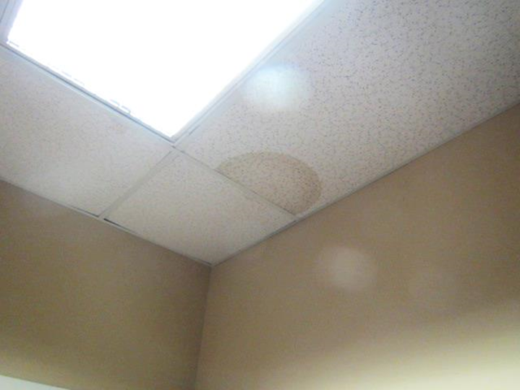
Water-damaged ceiling tile
Picture 2
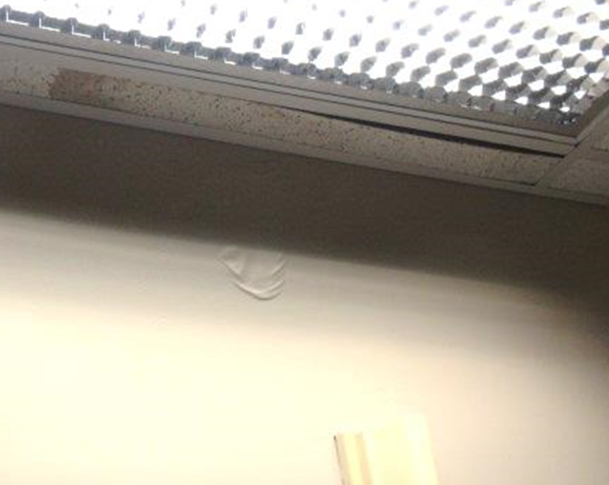
Water-damaged ceiling tile and sloughing paint in ladies restroom
Picture 3
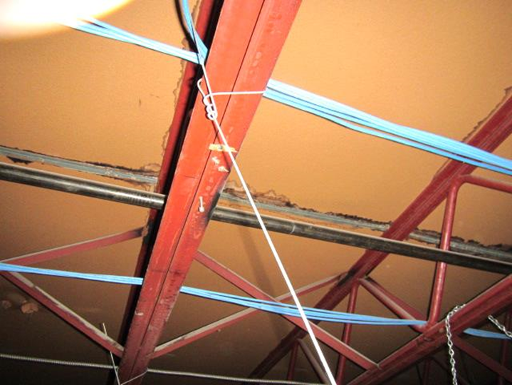
Water-damaged ceiling panels above suspended ceiling
Picture 4
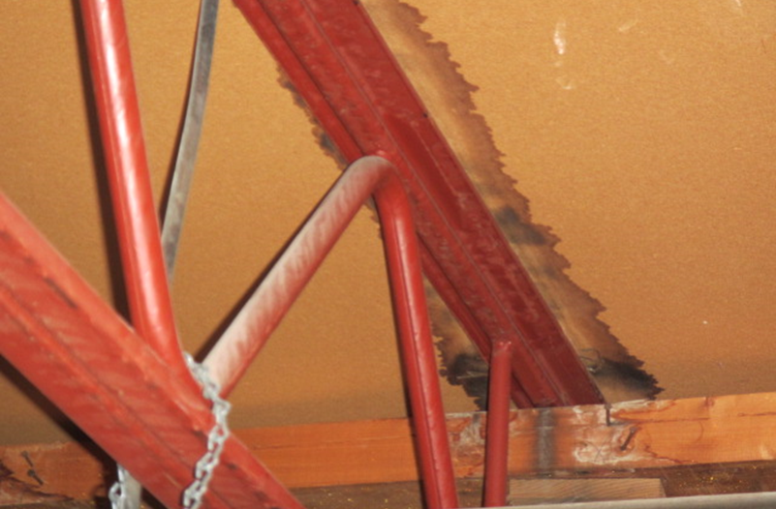
Water-damaged ceiling panels and wooden beams above ceiling tiles, Note light discoloration on beam, which may be mold
Picture 5
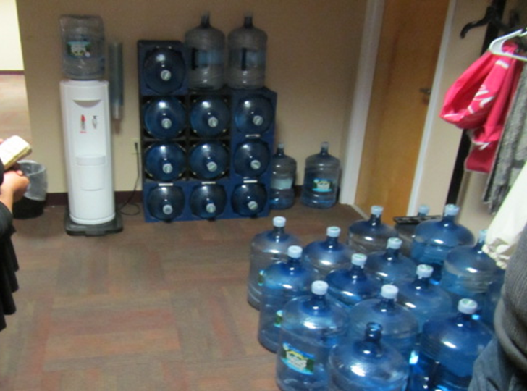
Water storage on carpeting
Picture 6
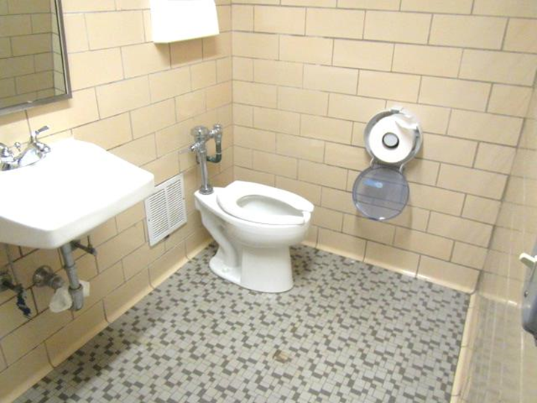
Leaking toilet and inactive exhaust vent in basement restroom
Location | Carbon  Dioxide  (ppm) | Carbon Monoxide  (ppm) | Temp  (°F) | Relative  Humidity  (%) | PM2.5  (µg/m³) | Occupants  in Room | Windows  Openable | Ventilation |  |  | Remarks
 |  |  |  |  |  |  |  | Intake | Exhaust |  | Remarks
Background | 385 | ND | 40 | 32 | 10-23 |  |  |  |  |  | Sunny/clear skies, cold and windy
126 | 701 | ND | 69 | 31 | 4 | 0 | N | Y |  | N
Water Cooler Area | 918 | ND | 74 | 27 | 3 | 0 | N | Y |  | Y | Water bottle storage
Ongoing Unit F | 1002 | ND | 74 | 28 | 3 | 1 | N | Y |  | Y
151 | 941 | ND | 73 | 27 | 5 | 0 | N | Y |  | N
Investigations Unit | 888 | ND | 73 | 27 | 3 | 0 | N | Y |  | Y
Screening Unit | 895 | ND | 74 | 27 | 7 | 1 | N | Y |  | N | Limited airflow supply vent
Adoption Unit | 963 | ND | 77 | 25 | 4 | 3 | N | Y |  | N
Reception | 929 | ND | 75 | 26 | 4 | 1 | N | Y |  | N
Basement Unit | 663 | ND | 72 | 28 | 9 | 2 | N | Y |  | N
Sheridan Office | 607 | ND | 72 | 27 | 4 | 0 | N | Y |  | N
Basement Restroom |  |  |  |  |  |  | N | N |  | Y | Exhaust not operating, plumbing leak when toilet flushes

