Background/Introduction

INDOOR AIR QUALITY ASSESSMENT

Commonwealth of Massachusetts
Department of Children and Families
500 Main Street
Hyannis, Massachusetts

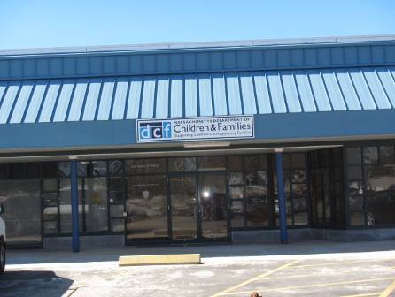

Prepared by:
Massachusetts Department of Public Health
Bureau of Environmental Health
Indoor Air Quality Program
May 2015

In response to a request by Rhett Cavicchi, Director of Labor Relations, Office of Children, Youth and Families (CYF), the Massachusetts Department of Public Health (MDPH), Bureau of Environmental Health (BEH) provided assistance and consultation regarding indoor air quality (IAQ) at the Department of Children and Families (DCF) located at 500 Main Street, Hyannis, Massachusetts. The request was prompted by general IAQ concerns as well as recent odor complaints related to mechanical ventilation issues/repairs. On March 12, 2015 the DCF office was visited by Ruth Alfasso, Environmental Engineer/Inspector and Cory Holmes Environmental Analyst/Regional Inspector in BEH’s IAQ Program to conduct an IAQ assessment.
The DCF occupies part of a large one-story building with a basement, located in downtown Hyannis. The space contains offices, open workstations, reception/waiting room, interview rooms, conference rooms, storage areas and kitchen/lounge areas. Ceilings consist of suspended ceiling tiles. Carpet squares are used for flooring in the majority of areas. Windows are not openable in the building. Other Executive Office of Health and Human Services (EOHHS) offices occupy adjacent space in the building.

Methods
Air tests for carbon monoxide, carbon dioxide, temperature and relative humidity were conducted with the TSI, Q-Trak, IAQ Monitor, Model 7565. Air tests for airborne particle matter with a diameter less than 2.5 micrometers were taken with the TSI, DUSTTRAK™ Aerosol Monitor Model 8520. Total Volatile Organic Compounds (TVOC) were measured using a MiniRAE lite photoionization detector. Moisture content of building materials in a few areas was measured using a Delmhorst BD2100 moisture meter. BEH/IAQ staff also performed a visual inspection of building materials for water damage and/or microbial growth.

Results
Approximately 50 employees work in the DCF portion of the building, which is visited by clients/members of the public daily. The tests were taken during normal operations and appear in Table 1.

Discussion

Ventilation
It can be seen from Table 1 that carbon dioxide levels were below 800 parts per million (ppm) in 45 out of 48 areas tested, indicating optimal air exchange in most areas on the day of the assessment. Note that many areas were vacant or sparsely populated, which would tend to decrease carbon dioxide levels. Carbon dioxide levels would be expected to rise with greater occupancy.
Fresh air is provided by rooftop air handling units (AHUs) ducted to ceiling-mounted supply diffusers (Picture 1). Return air is drawn back into ceiling vents (Picture 2) and returned to the AHUs. While most occupied areas had supply ventilation, many exhaust vents were located in hallways/common areas. Additional ventilation in restrooms is provided by exhausts vented directly to fans on the roof. At the time of the assessment most restroom exhaust vents were found to be off/nonfunctional and some appeared to be backdrafting. Lack of exhaust ventilation in restrooms can lead to a build-up of odors and moisture, which can then migrate to adjacent areas.
To maximize air exchange, the MDPH recommends that both supply and exhaust ventilation operate continuously during periods of occupancy. In order to have proper ventilation with a mechanical supply and exhaust system, the systems must be balanced to provide an adequate amount of fresh air to the interior of a room while removing stale air from the room. It is recommended that HVAC systems be re-balanced every five years to ensure adequate air systems function (SMACNA, 1994).
Minimum design ventilation rates are mandated by the Massachusetts State Building Code (MSBC). Until 2011, the minimum ventilation rate in Massachusetts was higher for both occupied office spaces and general classrooms, with similar requirements for other occupied spaces (BOCA, 1993). The current version of the MSBC, promulgated in 2011 by the State Board of Building Regulations and Standards (SBBRS), adopted the 2009 International Mechanical Code (IMC) to set minimum ventilation rates. Please note that the MSBC is a minimum standard that is not health-based. At lower rates of cubic feet per minute (cfm) per occupant of fresh air, carbon dioxide levels would be expected to rise significantly. A ventilation rate of 20 cfm per occupant of fresh air provides optimal air exchange resulting in carbon dioxide levels at or below 800 ppm in the indoor environment in each area measured. MDPH recommends that carbon dioxide levels be maintained at 800 ppm or below. This is because most environmental and occupational health scientists involved with research on IAQ and health effects have documented significant increases in indoor air quality complaints and/or health effects when carbon dioxide levels rise above the MDPH guidelines of 800 ppm for schools, office buildings and other occupied spaces (Sundell et al., 2011). The ventilation must be on at all times that the room is occupied. Providing adequate fresh air ventilation with open windows and maintaining the temperature in the comfort range during the cold weather season is impractical. Mechanical ventilation is usually required to provide adequate fresh air ventilation.
Carbon dioxide is not a problem in and of itself. It is used as an indicator of the adequacy of the fresh air ventilation. As carbon dioxide levels rise, it indicates that the ventilating system is malfunctioning or the design occupancy of the room is being exceeded. When this happens, a buildup of common indoor air pollutants can occur, leading to discomfort or health complaints. The Occupational Safety and Health Administration (OSHA) standard for carbon dioxide is 5,000 parts per million parts of air (ppm). Workers may be exposed to this level for 40 hours/week, based on a time-weighted average (OSHA, 1997).
The MDPH uses a guideline of 800 ppm for publicly occupied buildings. A guideline of 600 ppm or less is preferred in schools due to the fact that the majority of occupants are young and considered to be a more sensitive population in the evaluation of environmental health status. Inadequate ventilation and/or elevated temperatures are major causes of complaints such as respiratory, eye, nose and throat irritation, lethargy and headaches. For more information concerning carbon dioxide, please see Appendix A.
Temperature readings during the assessment ranged from 70ºF to 73ºF (Table 1), which were within the MDPH recommended comfort guidelines. The MDPH recommends that indoor air temperatures be maintained in a range of 70ºF to 78ºF in order to provide for the comfort of building occupants. In many cases concerning indoor air quality, fluctuations of temperature in occupied spaces are typically experienced, even in a building with an adequate fresh air supply.
The relative humidity measured during the assessment ranged from 18 to 38 percent, which was below the MDPH recommended comfort range. The MDPH recommends a comfort range of 40 to 60 percent for indoor air relative humidity. Relative humidity levels in the building would be expected to drop during the winter months due to heating. The sensation of dryness and irritation is common in a low relative humidity environment. Low relative humidity is a very common problem during the heating season in the northeast part of the United States.

Microbial/Moisture Concerns
A few water-damaged ceiling tiles were observed in offices/work areas (Picture 3, Table 1). These appeared to be from historic roof or plumbing leaks. In Interview room 2, water-damaged ceiling tiles and damaged paint were observed (Picture 4). Moisture measurements were taken of the ceiling tiles and wall in this area and the materials were found to be dry. Water-damaged ceiling tiles should be removed and replaced once the source of water has been identified and remediated. The wall with the water-damaged paint was determined to be dry and did not require removal however; the paint should be scraped and refinished. No odors or microbial colonization was noted.
Plants were observed in several areas (Table 1). Plants can be a source of pollen and mold, which can be respiratory irritants to some individuals. Plants should be properly maintained, over-watering of plants should be avoided and drip pans should be inspected periodically for mold growth.
Refrigerators in the lunch area were examined and one had significant mold staining on the gasket (Picture 5). Refrigerators in general, appeared to be in need of cleaning. Refrigerators should be kept clean to prevent mold and spoiled food odors from occurring.
Water coolers were observed on carpeted areas. Spills or leaks from these appliances can moisten carpeting. They should be located in a non-carpeted area or on waterproof mats.
The room housing data equipment was equipped with a ductless air conditioning unit to maintain proper temperature control. These units have condensation drains that are typically pumped to the outside of the building. These units should be regularly inspected to insure that the condensation drains and pumps are working properly and are not clogged or leaking.

Other IAQ Evaluations
Indoor air quality can be negatively influenced by the presence of respiratory irritants, such as products of combustion. The process of combustion produces a number of pollutants. Common combustion emissions include carbon monoxide, carbon dioxide, water vapor, and smoke (fine airborne particle material). Of these materials, exposure to carbon monoxide and particulate matter with a diameter of 2.5 micrometers (μm) or less (PM2.5) can produce immediate, acute health effects upon exposure. To determine whether combustion products were present in the indoor environment, BEH/IAQ staff obtained measurements for carbon monoxide and PM2.5.

Carbon Monoxide
Carbon monoxide is a by-product of incomplete combustion of organic matter (e.g., gasoline, wood and tobacco). Exposure to carbon monoxide can produce immediate and acute health effects. Several air quality standards have been established to address carbon monoxide and prevent symptoms from exposure to these substances. The MDPH established a corrective action level concerning carbon monoxide in ice skating rinks that use fossil-fueled ice resurfacing equipment. If an operator of an indoor ice rink measures a carbon monoxide level over 30 ppm, taken 20 minutes after resurfacing within a rink, that operator must take actions to reduce carbon monoxide levels (MDPH, 1997).
The American Society of Heating Refrigeration and Air-Conditioning Engineers (ASHRAE) has adopted the National Ambient Air Quality Standards (NAAQS) as one set of criteria for assessing indoor air quality and monitoring of fresh air introduced by HVAC systems (ASHRAE, 1989). The NAAQS are standards established by the US EPA to protect the public health from six criteria pollutants, including carbon monoxide and particulate matter (US EPA, 2006). As recommended by ASHRAE, pollutant levels of fresh air introduced to a building should not exceed the NAAQS levels (ASHRAE, 1989). The NAAQS were adopted by reference in the Building Officials & Code Administrators (BOCA) National Mechanical Code of 1993 (BOCA, 1993), which is now an HVAC standard included in the Massachusetts State Building Code (SBBRS, 2011). According to the NAAQS, carbon monoxide levels in outdoor air should not exceed 9 ppm in an eight-hour average (US EPA, 2006).
Carbon monoxide should not be present in a typical, indoor environment. If it is present, indoor carbon monoxide levels should be less than or equal to outdoor levels. During the visit outdoor carbon monoxide concentrations ranged from 1.0 to 2.7 ppm, likely due to traffic/parking nearby. Indoor levels were all non-detect (ND) with the exception of one office (Table 1). That reading was likely due to vehicles idling in close proximity around the building. M.G.L. chapter 90 section 16A prohibits the unnecessary operation of the engine of a motor vehicle for a foreseeable time in excess of five minutes (MGL, 1996). Anti-idling signs should be posted to discourage this behavior. Local police and health agents are given the authority to enforce this law.

Particulate Matter
The US EPA has established NAAQS limits for exposure to particulate matter. Particulate matter includes airborne solids that can be irritating to the eyes, nose and throat. The NAAQS originally established exposure limits to PM with a diameter of 10 μm or less (PM10). In 1997, US EPA established a more protective standard for fine airborne particulate matter with a diameter of 2.5 μm or less (PM2.5). This more stringent PM2.5 standard requires outdoor air particle levels be maintained below 35 μg/m³ over a 24-hour average (US EPA, 2006). Although both the ASHRAE standard and BOCA Code adopted the PM10 standard for evaluating air quality, MDPH uses the more protective PM2.5 standard for evaluating airborne PM concentrations in the indoor environment.
Outdoor PM2.5 concentrations were measured at 12 to 15 μg/m³ (Table 1). PM2.5 levels indoors ranged from ND to 35 μg/m³. All readings were at or below the NAAQS PM2.5 level of 35 μg/m³. Frequently, indoor air levels of particulate matter (including PM2.5) can be at higher levels than those measured outdoors. A number of activities that occur indoors and/or mechanical devices can generate particulate matter during normal operations. Sources of indoor airborne particulate matter may include but are not limited to particles generated during the operation of fan belts in the HVAC system, use of stoves and/or microwave ovens in kitchen areas; use of photocopiers, fax machines and computer printing devices; operation of an ordinary vacuum cleaner and heavy foot traffic indoors.

Volatile Organic Compounds
Indoor air concentrations can be greatly impacted by the use of products containing volatile organic compounds (VOCs). VOCs are carbon-containing substances that have the ability to evaporate at room temperature. Total volatile organic compounds (TVOCs) can result in eye and respiratory irritation if exposure occurs. For example chemicals evaporating from a paint can stored at room temperature would most likely contain VOCs.
In order to determine if VOCs were present, testing for TVOCs was conducted. Outdoor TVOC concentrations were ND on the day of the assessment (Table 1). No measureable levels of TVOCs were detected in the building during the assessment (Table 1).
Of note is the presence of copy machines within office areas with no dedicated exhaust ventilation (Table 1). Photocopiers can be sources of pollutants such as VOCs, ozone, heat and odors, particularly if the equipment is older and in frequent use. Both VOCs and ozone are respiratory irritants (Schmidt Etkin, 1992). Photocopiers should be kept in well-ventilated rooms/areas and should be located near windows or exhaust vents.
Additional sources of TVOCs in the office area include dry erase boards and related materials (Table 1). Materials such as dry erase markers and dry erase board cleaners may contain VOCs, such as methyl isobutyl ketone, n-butyl acetate and butyl-cellusolve (Sanford, 1999), which can be irritating to the eyes, nose and throat.
Hand sanitizer was also observed in office areas (Table 1); these products may contain ethyl alcohol and/or isopropyl alcohol, which are highly volatile and may be irritating to the eyes and nose. Sanitizing products may also contain fragrances to which some people may be sensitive.
Cleaning products, pesticides, air freshening sprays and scented products were also observed (Pictures 6 and 7, Table 1). Plug-in air fresheners and other air deodorizers contain chemicals that can be irritating to the eyes, nose and throat of sensitive individuals. Many air fresheners contain 1,4-dichlorobenzene, a VOC which may cause reductions in lung function (NIH, 2006). Furthermore, deodorizing agents do not remove materials causing odors, but rather mask odors that may be present in the area. Many cleaning products and pesticides contain chemicals that can be irritating to the eyes, nose and throat of sensitive individuals. Cleaning products and pesticides should be properly labeled and stored in an appropriate area. In addition, a Material Safety Data Sheet (MSDS) should be available at a central location for each product in the event of an emergency.

Other Conditions
Other conditions that can affect IAQ were observed during the assessment. In some areas, accumulations of items were seen on floors, windowsills, tabletops, counters, bookcases and desks, which provide a source for dusts to accumulate (Picture 8). These items (e.g., papers, folders, boxes) make it difficult for custodial staff to clean. Items should be relocated and/or be cleaned periodically to avoid excessive dust build up. The DCF also has a large number of items stored, including clothing, luggage and other items (Picture 9). Some of these items were observed to be in open bins or on floors in storage rooms, where they can become dusty, dirty or subject to condensation. Cardboard, paper, cloth and other porous items should not be stored in contact with floors.
Personal fans, supply and exhaust vents were found to be dusty in some areas (Picture 1, Table 1). Regular cleaning of supply diffusers, exhaust vents and personal fans will reduce aerosolizing any accumulated particulate matter on these surfaces.
Debris was observed in the cabinet under the kitchen sink (Picture 10). Organic debris may be attractive to pests. In addition, the area under the sink is a moist environment and debris may become colonized by mold. This area should be cleaned regularly and not used for storage of porous materials.
Most areas of the office space were carpeted. The Institute of Inspection, Cleaning and Restoration Certification (IICRC) recommends that carpeting be cleaned annually (or semi-annually in soiled high traffic areas) (IICRC, 2012). Regular cleaning with a high efficiency particulate arrestance (HEPA) filtered vacuum in combination with an annual cleaning will help to reduce accumulation and potential aerosolization of materials from the carpeting.

Conclusions/Recommendations
At the time of the assessment mechanical ventilation repairs had been completed; no lingering odors were detected/reported and no elevated levels of carbon monoxide, or TVOCs were measured. In view of the findings at the time of the visit, the following recommendations are made:
- Operate all ventilation systems throughout the building continuously during periods of occupancy to maximize air exchange. This would include leaving thermostat fan settings in the “on” mode (not auto) for continuous airflow.
- Inspect and activate motors for restroom exhaust vents, make repairs as needed.
- Consider adopting a balancing schedule of every 5 years for all mechanical ventilation systems, as recommended by ventilation industrial standards (SMACNA, 1994).
- For buildings in New England, periods of low relative humidity during the winter are often unavoidable. Therefore, scrupulous cleaning practices should be adopted to minimize common indoor air contaminants whose irritant effects can be enhanced when the relative humidity is low. To control for dusts, a high efficiency particulate arrestance (HEPA) filter equipped vacuum cleaner in conjunction with wet wiping of all surfaces is recommended. Avoid the use of feather dusters. Drinking water during the day can help ease some symptoms associated with a dry environment (throat and sinus irritations).
- Examine areas of leakage and ensure any water-damaged ceiling tiles are repaired and/or replaced. Examine the area above ceiling tiles for mold growth. Disinfect areas of water leaks with an appropriate antimicrobial, as needed.
- Scrape and refinish damaged paint in Interview room 2.
- Indoor plants should be properly maintained and equipped with drip pans to prevent water damage to porous building materials and be located away from ventilation sources to prevent the aerosolization of dirt, pollen or mold.
- Place water coolers/dispensers in areas without carpeting or place on a waterproof mat.
- Regularly inspect ductless air conditioning units for proper condensation drainage.
- Clean out refrigerators regularly. Clean stained gaskets with an antimicrobial solution. If gaskets cannot be cleaned, consider replacing them.
- Consider installing local exhaust vents near photocopiers or relocating them to areas with local exhaust ventilation and away from occupants.
- Use dry erase markers only in well-ventilated areas. Clean dry erase boards and trays to prevent accumulation of materials.
- Reduce the use of hand sanitizing products especially those containing fragrances.
- Avoid the use of air freshener sprays, solids and diffuser reeds to avoid exposure to VOCs and fragrance compounds.
- Ensure that items in storerooms are enclosed to protect from dust and are in plastic containers or on shelves off the floor to prevent condensation.
- Keep the area under the sink clean and avoid storage of porous materials.
- Regularly clean supply diffusers, exhaust vents and personal fans to avoid re-aerosolizing any accumulated debris.
- Vacuum carpet with a high efficiency particulate arrestance (HEPA) filtered vacuum in combination with an annual cleaning to help to reduce accumulation and potential aerosolization of materials from the carpeting.
- Refer to resource manuals and other related indoor air quality documents for further building-wide evaluations and advice on maintaining public buildings. Copies of these materials are located on the MDPH’s website: http://mass.gov/dph/iaq.

References
ASHRAE. 1989. Ventilation for Acceptable Indoor Air Quality. American Society of Heating, Refrigeration and Air Conditioning Engineers. ANSI/ASHRAE 62-1989.
BOCA. 1993. The BOCA National Mechanical Code/1993. 8th ed. Building Officials & Code Administrators International, Inc., Country Club Hills, IL.
IICRC. 2012. Carpet Cleaning FAQ 4 Institute of Inspection, Cleaning and Restoration Certification. Institute of Inspection Cleaning and Restoration, Vancouver, WA.
MDPH. 1997. Requirements to Maintain Air Quality in Indoor Skating Rinks (State Sanitary Code, Chapter XI). 105 CMR 675.000. Massachusetts Department of Public Health, Boston, MA.
MGL. 1996. Stopped motor vehicles; Operation of Engine; Time Limit; Penalty. Massachusetts General Laws. M.G.L. c. 90:16A.
NIH. 2006. Chemical in Many Air Fresheners May Reduce Lung Function. NIH News. National Institute of Health. July 27, 2006. http://www.nih.gov/news/pr/jul2006/niehs-27.htm
OSHA. 1997. Limits for Air Contaminants. Occupational Safety and Health Administration. Code of Federal Regulations. 29 C.F.R 1910.1000 Table Z-1-A.
Sanford. 1999. Material Safety Data Sheet (MSDS No: 198-17). Expo® Dry Erase Markers Bullet, Chisel, and Ultra Fine Tip. Sanford Corporation. Bellwood, IL.
SBBRS. 2011. Mechanical Ventilation. State Board of Building Regulations and Standards. Code of Massachusetts Regulations, 8th edition. 780 CMR 1209.0.
Schmidt Etkin, D. 1992. Office Furnishings/Equipment & IAQ Health Impacts, Prevention & Mitigation. Cutter Information Corporation, Indoor Air Quality Update, Arlington, MA.
SMACNA. 1994. HVAC Systems Commissioning Manual. 1st ed. Sheet Metal and Air Conditioning Contractors’ National Association, Inc., Chantilly, VA.
Sundell. 2011. Sundell, J., H. Levin, W. W. Nazaroff, W. S. Cain, W. J. Fisk, D. T. Grimsrud, F. Gyntelberg, Y. Li, A. K. Persily, A. C. Pickering, J. M. Samet, J. D. Spengler, S. T. Taylor, and C. J. Weschler. Ventilation rates and health: multidisciplinary review of the scientific literature. Indoor Air, Volume 21: pp 191–204.
US EPA. 2006. National Ambient Air Quality Standards (NAAQS). US Environmental Protection Agency, Office of Air Quality Planning and Standards, Washington, DC. http://www.epa.gov/air/criteria.html.
Picture 1
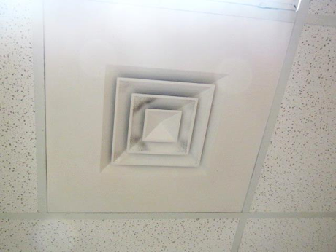
Typical supply vent, note dust/debris accumulation on louvers
Picture 2
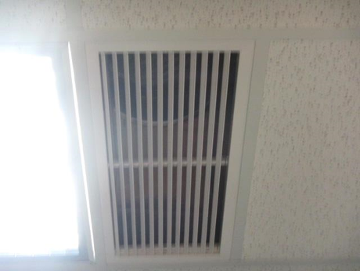
Typical exhaust vent
Picture 3
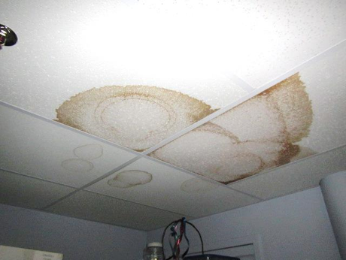
Water-damaged ceiling tiles in a storeroom
Picture 4
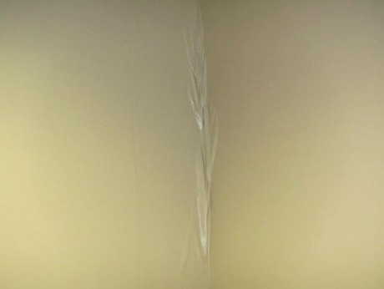
Close-up of peeling/water-damaged paint on wall of interview room 2
Picture 5
Mold staining and debris on refrigerator gasket
Picture 6
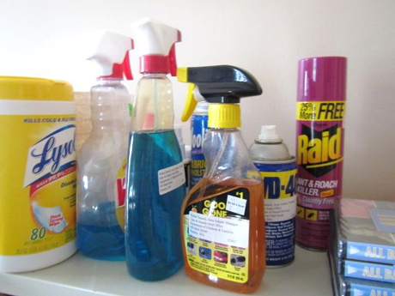
Cleaning products and pesticides in an office
Picture 7
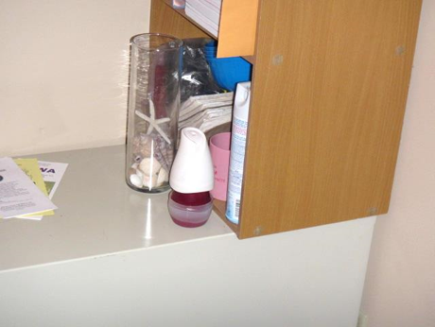
Air freshener product
Picture 8
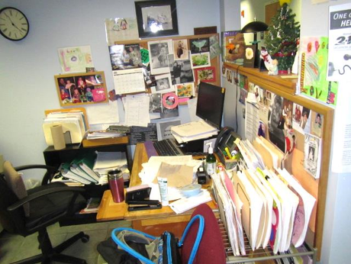
Papers and other items in an office
Picture 9
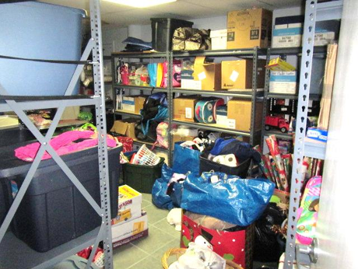
Items in storage
Picture 10
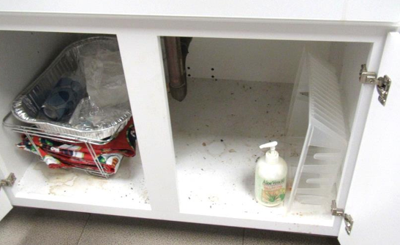
Debris in sink cabinet
Location | Carbon  Dioxide  (ppm) | Carbon Monoxide  (ppm) | Temp  (°F) | Relative  Humidity  (%) | PM2.5  (µg/m³) | TVOC  (ppm) | Occupants  in Room | Windows  Openable | Ventilation |  |  | Remarks
 |  |  |  |  |  |  |  |  | Intake | Exhaust
Background | 420 | 1.0-2.7 | 37 | 28 | 12-15 | ND |  |  |  |  |  | Cold and windy
117 | 642 | ND | 72 | 22 | 21 | ND | 1 | N | Y |  | N | DO
120 Manager | 635 | ND | 70 | 26 | 14 | ND | 0 | N | Y |  | Y | Boxes on floor, DO
121 | 620 | ND | 71 | 25 | 7 | ND | 0 | N | Y |  | Y | DO
122 | 640 | ND | 71 | 24 | 8 | ND | 0 | N | Y |  | Y | CP and pesticides
124 | 627 | ND | 71 | 25 | 19 | ND | 2 | N | Y dirty |  | Y dusty | Items on floor, HS, plant, DEM
127 | 630 | ND | 71 | 24 | 14 | ND | 0 | N | Y |  |  | DO
128 | 606 | ND | 71 | 23 | 8 | ND | 0 | N | Y |  | Y | DO
129 | 618 | ND | 71 | 24 | 21 | ND | 0 | N | Y |  | Y | DO, bouncy ball chairs, printers
130 | 627 | 1.1 | 72 | 23 | 7 | ND | 1 | N | Y |  | N | DO, car seats
137 | 567 | ND | 72 | 19 | 2 | ND | 0 | N | Y |  | N | DEM, WD CT in hallway outside, WC on carpet in hallway outside
140 | 587 | ND | 72 | 22 | 25 | ND | 2 | N | Y |  | N | PF, PC in hall
141 | 597 | ND | 73 | 22 | 8 | ND | 0 | N | Y |  | N | Fake plant, freezer on carpet
142 | 608 | ND | 73 | 21 | 6 | ND | 0 | N | Y |  | N
143 | 597 | ND | 73 | 21 | 4 | ND | 0 | N | Y |  | N | DEM
144 | 591 | ND | 73 | 21 | 9 | ND | 1 | N | Y |  | N | Plants, PF, boxes on floor
145 | 573 | ND | 73 | 21 | 6 | ND | 0 | N | Y |  | N | DO, CP, food
145 Hallway |  |  |  |  |  |  |  |  |  |  |  | WD CT
146 | 579 | ND | 73 | 21 | 14 | ND | 1 | N | Y |  | N | DO
147 | 601 | ND | 73 | 21 | 5 | ND | 0 | N | Y |  | N | DO, food
148 | 615 | ND | 73 | 21 | 3 | ND | 0 | N | Y |  | N | DO
149 | 573 | ND | 73 | 21 | 6 | ND | 0 | N | Y |  | N
150 | 781 | ND | 73 | 22 | 3 | ND | 0 | N | Y |  | N | DO, HS
151 | 654 | ND | 73 | 22 | 3 | ND | 0 | N | Y |  | N | Area rug, upholstered chairs
152 | 634 | ND | 73 | 22 | 4 | ND | 0 | N | Y |  | N | Plants
153 | 591 | ND | 73 | 22 | 9-23 | ND | 0 | N | Y |  | N | AF
154 | 598 | ND | 73 | 20 | 2 | ND | 0 | N | Y |  | N | DEM
157 | 782 | ND | 73 | 22 | 35 | ND | 4 | N | Y |  | N | Candles, boxes on floor, food
158 | 801 | ND | 73 | 22 | 10 | ND | 4 | N | Y |  | N | AI, CP, plants
159 | 646 | ND | 73 | 21 | 2 | ND | 0 | N | Y |  | N | AI
160 | 806 | ND | 73 | 23 | 9 | ND | 4 | N | Y |  | N | Boxes on floor, CP
161 | 815 | ND | 72 | 22 | 11 | ND | 3 | N | Y |  | N | HS
162 | 703 | ND | 72 | 22 | 2 | ND | 5 | N | Y |  | N | Food
163 | 779 | ND | 72 | 22 | 28 | ND | 4 | N | Y |  | N | AI, HS, plant
Conference Room D | 659 | ND | 72 | 18 | 13 | ND | 0 | N | Y |  | Y | DO
Copy Area |  |  |  |  |  |  |  | N | N |  | Y
Core Ladies’ Restroom |  |  |  |  |  |  |  | N | Y |  | Y off | WD CT
Core Men’s Restroom |  |  |  |  |  |  |  | N | Y |  | Y | WD CT
Elevator Vestibule Office | 637 | ND | 71 | 21 | 2 | ND | 1 | N | Y |  | N | NC
Interview 1 | 605 | ND | 70 | 23 | ND | ND | 0 | N | Y |  | N
Interview 2 | 633 | ND | 70 | 24 | 10 | ND | 2 | N | Y |  | N | WD CT and WD paint, NC
Interview 3 | 594 | ND | 71 | 22 | ND | ND | 0 | N | Y |  | Y | NC
Interview 4 | 588 | ND | 71 | 22 | ND | ND | 0 | N | Y |  | N | NC
Interview 5 | 580 | ND | 72 | 22 | ND | ND | 0 | N | Y |  | N | Carpeted, DEM
Interview 6 | 584 | ND | 72 | 21 | ND | ND | 0 | N | Y |  | Y | NC
Ladies Restroom |  |  |  |  |  |  |  | N | Y |  | Y off
Little Conference Room | 781 | ND | 70 | 38 | 17 | ND | 3 | N | Y |  | Y | Plant
Lunchroom | 622 | ND | 72 | 21 | 14 | ND | 0 | N | Y |  | Y | NC, refrigerators with mold staining and messy, microwaves, debris and items under sink
MDF Room | 622 | ND | 73 | 20 | ND | ND | 1 | N | Y |  | Y | Ductless AC
Men’s Restroom |  |  |  |  |  |  |  | N | Y |  | Y off | WD CT
Open Records |  |  |  |  |  |  |  |  |  |  |  | 2 WD CT
Public Restroom |  |  |  |  |  |  |  | N | N |  | Y | Exhaust may be backdrafting
Reception | 652 | ND | 71 | 24 | 25 | ND | 2 | N | Y |  | N | NC
Unisex Restroom (left) |  |  |  |  |  |  |  | N | N |  | Y | Exhaust may be backdrafting
Unisex Restroom (right) |  |  |  |  |  |  |  | N | N |  | Y
Waiting Area | 560 | ND | 70 | 23 | 11 | ND | 0 | N door | Y |  | Y | NC, runner carpets
Women’s Restroom |  |  |  |  |  |  |  | N | N |  | Y | Low ceiling, exhaust on
BASEMENT
Basement Offices | 552 | ND | 70 | 25 | 25 | ND | 0 | N | Y |  | Y | Plants, items, NC w/area rugs
DCF Documents |  |  |  |  |  |  |  | N | Y |  | N | Boxes on floor
DCF Storage 1 |  |  |  |  |  |  |  | N | N |  | N
DCF Storage 3 |  |  |  |  |  |  |  | N | Y |  | N | Items/suitcases, WD CT
DCF Storage 4 | 534 | ND | 70 | 24 | 24 | ND | 0 | N | Y |  | Y | WD CTs (3), items
Restroom |  |  |  |  |  |  |  | N | Y |  | Y off
Sheridan Office | 537 | ND | 71 | 23 | 23 | ND | 0 | N | Y dust/  debris |  | N | Area rug on NC floor, items/paper on the floor, PF

