INDOOR AIR QUALITY ASSESSMENT

Department of Revenue
60 Perseverance Way
Hyannis, MA

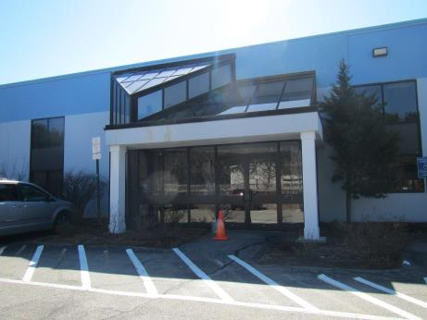

Prepared by:
Massachusetts Department of Public Health
Bureau of Environmental Health
Indoor Air Quality Program
April 2017

Background
Building: | Department of Revenue (DOR)
Address: | 60 Perseverance Way, Hyannis, MA
Assessment Requested by: | Joshua Martin, Deputy Director, Office of Facilities Management, Massachusetts DOR
Reason for Request: | Lease renewal indoor air quality (IAQ) status report
Date of Assessment: | March 30, 2017
Massachusetts Department of Public Health/Bureau of Environmental Health (MDPH/BEH) Staff Conducting Assessment: | Ruth Alfasso, Environmental Engineer/Inspector, IAQ Program
Building Description: | These offices are located on the first floor of a 2-story glass and cinderblock building located in the area of Hyannis with other office and industrial buildings. The building was constructed in the mid-1970s. Other office tenants are present on the first and second floor.
Building Population: | Approximately 20 employees in two office suites
Windows: | Not openable

Methods
Please refer to the IAQ Manual for methods, sampling procedures, and interpretation of results (MDPH, 2015).

IAQ Testing Results
The following is a summary of indoor air testing results (Table 1).
- Carbon dioxide levels were below 800 parts per million (ppm) in all but one area assessed, indicating adequate fresh air in the space.
- Temperature was within the recommended range of 70°F to 78°F in all areas assessed.
- Relative humidity was below the recommended range of 40% to 60% in all areas assessed which is typical of indoors during cold weather.
- Carbon monoxide levels were non-detectable in all indoor areas assessed.
- Fine particulate matter (PM2.5) concentrations measured were below the National Ambient Air Quality Standard (NAAQS) level of 35 μg/m³ in all areas assessed.

Ventilation
A heating, ventilating, and air conditioning (HVAC) system has several functions. First, it provides heating and, if equipped, cooling. Second, it is a source of fresh air. Finally, an HVAC system will dilute and remove normally-occurring indoor environmental pollutants by not only introducing fresh air, but also filtering the airstream and ejecting stale air to the outdoors via exhaust ventilation. Even if an HVAC system is operating as designed, point sources of respiratory irritation may exist and affect symptoms in sensitive individuals. The following analysis examines and identifies components of the HVAC system and likely sources of respiratory irritant/allergen exposure due to water damage, aerosolized dust, and/or chemicals found in the indoor environment.
Fresh air is provided by air handling units (AHUs). Air from the AHUs is filtered, heated/cooled, and delivered to rooms via ducted supply vents (Picture 1). Air is returned/exhausted through exhaust grills (Picture 2). Some thermostats examined were operating in fan “auto” mode (Picture 3) which only supplies fresh air when the temperature needs adjustment. It is recommended that during occupied periods, the HVAC system be operated with the fan “on.” Also note from Picture 3 that some thermostats were set to an incorrect time; the correct time is necessary so that temperature and fan settings can be adjusted for occupied versus unoccupied periods to increase comfort and reduce energy use.
The exhaust fan in the women’s restroom was not drawing air as demonstrated by lingering bathroom/cleaner odors in the space. It was reported that odors are a regular concern in this restroom. It was also reported that previously there were odors in the men’s restroom which were mitigated when the previous fan, which was reportedly too small/low capacity for the space and size of the building, was replaced. The fan in the women’s restroom should similarly be repaired or replaced and should be operated during all occupied periods to remove moisture and odors.
It is recommended that HVAC systems be re-balanced every five years to ensure adequate air systems function (SMACNA, 1994). It is not known when the last time these systems were balanced.
In some areas of the Child Support office, sunlight could be seen streaming in through the windows. Adjustable blinds should be used to control solar gain and assist with temperature control and reducing glare.

Microbial/Moisture Concerns
Window leaks had been reported previously in this building, which had reportedly been repaired. A water-damaged windowsill was observed in one office (Picture 4). A few water-damaged ceiling tiles were observed in the Child Support area (Picture 5). These are a result of plumbing or building envelope leaks that should be repaired, and the tiles should be replaced. Work to seal the brick/block façade was being conducted at the time of the visit; this is expected to further reduce water penetration.
The sprinkler/janitorial closet opens into an occupied area (Picture 6). Some water-damaged materials were present along the bottom edge of the wall inside that closet. The coving at the base of this wall peeled away easily, indicating that it had been wet in the past (Picture 7). The dark staining likely indicates microbial growth. This water damage may be the result of condensation on the sprinkler pipes, or moisture penetrating from outside. All coving should be removed in this area to prevent the build-up of moisture in the wall material and the wall should be cleaned, if possible. If the staining penetrates the wallboard, it should be cut to a level of at least one foot above the floor and either replaced or left as-is to prevent future damage. Porous items should not be stored in this area.
Plants were observed close to the foundation (Picture 8). Plants along the edges of the foundation can prevent walls from drying and lead to drainage problems/deterioration of the building envelope. When near air intakes, they can also be a source of odors, pollen and debris to the inside of the building.
Plants were observed in office areas (Table 1; Picture 9). Plants can be a source of pollen and mold, which can be respiratory irritants to some individuals. Plants should be properly maintained and equipped with drip pans to prevent water damage to porous materials. Plants should also be located away from air diffusers to prevent the aerosolization of dirt, pollen, and mold.
Small refrigerators and water dispensers were observed in carpeted areas (Table 1; Picture 9). These appliances may spill or leak and lead to carpet damage and microbial growth. It is recommended that these appliances be located in areas without carpeting or on waterproof mats. Carpet squares could also be replaced with tile in areas where water dispensers and refrigerators are located. Refrigerators should be kept clean to prevent odors and microbial growth.
The backsplash of the sink in the kitchen area had an unsealed space (Picture 10) which can lead to water damage of materials, including mold. The dark staining may indicate that microbial growth has occurred. This backsplash should be thoroughly cleaned and resealed with a water-resistance sealing compound or replaced with a one-piece backsplash with no gap.

Other IAQ Evaluations
Exposure to low levels of total volatile organic compounds (TVOCs) may produce eye, nose, throat, and/or respiratory irritation in some sensitive individuals. To determine if VOCs were present, BEH/IAQ staff examined rooms for products containing VOCs. BEH/IAQ staff noted cleaners, hand sanitizers and other products in use within the building (Table 1). All of these products have the potential to be irritants to the eyes, nose, throat, and respiratory system of sensitive individuals.
Cooking equipment, including toasters, microwave ovens and coffee machines, were located in various parts of the office space. Food areas and cooking equipment need to be kept clean to prevent odors and pests.
The offices were mostly carpeted. Carpets should be cleaned annually (or semi-annually in soiled/high traffic areas) in accordance with Institute of Inspection, Cleaning and Restoration Certification (IICRC) recommendations, (IICRC, 2012).
In some areas, stored materials and accumulated items make it more difficult for custodial staff to clean. Items should be stored neatly and moved periodically to allow for wet wiping and vacuuming of surfaces.
Personal fans were observed in a number of areas. Fan blades to some of these units had settled dust, which can be reaerosolized when the fan is activated. Some supply vents were also dusty (Picture 1).

Conclusions/Recommendations
Based on observations at the time of assessment, the following is recommended:
- Operate supply and exhaust ventilation in all areas during occupied periods. Ensure that thermostats have the correct time to allow for adjustments for occupied versus unoccupied periods.
- Repair or replace the exhaust fan system in the women’s restroom and operate continuously during occupied periods to remove moisture and odors.
- Have the HVAC system balanced every 5 years in accordance with SMACNA recommendations (SMACNA, 1994).
- Use blinds to reduce solar heating and glare.
- For buildings in New England, periods of low relative humidity during the winter are often unavoidable. Therefore, scrupulous cleaning practices should be adopted to minimize common indoor air contaminants whose irritant effects can be enhanced when the relative humidity is low. To control for dusts, a high efficiency particulate arrestance (HEPA) filter equipped vacuum cleaner in conjunction with wet wiping of all surfaces is recommended. Avoid the use of feather dusters. Drinking water during the day can help ease some symptoms associated with a dry environment (throat and sinus irritations).
- Repair water-damaged windowsill.
- Replace water-damaged ceiling tiles.
- Remove coving in sprinkler/janitorial closet and clean the wallboard. If wallboard cannot be cleaned, remove to at least a foot above the floor in the area of the stains and replace, or leave open. Avoid storing porous items in this area.
- Remove plants from close to the foundation outside the building.
- Keep indoor plants in good condition, avoid overwatering, and avoid placing them on porous items such as carpets or paper. Also, keep plants out of the air stream of supply vents.
- Clean and repair or replace the backsplash for the kitchen sink.
- Consider locating refrigerators and water dispensers in non-carpeted areas or place on a waterproof mat. Clean refrigerators out regularly to avoid odors and microbial growth.
- Reduce use of products containing VOCs including eliminating air freshening products.
- Ensure cooking areas/equipment are kept clean to prevent odors and pests. Consider reducing the number of areas where food is stored and locating them away from occupied areas.
- Change filters on AHUs on a regular schedule at least twice a year.
- Clean carpeting in accordance with IICRC recommendations (IICRC, 2012).
- Reduce accumulated materials on flat surfaces and store in an organized manner to allow for thorough cleaning.
- Clean the blades of personal fans, supply, and exhaust vents periodically to avoid aerosolizing dusts.
- Refer to resource manual and other related IAQ documents located on the MDPH’s website for further building-wide evaluations and advice on maintaining public buildings. These documents are available at: http://mass.gov/dph/iaq.

References
IICRC. 2012. Institute of Inspection, Cleaning and Restoration Certification. Carpet Cleaning: FAQ. Retrieved from http://www.iicrc.org/consumers/care/carpet-cleaning.
MDPH. 2015. Massachusetts Department of Public Health. Indoor Air Quality Manual: Chapters I-III. Available at: http://www.mass.gov/eohhs/gov/departments/dph/programs/environmental-health/exposure-topics/iaq/iaq-manual/.
SMACNA. 1994. HVAC Systems Commissioning Manual. 1st ed. Sheet Metal and Air Conditioning Contractors’ National Association, Inc., Chantilly, VA.
Picture 1
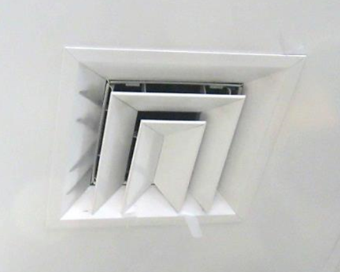
Supply vent
Picture 2
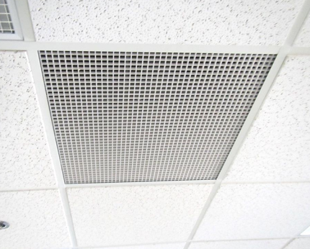
Exhaust grill
Picture 3
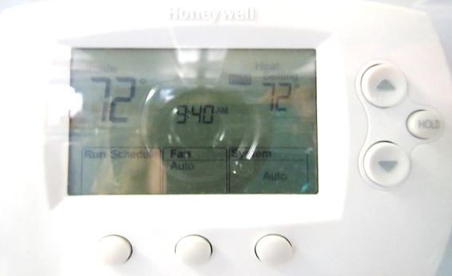
Thermostat showing fan in “auto” mode (arrow) and incorrect time
Picture 4
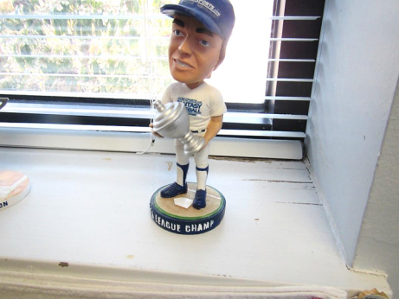
Water-damaged windowsill
Picture 5
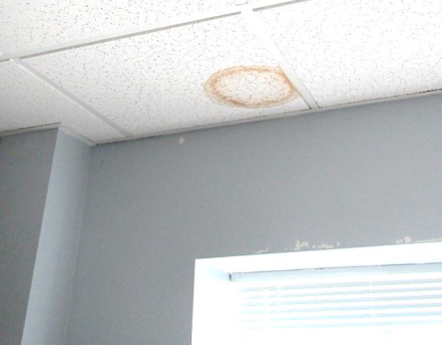
Water-damaged ceiling tile
Picture 6
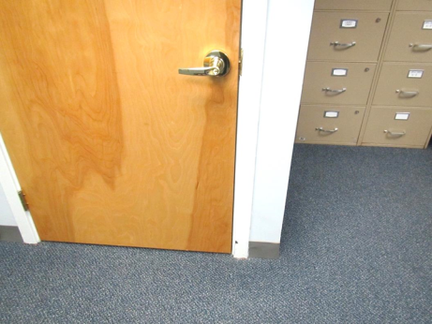
Door to sprinkler closet
Picture 7
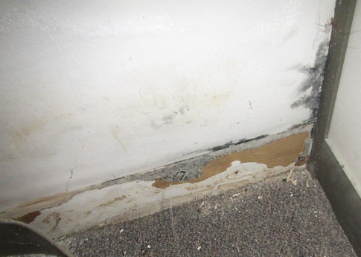
Water-damaged/mold stained wall and removable coving indicating past moisture
Picture 8
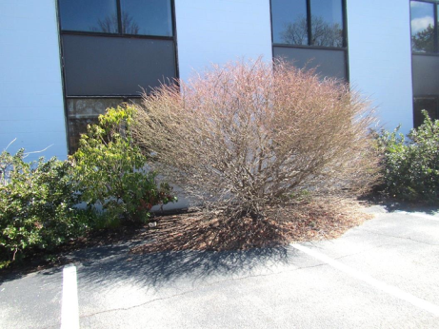
Plants in contact with foundation
Picture 9
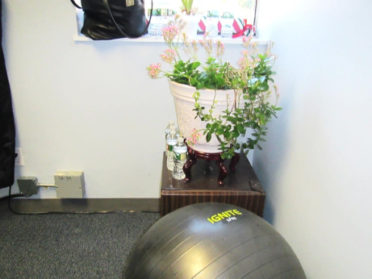
Plant in office, also note refrigerator on carpeted floor
Picture 10
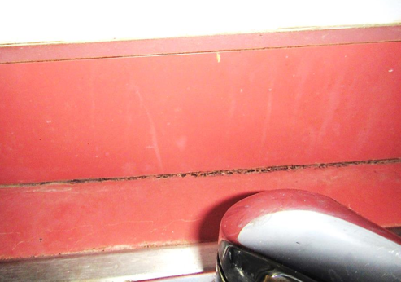
Open and stained backsplash at kitchen sink
Location | Carbon  Dioxide  (ppm) | Carbon Monoxide  (ppm) | Temp  (°F) | Relative  Humidity  (%) | PM2.5  (µg/m³) | Occupants  in Room | Windows  Openable | Ventilation |  | Remarks
 |  |  |  |  |  |  |  | Supply | Exhaust
Background | 492 | 0.8 | 55 | 24 | 6 |  |  |  |  | Breezy and partly sunny
Tax Office
Front/reception | 760 | ND | 71 | 29 | 3 | 0 | N | Y | Y | CP
Cubes next to Sprinkler room | 770 | ND | 72 | 28 | 3 | 3 | N | Y | Y | Plant, copiers
Interview | 702 | ND | 72 | 28 | 4 | 0 | N | Y | Y | Doors
Office (right) | 684 | ND | 72 | 27 | 4 | 0 | N | Y | N
Office (left) | 672 | ND | 72 | 28 | 4 | 0 | N | Y | Y | Leaks reported prior to this visit, WD windowsill and newly finished window observed
Cubes, rear | 716 | ND | 73 | 28 | 4 | 1 | N | Y | Y | Plants, refrigerator on carpet
Cubes, 2nd row | 689 | ND | 73 | 28 | 4 | 1 | N | Y | Y | WC on carpet
Cubes. 3rd row | 725 | ND | 72 | 27 | 4 | 1 | N | Y | Y | CP
Side cubes | 793 | ND | 73 | 28 | 4 | 2 | N | Y | Y | Cleaning odors from janitorial staff, HS, refrigerator on floor
Conference room | 816 | ND | 72 | 28 | 4 | 0 | N | Y | N | Microwave
Child Support
Cube near rear windows | 776 | ND | 73 | 28 | 4 | 0 | N | Y | Y | Next to stairs
Office 1 | 692 | ND | 71 | 28 | 4 | 0 | N | Y | Y
Office 2 | 641 | ND | 71 | 28 | 4 | 1 | N | Y | Y
Office 3 | 705 | ND | 71 | 29 | 4 | 0 | N | Y | Y | AI
Conference | 619 | ND | 71 | 28 | 6 | 0 | N | Y | Y | WD CT, fan/AP
Cubes near conference room | 766 | ND | 72 | 29 | 4 | 1 | N | Y | Y | Solar heating
Office 4 | 661 | ND | 72 | 28 | 4 | 0 | N | Y | Y | Dusty vent, plant, AI
Office 5 | 652 | ND | 73 | 28 | 4 | 1 | N | Y | Y | Refrigerator on carpet, microwave, toaster
Center cubes | 599 | ND | 73 | 27 | 4 | 0 | N | Y | Y | Refrigerator on carpet
Interview 1 | 787 | ND | 73 | 27 | 4 | 0 | N | Y | Y
Interview 2 | 622 | ND | 73 | 26 | 5 | 0 | N | Y | Y
Kitchen | 582 | ND | 73 | 27 | 5 | 0 | N | N | N | Refrigerator, sink backsplash open
Reception |  |  |  |  |  |  | N | N | Y
Women’s restroom |  |  |  |  |  |  | N | Y | Y off | Reported odors

