INDOOR AIR QUALITY ASSESSMENT
Department of Revenue
60 Perseverance Way
Hyannis, MA
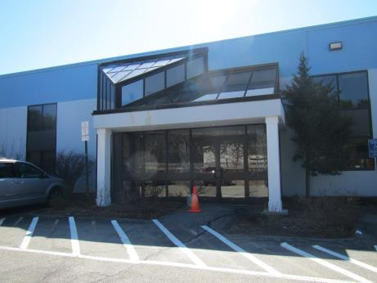
Prepared by:
Massachusetts Department of Public Health
Bureau of Environmental Health
Indoor Air Quality Program
August 2017

Background
Building: | Department of Revenue (DOR)
Address: | 60 Perseverance Way, Hyannis, MA
Assessment Requested by: | Joshua Martin, Deputy Director, Office of Facilities Management, Massachusetts DOR
Reason for Request: | Concerns regarding flying insects (gnats).
Date of Assessment: | August 3, 2017
Massachusetts Department of Public Health/Bureau of Environmental Health (MDPH/BEH) Staff Conducting Assessment: | Michael Feeney, Director, and Ruth Alfasso, Environmental Engineer/Inspector, Indoor Air Quality (IAQ) Program
Building Description: | These offices are located on the first floor of a 2-story cinderblock and glass building located in the area of Hyannis with other office and industrial buildings. The building was constructed in the mid-1970s. Other office tenants are present on the first and second floor.
Building Population: | Approximately 20 employees in two office suites
Windows: | Not openable

Methods
Please refer to the IAQ Manual for methods, sampling procedures, and interpretation of results (MDPH, 2015). Note that a general IAQ assessment was conducted at this site in April of 2017 with a report issued based on those findings, which can be viewed at http://www.mass.gov/eohhs/gov/departments/dph/programs/environmental-health/exposure-topics/iaq/iaq-rpts/cities-and-towns-b.html#barnstable.

IAQ Testing Results
The following is a summary of indoor air testing results (Table 1).
- Carbon dioxide levels were above 800 parts per million (ppm) in most areas of the DOR Tax office and below in all areas of the DOR Child Support office, indicating that the Tax office should be supplied with more fresh air.
- Temperature was within the recommended range of 70°F to 78°F in most areas assessed.
- Relative humidity was within or close to the lower end of the recommended range of 40% to 60% in all areas assessed.
- Carbon monoxide levels were non-detectable in all indoor areas assessed.
- Fine particulate matter (PM2.5) concentrations measured were below the National Ambient Air Quality Standard (NAAQS) level of 35 μg/m³ in all areas assessed.

Ventilation
A heating, ventilating, and air conditioning (HVAC) system has several functions. First, it provides heating and, if equipped, cooling. Second, it is a source of fresh air. Finally, an HVAC system will dilute and remove normally-occurring indoor environmental pollutants by not only introducing fresh air, but also filtering the airstream and ejecting stale air to the outdoors via exhaust ventilation. Even if an HVAC system is operating as designed, point sources of respiratory irritation may exist and affect symptoms in sensitive individuals. The following analysis examines and identifies components of the HVAC system and likely sources of respiratory irritant/allergen exposure due to water damage, aerosolized dust, and/or chemicals found in the indoor environment.
Fresh air is provided by air handling units (AHUs) located on the roof (Picture 1). Air from the AHUs is filtered, heated/cooled, and delivered to rooms via ducted supply vents (Picture 2). Air is returned/exhausted through exhaust grills. Some thermostats examined were operating in fan “auto” mode (Picture 3) which only supplies fresh air when the temperature needs adjustment. It is recommended that during occupied periods, the HVAC system be operated with the fan “on.” As was also noted in the April 2017 report, some thermostats are not set to the correct time, which can cause problems with settings for occupied versus unoccupied periods.
Rooms with higher occupancy such as conference rooms should have adequately designed fresh air supply as well as exhaust/return vents to remove stale air. IAQ staff did not observe any exhaust/return vent in the conference room. This condition may allow common indoor air pollutants to build up and increase IAQ/comfort complaints.
It is recommended that HVAC systems be re-balanced every five years to ensure adequate air systems function (SMACNA, 1994). It is not known when the last time these systems were balanced.

Microbial/Moisture Concerns
This visit was conducted in response to concerns about flying insects identified as gnats by the occupants. Although cleaning had reportedly been conducted, some insect residue was observed in the area of concern (Pictures 4). The source of the insects was traced to the roof where water was observed pooling next to the AHU (Picture 1). The source of water in this area is a combination of rainwater and condensate from the operation of the AHU in cooling mode. Some of the water was observed to contain organic matter that appeared to be insect eggs (Picture 5). Seagull nesting material, fecal waste and feathers were also observed on the roof, including near the AHUs (Pictures 1 and 6).
Water is pooling on the roof due to a lack of roof drains. Water can only drain from the roof via cut-outs (scuppers) in the parapet walls. Since the roof is not well pitched to the edges, there are areas which collect water. The slow trickle of condensate from the AHU during the cooling season provides a continual source of water to keep these pools moist allowing the propagation of insects. Continually moist organic waste/debris will also become mold-colonized.
Any insects hatching from this water, or other insects attracted to the roof by standing water and debris, can be drawn into the AHU fresh air vent. It also appeared that the filters inside the AHU were not fully flush with the casing, which can allow particulate matter and small flying insects to bypass the filter and be distributed to occupied spaces in the building. Another means of pest entry into the building would be through the condensate pipe, which is approximately three feet long (Picture 1). Extending this pipe would not only assist in drainage of condensate away from the AHU and off the roof, but would also be a barrier to pest entry. Consider installing one or more 90 degree bends in the pipe. The condensate drain pipe should maintain a properly designed “P trap” as recommended by the AHU manufacturer to further prevent pests as well as unconditioned air from entering the AHU.
No water-damaged ceiling tiles were observed in offices during this visit. Some water damage to paint and wall/ceiling material was observed in the atrium, resulting from recent heavy rains in the area (Picture 7).
Mulch and plants were observed close to and in contact with the building and foundation (Pictures 8 and 9). Plants and mulch hold water against the foundation which will lead to deterioration of the building envelope and potential water penetration. Mulch can also be attractive to pests, including termites, which have reportedly been an issue with this building recently. Mulch should be removed and plants should be trimmed significantly away from the building.
During the previous visit, water-damaged materials and likely mold colonization were observed inside a sprinkler/janitorial closet that opens to an occupied area. Since that visit, it appears that the base coving was removed as recommended in the previous report and the water-damaged gypsum wallboard had also been removed (Picture 10). Note, however, that the conditions in this room that led to water damage might reoccur, therefore the carpeting should probably be removed from the room and no porous materials (boxes and decorative items) should be stored there.
Small refrigerators and water dispensers were observed in carpeted areas (Table 1). These appliances may spill or leak and lead to carpet damage and microbial growth. It is recommended that these appliances be located in areas without carpeting or on waterproof mats. Carpet squares could also be replaced with tile in areas where water dispensers and refrigerators are located. Refrigerators should be kept clean to prevent odors and microbial growth.

Other IAQ Evaluations
Exposure to low levels of total volatile organic compounds (TVOCs) may produce eye, nose, throat, and/or respiratory irritation in some sensitive individuals. To determine if VOCs were present, BEH/IAQ staff examined rooms for products containing VOCs. BEH/IAQ staff noted cleaners, hand sanitizers and other products in use within the building (Table 1). All of these products have the potential to be irritants to the eyes, nose, throat, and respiratory system of sensitive individuals.
Cooking equipment, including toasters, microwave ovens and coffee machines, were located in various parts of the office space. Food areas and cooking equipment need to be kept clean to prevent odors and pests.
The offices were mostly carpeted. Carpets should be cleaned annually (or semi-annually in soiled/high traffic areas) in accordance with Institute of Inspection, Cleaning and Restoration Certification (IICRC) recommendations, (IICRC, 2012).
In some areas, stored materials and accumulated items make it more difficult for custodial staff to clean. Items should be stored neatly and moved periodically to allow for wet- wiping and vacuuming of surfaces.
Personal fans were observed in a number of areas. Fan blades to some of these units had settled dust, which can be reaerosolized when the fan is activated. Some supply vents were also dusty (Picture 2).

Conclusions/Recommendations
Based on observations at the time of assessment, the following is recommended:
- Use a larvicide in the standing water on the roof to control pests. Consult with a licensed pesticide applicator to identify an appropriate product for this use.
- Extend the length of the condensate drainage pipe from the AHU to discharge water further away from the air intake of the AHU and provide a barrier to pests. Consider installing one or more 90 degree bends in the pipe. Be sure to maintain a properly designed “P trap” on the condensate drain pipe and adequate drainage as recommended by the AHU manufacturer.
- Ensure that all filters are installed flush with the housings inside the AHU so that no bypass of insects or debris can occur. Inspect filters regularly and change in accordance with manufacturer’s instructions.
- Periodically remove debris and water from the roof to prevent a build-up of bird waste, feathers and other organic debris that can be attractive to pests and be a source of mold and odors.
- Investigate means to improve drainage from the roof.
- If roof drainage cannot be improved to eliminate standing water, consult with a licensed pesticide applicator regarding continued use of larvicidal tablets to treat the standing water.
- Consult with an HVAC contractor to ensure that the conference room has adequate fresh air supply for the intended occupancy as well as exhaust/return air vents as needed to remove stale air from this room.
- Remove mulch from the exterior foundation and trim plants to at least five feet away from the building exterior to reduce moisture held against the building envelope and discourage termites.
- Operate supply and exhaust ventilation in all areas during occupied periods. Ensure that thermostats have the correct time to allow for adjustments for occupied versus unoccupied periods.
- Have the HVAC system balanced every 5 years in accordance with SMACNA recommendations (SMACNA, 1994).
- For buildings in New England, periods of low relative humidity during the winter are often unavoidable. Therefore, scrupulous cleaning practices should be adopted to minimize common indoor air contaminants whose irritant effects can be enhanced when the relative humidity is low. To control for dusts, a high efficiency particulate arrestance (HEPA) filter equipped vacuum cleaner in conjunction with wet wiping of all surfaces is recommended. Avoid the use of feather dusters. Drinking water during the day can help ease some symptoms associated with a dry environment (throat and sinus irritations).
- Repair water-damaged paint/wall in the atrium and monitor for additional leaks during wet weather.
- Consider removing carpeting in sprinkler/janitorial closet to prevent water damage. Avoid storing porous materials in this area.
- Consider locating refrigerators and water dispensers in non-carpeted areas or place on a waterproof mat. Clean refrigerators out regularly to avoid odors and microbial growth.
- Reduce use of products containing VOCs including eliminating air freshening products.
- Clean carpeting in accordance with IICRC recommendations (IICRC, 2012).
- Reduce accumulated materials on flat surfaces and store in an organized manner to allow for thorough cleaning.
- Clean the blades of personal fans, supply, and exhaust vents periodically to avoid aerosolizing dusts.
- Refer to resource manual and other related IAQ documents located on the MDPH’s website for further building-wide evaluations and advice on maintaining public buildings. These documents are available at: http://mass.gov/dph/iaq.

References
IICRC. 2012. Institute of Inspection, Cleaning and Restoration Certification. Carpet Cleaning: FAQ. Retrieved from http://www.iicrc.org/consumers/care/carpet-cleaning.
MDPH. 2015. Massachusetts Department of Public Health. Indoor Air Quality Manual: Chapters I-III. Available at: http://www.mass.gov/eohhs/gov/departments/dph/programs/environmental-health/exposure-topics/iaq/iaq-manual/.
SMACNA. 1994. HVAC Systems Commissioning Manual. 1st ed. Sheet Metal and Air Conditioning Contractors’ National Association, Inc., Chantilly, VA.
Picture 1
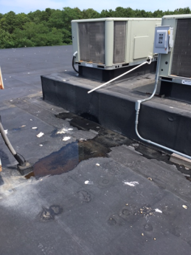
Rooftop air handling unit, note pooling water, bird waste (white spots) and drain pipe
Picture 2
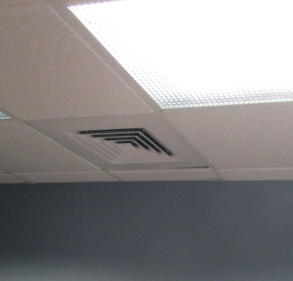
Ceiling-mounted supply vent
Picture 3
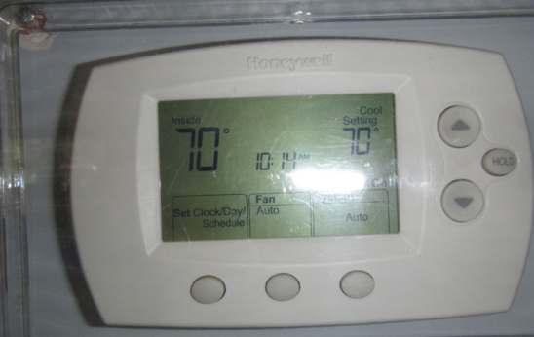
Thermostat, note “fan auto” mode
Picture 4
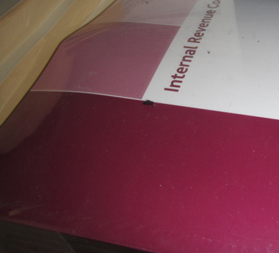
Dead insect on books
Picture 5
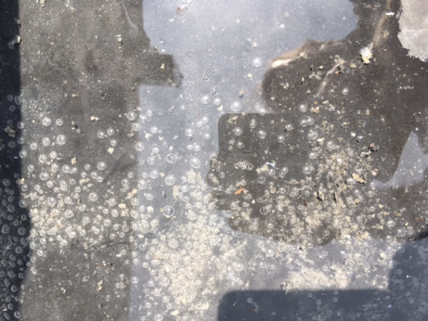
Pooling water with organic debris that may be insect eggs/larva
Picture 6
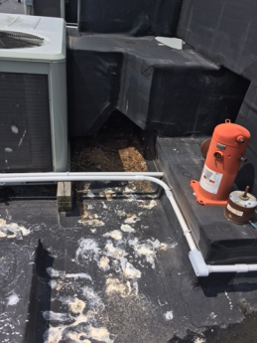
Bird waste, feathers, and debris near air handling units on the roof
Picture 7
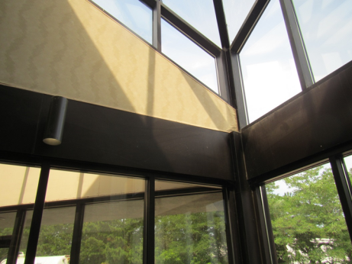
Water-damaged paint at corner of atrium
Picture 8
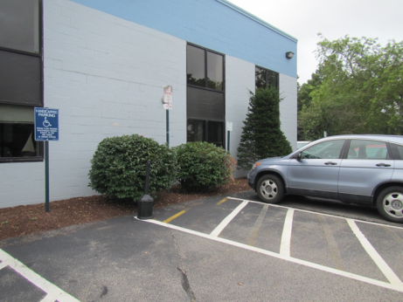
Mulch and plants near the foundation/walls of the building
Picture 9
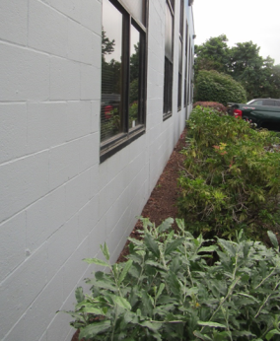
Shrubs and mulch next to the foundation
Picture 10
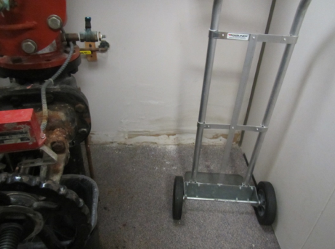
Removed coving and repaired wall in the sprinkler room, note carpeting
Location | Carbon  Dioxide  (ppm) | Carbon Monoxide  (ppm) | Temp  (°F) | Relative  Humidity  (%) | PM2.5  (µg/m³) | Occupants  in Room | Windows  Openable | Ventilation |  | Remarks
 |  |  |  |  |  |  |  | Supply | Exhaust
Background | 399 | ND | 77 | 77 | 0-4 |  |  |  |  | Partly cloudy
Lobby/atrium | 680 | ND | 73 | 50 | 3 | 0 | Door | Y | Y | WD wall/paint
Tax office
Conference room | 1218 | ND | 77 | 48 | 4 | 6 | N | Y | N | Microwave, CP
Eager (cubes) | 851 | ND | 73 | 37 | 2 | 0 | N | Y | Y | CP, insect evidence
Print/document recycling area | 846 | ND | 72 | 41 | 2 | 0 | N | Y | Y | Water cooler on carpet
Window cubes | 858 | ND | 72 | 39 | 2 | 2 | N | Y | Y
35, corner area | 849 | ND | 72 | 41 | 2 | 2 | N | Y | Y | Fridge on carpet, AI
36 office | 907 | ND | 72 | 41 | 3 | 1 | N | Y | Y | CP
Zopatt (cubes) | 838 | ND | 71 | 42 | 4 | 0 | N | Y | Y | Paper
Brown (cubes) | 883 | ND | 71 | 42 | 2 | 2 | N | Y | Y | Bag of recycling cans
O’Connor (cubes) | 892 | ND | 71 | 44 | 4 | 1 | N | Y | Y | Personal fan
Cubes | 885 | ND | 70 | 45 | 2 | 1 | N | Y | Y | Fridge
Segura (cubes) | 809 | ND | 71 | 44 | 2 | 0 | N | Y | Y
Sprinkler room |  |  |  |  |  |  | N | N | N | Still used for storage and still carpeted. WD wall removed and replaced
Office | 820 | ND | 70 | 45 | 2 | 1 | N | Y | Y
Desk near reception | 815 | ND | 70 | 45 | 2 | 1 | N | Y | Y
Interview room | 705 | ND | 67 | 40 | 2 | 0 | N | Y | Y | Cleaner odor
Child support
Child support lobby | 685 | ND | 69 | 49 | 2 | 0 | N | Y | Y
Box storge cube | 739 | ND | 70 | 47 | 3 | 1 | N | Y | Y
Mailing area | 716 | ND | 71 | 47 | 2 | 0 | N | Y | Y | Fake plant
Office | 720 | ND | 72 | 46 | 2 | 1 | N | Y | Y | Fridge
Office | 713 | ND | 73 | 45 | 2 | 0 | N | Y | Y
Conference | 717 | ND | 73 | 44 | 3 | 0 | N | Y | Y
Office | 772 | ND | 73 | 45 | 2 | 0 | N | Y | Y
Office | 773 | ND | 73 | 44 | 2 | 1 | N | Y | Y
Cubes | 772 | ND | 73 | 44 | 2 | 0 | N | Y | Y
Cubes | 751 | ND | 73 | 44 | 2 | 0 | N | Y | Y

