INDOOR AIR QUALITY ASSESSMENT

Massachusetts Department of Revenue
60 Perseverance Way
Hyannis, Massachusetts

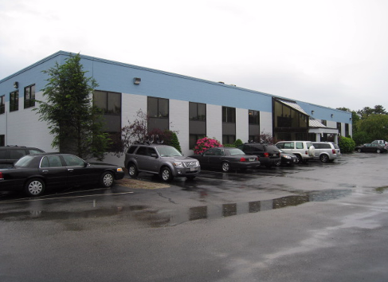

Prepared by:
Massachusetts Department of Public Health
Bureau of Environmental Health
Indoor Air Quality Program
September 2009

Background/Introduction
In response to a request from Richard Morrissey, Director, Office of Facilities Management, Department of Revenue (DOR) the Massachusetts Department of Public Health (MDPH), Bureau of Environmental Health (BEH), provided assistance and consultation regarding indoor air quality concerns at the, DOR office located at 60 Perseverance Way, Hyannis, Massachusetts. The request was prompted by water penetration issues and the possibility of mold growth on building materials.
On June 9, 2009, a visit to conduct an indoor air quality assessment was made to the DOR by Cory Holmes, Environmental Analyst/Inspector in BEH’s Indoor Air Quality (IAQ) Program. Mr. Holmes was accompanied for portions of the assessment by Andre Gomes, DOR CSE Division and Richard Elliott, DOR Audit Division.
The DOR is located on the ground floor of a two story concrete block building that formerly served as a telephone equipment manufacturer. The DOR has reportedly occupied the building since January of 2007. As part of the renovations prior to occupancy, windows were installed through the concrete block walls at the rear of the building. Windows along the front of the building are not openable.
Methods
Air tests for carbon dioxide, temperature and relative humidity were taken with the TSI, Q-Trak, IAQ Monitor 8551. Air tests for airborne particle matter with a diameter less than 2.5 micrometers were taken with the TSI, DUSTTRAK™ Aerosol Monitor Model 8520. BEH staff performed a visual inspection of building materials for water damage and/or microbial growth. Moisture content of porous building materials was measured with a Delmhorst, BD-2000 Model, Moisture Detector equipped with a Delmhorst Standard Probe.
Results
The DOR has an employee population of approximately 43 and is visited by up to 12 individuals daily. The tests were taken during normal operations. Test results appear in Table 1.
Discussion
Ventilation
It can be seen from Table 1 that carbon dioxide levels were below 800 parts per million (ppm) in all areas surveyed, with one exception, indicating adequate air exchange throughout the building the day of the assessment. Mechanical ventilation is provided by rooftop air-handling units (AHUs) (Picture 1). Fresh air is drawn into the AHUs and delivered to occupied areas via ceiling-mounted air diffusers (Picture 2). Return air is drawn into ceiling-mounted vents and ducted back to the AHUs (Picture 3).
Digital wall-mounted thermostats control the heating, ventilating and air conditioning (HVAC) system (Picture 4). Thermostats have fan settings of “on” and “automatic”. At the time of the MDPH assessment, the thermostats were set to the fan “auto” setting. The “automatic” setting on the thermostat activates the HVAC system at a preset temperature. Once the preset temperature is reached, the HVAC system is deactivated, whereas the fan “on” setting provides continuous airflow, which is recommended by the MDPH.
To maximize air exchange, the MDPH recommends that both supply and exhaust ventilation operate continuously during periods of occupancy. In order to have proper ventilation with a mechanical supply and exhaust system, the systems must be balanced to provide an adequate amount of fresh air to the interior of a room while removing stale air from the room. It is recommended that HVAC systems be re-balanced every five years to ensure adequate air systems function (SMACNA, 1994). The date of balancing was not available at the time of the assessment but should have occurred prior to occupancy by the DOR in 2007.
The Massachusetts Building Code requires a minimum ventilation rate of 20 cubic feet per minute (cfm) per occupant of fresh outside air or have openable windows in each room (SBBRS, 1997; BOCA, 1993). The ventilation must be on at all times that the room is occupied. Providing adequate fresh air ventilation with open windows and maintaining the temperature in the comfort range during the cold weather season is impractical. Mechanical ventilation is usually required to provide adequate fresh air ventilation.
Carbon dioxide is not a problem in and of itself. It is used as an indicator of the adequacy of the fresh air ventilation. As carbon dioxide levels rise, it indicates that the ventilating system is malfunctioning or the design occupancy of the room is being exceeded. When this happens, a buildup of common indoor air pollutants can occur, leading to discomfort or health complaints. The Occupational Safety and Health Administration (OSHA) standard for carbon dioxide is 5,000 parts per million parts of air (ppm). Workers may be exposed to this level for 40 hours/week, based on a time-weighted average (OSHA, 1997).
The MDPH uses a guideline of 800 ppm for publicly occupied buildings. A guideline of 600 ppm or less is preferred in schools due to the fact that the majority of occupants are young and considered to be a more sensitive population in the evaluation of environmental health status. Inadequate ventilation and/or elevated temperatures are major causes of complaints such as respiratory, eye, nose and throat irritation, lethargy and headaches. For more information concerning carbon dioxide, please see Appendix A.
Temperature readings ranged from 67º F to 74 º F, which were within the MDPH recommended comfort guidelines in all areas surveyed, with the exception of the interview rooms. The MDPH recommends that indoor air temperatures be maintained in a range of 70 º F to 78 º F in order to provide for the comfort of building occupants. In many cases concerning indoor air quality, fluctuations of temperature in occupied spaces are typically experienced, even in a building with an adequate fresh air supply. As mentioned the interview rooms had a temperature of 67º F, which was below the MDPH comfort guidelines. DOR staff report that the HVAC system that services the interview rooms is kept in its cooling mode during the heating season.
Relative humidity measurements in the building ranged from 37 to 49 percent, which were within or close to the lower end of the MDPH recommended comfort range in all areas surveyed the day of the assessment. The MDPH recommends a comfort range of 40 to 60 percent for indoor air relative humidity. Relative humidity levels in the building would be expected to drop during the winter months due to heating. The sensation of dryness and irritation is common in a low relative humidity environment. Low relative humidity is common during the heating season in the northeast part of the United States.
Microbial/Moisture Concerns
In order for building materials to support mold growth, a source of water exposure is necessary. Identification and elimination of water moistening building materials is necessary to control mold growth. As previously mentioned, the assessment was prompted by concerns of potential mold growth resulting from water damaged building materials. The main source of water penetration was reportedly through window systems (Pictures 5 and 6). According to Mr. Gomes, building management has repeatedly attempted to make repairs to window systems to prevent further water penetration. At the time of the assessment, the majority of water damaged building materials (e.g., gypsum wallboard) had been replaced/repaired and refinished. Building occupants reported that water penetration had either ceased or was only occuring periodically in some areas, particularly during heavy wind/rain patterns.
BEH staff examined areas that had been water damaged previously. All areas appeared dry and no visible mold growth and/or associated odors were observed/detected the day of the assessment. In addition, MDPH staff conducted moisture testing of building materials (e.g., gypsum wallboard, carpeting). Materials with increased moisture content over normal concentrations may indicate the possible presence of mold growth. All materials tested were found to have low (i.e., normal) moisture content (Table 1) at the time of the assessment.
In the main work area opposite the reception desk, a water stained ceiling tile had been removed to fix a plumbing/drainage leak (Pictures 7 and 8). Water damaged ceiling tiles can provide a source of mold and should be replaced after a water leak is discovered and repaired.
A water cooler was located over carpeting (Picture 9). Water spillage or overflow of cooler catch basins can result in the wetting of the carpet. In addition, some of the coolers had residue/build-up in the reservoir. These reservoirs are designed to catch excess water during operation and should be emptied/cleaned regularly to prevent microbial and/or bacterial growth.
BEH staff examined the perimeter of the building to identify breaches in the building envelope or other conditions that could provide a source for water penetration. Pooling of water against the building was observed in several areas at the rear of the building either due to clogged/damaged downspouts/elbow extensions and/or poor drainage around the building (Pictures 10 through 12). Over time these conditions can undermine the integrity of the building envelope and provide a means of water entry by capillary action into the building through exterior walls, foundation concrete and masonry (Lstiburek & Brennan, 2001).
Plants were observed in several areas. Plants, soil and drip pans can serve as sources of mold/bacterial growth. Plants should be properly maintained, over-watering of plants should be avoided and drip pans should be inspected periodically for mold growth.
The US Environmental Protection Agency (US EPA) and the American Conference of Governmental Industrial Hygienists (ACGIH) recommends that porous materials (carpeting, ceiling tiles, etc.) be dried with fans and heating within 24 to 48 hours of becoming wet (US EPA, 2001; ACGIH, 1989). If porous materials are not dried within this time frame, mold growth may occur. Water-damaged porous materials cannot be adequately cleaned to remove mold growth. The application of a mildewcide to moldy porous materials is not recommended.
Other IAQ Evaluations
Indoor air quality can be negatively influenced by the presence of respiratory irritants, such as products of combustion. The process of combustion produces a number of pollutants. Common combustion emissions include carbon monoxide, carbon dioxide, water vapor and smoke (fine airborne particle material). Of these materials, exposure to carbon monoxide and particulate matter with a diameter of 2.5 micrometers (μm) or less (PM2.5) can produce immediate, acute health effects upon exposure. To determine whether combustion products were present in the building, BEH staff obtained measurements for carbon monoxide and PM2.5.
Carbon Monoxide
Carbon monoxide is a by-product of incomplete combustion of organic matter (e.g., gasoline, wood and tobacco). Exposure to carbon monoxide can produce immediate and acute health effects. Several air quality standards have been established to address carbon monoxide and prevent symptoms from exposure to these substances. The MDPH established a corrective action level concerning carbon monoxide in ice skating rinks that use fossil-fueled ice resurfacing equipment. If an operator of an indoor ice rink measures a carbon monoxide level over 30 ppm, taken 20 minutes after resurfacing within a rink, that operator must take actions to reduce carbon monoxide levels (MDPH, 1997).
The American Society of Heating Refrigeration and Air-Conditioning Engineers (ASHRAE) has adopted the National Ambient Air Quality Standards (NAAQS) as one set of criteria for assessing indoor air quality and monitoring of fresh air introduced by HVAC systems (ASHRAE, 1989). The NAAQS are standards established by the US EPA to protect the public health from six criteria pollutants, including carbon monoxide and particulate matter (US EPA, 2006). As recommended by ASHRAE, pollutant levels of fresh air introduced to a building should not exceed the NAAQS levels (ASHRAE, 1989). The NAAQS were adopted by reference in the Building Officials & Code Administrators (BOCA) National Mechanical Code of 1993 (BOCA, 1993), which is now an HVAC standard included in the Massachusetts State Building Code (SBBRS, 1997). According to the NAAQS, carbon monoxide levels in outdoor air should not exceed 9 ppm in an eight-hour average (US EPA, 2006).
Carbon monoxide should not be present in a typical, indoor environment. If it is present, indoor carbon monoxide levels should be less than or equal to outdoor levels. On the day of assessment, outdoor carbon monoxide concentrations were non-detect (ND) to 1 ppm (Table 1). No detectable levels of carbon monoxide were measured inside the building at the time of the assessment (Table 1).
As a proactive measure, wall-mounted carbon monoxide detectors were installed in the building (Picture 15). Carbon monoxide detectors have a varying shelf-life depending on make and model. To ensure proper working order carbon monoxide monitors should be tested and replaced as per the manufacture’s instructions.
Particulate Matter (PM2.5)
The US EPA has established NAAQS limits for exposure to particulate matter. Particulate matter is airborne solids that can be irritating to the eyes, nose and throat. The NAAQS originally established exposure limits to particulate matter with a diameter of 10 μm or less (PM10). According to the NAAQS, PM10 levels should not exceed 150 microgram per cubic meter (μg/m³) in a 24-hour average (US EPA, 2006). These standards were adopted by both ASHRAE and BOCA. Since the issuance of the ASHRAE standard and BOCA Code, US EPA established a more protective standard for fine airborne particles. This more stringent PM2.5 standard requires outdoor air particle levels be maintained below 35 μg/m³ over a 24-hour average (US EPA, 2006). Although both the ASHRAE standard and BOCA Code adopted the PM10 standard for evaluating air quality, MDPH uses the more protective PM2.5 standard for evaluating airborne particulate matter concentrations in the indoor environment.
Outdoor PM2.5 concentrations were measured at 3 μg/m³ (Table 1). PM2.5 levels measured indoors ranged from 2 to 5 μg/m³ (Table 1), which were below the NAAQS PM2.5 level of 35 μg/m³. Frequently, indoor air levels of particulates (including PM2.5) can be at higher levels than those measured outdoors. A number of mechanical devices and/or activities that occur in buildings can generate particulate during normal operations. Sources of indoor airborne particulates may include but are not limited to particles generated during the operation of fan belts in the HVAC system, cooking in stoves and microwave ovens; use of photocopiers, fax machines and computer printing devices; operation of an ordinary vacuum cleaner and heavy foot traffic indoors.
Volatile Organic Compounds
Indoor air quality can also be impacted by the presence of materials containing volatile organic compounds (VOCs). VOCs are substances that have the ability to evaporate at room temperature. Frequently, exposure to low levels of total VOCs (TVOCs) may produce eye, nose, throat and/or respiratory irritation in some sensitive individuals. For example, chemicals evaporating from a paint can stored at room temperature would most likely contain VOCs. In an effort to identify materials that can potentially increase indoor VOC concentrations, BEH staff examined the DOR for products containing these respiratory irritants.
Some areas contained dry erase boards and related materials. Materials such as dry erase markers and dry erase board cleaners may contain VOCs, such as methyl isobutyl ketone, n-butyl acetate and butyl-cellusolve (Sanford, 1999), which can be irritating to the eyes, nose and throat. Lastly, VOC-containing cleaning materials were observed (Pictures 13 and 14) in some personal work areas. These materials contain several VOCs (e.g., isopropyl alcohol and monoethanolamine) that can be irritating to the eyes, nose and throat (3M, 2000).
Other Conditions
Restroom exhaust is provided by ceiling-mounted vents that are designed to remove odors and excess moisture. BEH staff examined the vents in the men’s room and determined that it was not ducted to the outside of the building (Picture 16). Exhaust ventilation is necessary in restrooms to remove moisture and to prevent restroom odors from penetrating into adjacent areas. Local exhaust vents in the women’s restroom appeared to be ducted to the outside.
Conclusions/Recommendations
In view of the findings at the time of this visit, the following recommendations are made to improve indoor air quality:
- Set thermostat controls in the fan “on” position to provide continuous air exchange during periods of occupancy.
- Consult with an HVAC engineer to ascertain the most appropriate method to improve comfort in the interview rooms. Options may include the relocation of supply vents outside the rooms and the installation of passive door vents to allow air exchange.
- Improve temperature control in the interview rooms
- For buildings in New England, periods of low relative humidity during the winter are often unavoidable. Therefore, scrupulous cleaning practices should be adopted to minimize common indoor air contaminants whose irritant effects can be enhanced when the relative humidity is low. To control for dusts, a high efficiency particulate arrestance (HEPA) filter equipped vacuum cleaner in conjunction with wet wiping of all surfaces is recommended. Drinking water during the day can help ease some symptoms associated with a dry environment (throat and sinus irritations).
- Continue working with building management to identify and address window leaks.
- Replace water damaged wooden windowsills.
- Replace water-damaged ceiling tiles. Examine above and around these areas for microbial growth. Disinfect areas of water leaks with an appropriate antimicrobial as needed.
- Inspect downspouts and elbows for proper drainage. Consider regarding outside perimeter of building to draw water away from the building.
- Avoid over watering of plants. Ensure flat surfaces around plants are free of potting soil and other plant debris. Examine drip pans periodically for mold growth and disinfect with an appropriate antimicrobial where necessary.
- Discontinue the use of VOC-containing cleaners. Less irritating materials, (soap and water) may suffice to clean in these areas.
- Ensure that restroom local exhaust vents are ducted to the outdoors to remove odors and excess moisture.
- Test carbon monoxide detectors to ensure proper working order and replace as per the manufacture’s recommendations.
- Refer to resource manuals and other related indoor air quality documents for further building-wide evaluations and advice on maintaining public buildings. Copies of these materials are located on the MDPH’s website: http://mass.gov/dph/iaq.
References
3M 2000. Material Safety Data Sheet (MSDS Document No: 10-0157-7). 3M Brand Desk and Office Cleaner 573. Minnesota Mining and Manufacturing Company. St. Paul, Minnesota.

ACGIH. 1989. Guidelines for the Assessment of Bioaerosols in the Indoor Environment. American Conference of Governmental Industrial Hygienists, Cincinnati, OH.

ASHRAE. 1989. Ventilation for Acceptable Indoor Air Quality. American Society of Heating, Refrigeration and Air Conditioning Engineers. ANSI/ASHRAE 62-1989.
BOCA. 1993. The BOCA National Mechanical Code/1993. 8th ed. Building Officials and Code Administrators International, Inc., Country Club Hill, IL. Section M-308.1.1.

MDPH. 1997. Requirements to Maintain Air Quality in Indoor Skating Rinks (State Sanitary Code, Chapter XI). 105 CMR 675.000. Massachusetts Department of Public Health, Boston, MA.
OSHA. 1997. Limits for Air Contaminants. Occupational Safety and Health Administration. Code of Federal Regulations. 29 C.F.R 1910.1000 Table Z-1-A.

Sanford. 1999. Material Safety Data Sheet (MSDS No: 198-17). Expo® Dry Erase Markers Bullet, Chisel, and Ultra Fine Tip. Sanford Corporation, Bellwood, IL.
SBBRS. 1997. Mechanical Ventilation. State Board of Building Regulations and Standards. Code of Massachusetts Regulations. 780 CMR 1209.0.
SMACNA. 1994. HVAC Systems Commissioning Manual. 1st ed. Sheet Metal and Air Conditioning Contractors’ National Association, Inc., Chantilly, VA.
US EPA. 2000. Tools for Schools. Office of Air and Radiation, Office of Radiation and Indoor Air, Indoor Environments Division (6609J). EPA 402-K-95-001, Second Edition. http://www.epa.gov/iaq/schools/tools4s2.html
US EPA. 2006. National Ambient Air Quality Standards (NAAQS). . US Environmental Protection Agency, Office of Air Quality Planning and Standards, Washington, DC. http://www.epa.gov/air/criteria.html.
Picture 1

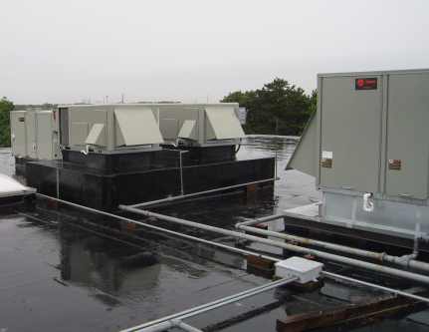

Rooftop AHUs

Picture 2

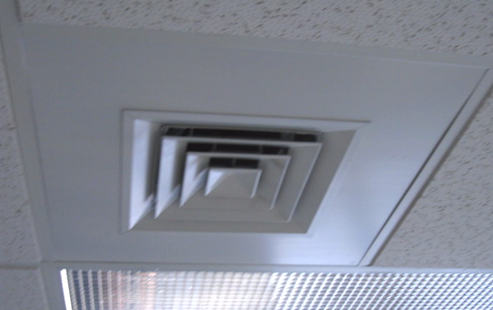

Ceiling-Mounted Air Diffuser

Picture 3

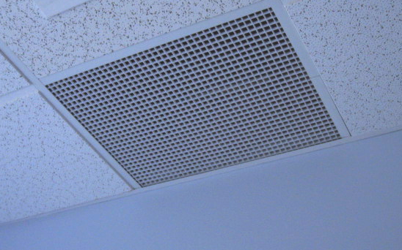

Ceiling-Mounted Return Grill

Picture 4

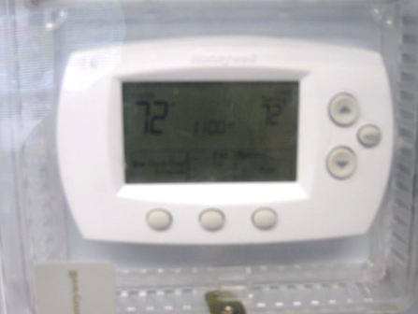

Digital Wall Thermostat

Picture 5

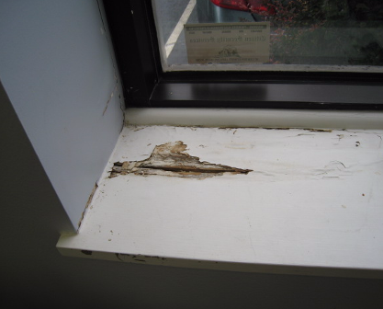

Water Damaged Wooden Window Sill

Picture 6

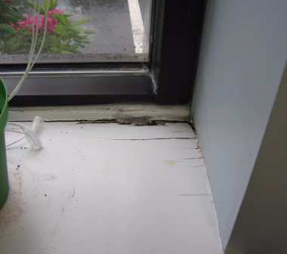

Water Damaged Wooden Window Sill

Picture 7

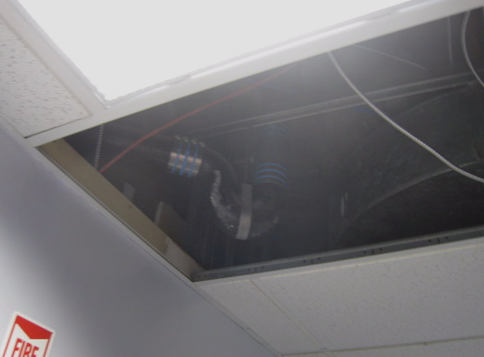

Ceiling Tile Removed to Fix Plumbing/Drainage Leak

Picture 8

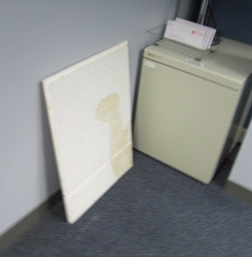

Water Stained Ceiling Tile Removed to Fix Plumbing/Drainage Leak

Picture 9

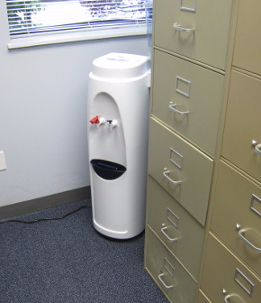

Water Cooler on Carpeting

Picture 10

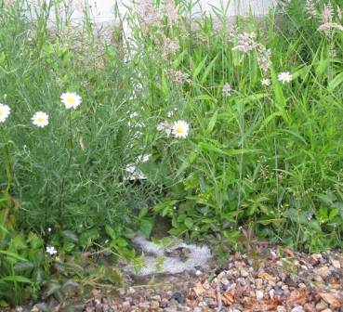

Downspout Missing Elbow Extension Note Water Pooling against Exterior Wall

Picture 11

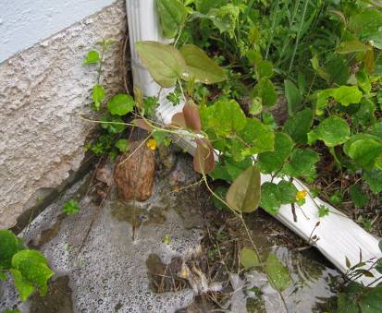

Clogged/Damaged Downspout/Elbow Extension Emptying Water against Exterior Wall

Picture 12

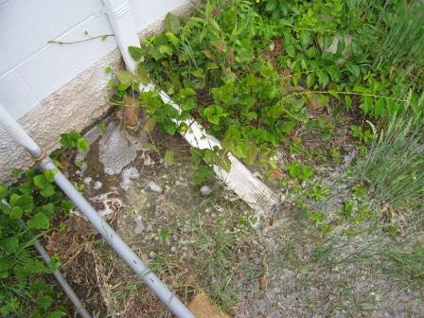

Water Pooling against Exterior Wall

Picture 13

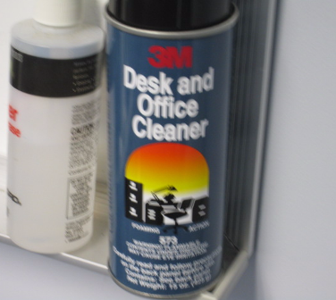

VOC-Containing Office Cleaner

Picture 14

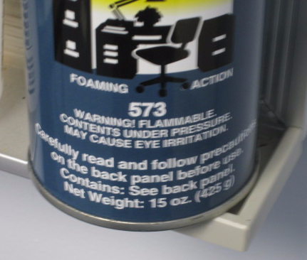

Close-Up of Label in Preceding Picture, Note Flammable/Causes Eye Irritation

Picture 15

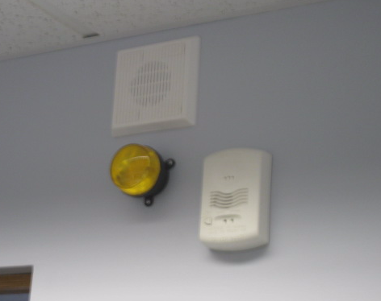

Wall-Mounted Carbon Monoxide Detector

Picture 16

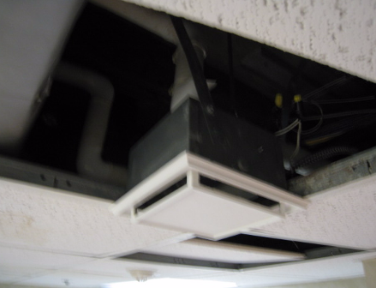

Unducted Local Exhaust Vent in Men’s Restroom
Location/ Room | Occupants  in Room | Temp  (°F) | Relative  Humidity  (%) | Carbon  Dioxide  (ppm) | Carbon Monoxide  (ppm) | PM2.5  (µg/m³) | Windows  Openable | Ventilation |  | Remarks
 |  |  |  |  |  |  |  | Supply | Exhaust | Remarks
background |  | 61 | 45 | 338 | ND - 1 | 3 |  |  |  | Overcast, cool, intermittent rainfall, winds: 1-10 mph, gusts up to 20 mph
Conference Room | 3 | 72 | 44 | 618 | ND | 3 | Y | Y | Y
Melissa’s Office | 0 | 72 | 44 | 645 | ND | 3 | Y | Y | Y | Minor paint peeling, coving not adhered, area of previous leaks  moisture measurements:  Carpet – Low (normal)  GW/window – Low (normal)
Adams | 1 | 74 | 41 | 713 | ND | 2 | Y | Y | Y | Reported site of worst WD-repaired, reports of occasional drips/leaks
Han-Mcb | 4 | 73 | 39 | 774 | ND | 2 | N | Y | Y
Capias Office | 0 | 71 | 37 | 628 | ND | 3 | N | Y | Y | DO
Lastina Office | 0 | 71 | 39 | 634 | ND | 3 | N | Y | Y | DO
Velsa Office | 0 | 71 | 39 | 595 | ND | 3 | N | Y | Y | DO
Alpha Split Area | 2 | 71 | 41 | 609 | ND | 2 | N | Y | Y | Window leaks, WD wooden windowsill, peeling paint
Gomes Cubicle | 1 | 73 | 42 | 668 | ND | 3 | N | Y | Y
Vancisin/ O’neil | 1 | 73 | 41 | 655 | ND | 4 | N | Y | Y
Mec-Ros | 1 | 73 | 41 | 687 | ND | 3 | N | Y | Y
Reception | 0 | 73 | 40 | 669 | ND | 3 | N | N | N
Kitchen | 0 | 73 | 40 | 645 | ND | 3 | N | Y | N
Interview Rooms | 0 | 67 | 40 | 676 | ND | 4 | N | Y | N | Chronic cold complaints
Front Reception |  |  |  |  |  |  |  |  |  | WD/missing CT from previous leak
Men’s Restroom | 0 |  |  |  |  |  | N | Y | Y | Local exhaust vent not ducted to outside, 5 WD CTs
Women’s Restroom |  |  |  |  |  |  | N | Y | Y | Local exhaust ducted
File Room | 0 | 71 | 49 | 437 | ND | 3 | N | Y | Y
Tax Payers Area | 1 | 73 | 45 | 550 | ND | 4 | N | Y | Y | Periodic window leaks reported, water cooler on carpet, plants
Zopatti | 1 | 72 | 45 | 523 | ND | 5 | N | Y | Y
Conference Room | 0 | 72 | 45 | 489 | ND | 3 | N | Y | Y | DO
DeBettencourt | 0 | 72 | 46 | 532 | ND | 4 | N | Y | Y | Area of previous window leaks
O’Connell | 1 | 72 | 46 | 523 | ND | 3 | N | Y | Y
Donnelly | 1 | 73 | 45 | 515 | ND | 4 | N | Y | Y | WD wooden windowsill
Jenkins | 0 | 73 | 46 | 538 | ND | 4 | N | Y | Y | Wood/GW-low (normal) moisture measurement
Elliot | 0 | 72 | 46 | 540 | ND | 4 | N | Y | Y | WD wooden window sill Low (normal) moisture measurements
Dincecco | 0 | 72 | 46 | 518 | ND | 4 | N | Y | Y
Conference Room | 0 | 72 | 46 | 566 | ND | 4 | N | Y | Y
Lobby | 0 | 72 | 44 | 528 | ND | 4 | N | Y | Y

