INDOOR AIR QUALITY ASSESSMENT

**Department of Children and Families**

**EOHHS Service Center**

**500 Main Street**

**Hyannis, MA**

**April 2025**

Exterior view of the Department of Children and Families
EOHHS Service Center
500 Main Street
Hyannis, MA


Prepared by:

Massachusetts Department of Public Health

Bureau of Climate and Environmental Health

Division of Environmental Health Regulations and Standards

# CONTENTS

EXECUTIVE SUMMARY 3

BACKGROUND 4

RESULTS AND DISCUSSION 5

Ventilation 5

HVAC System Maintenance 6

Water Damage and Moisture Concerns 6

Sources of Respiratory Irritants/Possible Asthma Triggers 8

CONCLUSIONS AND RECOMMENDATIONS 9

REFERENCES 13

PICTURES 14

Ventilation Pictures 14

Water Damage Pictures 15

External Damage Pictures 20

Respiratory Irritants Pictures 23

Table 1 24

Table 2A 28

Table 2B 29

Table 2C 30

Table 3 31

Table 4 33

# EXECUTIVE SUMMARY

The Massachusetts Department of Public Health’s (MDPH) Division of Environmental Health Regulations and Standards (EHRS) conducted an Indoor Air Quality (IAQ) assessment of the Department of Children and Families (DCF) office located at 500 Main Street, Hyannis, MA on March 20, 2025. This assessment was requested by Pedro Batista, Project Coordinator, Executive Office of Health and Human Services (EOHHS) in response to water damage/mold concerns and reports/sightings of mushroom growth within the building (Picture 1).

(Results and Discussion)

The building is experiencing chronic water penetration issues around windows that are resulting in water-damaged gypsum wallboard and visible mold growth around windows in DCF space. At the time of assessment, the mushrooms were removed, and no further growth was observed, however, the landlord was planning to remove the front façade of the building to observe conditions and to make needed repairs (Picture 2). However, this work should be expanded to other areas that are not in the original purview of this work (i.e., along the front wall). As a result of this assessment, a number of primary recommendations are made. (Conclusions and Recommendations)

* Continue with plans to work with a building engineer to remove front façade of the building for inspection. Prior to any destructive activities generating dust/debris/odors, the following measures should be taken to protect building materials and occupants in accordance with DPH’s [Construction and renovation generated pollutants in occupied buildings | Mass.gov](https://www.mass.gov/info-details/construction-and-renovation-generated-pollutants-in-occupied-buildings):
  + If possible, conduct work during unoccupied periods or relocate staff;
  + Deactivate or seal HVAC vents/components in the area to avoid entrainment into HVAC system;
  + Remove items from general area or cover with plastic to aid clean up;
  + Use depressurization techniques (e.g., fans blowing out windows);
  + Seal areas with plastic polyethylene sheeting and duct-tape,
  + Change filters and flush the HVAC system out for 24 hours prior to reoccupancy,
  + Once remediation activities are concluded, clean all items and surfaces with a high efficiency particulate arrestance (HEPA) filter equipped vacuum cleaner combined with wet wiping prior to reoccupation.
* Expand work to other areas that are experiencing water penetration along windows (Table 1).
* Have the building envelope specialist determine best practices to prevent water penetration and damage to building materials around windows.
* Have the mechanical ventilation systems on and operational during occupied hours in all rooms.

As climate change and global warming intensifies, without significant repair of the building envelope, building conditions and indoor air quality will continue to degrade.

(Conclusions and Recommendations)

# BACKGROUND

|  |  |
| --- | --- |
| Building: | Department of Children and Families (DCF) |
| Address: | 500 Main Street, Hyannis, MA |
| Coordinated Via: | Pedro Batista, Project Coordinator, Executive Office of Health and Human Services (EOHHS) |
| Reason for Request: | General indoor air quality (IAQ) issues |
| Date of Assessment: | March 20, 2025 |
| Massachusetts Department of Public Health/Bureau of Climate and Environmental Health/**Division of Environmental Health Regulations and Standards** (MDPH/BCEH/EHRS) Staff Conducting Assessment: | Cory Holmes, Senior Advisor for Indoor Air Quality Inspections, Audits, Outreach and Training, EHRS |
| Building Description: | |  | | --- | | It is important to note that the building has been previously assessed by the DPH. The reports and building description can be viewed at this webpage: <https://www.mass.gov/info-details/indoor-air-quality-reports-cities-and-towns-b#barnstable-> | |
| Windows: | Windows in the building are not openable. |
| **Building Population:** | The building is occupied by state employees on a hybrid work schedule. |

# RESULTS AND DISCUSSION

The following is a summary of indoor air testing results (Table 1)

|  |  |  |
| --- | --- | --- |
| * ***Carbon dioxide (CO2)*** | *a measure of the adequacy of ventilation* | Levels were below the MDPH guideline of 800 parts per million (ppm) in all but three areas surveyed, indicating a lack of air exchange in those areas. Levels would be expected to be higher with full occupancy. |
| * ***Temperature*** | *a measure of comfort* | It was mostly within the MDPH recommended range of 70°F to 78°F in occupied areas, however some levels were below that range, and occupants reported a number of temperature control issues. |
| * ***Relative humidity*** | *a measure of comfort and, when in excess for an extended period, a way to reflect the potential for mold and fungal growth* | It was within or close to the lower level of the MDPH recommended range of 40 to 60% in all areas tested. |
| * ***Carbon monoxide***   ***(CO)*** | *a product of combustion that can result in acute and long term cardiovascular, respiratory, and neurological symptoms* | Levels were non-detect (ND) in all occupied areas tested. |
| * ***Particulate matter (PM2.5)*** | *a way to measure inhalable particle distribution in the air* | Concentrations were below the National Ambient Air Quality Standard (NAAQS) of 35 micrograms per cubic meter (μg/m3) in all areas tested. |

## Ventilation

Ventilation refers to both the supply of fresh air and the removal of stale air from a room. The introduction of fresh air into an occupied space will dilute normally occurring pollutants that are generated by occupancy and other activities. In addition, a heating, ventilation and air conditioning (HVAC) system will remove pollutants from a building if operating appropriately. All ventilation systems throughout the building should operate continuously during periods of occupancy.

Fresh air is provided by air handling units (AHUs) located on the roof. Air from the AHUs is filtered, heated/cooled, and delivered to rooms via ducted supply diffusers. Air is returned/exhausted through exhaust grills. A number of complaints of poor air circulation and lack of temperature control were expressed by staff. It is recommended that HVAC systems be re-balanced every five years to ensure adequate air systems function (SMACNA, 1994). It is not known when the last time these systems were balanced.

The various types of ventilation components as well as devices that can move/redirect airflow that were identified in the building are listed in Table 2A, Table 2B and Table 2C.

### HVAC System Maintenance

It is recommended that AHUs be outfitted with pleated filters of a Minimum Efficiency Reporting Value (MERV) of 8 or higher, which are adequate in filtering out pollen and mold spores (ASHRAE, 2012). In addition, filters should be changed 2-4 times a year or in accordance with the manufacture’s recommendations.

**Balancing**

To have proper ventilation with a mechanical supply and exhaust system, a system must be balanced to provide an adequate amount of fresh air to the interior of a room while also removing stale air from the room. It is recommended that HVAC systems be re-balanced every five years to ensure adequate air systems function (SMACNA, 1994).

(see Ventilation pictures)

## Water Damage and Moisture Concerns

Please note that the MDPH does not recommend conducting mold testing in a typical water damage remediation. For details, please consult [Guidance Regarding Testing for Mold in Water-Damaged Public Buildings](https://www.mass.gov/info-details/guidance-regarding-testing-for-mold-in-water-damaged-public-buildings) | Mass.gov

The application of a mildewcide to moldy porous materials is not recommended.

Molds are found naturally in our environment both indoors and outdoors. Inside, mold growth may occur when items, particularly porous products such as paper or gypsum wallboard, are exposed to moisture. Typical water sources include leaks, floods, and condensation. To avoid mold growth, dry all water-damaged items and affected areas within 24-48 hours and reduce indoor humidity. Some people with chronic respiratory conditions, such as asthma, are more likely to experience health symptoms associated with molds, including allergic reactions and respiratory irritation. Controlling moisture is the key to preventing mold growth and potential health symptoms. [Climate fact sheet: mold growth | Mass.gov](https://www.mass.gov/info-details/climate-fact-sheet-mold-growth)

Hot, humid summers are becoming more frequent due to climate change. Massachusetts has experienced hot, humid, and rainy summers in 2018, 2021, and 2023. July of 2021 was the wettest ever recorded in Massachusetts, and the three-month period from June through August, known as the meteorological summer, was the fourth wettest on record, according to the National Oceanic and Atmospheric Administration’s (NOAA) Centers for Environmental Information (NOAA, 2021). The summers of of 2023 and 2024 were also hot, and wet, with 2023 being measured as the second rainiest on record (WBUR, 2023). These conditions are challenging for buildings, particularly those without central air conditioning.

During these hot and wet summers, extended periods of outdoor relative humidity above 70% occurred. Under this weather, public buildings experienced extended periods of water vapor exposure from high relative humidity. When exposed to these conditions, porous materials such as gypsum wallboard, cardboard, and other materials may become prone to developing mold colonization, particularly if located in areas that are prone to developing condensation on floors and walls (e.g., below grade space).

In order to remove mold from buildings, of primary importance is to identify, repair and/or limit the moisture source causing damage in the building. Once the moisture source is remediated, then discarding and/or cleaning of mold contaminated materials can be completed.

All areas examinned were assessed for the presence of either mold, moisture, or visible water damage and an exterior evaluation was conducted to identify potential pathways for water penetration. The following issues were noted.

* **Visible mold growth (Pictures 3 and 4) was observed on porous building materials (i.e., gypsum wallboard) in a few rooms along the same wall (Table 1)**.
* **Elevated moisture measurements were taken and water-damaged gypsum wallboard and peeling paint, indicating current/chronic leaks, were noted around window frames (Pictures 3 through 8; Table 1).** **Peeling paint** **can make surfaces difficult to clean and can introduce dust and debris into rooms.**
* **Water-damaged ceiling tiles were noted in a few areas (Table 1), which can provide a source of mold and should be replaced after a water leak is discovered and repaired**.
* **On-going leaks/water streaming down the wall, were reported by DCF staff in room 1276 (Picture 9).** **The ceiling tiles were removed for inspection in this area, no musty odors were detected or visible mold observed on materials in the ceiling plenum (Picture 10). This area should be investigated further to determine if the water is from roof leaks or related to the HVAC or plumbing system and repaired.**
* **Light was seen penetrating beneath the exterior door in the back hallway (near 1288, Picture 11).** Good door-sweeps/weatherstripping can not only exclude pests but can keep unconditioned outside air and moisture from entering the building.
* **Missing/damaged caulking was noted in breakroom 1263 (Picture 12).** If a sink backsplash is damaged, it becomes very difficult to keep clean and can lead to mold growth and additional damage to the material underneath.

An exterior evaluation was also conducted to identify potential pathways for water penetration and pest entry. The following issues were noted.

* **Open seams and missing/damaged caulking around exterior windows (Pictures 13 and 14)**, which can accelerate water damage, lead to mold growth and rot, allowing a pathway for drafts, moisture, and pest entry into the building.
* **Damaged exterior siding/panels (Pictures 15 through 17).**
* **Water staining and moss growth indicating chronic moisture exposure/running down the side of the building (Pictures 17 and 18).**
* **Gutters/downspouts emptying close to the building foundation (Picture 19).**

Each of these issues can accelerate water damage, lead to mold growth and rot allowing a pathway for drafts, moisture, and pest entry into the building.

A list of water damage issues identified inside and outside the building is included as Table 3.

(see Water Damage Pictures)

**Mold Growth**

Porous materials (e.g., gypsum wallboard, ceiling tiles and carpeting) can be dried with fans and heating within 24 to 48 hours of becoming wet (US EPA, 2008).

If porous materials are not dried within this time frame, mold growth may occur.

Moldy materials should be cleaned following the guidance in EPA’s Mold Remediation in Schools and Commercial Building (US EPA, 2008).

## Sources of Respiratory Irritants/Possible Asthma Triggers

Asthma is a lung disease that can make breathing difficult. Without careful management of asthma, some people can have symptoms, like a tight feeling in the chest, shortness of breath, coughing, or wheezing. Although there is no cure for asthma, people with asthma can live healthy, active lives. A safe and healthy environment helps to reduce asthma symptoms.

* **Dust, a common respiratory and eye irritant, can collect on surfaces and items.** Although janitorial and maintenance staff perform routine cleaning, they may not be able to clean as effectively if accumulated items are not picked up or surfaces are cluttered.
* Even with a properly functioning ventilation system, it is necessary to **reduce the use of materials that can be a source of respiratory irritants** to prevent symptoms in individuals who have sensitivity to such pollutants.

Possible asthma triggers and/or airborne pollutants exist in the building. These are listed below as well as in (Table 4).

(see Sources of Respiratory Irritant Pictures)

* **Many areas had carpet tiles.** Carpets should be vacuumed regularly with a high efficiency particulate arrestance (HEPA) filter equipped vacuum cleaner and cleaned annually (or semi-annually in soiled/high traffic areas) in accordance with Institute of Inspection, Cleaning and Restoration Certification (IICRC) recommendations, (IICRC, 2012).
* **In some areas dust and debris were seen accumulating on windowsills (Table 1; Picture 20).** This dust can be aerosolized under certain conditions and can also be a medium for mold growth.
* **Exposure to low levels of total volatile organic compounds (TVOCs) may produce eye, nose, throat, and/or respiratory irritation in some sensitive individuals.** To determine if VOCs were present, EHRS staff examined rooms for products containing VOCs. and noted cleaners, hand sanitizers, dry erase materials, and other products in use within the building. All of these products have the potential to be irritants to the eyes, nose, throat, and respiratory system of sensitive individuals.
* **During the Covid-19 pandemic many schools and public buildings supplemented fresh air and filtration by using high-efficiency particulate arrestance (HEPA) air purifiers.** HEPA units remove up to 99% of airborne contaminants as small as 0.1 microns including airborne mold/mushroom spores. These are good choices for use in occupied areas. None of these types of units were observed in the workspace.
* **Finally, DCF leadership expressed frustration/staff concerns with issues/odors related to the HVAC system.** The issue was described as “puff backs” during activation of the combustion-powered rooftop units and related odors of gas/emissions within the building. The issue has resulted in several evacuations with emergency response from the local fire department. The landlord is reportedly working with his HVAC company and utility provider to investigate. Combustion equipment should be maintained regularly to reduce the emission of products of combustion. Enough make-up air should be present to allow all combustion equipment to operate fully.

# CONCLUSIONS AND RECOMMENDATIONS

|  |  |  |  |
| --- | --- | --- | --- |
|  | **HVAC System** | | **Helpful Links** |
| 1. If | Ensure all AHUs and restroom exhaust vents are on and operating continuously during occupied periods. |  | |
|  | Change HVAC filters 2-4 times a year using MERV 8 or the best MERV-rating that can work with current equipment. | [ANSI/ASHRAE Standard 52.2-2017](https://www.ashrae.org/File%20Library/Technical%20Resources/COVID-19/52_2_2017_COVID-19_20200401.pdf) | |
|  | During filter changes, clean dust and debris from the inside of HVAC cabinets. |  | |
|  | Clean dust and debris from vents, ceiling fans, and personal fans periodically. |  | |
|  | Have the HVAC system balanced if it has been more than 5 years since the last balancing. |  | |
|  | Employ the use of HEPA air filtration units within the space. Ensure air purifiers are maintained in accordance with the manufacturer’s instructions. When in use, place the outlet air in the breathing zone whenever possible. |  | |
|  | **Water damage** | | |
|  | Continue with plans to consult with a building envelope specialist regarding water penetration and the condition of interior walls around windows, make repairs as needed. |  | |
|  | Remove or clean any water-damaged/mold-contaminated material in accordance with the US EPA’s “Mold Remediation in Schools and Commercial Buildings”.   * When performing activities that may generate large amounts of airborne dust/debris, seal off area (if possible) and deactivate HVAC system (or seal vents) and/or use *depressurization* techniques to vent away from occupied areas and out of the building (if possible). * When removing/replacing water-damaged materials items should be placed in plastic bags for transport. * Operate/flush out the HVAC system and change filters prior to reoccupancy.   Once remediation activities are concluded, clean all items and surfaces with a high efficiency particulate arrestance (HEPA) filter equipped vacuum cleaner combined with wet wiping prior to reoccupation. | <http://www.epa.gov/mold/mold-remediation-schools-and-commercial-buildings-guide>  [Construction and renovation generated pollutants in occupied buildings | Mass.gov](https://www.mass.gov/info-details/construction-and-renovation-generated-pollutants-in-occupied-buildings) | |
|  | Ensure proper drainage on the roof, gutters, and downspouts away from building. |  | |
|  | Replace or make repairs to damaged siding and panels. |  | |
|  | Ensure there is a system for reporting and monitoring leaks. Building occupants should ensure they report active leaks to building management for investigation and repairs. |  | |
|  | **Respiratory Irritants/Possible Asthma Triggers** | | |
|  | Continue working with HVAC engineer and utility providers to investigate and make adjustments to prevent combustion odors within occupied areas.   * Consider extending exhaust for rooftop AHU if possible * Install digital readout carbon monoxide detectors for a visual real-time measurement,   Consider obtaining a 2nd opinion from alternative HVAC engineer if problem cannot be solved (or reduced) |  | |
|  | Maintain combustion HVAC equipment to ensure clean combustion. Ensure enough combustion make-up air is present for equipment to work properly. |  | |
|  | Reduce clutter. Periodically remove unwanted items. Store the remaining items neatly and off the floor. Where rooms have a history of moisture issues, consider storing items in waterproof totes |  | |
|  | Reduce use of products and equipment that create irritating volatile organic compounds (VOCs) and only use in well-ventilated areas. Minimize the use of air fresheners (e.g., plug-ins), deodorizers, and scented products. | [Clean Air Is Odor Free](https://www.mass.gov/doc/clean-air-is-odor-free-removing-fragrances-to-improve-indoor-air-quality-in-schools-and-offices-0/download) | |
|  | Supplement mechanical ventilation with portable air purifiers equipped with high efficiency particulate arrestance (HEPA) filters. While these do not supply fresh air, they can remove particles including mold spores and microbes.  Units that may produce ozone should not be used. Maintain all in accordance with manufacturer’s instructions.  Place them so the filtered airstream is in the breathing zone of occupants and away from open doors. | <https://www.epa.gov/indoor-air-quality-iaq/ozone-generators-are-sold-air-cleaners> | |
|  | Clean carpeting annually (or semi-annually in soiled high traffic areas) as per recommendations of the Institute of Inspection, Cleaning and Restoration Certification (IICRC, 2012). |  | |

# REFERENCES

ASHRAE. 2012. American Society of Heating, Refrigeration and Air Conditioning Engineers (ASHRAE) Standard 52.2-2012 – Method of Testing General Ventilation Air-Cleaning Devices for Removal Efficiency by Particle Size (ANSI Approved).

IICRC. 2012. Institute of Inspection Cleaning and Restoration Certification. Institute of Inspection, Cleaning and Restoration Certification. Carpet Cleaning: FAQ.

NOAA. 2021. Summer 2021 neck and neck with Dust Bowl summer for hottest on record. National Oceanic and Atmospheric Administration, 1401 Constitution Avenue NW, Room 5128, Washington, DC 20230 <https://www.noaa.gov/news/summer-2021-neck-and-neck-with-dust-bowl-summer-for-hottest-on-record>

SMACNA. 1994. HVAC Systems Commissioning Manual. 1st ed. Sheet Metal and Air Conditioning Contractors’ National Association, Inc., Chantilly, VA.

US EPA. 2008. Mold Remediation in Schools and Commercial Buildings. US Environmental Protection Agency, Office of Air and Radiation, Indoor Environments Division, Washington, D.C. EPA 402-K-01-001. <http://www.epa.gov/mold/mold-remediation-schools-and-commercial-buildings-guide>.

WBUR. 2023. “It’s been a summer of rain and flooding misery in Mass.” WBUR local news. September 12, 2023. <https://www.wbur.org/news/2023/09/12/summer-flooding-rain-massachusetts>

(Click to link back to report)

# PICTURES

## Background and Ventilation Pictures

**Picture 1**

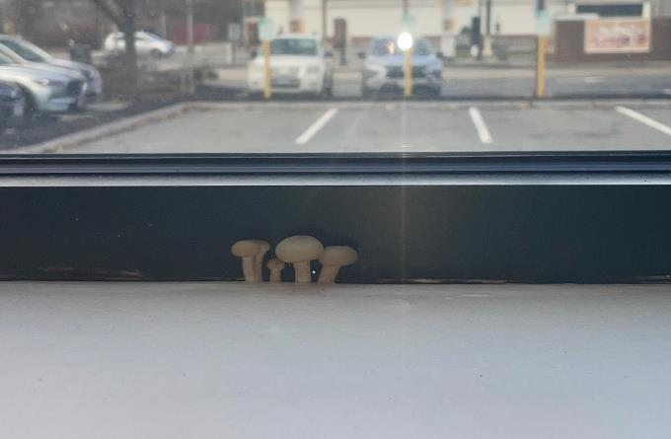

**Mushroom growth along windowsill in DCF office (picture provided by DCF Staff to DPH via Pedro Batista, EOHHS)**

**Picture 2**

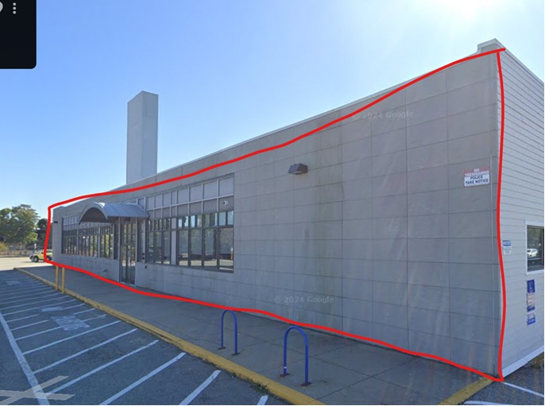

**Front façade of building where Landlord plans on removing and making repairs to the building envelope to prevent further water penetration (picture provided to DPH via Pedro Batista, EOHHS)**

## Water Damage Pictures

Picture 3

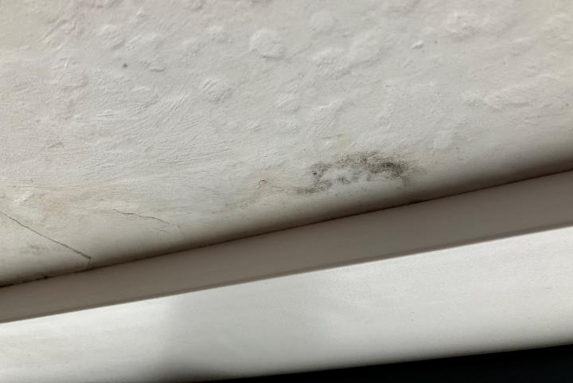

Mold growth dark staining (arrow) on gypsum wallboard windowsill in office

Picture 4

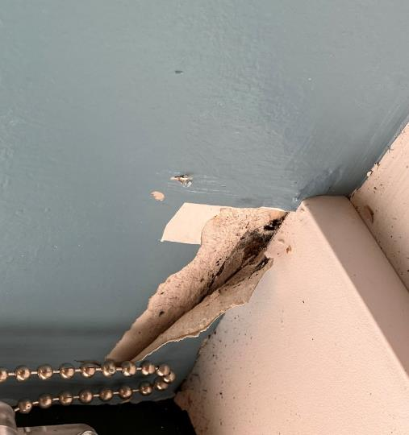

Mold growth dark staining on gypsum wallboard windowsill in room 1214

Picture 5

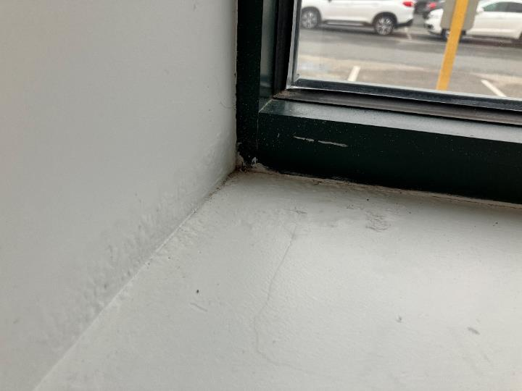

Water damage gypsum wallboard and bubbling paint in office

Picture 6

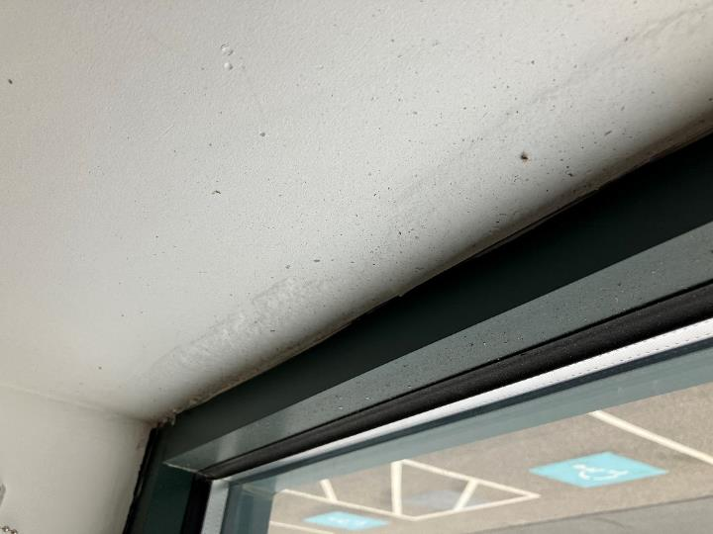

Water damage gypsum wallboard and bubbling paint in office

Picture 7

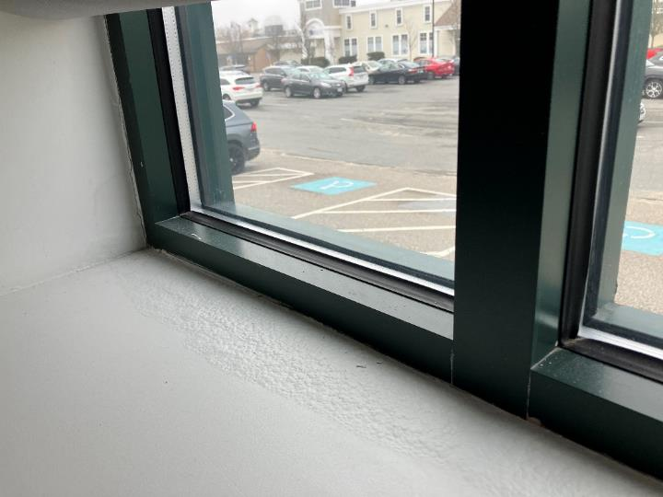

Water damage gypsum wallboard and bubbling paint in office

Picture 8

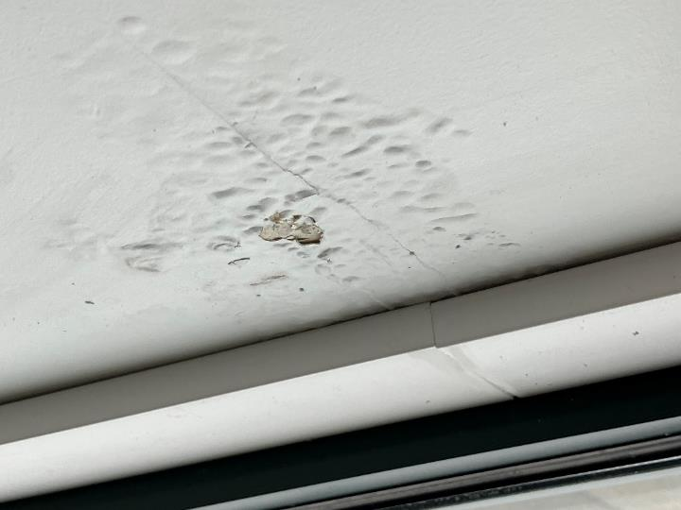

Water damage gypsum wallboard and bubbling paint in office

Picture 9

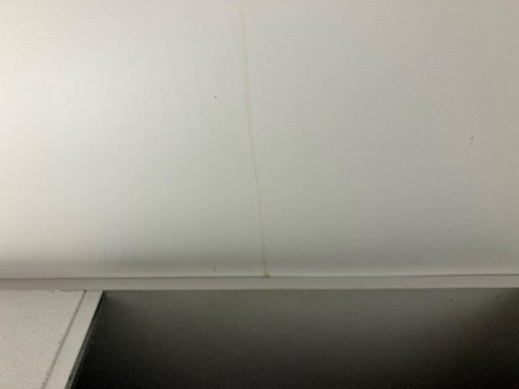

Water stain running down gypsum wallboard in room 1276

Picture 10

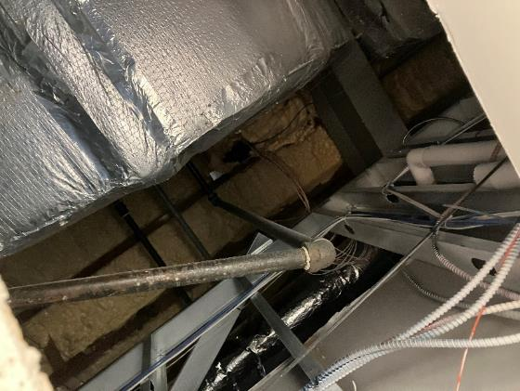

Above ceiling in room 1276 where on-going leaks are reported

Picture 11

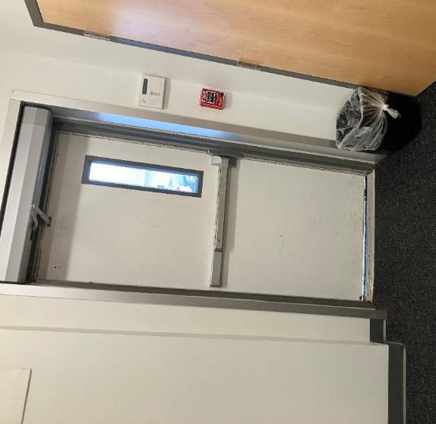

Light penetrating through space beneath exterior door in back hallway (near 1288)

Picture 12

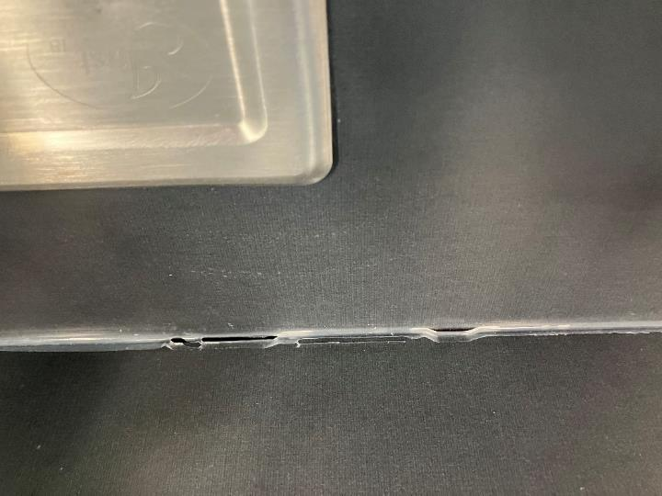

Missing/damaged caulking around sink in breakroom

## External Damage Pictures

Picture 13

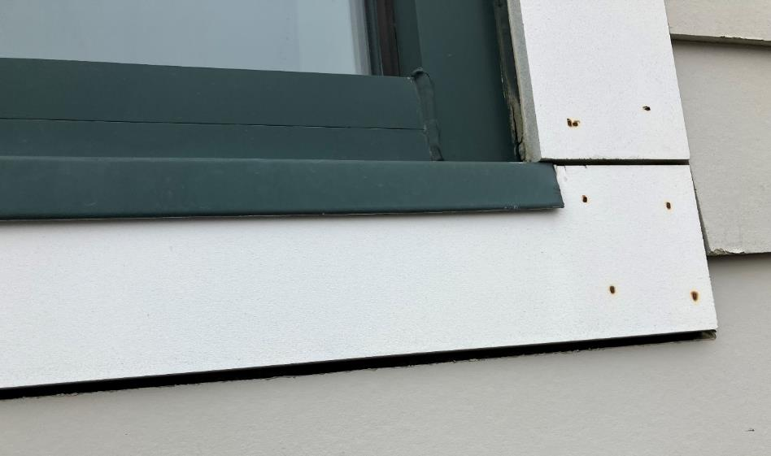

Open seams around exterior window trim

Picture 14

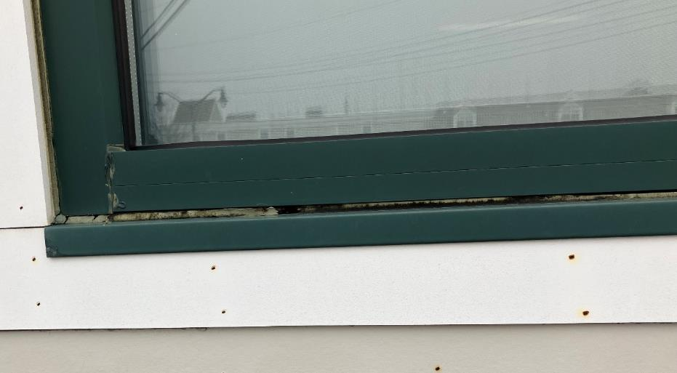

Open seams around exterior window trim, note missing/damaged caulking

Picture 15

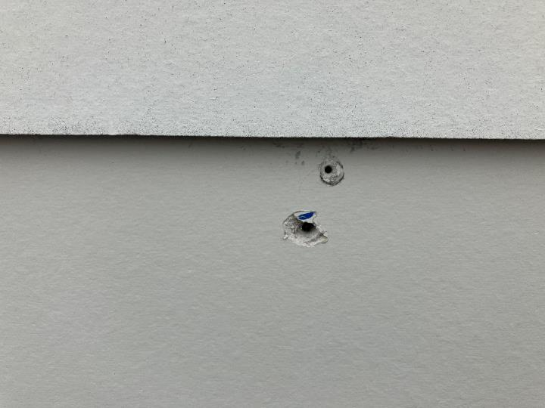

Open holes in siding

Picture 16

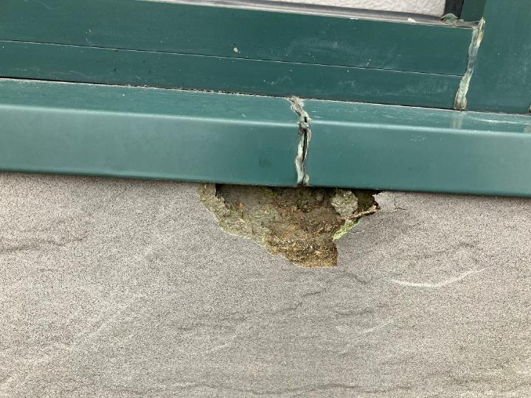

Damaged wall panels along front of building (within red area of Picture 2)

Picture 17

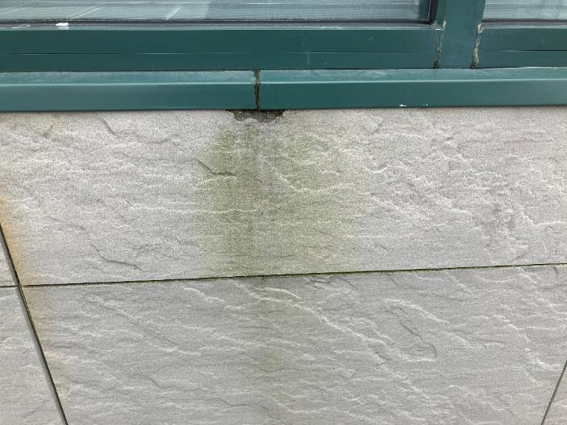

Damaged wall panel along front of building (within red area of Picture 2), note staining/moss growth indicating chronic moisture exposure

Picture 18

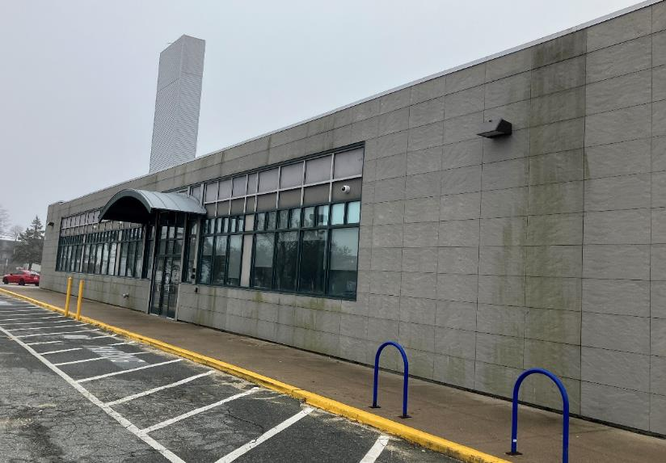

Water staining/moss growth indicating chronic moisture exposure

Picture 19

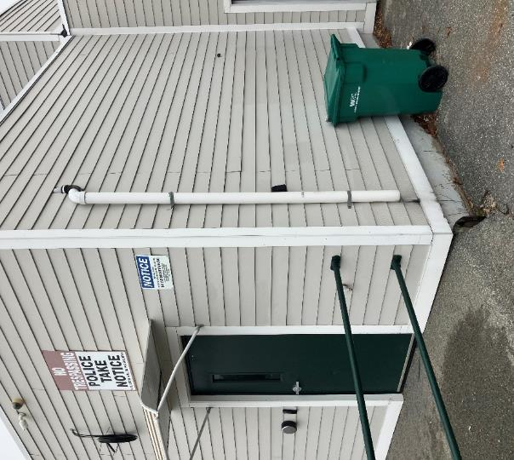

Downspout missing elbow extension emptying water against foundation

## Respiratory Irritants Pictures

Picture 20

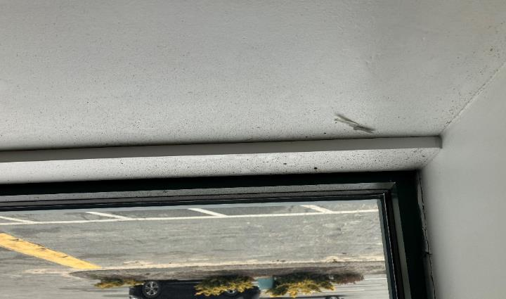

Dust/debris on windowsill in area 1338

Click to link back to report

# Table 1

| **Location** | **Carbon**  **Dioxide**  **(ppm)** | **Carbon Monoxide**  **(ppm)** | **Temp**  **(°F)** | **Relative**  **Humidity**  **(%)** | **PM2.5**  **(g/m3)** | **Occupants**  **in Room** | **Windows**  **Openable** | **Ventilation** | | **Remarks** |
| --- | --- | --- | --- | --- | --- | --- | --- | --- | --- | --- |
| **Supply** | **Exhaust** |
| Background (outside) | 455 | ND | 45 | 84 | ND |  |  |  |  | Cold, windy, fog |
| 1284 | 748 | ND | 69 | 43 | ND | 1 | N | Y | Y | 2 WD windows/elevated moisture measurements |
| Back Hallway 1288 |  |  |  |  |  |  |  |  |  | Space under exterior door – rec. installing tile and replacing weather-stripping |
| 1281 | 720 | ND | 68 | 42 | ND | 1 | N | Y | Y | Elevated moisture measurements around windows |
| 1283 | 713 | ND | 68 | 42 | ND | 0 | N | Y | Y | Elevated moisture measurements around windows, visible WD GW around windows |
| 1347 | 608 | ND | 70 | 39 | ND | 1 | N | Y | Y | Elevated moisture measurements around windows |
| 1279 | 573 | ND | 70 | 39 | ND | 1 | N | Y | Y | Water damaged windowsill |
| 1278 Conference Room | 691 | ND | 70 | 40 | ND | 7 | N | Y | Y | WD windows, peeling paint/elevated moisture measurements |
| 1338 Area | 580 | ND | 69 | 40 | ND | 0 | N | Y | Y | WD windows, peeling paint/elevated moisture measurements |
| 1276 | 593 | ND | 71 | 38 | ND | 0 | N | Y | Y | Ongoing leak reported to stream down walls |
| 1273 | 706 | ND | 73 | 37 | ND | 1 | N | Y | Y |  |
| 1272 Conference Room | 845 | ND | 76 | 36 | ND | 0 | N | Y | Y | Cassettes – AHUs in ceiling |
| 1254 | 618 | ND | 74 | 35 | ND | 0 | N | Y | Y |  |
| 1263 Break Room | 690 | ND | 74 | 35 | ND | 0 | N | Y | Y | Missing/damaged caulking sink |
| 1251 | 574 | ND | 73 | 35 | ND | 0 | N | Y | Y |  |
| 1261 | 1068 | ND | 73 | 38 | ND | 0 | N | Y | Y |  |
| 1300/1308 | 611 | ND | 72 | 37 | ND | 1 | N | Y | Y | Windows clean and dry |
| 1309/1318 | 620 | ND | 71 | 38 | ND | 6 | N | Y | Y |  |
| 1246 | 643 | ND | 72 | 38 | ND | 0 | N | Y | Y |  |
| 1247 | 632 | ND | 72 | 38 | ND | 1 | N | Y | Y | 2 WD CTs |
| 1258 | 623 | ND | 71 | 38 | ND | 0 | N | Y | Y |  |
| 1245 | 553 | ND | 71 | 37 | ND | 0 | N | Y | Y | Dislodged CT, plant |
| 1227/1228 | 551 | ND | 72 | 37 | ND | 0 | N | Y | Y | 2 WD CTs (reportedly changed recently) |
| Mailroom | 679 | ND | 73 | 37 | ND | 0 | N | Y | Y |  |
| Records Room | 550 | ND | 73 | 36 | ND | 0 | N | Y | Y |  |
| 1223 | 687 | ND | 73 | 37 | ND | 1 | N | Y | Y |  |
| 1205 | 1153 | ND | 74 | 38 | ND | 4 | N | Y | Y |  |
| 1231 | 576 | ND | 72 | 37 | ND | 0 | N | Y | Y |  |
| 1233 | 557 | ND | 71 | 38 | ND | 0 | N | Y | Y |  |
| 1330/1322 | 690 | ND | 71 | 39 | ND | 3 | N | N | Y | Area of mushroom growth  1327 & 1325-elevated moisture measurements and WD |
| 1236 | 589 | ND | 70 | 39 | ND | 1 | N | Y | Y |  |
| 1237 | 605 | ND | 71 | 40 | ND | 1 | N | Y | Y |  |
| 1230 | 585 | ND | 70 | 39 | ND | 0 | N | Y | Y |  |
| Lobby | 565 | ND | 71 | 39 | ND | 0 | N | Y | Y |  |
| 1215 | 564 | ND | 71 | 39 | ND | 0 | N | Y | Y | WD windowsill |
| 1214 | 672 | ND | 72 | 37 | ND | 0 | N | Y | Y | Visible mold in corner |
| 1213 | 580 | ND | 71 | 40 | ND | 0 | N | Y | Y | WD windowsill |
| 1212 | 674 | ND | 70 | 40 | ND | 0 | N | Y | Y | WD windows/elevated moisture measurements |
| 1211 | 556 | ND | 71 | 39 | ND | 0 | N | Y | Y | WD windows/elevated moisture measurements |
| 1208 | 562 | ND | 71 | 39 | ND | 0 | N | Y | Y |  |

(Click to link back to report)

# Table 2A

|  |  |  |  |  |  |
| --- | --- | --- | --- | --- | --- |
| **Equipment Present in Building**  **(X = Yes)** | **Type of Heating/Cooling Ventilation**  **Equipment** | **Fresh**  **Air**  **Supply**  **(X = Yes)** | **Type of Location(s)** | **Air Filters Installed**  **MERV Rating**  **(1-15, U*)**  **(X = Yes)** | **Comments** |
|  | Univents |  |  |  |  |
| X | Rooftop Air Handling Units | X |  |  |  |
|  | Outdoor, Ground-Installed Air Handling Units |  |  |  |  |
|  | Attic/Crawlspace Air Handling Units |  |  |  |  |
| X | Ceiling-Mounted Air Handling Units (including inside plenum) |  | Conference Rooms |  |  |
|  | Basement/Crawlspace-Installed Air Handling Units |  |  |  |  |
|  | Mechanical Room-installed Air Handling Units |  |  |  |  |
|  | Fan Coil Units |  |  |  |  |
|  | Window-Mounted Air Conditioners |  |  |  |  |
|  | Portable air conditioners |  |  |  |  |
|  | Wall Louver-Controlled Gravity Air Supply |  |  |  |  |
|  | Windows |  |  |  |  |
|  | Fan in window (blowing in) |  |  |  |  |
|  | Built in wall fan (switched) |  |  |  |  |
|  | Heat recovery ventilator unit |  |  |  |  |
|  | Energy recovery ventilator unit |  |  |  |  |
|  | Chilled Beam |  |  |  |  |
|  | Passive combustion supply vent in basement/boiler room |  |  |  |  |

*U = Filter Rating underdetermined due to inaccessibility during building visit

# Table 2B

|  |  |  |  |  |
| --- | --- | --- | --- | --- |
| **Equipment Present in Building**  **(X = Yes)** | **Type of Exhaust Ventilation**  **Equipment** | **Ducted**  **To Outdoors**  **(X = Yes)** | **Type of Location(s)** | **Comments** |
| X | Rooftop Motors/Fans | X | Offices and common areas |  |
|  | Unit Exhaust |  |  |  |
|  | Ceiling Return Vent |  |  |  |
| X | Ceiling Return Vent, Plenum |  | Offices and common areas |  |
|  | Wall Return Vent |  |  |  |
|  | Ceiling fan |  |  |  |
|  | Kitchen Stove Hood |  |  |  |
| X | Restroom Exhaust Vent | X |  |  |
|  | Photocopier Exhaust Vent |  |  |  |
|  | Garage |  |  |  |
|  | Chemical Hood(s) |  |  |  |
|  | Locker Rooms |  |  |  |
|  | Showers |  |  |  |
|  | Clothes Dryers |  |  |  |
|  | Gas Water Heaters |  |  |  |
|  | Furnace-Flue to Chimney |  |  |  |
|  | Furnace/Boiler direct vent or power vent (no combustion air supply) |  |  |  |
|  | Kiln, Pottery |  |  |  |
|  | Dark Room |  |  |  |
|  | Generator Room |  |  |  |
|  | Wood Shop Dust Collector |  |  |  |
|  | Spray Paint Booths |  |  |  |
|  | Fan in window (blowing out) |  |  |  |

# Table 2C

|  |  |  |  |
| --- | --- | --- | --- |
| **Equipment Present in Building**  **(X = Yes)** | **Type of Equipment** | **Type of Location(s)** | **Comments** |
|  | Floor Fans, pedestal |  |  |
|  | Floor Fans, portable |  |  |
|  | Air Purifier (HEPA, other) |  |  |
|  | Floor heaters, portable |  |  |
| X | Refrigerators, Cold Beverage Vending Machines | Staff Room |  |
|  | Radiator, wall-mounted |  |  |
|  | Radiator, floor-mounted |  |  |
|  | Passive Vents (Wall/Door) |  |  |

(Click to link back to report)

# Table 3

| **Found in Building**  **X = Yes** | **Water-Damaged Materials, Building Components or Stored Materials** | **Location** | **Visible Microbial Growth?**  **X = Yes** | **Musty odor detected?**  **X = Yes** | **Comments** |
| --- | --- | --- | --- | --- | --- |
|  | Books-other bound materials |  |  |  |  |
|  | Brick walls – broken, missing mortar |  |  |  |  |
|  | Brick walls – blocked weep holes |  |  |  |  |
|  | Cardboard boxes |  |  |  |  |
|  | Carpet tiles |  |  |  |  |
|  | Carpet - Area rugs |  |  |  |  |
|  | Carpet wall-to-wall |  |  |  |  |
|  | Ceiling tiles - affixed directly to ceiling surface |  |  |  |  |
|  | Ceiling tiles - bowing-in suspended ceiling |  |  |  |  |
|  | Ceiling tiles - water-stained in splined ceiling |  |  |  |  |
| X | Ceiling tiles - water-stained in suspended ceiling | Offices, common areas | No | No |  |
|  | Chairs - laminated |  |  |  |  |
|  | Cloth |  |  |  |  |
| X | Countertops (around sinks) | Breakroom | No | No | Missing/damaged caulking |
|  | Curtains |  |  |  |  |
|  | Dust/debris within AHU, uninvent, HVAC, chilled beam units, etc. (WD through condensation, humidity, or leaks) |  |  |  |  |
|  | Efflorescence (i.e., mineral deposits) |  |  |  |  |
|  | Engineered woods - particleboard, plywood, Masonite |  |  |  |  |
|  | Flooring – loosened tiles |  |  |  |  |
|  | Flooring - wooden |  |  |  |  |
|  | Furniture - laminated |  |  |  |  |
|  | Furniture - upholstered |  |  |  |  |
|  | Gypsum wallboard - ceiling |  |  |  |  |
|  | Gypsum wallboard - restroom wall |  |  |  |  |
| X | Gypsum wallboard - interior wall | Around windows in offices | Yes | No | Elevated moisture measurements in many areas |
|  | Gypsum wallboard – located on exterior wall |  |  |  |  |
|  | HVAC drain pan – lack of draining |  |  |  |  |
|  | HVAC filters |  |  |  |  |
|  | Insulation- attic (paper-backed) |  |  |  |  |
|  | Insulation - inside air handling unit |  |  |  |  |
|  | Insulation - on pipe(s) fiberglass |  |  |  |  |
|  | Insulation - on pipe(s) other/plaster-like material |  |  |  |  |
|  | Insulation - wall cavity |  |  |  |  |
|  | Insulation – ceiling plenum |  |  |  |  |
|  | Modular furniture – walls/cloth partitions |  |  |  |  |
|  | Musical instrument cases |  |  |  |  |
|  | Plaster ceilings |  |  |  |  |
|  | Records/files |  |  |  |  |
|  | Refrigerator - door gasket |  |  |  |  |
|  | Refrigerator - drip pan |  |  |  |  |
|  | Refrigerator - Interior surfaces |  |  |  |  |
|  | Room divider - ceiling-mounted, sliding |  |  |  |  |
| X | Sink backsplash | Breakroom | No | No | Missing/damaged caulking |
|  | Tables – laminated |  |  |  |  |
|  | Wallpaper |  |  |  |  |
|  | Wood - attic/roof materials |  |  |  |  |
|  | Wood - floor joists in basement ceiling |  |  |  |  |
|  | Wood - wall framing |  |  |  |  |
|  | Wood - window sills |  |  |  |  |
|  | Wood - window-mounted air conditioner framing |  |  |  |  |
| X | OTHER | Exterior wall panels and siding |  |  | Damaged in many areas, moss growth and staining due to chronic water exposure |

WHAT ARE ENVIRONMENTAL ASTHMA TRIGGERS?

Asthma triggers are any chemical, pollutant, or allergen that can make your asthma worse. Asthma triggers can also be strong chemical smells, dust, or pets. Your asthma triggers may be different from those of other people. Not all asthma triggers affect people the same way. Environmental asthma triggers are found both indoors and outdoors. DPH link: [Asthma and Your Environment (mass.gov)](https://www.mass.gov/doc/asthma-and-your-environment-english/download)

(click to link back to report)

# Table 4

| **Condition Present**  **X = Yes** | **Possible asthma symptom-inducing environmental pollutant** | **Recommendation to reduce or eliminate the pollutant** |
| --- | --- | --- |
| X | Water Damage and/or Mold  (allergen) | Identify water source and repair to eliminate.  Clean non-porous materials.  Remove and replace porous materials susceptible to mold growth.  Perform regular water damage assessments as a tool to ensure timely mitigation as needed.  Use NIOSH water damage assessment protocol as a guide: [NIOSH water damage assessment guideline](https://www.cdc.gov/niosh/docs/2019-115/pdfs/2019-115.pdf?id=10.26616/NIOSHPUB2019115&inf_contact_key=241b5c2ed98c27d94b530dedc36f1623f651f238aa2edbb9c8b7cff03e0b16a0). |
|  | Moistening of building components during hot, humid weather (>2 days in length) (mold, allergen) | Remove materials not dried in <2 days in a manner consistent with [US EPA Mold Removal in Commercial Buildings guideline](https://www.epa.gov/mold/pdf-version-checklist-mold-remediation-mold-remediation-schools-and-commercial-buildings).  Use dehumidification in occupied basement areas and other areas with chronic dampness. |
|  | Vegetation against exterior of building (water damage-mold) | Remove all vegetation preventing building exterior drying.  Remove all vegetation capable of falling onto a building or depositing debris onto the roof. |
|  | Personal humidifiers (lack of proper maintenance)  (pollutant and allergen) | Clean and maintain properly.  Use distilled water to eliminate metal and water treatment odors.  Maintain hydration by increasing water consumption. |
|  | Drains: Floor drains, Sink drains (abandoned use)  Water bubblers (abandoned use) | If in use, pour water into drain at least twice a week.  If not in use, seal the drain with appropriate material in accordance with the Massachusetts Plumbing Code (248 CMR 10.00). |
|  | Live Animals (turtles, gerbils, birds, rabbits, etc.) | Ensure cleanliness or remove animals from the location. |
|  | Improperly maintained aquariums and terrariums (allergen) | Maintain such equipment properly to eliminate odor.  Discontinue use. |
| X | Plants and flowers  (allergen and mold) | Keep indoor plants well maintained and not overwatered. Monitor for signs of mold and pests.  Ensure water for cut flowers does not become stagnant.  Ensure dried plant material is free of odors, mold, and pests and handled carefully  If asthma risks are high, eliminate plants and flowers. |
|  | HVAC system moisture issues  (mold, allergen) | Consult ASHRAE’s minimum standards for HVAC maintenance and inspection of commercial HVAC systems (<https://www.ashrae.org/technical-resources/bookstore/standards-180-and-211>). |
|  | HVAC system contaminant issues (allergen) | Consult ASHRAE’s minimum standards for HVAC maintenance and inspection of commercial HVAC systems (<https://www.ashrae.org/technical-resources/bookstore/standards-180-and-211>). |
|  | Indoor swimming pool odors outside of swimming pool (mold, chemical) | Maintain and operate pool HVAC systems to vent odors from building.  Ensure locker room exhaust vents operate during building hours.  All doors leading to the pool should be rendered airtight and be closed. |
|  | Pollen (allergen) | Recommend installation of MERV 8 or better filters if HVAC engineer confirms HVAC system can be so equipped without adversely affecting function.  Cut grass after hours.  Cut grass in a pattern to direct clippings away from exterior wall.  Remove trees and shrubs from in front of windows and air intakes. |
|  | Dry air | Maintain hydration.  Avoid overheating of air. |
|  | Dust mites  (allergen) | Recommendation to remove non-official upholstered furniture, area rugs, pillows, cushions, etc.  Cleaning with use of HEPA-filtered vacuum cleaner.  Eliminating clutter, storing items in dust and moisture-proof containers, and regularly removing dust through wet wiping. |
|  | Pests, including rodents and cockroaches  (allergen) | Use of integrated pest management guidelines, including:   * Proper disposal of food containers * Proper storage of food products in airtight containers * Elimination of use of food as art projects * Remove pest harborages/clutter * Regular monitoring for pests   [EPA IPM guideline link](https://www.epa.gov/ipm/introduction-integrated-pest-management) |
|  | Latex-containing materials | Remove tennis balls from furniture legs. |
|  | Fragrances  (chemical) | Eliminate point sources, such as:   * Plug-in air fresheners * Aroma/oil reed diffusers * Scented sprays * Discontinue use of other scented materials * Consult DPH fragrance guideline: [*Clean air is odor-free*](https://www.mass.gov/doc/clean-air-is-odor-free-removing-fragrances-to-improve-indoor-air-quality-in-schools-and-0/download) |
|  | Strong smells from /use of Chemicals (such as cleaning products)  (chemical) | Use building-issued cleaning products.  Use products in accordance with manufacturer’s instructions including dilution, application, and ventilation.  Avoid using products that are stronger than needed for the situation. |
|  | Strong odors from new building materials (carpeting/furniture)  (chemical) | Use low VOC-emitting materials.  Air out materials (outside or in an unoccupied area) prior to installation. |
|  | Tobacco smoke  Secondhand Smoke  (pollutant) | Eliminate tobacco smoking.  Seal all shared wall penetrations. |
|  | Products with strong odor such as paint, perfume, hairspray, air fresheners, bug-spray, laminators, candles, wax melters, dry erase markers and other VOC-containing products  (chemical) | If essential:   * Provide proper exhaust ventilation to eject aerosolized products directly outdoors. * Avoid/reduce use during occupied hours.   If not necessary, remove and eliminate. |
|  | Vehicle exhaust  (pollutant) | Enforce anti-idling regulations and post signs to give notice.  Relocate vehicles away from fresh air intakes.  Require cars to park face-in at building walls.  [MA anti-idling law FAQs](https://www.mass.gov/files/documents/2018/02/20/idling-faq.pdf#:~:text=The%20Massachusetts%20Anti-Idling%20Law%20The%20goal%20of%20the,sometime%20wonder%20when%20idling%20might%20be%20considered%20necessary.) |
| X | Vapors and or fumes from gas, oil, or kerosene stoves  (pollutant) | Operate stove hood when stove is in use.  Install stove hood if not present.  Ensure the equipment is in good working order. |
|  | Ozone (pollutant) | Eliminate use of ozone generating equipment. |
|  | Window Air Conditioners (if not properly maintained) (allergen) | Equip with proper filter and clean periodically.  Clean drip pans.  Install in window with weathertight, non-mold-growth sustaining material. |
|  | Pottery (pollutant) | Do not operate kiln during occupied hours.  Operate kiln with exhaust system activated.  Seal all seams and holes in kiln vent.  Ensure kiln exhaust discharge terminates outdoors. |
| X | Carpeting (allergen) | Clean carpeting in a manner consistent with IICRC standards, including regular vacuuming with a high efficiency particulate air (HEPA) filtered vacuum in combination with annual cleaning or semi-annual cleaning in soiled high traffic areas. |
|  | Sweeping/dusting vs HEPA vacuuming/wet wiping  (allergen or pollutant) | Refrain from using feather dusters or brooms.  Utilize HEPA vacuums and wet wiping to minimize aerosolizing particulate matter. |
|  | Lack of adequate air exchange/mechanical ventilation | Make repairs as necessary and ensure all HVAC system components are operating continuously when building is occupied. |
|  | Lack of local exhaust at source of pollution (vocational shop activities, kitchen exhaust hood) (all) | Recommend installation of exhaust ventilation to direct pollutants directly outdoors. |
|  | Renovating buildings while occupied  (chemical) | Use all SMACNA guidelines for Renovation While Buildings Are Occupied. For information, visit <https://www.mass.gov/service-details/construction-and-renovation-generated-pollutants-in-occupied-buildings>. |
|  | Chemistry program chemical storage  (chemical) | Repair (if needed) and operate chemical storeroom vents appropriately.  Reduce or eliminate unneeded or overstocked chemicals.  Store all chemicals in a manner to separate incompatible chemicals.  Keep chemical storerooms clean. |
| X | Photocopiers/duplicating machines | All machines should have dedicated exhaust vents. |