INDOOR AIR QUALITY ASSESSMENT

Massachusetts Rehabilitation Commission
EOHHS Service Center
181 North Street
Hyannis, MA

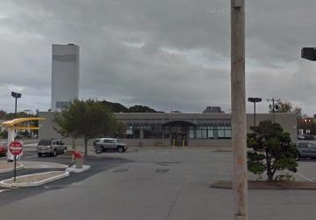

Prepared by:
Massachusetts Department of Public Health
Bureau of Environmental Health
Indoor Air Quality Program
September 2018

Background
Building: | Massachusetts Rehabilitation Commission (MRC) located within the Executive Office of Health and Human Services (EOHHS) Service Center
Address: | 181 North Street, Hyannis, MA.
Assessment Requested by: | Erin McCabe, EHS Facilities Deputy Director for Finance and Operations
Reason for Request: | Occupant respiratory symptoms
Date of Assessment: | September 10, 2018
Massachusetts Department of Public Health/Bureau of Environmental Health (MDPH/BEH) Staff Conducting Assessment: | Cory Holmes, Environmental Analyst/Inspector, IAQ Program
Building Description: | The building is a single story, flat roofed building, housing several state agencies with some office space in the basement.
Windows: | Not openable

Methods
Please refer to the IAQ Manual for methods, sampling procedures, and interpretation of results (MDPH, 2015). Note that this building has been visited numerous times for a multitude of issues since occupation in 2010. Reports for several of these visits can be viewed at
http://www.mass.gov/eohhs/gov/departments/dph/programs/environmental-health/exposure-topics/iaq/iaq-rpts/.

IAQ Testing Results
The following is a summary of indoor air testing results (Table 1).
- Total Volatile Organic Compounds (TVOCs) levels were non-detectable in all areas assessed.
- Fine particulate matter (PM2.5) concentrations measured were below the National Ambient Air Quality Standard (NAAQS) level of 35 μg/m³ in all areas assessed.
- Moisture Measurement of porous building materials (e.g., carpet and drywall) were normal (i.e., dry).

Ventilation
A heating, ventilating, and air conditioning (HVAC) system has several functions. First, it provides heating and, if equipped, cooling. Second, it is a source of fresh air. Finally, an HVAC system will dilute and remove normally-occurring indoor environmental pollutants by not only introducing fresh air, but also filtering the airstream and ejecting stale air to the outdoors via exhaust ventilation. Even if an HVAC system is operating as designed, point sources of respiratory irritation may exist and affect symptoms in sensitive individuals.
Fresh air is provided by an air handling unit (AHU) located on the roof (Picture 1). Air from the AHU is filtered, heated/cooled, and delivered to rooms via ducted supply diffusers (Picture 2). Air is returned back to the AHU via ceiling-mounted grates (Picture 3). It is recommended that HVAC systems be re-balanced every five years to ensure adequate air systems function (SMACNA, 1994). It is not known when the last time these systems were balanced.
It was reported that the HVAC system is automated/programmed to operate in the fan “on” mode, which supplies a continuous source of fresh air and filtration. It is recommended that this be confirmed by building management’s HVAC engineer to ensure that the software/controls are working as designed. It was reported that they would be on site over the next several weeks to change the system over from cooling to heat and change filters.
Filters appear to be of a good quality/pleated type (Picture 4). It is recommended that AHUs be outfitted with pleated filters of a Minimum Efficiency Reporting Value (MERV) of 8 or higher, which are adequate in filtering out pollen and mold spores (ASHRAE, 2012). In addition, filters should be changed 2-4 times a year or in accordance with the manufacture’s recommendations.
Small refrigerators were observed in carpeted areas. These appliances may lead to carpet damage and microbial growth. It is recommended that these appliances be located in areas without carpeting or on waterproof mats. Carpet squares could also be replaced with tile in areas where water dispensers and refrigerators are located. Refrigerators should be kept clean to prevent odors and microbial growth.

Microbial/Moisture Concerns
In order for building materials to support mold growth, a source of water exposure is necessary. At the time of assessment no visual signs of water damage/mold growth were observed and as previously stated, moisture measurements of carpeting and drywall in the area of concern were normal (i.e., dry).

Other IAQ Evaluations
Exposure to low levels of total volatile organic compounds (TVOCs) may produce eye, nose, throat, and/or respiratory irritation in some sensitive individuals. Although no measurable levels of TVOCs were detected in the air, BEH/IAQ staff noted cleaners, hand sanitizers, air fresheners and other products in use within the building. All of these products have the potential to be irritants to the eyes, nose, throat, and respiratory system of sensitive individuals.
The offices were carpeted. Carpets should be vacuumed regularly with a high efficiency particulate arrestance (HEPA) filter equipped vacuum cleaner and cleaned annually (or semi-annually in soiled/high traffic areas) in accordance with Institute of Inspection, Cleaning and Restoration Certification (IICRC) recommendations, (IICRC, 2012).
In some areas, stored materials and accumulated items make it more difficult for custodial staff to clean. Items should be stored neatly and moved periodically to allow for wet- wiping and vacuuming of surfaces. Air purifiers were in use in some areas. These devices contain filters that should be cleaned/changed as per the manufacturer’s instructions.

Conclusions/Recommendations
Based on observations at the time of assessment, the following is recommended:
- Work with HVAC engineer to confirm system is operating as designed. Operate supply and exhaust ventilation in all areas during occupied periods. This includes using the “fan-on” setting for mechanical ventilation to supply fresh air circulation and filtration even when the temperature is within comfort limits.
- Ensure that all exhaust vents are functional and turned on when the building is occupied.
- Have the HVAC system balanced every 5 years in accordance with SMACNA recommendations (SMACNA, 1994).
- Use pleated MERV 8 filters in AHUs, which are adequate in filtering out pollen and mold spores (ASHRAE, 2012). Change 2-4 times a year or in accordance with the manufacture’s recommendations.
- For buildings in New England, periods of low relative humidity during the winter are often unavoidable. Therefore, scrupulous cleaning practices should be adopted to minimize common indoor air contaminants whose irritant effects can be enhanced when the relative humidity is low. To control for dusts, a high efficiency particulate arrestance (HEPA) filter equipped vacuum cleaner in conjunction with wet wiping of all surfaces is recommended. Avoid the use of feather dusters. Drinking water during the day can help ease some symptoms associated with a dry environment (throat and sinus irritations).
- Consider locating refrigerators and water dispensers in non-carpeted areas or place on a waterproof mat. Clean refrigerators out regularly to avoid odors and microbial growth.
- Reduce use of products containing VOCs including eliminating air freshening products.
- Clean carpeting annually (or semi-annually in soiled/high traffic areas) in accordance with IICRC recommendations (IICRC, 2012).
- Reduce accumulated materials on flat surfaces and store in an organized manner to allow for thorough cleaning.
- Ensure air purifiers are maintained in accordance with manufacturer’s instructions. Consider elevating units off floor (e.g., in the breathing zone).
- Refer to resource manual and other related IAQ documents located on the MDPH’s website for further building-wide evaluations and advice on maintaining public buildings. These documents are available at: http://mass.gov/dph/iaq.

References
ASHRAE. 2012. American Society of Heating, Refrigeration and Air Conditioning Engineers (ASHRAE) Standard 52.2-2012 -- Method of Testing General Ventilation Air-Cleaning Devices for Removal Efficiency by Particle Size (ANSI Approved).
IICRC. 2012. Institute of Inspection, Cleaning and Restoration Certification. Carpet Cleaning: FAQ.
MDPH. 2015. Massachusetts Department of Public Health. Indoor Air Quality Manual: Chapters I-III. Available at: http://www.mass.gov/eohhs/gov/departments/dph/programs/environmental-health/exposure-topics/iaq/iaq-manual/.
SMACNA. 1994. HVAC Systems Commissioning Manual. 1st ed. Sheet Metal and Air Conditioning Contractors’ National Association, Inc., Chantilly, VA.
Picture 1
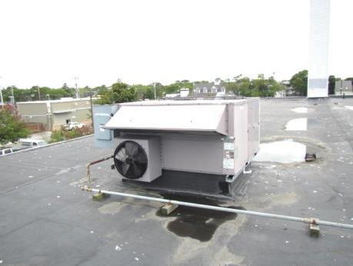
Rooftop air handling unit
Picture 2
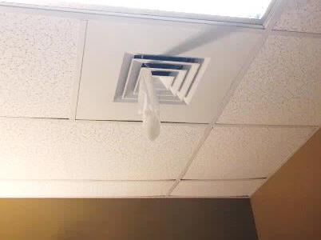
Supply diffuser
Picture 3
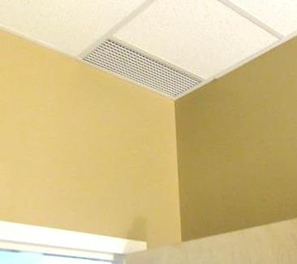
Ceiling-mounted return grate
Picture 4
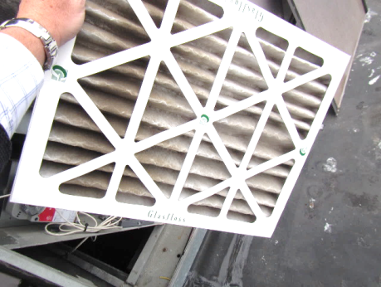
Pleated filters in rooftop air handling unit
Location | TVOCs  (ppm) | PM2.5  (µg/m³) | Windows  Openable | Ventilation |  |  | Remarks
 |  |  |  | Intake | Exhaust
Background (outdoors) | ND | 10-14
Conference Room | ND | 1 | N | Y |  | Y
MRC Supervisor | ND | 1 | N | Y |  | Y | Air purifier on carpet, small fridge, no water damage/carpet dry
Work Stations Left | ND | 1-2 | N | Y |  | Y
Work Stations Right | ND | 1-2 | N | Y |  | Y
Area Director | ND | 1 | N | Y |  | Y | Dry erase materials
Storage/Photo Copy Area | ND | 2 | N | Y |  | Y | Cleaning products, hand sanitizer

