**INDOOR AIR QUALITY ASSESSMENT**

**Hyannis West Elementary School**

**549 West Main Street**

**Hyannis, Massachusetts**

Exterior view
Hyannis West Elementary School
549 West Main Street
Hyannis, Massachusetts


Prepared by:

Massachusetts Department of Public Health

Bureau of Climate and Environmental Health

Division of Environmental Health Regulations and Standards

December 2024

# BACKGROUND

|  |  |
| --- | --- |
| Building: | Hyannis West Elementary School (HWES) |
| Address: | 549 West Main Street, Hyannis, MA |
| Assessment Requested by: | Barnstable Public Schools (BPS) |
| Reason for Request: | Mold odors in several classrooms |
| Date of Assessment: | October 25, 2024 |
| Massachusetts Department of Public Health/Bureau of Climate and Environmental Health (MDPH/BCEH) Staff Conducting Assessment: | Michael Feeney, Special Advisor to the Bureau, Bureau of Climate and Environmental Health (BCEH) |
| Date of Building Construction: | Originally constructed in 1963 |
| Building Description: | Single-story brick/concrete block building |
| Windows: | Openable |

# INTRODUCTION

DPH previously visited the school in 2011 and 2019 which provided both observations and recommendations for improving indoor air quality at that time. Both reports can be accessed at <https://www.mass.gov/doc/hyannis-west-elementary-school-april-2012/download> and <https://www.mass.gov/doc/hyannis-west-elementary-school-february-2019/download> respectively. This report is an updated summary of observations and recommendations regarding water damage and related mold odors as reported in this building over the summer and early fall.

# METHODS

Staff conducted temperature and relative humidity measurements as well as a visual inspection of rooms with reported mold/odors to identify sources of moisture that would damage materials in the building to cause mold growth. Please refer to the IAQ Manual and appendices for methods, sampling procedures, and interpretation of results (MDPH, 2015).

# RESULTS AND DISCUSSION

The following is a summary of indoor air testing results (Table 1).

* ***Temperature*** was within or close to the MDPH recommended range of 70°F to 78°F in occupied areas. Temperature control issues were reported in a few areas.
* ***Relative humidity*** was below the MDPH recommended range of 40 to 60% in a few areas tested the day of assessment, which is typical of conditions during the heating season.

## Ventilation

Two classrooms had mold odors which were traced to the univent. Return vents for each univent were coated with accumulated dust and debris. Of note is the configurations of univents, where the louvers and fans are sealed behind a permanently affixed metal cover (Picture 1). As reported by school staff, it was reported that instructions were received to not remove these metal covers. However, if metal covers *are not removed*, cleaning of accumulated dirt and debris cannot be done. If exposed to air with high relative humidity, this accumulated dust and debris can become wet and serve as a medium for mold growth.

## Microbial/Moisture Concerns

One sign of high relative humidity in the HWES is the presence of bowed ceiling tiles (Table 1). If a building experiences high relative humidity indoors over an extended period of time, moisture exposure may cause ceiling tiles to bow and other signs of water damage may occur, including mold growth. It is recommended that porous material be dried with fans and heating within 24 to 48 hours of becoming wet (US EPA, 2008, ACGIH, 1989). Staff conducted temperature and relative humidity testing in areas with reported mold odors. At the time of testing, temperature and relative humidity conditions were not at levels that would be cause mold growth in building materials.

Bowed ceiling tiles without discoloration/stains are not mold-colonized but are a sign of water vapor exposure causing the sagging due to the weight of water in the ceiling tile and its effect on binders that hold the tile intact. Bowing ceiling tiles are typically found in classrooms and cafeterias with sink or floor drains where the trap has dried. A trap is a section of pipe below the drain opening that fills with water to form an airtight seal. The airtight seal prevents combustible sewer gas, odors, and water vapor from the drain systems from backing up the drain to enter occupied space. Depending on various conditions, water evaporates from the trap if a plumbing device is not used for several days.

Wetting drain traps regularly to maintain the airtight water seal is particularly important when heavy rains occur, which can pressurize the storm drain/sewer system when large amounts of water enter. Air and other water vapor/odors/pollutants can be forced up the drainpipe, which would be prevented from entering the occupied space by the wet drain trap.

Schools are particularly vulnerable to dry drain traps due to the extended summer vacation when the building is unoccupied by students. The source of the water vapor that caused the water damage noted is likely a combination of weather with high relative humidity >70% combined with water vapor from drains with dry drain traps. A number of water vapor sources exists in the building including:

* Various floor drains;
* Disused custodial closet that contained an unused utility sink with an open drain (Picture 2);
* Exhaust vent without louvers that close when the fan is deactivated (Picture 3); and
* Seams between the roof structure and exterior wall which do not appear to have sealant between the roof and brick wall seam (Picture 4). Without sealant, wind-driven moist air may enter the roof structure to penetration into the building interior.

Each of these water vapor sources may individually or in combination, allow for water vapor to interior space, which then in turn moisten building materials and contents.

## Extreme Weather Conditions

It is also important to note that the HWES HVAC system is not equipped with chillers to provide cooling during hot weather. In addition to providing cooling, HVAC systems can reduce humidity during operation. Since such a system does not exist at the HWES, the use of dehumidifiers during hot, humid weather on the ground floor may be used to reduce humidity.

Hot humid summers are becoming more frequent due to climate change. Massachusetts has experienced hot, humid, and rainy summers in 2018, 2021, 2023 and 2024. As an example, July of 2021 was the wettest ever recorded in Massachusetts, and the three-month period from June through August, known as the meteorological summer, was the fourth wettest on record, according to the National Oceanic and Atmospheric Administration’s (NOAA) Centers for Environmental Information (NOAA, 2021). The summer of 2023 was also hot, and wet, being measured as the second rainiest on record (WBUR, 2023). The summer of 2024 also had significant stretches of hot, humid weather. These conditions are challenging for buildings, particularly those without central air conditioning.

Under these weather conditions, public buildings experienced extended periods of water vapor exposure from high relative humidity. When exposed to these conditions, porous materials such as gypsum wallboard, cardboard, carpeting and other materials may become moistened and colonized with mold, particularly if located in areas that are prone to developing condensation, such as floors and walls in contact with the ground (e.g., below grade space).

The guideline “Preventing Mold Growth In Schools During Hot, Humid Weather” <https://www.mass.gov/info-details/preventing-mold-growth-in-massachusetts-schools-during-hot-humid-weather> should be used to minimize the impact of such weather on classroom materials. This includes use of air conditioning and dehumidifiers, ensuring exhaust vents are on and operable, keeping windows closed, and ensuring air can circulate around porous materials.

## Other Conditions

Bat droppings were noted in the attic (Picture 5). Ductwork for the exhaust system has a golf ball-sized hole. The exhaust vent opening does not have a bird screen or louvers that would close when the exhaust system is deactivated. Without either type of equipment, bats can enter a building to roost and form a bat colony. Please note that mold odors from univents are not likely related to the finding of bat droppings in the attic which is not likely to have an effect on classrooms. When signs of bats or birds roosting are found, recommendations to remove roosting bats and birds are made to prevent further damage inside a building.

A number of guidelines/procedures exist for removal of bat guano. The University of Connecticut makes the following recommendations regarding removal and cleaning of bat guano from a building:

* Moisten the droppings with a light mist of water to keep dust and spores from becoming airborne.
* Put droppings into doubled plastic garbage bags, seal the bags, and place them in a dumpster for disposal as normal trash.
* Use a 10% bleach solution to disinfect the area after the droppings have been removed.
* Modify the structure to prevent birds or bats from re-establishing the roost. (UConn. unknown).

Taking these precautions can prevent building occupant exposure to bat guano-related pollutants during remediation and prevent future bat roosting.

## Mold Testing Recommendations

The presence of mold does not necessarily indicate a problem. Visual evidence of mold growth and/or the presence of musty odors are reliable indicators of mold problems that are correlated with health risks in buildings where indoor environmental complaints have been made. Mold spores waft through the indoor and outdoor air continually. There is no practical way to eliminate all mold and mold spores in the indoor environment; the way to control indoor mold growth is to control moisture (U.S. EPA, 2024).

There is no means by which to determine whether an individual’s symptoms or reactions were caused by mold by conducting environmental air testing for mold. While mold, spores, and other associated materials can make allergies and asthma symptoms worse, different people react differently to mold and mold spores. In addition to mold, reactions experienced by individuals could be caused by bacteria, other compounds in the air caused by the breakdown of wet building materials, or something different altogether (NIOSH, 2024; California DPH, unknown; Mendell, M. J., Mirer, A. G., Cheung, K., & Douwes, J. 2011; WHO. 2009).

The U.S. Environmental Protection Agency (EPA) does not recommend testing. DPH follows the guidelines contained in the U.S. EPA Mold Remediation in Schools and Commercial Buildings report for cleaning and removing water-damaged materials. US EPA’s guidelines recommend, in most cases, that if visible mold growth is present, mold sampling is not necessary. A number of international, US Federal, and state agencies either do not have or recommend against conducting mold testing as part of mold remediation (see References with headings of: Agencies with guidelines recommending against mold testing and References from government agencies, industrial hygiene groups and/or other environmental professional guidelines that denote that no mold exposure limits have been established for mold in workplaces, government buildings, or residences). For example, the U.S. Department of Housing and Urban Development (HUD) does not recommend conducting environmental mold testing.

*“No matter what kind of mold you have, you need to get rid of it and fix the moisture problems that made it grow. Most experts think it’s better to spend your time and money on cleaning up the problem than testing”* (HUD, 2024).

In addition, multiple worker safety agencies and organizations have no worker safety air levels established for exposure to species of mold. The following agencies and professional industrial hygiene agencies have not established mold exposure levels in the workplace that would justify air testing. The following industrial safety guidelines do not list any mold species and air level concentrations:

* US Occupational Safety and Health Administration has not established any mold Permissible Exposure Limits (PELs) for mold air levels.
* American Conference of Governmental Industrial Hygienists (ACGIH) has no established Threshold Limit Values (TLVs) for mold air levels.
* National Institute of Occupational Safety and Health (NIOSH) has no established Recommended Exposure Limits (RELs) for mold air levels.
* American Industrial Hygiene Association (AIHA) has no established Workplace Environmental Exposure Levels (WEELs) for mold air levels.

In addition, even if worker safety exposure limits existed for mold, such guidelines **would not apply** to non-employees in a building. These individuals include students in primary education schools; students in secondary education facilities; adults outside worker ages as defined by OSHA; individuals with chronic health conditions; patients in any medical facility; adults who are invitees, customers, or visitors to the workplace and other members of the general public.

For non-employees, there are **no established mold exposure limits** (international, Federal, or state regulations, building standards or guidelines) on how much mold can exist in air before health impacts are expected for the general population. In addition, no international, Federal, state, or building standards agency have established mold remediation clean-up levels that must be achieved after mold remediation efforts are completed.

This means that even if tests are conducted, there is no way to compare results or determine whether the measured level could cause health effects or meet clean-up levels. Multiple Federal agencies, including the US EPA, US Department of Housing and Urban Development and the US Federal Emergency Management Agency (FEMA) have not established mold exposure standard or recommend environmental mold testing in any water damage/flood recovery guidelines. With no established worker or general public safety exposure limits, air testing will not influence how mold remediation efforts would be conducted.

In order to remove mold from buildings, of primary importance is to identify, repair and/ or limit the moisture source causing damage in the building. Once the moisture source is remediated, then discarding and/or cleaning of mold contaminated materials can be completed.

# RECOMMENDATIONS

In view of the findings at the time of the visit, the following recommendations are made:

## Classroom Mold Odors

1. Remove metallic covers from univents in rooms with mold odors and clean all dust/debris from interior.
2. Examine the feasibility of replacing univent metal cover screws with other fasteners to increase ease of cleaning accumulated debris.
3. Regularly clean debris from univent grills, vents, and interior (e.g., during filter changes). To prevent mold growth, cleaning of univent dust and debris should occur prior to the beginning of periods of hot, humid weather that occurs at the end of the school year each summer.
4. Ensure that all univents are equipped with filters that have a minimum MERV rating of 8 to remove mold, mold spores and pollen from the univent air stream.
5. Examine all univent heating pipe openings for spaces between the pipe and cement floor. Seal any opening with a fire-rated spray foam insulation.

## Bat Roosting Remediation

1. Seal all holes in the exhaust ventilation system duct.
2. Have the possible bat roosting investigated by a professional pest removal contractor. If bird screens are not installed over exhaust system vents, consider installing to prevent bat roosting in the attic.
3. Consider install closable louvers for exhaust vent openings to reduce outdoor humid air entering the building when HVAC system is deactivated.

## Indoor Water Vapor Reduction Measures

1. Ensure that sinks have wet drain traps during summer months. Pouring water down sinks once a week is recommended to maintain water trap airtight seal.
2. If drain is no longer in use, permanently seal drain opening and deactivate water supply to the sink.
3. Examine seams between wood and brick exterior walls for openings or unsealed seams, particularly around roof structures over entrances. Consult with a building engineer on the most appropriate method to seal these seams to prevent moist introduction into the building interior from wind-driven humid air.
4. For more information on mold refer to the US EPA’s “Mold Remediation in Schools and Commercial Buildings,” available at: <http://www.epa.gov/mold/mold-remediation-schools-and-commercial-buildings-guide>.
5. Management of buildings in extreme relative humidity and rain can be challenging. The following documents can provide guidance that can be used to reduce the impact of hot, humid weather in buildings:
   1. Mold Growth Prevention During Hot, Humid Weather <https://www.mass.gov/service-details/preventing-mold-growth-in-massachusetts-schools-during-hot-humid-weather> and
   2. Remediation and Prevention of Mold Growth and Water Damage in Public Schools <https://www.mass.gov/service-details/remediation-and-prevention-of-mold-growth-and-water-damage-in-public-schools-and>.
6. Refer to resource manuals and other related IAQ documents for further building-wide evaluations and advice on maintaining public buildings. Copies of these materials are located on the MDPH’s website: <http://mass.gov/dph/iaq>.

# REFERENCES

## General References

ACGIH, 1989. Guidelines for the Assessment of Bioaerosols in the Indoor Environment. American Conference of Governmental Industrial Hygienists, Cincinnati, OH

MDPH. 2015. Massachusetts Department of Public Health. Indoor Air Quality Manual: Chapters I-III. Available at: [Indoor air quality - manual and appendices | Mass.gov](https://www.mass.gov/lists/indoor-air-quality-manual-and-appendices?_gl=1*1rcbeba*_ga*NTA2MjAzNDY1LjE3MTQwNzc0NDU.*_ga_MCLPEGW7WM*MTcxODIxODUzMy4xOC4wLjE3MTgyMTg1MzMuMC4wLjA.).

NOAA. 2021. Summer 2021 neck and neck with Dust Bowl summer for hottest on record. National Oceanic and Atmospheric Administration, 1401 Constitution Avenue NW, Room 5128, Washington, DC 20230<https://www.noaa.gov/news/summer-2021-neck-and-neck-with-dust-bowl-summer-for-hottest-on-record>.

UConn. Unknown. Removal and Cleanup of Bird and Bat droppings. University of Connecticut, Storrs, CT. <https://media.ehs.uconn.edu/Biological/RemovalandCleanupOfBirdAndBatDroppings.pdf>

US EPA, 2008. “Mold Remediation in Schools and Commercial Buildings”. Office of Air and Radiation, Indoor Environments Division, Washington, DC. EPA 402-K-01-001. September 2008. Available at: <http://www.epa.gov/mold/mold-remediation-schools-and-commercial-buildings-guide>

WBUR. 2023. “It's been a summer of rain and flooding misery in Mass.” WBUR local news. September 12, 2023. <https://www.wbur.org/news/2023/09/12/summer-flooding-rain-massachusetts>.

## Mold Testing References

ACGIH, 1989. Guidelines for the Assessment of Bioaerosols in the Indoor Environment. American Conference of Governmental Industrial Hygienists, Cincinnati, OH

ASHRAE, 1985. ASHRAE Transactions. Optimum Relative Humidity Ranges for Health. American Society of Heating, Refrigeration and Air Conditioning Engineers. Vol. 91, Part 1B.

CA DPH, unknown. California Department of Public Health Statement on Building Dampness, Mold, and Health. [California Department of Public Health Statement on Building Dampness Mold and Health](https://www.cdph.ca.gov/Programs/cls/dehl/ehl/CDPH%20Document%20Library/MoldDampStatement2017_ENG.pdf)

HUD. 2024. Help Yourself to a Healthy Home. US Department of Housing and Urban Development. Washington, DC. PAGES and Cover002.indd (hud.gov).

IICRC, 1997. IICRC S001 Standards Reference Guide for Professional On-location Cleaning of Installed Textile Floor Covering Materials. 3rd ed. The Institute of Inspection, Cleaning and Restoration Certification, Vancouver, WA.

Mendell, M. J., Mirer, A. G., Cheung, K., & Douwes, J. 2011. Respiratory and allergic health effects of dampness, mold, and dampness-related agents: a review of the epidemiologic evidence. Environmental Health Perspectives 119(6):748. <https://pubmed.ncbi.nlm.nih.gov/21269928/>

NIOSH, 2024. [Mold, Testing, and Remediation | Workplace Mold | CDC](https://www.cdc.gov/niosh/mold/testing-remediation/index.html)

US EPA, 2008. “Mold Remediation in Schools and Commercial Buildings”. Office of Air and Radiation, Indoor Environments Division, Washington, DC. EPA 402-K-01-001. September 2008. Available at: <http://www.epa.gov/mold/mold-remediation-schools-and-commercial-buildings-guide>

U.S. EPA, 2024, Frequent Questions on Mold and Moisture, Updated: October 14, 2024. [Mold Frequently Asked Questions | US EPA](https://www.epa.gov/mold/mold-frequently-asked-questions)

WHO, 2009. WHO Guidelines for Indoor Air Quality: Dampness and Mould. World Health Organization Copenhagen: WHO Europe. WHO guidelines for indoor air quality: dampness and mould <https://www.who.int/publications/i/item/9789289041683>

## Agencies with guidelines recommending against mold testing

APHC. Residential Indoor Mold and Residential Mold Air Sample Results What Do They Mean? FACT SHEET 55-026-0319. U.S. Army Public Health Center, Industrial Hygiene Field Services Program, Aberdeen Proving Ground, Maryland. [Microsoft Word - IAQ and Mold Sample Result Fact Sheet_Version 4 HRCD 28 Mar](https://ph.health.mil/PHC%20Resource%20Library/IAQandMoldSampleResultFactSheet.pdf)

CA HESIS. 2005. Molds in Indoor Workplaces. California Hazard Evaluation System and Information Service. P.2 Molds in Indoor Workplaces: Fact Sheet for Workers and Employers (ca.gov) Nov. 2005 <https://www.cdph.ca.gov/Programs/CCDPHP/DEODC/OHB/HESIS/CDPH%20Document%20Library/molds.pdf>

CDC. 2024. Mold. Centers for Disease Control. Atlanta, GA. [Mold | Mold | CDC](https://www.cdc.gov/mold-health/about/index.html).

CTDPH. 2012. Get the Mold Out: Mold Clean-Up Guidance for Residences Fact Sheet. Connecticut Department of Public Health Environmental & Occupational Health Assessment Program Environmental Health Secon 410 Capitol Avenue, MS # 11EOH. [Get The Mold Out_ fact sheet082012](https://portal.ct.gov/-/media/departments-and-agencies/dph/dph/environmental_health/eoha/pdf/getthemoldoutpdf.pdf)

FEMA, 2015. Homeowner’s and Renter’s Guilder to Mold Cleanup after Disasters. <https://www.fema.gov/sites/default/files/documents/fema_hm-cdc-homeowners-and-renters-mold-guide_english.pdf>

Health Canada. Guide to addressing moisture and mould indoors. <https://www.canada.ca/en/health-canada/services/publications/healthy-living/addressing-moisture-mould-your-home.html>

MDHHS. 2010. Mold Fact Sheet. Maine Department of Health and Human Services, Bangor, ME. <https://www.maine.gov/dhhs/mecdc/infectious-disease/epi/disease/documents/pdf/mold.pdf>

MNDPH. 2024. Testing for Mold. [Testing For Mold - MN Dept. of Health (state.mn.us)](https://www.health.state.mn.us/communities/environment/air/mold/moldtest.html)

NHDHHS. 2013. Mold and moisture. New Hampshire Department of Health and Human Services, Concord, NH. <https://www.dhhs.nh.gov/sites/g/files/ehbemt476/files/documents/2021-11/holu-dphs-mold-policy-letter.pdf>

NIOSH. 2024. Mold, Testing, and Remediation. National Institute of Occupational Safety and Health, Cincinnati, OH.

NYDOL. Mold Assessment and Remediation in New York State. Mold Assessment and Remediation in New York State. New York Department of Labor. [p227.pdf (ny.gov)](https://dol.ny.gov/system/files/documents/2021/03/p227.pdf)

ODHS. Unknown. FAST FACTs: Household Mold. Oregon Department of Human Services, Public Health Division, Office of Environmental Public Health: Toxicology Consulting Services. [Moldfactsheet.pdf (oregon.gov)](https://www.oregon.gov/oha/ph/HealthyEnvironments/TrackingAssessment/EnvironmentalHealthAssessment/Documents/Moldfactsheet.pdf)

OSHA. Mold. US Occupational Safety and Health Administration. [Mold - Recognize Mold Hazards | Occupational Safety and Health Administration (osha.gov)](https://www.osha.gov/mold/hazards)

USAPHC. 2018. Technical Guide 278 Industrial Hygiene Public Health Mold Assessment Guide. US Army Public Health Center, Public Health 6582 Magrath Ave BLDG 2059 Fort Carson, Colorado. <https://ph.health.mil/PHC%20Resource%20Library/TG278.pdf> .

VTDH. 2024. Mold Inside Home and Other Buildings. <https://www.healthvermont.gov/sites/default/files/document/env-hh-mold-indoors.pdf>

WSDH. Unknown. Mold. Washington State Department of Health, [Mold | Washington State Department of Health](https://doh.wa.gov/community-and-environment/contaminants/mold)

## References from government agencies, industrial hygiene groups and/or other environmental professional guidelines that denote that no mold exposure limits have been established for mold in workplace, government buildings or residences.

AIHA. 2019. FAQs About Spore Trap Air Sampling for Mold for Direct Microscopical Examination Mold Analysis Document. American Industrial Hygiene Association, Falls Church, VA. <https://aiha-assets.sfo2.digitaloceanspaces.com/AIHA/resources/FAQs-About-Spore-Trap-Air-Sampling-for-Mold-for-Direct-Examination-Guidance-Document.pdf>

APHC. Residential Indoor Mold and Residential Mold Air Sample Results What Do They Mean? FACT SHEET 55-026-0319. U.S. Army Public Health Center, Industrial Hygiene Field Services Program, Aberdeen Proving Ground, Maryland. [Microsoft Word - IAQ and Mold Sample Result Fact Sheet_Version 4 HRCD 28 Mar](https://ph.health.mil/PHC%20Resource%20Library/IAQandMoldSampleResultFactSheet.pdf)

FEMA, 2015. Homeowner’s and Renter’s Guilder to Mold Cleanup after Disasters. <https://www.fema.gov/sites/default/files/documents/fema_hm-cdc-homeowners-and-renters-mold-guide_english.pdf>

MDHHS. 2010. Mold Fact Sheet. Maine Department of Health and Human Services, Bangor, ME. <https://www.maine.gov/dhhs/mecdc/infectious-disease/epi/disease/documents/pdf/mold.pdf>

OHHN. 2023. Mold Basics. Ohio Healthy Homes Network, Columbus, Ohio. [Mold Basics | Ohio Healthy Homes Network (ohhn.org)](https://www.ohhn.org/mold-basics/)

WDHS. 2021. Controlling Mold and Moisture Household Mold Guidance for Local Health Professionals Wisconsin Department of Health Services, Indoor Air and Radon Program Division of Public Health, Bureau of Environmental and Occupational Health. <https://www.dhs.wisconsin.gov/publications/p02069.pdf>

WHO, 2009. WHO Guidelines for Indoor Air Quality: Dampness and Mould. World Health Organization Copenhagen: WHO Europe. WHO guidelines for indoor air quality: dampness and mould <https://www.who.int/publications/i/item/9789289041683>

**Picture 1**

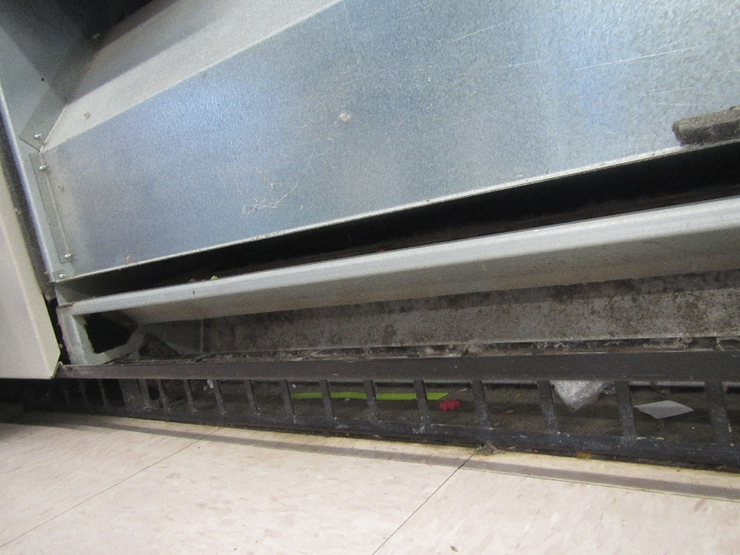

**Metal cover fixed in place with screws inside univent that prevents access to fan motors, coils; note accumulated dust and debris behind return vent**

**Picture 2**

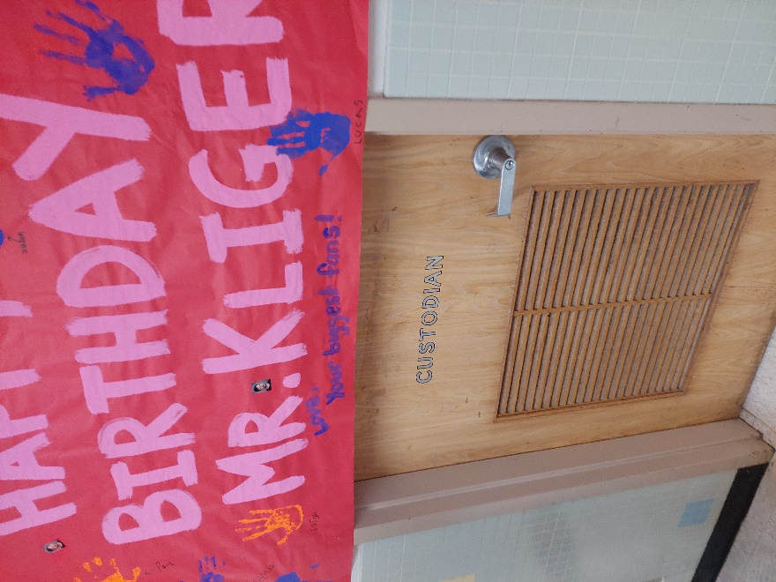

**Custodial closet with unused custodial sink; note passive door vent that allows for water vapor from dry drain trap to enter hallway if exhaust vent is not operating**

**Picture 3**

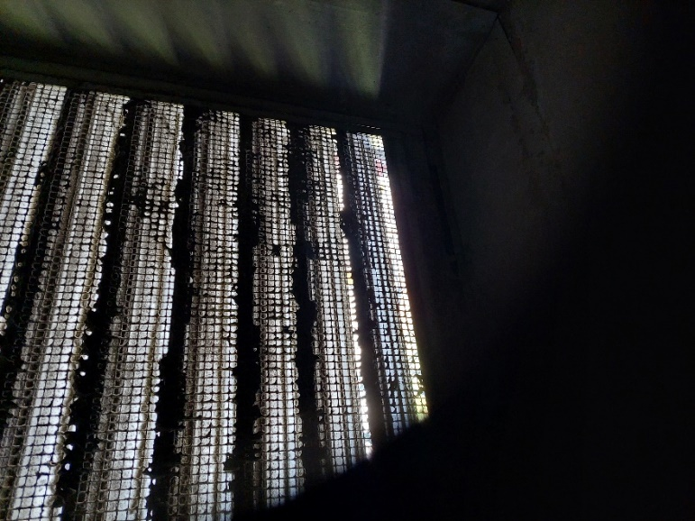

**Exhaust fan vent with fixed, open louvers**

**Picture 4**

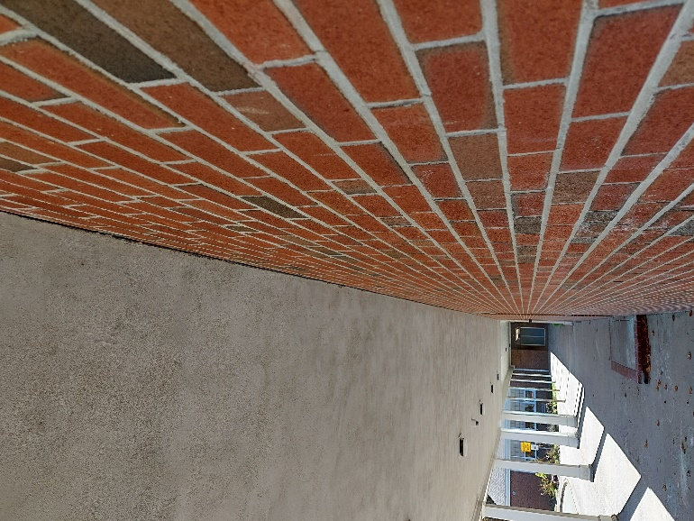

**Wood and brick structures with open seam (arrow)**

**Picture 5**

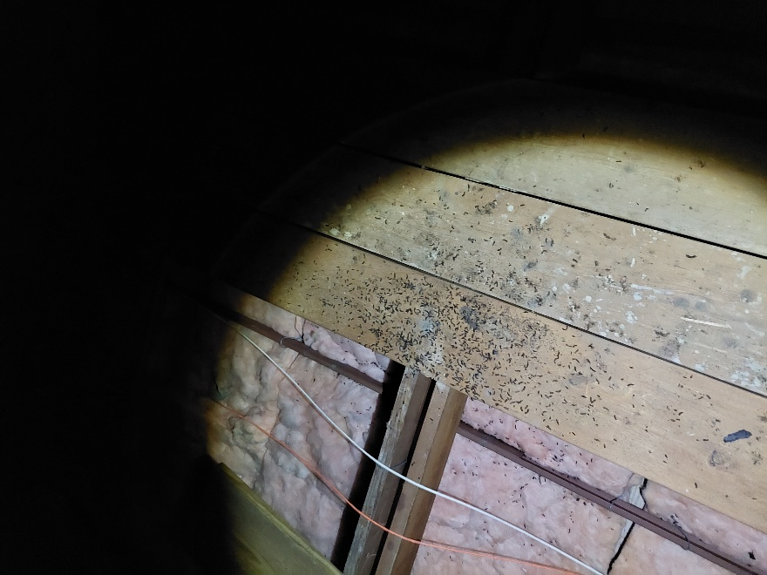

**Bat guano on attic walkway**

|  |  |
| --- | --- |
|  | |
| **Location** | | **Temp**  **(°F)** | **Relative**  **Humidity**  **(%)** | **Dew Point**  **(°F)** | **Bowed CT**  **(No.)** | **Windows**  **Openable** | **Ventilation** | | | **Remarks** |
| **Intake** | **Exhaust** | |
| Background (outdoors) | | 60 | 30 | 36 |  |  |  | |  |  |
| 1 | | 72 | 42 | 47 | Y | Y | Y | | Y | Mold odor after univent activated |
| 10 | | 71 | 45 | 49 | Y | Y | Y | | Y | Mold odor from univents |
| 20 | | 75 | 34 | 44 | Y | Y | Y | | Y |  |
| 22 | | 72 | 35 | 43 | Y | Y | Y | | Y |  |