INDOOR AIR QUALITY ASSESSMENT

Hyannis West Elementary School
549 West Main Street
Hyannis, Massachusetts

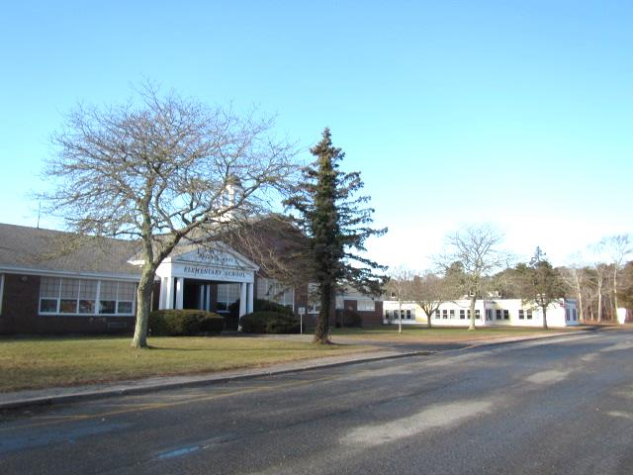

Prepared by:
Massachusetts Department of Public Health
Bureau of Environmental Health
Indoor Air Quality Program
February 2019

BACKGROUND
Building: | Hyannis West Elementary School (HWES)
Address: | 549 West Main Street, Hyannis, MA
Assessment Requested by: | Barnstable Public Schools (BPS)
Reason for Request: | Collaborative effort to perform general indoor air quality (IAQ) assessments throughout the Barnstable School District.
Date of Assessment: | January 25, 2019
Massachusetts Department of Public Health/Bureau of Environmental Health (MDPH/BEH) Staff Conducting Assessment: | Cory Holmes, Environmental Inspector, IAQ Program accompanied by Michael Lambros, Deputy Director of Facilities, BPS
Date of Building Construction: | Originally constructed in 1963.
Building Description: | This is a single-story brick/concrete block building. Since the building was last visited by MDPH/BEH in 2011 new unit ventilators have been installed in classrooms and old modular buildings have been removed and replaced with newly constructed units that house the Enoch Cobb Early Learning Center and kindergarten, which will be the subject of a separate report.
Windows: | Openable

METHODS
Please refer to the IAQ Manual and appendices for methods, sampling procedures, and interpretation of results (MDPH, 2015).

RESULTS and DISCUSSION
The following is a summary of indoor air testing results (Table 1).
- Carbon dioxide levels were above the MDPH recommended level of 800 parts per million (ppm) in about two-thirds of the areas surveyed, which indicates a lack of air exchange in many classrooms at the time of assessment. This is most likely due to deactivated mechanical ventilation components as well as limitations on outside air introduction, which is typical during winter months and explained further in the Ventilation section of this report.
- Temperature was within or close to the MDPH recommended range of 70°F to 78°F in occupied areas, with the exception of the Teacher’s breakroom and workroom, which were elevated (80/84°F). Temperature control issues were also reported in a few areas.
- Relative humidity was below the MDPH recommended range of 40 to 60% in all areas tested the day of assessment, which is typical of conditions during the heating season.
- Carbon monoxide levels were non-detectable (ND) in all areas tested.
- Particulate matter (PM2.5) concentrations measured were below the National Ambient Air Quality (NAAQS) level of 35 μg/m³ in all areas tested.

Ventilation
A heating, ventilating and air conditioning (HVAC) system has several functions. First it provides heating and, if equipped, cooling. Second, it is a source of fresh air. Finally, an HVAC system will dilute and remove normally-occurring indoor environmental pollutants by not only introducing fresh air, but by filtering the airstream and ejecting stale air to the outdoors via exhaust ventilation. Even if an HVAC system is operating as designed, point sources of respiratory irritation may exist and cause symptoms in sensitive individuals.
Fresh air in classrooms is supplied by unit ventilators (univents, Picture 1). Univents draw air from the outdoors through a fresh air intake located on the exterior wall of the building (Picture 2) and return air through an air intake located at the base of the unit. Fresh and return air are mixed, filtered, heated or cooled and provided to rooms through an air diffuser located in the top of the unit (Figure 1). In several rooms univents were inadvertently deactivated via wall-mounted thermostats, therefore no fresh air was being introduced at the time of testing. In addition, in some rooms the top and/or front of some univents were blocked by classroom items (Pictures 3 and 4). In order for univents to provide fresh air as designed, intakes/returns must remain free of obstructions. Importantly, these units must remain on and be allowed to operate while rooms are occupied. It is also important to note that outside air is typically limited (by pneumatically adjusting intake louvers) during cold/winter months to provide comfort and prevent the freezing of pipes.
Classroom exhaust vents are located in the ceilings of coat closets (Picture 5) and are connected with ducts to exhaust fans on the roof. The majority of these exhaust vents were not drawing air during the assessment; some bathroom vents were also found non-functional. Note that in many classrooms, exhaust vents were located near classroom doors (Picture 6). This design works best with the doors to the hallway closed, otherwise the exhaust vents tend to draw air from the hallway rather than the room which reduces the effectiveness of air circulation. Without adequate supply and exhaust ventilation, excess heat and environmental pollutants can build up and lead to indoor air/comfort complaints.
To maximize air exchange, the IAQ program recommends that both supply and exhaust ventilation operate continuously during periods of occupancy. In order to have proper ventilation with a mechanical ventilation system, the systems must be balanced after installation to provide an adequate amount of fresh air to the interior of a room while removing stale air from the room. It is recommended that HVAC systems be re-balanced every five years to ensure adequate air systems function (SMACNA, 1994).

Microbial/Moisture Concerns
Water-damaged ceilings/tiles were observed in a few areas (Pictures 7 and 8), which can indicate current/historic roof/plumbing leaks or other water infiltration. Water-damaged ceiling tiles can provide a source of mold and should be replaced after a water leak is discovered and repaired. Mr. Lambros reported that known leaks occur during occasional wind/weather patterns in classroom 1 and in the former girls’ locker room area. Plans to investigate/make repairs are in place.
Plants were present in some classrooms and other areas. Plants should be well maintained, not overwatered, and not placed on porous materials or in the airstream of ventilation equipment. An aquarium was found in the library. Aquariums should also be kept in good condition to prevent odors.

Other Conditions
Exposure to low levels of total volatile organic compounds (TVOCs) may produce eye, nose, throat, and/or respiratory irritation in some sensitive individuals. BEH/IAQ staff examined rooms for products containing VOCs. BEH/IAQ staff noted hand sanitizers, scented products, cleaners, and dry erase materials in use within the building. These products have the potential to be irritants to the eyes, nose, throat, and respiratory system of sensitive individuals.
The copy room contains several photocopiers and a lamination machine. This area is not equipped with local exhaust ventilation. Laminating machines and photocopiers can give off waste heat and irritating odors. VOCs and ozone can be produced by photocopiers, particularly if the equipment is older and in frequent use. Ozone is a respiratory irritant (Schmidt Etkin, D., 1992). In addition, this area contains the computer mainframe and a full-sized refrigerator, which also contribute waste heat to the room.
In a few areas, tennis balls had been sliced open and placed on table/chair footings to reduce noise (Picture 9). Tennis balls are made of a number of materials that are a source of respiratory irritants. Constant wearing of tennis balls can produce fibers and lead to off-gassing of VOCs. Tennis balls are made with a natural rubber latex bladder, which becomes abraded when used as a chair leg pad. Use of tennis balls in this manner may introduce latex dust into the school environment. Some individuals are highly allergic to latex (e.g., spina bifida patients) (SBAA, 2001). It is recommended that the use of materials containing latex be limited in buildings to reduce the likelihood of symptoms in sensitive individuals (NIOSH, 1997; NIOSH, 1998).
The MDPH recommends pleated filters with a Minimum Efficiency Reporting Value (MERV) of 8, which are adequate in filtering out pollen and mold spores (ASHRAE, 2012). Filters should also be changed two to four times a year, or per the manufacturer’s recommendations. Filters at the HWES are reportedly MERV 10 and changed two to three times a year.
In some areas, exhaust vents and personal fans were dusty (Table 1). This dust can be reaerosolized under certain conditions, and can also be a medium for mold growth. Univent cabinets can also accumulate dust and debris which should be cleaned when the filters are changed.
Area rugs were observed in many classrooms (Table 1). Carpets should be cleaned annually (or semi-annually in soiled/high traffic areas) in accordance with Institute of Inspection, Cleaning and Restoration Certification (IICRC) recommendations, (IICRC, 2012). Regular cleaning with a high efficiency particulate air (HEPA) filtered vacuum in combination with an annual cleaning will help to reduce accumulation and potential aerosolization of materials from carpeting. Area carpets too worn to be effectively cleaned should be replaced. Area rugs should be rolled up and stored in a clean, dry place when rooms are not occupied during the summer months to prevent moistening due to condensation.
In many classrooms, large numbers of items were on floors, windowsills, tabletops, counters, bookcases and desks, which provide a source for dusts to accumulate (Picture 25). These items (e.g., papers, folders, boxes) make it difficult for custodial staff to clean. Items should be relocated and/or be cleaned periodically to avoid excessive dust build up. In addition, dust and debris can accumulate on flat surfaces (e.g., desktops, shelving and carpets) in occupied areas and subsequently be re-aerosolized causing further irritation.
Note that the Environmental Protection Agency (EPA) conducted a National School Radon Survey in which it discovered nearly one in five schools had “…at least one frequently occupied ground contact room with short-term radon levels above 4 [picocuries per liter] pCi/L” (US EPA 1993). The BEH/IAQ Program therefore recommends that every school be tested for radon, and that this testing be conducted during the heating season while school is in session in a manner consistent with USEPA radon testing guidelines. Radon measurement specialists and other information can be found at www.nrsb.org and http://aarst-nrpp.com/wp, with additional information at: http://www.mass.gov/eohhs/gov/departments/dph/programs/environmental-health/exposure-topics/iaq/radon.

RECOMMENDATIONS
In view of the findings at the time of the visit, the following recommendations are made:
- Operate the HVAC system to provide for continuous fresh air ventilation during occupied hours.
- Remove furniture and items blocking the front and top of univents.
- Periodically assess whether exhaust vents (classrooms and restrooms) are drawing air and repair as needed.
- Use openable windows to supplement fresh air during temperate weather. Ensure all windows are closed tightly at the end of each day.
- Consider closing classroom doors during occupancy to allow for more effective function of exhaust vents.
- Work with staff to troubleshoot temperature control problems.
- Utilize a system to report and track maintenance issues (e.g., school dude) so that concerns can be reported by staff and maintenance staff can report when issues have been resolved.
- Consider adopting a balancing schedule of every 5 years for all mechanical ventilation systems, as recommended by ventilation industrial standards (SMACNA, 1994).
- Work with a roofing contractor/building engineer to investigate/repair building envelope leaks. Until this has been completed, avoid storing porous materials in areas of known leaks.
- Once repairs are made, refinish water-damaged ceiling plaster in the girl’s locker room and replace water-damaged ceiling tiles. Inspect the area above the stained tiles for water damage or odors and remediate or clean as necessary.
- Keep classroom/office plants in good condition, avoid overwatering, and keep them away from the airstream of ventilation equipment.
- Ensure aquariums are clean and odor free.
- Reduce or eliminate the use of air fresheners, scented cleaners, hand sanitizers and dry erase materials to reduce irritation.
- Replace tennis balls on chair/table footings with latex-free glides.
- Consider installing local exhaust ventilation/temperature control (AC) in the Teacher’s Workroom.
- Continue to change filters in HVAC units at least twice a year with MERV 8 or higher (e.g., MERV 10 in use now) filters. Clean HVAC and univent cabinets of debris and dust when filters are changed.
- Clean exhaust vents and fans regularly to remove accumulated dust/debris.
- For buildings in New England, periods of low relative humidity during the winter are often unavoidable. Therefore, scrupulous cleaning practices should be adopted to minimize common indoor air contaminants whose irritant effects can be enhanced when the relative humidity is low. To control for dusts, a high efficiency particulate arrestance (HEPA) filter equipped vacuum cleaner in conjunction with wet wiping of all surfaces is recommended. Avoid the use of feather dusters. Drinking water during the day can help ease some symptoms associated with a dry environment (throat and sinus irritations).
- Clean carpeting and rugs at least once per year according to IICRC recommendations (IICRC 2012). Area carpets too worn to be effectively cleaned should be replaced. Roll up and store are rugs in a clean, dry place during the summer.
- Relocate or consider reducing the amount of materials stored in classrooms to allow for more thorough cleaning of classrooms. Clean items regularly with a wet cloth or sponge to prevent excessive dust build-up.
- Continue to utilize the US EPA’s (2000), “Tools for Schools”, as an instrument for maintaining a good IAQ environment in the building available at: http://www.epa.gov/iaq/schools/index.html.
- The school should be tested for radon by a certified radon measurement specialist during the heating season when school is in session. Radon measurement specialists and other information can be found at: www.nrsb.org, and http://aarst-nrpp.com/wp.
- Refer to resource manuals and other related IAQ documents for further building-wide evaluations and advice on maintaining public buildings. Copies of these materials are located on the MDPH’s website: http://mass.gov/dph/iaq.

REFERENCES
ASHRAE. 2012. American Society of Heating, Refrigeration and Air Conditioning Engineers (ASHRAE) Standard 52.2-2012 -- Method of Testing General Ventilation Air-Cleaning Devices for Removal Efficiency by Particle Size (ANSI Approved). 2012.
IICRC. 2012. Institute of Inspection Cleaning and Restoration Certification. Institute of Inspection, Cleaning and Restoration Certification. Carpet Cleaning: FAQ.
MDPH. 2015. Massachusetts Department of Public Health. Indoor Air Quality Manual: Chapters I-III. Available at: http://www.mass.gov/eohhs/gov/departments/dph/programs/environmental-health/exposure-topics/iaq/iaq-manual/.
NIOSH. 1997. National Institute for Occupational Safety and Health. Alert Preventing Allergic Reactions to Natural Rubber latex in the Workplace. National Institute for Occupational Safety and Health, Atlanta, GA.
NIOSH. 1998. National Institute for Occupational Safety and Health. Latex Allergy A Prevention. National Institute for Occupational Safety and Health, Atlanta, GA.
SBAA. 2001. Latex In the Home And Community Updated Spring 2001. Spina Bifida Association of America, Washington, DC.
Schmidt Etkin, D. 1992. Office Furnishings/Equipment & IAQ Health Impacts, Prevention & Mitigation. Cutter Information Corporation, Indoor Air Quality Update, Arlington, MA.
SMACNA. 1994. HVAC Systems Commissioning Manual. 1st ed. Sheet Metal and Air Conditioning Contractors’ National Association, Inc., Chantilly, VA.
US EPA. 1993. Radon Measurement in Schools, Revised Edition. Office of Air and Radiation, Office of Radiation and Indoor Air, Indoor Environments Division (6609J). EPA 402-R-92-014. https://www.epa.gov/sites/production/files/2014-08/documents/radon_measurement_in_schools.pdf
US EPA. 2000. Tools for Schools. Office of Air and Radiation, Office of Radiation and Indoor Air, Indoor Environments Division (6609J). EPA 402-K-95-001, Second Edition. http://www.epa.gov/iaq/schools/index.html.
Picture 1
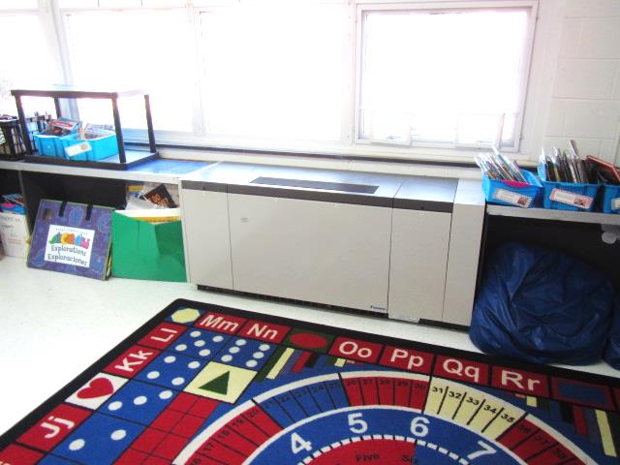
Classroom univent
Picture 2
Univent fresh air intakes
Picture 3
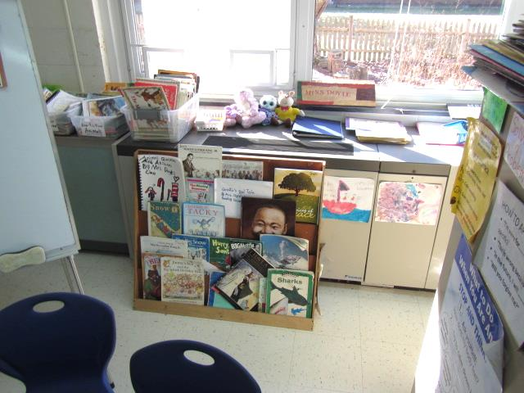
Univent return vent (lower front) obstructed by bookcase
Picture 4
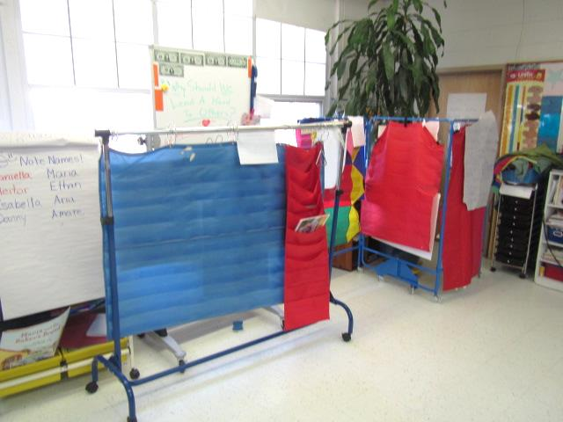
Univent airflow obstructed
Picture 5
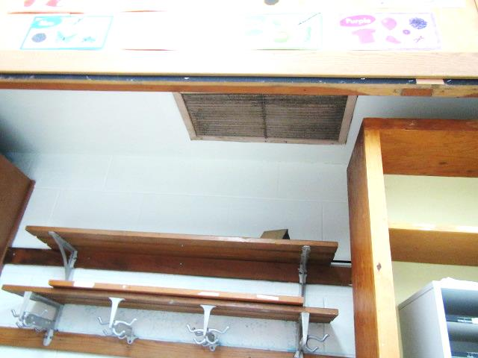
Classroom exhaust vent in coat closet
Picture 6
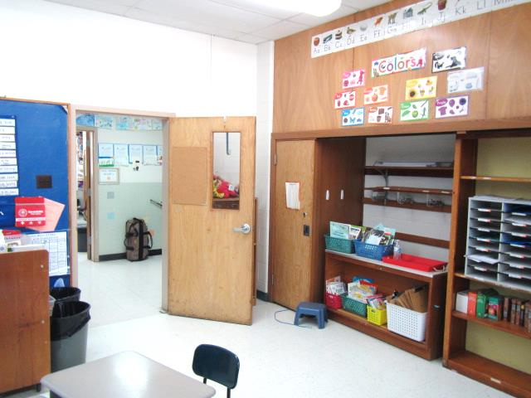
Proximity of exhaust vent to open classroom door (arrows)
Picture 7
Water-damaged ceiling tiles
Picture 8
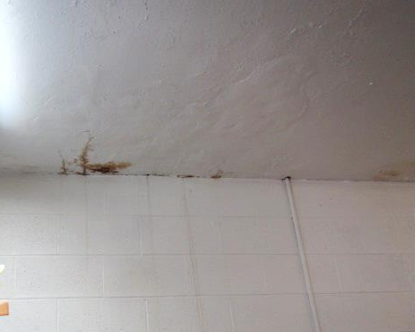
Water-stained ceiling plaster in former girls’ locker room
Picture 9
Tennis balls on desk legs

Location | Carbon  Dioxide  (ppm) | Carbon Monoxide  (ppm) | Temp  (°F) | Relative  Humidity  (%) | PM2.5  (µg/m³) | Occupants  in Room | Windows  Openable | Ventilation |  | Remarks
 |  |  |  |  |  |  |  | Supply | Exhaust
Background (outside) | 393 | ND | 46 | 29 | 7 |  |  |  |  | Clear, cold, sunny, day after heavy rain
1 | 824 | ND | 68 | 33 | 3 | 0 | Y | Y | Y  Off | Occasional leak-on repair list, exhaust motor on repair list, DO, area carpet, CP under sink
2 | 621 | ND | 74 | 23 | 4 | 16 | Y  Open | Y | Y  Off | DO
3 | 1265 | ND | 74 | 32 | 4 | 18 | Y | Y | Y  Off | DO
4 | 763 | ND | 73 | 33 | 4 | 20 | Y | Y | Y  Off | DO, AI, TB, CP under sink, 3 WD CTs, items on/front of UV
5 | 1046 | ND | 72 | 30 | 5 | 19 | Y | Y | Y  Off | DO, PF
6 | 998 | ND | 73 | 33 | 9 | 19 | Y | Y | Y  Off | DO
7 | 1177 | ND | 70 | 34 | 4 | 22 | Y | Y | Y  Off | DO, AI, items on/front of UV
8 | 1287 | ND | 73 | 36 | 5 | 21 | Y | Y | Y  Off | DO, HS
9 | 1547 | ND | 71 | 34 | 6 | 21 | Y | Y | Y  Off | Plants, chalkboard, blockage of airflow (classroom items)
10 | 1313 | ND | 72 | 35 | 4 | 21 | Y | Y | Y  Off | DO, HS, area rug
Principal’s Office | 751 | ND | 75 | 32 | 5 | 0 | Y | N | N | DO
Guidance | 436 | ND | 75 | 16 | 5 | 0 | Y  Open | N | N | DO, PF
Teacher’s Lunchroom | 621 | ND | 80 | 18 | 5 | 5 | Y | N | N | DO, PF, 2 WD CT
Teacher’s Workroom | 600 | ND | 84 | 15 | 7 | 0 | N | N | N | 2 PC, laminator, refrigerator, network/mainframe
11 | 796 | ND | 78 | 21 | 5 | 21 | Y | Y | Y  Off | 4 WD CT over sink
12 | 441 | ND | 72 | 18 | 5 | 0 | Y | Y  Off | Y  Off | PF-dusty, area rug
13 | 1510 | ND | 76 | 29 | 3 | 21 | Y | Y | Y  Off | Area rug, plant
14 | 1496 | ND | 76 | 33 | 9 | 21 | Y | Y  Off | Y  Off | Area rug
15 | 1162 | ND | 74 | 29 | 5 | 18 | Y | Y | Y  Off | DO, HS, area rug, PF, CP under sink
16 | 1602 | ND | 77 | 35 | 7 | 17 | Y | Y | Y  Off | DO, PF, area rug, CT ajar
17 | 987 | ND | 72 | 30 | 5 | 0 | Y | Y | Y  Off | DO, area rug
18 | 797 | ND | 75 | 29 | 5 | 0 | Y | Y  Off | Y  Off | DO, PF
19 | 873 | ND | 75 | 27 | 5 | 1 | Y | Y | Y  Off | DO, area rug, restroom-exhaust off
20 | 815 | ND | 75 | 29 | 7 | 1 | Y | Y | Y | DO, area rug
22A | 932 | ND | 76 | 34 | 13 | 4 | Y | Y | Y  Off | Exhaust-dusty, PF
22B | 730 | ND | 75 | 39 | 21 | 2 | Y | Y  Off | Y | Exhaust-dusty
22C | 806 | ND | 75 | 37 | 16 | 0 | N | Y  Passive | N
Library | 818 | ND | 74 | 36 | 15 | 21 | Y | Y | Y  Off | Area rugs, plant, aquarium-turtles
Gym/Cafeteria | 836 | ND | 71 | 33 | 6 | ~60 | Y | Y | Y | DO, WD CTs
Girls Locker Room Area | 748 | ND | 76 | 28 | 7 | 0 | Y | Y | Y | Leak-WD ceiling plaster (stained)-on repair list
Boys Locker Room Area | 620 | ND | 77 | 30 | 4 | 0 | Y | Y | Y

