Executive Summary

INDOOR AIR QUALITY ASSESSMENT

Commonwealth of Massachusetts
Department of Children and Families
1530 River Street
Hyde Park, MA

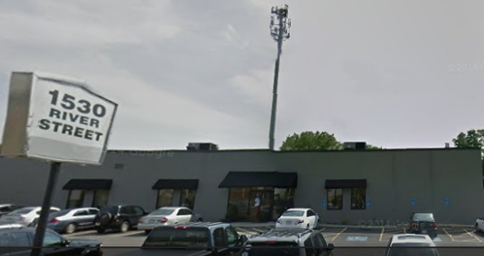

Prepared by:
Massachusetts Department of Public Health
Bureau of Environmental Health
Indoor Air Quality Program
December 2015

Building-wide rodent infestation was identified during this assessment. In addition to working with the pest contractor, more aggressive methods to seal rodent pathways as well as implementing an Integrated Pest Management (IPM) strategy are highlighted. Ventilation was inadequate at the time of the site visit as evidenced by elevated carbon dioxide (CO2) levels. Recommendations are made to eliminate the rodent infestation and increase ventilation/filtration in the occupied space.

Background/Introduction
Building: | Department of Children and Families (DCF)
Address: | 1530 River Street, Hyde Park, Massachusetts
Assessment Requested by: | Deborah Coleman, Facilities Director  Executive Office of Health and Human Services
Date of Assessment: | November 12, 2015
Bureau of Environmental Health/Indoor Air Quality (BEH/IAQ) Program Staff Conducting Assessment: | Jason Dustin, Environmental Analyst/Inspector
Date of Building Construction: | 1950s
Reason for Request: | Rodent infestation/IAQ concerns

Building Description
The building is a one-story brick, flat-roofed structure that was originally used as a bowling alley. The office space assessed was renovated in 1999-2000. Renovations included interior walls/paint ceilings, floors, appliances, carpeting and heating, ventilating and air conditioning (HVAC) systems. Most areas of the DCF have drop ceilings and carpeting. Windows in the building are not openable.

Methods
Please refer to the IAQ Manual for methods, sampling procedures, and interpretation of results (MDPH, 2015).

Results
The DCF houses approximately 100 employees. Some members of the public/clients also visit the space daily. Test results are presented in Table 1.

Discussion

Ventilation
It can be seen from Table 1 that carbon dioxide levels were above 800 parts per million (ppm) in all areas tested, indicating inadequate air exchange at the time of the assessment. Fresh air is provided by rooftop air-handling units (AHUs). Once air is filtered, it is heated or cooled and delivered to occupied areas via ducted supply diffusers (Picture 1). Return air is drawn through grates (Picture 2) to a ceiling plenum and returned back to rooftop AHUs.
The HVAC system for the DCF office is controlled by digital thermostats. Thermostats examined had a fan switch with two settings, on and auto. When the fan is set to on, the system provides a continuous source of air circulation and filtration. The automatic setting on the thermostat activates the HVAC system at a pre-set temperature. Once the pre-set temperature is reached, the HVAC system is deactivated. Therefore, no mechanical ventilation is provided until the thermostat re-activates the system. At the time of the assessment, the thermostat fan settings appeared to be in the “auto” position, which likely resulted in intermittent rather than continuous ventilation and higher carbon dioxide levels observed.
To maximize air exchange, the Massachusetts Department of Public Health (MDPH) recommends that both supply and exhaust ventilation operate continuously during periods of occupancy. In order to have proper ventilation with a mechanical supply and exhaust system, the systems must be balanced to provide an adequate amount of fresh air to the interior of a room while removing stale air from the room. It is recommended that HVAC systems be re-balanced every five years to ensure adequate air systems function (SMACNA, 1994). The last system balancing date was unknown at the time of the assessment.

Temperature and Relative Humidity
Indoor temperature measurements at the time of the assessment ranged from 63°F to 71°F (Table 1). Most temperatures in occupied spaces were within or just below the MDPH recommended comfort range. The low temperature of 63°F was recorded in the waiting room adjacent to the buildings front entrance. The MDPH recommends that indoor air temperatures be maintained in a range of 70°F to 78°F in order to provide for the comfort of building occupants.
Indoor relative humidity measurements at the time of the assessment ranged from 45 to 59 percent (Table 1), which were within the MDPH recommended comfort range in all areas tested. The MDPH recommends a comfort range of 40 to 60 percent for indoor air relative humidity.

Microbial/Moisture Concerns
In order for building materials to support mold growth, a source of water exposure is necessary. Identification and elimination of the source of water moistening building materials is necessary to control mold growth. If sufficiently moist for a period of time, porous materials such as gypsum wallboard, insulation, and carpeting can support mold growth (US EPA, 2001). The United States Environmental Protection Agency (US EPA) and the American Conference of Governmental Industrial Hygienists (ACGIH) recommend that porous materials be dried with fans and heating within 24 to 48 hours of becoming wet (US EPA, 2001; ACGIH, 1989). If porous materials are not dried within this time frame, they should be removed and discarded.
DCF staff reported that there were building-wide chronic water leaks in the past due to issues with the old roof. The roof was recently repaired; however the carpeting was reportedly never dried properly after the water damage events. The carpet also appeared to be worn and soiled throughout the DCF space (Pictures 3 to 4). Most ceiling tiles did not appear to have water damage. BEH/IAQ staff did note the presence of one water-damaged ceiling tile near the side entrance (Picture 5).
Plants were noted in a few areas (Picture 6). Plants can be a source of pollen and mold, which can be respiratory irritants to some individuals. Plants should be properly maintained and equipped with drip pans and should be located away from air diffusers to prevent the aerosolization of dirt, pollen and mold.
Some areas of the DCF had refrigerators placed directly on the carpeting (Picture 7). Spills or leaks from this equipment can moisten the carpet and may cause microbial growth and carpet degradation. Refrigerators and water coolers should be moved to non-carpeted areas or have water proof trays placed beneath them.

Other IAQ Evaluations
Indoor air quality can be negatively influenced by the presence of respiratory irritants, such as products of combustion. The process of combustion produces a number of pollutants. Common combustion emissions include carbon monoxide, carbon dioxide, water vapor, and smoke (fine airborne particle material). Of these materials, exposure to carbon monoxide and particulate matter with a diameter of 2.5 micrometers (μm) or less (PM2.5) can produce immediate, acute health effects upon exposure. To determine whether combustion products were present in the indoor environment, BEH/IAQ staff obtained measurements for carbon monoxide and PM2.5.

Carbon Monoxide
Carbon monoxide should not be present in a typical, indoor environment. If it is present, indoor carbon monoxide levels should be less than or equal to outdoor levels. On the day of the assessment, outdoor carbon monoxide concentrations were 1.5 ppm (Table 1). No measurable levels of carbon monoxide were detected inside the building (Table 1).

Particulate Matter
Outdoor PM2.5 was measured at 24 μg/m³ (Table 1). PM2.5 levels measured in the majority of indoor areas ranged from 8 to 17 μg/m³ (Table 1), which were below the NAAQS PM2.5 level of 35 μg/m³. The exception was the kitchen area, which has a PM2.5 measurement of 84 μg/m³, above the NAAQS level. The elevated PM2.5 levels in the kitchen area were due to the absence of a local exhaust vent, which is necessary to remove particulate matter from produced when cooking outside the space.
Supply vents were found to have accumulated dust on the surface of the diffusers (Picture 1). These vents should be cleaned regularly to avoid aerosolizing the particulate matter. The air handling unit (AHU) filters did not appear to be changed regularly and the filter efficiency (MERV rating) would likely need to be increased. Installing filters of higher efficiency in the AHUs in conjunction with wet wiping and daily vacuuming of the DCF space with a high efficiency particulate arrestance (HEPA) filter equipped vacuum cleaner should reduce exposure to particulate matter including any allergens in the space.

Volatile Organic Compounds
Exposure to low levels of total VOCs (TVOCs) may produce eye, nose, throat and/or respiratory irritation in some sensitive individuals. In order to determine if VOCs were present, BEH/IAQ staff examined rooms for products containing VOCs. BEH/IAQ staff noted air fresheners, hand sanitizer, cleaners and dry erase materials in use within the space (Table 1). All of these have the potential to be irritants to the eyes, nose, throat, and respiratory system of sensitive individuals.

Other Conditions
Other conditions that can affect indoor air quality were observed during the assessment. BEH/IAQ staff confirmed DCF staff reports of rodent infestation. Mouse droppings were observed throughout the DCF space including on desks, in drawers, behind appliances (Pictures 8 to 9). DCF staff reported that there is a contract in place with a pest control company (Waltham Pest) and numerous mouse traps/bait stations were observed in the space (Pictures 10 and 13).
Rodent infestation can result in IAQ related symptoms due to materials in their wastes. Mouse urine contains a protein that is a known sensitizer (US EPA, 1992). A sensitizer is a material that can produce symptoms (e.g., running nose or skin rashes) in sensitive individuals after repeated exposure. A three-step approach is necessary to eliminate rodent infestation:
• removal of the rodents;
• cleaning of waste products from the interior of the building; and
• reduction/elimination of pathways/food sources that are attracting rodents.
To eliminate exposure to allergens, rodents must be removed from the building. Please note that removal, even after cleaning, may not provide immediate relief since allergens can exist in the interior for several months after rodents are eliminated (Burge, 1995). Once the infestation is eliminated, a combination of cleaning and increased ventilation and filtration should serve to reduce allergens associated with rodents.
Particular attention should be made to sealing the numerous gaps and cracks along the slab foundation and openings around any exterior doors (Pictures 14 to 18) as these are the primary pathways of entry for the rodents according to the pest contractor. Most exterior doors are fitted with ineffective brush style door sweeps that leave large gaps between the door edges. The building appears to be settling. It may be challenging to identify pathways that are not immediately at grade level or clearly visible. Nevertheless, building management should be aggressive in their attempts to find and seal all pathways to eliminate this infestation. In addition, some areas along the cracks at the base of the building appeared to have recurring sumac growth (Picture 15). Plant roots can cause openings to widen.
Cleaning activities did not appear to be thorough, and many occupants reported that the cleaning company only vacuums main corridors (Picture 19). Cleaning activity can also be hindered by the amount of accumulated items throughout the space (e.g. files, boxes, clothes, car seats) which demonstrates a clear need for further storage solutions (Picture 20).
BEH/IAQ staff noted improper storage of spent fluorescent bulbs (Picture 21). These bulbs are currently stored unprotected near the side entrance. Accidental breakage of the bulbs could release limited quantities of mercury in the building.
Most areas in the DCF space are covered with carpeting. The Institute of Inspection, Cleaning and Restoration Certification (IICRC), recommends that carpeting be cleaned annually (or semi-annually in soiled high traffic areas) (IICRC, 2012).

Conclusions/Recommendations
In view of the findings at the time of the visit, the following recommendations are made:
- Work with an HVAC engineer to increase the AHU filter efficiency to a MERV 12 or higher rated filter. Manufacturer recommendations and pressure drop considerations should be accounted for prior to an increase in filter efficiency. Ensure filters are changed at least quarterly.
- Adjust all thermostats to the fan “on” setting for continuous air circulation/filtration during occupied hours. Increase the amount of fresh air supply if necessary.
- Continue to work with a pest control company to remove rodent infestation. Building management or their consultant should be aggressive in finding and sealing all pathways that rodents may use to enter the building. Some of these pathways may not be at grade level due to settling of the building’s slab foundation. Vegetation, especially the sumac plants along the slab foundation, should be removed.
- Use the principles of integrated pest management (IPM) to rid this building of pests. Activities that can be used to eliminate pest infestation may include the following:
  - Keep list/inventory of location of all rodent bait/sticky traps, monitor on a regular basis and replace as needed to prevent odors from rodent die off. Do not place rodent traps in the airstream of ventilation equipment;
  - Do not use recycled food containers for other purposes. Seal containers to be recycled in a container with a tight fitting lid to prevent rodent access;
  - Remove non-food items that rodents are consuming or using as bedding;
  - Store foods in tight-fitting containers;
  - In areas were food is consumed, vacuum periodically to remove crumbs;
  - Regularly clean crumbs and other food residues from toasters, toaster ovens, microwave ovens coffee pots and other food preparation equipment;
  - Examine each room and the exterior walls of the building for means of rodent egress and seal appropriately. Holes as small as ¼” is enough space for rodents to enter an area. If doors do not seal at the bottom, install a weather strip as a barrier to rodents;
  - Reduce harborages (cardboard boxes, paper) where rodents may reside; and
  - Refer to the IPM Guide, which can be obtained at the following Internet address: http://www.mass.gov/eea/docs/agr/pesticides/publications/ipm-kit-for-bldg-mgrs.pdf
- Contract with a professional cleaning company to remove rodent droppings/waste and sanitize all surfaces in the DCF building.
- Ensure that the DCF space is cleaned thoroughly on a daily basis. Scrupulous cleaning practices should be adopted to minimize common indoor air contaminants whose irritant effects can be enhanced when the relative humidity is low. To control for dusts/allergens, a high efficiency particulate arrestance (HEPA) filter equipped vacuum cleaner in conjunction with wet wiping of all surfaces is recommended. Avoid the use of feather dusters/brooms. Drinking water during the day can help ease some symptoms associated with a dry environment (throat and sinus irritations).
- Remove water-damaged ceiling tile(s) and replace with new.
- Consider replacing soiled and water-damaged carpeting with new carpet tiles.
- Identify/create storage solutions to reduce the accumulated items on surfaces and flooring so that these items do not interfere with thorough cleaning of the space.
- Consider installing a local exhaust vent in the kitchen area to eject particulate matter from the microwave and toaster outside of the space rather than entrain it in the general HVAC return system.
- Clean supply and return vents regularly to avoid aerosolizing any accumulated particulate matter.
- Plants should be properly maintained, equipped with drip pans, and located away from air diffusers to prevent the aerosolization of dirt, pollen, and mold.
- Refrigerators and water coolers should be moved to non-carpeted areas or water proof trays should be placed beneath them to prevent moistening carpet.
- Reduce or eliminate the use of air fresheners, hand sanitizer, harsh cleaners and dry erase materials all of which may have irritant effects on building occupants.
- The Institute of Inspection, Cleaning and Restoration Certification (IICRC), recommends that carpeting be cleaned annually (or semi-annually in soiled high traffic areas) (IICRC, 2012).
- Consider adopting a balancing schedule of every 5 years for all mechanical ventilation systems, as recommended by ventilation industrial standards (SMACNA, 1994).
- Properly secure and store used fluorescent bulbs until recycled to avoid breakage.
- Refer to resource manual and other related indoor air quality documents located on the MDPH’s website for further building-wide evaluations and advice on maintaining public buildings. These documents are available at http://mass.gov/dph/iaq.

References
ACGIH. 1989. Guidelines for the Assessment of Bioaerosols in the Indoor Environment. American Conference of Governmental Industrial Hygienists, Cincinnati, OH.
Burge, H.A. 1995. Bioaerosols. Lewis Publishing Company, Boca Raton, FL.
IICRC. 2012. Carpet Cleaning FAQ 4 Institute of Inspection, Cleaning and Restoration Certification. Institute of Inspection Cleaning and Restoration, Vancouver, WA.
MDPH. 2015. Indoor Air Quality Manual. Available at: http://www.mass.gov/eohhs/gov/departments/dph/programs/environmental-health/exposure-topics/iaq/iaq-rpts/general-appendices-for-iaq-reports.html
SMACNA. 1994. HVAC Systems Commissioning Manual. 1st ed. Sheet Metal and Air Conditioning Contractors’ National Association, Inc., Chantilly, VA.
US EPA. 1992. Indoor Biological Pollutants. US Environmental Protection Agency, Environmental Criteria and Assessment Office, Office of Health and Environmental Assessment, research Triangle Park, NC. EPA 600/8-91/202. January 1992.
US EPA. 2001. “Mold Remediation in Schools and Commercial Buildings”. Office of Air and Radiation, Indoor Environments Division, Washington, DC. EPA 402-K-01-001. March 2001. Available at: http://www.epa.gov/iaq/molds/mold_remediation.html.

Picture 1
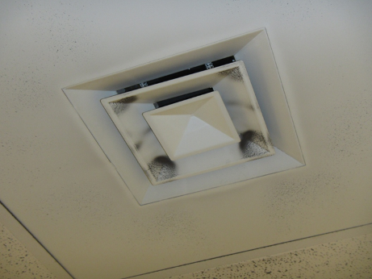
Supply air diffuser (note debris accumulation)
Picture 2
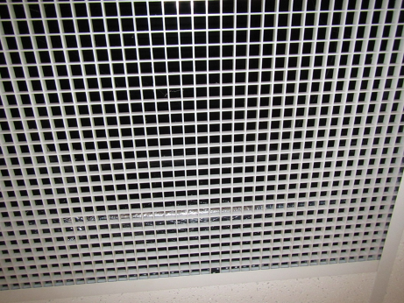
Return air grate
Picture 3
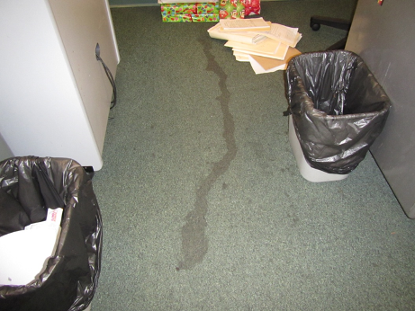
Soiled carpeting
Picture 4
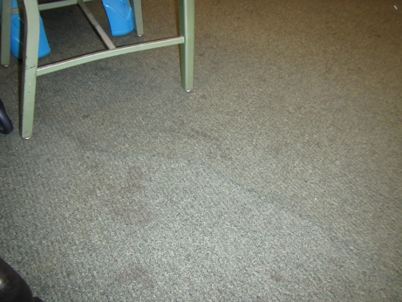
Water-damaged carpeting showing signs of uplifting (arrows)
Picture 5
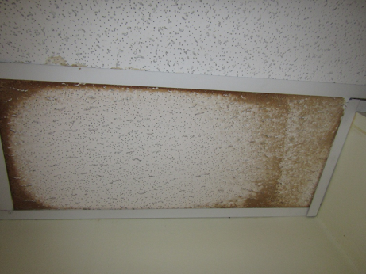
Water-damaged ceiling tile
Picture 6
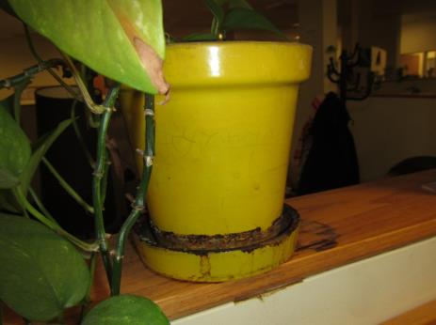
Plant with historic leaks
Picture 7
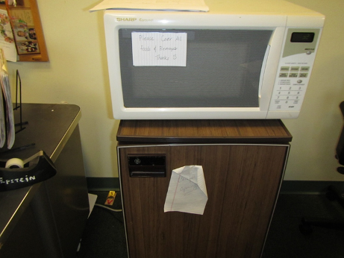
Refrigerator placed directly on carpeting
Picture 8
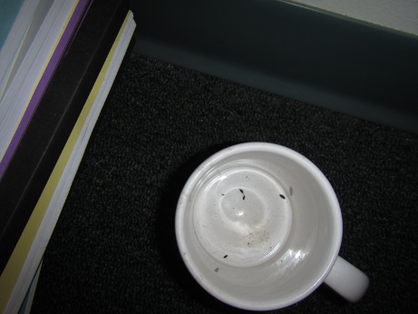
Mouse droppings in coffee mug
Picture 9
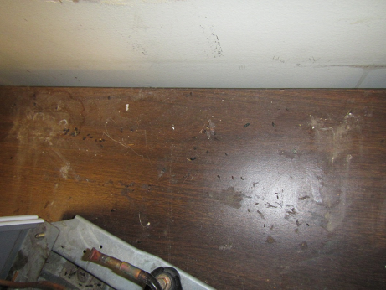
Numerous mouse droppings on table and behind mini fridge
Picture 10
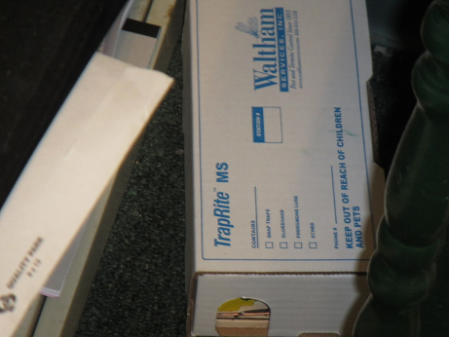
Mouse trap within covered box
Picture 11
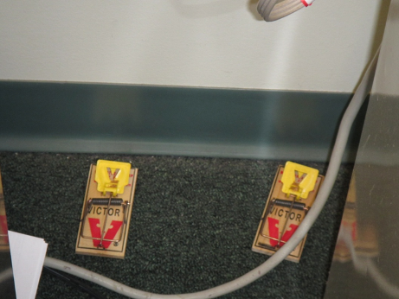
Mouse traps behind desk
Picture 12
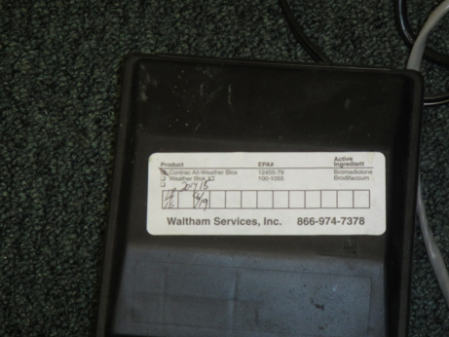
Rodent bait station
Picture 13
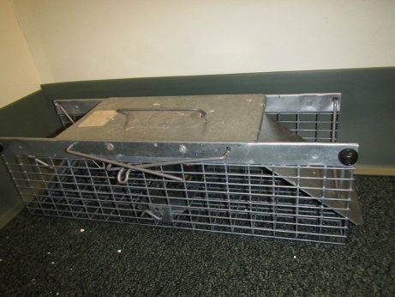
Large live catch trap in closed position
Picture 14
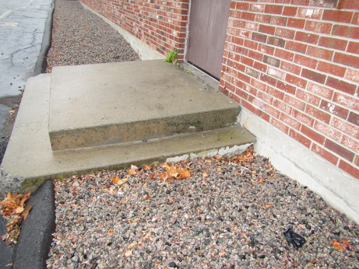
Large cracks/gaps created at stairs/slab interface due to settling (arrows)
Picture 15
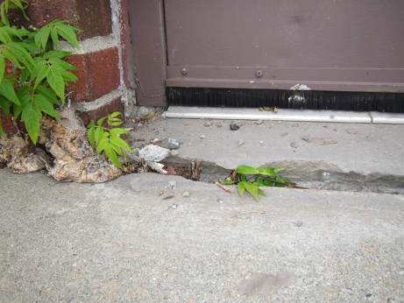
Large gap near side entrance (note sumac growth in gap)
Picture 16
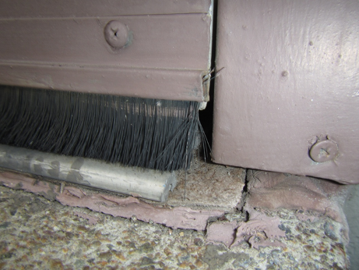
Loose brush style door sweep with gaps on side door
Picture 17
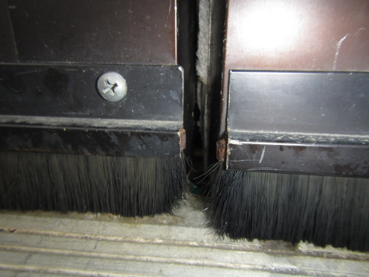
Gaps between front entrance doors equipped with brush sweeps
Picture 18
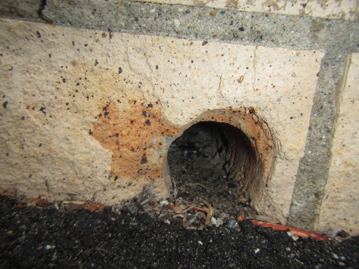
Large (~2”) apparent drain hole in masonry wall with no rodent screen
Picture 19
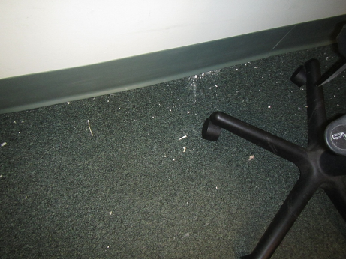
Debris on carpeting neglected by cleaning company
Picture 20
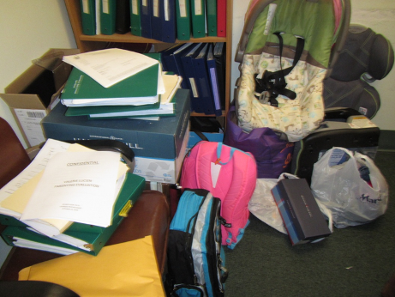
Accumulated items hinder cleaning efforts and highlights storage needs
Picture 21
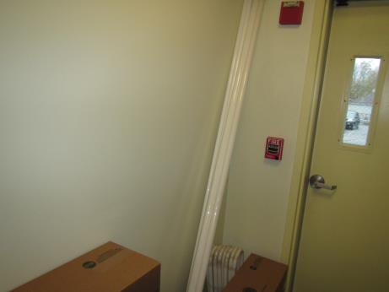
Fluorescent bulbs improperly stored

Location | Carbon  Dioxide  (ppm) | Carbon Monoxide  (ppm) | Temp  (°F) | Relative  Humidity  (%) | PM2.5  (µg/m³) | Occupants  in Room | Windows  Openable | Ventilation |  |  | Remarks
 |  |  |  |  |  |  |  | Intake | Exhaust
Background (outside) | 410 | 1.5 | 52 | 64 | 24 |  |  |  |  |  | Overcast
Waiting Room | 1210 | ND | 63 | 59 | 11 | 4 | N | Y |  | Y | Carpet tile
25 | 1942 | ND | 68 | 54 | 9 | 2 | N | Y |  | Y | Plants, many RD under and around fridge
24 | 1867 | ND | 69 | 50 | 12 | 2 | N | Y |  | Y | HS, RD
23 | 1210 | ND | 69 | 49 | 11 | 2 | N | Y |  | Y | HS, RD, stained carpet
27 office | 1248 | ND | 70 | 48 | 10 | 2 | N | Y |  | Y
32 | 1176 | ND | 70 | 47 | 10 | 3 | N | Y |  | Y
33 office | 1253 | ND | 70 | 47 | 11 | 3 | N | Y |  | Y
34 | 1214 | ND | 70 | 47 | 11 | 3 | N | Y |  | Y | Plush dolls, RD
35 office | 1140 | ND | 68 | 45 | 8 | 0 | N | Y |  | Y | AI
36 | 1182 | ND | 69 | 47 | 11 | 2 | N | Y |  | Y
41 office | 1379 | ND | 70 | 48 | 13 | 2 | N | Y |  | Y | DEM
40 | 1365 | ND | 71 | 47 | 12 | 1 | N | Y |  | Y | HS, RD
43 office | 1415 | ND | 71 | 47 | 11 | 1 | N | Y |  | Y
42 | 1407 | ND | 71 | 47 | 10 | 3 | N | Y |  | Y | Dirty carpet, RD
45 | 1438 | ND | 71 | 46 | 13 | 2 | N | Y |  | Y | WD carpet, RD, plush doll
46 | 1430 | ND | 71 | 46 | 10 | 1 | N | Y |  | Y | CP, HS, RD
44 | 1425 | ND | 71 | 46 | 12 | 3 | N | Y |  | Y | Bags of clothes, car seats, stained carpet, RD
47 | 1374 | ND | 70 | 46 | 10 | 2 | N | Y |  | Y | AI, rodent bait station, CP
48 | 1372 | ND | 70 | 46 | 10 | 1 | N | Y |  | Y | Recent trapped mouse
49 | 1248 | ND | 70 | 46 | 10 | 1 | N | Y |  | Y | Comfort complaints
52 | 1377 | ND | 70 | 47 | 12 | 3 | N | Y |  | Y | Stained carpet, mouse traps
53 | 1279 | ND | 70 | 45 | 9 | 0 | N | Y |  | Y | Mouse trap
54 | 1482 | ND | 71 | 47 | 13 | 4 | N | Y |  | Y | Candy, HS
55 | 1444 | ND | 72 | 45 | 11 | 4 | N | Y |  | Y | Heat complaints
56 | 1471 | ND | 72 | 45 | 11 | 4 | N | Y |  | Y | AI, RD
57 | 1415 | ND | 72 | 44 | 10 | 1 | N | Y |  | Y | DEM, AI
Conference B | 1180 | ND | 71 | 45 | 11 | 0 | N | Y |  | Y
File storage | - | - | - | - | - | - | - | - |  | - | Boxes on floor
17 | 1083 | ND | 70 | 46 | 17 | 0 | N | N |  | Y
16 | 1104 | ND | 70 | 46 | 14 | 0 | N | N |  | Y | Multiple traps, HS
Conference 14 | 1114 | ND | 70 | 45 | 10 | 2 | N | N |  | Y
Conference 12 | 986 | ND | 70 | 45 | 12 | 0 | N | Y |  | Y
10 baby room | 990 | ND | 70 | 46 | 14 | 0 | N | Y |  | Y
9 | 1017 | ND | 70 | 45 | 11 | 1 | N | Y |  | Y | Mouse trap
8 | 1357 | ND | 70 | 45 | 9 | 0 | N | Y |  | Y
Inside reception | 1339 | ND | 71 | 47 | 12 | 1 | N | Y |  | Y | RD
61 | 1409 | ND | 70 | 47 | 14 | 1 | N | Y |  | Y
Break room hall/side entrance | - | - | - | - | - | - | - | - |  | - | Fluorescent bulbs improperly stored
Break room | 1199 | ND | 68 | 51 | 84 | 3 | N | Y |  | Y | Cooking/Microwave, no local exhaust

