INDOOR AIR QUALITY ASSESSMENT
Department of Children and Families
1530 River Street
Hyde Park, MA
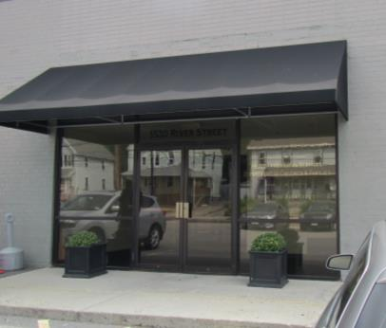
Prepared by:
Massachusetts Department of Public Health
Bureau of Environmental Health
Indoor Air Quality Program
August 2017

Background
Building: | Department of Children and Families (DCF)
Address: | 1530 River Street, Hyde Park, MA
Assessment Requested by: | Sharlene Sharif, Field Operations, Executive Office of Health and Human Services (EOHHS)
Reason for Request: | Concerns regarding remediation of water damage and general indoor air quality (IAQ)
Date of Assessment: | August 22, 2017
Massachusetts Department of Public Health/Bureau of Environmental Health (MDPH/BEH) Staff Conducting Assessment: | Ruth Alfasso, Environmental Engineer/Inspector IAQ Program
Building Description: | Originally constructed as a bowling alley, this one-story brick building has been office space occupied by DCF since approximately 2000.
Building Population: | Approximately 100 employees
Windows: | Not openable

Methods
Please refer to the IAQ Manual for methods, sampling procedures, and interpretation of results (MDPH, 2015). Note that several IAQ assessments were conducted at this site, most recently in late 2015, the report from that visit can be found at: http://www.mass.gov/eohhs/gov/departments/dph/programs/environmental-health/exposure-topics/iaq/iaq-rpts/cities-and-towns-b.html#boston.

IAQ Testing Results
The following is a summary of indoor air testing results (Table 1).
- Carbon dioxide levels were below 800 parts per million (ppm) all areas assessed. Note that during the assessment, most staff were in a meeting, so many areas were vacant or had low occupancy which would reduce carbon dioxide levels.
- Temperature was within the recommended range of 70°F to 78°F in all areas assessed.
- Relative humidity was within or close to the upper end of the recommended range of 40% to 60% in all areas assessed.
- Carbon monoxide levels were non-detectable in all indoor areas assessed.
- Fine particulate matter (PM2.5) concentrations measured were below the National Ambient Air Quality Standard (NAAQS) level of 35 μg/m³ in all indoor areas assessed.

Ventilation
A heating, ventilating, and air conditioning (HVAC) system has several functions. First, it provides heating and, if equipped, cooling. Second, it is a source of fresh air. Finally, an HVAC system will dilute and remove normally-occurring indoor environmental pollutants by not only introducing fresh air, but also filtering the airstream and ejecting stale air to the outdoors via exhaust ventilation. Even if an HVAC system is operating as designed, point sources of respiratory irritation may exist and affect symptoms in sensitive individuals. The following analysis examines and identifies components of the HVAC system and likely sources of respiratory irritant/allergen exposure due to water damage, aerosolized dust, and/or chemicals found in the indoor environment.
Fresh air is provided by air handling units (AHUs) located on the roof. Air from the AHUs is filtered, heated/cooled, and delivered to rooms via ducted supply vents (Picture 1). Air is returned/exhausted through exhaust grills (Picture 1). It is recommended that HVAC systems be re-balanced every five years to ensure adequate air systems function (SMACNA, 1994). It is not known when the last time these systems were balanced.

Microbial/Moisture Concerns
This visit was conducted in response to concerns about water damage that had occurred in the spring. Reportedly in March of 2017, roof leaks during a heavy rainstorm occurred and moistened an area in the rear of the building, including ceiling tiles, carpeting, and gypsum wallboard. Reportedly, a water damage service contractor was quickly hired to perform remediation, including fan-assisted drying, removal/replacement of damaged wallboard, and replacement of water-damaged carpeting and ceiling tiles. It was also reported that water-damaged items and furnishings were remediated or discarded as applicable. The roof was reportedly repaired shortly afterwards. Building staff report that no more leaks have occurred since then, including during some heavy rains this summer.
At the time of the visit, no water-damaged materials were observed in the area where the leak had been reported. The carpeting was new and in good condition, and the coving was found securely attached to the wall. According to observations made during this visit, the water damage remediation was adequate and the roof appears to be functioning properly.
A water-damaged ceiling tile was observed in an office on the other side of the building, which was reported to be from a historic leak. Water damage to a wall in an office was observed (Picture 2) that appeared to be cause by a coffee pot. The wall was also soiled and should be cleaned. The computer room had a ductless air conditioner on the wall with a water stain (Picture 3) indicating that the condensate from this unit had leaked in the past. Condensate pumps and associated piping from these units should be checked periodically for clogs and leaks and no porous materials should be stored underneath. It was reported that due to security concerns, this area is only infrequently accessible to cleaning staff which makes it more difficult to detect problems.
Refrigerators, including a large one in the hallway next to the kitchen, a refrigerated vending machine, and water dispensers were observed in carpeted areas (Pictures 4 and 5; Table 1). These appliances may spill or leak and lead to carpet damage and microbial growth. It is recommended that these appliances be located in areas without carpeting or on waterproof mats. Carpet squares could also be replaced with tile in areas where water dispensers and refrigerators are located. Refrigerators should be kept clean to prevent odors and microbial growth.
A small humidifier was observed in an office. If not properly maintained, these appliances can create conditions leading to stagnant water inside the reservoir and can then spread microbes and odors. Humidification equipment is typically not recommended for office environments.
Plants were found in some offices. Some were without drip pans and/or placed on porous materials such as carpeting and boxes (Picture 6). Plants should be well maintained, not overwatered and placed on non-porous drip pans which are cleaned of debris regularly.

Other IAQ Evaluations
Exposure to low levels of total volatile organic compounds (TVOCs) may produce eye, nose, throat, and/or respiratory irritation in some sensitive individuals. To determine if VOCs were present, BEH/IAQ staff examined rooms for products containing VOCs. BEH/IAQ staff noted cleaners, hand sanitizers and various scented products such as candles in use within the building (Picture 7; Table 1). All of these products have the potential to be irritants to the eyes, nose, throat, and respiratory system of sensitive individuals.
Cooking equipment, including toasters, microwave ovens and coffee machines, were located in various parts of the office space. Food areas and cooking equipment need to be kept clean to prevent odors and pests. During the previous visit in 2015, a rodent problem was reported; during this visit, no signs or reports of rodents were noted.
Upholstered furniture and plush toys were observed in offices (Picture 8). These should also be cleaned regularly to remove the build-up of oils and debris.
The offices were mostly carpeted. Some of the carpeting is new, in response to leaks as reported above, or as a part of the planned gradual change-out of all the carpeting in the building. Older carpeting, which was installed when the building was renovated into offices in 1999/2000, is stained, wrinkled, and worn in many areas (Picture 9). Aging carpet can produce fibers that can be irritating to the respiratory system. In addition, lumpy, torn or lifting carpet can create tripping hazards. Carpeting should be cleaned annually or semi-annually in soiled high traffic areas as per the recommendations of the Institute of Inspection, Cleaning, and Restoration Certification (IICRC, 2012).
In some areas, stored materials and accumulated items make it more difficult for custodial staff to clean (Picture 10). It was reported that there is an ongoing process of finding better areas and ways to store items such as clothing, toys, and car seats in this office. Items should be stored neatly and moved periodically to allow for wet-wiping and vacuuming of surfaces. Items should also be stored off the floor to protect from dust and condensation.
Personal fans were observed in a number of areas. Fan blades to some of these units had settled dust, which can be reaerosolized when the fan is activated (Picture 11). Some supply and exhaust vents were also dusty (Picture 12).

Conclusions/Recommendations
Based on observations at the time of assessment, the following is recommended:
- Operate supply and exhaust ventilation in all areas during occupied periods.
- Have the HVAC system balanced every 5 years in accordance with SMACNA recommendations (SMACNA, 1994).
- For buildings in New England, periods of low relative humidity during the winter are often unavoidable. Therefore, scrupulous cleaning practices should be adopted to minimize common indoor air contaminants whose irritant effects can be enhanced when the relative humidity is low. To control for dusts, a high efficiency particulate arrestance (HEPA) filter equipped vacuum cleaner in conjunction with wet wiping of all surfaces is recommended. Avoid the use of feather dusters. Drinking water during the day can help ease some symptoms associated with a dry environment (throat and sinus irritations).
- Replace any water-damaged ceiling tiles when they are discovered and repair leaks as needed.
- Clean water-damaged, soiled wall in Picture 2.
- Ensure that the condensate removal system for the ductless air conditioning unit is functioning and is not clogged or leaking. Due to access issues with this room, consider regularly scheduled supervised access to this area for monitoring and cleaning. Ensure that no items are stored underneath the ductless unit.
- Consider locating refrigerators and water dispensers in non-carpeted areas. Clean refrigerators out regularly to avoid odors and microbial growth.
- Ensure that any humidifiers used in the office are properly maintained to prevent odors and microbial growth.
- Ensure that all plants are properly maintained, not overwatered, and placed on waterproof drip pans instead of on porous items. Ensure water for cut flowers is changed regularly to prevent odors.
- Reduce use of products containing VOCs including eliminating air freshening and scented products.
- Keep food in sealed pest-proof containers. Keep cooking equipment clean to prevent smoke, odors and the attracting of pests.
- Clean carpeting in accordance with IICRC recommendations (IICRC, 2012). Continue with plans to replace carpeting that is beyond its service life.
- Clean upholstered and plush items regularly to remove dust, oils and debris.
- Reduce accumulated materials on flat surfaces and store in an organized manner to allow for thorough cleaning. Continue with plans for new/reorganized storage space for items such as clothing, toys and car seats. Ensure that storage methods keep items off the ground and protected from moisture and dusts.
- Clean the blades of personal fans, supply, and exhaust vents periodically to avoid aerosolizing dusts.
- Refer to resource manual and other related IAQ documents located on the MDPH’s website for further building-wide evaluations and advice on maintaining public buildings. These documents are available at: http://mass.gov/dph/iaq.

References
IICRC. 2012. Institute of Inspection, Cleaning and Restoration Certification. Carpet Cleaning: FAQ. Retrieved from http://www.iicrc.org/consumers/care/carpet-cleaning.
MDPH. 2015. Massachusetts Department of Public Health. Indoor Air Quality Manual: Chapters I-III. Available at: http://www.mass.gov/eohhs/gov/departments/dph/programs/environmental-health/exposure-topics/iaq/iaq-manual/.
SMACNA. 1994. HVAC Systems Commissioning Manual. 1st ed. Sheet Metal and Air Conditioning Contractors’ National Association, Inc., Chantilly, VA.
Picture 1
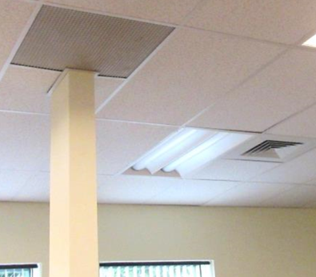
Typical supply (right rear) and exhaust vents
Picture 2
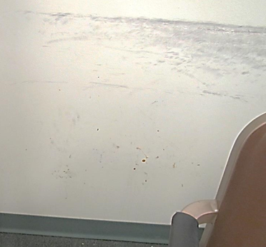
Water-stained, soiled wall
Picture 3
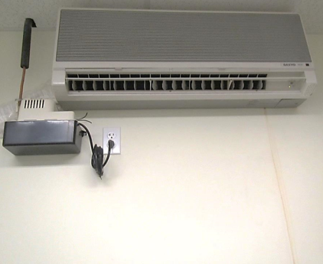
Ductless air conditioning unit with water stain on wall
Picture 4
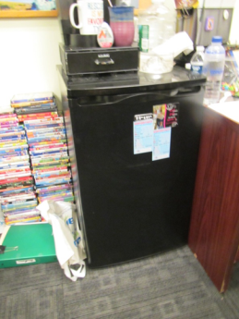
Small refrigerator on carpet, note coffee maker
Picture 5
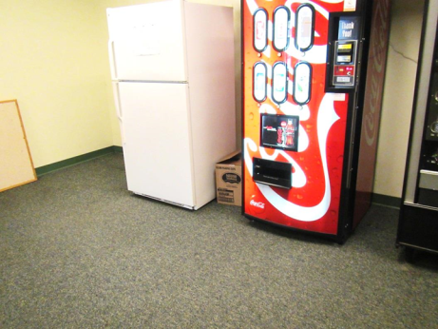
Refrigerator and refrigerated vending machine on carpet
Picture 6
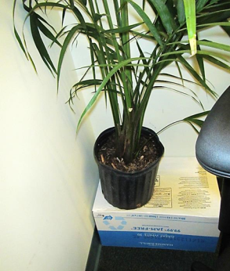
Plant on porous box
Picture 7
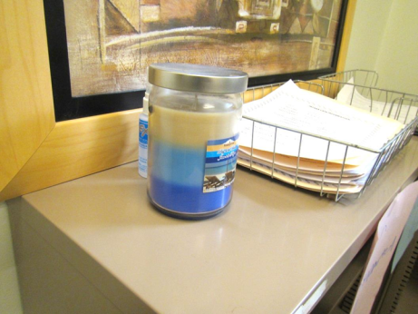
Scented candle
Picture 8
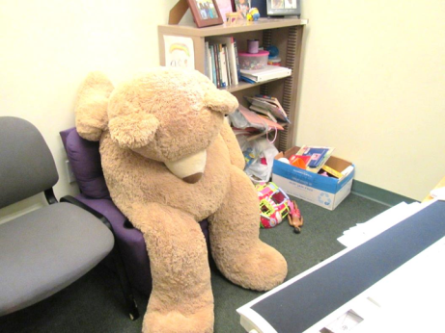
Plush toy and upholstered furniture, also note boxes on the floor
Picture 9
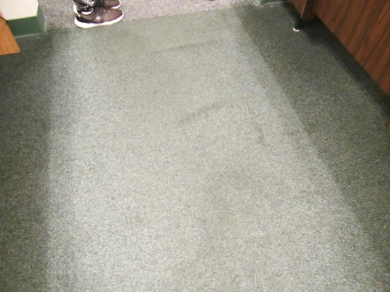
Wrinkled and stained carpeting
Picture 10
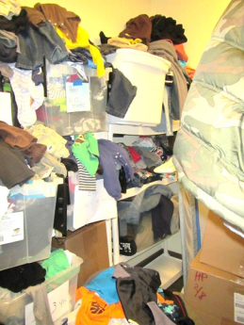
Stored items, many not in bins
Picture 11
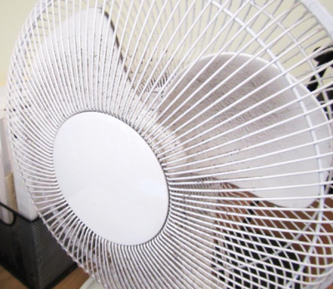
Dusty fan
Picture 12
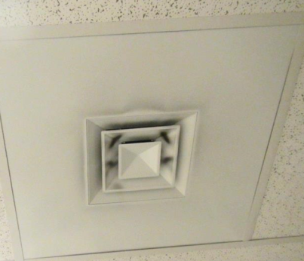
Dusty supply vent
Location | Carbon  Dioxide  (ppm) | Carbon Monoxide  (ppm) | Temp  (°F) | Relative  Humidity  (%) | PM2.5  (µg/m³) | Occupants  in Room | Windows  Openable | Ventilation |  | Remarks
 |  |  |  |  |  |  |  | Supply | Exhaust
Background | 376 | ND | 80 | 82 | 43 |  |  |  |  | Sunny and hot
Conference Room B | 522 | ND | 75 | 59 | 11 | 15 | N | Y | Y | Beginning of all-staff meeting
11 office | 619 | ND | 74 | 56 | 13 | 1 | N | Y | Y | DEM
16 office | 617 | ND | 75 | 57 | 13 | 0 | N | Y | Y | Popcorn machine (empty), items on floor
17 office | 516 | ND | 75 | 57 | 13 | 0 | N | Y | Y | Fridge, AF
24 pod | 606 | ND | 74 | 60 | 14 | 0 | N | Y | Y | DEM, HS, plush toys
25 pod | 607 | ND | 74 | 60 | 15 | 0 | N | Y | Y | Water cooler on carpet
26 office | 616 | ND | 76 | 57 | 13 | 0 | N | Y | Y | Fridge
27 office | 650 | ND | 76 | 57 | 12 | 0 | N | Y | Y | DEM, leather sofa, plant in need of drip pan, wax warmer
28 office | 621 | ND | 76 | 57 | 13 | 1 | N | Y | Y | DEM, HS
29 office | 644 | ND | 76 | 57 | 12 | 0 | N | Y | Y | Plant
30 office | 549 | ND | 76 | 56 | 12 | 0 | N | Y | Y | Very lightly water-stained ceiling tile
31 office | 568 | ND | 76 | 58 | 11 | 0 | N | Y | Y | Papers/boxes on floor
33 office | 574 | ND | 75 | 59 | 12 | 0 | N | Y | Y | Items, fridge and microwave
35 office | 559 | ND | 75 | 59 | 12 | 1 | N | Y | Y
37 office | 552 | ND | 75 | 59 | 11 | 0 | N | Y | Y | HS, plant
38 office | 562 | ND | 74 | 55 | 12 | 0 | N | Y | Y | DEM, plants and flowers
41 office | 582 | ND | 74 | 54 | 12 | 0 | N | Y | Y | Plush items, DEM, HS
43 office | 640 | ND | 75 | 55 | 12 | 0 | N | Y | Y | Fridge on carpet, DEM, plants
43 pod | 664 | ND | 74 | 56 | 14 | 0 | N | Y | Y | Items, DEM
44 pod | 645 | ND | 74 | 55 | 15 | 2 | N | Y | Y | Items on floor
45 pod | 599 | ND | 75 | 54 | 21 | 0 | N | Y | Y | AI, plush toys, food, mini fridge
46 pod | 616 | ND | 75 | 54 | 14 | 1 | N | Y | Y | Plants, car seats
47 office | 697 | ND | 75 | 54 | 12 | 0 | N | Y | Y | Fridge on carpet, upholstered furniture, PF, DEM
48 office | 645 | ND | 74 | 52 | 3 | 0 | N | Y | Y
49 office | 649 | ND | 74 | 52 | 14 | 0 | N | Y | Y | Items, stained/soiled wall, stained chair
50 office | 624 | ND | 75 | 55 | 14 | 0 | N | Y | Y | Humidifier, stained carpet
52 pod | 604 | ND | 75 | 58 | 14 | 2 | N | Y | Y | Fridge on carpet, stained carpeting
54 pod | 616 | ND | 75 | 58 | 14 | 1 | N | Y | Y | Wrinkled carpet
55 pod | 604 | ND | 75 | 57 | 14 | 3 | N | Y | Y | Fridge on carpet, stained carpeting
56 pod | 612 | ND | 75 | 58 | 14 | 1 | N | Y | Y | Stained carpet
57 pod | 605 | ND | 74 | 58 | 14 | 1 | N | Y | Y | DEM, items
09 office | 600 | ND | 74 | 56 | 14 | 0 | N | Y | Y | Stained carpet
Area director’s conference room | 675 | ND | 76 | 56 | 13 | 2 | N | Y | Y
B directors office | 641 | ND | 75 | 56 | 13 | 0 | N | Y | Y
Case files | 580 | ND | 74 | 58 | 14 | 0 | N | Y | Y | NC
Closed files | 576 | ND | 76 | 57 | 10 | 0 | N | Y | Y | NC, boxes on floor
Electric utility |  |  |  |  |  |  | N | Y | Y | NC, no wallboards or ceiling tiles, storage in bins
Family meeting | 611 | ND | 75 | 56 | 13 | 1 | N | Y | Y | Plants, stained carpet
Pod | 615 | ND | 74 | 56 | 14 | 0 | N | Y | Y | Items
Storage |  |  |  |  |  |  | N | Y | Y | Boxes on floor
Storage/former infant room | 591 | ND | 74 | 57 | 14 | 0 | N | Y | Y | Items, some enclosed in totes, some not
Kitchen hallway |  |  |  |  |  | 0 | N | Y | Y | Fridge and vending machines, carpeted
Kitchen |  |  |  |  |  | 0 | N | Y | Y | NC, toaster and microwave
Women’s restroom |  |  |  |  |  | 0 | N | Y | Y | Air freshening spray
Janitorial closet |  |  |  |  |  | 0 | N | Y | Y | Mop bucket with water
Management office | 636 | ND | 74 | 60 | 15 | 0 | N | Y | Y | Ajar ceiling tile, items, door to outside
Office | 592 | ND | 74 | 60 | 15 | 0 | N | Y | Y | Plush toys
Storage | 629 | ND | 74 | 60 | 15 | 0 | N | Y | Y | Car seats
Reception | 714 | ND | 75 | 61 | 15 | 2 | N | Y | Y | Stained carpeting
Computer area |  |  |  |  |  |  | N | Y | Y | Ductless air conditioning with water-stained wall
Waiting room | 700 | ND | 74 | 64 | 17 | 5 | N | Y | Y
Interview 4 | 751 | ND | 74 | 64 | 17 | 0 | N | Y | Y | NC
Interview 3 | 699 | ND | 74 | 63 | 17 | 0 | N | Y | Y | NC
Interview 2 | 671 | ND | 74 | 63 | 17 | 0 | N | Y | Y | NC
Interview 1 | 673 | ND | 74 | 63 | 17 | 0 | N | Y | Y | NC
Children’s room | 701 | ND | 74 | 63 | 17 | 3 | N | Y | Y | NC

