Independent Cost Analysis for:

Boston Children’s Hospital Determination of Need Proposed Project

DoN Application # BCH-20171411-HE

September 6, 2022

APPENDIX

Prepared for Submission to:
Massachusetts Department of Public Health

Authored by:
Jeremy Nighohossian, Ph.D.
Margaret Guerin-Calvert
Center for Healthcare Economics and Policy,
FTI Consulting, Inc.
555 12th Street NW, Suite 700
Washington, D.C. 20004

The primary authors of this report are Jeremy Nighohossian, PhD, Managing Director and Margaret Guerin-Calvert, President and Senior Managing Director, Center for Healthcare Economics and Policy FTI Consulting Inc. with substantial assistance in the empirical analyses provided by Shanshan Wang, Director and Suhail Thahir, Consultant. The authors take responsibility for any errors or admission. The views expressed herein are those of the author(s) and not necessarily the views of FTI Consulting, Inc., its management, its subsidiaries, its affiliates, or its other professionals. The reader agrees to release FTI Consulting, Inc. and its personnel from any claim by the reader that arises as a result of the reader having access to the report.
Table of Contents FOR APPENDIX
I. Tables Referenced in Report 5
II. Data Sources for FTI ICA Report 7
A. Massachusetts All-Payer Claims Database (APCD) 7
B. Demographic Data and Population Data 8
1. University of Massachusetts Donahue Institute Population Projections for Massachusetts Municipalities 8
2. BCH Application Demographic, Population Data, and Utilization Data 8
C. Geographic Data and Information 9
1. HSA Definitions 9
2. Driving Distance and Other Data Used in Modeling 9
D. Pricing 9
E. Hospital, Facility and Capacity Information 9
1. MA Facility Data 9
2. Description of Methodology for Identifying Facilities, NPI, Matching etc. 10
3. Location of Facilities for Maps were Sourced from Independent Research on “Children’s Hospitals” and/or Facility Lists identified in this Section 12
4. Hospital Research on Massachusetts Hospitals and Their Outpatient Facilities 12
5. Providers Offering Partial Hospitalization Programs 13
F. BCH Standard Pricing Data 14
G. Cost Trend Sources and Data 14
III. Materials Reviewed or Relied Upon 15
A. Reports, Academic Articles, Studies 15
B. Codes and Supporting Data Reports 15
C. Service Area Definitions 19
1. MRI – Needham 19
2. MRI – Waltham 19
3. MRI – Weymouth 19
4. Imaging – Needham 20
5. Imaging – Waltham 20
6. Imaging – Weymouth 20
7. ASC – Needham 20
8. ASC – Waltham 21
D. Proposed Project – Sources of Information 21
IV. Supplemental Tables 23
A. Share Analyses by Service Line (State/PSA) 23
B. Diversion Analyses 25
V. Supplemental FIGURES 29

Table of FIGURES
Supplemental Figure 1: Overview of Massachusetts Health Systems with Children’s Hospitals 29
Supplemental Figure 1: Overview of Boston Area Health Systems with Children’s Hospitals 30
Supplemental Figure 1: Needham Service Area, ASC 31
Supplemental Figure 2: Waltham Service Area, ASC 32
Supplemental Figure 3: Weymouth Service Area, ASC 33
Supplemental Figure 4: Needham Service Area, MRI 34
Supplemental Figure 5: Waltham Service Area, MRI 35
Supplemental Figure 6: Weymouth Service Area, MRI 36
Supplemental Figure 7: Needham Service Area, Imaging 37
Supplemental Figure 8: Waltham Service Area, Imaging 38
Supplemental Figure 9: Weymouth Service Area, Imaging 39

Table of Tables
Table A1: Projected Utilization of Imaging Services by HSA and Payer, Ages 0 – 18 (2025 – 2040) 5
Table A2: Projected Utilization of Ambulatory Surgical Services by HSA and Payer, Ages 0 – 18 6
Table A3:Projected Utilization of MRI Services by HSA and Payer, Ages 0 – 18 (2025 – 2040) 7
Table A4: Types of facilities from “List of health care facilities licensed or certified by the division” 10
Supplemental Table 1: Share of Six Health Systems in MA, ASC 2019 23
Supplemental Table 2: Share of Six Health Systems in MA, Imaging 2019 23
Supplemental Table 3: Share of Six Health Systems in MA, MRI 2019 23
Supplemental Table 4: BCH Visits and Payer Mix in MA, ASC 2019 24
Supplemental Table 5: BCH Visits and Payer Mix in MA, Imaging 2019 24
Supplemental Table 6: BCH Visits and Payer Mix in MA, MRI 2019 25
Supplemental Table 7: Diversions to New BCH Facilities for Ambulatory Surgery Center Services, Commercial (MA, Patients Aged 0 – 18) 25
Supplemental Table 8: Diversions to New BCH Facilities for Ambulatory Surgery Center Services, Medicaid (MA, Patients Aged 0 – 18) 26
Supplemental Table 10: Diversions to New BCH Facilities for Imaging Services, Commercial (MA, Patients Aged 0 – 18) 26
Supplemental Table 11: Diversions to New BCH Facilities for Imaging Services, Medicaid (MA, Patients Aged 0 – 18) 27
Supplemental Table 13: Diversions to New BCH Facilities for MRI Services, Commercial (MA, Patients Aged 0 – 18) 27
Supplemental Table 14: Diversions to New BCH Facilities for MRI Services, Medicaid (MA, Patients Aged 0 – 18) 28

Tables Referenced in Report
Table A1: Projected Utilization of Imaging Services by HSA and Payer, Ages 0 – 18 (2025 – 2040)
HSA | Payer Category | % Change (2025 - 2040)
Commercial | Metro West | -2.2%
Commercial | Northeast | -4.4%
Commercial | Southeast | -4.9%
Commercial | Central | -3.5%
Commercial | Western | -5.1%
Commercial | Boston | 8.3%
Medicaid | Western | -3.9%
Medicaid | Central | -5.4%
Medicaid | Southeast | -7.9%
Medicaid | Northeast | -3.1%
Medicaid | Boston | 8.7%
Medicaid | Metro West | -2.8%
All Other | Central | -3.3%
All Other | Metro West | -2.6%
All Other | Western | -3.8%
All Other | Northeast | -3.1%
All Other | Southeast | 4.8%
All Other | Boston | 33.3%
Total |  | -2.9%
Source: The result is based on all imaging claims from the 2019 CHIA all-payer medical claim data. The data is restricted to visits from members younger than 19 years old residing in Massachusetts.
Table A2: Projected Utilization of Ambulatory Surgical Services by HSA and Payer, Ages 0 – 18
(2025 – 2040)
Payer Category | HSA | % Change (2025 - 2040)
Commercial | Metro West | -2.3%
Commercial | Northeast | -6.4%
Commercial | Southeast | -6.7%
Commercial | Central | -5.2%
Commercial | Western | -5.4%
Commercial | Boston | 2.8%
Medicaid | Northeast | -2.7%
Medicaid | Southeast | -5.3%
Medicaid | Western | -2.4%
Medicaid | Boston | 2.9%
Medicaid | Central | -4.4%
Medicaid | Metro West | -1.4%
All Other | Central | -8.4%
All Other | Metro West | 11.5%
All Other | Southeast | -27.3%
All Other | Western | 0.0%
All Other | Northeast | -50.0%
All Other | Boston | 33.3%
Total |  | -3.0%
Source: The result is based on ASC claims from the 2019 CHIA all-payer medical claim data. The data is restricted to visits from members younger than 19 years old residing in Massachusetts.

Table A3:Projected Utilization of MRI Services by HSA and Payer, Ages 0 – 18 (2025 – 2040)
Payer Category | HSA | % Change (2025 - 2040)
Commercial | Boston | 9.5%
Commercial | Metro West | -4.2%
Commercial | Northeast | -4.3%
Commercial | Western | -4.6%
Commercial | Central | -2.9%
Commercial | Southeast | -4.4%
Medicaid | Southeast | -7.7%
Medicaid | Boston | 8.9%
Medicaid | Northeast | -2.3%
Medicaid | Metro West | -3.2%
Medicaid | Central | -5.4%
Medicaid | Western | -3.8%
All Other | Southeast | 0.0%
All Other | Northeast | 0.0%
All Other | Western | -25.0%
All Other | Central | -4.2%
All Other | Boston | 0.0%
All Other | Metro West | -5.3%
Total |  | -2.8%
Source: The result is based on MRI claims from the 2019 CHIA all-payer medical claim data. The data is restricted to visits from members younger than 19 years old residing in Massachusetts.

Data Sources for FTI ICA Report
The ICA requirements and DPH’s request for the FTI ICA Report involved use of several datasets and data sources for empirical analyses to address specific questions and issues. These include claims data as well as demographic, health, capacity, pricing, and cost trend data. For convenience, this section summarizes the key data sources and information used; the FTI ICA Report includes references or citations to specific data sources in each of the sections or analyses.

Massachusetts All-Payer Claims Database (APCD)
Massachusetts’s Center for Health Information and Analysis (CHIA) collects, manages, and provides a detailed set of claims data for Massachusetts residents and employees covered by Massachusetts companies. The purpose of the dataset is to allow researchers and policymakers to analyze utilization, costs, and quality to improve the provision of healthcare in the Commonwealth of Massachusetts. The APCD comprises dental, medical, and pharmacy claims data for both public and privet insurance members. Private plans include all fully insured Massachusetts commercial plans and self-insured commercial plans that choose to report to CHIA. Public plans, for purposes of this ICA report, include Medicaid but not Medicare claims, since BCH only offers pediatric services which generally are not covered by Medicare. (Medicaid claims include MassHealth claims and analyses combined MassHealth and Medicaid claims. Specific limitations on the CHIA data for MassHealth/Medicaid are addressed in the report.)
The ICA analysis in this report uses APCD data which includes claims from 2015-2020. As the Proposed Projects relates specifically to outpatient services, we used only the Medical Claims (MC) and Provider (PV) files. For the Medical Claims file, years covered are based on Date of Service To. It contains dates of service and payments, amount of payment, diagnosis and procedure codes associated with claim, provider of service, type of facility, location and demographics of the member. The Provider file contains information on the provider of the service including name, NPI, specialty, and location. This dataset includes both organizational providers like hospitals and clinics and individual physicians.

Demographic Data and Population Data

University of Massachusetts Donahue Institute Population Projections for Massachusetts Municipalities
The University of Massachusetts Donahue Institute produced population projections in 2015 for Massachusetts at the city level. These projections were initially created with 2010 Census data and updated in 2020 with new inputs from 2018. This data is disaggregated to the city level, with 5-year age breakdown by sex. There are 351 towns included in the data set with 18 age brackets and 2 sex categories for each town. These projections start with the 2010 census estimates as baseline and are projected for every 5 years until 2040.

BCH Application Demographic, Population Data, and Utilization Data
FTI’s ICA Report used several sources of demographic and population data and information from BCH Application materials. The BCH Application included data on utilization, including, for example, visits, cases, or patients by HSA, by specific towns or locations, by service area, across time, and BCH patient profiles. These data sources are primarily from BCH internal data for BCH locations or patients, or, from cited external sources for general pediatric populations, visits and by geographic areas in Massachusetts. Data and information sources used are referenced and sourced in the Report and include several tables and analyses specific to the Proposed Project, including BCH responses to questions. Unless otherwise noted, FTI had access only to tables as presented in the BCH public submissions: All DON Application materials located at https://www.mass.gov/lists/the-childrens-medical-center-corporation-hospitalclinic-substantial-capital-expenditure and the detailed files and documents located therein.

Geographic Data and Information

HSA Definitions
The Massachusetts’ Department of Public Health’s Bureau of Environmental Health’s Executive Office of Health and Human Services (EOHHS) outlines 6 health service regions (HSAs) using zip code boundaries. These 6 regions are designated as Western (144 zip codes), Central (116), Northeast (84), Metro West (117), Southeast (166), and Boston (54). Using these definitions, FTI created a crosswalk to enable mapping claims data to HSAs.

Driving Distance and Other Data Used in Modeling
Using an open source routing command, FTI creates a crosswalk of drive times between Zip Code Tabulation Areas (ZCTAs) in Massachusetts. To convert ZIP codes from the CHIA data to ZCTAs, FTI used the website UDS Mapper from the American Academy of Family Physicians’ crosswalk which maps ZIP codes to their corresponding ZCTA.

Pricing
All pricing information used in this report came from the Massachusetts APCD (see section II.A). Exclusions used are listed in Section XI of the report.

Hospital, Facility and Capacity Information
As part of the APCD request, FTI received and used their Provider file which contains the names, addresses, and other information for all service providers identified in the medical claims file. This included a CHIA-specific provider identification number that was used to identify the same provider location despite having different identifying information within the claims file.

MA Facility Data
Division of Health Care Facility Licensure & Certification. (February 9th, 2022). List of health care facilities licensed or certified by the Division. healthcare-facilities.xls | Mass.gov. Retrieved March 8, 2022, from https://www.mass.gov/doc/list-of-health-care-facilities-licensed-or-certified-by-the-division. Description: The Massachusetts Division of Healthcare Facility Licensure & Certification provides data for the list of 2,986 licensed or certified health care facilities in the State. The data provides information on facility types, facility ids, facility names, locations (street, city/town, and zip code), contact information, bed count (for applicable facility types only), and adult day health capacity (for applicable facility types only). The data covers 22 types of facilities, as summarized in Table 1.
Table A4: Types of facilities from “List of health care facilities licensed or certified by the division”
Types of Facilities
Nursing Home
Rest Home
Acute Hospital
Non-acute Hospital
Satellite Inpatient Unit
Satellite Emergency Facility
Hospital Satellite
Clinic
Mobile/Portable Clinic
Clinic Satellite
Mobile/Portable Clinic Satellite
Certified Home Health Agency
Adult Day Health
Hospice
Hospice Inpatient Satellite
Ambulatory Surgical Ctr.
Renal Dialysis (ESRD)
ICFIID
Outpt. Phys. Ther/Speech Path.
Temp. Nursing Agency
Organ Procurement
Stem Cell Research

Description of Methodology for Identifying Facilities, NPI, Matching etc.
The provider field from the MA all-payer medical claims is not standardized. Therefore, FTI could not assess utilization, costs, and prices directly using the provider field. To resolve this issue, FTI developed standardized names for all distinct facilities for BCH and other providers. The product of this exercise is a crosswalk among unique facilities, addresses, affiliated health systems, and all associated NPIs. The unique identifier included facility name, NPI, ZIP code where service was provided, and city where service was provided. Below are the detailed steps.
Step 1: Identify unique facilities for BCH and other major health systems with “children’s hospitals”
From independent research and reference to various state and public data sources, detailed below, FTI identified six health systems, including BCH, associated with standalone children’s hospitals, hospitals named “children’s hospital” which were located on the same campus or co-located with a major hospital, or major pediatric departments of a major hospital. FTI identified unique hospital and hospital satellite facilities for each of these six health systems (BCH + 5 other systems) from the healthcare facility list from MA Department of Public Health and from independent research.
The six health systems selected for such detailed data development are
- Boston Children's Hospital (BCH)
- Mass General Brigham (MGB)
- Baystate Health (Baystate)
- Tufts Medical Center (Tufts)
- Boston Medical Center (BMC)
- UMass Memorial Health Care (UMass)
Step 2: Identify all possible names associated with a facility from the all-payer claims data
FTI used various search terms and identified a potential list of all possible provider names associated with a facility from the all-payer medical claims data. It restricted provider state to MA to make the potential list more targeted. This exercise was conducted for all facilities from the six health systems.
Step 3: Finalize the list of relevant information to create a standardized facility name
From this potential list, FTI manually reviewed every provider name (SERVICEPROVIDERLASTNAMEORORGANIZ) to determine if it was a relevant facility of one of the six health systems and to assign standardized facility name to it. FTI also relied on other fields and source of information (below) to correctly identify hospital satellite facilities:
- When the provider name is too general, FTI examined service ZIP code and city to determine hospital satellite facilities (e.g., Boston Children’s at Waltham, UMass Memorial Health – Harrington Hospital). For example, many BCH providers are under a general name “the childrens hospital corp dba”. FTI then examined the ZIP codes associated with the name and assigned the provider to BCH Waltham if the zip code is 02453 or the city is Waltham. FTI assigned the provider to BCH Peabody if the ZIP code is 01960 and the city is Peabody.
- As a secondary step to identify facilities, FTI used the NPPES NPI Registry to obtain the ZIP code and city information for these relevant facilities when the provider name indicates it belongs to one of the six health systems but the ZIP code does not match to any of the relevant facilities’ ZIP codes. In this case, FTI looked up the NPI number indicated in the APCD and retrieved information for that provider from the NPI registry. If the ZIP code listed in the NPI registry matched that of the relevant facility, the claim was assigned to that facility.
- Once these two processes were complete, facilities were further identified by using the APCD-specific service provider identifier, and separately the NPI number. Any claims where the service provider matched one of these two identifiers for claims that had already been identified as taking place at a certain facility were assumed to also take place at that facility.
- Finally, FTI used the billing provider identifiers included in the claims data to identify claims where services were provided by the same system, but at a different facility. These were categorized as “Other” for that system.

Location of Facilities for Maps were Sourced from Independent Research on “Children’s Hospitals” and/or Facility Lists identified in this Section

Hospital Research on Massachusetts Hospitals and Their Outpatient Facilities
Outpatient services have hundreds of providers, including those serving a wide range of ages and services; there are thousands of individual providers in the CHIA data. The FTI ICA Report sought to develop data and information on the providers that had larger or more specialized hospital-based or outpatient alternatives serving pediatric populations in the locations in which BCH serves or planned additionally to serve patients. These include facilities known as Children’s Hospitals (e.g., standalone Children’s Hospitals) as well as hospitals with a children’s hospital name as part of a major health system (e.g., MassGeneral Hospital for Children). We examined public information, reports on children’s and pediatric services in Massachusetts and then the individual websites of several health systems with children’s hospitals and pediatric outpatient facilities; the websites included detailed information on location, types of services, and types of facilities for each six health systems that were employed in the Report. For convenience in the report, we refer to these collectively as health systems with “children’s hospitals.” The health systems with children’s hospitals or pediatric services include: Baystate, Boston Children’s, Boston Medical Center, Mass General Hospital for Children, Tufts, and UMass.
Other sources of information used on outpatient services at children’s hospitals, include articles on payer mix and the types of payment coverage for patients (e.g., Medicaid, different types of managed Medicaid (capitated) or commercial coverage). See for example, “Pediatric Outpatient Utilization By Differing Medicaid Payment Models In The United States” https://bmchealthservres.biomedcentral.com/articles/10.1186/s12913-020-05409-w.

Providers Offering Partial Hospitalization Programs
FTI conducted research to identify provider and facilities offering Partial Hospitalization Programs (PHP); approximately 30 individual locations were identified as candidates based on available information – these included locations/programs offered in more than one location by a common provider.
FTI’s research of public information included review of Regional Guides for the Massachusetts Behavioral Partnership and identified Adolescent Partial Hospitalization Programs; these are limited in number. The individual guides list each of the Adolescent Partial Hospitalization programs in each of the regions, including their address and location and age range of patient population served. These include Baystate Medical Center (Western Region); Arbour Counseling Services, Henry Heywood Hospital, Walden Behavioral Care, and Wayside Youth and Family Support (Central Region); Boston Center HRI Clinics, Inc., Bournewood Hospital, and Walden Behavioral Care (Metro Boston Region); Salem Hospital and Walden (Northeast Region); and Justice Resource Institute, McLean, and Pembroke Hospital (Southeast Region).

See, “Regional Provider Guide: Western Region.” Massachusetts Behavioral Health Partnership (Updated: March 31, 2019). https://www.masspartnership.com/pdf/WesternRegionalGuide.pdf; “Regional Provider Guide: Central Region.” Massachusetts Behavioral Health Partnership (Updated: March 31, 2019). https://www.masspartnership.com/pdf/CentralRegionalGuide.pdf.; “Regional Provider Guide: Metro Boston Region.” Massachusetts Behavioral Health Partnership (Updated: March 31, 2019).
https://www.masspartnership.com/pdf/MetroBostonRegionalGuide.pdf.
“Regional Provider Guide: Northeast Region.” Massachusetts Behavioral Health Partnership (Updated: March 31, 2019). https://www.masspartnership.com/pdf/NortheastRegionalGuide.pdf and “Regional Provider Guide: Southeast Region.” Massachusetts Behavioral Health Partnership (Updated: March 31, 2019). https://www.masspartnership.com/pdf/southeastRegionalGuide.pdf.

BCH Standard Pricing Data
BCH publicly posts “gross standard charges [for a list of inpatient or outpatient hospital services performed at Boston Children’s Hospital], payer-specific negotiated charges, by payer and by plan offered (where applicable for inpatient and outpatient services), and de-identified minimum and maximum negotiated charges payer-specific negotiated charges, by payer and by plan offered (where applicable for inpatient and outpatient services), and de-identified minimum and maximum negotiated charges.” These are provided by CPT Code and Hospital Charge codes for each of 2 location types: LW and SAT. Each CPT-Hospital Charge code combination includes charges (if applicable) including Inpatient and Outpatient charges for different insurance plans, including commercial payers. The most recent standard charges table is from January 1, 2022 and can be located on BCH’s website.

Cost Trend Sources and Data
HPC Cost Containment Goals: Specific sources are identified in ICA Report at Section III C.

Materials Reviewed or Relied Upon

Reports, Academic Articles, Studies
The Report includes citations to academic articles, materials, or reports. In addition, it cites specifically to individual studies or supporting materials in the BCH Application; All DON Application materials located at https://www.mass.gov/lists/the-childrens-medical-center-corporation-hospitalclinic-substantial-capital-expenditure.

Codes and Supporting Data Reports
MRI CPT codes were identified from the Diagnostic Centers of America 2019 Radiology CPT codes and 2018 Children’s Healthcare of Atlanta Radiology CPT code list. These codes include both MRI and MRA procedures as both are conducted using the MRI equipment. Codes were augmented through manual inspection of CPT codes to ensure all MRI and MRA CPT codes were included.
70544, 70545, 70546, 70547, 70548, 70549, 71555, 72197, 72198, 73225, 73725, 74185, 76377, 70336, 70540, 70542, 70543, 70551, 70552, 70553, 70554, 70555, 70557, 70558, 70559, 71550, 71551, 71552, 71555, 72141, 72142, 72146, 72147, 72148, 72149, 72156, 72157, 72158, 72159, 72195, 72196, 72197, 73218, 73219, 73220, 73221, 73222, 73223, 73718, 73719, 73720, 73721, 73722, 73723, 74181, 74182, 74183, 75557, 75559, 75561, 75563, 75565, 76376, 76390, 76498, 77021, 77022, 77058, 77059, 77084.
The Health Policy Commission Comment on the ICA for the Massachusetts General Hospital # MGB-20121612-HE, Brigham and Women’s Faulkner Hospital # MGB20121716-HE, and Multisite # Multisite-21012113-AS included analysis of advanced imaging that identified MRI and MRA codes. FTI reviewed and compared the list to the FTI list; comparable MRI and MRA codes are included.
The procedures identified above and used in FTI’s analysis range from MRIs of the brain, spine, and neck to chest, joints, and more. In addition to MRI procedures, these CPT codes include other types of magnetic imaging techniques such as angiography (MRA) and 3-D rendering. As examples, CPT 70544-70579, 72159, 72198, 74185, and 74185 are included in MRA procedures. Additionally, CPT 76376-76377 are procedures that utilized 3-D rendering, a type of diagnostic imaging, while the remaining CPT codes are for miscellaneous MRI or diagnostic imaging procedures.
In addition to MRI codes, a broader set of codes that cover all types of imaging and diagnostic radiology include codes for CT scans and ultrasounds among other imaging services.
CT Codes: 70450, 70460, 70470, 70480, 70481, 70482, 70486, 70487, 70490, 70491, 70496, 70498, 71250, 71260, 71270, 71275, 72125, 72126, 72128, 72129, 72131, 72132, 72192, 72193, 72194, 73200, 73201, 73700, 73701, 74150, 74160, 74170, 74174, 74175, 74176, 74177, 74178, 75571, 75572, 75574, 76377, 76380, 78608, 78815, 78816, 71260, 74177, 78608, 78815, 78816
Ultrasound Codes: 76536, 76604, 76641, 76642, 76700, 76705, 76770, 76775, 76801, 76802, 76805, 76817, 76830, 76856, 76857, 76870, 76882, 93000, 93306, 93351, 93880, 93925, 93926, 93970, 93971
All other imaging codes: 23350, 24220, 25246, 27093, 73040, 73085, 73115, 73222, 73525, 73722, 77080, 93306, 93307, 93350, 93351, 99308, 76000, 76001, 77002, 77003, 77063, 77065, 77066, 77067, G0279, 78014, 78018, 78070, 78205, 78215, 78226, 78227, 78264, 78306, 78315, 78320, 78472, 78607, 78708, 93015, 78452, 70030, 70110, 70150, 70160, 70200, 70220, 70260, 70330, 70360, 71045, 71046, 71047, 71048, 71101, 71111, 71120, 71130, 72040, 72050, 72052, 72072, 72081, 72082, 72100, 72110, 72114, 72120, 72170, 72202, 72220, 73000, 73010, 73030, 73050, 73060, 73080, 73090, 73110, 73130, 73140, 73502, 73523, 73552, 73562, 73590, 73610, 73630, 73650, 73660, 74018, 74019, 74021, 74400, 77072, 77075
Ambulatory Surgery CPT codes: to identify ambulatory surgery for pediatric patients were derived from the Accreditation Council for Graduate Medical Education list of tracked codes for pediatric surgery.
11000, 11004, 11005, 11006, 11010, 11011, 11012, 11042, 11043, 11400, 11401, 11402, 11403, 11404, 11406, 11420, 11421, 11422, 11423, 11424, 11426, 11440, 11441, 11442, 11443, 11444, 11446, 11600, 11601, 11602, 11603, 11604, 11606, 11620, 11621, 11622, 11623, 11624, 11626, 11640, 11641, 11642, 11643, 11644, 11646, 11770, 11771, 11772, 13100, 13101, 13120, 13121, 13131, 13132, 13151, 13152, 13160, 15004, 15040, 15050, 15100, 15110, 15115, 15120, 15130, 15135, 15150, 15200, 15220, 15240, 15260, 16020, 16025, 16030, 16035, 19101, 19120, 19260, 19271, 19272, 19300, 19304, 20100, 20101, 20102, 20103, 20200, 20205, 20520, 20525, 20670, 20680, 21015, 21550, 21555, 21556, 21557, 21740, 21742, 21743, 21920, 21925, 21930, 21935, 22900, 23065, 23066, 23075, 23076, 23077, 24065, 24066, 24075, 24076, 24077, 25020, 25023, 25024, 25025, 25065, 25066, 25075, 25076, 25077, 25111, 25112, 26115, 26116, 26117, 27040, 27041, 27047, 27048, 27049, 27305, 27323, 27324, 27327, 27328, 27329, 27345, 27590, 27600, 27601, 27602, 27613, 27614, 27615, 27618, 27619, 27880, 27892, 27893, 27894, 28043, 28045, 28046, 31515, 31520, 31525, 31530, 31575, 31577, 31600, 31601, 31603, 31605, 31622, 31625, 31628, 31629, 31630, 31631, 31635, 31636, 31640, 31641, 31645, 31646, 31755, 31760, 31766, 31770, 31775, 31780, 31781, 31785, 31786, 31800, 31805, 31820, 31825, 31830, 32035, 32036, 32100, 32110, 32120, 32124, 32140, 32141, 32150, 32160, 32200, 32215, 32220, 32310, 32440, 32442, 32445, 32480, 32482, 32484, 32486, 32488, 32491, 32505, 32506, 32507, 32551, 32601, 32604, 32606, 32650, 32651, 32652, 32653, 32654, 32655, 32656, 32658, 32659, 32661, 32662, 32663, 32664, 32665, 32666, 32667, 32670, 32671, 32820, 32905, 33025, 33050, 33300, 33305, 33320, 33321, 33322, 33335, 33800, 33802, 33803, 33820, 33840, 33845, 33851, 33946, 33947, 33948, 33949, 33951, 33952, 33953, 33954, 33955, 33956, 33957, 33958, 33959, 33962, 33963, 33964, 33965, 33966, 33969, 33984, 33985, 33986, 34001, 34051, 34101, 34111, 34151, 35180, 35182, 35184, 35188, 35189, 35190, 35201, 35206, 35211, 35216, 35221, 35226, 35231, 35236, 35251, 35256, 35271, 35281, 35286, 35301, 35302, 35303, 35304, 35305, 35306, 35311, 35331, 35341, 35351, 35355, 35361, 35363, 35371, 35372, 35501, 35525, 35536, 35556, 35558, 35560, 35631, 35636, 35800, 35820, 35840, 35860, 36555, 36556, 36557, 36558, 36560, 36561, 36563, 36565, 36566, 36568, 36569, 36570, 36571, 36575, 36576, 36578, 36581, 36582, 36583, 36585, 36589, 36590, 36800, 36815, 36818, 36819, 36820, 36821, 36825, 36830, 36832, 36833, 37140, 37145, 37160, 37180, 37181, 37615, 37616, 37617, 37618, 37799, 38100, 38101, 38102, 38115, 38120, 38129, 38381, 38382, 38510, 38520, 38525, 38550, 38555, 38562, 38564, 38570, 38571, 38572, 39010, 39200, 39220, 39501, 39503, 39540, 39541, 39545, 39560, 39561, 42410, 42415, 42420, 42440, 42810, 42815, 43020, 43030, 43045, 43100, 43101, 43107, 43108, 43112, 43113, 43116, 43117, 43118, 43121, 43122, 43123, 43124, 43130, 43135, 43200, 43202, 43204, 43205, 43215, 43216, 43217, 43220, 43226, 43227, 43235, 43239, 43240, 43246, 43247, 43248, 43249, 43279, 43280, 43281, 43282, 43283, 43300, 43305, 43310, 43312, 43313, 43314, 43320, 43325, 43327, 43328, 43330, 43331, 43332, 43333, 43334, 43335, 43336, 43340, 43341, 43352, 43360, 43361, 43405, 43410, 43415, 43420, 43425, 43450, 43453, 43500, 43605, 43610, 43611, 43621, 43622, 43631, 43632, 43633, 43634, 43635, 43640, 43641, 43644, 43645, 43653, 43770, 43772, 43800, 43810, 43820, 43825, 43830, 43831, 43832, 43840, 43842, 43845, 43846, 43848, 43850, 43860, 43870, 43880, 44005, 44020, 44025, 44050, 44055, 44110, 44111, 44120, 44121, 44125, 44126, 44127, 44128, 44130, 44140, 44141, 44143, 44144, 44145, 44146, 44147, 44150, 44151, 44155, 44156, 44157, 44158, 44160, 44180, 44186, 44187, 44188, 44202, 44203, 44204, 44205, 44206, 44207, 44208, 44210, 44211, 44212, 44300, 44310, 44312, 44314, 44316, 44320, 44322, 44340, 44345, 44346, 44602, 44603, 44604, 44605, 44615, 44620, 44625, 44626, 44640, 44650, 44660, 44680, 44799, 44820, 44899, 44950, 44955, 44960, 44970, 45100, 45108, 45110, 45111, 45112, 45113, 45114, 45116, 45119, 45120, 45121, 45300, 45303, 45305, 45307, 45308, 45309, 45315, 45317, 45320, 45321, 45330, 45331, 45332, 45333, 45334, 45337, 45338, 45378, 45379, 45380, 45382, 45384, 45385, 45395, 45397, 45400, 45402, 45499, 45520, 45541, 45562, 45563, 46270, 46275, 46280, 46705, 46715, 46716, 46730, 46735, 46740, 46742, 46744, 46746, 46748, 46753, 47100, 47120, 47122, 47125, 47130, 47133, 47135, 47300, 47350, 47360, 47361, 47362, 47420, 47425, 47460, 47562, 47563, 47564, 47600, 47605, 47610, 47612, 47620, 47700, 47701, 47711, 47712, 47715, 47780, 47785, 47800, 47900, 48000, 48100, 48105, 48120, 48140, 48145, 48146, 48150, 48152, 48153, 48154, 48155, 48160, 48500, 48510, 48520, 48540, 48545, 48547, 48548, 49000, 49002, 49010, 49020, 49040, 49060, 49203, 49204, 49205, 49215, 49255, 49320, 49321, 49322, 49323, 49325, 49421, 49422, 49491, 49492, 49495, 49496, 49500, 49501, 49505, 49507, 49520, 49521, 49525, 49540, 49553, 49555, 49557, 49560, 49561, 49565, 49566, 49568, 49570, 49580, 49582, 49585, 49587, 49590, 49600, 49605, 49606, 49610, 49611, 49650, 49651, 50010, 50120, 50205, 50220, 50225, 50230, 50240, 50300, 50320, 50340, 50360, 50365, 50370, 50400, 50405, 50500, 50541, 50543, 50544, 50545, 50546, 50547, 50600, 50760, 50770, 50780, 50800, 50845, 50860, 50900, 51040, 51045, 51500, 51550, 51555, 51596, 51860, 51865, 51880, 51900, 51940, 51960, 51980, 52000, 52005, 52007, 52310, 54000, 54001, 54150, 54160, 54161, 54300, 54304, 54308, 54312, 54322, 54324, 54326, 54328, 54440, 54505, 54520, 54530, 54535, 54550, 54560, 54600, 54620, 54640, 54650, 54670, 54680, 54690, 54692, 55040, 55041, 55060, 55400, 55520, 55530, 55535, 55540, 55550, 55559, 56605, 56740, 56800, 56805, 56810, 57023, 57106, 57110, 57111, 57130, 57135, 57200, 57210, 57291, 57292, 57295, 57300, 57305, 57308, 57335, 57420, 57421, 58200, 58210, 58540, 58550, 58552, 58660, 58661, 58700, 58720, 58805, 58825, 58900, 58920, 58925, 58940, 58943, 58950, 58951, 58952, 58953, 58954, 58956, 58957, 58958, 58960, 59100, 60100, 60200, 60210, 60212, 60220, 60225, 60240, 60252, 60254, 60260, 60270, 60271, 60280, 60281, 60300, 60500, 60502, 60505, 60520, 60521, 60522, 60540, 60545, 60650, 62223, 94002, 94003, 99291, 99292, 99471, 99472, 99475, 99476, 59425, 59426, 59430, 99201, 99202, 99203, 99204, 99205, 99206, 99207, 99208, 99209, 99210, 99211, 99212, 99213, 99214, 99215, 99216, 99217, 99218, 99219, 99220, 99221, 99222, 99223, 99224, 99225, 99381, 99382, 99383, 99384, 99385, 99391, 99392, 99393, 99394, 99395, 99461
Codes include surgeries for many types, such as abdominal, cancer, cardiovascular, thoracic, etc.
Gastroenterology CPT codes to identify Gastroenterology visits for pediatric patients were derived from the Cook Medical’s 2022 GI Endoscopy Coding and Reimbursement Guide.
43191, 43192, 43193, 43194, 43195, 43196, 43197, 43198, 43200, 43201, 43202, 43204, 43205, 43212, 43213, 43214, 43215, 43216, 43220, 43226, 43227, 43229, 43231, 43232, 43233, 43235, 43236, 43237, 43238, 43239, 43242, 43243, 43244, 43245, 43246, 43247, 43248, 43249, 43250, 43251, 43255, 43259, 43260, 43261, 43262, 43263, 43264, 43265, 43266, 43270, 43274, 43275, 43276, 43277, 43278, 43762, 43763, 44363, 44364, 44365, 44366, 44369, 44370, 44372, 44373, 44376, 44377, 44378, 44379, 44380, 44381, 44382, 44384, 44388, 44389, 44390, 44391, 44392, 44394, 44401, 44402, 44404, 44405, 44406, 44407, 45330, 45331, 45332, 45333, 45334, 45335, 45338, 45340, 45341, 45342, 45346, 45347, 45378, 45379, 45380, 45381, 45382, 45384, 45385, 45386, 45388, 45389, 45391, 45392, 49450, 90760, 90761, 90765, 90766, 90767, 90768, 90779, 91010, 91011, 91012, 91013, 91014, 91015, 91016, 91017, 91018, 91019, 91020, 91021, 91022, 91023, 91024, 91025, 91026, 91027, 91028, 91029, 91030, 91031, 91032, 91033, 91034, 91035, 91036, 91037, 91038, 91039, 91040, 91041, 91042, 91043, 91044, 91045, 91046, 91047, 91048, 91049, 91050, 91051, 91052, 91053, 91054, 91055, 91056, 91057, 91058, 91059, 91060, 91061, 91062, 91063, 91064, 91065, 91066, 91067, 91068, 91069, 91070, 91071, 91072, 91073, 91074, 91075, 91076, 91077, 91078, 91079, 91080, 91081, 91082, 91083, 91084, 91085, 91086, 91087, 91088, 91089, 91090, 91091, 91092, 91093, 91094, 91095, 91096, 91097, 91098, 91099, 91100, 91101, 91102, 91103, 91104, 91105, 91106, 91107, 91108, 91109, 91110, 91111, 91112, 91113, 91114, 91115, 91116, 91117, 91118, 91119, 91120, 91121, 91122, 91123, 91124, 91125, 91126, 91127, 91128, 91129, 91130, 91131, 91132, 91133, 91134, 91135, 91136, 91137, 91138, 91139, 91140, 91141, 91142, 91143, 91144, 91145, 91146, 91147, 91148, 91149, 91150, 91151, 91152, 91153, 91154, 91155, 91156, 91157, 91158, 91159, 91160, 91161, 91162, 91163, 91164, 91165, 91166, 91167, 91168, 91169, 91170, 91171, 91172, 91173, 91174, 91175, 91176, 91177, 91178, 91179, 91180, 91181, 91182, 91183, 91184, 91185, 91186, 91187, 91188, 91189, 91190, 91191, 91192, 91193, 91194, 91195, 91196, 91197, 91198, 91199, 91200, 91201, 91202, 91203, 91204, 91205, 91206, 91207, 91208, 91209, 91210, 91211, 91212, 91213, 91214, 91215, 91216, 91217, 91218, 91219, 91220, 91221, 91222, 91223, 91224, 91225, 91226, 91227, 91228, 91229, 91230, 91231, 91232, 91233, 91234, 91235, 91236, 91237, 91238, 91239, 91240, 91241, 91242, 91243, 91244, 91245, 91246, 91247, 91248, 91249, 91250, 91251, 91252, 91253, 91254, 91255, 91256, 91257, 91258, 91259, 91260, 91261, 91262, 91263, 91264, 91265, 91266, 91267, 91268, 91269, 91270, 91271, 91272, 91273, 91274, 91275, 91276, 91277, 91278, 91279, 91280, 91281, 91282, 91283, 91284, 91285, 91286, 91287, 91288, 91289, 91290, 91291, 91292, 91293, 91294, 91295, 91296, 91297, 91298, 91299
Sleep Medicine CPT codes were identified from the American Academy of Sleep Medicine.
94660, 95782, 95783, 95800, 95801, 95803, 95805, 95806, 95807, 95808, 95810, 95811

Service Area Definitions
Provided here are a list of the ZIP codes comprising the service areas used in the analysis. Please note that service areas used in tables in report are combined service areas across the facilities.

MRI – Needham
2188, 2030, 2199, 2478, 1748, 1701, 2124, 2048, 2134, 1906, 2191, 2111, 1752, 2457, 2136, 2109, 2043, 1890, 2445, 2125, 2145, 2128, 2215, 2143, 2203, 1731, 2460, 2472, 2210, 1770, 1867, 2301, 2130, 1803, 2116, 2052, 2474, 2452, 1741, 2110, 2493, 2356, 1862, 1880, 2302, 2142, 2093, 2762, 2035, 2139, 2067, 2032, 1772, 2462, 2071, 2114, 2494, 2118, 1940, 1757, 2072, 1773, 2122, 1887, 2126, 1778, 2351, 2138, 2115, 2129, 2163, 2375, 2357, 2459, 2169, 2132, 2171, 2090, 2322, 2421, 2467, 2382, 2466, 1581, 2180, 1745, 2141, 2465, 1746, 2019, 1720, 1742, 1721, 2140, 1776, 2149, 2056, 2458, 2184, 2119, 2476, 2131, 1760, 2763, 2379, 2135, 2468, 2021, 1801, 2062, 2464, 1821, 1754, 2053, 2170, 2081, 2186, 1730, 1718, 2461, 2144, 2152, 2120, 2453, 2155, 1749, 2451, 2370, 2446, 2492, 2343, 2150, 1702, 2121, 2368, 1901, 2189, 2190, 2108, 2420, 2151, 2482, 2026, 2113, 2148, 2038, 2127, 2176, 2054, 2481

MRI – Waltham
2461, 2115, 1905, 1754, 2043, 1748, 1773, 2148, 2492, 1742, 2189, 1770, 1740, 1731, 2457, 2184, 2053, 1581, 1778, 2460, 1503, 1432, 2062, 1960, 1949, 2151, 2128, 1908, 1536, 2176, 2052, 2482, 2125, 1886, 1880, 2215, 2163, 1867, 1864, 2421, 1772, 1854, 2445, 1863, 1718, 1826, 2474, 2035, 1747, 1945, 2476, 2169, 2132, 2493, 2144, 2135, 2121, 2067, 1721, 2056, 1887, 1757, 2370, 1876, 2130, 1983, 2451, 2170, 2071, 1752, 2462, 2140, 2109, 2081, 2420, 2210, 1775, 1879, 1840, 2126, 2368, 1852, 2472, 2116, 2119, 2466, 2110, 2127, 1749, 2120, 2191, 2032, 2150, 2129, 1902, 2054, 1923, 1801, 2138, 2152, 2186, 1841, 2072, 1505, 2379, 2446, 1702, 2145, 1545, 2131, 2143, 2188, 1719, 2481, 1701, 2118, 1760, 1821, 1862, 2136, 2171, 1824, 2322, 1915, 2763, 1901, 1907, 2452, 2343, 2124, 2048, 2302, 2301, 2030, 2026, 2180, 1904, 2090, 1843, 2111, 2453, 1451, 2142, 1741, 2478, 1745, 2113, 2468, 1460, 2141, 2494, 2149, 1906, 2155, 2467, 1532, 2351, 2122, 2203, 1851, 2464, 2190, 2356, 2139, 1890, 1776, 2199, 2038, 2465, 1803, 2357, 2458, 1730, 2108, 1568, 1940, 1746, 2021, 2459, 1810, 1604, 2134, 2375, 1720, 1850, 2114

MRI – Weymouth
2215, 2148, 2176, 2203, 2375, 2478, 2125, 2149, 2302, 2109, 2357, 2129, 2110, 2461, 2482, 2134, 2184, 2127, 2474, 2114, 2341, 2115, 2120, 2359, 2045, 2121, 2324, 1880, 2379, 2047, 2141, 2126, 2021, 2462, 2128, 2190, 2124, 2061, 2081, 2356, 2368, 2189, 2043, 2139, 2451, 2062, 2338, 2322, 1902, 2446, 2050, 2339, 2090, 2171, 2030, 2119, 2151, 2067, 1901, 2210, 2143, 2458, 2186, 1760, 2140, 2170, 2180, 2032, 2163, 2382, 2150, 2138, 1906, 2130, 2135, 2142, 2476, 2145, 2116, 2367, 2144, 2464, 2494, 2052, 2155, 1905, 1890, 2132, 2465, 2364, 2188, 2026, 1801, 2152, 2445, 1867, 2301, 2332, 2169, 2048, 2136, 2333, 2492, 2472, 2453, 2466, 2035, 2370, 2460, 2459, 2113, 2072, 2457, 2118, 2131, 2108, 2481, 2468, 2111, 2122, 2066, 2493, 2025, 2071, 2191, 2351, 2343, 2467, 2199, 2767

Imaging – Needham
2108, 1803, 2054, 2035, 2121, 2135, 2322, 2026, 2453, 2114, 2468, 2481, 2460, 1745, 1701, 2464, 2067, 2062, 2136, 1772, 2021, 2052, 2056, 2446, 2127, 2120, 2210, 2188, 2081, 1702, 1778, 2125, 2474, 1746, 2139, 2301, 2132, 1776, 2155, 2131, 2420, 2118, 2130, 1721, 2110, 2116, 2113, 2461, 2482, 2109, 2163, 2143, 2030, 2142, 2119, 2053, 2452, 2459, 2421, 2134, 2169, 2144, 2451, 2141, 2122, 2111, 2170, 2090, 2203, 2472, 2457, 2215, 1742, 2071, 2462, 2494, 2149, 2184, 1770, 1731, 2465, 2072, 2466, 2138, 2199, 2467, 1730, 2368, 2126, 2145, 2445, 2478, 2140, 2493, 1760, 1773, 2492, 2476, 2186, 2124, 1801, 2032, 2128, 2150, 2458, 2115, 2129

Imaging – Waltham
1770, 2461, 2142, 1702, 2118, 1775, 1824, 1776, 2116, 2203, 1719, 1908, 2134, 1851, 1810, 1581, 2464, 2188, 2493, 1863, 2150, 1730, 2482, 2138, 1731, 1754, 1862, 2135, 2301, 1852, 2155, 1720, 2124, 1803, 2466, 2481, 2143, 1778, 2163, 2109, 2145, 1532, 2115, 2062, 1821, 2492, 1749, 2081, 1904, 2152, 1718, 2169, 2054, 2113, 1801, 1741, 1880, 1854, 2180, 2476, 2130, 1701, 2108, 2119, 1864, 2120, 2199, 2136, 2215, 1826, 2148, 1867, 2125, 2140, 2052, 2127, 2151, 2032, 1902, 2114, 2132, 2035, 1757, 2128, 2451, 2457, 2170, 2071, 2126, 2452, 2090, 1752, 1746, 1760, 1773, 2465, 2053, 2186, 2478, 2026, 2191, 1905, 2121, 2474, 2122, 1772, 2467, 1940, 2459, 2420, 2139, 2462, 2171, 2468, 1890, 2322, 2189, 2302, 1907, 2067, 2030, 1906, 2176, 2446, 2149, 2141, 2190, 2458, 2184, 2131, 1748, 2144, 1721, 2129, 1886, 2110, 2111, 2072, 1876, 2472, 1887, 2453, 1960, 2210, 1850, 2460, 2421, 1745, 2021, 2494, 2445, 1460, 2368, 1742

Imaging – Weymouth
2170, 2067, 2066, 2120, 2021, 2050, 2043, 2072, 2301, 2126, 2492, 2047, 2132, 2135, 2125, 2302, 2090, 2134, 2026, 2332, 2149, 2351, 2375, 2189, 2186, 2130, 2045, 2128, 2108, 2138, 2025, 2144, 2151, 2467, 2143, 2121, 2191, 2142, 2370, 2163, 2169, 2114, 2131, 2446, 2199, 2141, 2118, 2115, 2184, 2139, 2127, 2032, 2171, 2188, 2150, 2129, 2368, 2136, 2113, 2119, 2071, 2322, 2333, 2109, 2359, 2190, 2379, 2382, 2458, 2215, 2364, 2341, 2343, 2339, 2155, 2122, 2110, 2494, 2357, 2111, 2124, 2203, 2062, 2145, 2210, 2116, 2061, 2445, 2461, 2482, 2134, 2184, 2127, 2474, 2114, 2341, 2115, 2120, 2359, 2045, 2121, 2324, 1880, 2379, 2047, 2141, 2126, 2021, 2462, 2128, 2190, 2124, 2061, 2081, 2356, 2368, 2189, 2043, 2139, 2451, 2062, 2338, 2322, 1902, 2446, 2050, 2339, 2090, 2171, 2030, 2119, 2151, 2067, 1901, 2210, 2143, 2458, 2186, 1760, 2140, 2170, 2180, 2032, 2163, 2382, 2150, 2138, 1906, 2130, 2135, 2142, 2476, 2145, 2116, 2367, 2144, 2464, 2494, 2052, 2155, 1905, 1890, 2132, 2465, 2364, 2188, 2026, 1801, 2152, 2445, 1867, 2301, 2332, 2169, 2048, 2136, 2333, 2492, 2472, 2453, 2466, 2035, 2370, 2460, 2459, 2113, 2072, 2457, 2118, 2131, 2108, 2481, 2468, 2111, 2122, 2066, 2493, 2025, 2071, 2191, 2351, 2343, 2467, 2199, 2767

ASC – Needham
1432, 1451, 1460, 1501, 1503, 1504, 1505, 1510, 1519, 1527, 1532, 1534, 1536, 1537, 1545, 1560, 1561, 1568, 1581, 1583, 1603, 1604, 1605, 1606, 1607, 1608, 1609, 1610, 1701, 1702, 1718, 1719, 1720, 1721, 1730, 1731, 1740, 1741, 1742, 1745, 1746, 1747, 1748, 1749, 1752, 1754, 1756, 1757, 1760, 1770, 1772, 1773, 1775, 1776, 1778, 1801, 1803, 1810, 1821, 1824, 1826, 1840, 1841, 1843, 1850, 1851, 1852, 1854, 1862, 1863, 1864, 1867, 1876, 1879, 1880, 1886, 1887, 1890, 1901, 1902, 1904, 1905, 1906, 1907, 1908, 1915, 1923, 1937, 1940, 1945, 1960, 1983, 2019, 2021, 2025, 2026, 2030, 2032, 2035, 2038, 2043, 2045, 2047, 2048, 2050, 2052, 2053, 2054, 2056, 2061, 2062, 2066, 2067, 2071, 2072, 2081, 2090, 2093, 2108, 2109, 2110, 2111, 2113, 2114, 2115, 2116, 2118, 2119, 2120, 2121, 2122, 2124, 2125, 2126, 2127, 2128, 2129, 2130, 2131, 2132, 2134, 2135, 2136, 2138, 2139, 2140, 2141, 2142, 2143, 2144, 2145, 2148, 2149, 2150, 2151, 2152, 2155, 2163, 2169, 2170, 2171, 2176, 2180, 2184, 2186, 2188, 2189, 2190, 2191, 2199, 2203, 2210, 2215, 2301, 2302, 2322, 2324, 2332, 2333, 2338, 2339, 2341, 2343, 2346, 2351, 2356, 2357, 2359, 2368, 2370, 2375, 2379, 2382, 2420, 2421, 2445, 2446, 2451, 2452, 2453, 2457, 2458, 2459, 2460, 2461, 2462, 2464, 2465, 2466, 2467, 2468, 2472, 2474, 2476, 2478, 2481, 2482, 2492, 2493, 2494, 2702, 2703, 2718, 2760, 2762, 2763, 2766, 2767, 2779, 2780, 2861

ASC – Waltham
1432, 1451, 1460, 1519, 1532, 1545, 1560, 1568, 1581, 1604, 1701, 1702, 1719, 1720, 1721, 1730, 1740, 1741, 1742, 1746, 1747, 1748, 1749, 1752, 1754, 1756, 1757, 1760, 1772, 1773, 1775, 1776, 1778, 1801, 1803, 1810, 1821, 1824, 1826, 1841, 1843, 1850, 1851, 1852, 1854, 1862, 1863, 1864, 1867, 1876, 1879, 1880, 1886, 1887, 1890, 1902, 1904, 1905, 1906, 1907, 1908, 1915, 1923, 1940, 1945, 1960, 1970, 1983, 2019, 2021, 2026, 2030, 2032, 2035, 2038, 2043, 2048, 2052, 2053, 2054, 2056, 2062, 2067, 2071, 2072, 2081, 2090, 2093, 2109, 2116, 2118, 2119, 2120, 2122, 2124, 2125, 2126, 2127, 2128, 2130, 2131, 2132, 2134, 2135, 2136, 2138, 2139, 2140, 2141, 2142, 2143, 2144, 2145, 2148, 2149, 2150, 2151, 2152, 2155, 2169, 2170, 2171, 2176, 2180, 2184, 2186, 2188, 2189, 2190, 2191, 2210, 2301, 2302, 2322, 2343, 2351, 2356, 2368, 2370, 2375, 2379, 2382, 2420, 2421, 2445, 2446, 2451, 2452, 2453, 2458, 2459, 2460, 2461, 2464, 2465, 2466, 2467, 2468, 2472, 2474, 2476, 2478, 2481, 2482, 2492, 2493, 2494, 2703, 2760, 2762, 2763, 2766

Proposed Project – Sources of Information
FTI made use of materials and information in the BCH Application materials available on the DPH website, particularly from the materials listed therein on the Proposed Project, the proposed new services by location, and existing and expanding services, and the specific changes in capacity (e.g., MRIs) at specific locations. These are sourced and referenced in the Report.
The Proposed Project (BCH-20171411-HE) includes:
Location | Description | Scope of Work | Proposed Expenditure
Waltham | Renovation and equipping of approximately 78,395 GSF of space at the Hospital’s Waltham facility and the expansion of clinical areas including existing infusion, sleep disorders, radiology, and BH services, including the establishment of a medical-psychiatric partial hospitalization program | Renovation of existing space; results in 89,603 gross square feet (up from 87,592 currently) | $77,069,234
Needham | Land acquisition, construction, fit-out and equipping of approximately 224,000 GSF facility zoned for pediatric medical use to include 8 operating rooms (ORs) dedicated to ambulatory surgery services, as well as hospital outpatient space to include phlebotomy, physical and occupational therapy, ophthalmology, and diagnostic radiology, including one magnetic resonance imaging system (an MRI) | New building (224,000 gross square feet)  One new MRI machine | $249,261,330
Weymouth | Leasing, construction, fit-out, and equipping of approximately 33,862 GSF within a building to accommodate diagnostic and therapeutic hospital services including audiology, speech therapy, vision function testing, phlebotomy, echocardiography and radiology, including on MRI. | 36,589 gross square feet  This is a move of existing capacity to a new building with one new MRI machine | $40,364,293
In addition to the Application Narrative, the following were primary sources used, yet are not meant to be mutually exclusive of Application materials reviewed or used for the Report:
“The Children’s Medical Center Corporation DoN Application No. BCH-20171411-HE Attachments, Substantial Capital Expenditure Ambulatory Surgery Center & DoN Required Equipment Boston Children’s Hospital.” Submitted By The Children’s Medical Center Corporation. July 15, 2021. https://www.mass.gov/doc/application-narrative-0/download. (Application Narrative);
“Massachusetts Department of Public Health Determination of Need, Change in Service.” Submitted by The Children's Medical Center Corporation. Version: Draft June 14, 2017. Original Application Date: July 15, 2021 6:44 am. https://www.mass.gov/doc/change-of-service/download. (Change of “# BCH-21071411-HE);
“The Children’s Medical Center Corporation.” October 8, 2021. https://www.mass.gov/doc/the-childrens-medical-center-corporation-hospitalclinic-substantial-capital-expenditure-responses/download. (The Children’s Medical Center Corporation – Hospital/Clinic Substantial Capital Expenditure – Responses);
"The Children’s Medical Center Corporation – Multisite, # BCH-21071411-HE Application." Draft, April 4, 2022. https://www.mass.gov/doc/the-childrens-medical-center-corporation-hospitalclinic-substantial-capital-expenditure-responses-ii/download. (The Children’s Medical Center Corporation – Hospital/Clinic Substantial Capital Expenditure – Responses II); and
"bch-municipality-of-patient-origin-data.xlsx." Table: Waltham - FY19 (MA patients only); Table: All Other towns for Waltham (with patient count less than 11); Table: Weymouth - FY19 (MA patients only); Table: All Other towns for Weymouth (with patient count less than 11). https://www.mass.gov/doc/the-childrens-medical-center-corporation-patient-origin-data/download. (The Children’s Medical Center Corporation – Patient Origin Data).

Supplemental Tables

Share Analyses by Service Line (State/PSA)
Supplemental Table 1: Share of Six Health Systems in MA, ASC 2019
System | Share of Visits | % Commercial | % Medicaid
All Visits | 100.0% | 40.6% | 59.3%
BCH | 10.2% | 40.4% | 59.6%
Baystate | 4.8% | 21.0% | 79.0%
Boston Medical | 0.7% | 7.0% | 93.0%
Mass General | 16.4% | 64.1% | 35.8%
Tufts | 1.9% | 28.0% | 71.9%
UMASS | 4.5% | 18.1% | 81.9%
Other | 61.4% | 38.3% | 61.6%
Source: The result is based on ASC claims from the 2019 CHIA all-payer medical claim data. The data is restricted to visits from members younger than 19 years old.
Supplemental Table 2: Share of Six Health Systems in MA, Imaging 2019
System | Share of Visits | % Commercial | % Medicaid
All Visits | 100.0% | 44.8% | 55.1%
BCH | 15.4% | 53.1% | 46.9%
Baystate | 2.7% | 27.5% | 72.5%
Boston Medical | 1.0% | 8.9% | 91.1%
Mass General | 12.8% | 69.2% | 30.6%
Tufts | 0.9% | 28.9% | 71.0%
UMASS | 5.9% | 26.9% | 73.1%
Other | 61.4% | 40.9% | 59.0%
Source: The result is based on Imaging claims from the 2019 CHIA all-payer medical claim data. The data is restricted to visits from members younger than 19 years old.
Supplemental Table 3: Share of Six Health Systems in MA, MRI 2019
System | Share of Visits | % Commercial | % Medicaid
All Visits | 100.0% | 53.7% | 46.2%
BCH | 26.8% | 48.0% | 52.0%
Baystate | 2.6% | 40.2% | 59.8%
Boston Medical | 1.2% | 10.3% | 89.7%
Mass General | 7.5% | 50.1% | 49.8%
Tufts | 1.6% | 28.0% | 71.9%
UMASS | 4.1% | 36.0% | 63.8%
Other | 56.2% | 60.5% | 39.4%
Source: The result is based on MRI claims from the 2019 CHIA all-payer medical claim data. The data is restricted to visits from members younger than 19 years old.
Supplemental Table 4: BCH Visits and Payer Mix in MA, ASC 2019
Standardized Name | % Commercial | % Medicaid
BCH - Other - Entity | 100.0% | 0.0%
BCH - Other - Individual | 51.8% | 48.2%
BOSTON CHILDREN'S AT LEXINGTON | 100.0% | 0.0%
BOSTON CHILDREN'S AT PEABODY | 100.0% | 0.0%
BOSTON CHILDREN'S AT WALTHAM | 100.0% | 0.0%
BOSTON CHILDREN'S HOSPITAL | 34.3% | 65.7%
BOSTON CHILDREN'S at NORTH DARTMOUTH | 100.0% | 0.0%
Source: The result is based on ASC claims from the 2019 CHIA all-payer medical claim data. The data is restricted to visits from members younger than 19 years old.
Supplemental Table 5: BCH Visits and Payer Mix in MA, Imaging 2019
Standardized Name | % Commercial | % Medicaid
BCH - Other - Entity | 94.2% | 5.8%
BCH - Other - Individual | 69.2% | 30.8%
BOSTON CHILDREN'S AT BROOKLINE PLAC | 100.0% | 0.0%
BOSTON CHILDREN'S AT LEXINGTON | 100.0% | 0.0%
BOSTON CHILDREN'S AT PEABODY | 100.0% | 0.0%
BOSTON CHILDREN'S AT WALTHAM | 100.0% | 0.0%
BOSTON CHILDREN'S HOSPITAL | 39.1% | 60.9%
BOSTON CHILDREN'S at NORTH DARTMOUTH | 100.0% | 0.0%
Source: The result is based on Imaging claims from the 2019 CHIA all-payer medical claim data. The data is restricted to visits from members younger than 19 years old.
Note: The CHIA data does not accurately identify BCH providers for Medicaid patients. See note in text.
Supplemental Table 6: BCH Visits and Payer Mix in MA, MRI 2019
Standardized Name | % Commercial | % Medicaid
BCH - Other - Entity | 100.0% | 0.0%
BCH - Other - Individual | 79.9% | 20.1%
BOSTON CHILDREN'S AT LEXINGTON | 100.0% | 0.0%
BOSTON CHILDREN'S AT PEABODY | 100.0% | 0.0%
BOSTON CHILDREN'S AT WALTHAM | 100.0% | 0.0%
BOSTON CHILDREN'S HOSPITAL | 39.5% | 60.5%
BOSTON CHILDREN'S at NORTH DARTMOUTH | 100.0% | 0.0%
Source: The result is based on MRI claims from the 2019 CHIA all-payer medical claim data. The data is restricted to visits from members younger than 19 years old.
Note: The CHIA data does not accurately identify BCH providers for Medicaid patients. See note in text.

Diversion Analyses
Diversion shares (Tables 25-27) by payer:
Supplemental Table 7: Diversions to New BCH Facilities for Ambulatory Surgery Center Services, Commercial (MA, Patients Aged 0 – 18)
System | Share of Net New Visits Diverted to New Facilities
BCH | 47%
Baystate | 2%
Boston Medical | 1%
Mass General | 9%
Tufts | 2%
UMASS | 3%
Outside Option | 36%
Source: The result is based on ASC claims from the 2019 CHIA all-payer medical claim data. The data is restricted to visits from members younger than 19 years old residing in Massachusetts.
Supplemental Table 8: Diversions to New BCH Facilities for Ambulatory Surgery Center Services, Medicaid (MA, Patients Aged 0 – 18)
System | Share of Visits Diverted to New Facilities
BCH | 47%
Baystate | 2%
Boston Medical | 1%
Mass General | 10%
Tufts | 2%
UMASS | 3%
Outside Option | 36%
Source: The result is based on ASC claims from the 2019 CHIA all-payer medical claim data. The data is restricted to visits from members younger than 19 years old residing in Massachusetts.
Supplemental Table 9: Diversions to New BCH Facilities for Imaging Services, Commercial (MA, Patients Aged 0 – 18)
System | Share of Visits Diverted to New Facilities
BCH | 20%
Baystate | 0%
Boston Medical | 2%
Mass General | 10%
Tufts | 1%
UMASS | 4%
Outside Option | 63%
Source: The result is based on Imaging claims from the 2019 CHIA all-payer medical claim data. The data is restricted to visits from members younger than 19 years old residing in Massachusetts.
Supplemental Table 10: Diversions to New BCH Facilities for Imaging Services, Medicaid (MA, Patients Aged 0 – 18)
System | Share of Visits Diverted to New Facilities
BCH | 20%
Baystate | 0%
Boston Medical | 2%
Mass General | 11%
Tufts | 2%
UMASS | 4%
Outside Option | 62%
Source: The result is based on Imaging claims from the 2019 CHIA all-payer medical claim data. The data is restricted to visits from members younger than 19 years old residing in Massachusetts.
Supplemental Table 11: Diversions to New BCH Facilities for MRI Services, Commercial (MA, Patients Aged 0 – 18)
System | Share of Visits Diverted to New Facilities
BCH | 29%
Baystate | 1%
Boston Medical | 2%
Mass General | 9%
Tufts | 2%
UMASS | 4%
Outside Option | 54%
Source: The result is based on MRI claims from the 2019 CHIA all-payer medical claim data. The data is restricted to visits from members younger than 19 years old residing in Massachusetts.
Supplemental Table 12: Diversions to New BCH Facilities for MRI Services, Medicaid (MA, Patients Aged 0 – 18)
System | Share of Visits Diverted to New Facilities
BCH | 29%
Baystate | 1%
Boston Medical | 2%
Mass General | 9%
Tufts | 2%
UMASS | 4%
Outside Option | 53%
Source: The result is based on MRI claims from the 2019 CHIA all-payer medical claim data. The data is restricted to visits from members younger than 19 years old residing in Massachusetts.

Supplemental FIGURES
Supplemental Figure 1: Overview of Massachusetts Health Systems with Children’s Hospitals
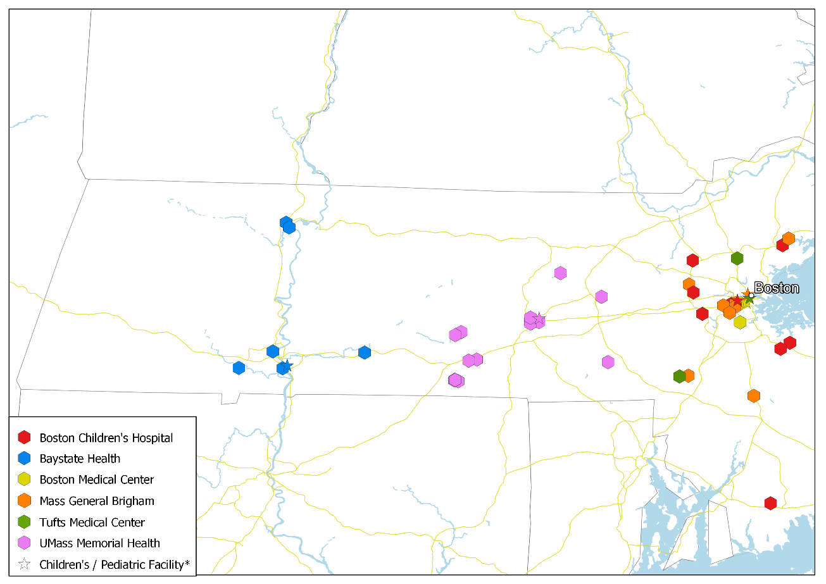
Health System | Facility Name | City and Town
Boston Children's Hospital | Boston Children's at Waltham | Waltham
 | Boston Children's at North Dartmouth | Dartmouth
 | Boston Children's at Brookline | Brookline
 | Boston Children's at Lexington | Lexington
 | Boston Children's at Peabody | Peabody
 | Boston Children's Hospital* | Boston
 | Boston Children's at Weymouth (New Location) | Weymouth
 | Boston Children's at Weymouth (Current Location) | Weymouth
 | Boston Children's at Needham (New Location) | Needham
Baystate Health | Baystate Behavioral Health- Child Partial Hospitalization Program | Holyoke
 | Baystate Brightwood HC/Centro De Sa | Springfield
 | Baystate Franklin Medical Center Infusion Bus | Greenfield
 | Baystate Franklin Medical Center | Greenfield
 | Baystate Medical Center/Baystate Children's Hospital* | Springfield
 | Baystate Noble Hospital | Westfield
 | Baystate Wing Hospital and Medical Centers | Palmer
Boston Medical Center | Boston Medical Center/Boston Medical Center Pediatrics* | Boston
 | Boston Med Ctr Radiology at Mattapan | Boston
 | Boston Med Ctr Radiology at Whittier | Tremont
Mass General Brigham | Massachusetts General Hospital/Mass General Hospital for Children (MGHfC)* | Boston
 | Mass General Waltham | Waltham
 | Mass General/North Shore Ctr Opt Cr | Danvers
 | Brigham And Women's Hospital | Boston
 | Brigham & Women Advanced Primary Ca | Boston
 | Brigham & Women Mri at W Bridgewater | West Bridgewater
 | Brigham & Women's Health Care Ctr | Brookline
 | Brigham & Women's/Mass Gen Hlt Care | Foxborough
 | Brigham And Women's Faulkner Hospital | Boston
Tufts Medical Center | Tufts Medical Center/Tufts Children's Hospital* | Boston
 | Tufts Medical Center Cancer Center | Stoneham
 | Tufts Norfolk Imaging | Norfolk
UMass Memorial Health | UMass Memorial Health - Harrington Hospital | Southbridge
 | UMass Memorial Med Ctr/Mem Campus | Worcester
 | UMass Memorial Med Ctr/Univ Campus/UMass Mem. Children's Medical Center* | Worcester
 | UMass Mem Med Ctr Milford Radiology | Milford
 | UMass Memorial Ambulatory Care Cent | Worcester
 | UMass Memorial Endoscopy Center | Worcester
 | UMass Memorial Med Ctr/Hahnemann | Worcester
 | UMass MMC Cancer at Marlboro Hosp | Marlborough
 | UMass Health Alliance - Clinton Hospital | Clinton
 | UMass Memorial Health- Harrington at Charlton | Charlton
 | UMass Memorial Health- Harrington at R169 rehabilitation | Charlton
 | UMass Memorial Health- Harrington at Spencer | Spencer
 | UMass Memorial Health- Harrington Behavioral Health | East Brookfield
 | UMass Memorial Health- Harrington Behavioral Health | Southbridge
 | UMass Memorial Health- Harrington Behavioral Health | Southbridge
 | UMass Memorial Health- Carrington Cancer Center | Southbridge
 | UMass Memorial Health- Harrington Occupational Health | Southbridge
Supplemental Figure 2: Overview of Boston Area Health Systems with Children’s Hospitals
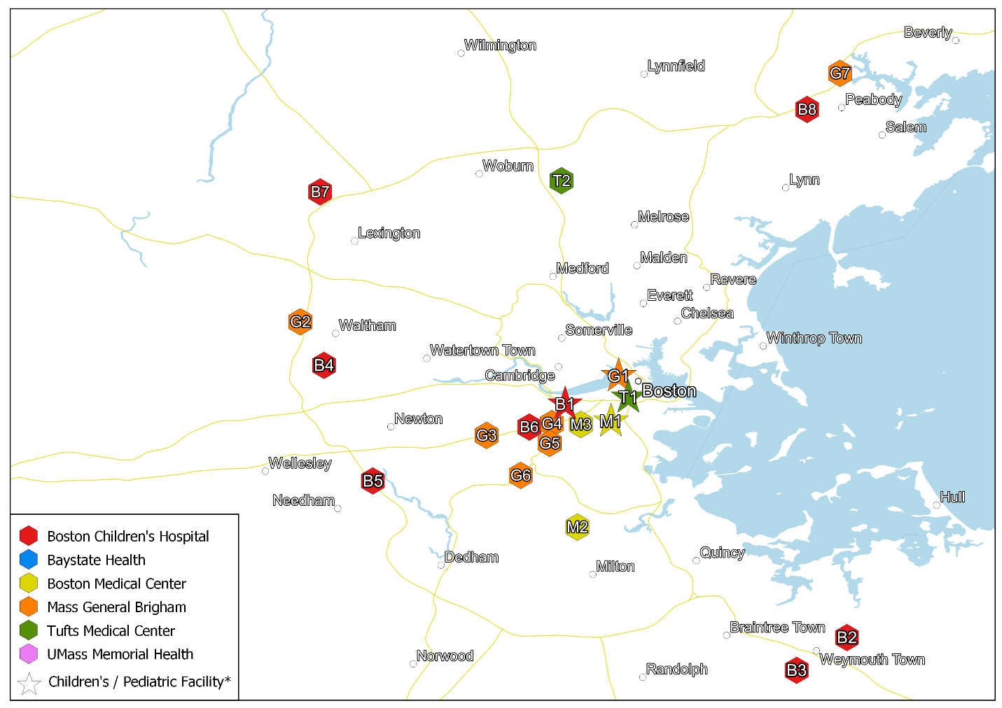
Health System | Facility Code | Facility Name | City and Town
Boston Children's Hospital | B1 | Boston Children’s Hospital* | Boston
 | B2 | Boston Children’s at Weymouth (New Location) | Weymouth
 | B3 | Boston Children’s at Weymouth (Current Location) | Weymouth
 | B4 | Boston Children’s at Waltham | Waltham
 | B5 | Boston Children’s at Needham | Needham
 | B6 | Boston Children’s at Brookline | Brookline
 | B7 | Boston Children’s at Lexington | Lexington
 | B8 | Boston Children’s at Peabody | Peabody
Tufts Medical Center | T1 | Tuft’s Medical Center/Tufts Children’s Hospital* | Boston
 | T2 | Tufts Medical Center Cancer Center | Stoneham
Boston Medical Center | M1 | Boston Medical Center/Boston Medical Center Pediatrics* | Boston
 | M2 | Boston Med Ctr Radiology at Mattapan | Boston
 | M3 | Boston Med Ctr Radiology at Whittier | Tremont
Mass General Brigham | G1 | Massachusetts General Hospital/Mass General Hospital for Children (MGHfC)* | Boston
 | G2 | Mass General Waltham | Waltham
 | G3 | Brigham & Women's Health Care Ctr | Brookline
 | G4 | Brigham And Women's Hospital | Boston
 | G5 | Brigham & Women Advanced Primary Care | Boston
 | G6 | Brigham & Women Faulkner Hospital | Boston
 | G7 | Mass General/ North Shore Ctr Opt Cr | Danvers
Supplemental Figure 3: Needham Service Area, ASC
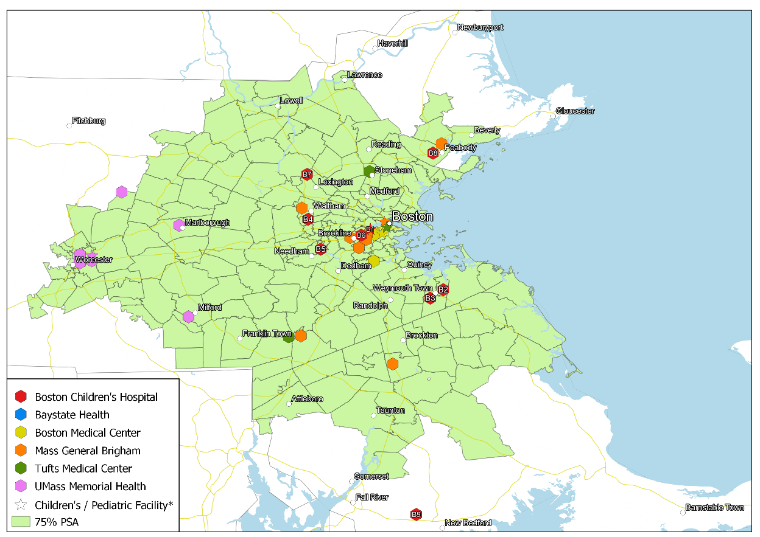
Facility Code | Facility Name | City and Town
B1 | Boston Children’s Hospital* | Boston
B2 | Boston Children’s at Weymouth (New Location) | Weymouth
B3 | Boston Children’s at Weymouth (Current Location) | Weymouth
B4 | Boston Children’s at Waltham | Waltham
B5 | Boston Children’s at Needham | Needham
B6 | Boston Children’s at Brookline | Brookline
B7 | Boston Children’s at Lexington | Lexington
B8 | Boston Children’s at Peabody | Peabody
B9 | Boston Children’s at North Dartmouth | Dartmouth

Supplemental Figure 4: Waltham Service Area, ASC
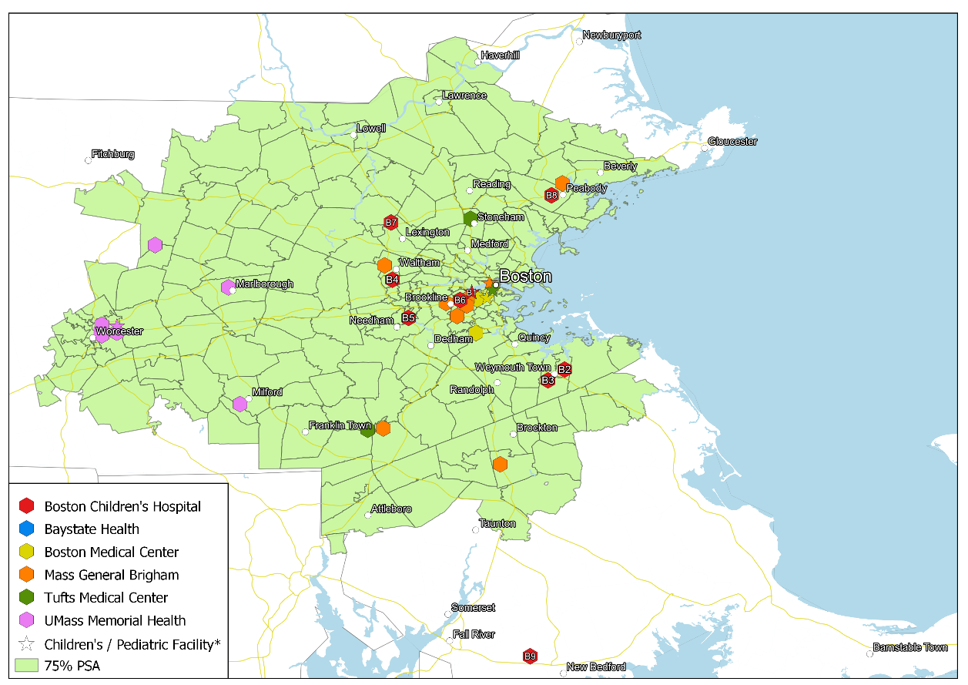
Facility Code | Facility Name | City and Town
B1 | Boston Children’s Hospital* | Boston
B2 | Boston Children’s at Weymouth (New Location) | Weymouth
B3 | Boston Children’s at Weymouth (Current Location) | Weymouth
B4 | Boston Children’s at Waltham | Waltham
B5 | Boston Children’s at Needham | Needham
B6 | Boston Children’s at Brookline | Brookline
B7 | Boston Children’s at Lexington | Lexington
B8 | Boston Children’s at Peabody | Peabody
B9 | Boston Children’s at North Dartmouth | Dartmouth

Supplemental Figure 5: Weymouth Service Area, ASC
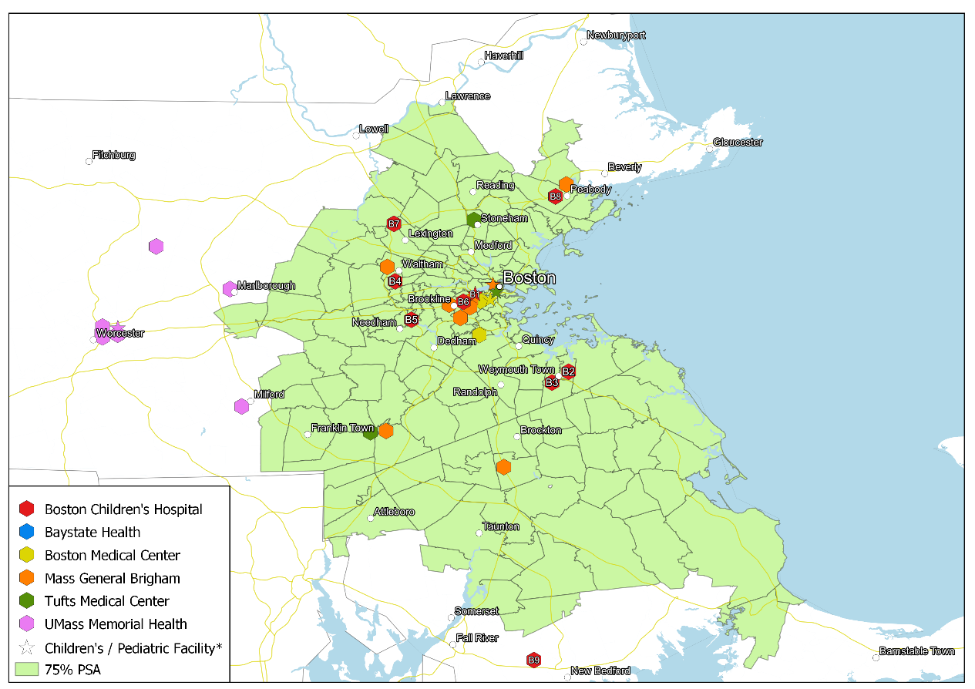
Facility Code | Facility Name | City and Town
B1 | Boston Children’s Hospital* | Boston
B2 | Boston Children’s at Weymouth (New Location) | Weymouth
B3 | Boston Children’s at Weymouth (Current Location) | Weymouth
B4 | Boston Children’s at Waltham | Waltham
B5 | Boston Children’s at Needham | Needham
B6 | Boston Children’s at Brookline | Brookline
B7 | Boston Children’s at Lexington | Lexington
B8 | Boston Children’s at Peabody | Peabody
B9 | Boston Children’s at North Dartmouth | Dartmouth

Supplemental Figure 6: Needham Service Area, MRI
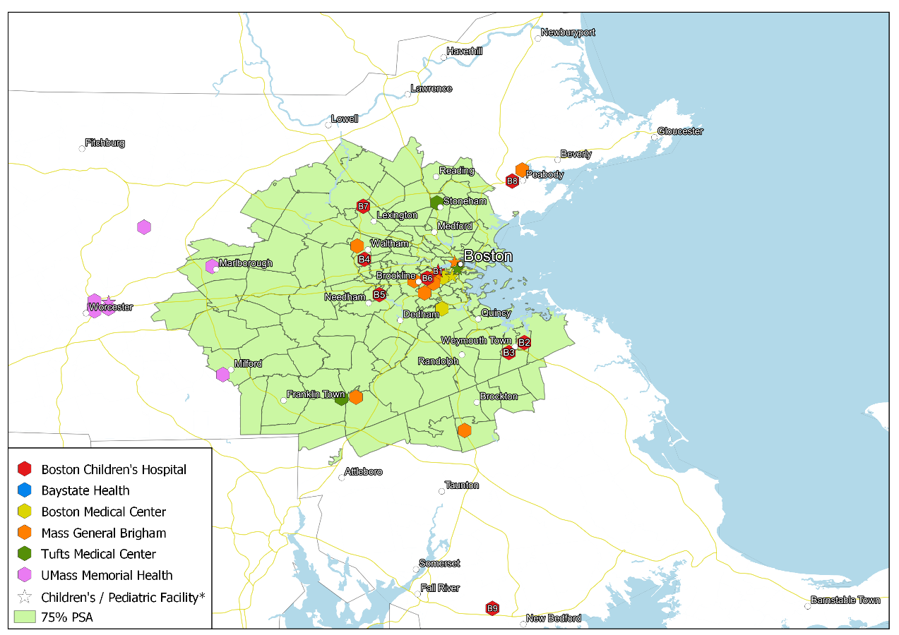
Facility Code | Facility Name | City and Town
B1 | Boston Children’s Hospital* | Boston
B2 | Boston Children’s at Weymouth (New Location) | Weymouth
B3 | Boston Children’s at Weymouth (Current Location) | Weymouth
B4 | Boston Children’s at Waltham | Waltham
B5 | Boston Children’s at Needham | Needham
B6 | Boston Children’s at Brookline | Brookline
B7 | Boston Children’s at Lexington | Lexington
B8 | Boston Children’s at Peabody | Peabody
B9 | Boston Children’s at North Dartmouth | Dartmouth

Supplemental Figure 7: Waltham Service Area, MRI
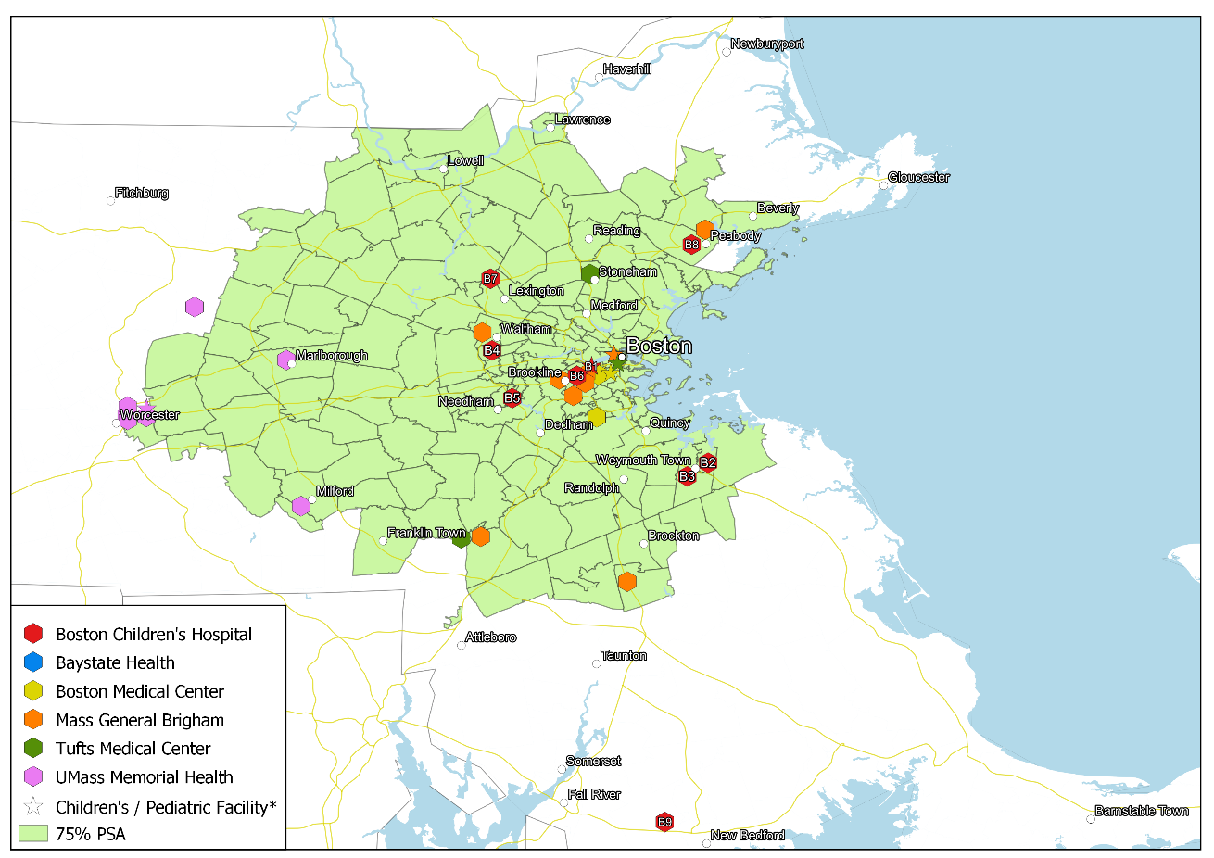
Facility Code | Facility Name | City and Town
B1 | Boston Children’s Hospital* | Boston
B2 | Boston Children’s at Weymouth (New Location) | Weymouth
B3 | Boston Children’s at Weymouth (Current Location) | Weymouth
B4 | Boston Children’s at Waltham | Waltham
B5 | Boston Children’s at Needham | Needham
B6 | Boston Children’s at Brookline | Brookline
B7 | Boston Children’s at Lexington | Lexington
B8 | Boston Children’s at Peabody | Peabody
B9 | Boston Children’s at North Dartmouth | Dartmouth

Supplemental Figure 8: Weymouth Service Area, MRI
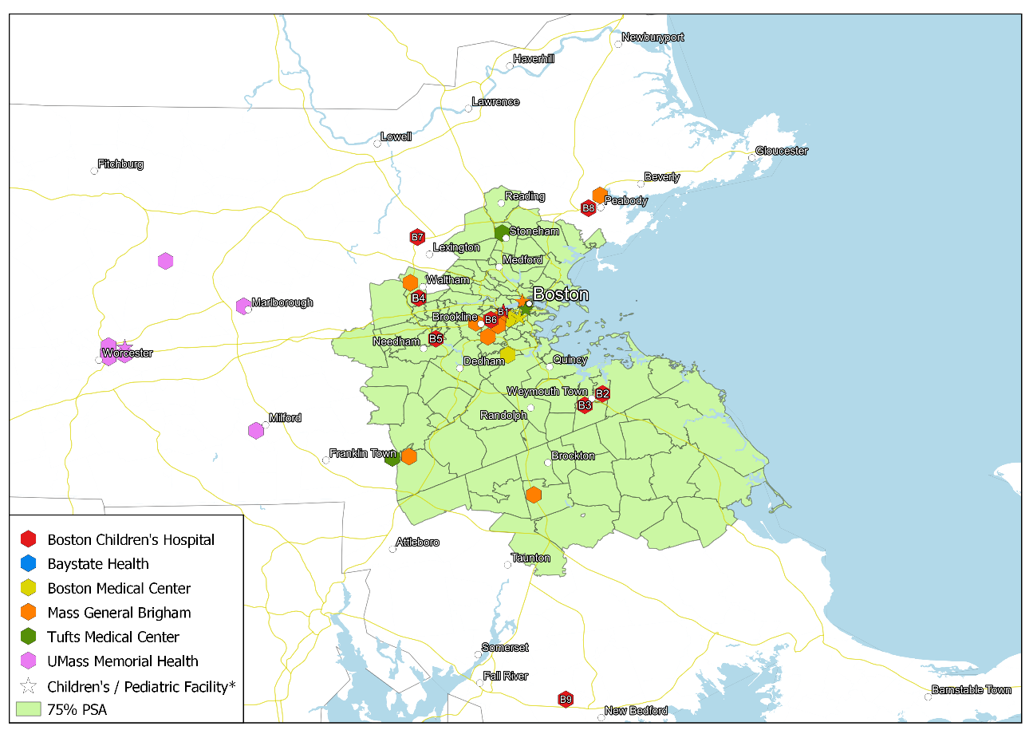
Facility Code | Facility Name | City and Town
B1 | Boston Children’s Hospital* | Boston
B2 | Boston Children’s at Weymouth (New Location) | Weymouth
B3 | Boston Children’s at Weymouth (Current Location) | Weymouth
B4 | Boston Children’s at Waltham | Waltham
B5 | Boston Children’s at Needham | Needham
B6 | Boston Children’s at Brookline | Brookline
B7 | Boston Children’s at Lexington | Lexington
B8 | Boston Children’s at Peabody | Peabody
B9 | Boston Children’s at North Dartmouth | Dartmouth

Supplemental Figure 9: Needham Service Area, Imaging
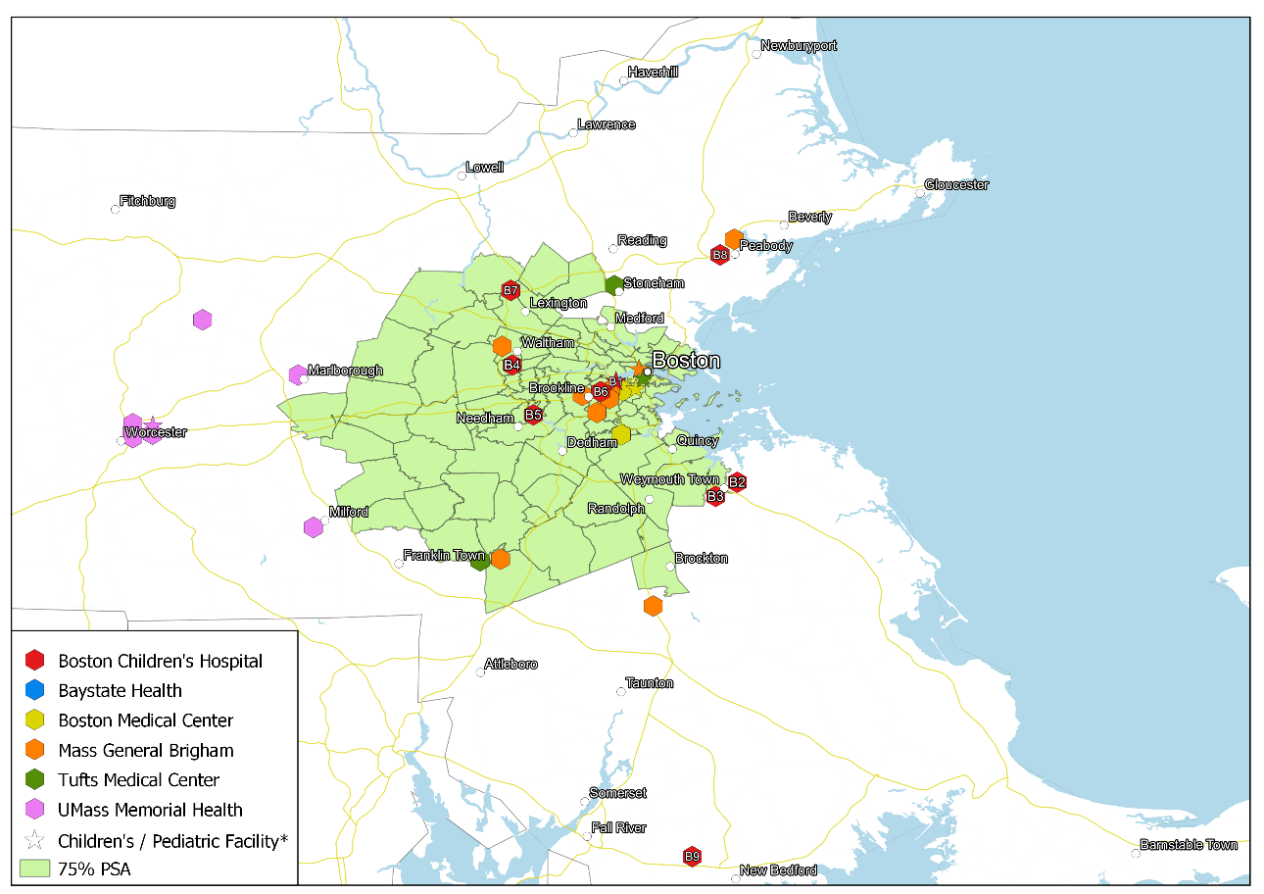
Facility Code | Facility Name | City and Town
B1 | Boston Children’s Hospital* | Boston
B2 | Boston Children’s at Weymouth (New Location) | Weymouth
B3 | Boston Children’s at Weymouth (Current Location) | Weymouth
B4 | Boston Children’s at Waltham | Waltham
B5 | Boston Children’s at Needham | Needham
B6 | Boston Children’s at Brookline | Brookline
B7 | Boston Children’s at Lexington | Lexington
B8 | Boston Children’s at Peabody | Peabody
B9 | Boston Children’s at North Dartmouth | Dartmouth

Supplemental Figure 10: Waltham Service Area, Imaging
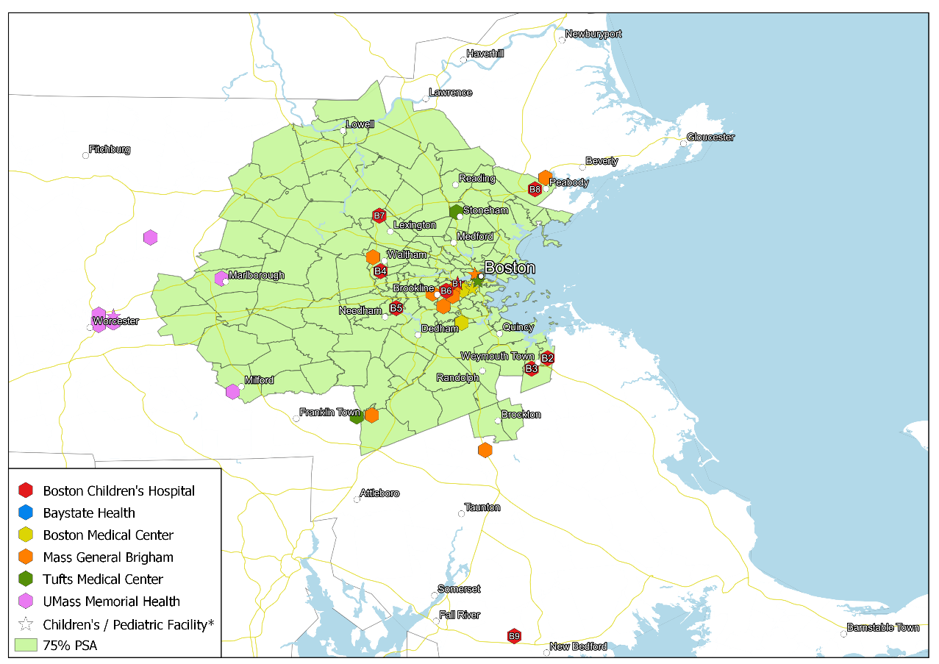
Facility Code | Facility Name | City and Town
B1 | Boston Children’s Hospital* | Boston
B2 | Boston Children’s at Weymouth (New Location) | Weymouth
B3 | Boston Children’s at Weymouth (Current Location) | Weymouth
B4 | Boston Children’s at Waltham | Waltham
B5 | Boston Children’s at Needham | Needham
B6 | Boston Children’s at Brookline | Brookline
B7 | Boston Children’s at Lexington | Lexington
B8 | Boston Children’s at Peabody | Peabody
B9 | Boston Children’s at North Dartmouth | Dartmouth

Supplemental Figure 11: Weymouth Service Area, Imaging
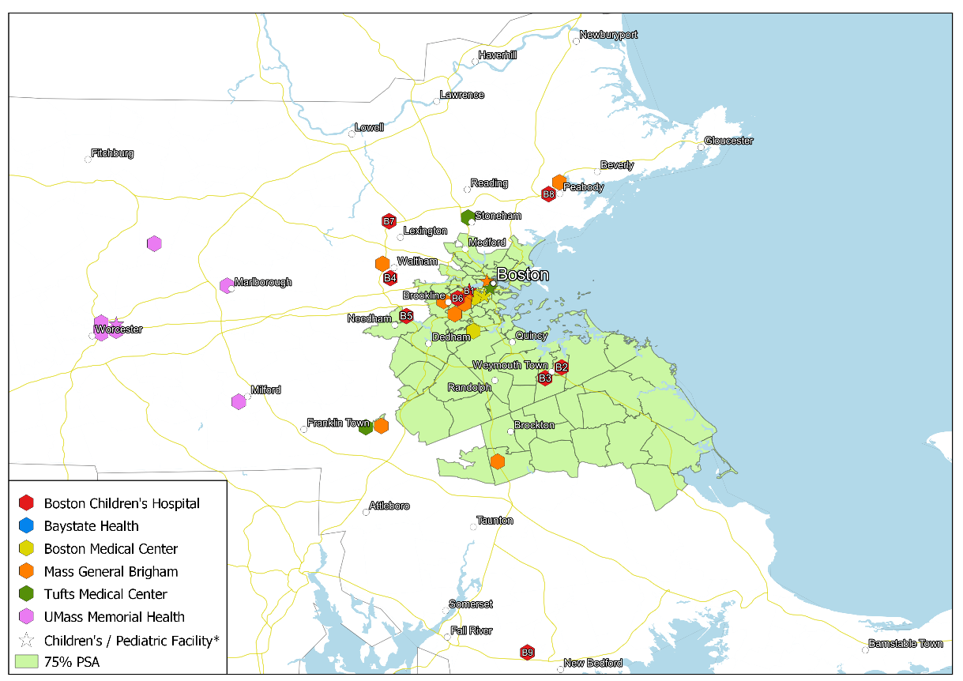
Facility Code | Facility Name | City and Town
B1 | Boston Children’s Hospital* | Boston
B2 | Boston Children’s at Weymouth (New Location) | Weymouth
B3 | Boston Children’s at Weymouth (Current Location) | Weymouth
B4 | Boston Children’s at Waltham | Waltham
B5 | Boston Children’s at Needham | Needham
B6 | Boston Children’s at Brookline | Brookline
B7 | Boston Children’s at Lexington | Lexington
B8 | Boston Children’s at Peabody | Peabody
B9 | Boston Children’s at North Dartmouth | Dartmouth

Massachusetts All-Payer Claims Database (MA APCD) 2016-2020 Documentation Guide. Center for Health Information and Analysis. 2020. https://www.chiamass.gov/assets/docs/p/apcd/MA-APCD-CY2020/MA-APCD-CY2020-Documentation-Guide.pdf.
According to the Documentation Guide, by end of 2018, only 25% of members of self-insured plans were included.
Full list of variables is at https://www.chiamass.gov/assets/docs/p/apcd/MA-APCD-CY2020/MA-APCD-CY2020-Government-Request-Data-Specification-Workbook.xlsx.
UMass Donahue Institute Population Estimates Program; at http://www.pep.donahue-institute.org/ (accessed May 10, 2022).
https://matracking.ehs.state.ma.us/eohhs_regions/eohhs_regions.html
Huber, Stephan and Rust, Christoph, osrmtime: Calculate Travel Time and Distance with OpenStreetMap Data Using the Open Source Routing Machine (OSRM) (January 26, 2016). The Stata Journal, Volume 16, Number 2: pp. 416-423, 2016. Available at SSRN: https://ssrn.com/abstract=2691551. osrmtime calculates the shortest travel distance and travel time between two points using an algorithm. The program takes XY Data (latitude, longitude) and simulates driving, cycling, or walking on an open source map layer. osrmtime relies on Open Street Map data to generate distance results.
We also referenced among other sources, websites identifying hospitals to which children could be referred or transferred for care at locations with pediatric services. These include standalone named children’s hospitals, and ones co-located with large tertiary hospital yet identified as “Children’s Hospital” See, e.g., https://www.mass.gov/service-details/hospitals-for-children-in-massachusetts.
We are able to identify BCH Weymouth under the provider name “children's hospital pediatric associates at Weymouth”. However, there are no ASC, imaging, or MRI claims under this facility.
The NPI registry is provided by CMS and includes information on all providers licensed to serve Medicare patients. Information includes name, location, specialties which were used in combination with the APCD from Massachusetts.
The main facility for pediatric care is called “Baystate Children’s Hospital.” Baystate Children’s Hospital is a “107-bed and 57-bassinette hospital located within Baystate Medical Center” and is the “only accredited full-service children’s hospital in western Massachusetts.” “About Baystate Children’s Hospital.” https://www.baystatehealth.org/locations/childrens-hospital.
The main facility for pediatric care is called “Boston Children’s Hospital.” It is the primary pediatric teaching hospital for Harvard Medical School.” See “About Us.” https://www.childrenshospital.org/about-us
The main facility for pediatric care is called “Boston Medical Center Pediatrics” and is located at the “Yawkey Ambulatory Care Center at Boston Medical Center” and “Shapiro Building” at Boston Medical Center. “The Pediatrics Department at Boston Medical Center offers primary care and a variety of specialty care services to infants, children and young adults.” “The Division of Pediatric Emergency Medicine is part of the Department of Pediatrics at Boston Medical Center and Boston University School of Medicine. Boston Medical Center plays a major role in the care of children in Boston, especially from communities that are traditionally under-served by the health care system. BMC’s Pediatrics Department is a leading force in ambulatory pediatrics nationally and an incubator of innovative programs that address pediatric health care needs as a comprehensive, multifaceted challenge.” See “Pediatric Care.” https://www.bmc.org/pediatric-care and “Pediatric Emergency Medicine.” https://www.bmc.org/emergency-medicine/residency/pediatric-emergency-medicine.
The main facility for pediatric care is called “MassGeneral Hospital for Children.” MassGeneral Hospital for Children “has more than 300 physicians, 50 medical specialties, 15 surgical services, state-of-the-art facilities and technologies, and preventive and primary care for the health care needs of infants, children and adolescents.” Annually, more than 12,000 pediatric emergency visits, 3,000 admissions and 3,500 births take place at MGfC. See “About Us.” https://www.massgeneral.org/children/about.
The main facility for pediatric care is called “Tufts Children’s Hospital.” “Tufts Children’s Hospital is a major academic medical institution with innovative programs in clinical care, biomedical research, education and health care delivery. It is only one of two stand-alone full-service children’s hospitals in Massachusetts, complete with a Level 1 emergency department and a Level 3 Neonatal Intensive Care Unit (NICU). Aligned with Tufts Medical Center to care for patients and families all along the continuum of care, we offer a full range of inpatient and outpatient services. facility within the Tufts Medical Center complex.” See “Who We Are.” https://www.tuftschildrenshospital.org/About-Us/Overview.
The main facility for pediatric care is called “UMass Children’s Medical Center.” “UMass Children’s Medical Center is located in Worcester and is the only children’s hospital in Central Massachusetts. More than 200 medical and surgical experts in more than 30 specialties devote their expertise to the care of infants, children and adolescents - care that truly surrounds the family. UMass Children’s Medical Center has a 10-bed Pediatric Intensive Care Unit, a 49-bed Neonatal Intensive Care Unit and a 30-bed Inpatient Pediatric Unit staffed with pediatric trained specialists. See “Children’s Medical Center/Pediatrics.” https://www.ummhealth.org/umass-memorial-medical-center/childrens-medical-center and « About Our Children’s Medical Center. » https://www.ummhealth.org/umass-memorial-medical-center/services-treatments/childrens-medical-center/about-our-children%E2%80%99s-medical-center.
https://www.childrenshospital.org/patient-resources/financial-and-billing-matters/hospital-services-and-charges.
Available at https://www.dcamedical.com/pdf/DCA%202019%20CPT%20Code.pdf.
Available at https://www.choa.org/~/media/files/Childrens/medical-professionals/physician-resources/radiology/rad_cptcode_x-ray.pdf.
Mass General Brigham Incorporated Determination of Need Applications - Massachusetts General Hospital # MGB-20121612-HE, Brigham and Women’s Faulkner Hospital # MGB20121716-HE, and Multisite # Multisite-21012113-AS Independent Cost-Analysis Comment. Available at https://www.mass.gov/doc/commonwealth-of-massachusetts-health-policy-commission-pdf-0/download. See, Appendix I.A: HPC Methods and Data Sources Overview.
https://www.acgme.org/globalassets/Pediatric_Surgery_Mappings_2020.pdf.
Available at: https://www.cookmedical.com/wp-content/uploads/2021/12/RG_ESC_50099_RE_202201-1.pdf.
https://aasm.org/clinical-resources/coding-reimbursement/sleep-medicine-codes/.

