ICC Family Engagement Subcommittee Meeting
Minutes
January 3, 2024

In attendance: Dina Tedeschi (v), Cambria Russell (v), Sanya Agrawal (v), Mallorie Brown (v), Johan de Besche (v), Liz Cox, Kathleen Amaral, Tory Karlsen, Pat Cameron, Sanya Agrawal (v), Casandra Greeno (v), Jennifer Clark (v), Amy Muehlberger, Mary Bishop, Kris Martone-Levine; voting members absent: Asha Abdullahi, Shirley Fan-Chan, Rosa Hsu, Andrea Goncalves Oliveira, Michelle Grewal. Meeting held virtually.

Agenda:
- Introductions
- Review Charge
- Meeting Minutes Approval
- Presentation/s
- Discussion
- Questions
- Action plan
- Adjourn

Quorum met at 10:12am. The roll call was done, and the meeting was called to order at 10:12 am. 6 voting members for a quorum (7 if Johan’s attendance counts towards quorum).

Welcome by Dina Tedeschi, ICC, and Family Engagement Co-chair.

Who are the voting members for Family Engagement – are ICC voting members who attend a subcommittee meeting considered voting members in that subcommittee meeting?

Minutes: Minutes can only be shared online with voting members. Minutes can always be changed after approval.

Dina motioned to approve the minutes. Cambria seconded the motion. Only voting members that were in attendance can vote to approve minutes. Kris will add Mallorie and Asha to attendance – voting members absent from the December 6, 2023, meeting. Should chat be included? Request clarification. Dina motioned to approve minutes; Cambria seconded the motion. The roll call of those in attendance at the December 6 meeting was completed to approve minutes.

Tomorrow (January 4, 2024), the Steering Committee will discuss combining the Family Engagement and Racial Equity subcommittees and their charges. At today’s Family Engagement meeting, the Family Engagement and Racial Equity committee chairs are looking to discuss the success of previous charges in preparation for the Steering Committee meeting.

Last year, the Racial Equity Committee was charged with providing guidance on CLAS training that the EI Division would be doing. This was completed.

This year, the possible charge will be focusing the Family Engagement and Racial Equity Committees on the NCSEAM Impact Family Survey with the charge of ensuring that the NCSEAM Impact Family Survey is as family-friendly and family-focused as possible. As we move from a random sampling of families to a census sampling approach, minimizing barriers for families, especially nonresponse bias is important. There was discussion of the current NCSEAM Impact Survey, which is currently feeling more OSEP-focused, and that this is an opportunity to make this more about and for families. Questions like, “How will it work, and how do we make it better?” came up. Census sampling shift is a huge change – there are biases that may make it difficult for families to respond, which are multiplied by being a family of color.

Dina reminded the group of the Family Engagement Subcommittee’s achievements last year. They included a single-page infographic, the addition of an introductory statement, and best practices, including additional touchpoints.

Family and Equity overarch pillars in the FY24 ICC strategic plan. Reviewed: Pillars of ICC Strategic Plan to pull key points that may help guide conversations tomorrow, specifically around public awareness and CLAS. The question around access to data around underrepresentation- do the demographics match the population? How can we use this information to help focus our work to provide specific and targeted recommendations? How are staffing issues impacting equitable service delivery?

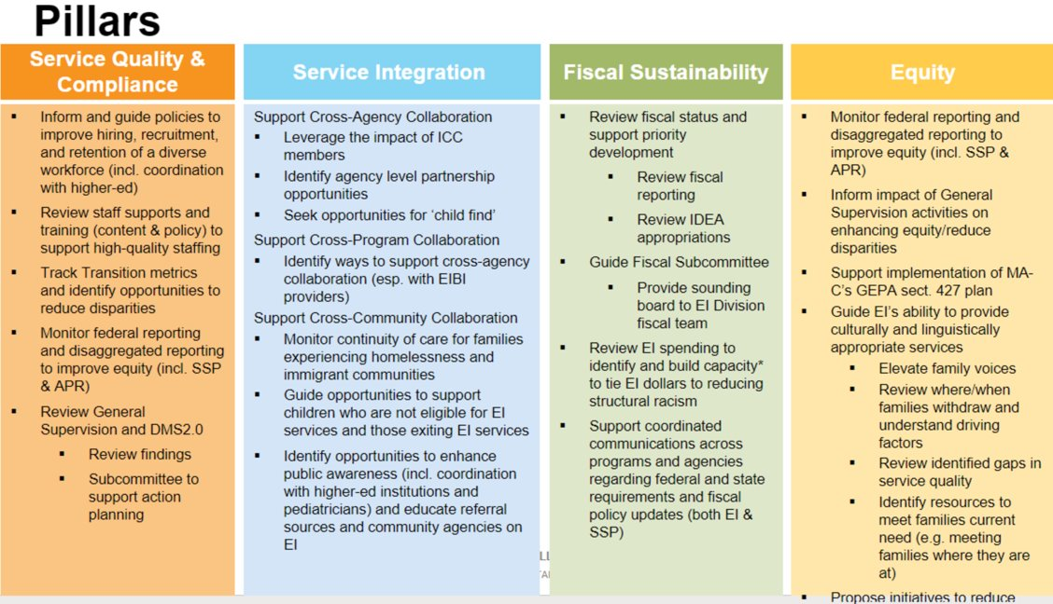

Cross collaboration opportunities:
Service Integration:
- Public awareness ties into NCSEAM touchpoints
- Monitor continuity of care for families experiencing homelessness and immigrant communities.
Equity:
- EI’s ability to provide culturally and linguistically appropriate services.
- As well as the Section 427 plan. Equity and family engagement tie together closely.

Racial equity training is now referred to as CLAS training (OSEP language).

A request for data access to inform what communities are underrepresented came up. This data exists and is captured – there are HIPPA implications – ‘ready to go, except there are too many small number inconsistencies that it causes inferences.’ The EI Division is working on this. Would this data be available to ICC as an advisory body? There may be some general high-level data that could help inform this committee’s work. If every family is asked to complete the NCSEAM Impact Family Survey, would it be possible to compare the service data to the NCSEAM Impact Family Survey data? And add cross-referencing to programs that get great results (best practices). Dina shared that Shari presented NCSEAM regional information data and the results from the NCSEAM dashboard. Garnered a better understanding of the data and program-related results.

Support cross-community challenges. Dealing with staff shortages, kids are losing services. In western MA, there are staff shortages for children transitioning, and they are not receiving the services they need. Staffing shows up in all of the pillars of the ICC Strategic Plan – it is a known challenge. Post-pandemic staff shortages across the board and there is a new normal in the making. EI used to be the catch all and EI can no longer do this level of work because of staffing. It has a domino effect, and there isn’t the opportunity to build rapport with families to better support them. Service coordinators are not as integrated into families' lives, further confirming that there is a new normal. Paring down and refocusing efforts so that the care cascades continue to have an impact on children and families. It is not all bad; parents have taken more ownership to meet their child’s needs because they have been supported by the PIWI philosophy; there is a happy medium, and that is where EI needs to get to. New parents to the system don’t know how it was, and this shift in parents' experiences has resulted in parents feeling more competent and confident in supporting their child/ren. Preschool and elementary school teachers are experiencing a similar new normal where families/parents have/need more onus. Increased workload on EI providers 20 families/week or 40 families/month – maintaining relationships, paperwork, deadlines, etc., becomes unwieldy and impacts the workload on individual providers.

Acknowledging what was, is, and is going to be, is critical to navigating new normal. This adds another step in the EI process of helping families build advocacy and leadership skills to better navigate the future of their children.

A request was made to perform the PDSA Cycle on the NCSEAM Impact Family Survey after consensus sampling. This review will evaluate the impacts of implementing a new NCSEAM Family Survey census sampling.

Discussion about any other outstanding topics to be raised at the Steering Committee.

Dina motioned to adjourn at 11:13 am; Cambria seconded the motion. The meeting adjourned at 11:13 am.

Respectfully submitted,
Kris Martone-Levine

