**Massachusetts Department of Public Health**

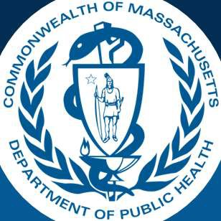

# Everything You Wanted to Know About the Impacts on Family Survey

### *(but were afraid to ask)*

Emily White, PhD, BCBA-D, LABA

Director, Early Intervention Division

## It’s easier than explaining what you really do.

* 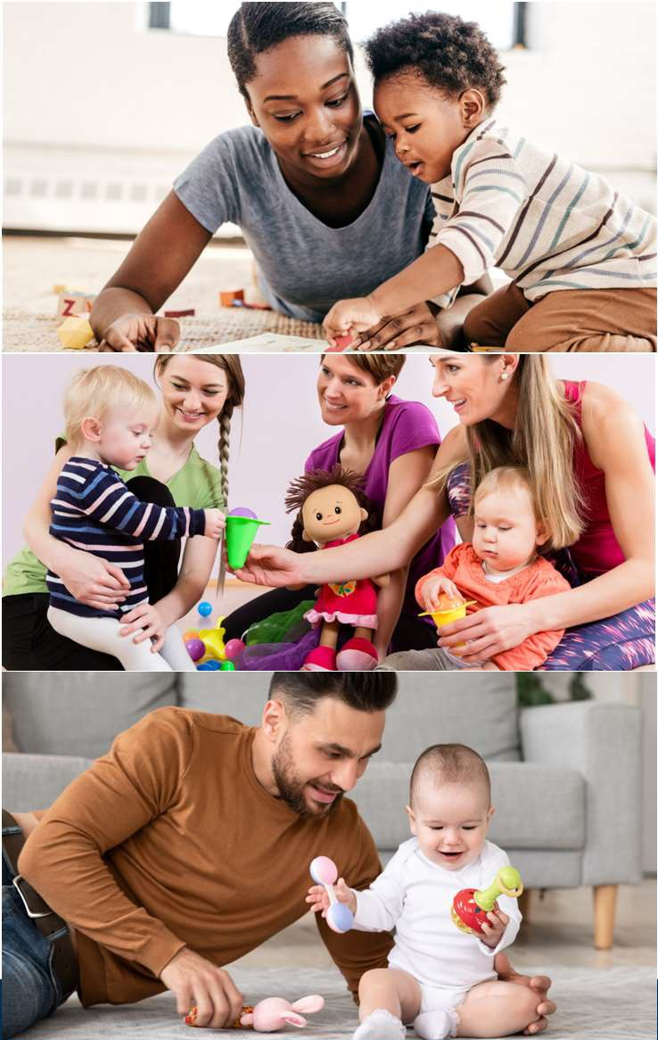 ~~Complicated Math~~

**Overview**

* ~~Psychometrics or Rausch Analyses~~
* Photos of adorable babies
* Describe what the survey is
* How we use
* What we learn from it

Massachusetts Department of Public Health | mass.gov/dph

3

## What does the EI Family Survey Look Like?

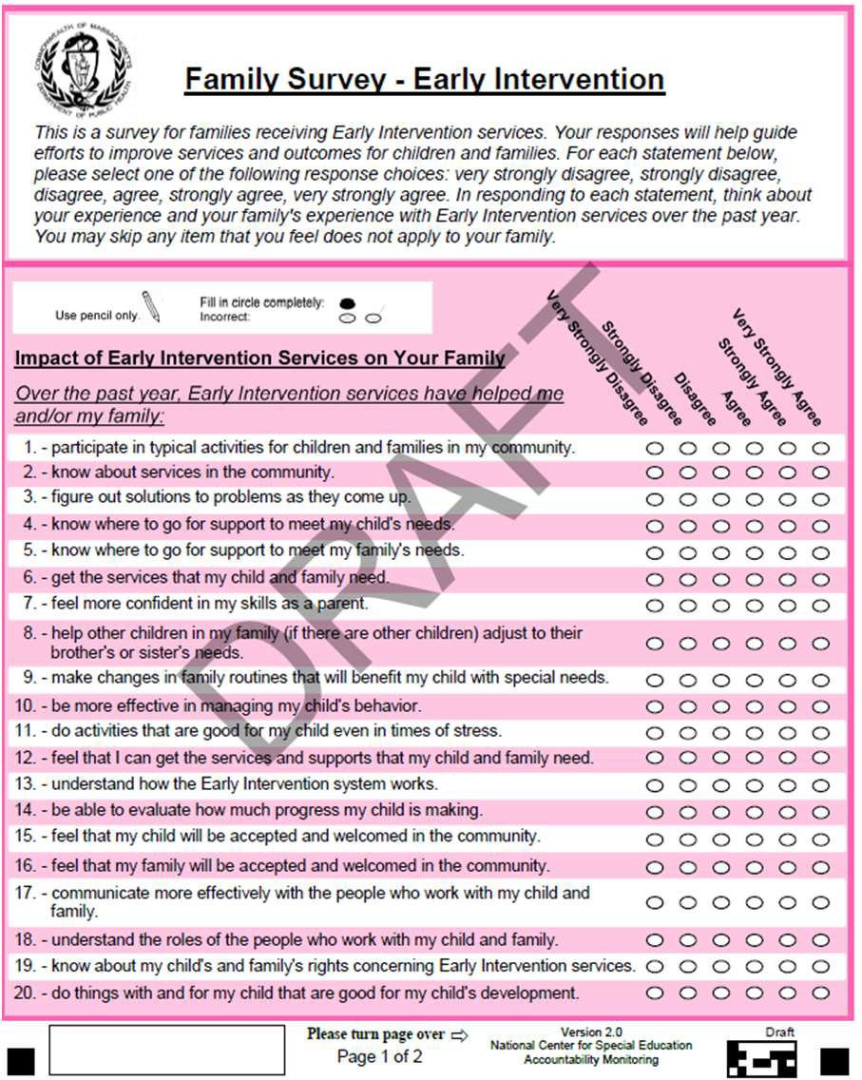 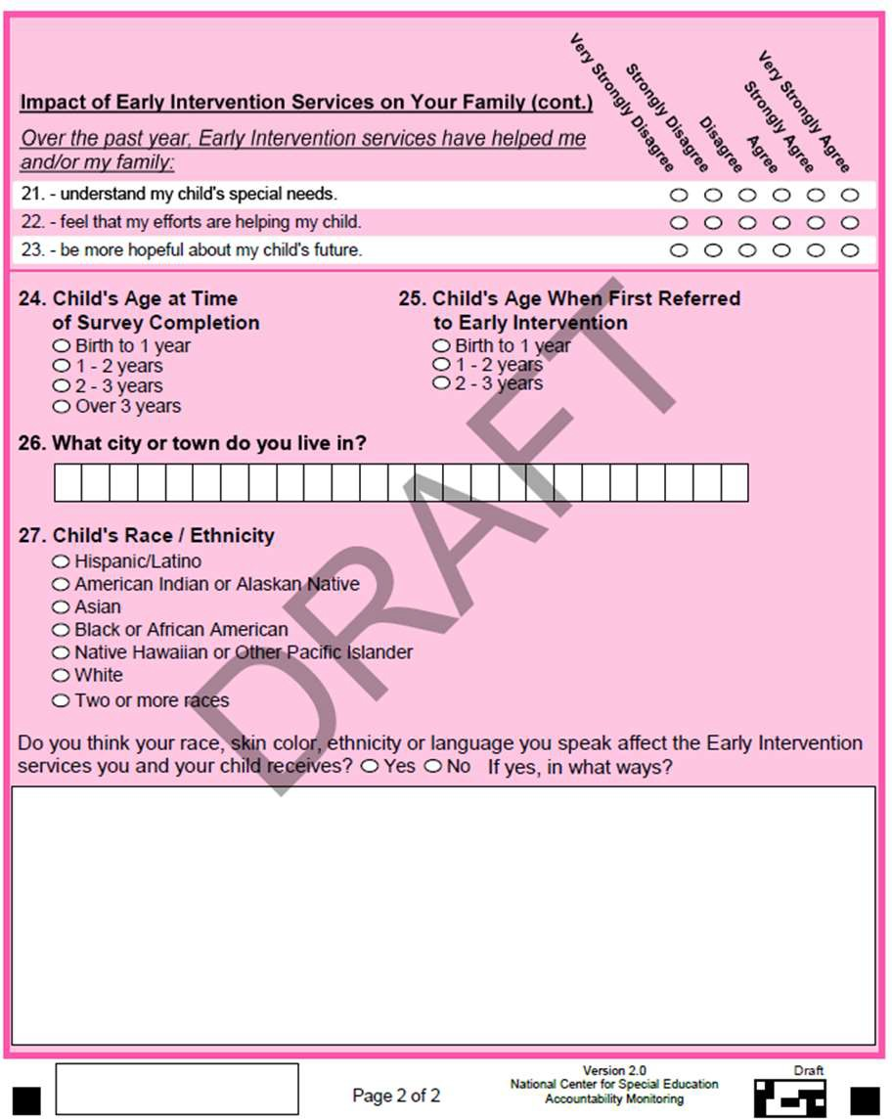

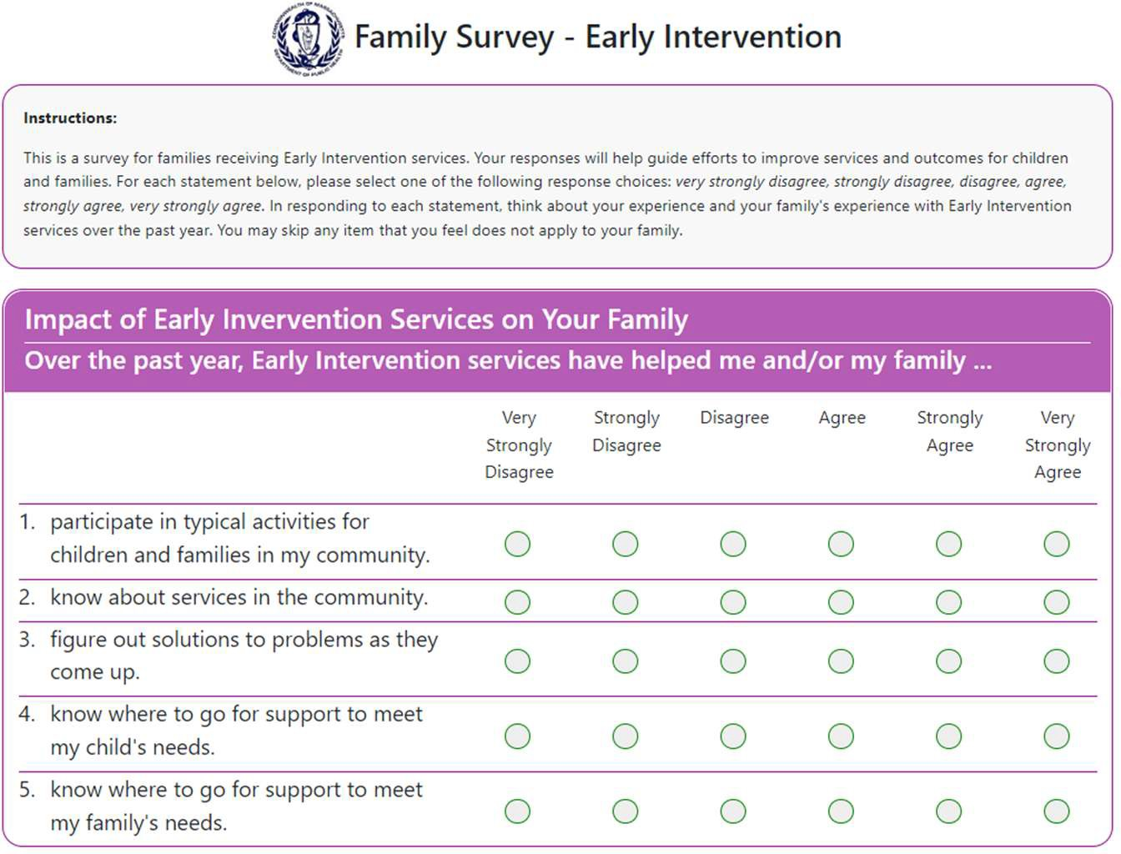

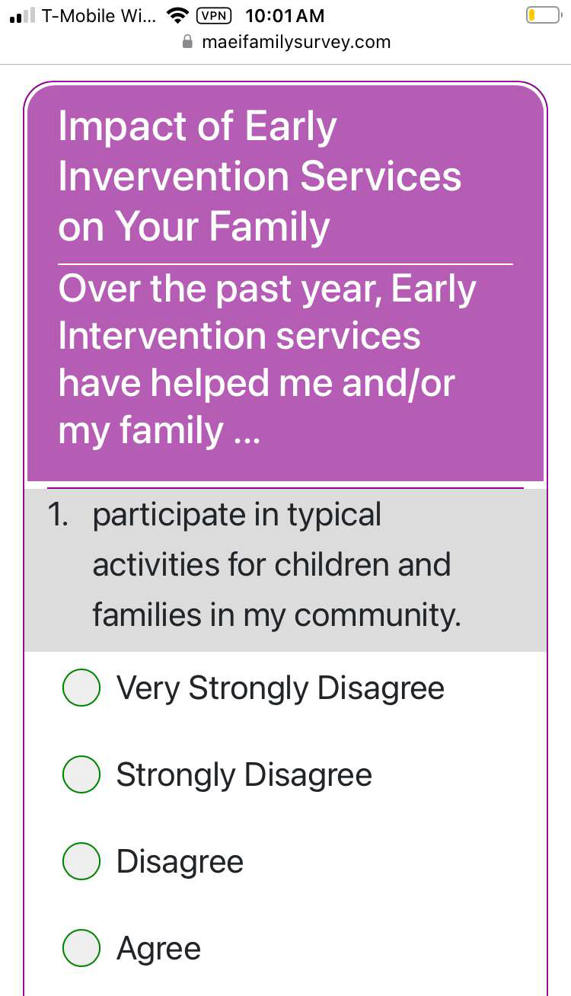

## When can I take the survey?

**MYTH:**

40.00%

35.00% 33.40% 32.70%

31.22% 32.60%

30.00% 27.82%

25.00% 23.29%

20.00%

15.00%

10.00%

5.00%

0.00%

#### NCSEAM*Impactson* FamilySurveyisONLY openOctober&April

Regional Response Rate State Response Rate

**MYTH:**

40.00%

35.00% 33.40% 32.70%

31.22% 32.60%

30.00% 27.82%

25.00% 23.29%

20.00%

15.00%

10.00%

5.00%

0.00%

#### NCSEAM*Impactson* FamilySurveyisONLY openOctober&April

**FACT:**

**NCSEAM*Impactson FamilySurveyisopen July1-May30***

Regional Response Rate State Response Rate

## Why do we have a family survey?

Parents’ Perspectives are Data

**Parents’ Experiences Inform Programmatic Improvement**

* 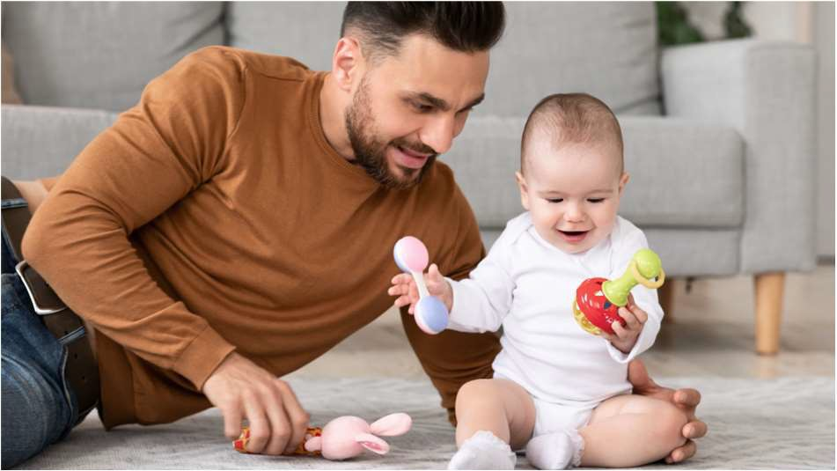Results indicator
* Percentage of families participating in Part C/early intervention who report that early intervention services have helped the family:
  + Know their rights
  + Effectively communication their children’s needs
  + Help their children develop and learn
* 29-question *Impacts on Family Scale* developed by the National Center for Special Education Accountability and Monitoring

## Is the survey available in multiple languages?

###### Seven Languages

**The Survey is Available in Seven Languages**

1. Arabic
2. Chinese
3. English
4. Haitian Creole
5. Portuguese
6. Spanish
7. Vietnamese

## Does everyone receive a survey?

No, only a sample of families enrolled in Part C/early intervention receive a survey.

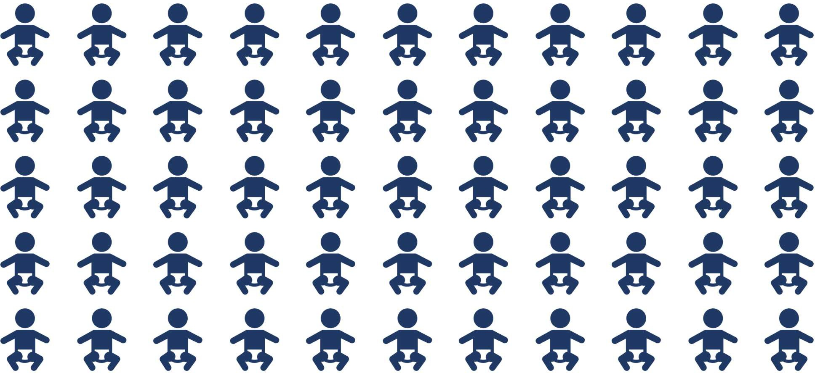

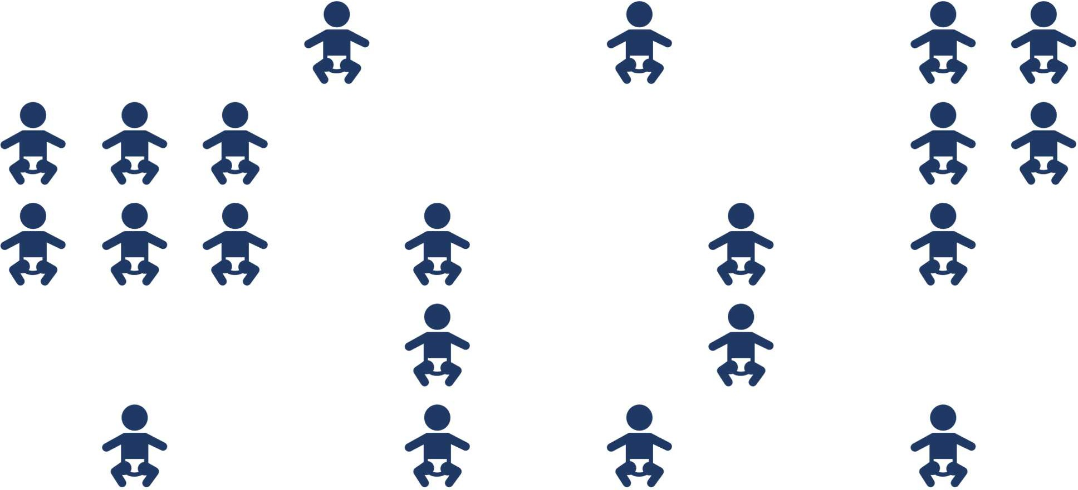



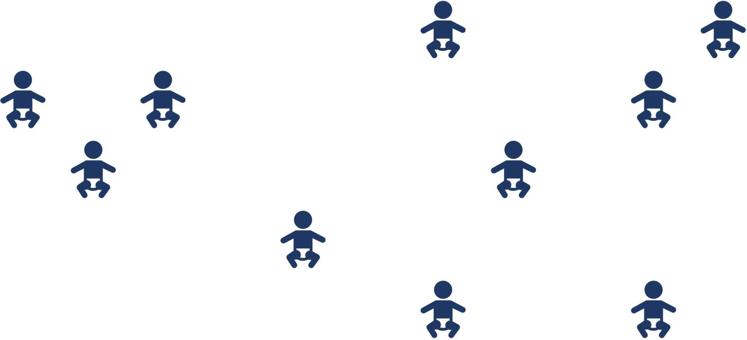

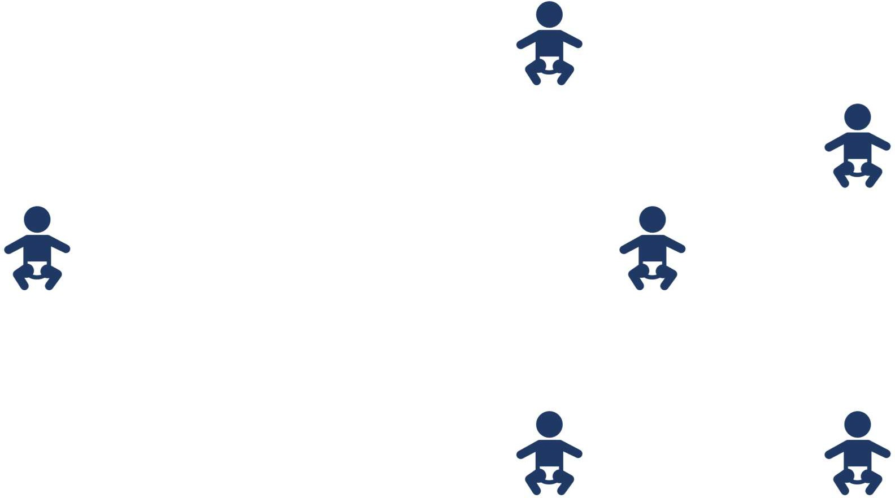

## Does anyone know if I completed the survey?

Yes, the EI Program Director will know if you have completed the survey.

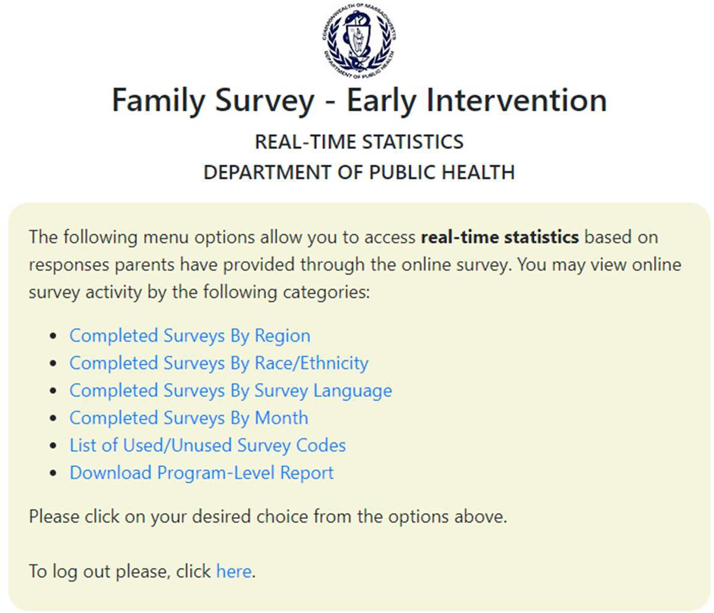

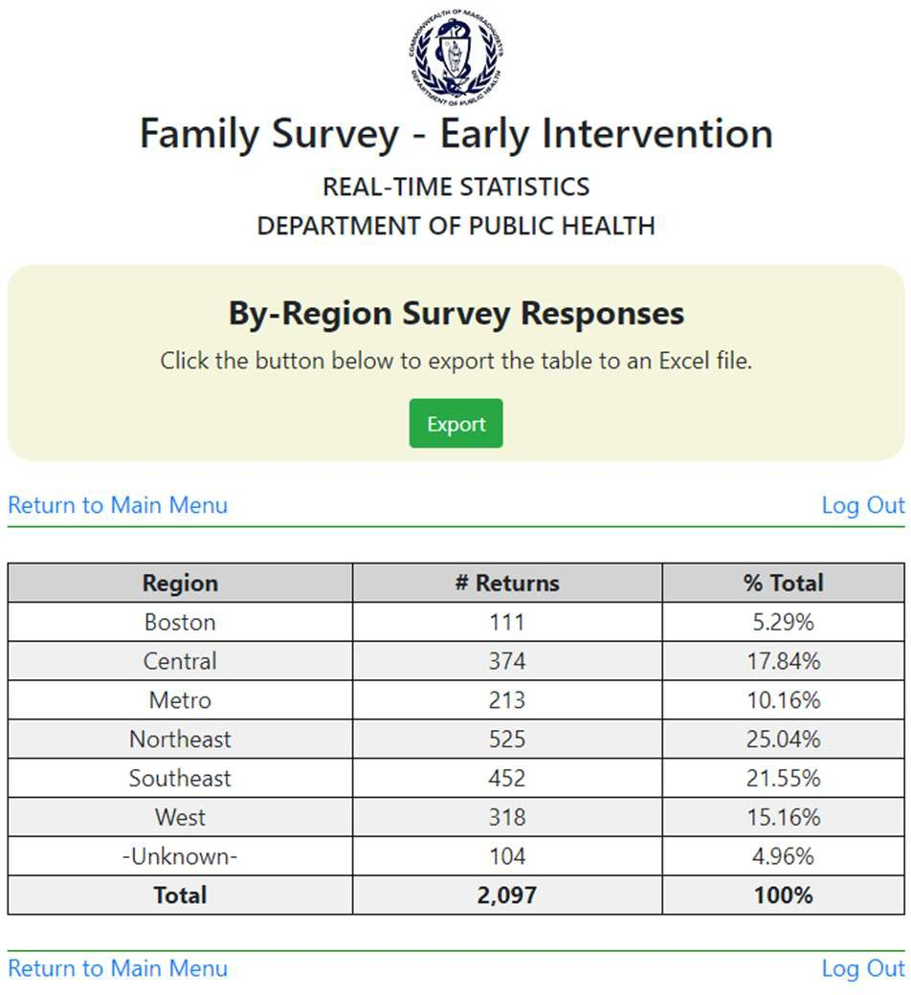

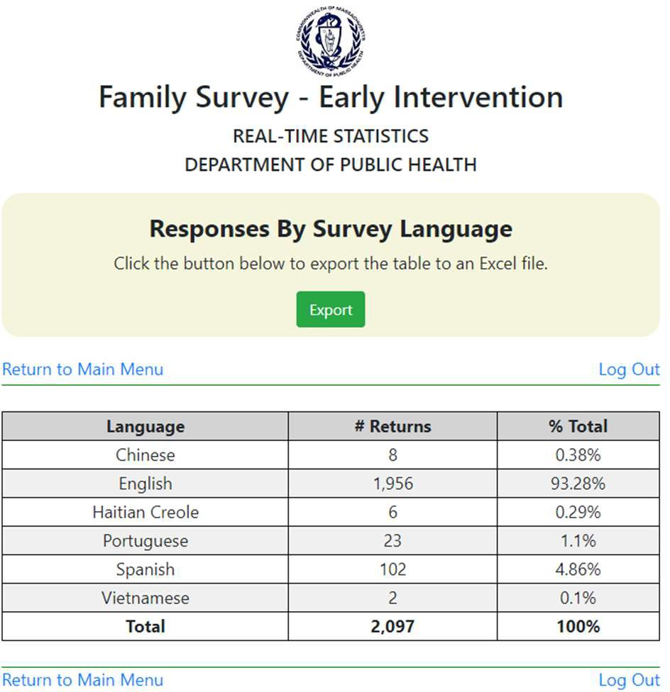

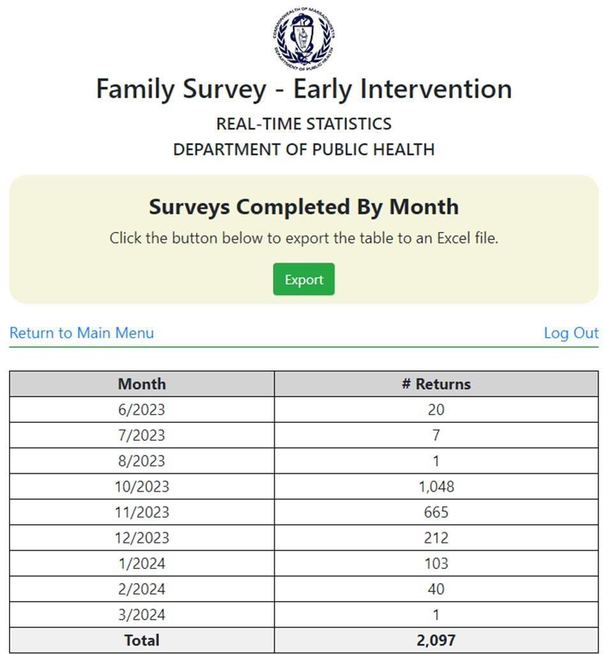

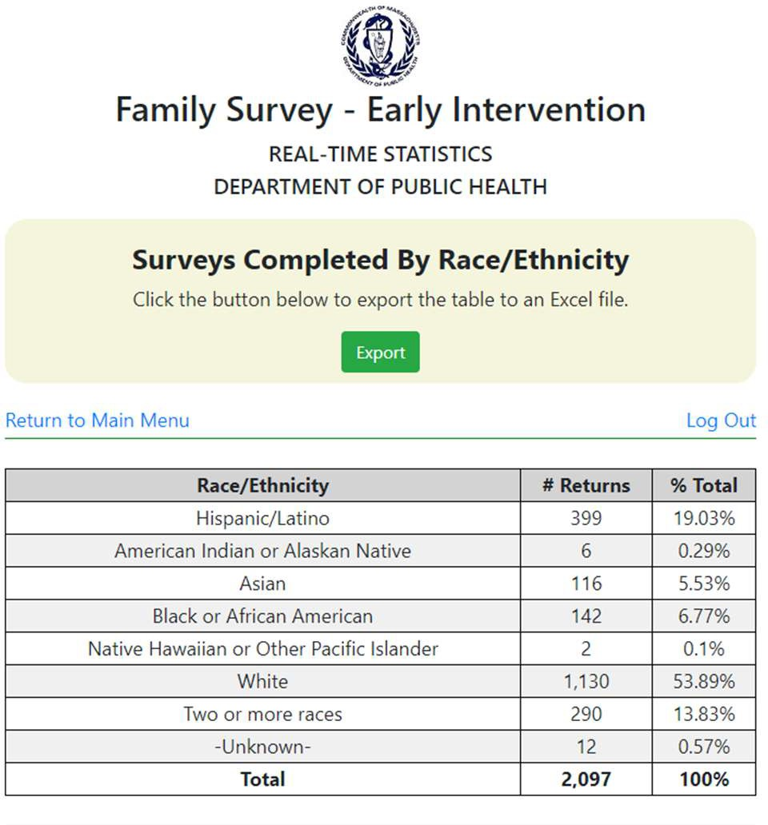

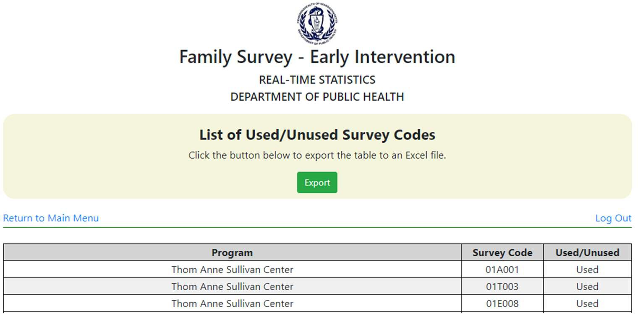

## Does my early intervention provider know how I answered the questions on the survey?

No, your responses are confidential.

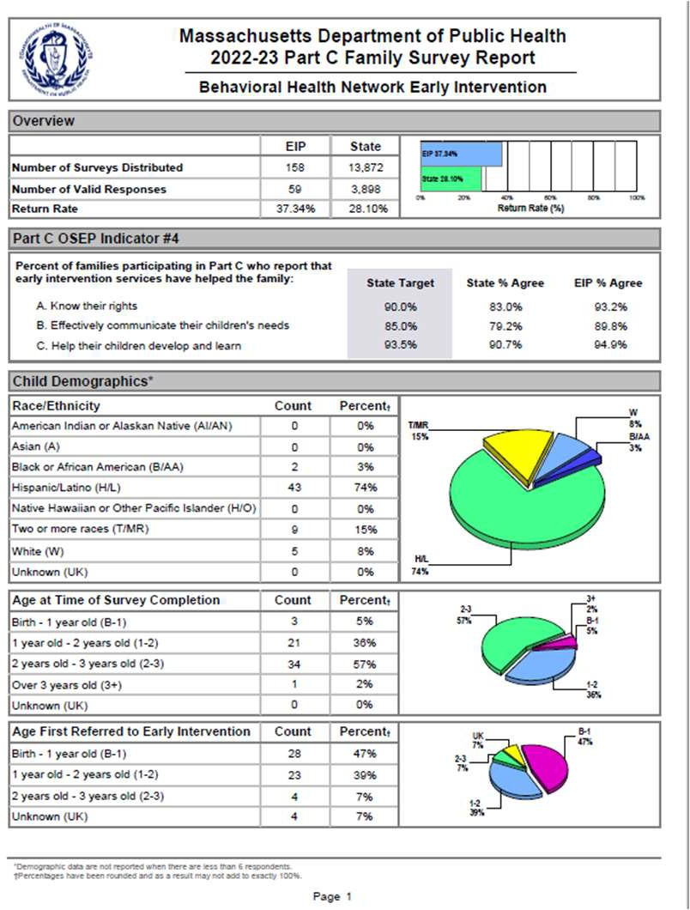 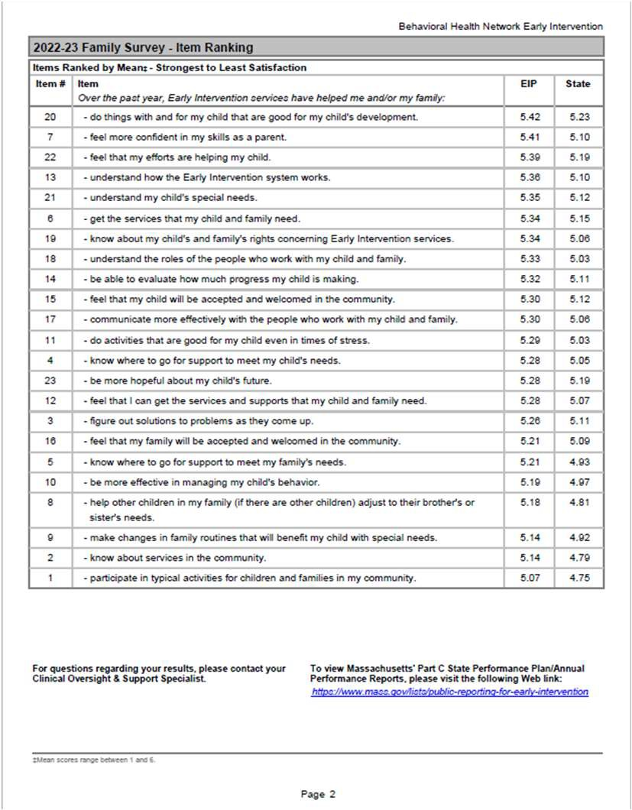

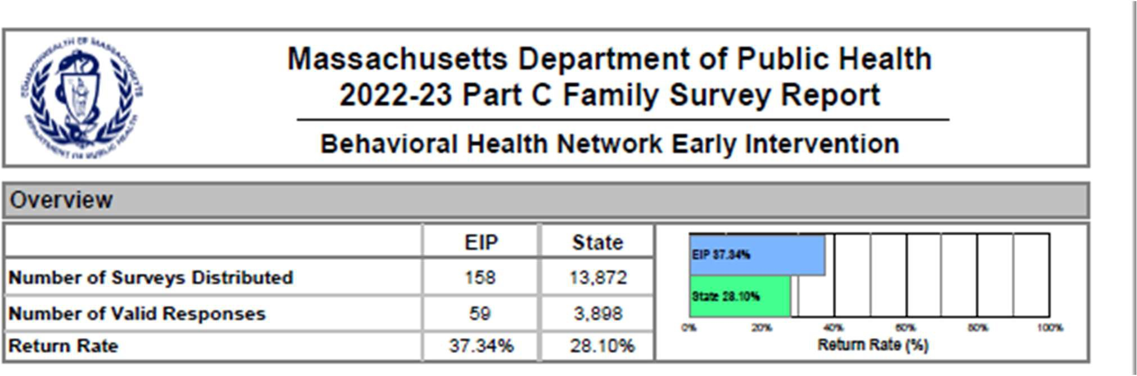

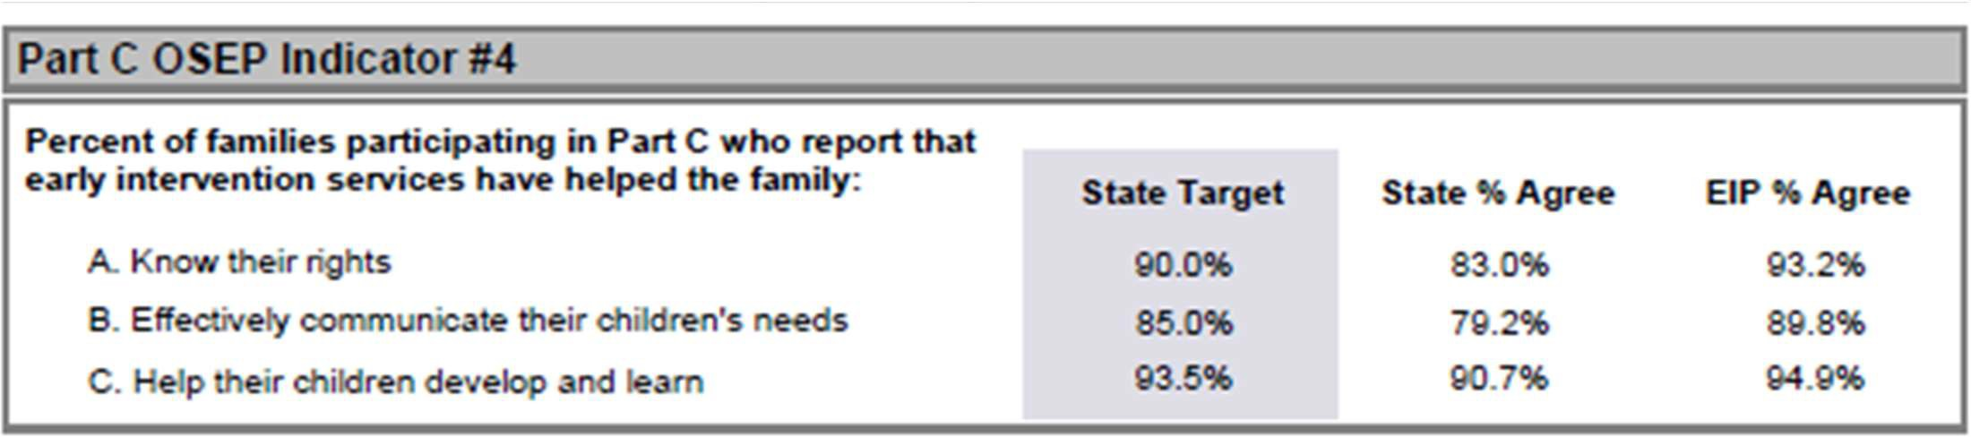

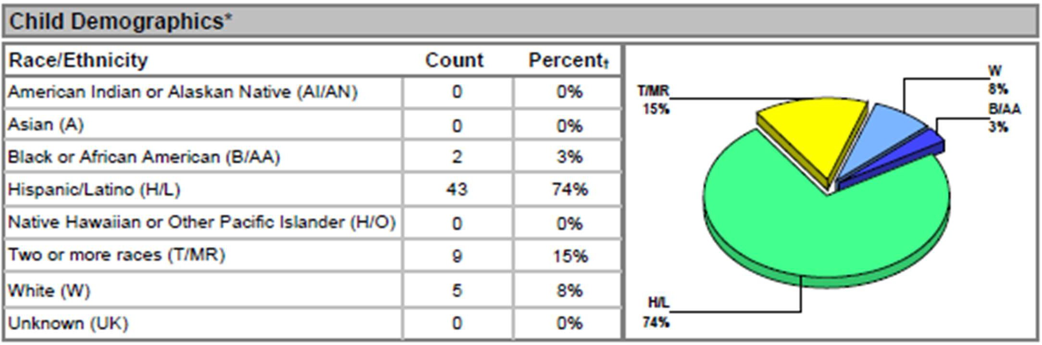

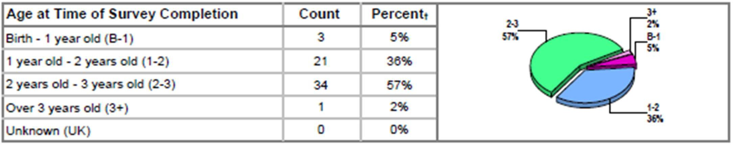

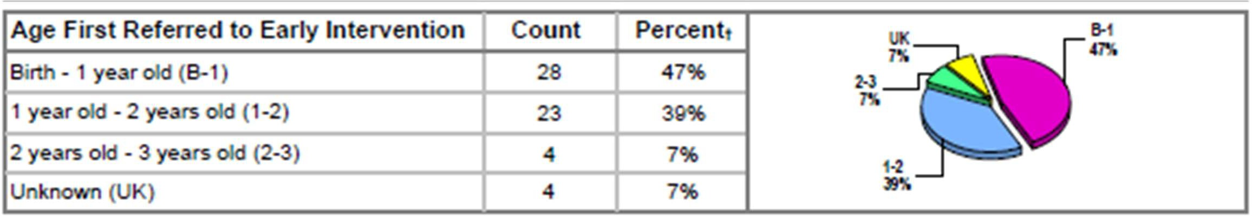

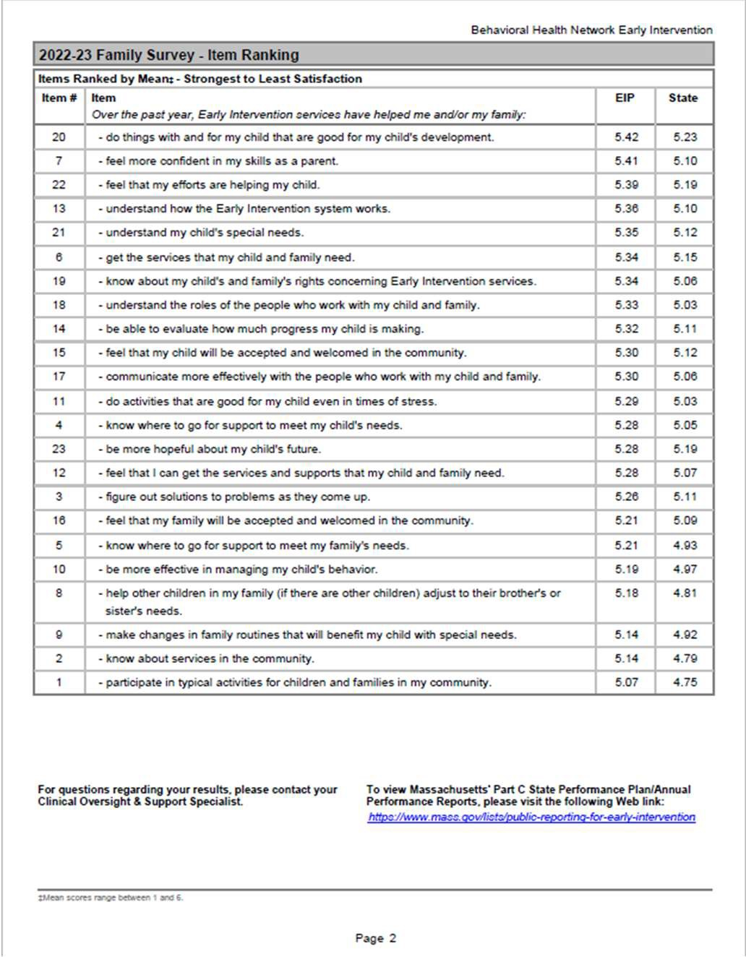38

## What Happens After A Family Completes the Survey?

Data are analyzed by the EI Division, reported to the Office of Special Education Programs, used for programmatic improvements, and shared with early intervention services programs.

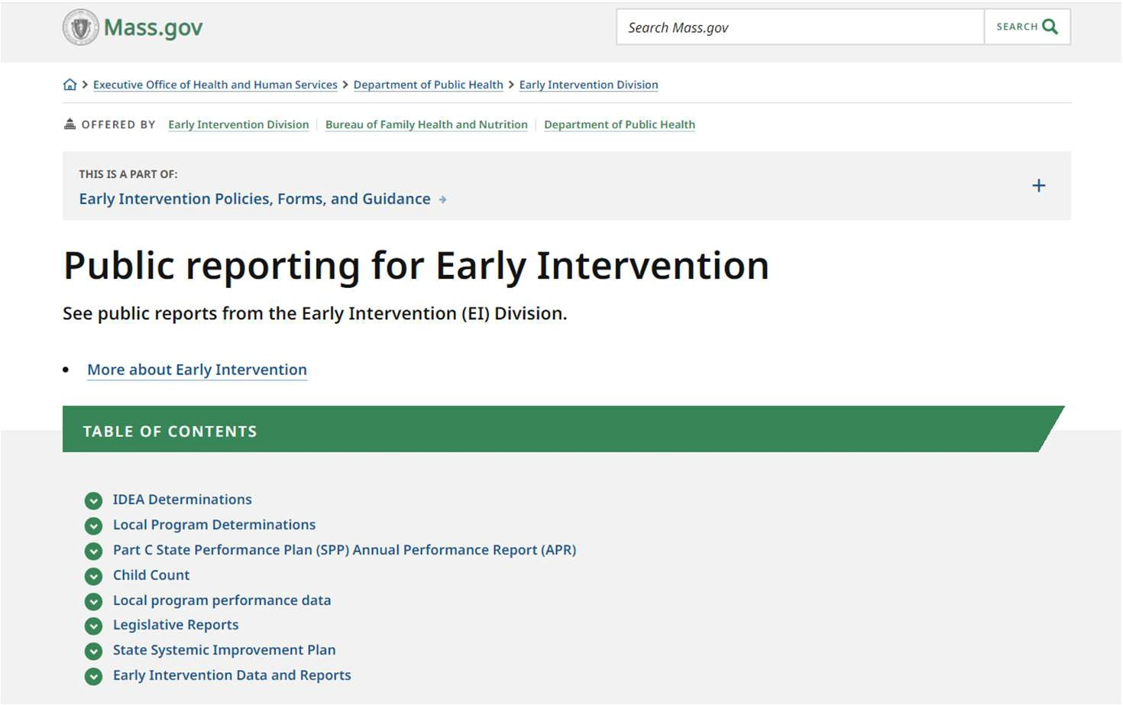

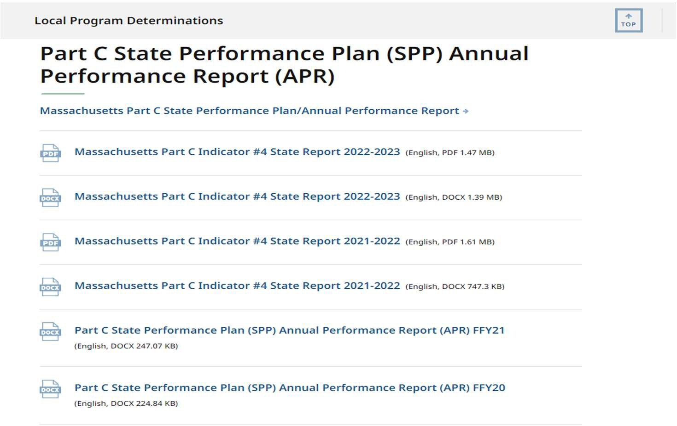

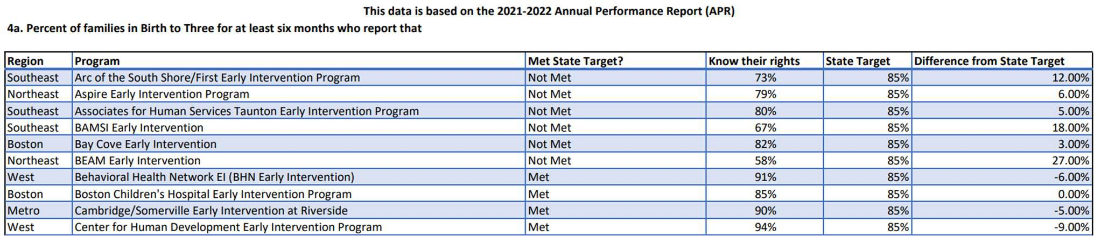

## What is “nonresponse bias”?

Why is it important?

Nonresponse bias means a significant amount of people in who don’t respond to the survey share the same characteristics.

When we see nonresponse bias, it tells us we might need to change something about the survey (e.g., format, length, wording, delivery method).

50%

Response Rate



**# Surveys Returned**

**x 100**

**# Surveys Sent**

45%

40%

35%

30%

25%

20%

15%

10%

5%

0%

African American or Black

American Indian or Alaskan Native

Asian Native Hawaiian or Pacific Islander

 Response Rate

White More than one Race Hispanic

50%

Response Rate



**Race options under Part C**

45%

40%

35%

30%

25%

20%

15%

10%

5%

0%

African American or Black

American Indian or Alaskan Native

Asian Native Hawaiian or Pacific Islander

 Response Rate

White More than one Race Hispanic

50%

45%

40%

35%

30%

25%

20%

15%

10%

5%

0%

African American or Black

American Indian or Alaskan Native

Asian Native Hawaiian or Pacific Islander

Response Rate

White More than one Race Hispanic

The first step toward reducing nonresponse bias is to increase response rate.

## What does “response rate” mean?

Why is it important?

Response rate means the percentage of people who received the survey that responded to the survey.

Although there isn’t a magic number, improving response rates can help avoid bias.









Increasing response rate can help to improve representativeness.

## What does “representativeness” mean?

Why is it important?

Representativeness means that the family characteristics of those responding to the survey match the family characteristics of those participating in Part C/early intervention.

Evaluates whether the survey results are representative overall of the state.

This involves assessing whether the families surveyed adequately represent the broader population of families who received early intervention services.

Representativeness is important because we want to receive input from all families with diverse perspective and experiences.

Asian

6%

White

52%

Nativve Hawaiian or Pacific Islander 1%

African American or Black 6%

American Indian or Alaskan Native 1%

Hispanic/Latino 19%

Two or More 14%

Missing 1%

Distribution of Race/Ethnicity

Arabic Chinese English

Survey Language

**Percentage of all Completed Surveys**

0%

<1%

92%

Haitian Creole Portuguese Spanish Vietnamese

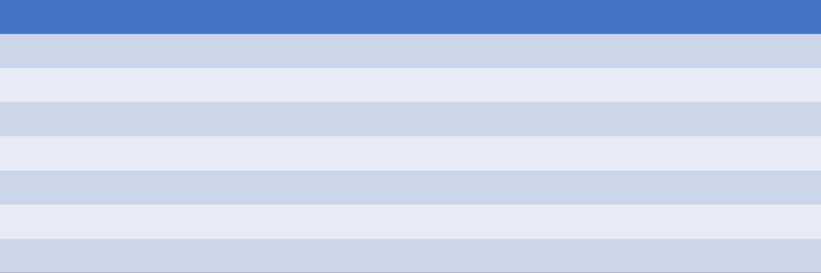

<1%

1%

6%

0%

West

6%

Metro

11%

Northeast 27%

Southeast 21%

Central 22%

Boston 7%

Unknown 6%

Distribution of Region

## What do the survey results suggest?

Families report a range of early intervention experiences.

100

90

80

70

60

50 Percentage of

40 Respondents

30

20

10

0

2011 2012 2013 2014 2015 2016 2017 2018 2019 2020 2021 2022

Know Their Rights Effectively Communicate Develop and Learn

100

90

80

70

60 Family Outcomes

50

40

30

20

10

0

2011 2012 2013 2014 2015 2016 2017 2018 2019 2020 2021 2022

 Know Their Rights  Effectively Communicate  Develop and Learn

100

90

80

Reporting Year

70

60

50

40

30

20

10

0

2011 2012 2013 2014 2015 2016 2017 2018 2019 2020 2021 2022

 Know Their Rights  Effectively Communicate  Develop and Learn

100

90

80

70

60

50

40

30

20

10

0

2011 2012 2013 2014 2015 2016 2017 2018 2019 2020 2021 2022

 Know Their Rights

100

90

80

70

60

50

40

30

20

10

0

2011 2012 2013 2014 2015 2016 2017 2018 2019 2020 2021 2022

 Effectively Communicate

100

90

80

70

60

50

40

30

20

10

0

2011 2012 2013 2014 2015 2016 2017 2018 2019 2020 2021 2022

 Develop and Learn

100

90

80

70

60

50

40

30

20

10

0

2011 2012 2013 2014 2015 2016 2017 2018 2019 2020 2021 2022

 Know Their Rights  Effectively Communicate  Develop and Learn



73

###### 700 Very Strongly Agree:

**Something Unusual About Responses**

Difficult to distinguish between responses that are authentic and those that are complying with a task

###### Early intervention services have helped me and/or my family

Do things with and for my child that are good for my child’s development (77%)

Feel that my efforts are helping my child (76%)

Be more hopeful about my child’s future (75%)

###### Early intervention services have helped me and/or my family

**Interesting Themes**

Know about services in the community (58%)

Help other children in my family adjust to their brother or sister’s needs (58%)

Participate in typical activities for children and families in my community (56%)

 

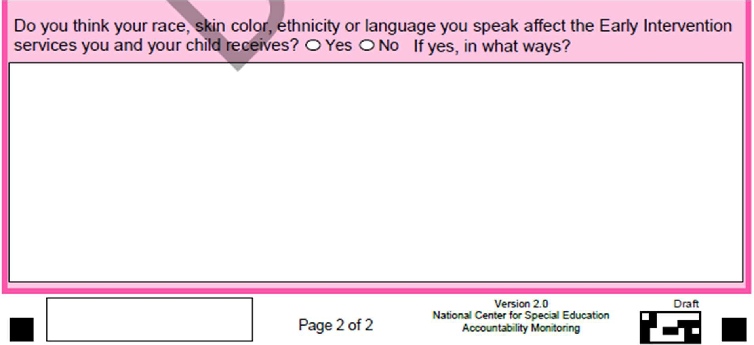

##### 98% of families did not feel that their race, skin color, ethnicity, or spoken language affected the early intervention services their children received.

**2% responded “yes”**

Massachusetts Department of Public Health | mass.gov/dph

80

###### Language influenced early intervention services

**Interesting Themes**

* General communication between families and EI staff

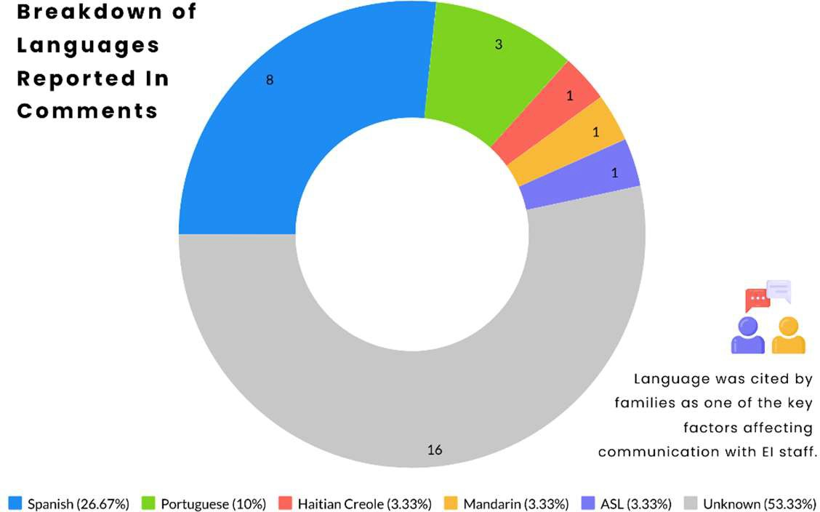

* Trouble translating specific words to native languages and vice versa
* Difficulties expressing preferences, concerns, and opinions

## How does Massachusetts compare to other states?

95%

90%

85%

80%

75%

70%

**# Agree**

**x 100**

**# Responses**

**Figure 2. Part C Indicator 4A: Know their Rights**

87% 87%

86% 85% 85% 86% 86% 87% 87%

83% 84%

2011 2012 2013 2014 2015 2016 2017 2018 2019 2020 2021

Massachusetts -1 STD National +1 STD Target



65%

60%

55%

50%

95%

90%

85%

80%

##### Reporting Year

**Figure 2. Part C Indicator 4A: Know their Rights**

87% 87%

86% 85% 85% 86% 86% 87% 87%

83% 84%



75%

70%

65%

60%

55%

50%

2011 2012 2013 2014 2015 2016 2017 2018 2019 2020 2021

Massachusetts -1 STD National +1 STD Target

95%

90%

##### Massachusetts

85%

**Highest-performing States**

**Nationwide Average**

**Lowest Performing States Massachusetts Target**

80%

75%

70%

65%

60%

55%

50%

**Figure 2. Part C Indicator 4A: Know their Rights**

87% 87%

86% 85% 85% 86% 86% 87% 87%

83% 84%



2011 2012 2013 2014 2015 2016 2017 2018 2019 2020 2021

Massachusetts  -1 STD  National  +1 STD  Target

95%

90%

85%

80%

##### Massachusetts

**Highest-performing States**

75%

**Nationwide Average**

**Lowest Performing States Massachusetts Target**

70%

65%

60%

55%

50%

**Figure 2. Part C Indicator 4A: Know their Rights**

87% 87%

86% 85% 85% 86% 86% 87% 87%

83% 84%



2011 2012 2013 2014 2015 2016 2017 2018 2019 2020 2021

Massachusetts  -1 STD  National  +1 STD  Target

95%

90%

85%

80%

75%

##### Massachusetts

**Highest-performing States Nationwide Average**

70%

**Lowest Performing States**

**Massachusetts Target**

65%

60%

55%

50%

**Figure 2. Part C Indicator 4A: Know their Rights**

87% 87%

86% 85% 85% 86% 86% 87% 87%

83% 84%



2011 2012 2013 2014 2015 2016 2017 2018 2019 2020 2021

Massachusetts  -1 STD  National  +1 STD  Target

95%

90%

85%

80%

75%

70%

65%

##### Massachusetts

**Highest-performing States Nationwide Average Lowest Performing States**

60%

**Massachusetts Target**

55%

50%

**Figure 2. Part C Indicator 4A: Know their Rights**

87% 87%

86% 85% 85% 86% 86% 87% 87%

83% 84%



2011 2012 2013 2014 2015 2016 2017 2018 2019 2020 2021

Massachusetts  -1 STD  National  +1 STD  Target

95%

90%

85%

80%

75%

70%

65%

60%

##### Massachusetts

**Highest-performing States Nationwide Average Lowest Performing States Massachusetts Target**

55%

50%

**Figure 2. Part C Indicator 4A: Know their Rights**

87% 87%

86% 85% 85% 86% 86% 87% 87%

83% 84%



2011 2012 2013 2014 2015 2016 2017 2018 2019 2020 2021

Massachusetts  -1 STD  National  +1 STD  Target

95%



86%

85%

85%

86%

86%

87%

87%

87%

87%

83%

84%

90%

85%

80%

75%

70%

65%

60%

55%

50%

2011 2012 2013 2014 2015 2016 2017 2018 2019 2020 2021

Massachusetts  -1 STD  National  +1 STD  Target

95%



86%

85%

85%

86%

86%

87%

87%

87%

87%

83%

84%

90%

85%

80%

75%

70%

65%

60%

55%

50%

2011 2012 2013 2014 2015 2016 2017 2018 2019 2020 2021

Massachusetts  -1 STD  National  +1 STD  Target

95%



83%

82%

83%

83%

83%

84%

84%

85%

85%

78%

80%

90%

85%

80%

75%

70%

65%

60%

55%

50%

2011 2012 2013 2014 2015 2016 2017 2018 2019 2020 2021

Massachusetts  -1 STD  National  +1 STD  Target

95%



92%

91%

92%

92%

92%

94%

93%

94%

94%

91%

91%

90%

85%

80%

75%

70%

65%

60%

55%

50%

2011 2012 2013 2014 2015 2016 2017 2018 2019 2020 2021

Massachusetts  -1 STD  National  +1 STD  Target

## Do you have any changes planned for the future?

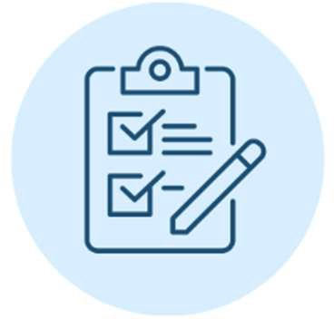 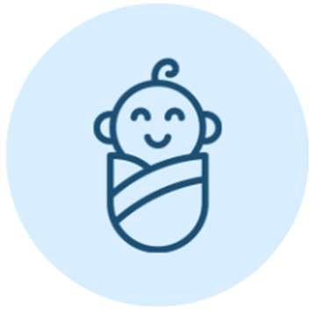 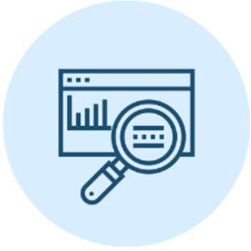 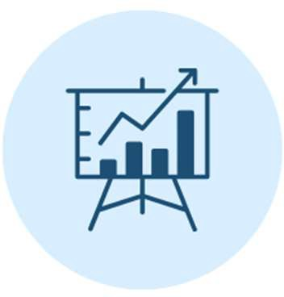

**Improve representativeness of families responding to outcomes survey**

**EI Priorities for FY24**

**Improve child outcomes Revise monitoring to**

**meet federal guidance**

**Improve data quality**







**Massachusetts Department of Public Health**



# Everything You Wanted to Know About the Impacts on Family Survey

### *(but were afraid to ask)*

Emily White, PhD, BCBA-D, LABA

Director, Early Intervention Division