**Massachusetts Department of Public Health**



# ICC Fiscal Subcommittee

April 15, 2025

### Emily White, PhD, BCBA-D, LABA Part C Coordinator

**Director, Early Intervention Division**

Please standby as appointed ICC Steering Committee members join, and we calculate quorum.

**This meeting will begin shortly**

Only appointed ICC Steering Committee members will have access to camera and microphone throughout the meeting.

### Public participation is encouraged.

* Please click the ***raise hand*** feature or use the ***Q&A*** to provide comment(s).
* Please ***display your full name*** so minutes accurately reflect your statements

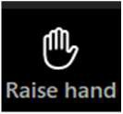

**Raise hand:** Attendee may be given access to microphone to ask question and/or comment

**Q&A:** Questions will be answered directly via the Q&A feature

* Welcome

**Agenda**

* + Roll Call
  + Review and Approval of Minutes from February Meeting
* Fiscal Federal and State Updates
* Overview of the FFY25 Part C application
* Ongoing Business

## Welcome & Roll Call

**Roll Call**: Please unmute so prepare to verbally acknowledge your attendance by saying **“Present”** when your name is called

**Roll Call Attendance – Appointed Members**

To comply with the Open Meeting Law, a quorum of appointed members must be established.

**Quorum**: **A simple majority (51%)** of the members of a public body, unless otherwise provided in a general or special law, executive order, or other authorizing provision. G.L. c. 30A, § 18

## Vote Minutes February 13, 2025

6

**Cameras:** Camera should be on throughout, but **required** for roll call & voting

**Vote February 13 Minutes**

**Voting Responses**: Please respond either "**Yes", "No", or "Abstain"**

|  |  |  |
| --- | --- | --- |
| **Attendance December 5, 2024** | | |
| **Lori Rusell** | **Scott Geer** | **Colleen Wellman** |
| **Jheanell West** |  |  |

## Federal & State Updates

* DMS 2.0 onsite visit begins November 17, 2025

**Federal & State Updates**

* Ask Away Training has been added to the mass.gov Early Intervention webpage
* Governor Healey’s Budget was submitted
  + FY26 Proposed State budget for EI is $37,719,649.00
  + The House will now review and submit their proposal on or around April 16
* The Annual State Application for Part C of IDEA for Federal Fiscal Year 2025 has been posted on mass.gov website

## FFY25 Part C Grant Application

**FFY25 Part C Grant Application**

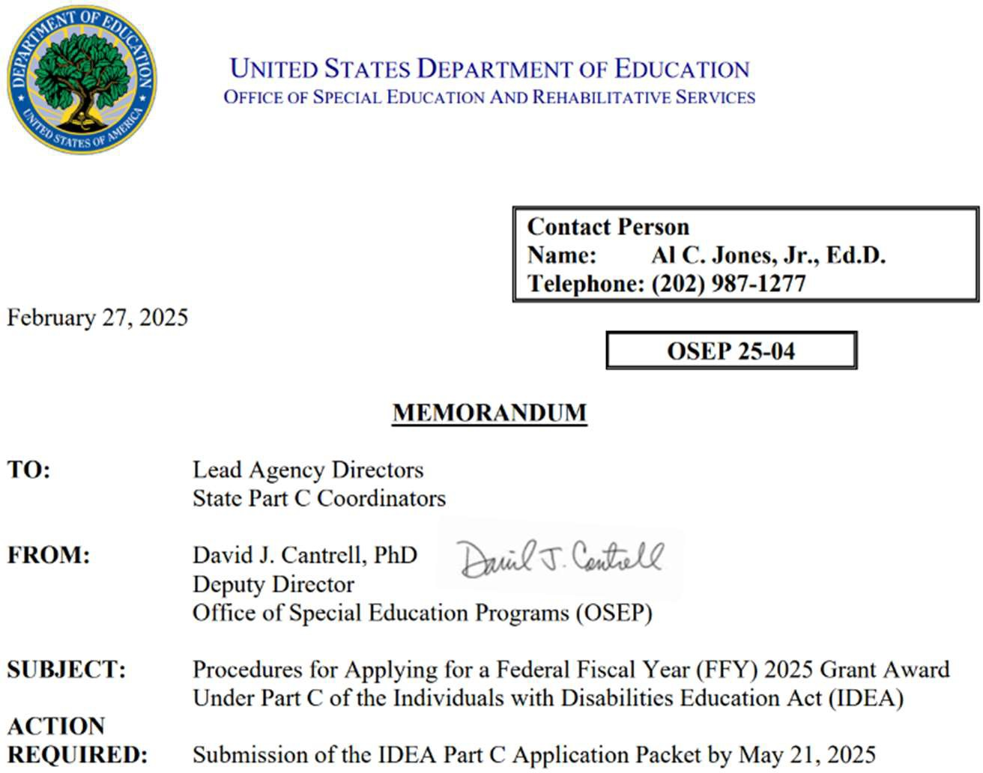

**IDEA Part C Grant Application Timeline**



October 2026

* Begin Obligating Funds

Jan 2025

* MA-C Planning

July 2025

* Funding Received

March 2025

* Application Released

June 2025

* Allocation Announced & Funding Received

April 2025

* Public Comment

May 2025

* Application Submitted

**View Draft Application & Provide Feedback**

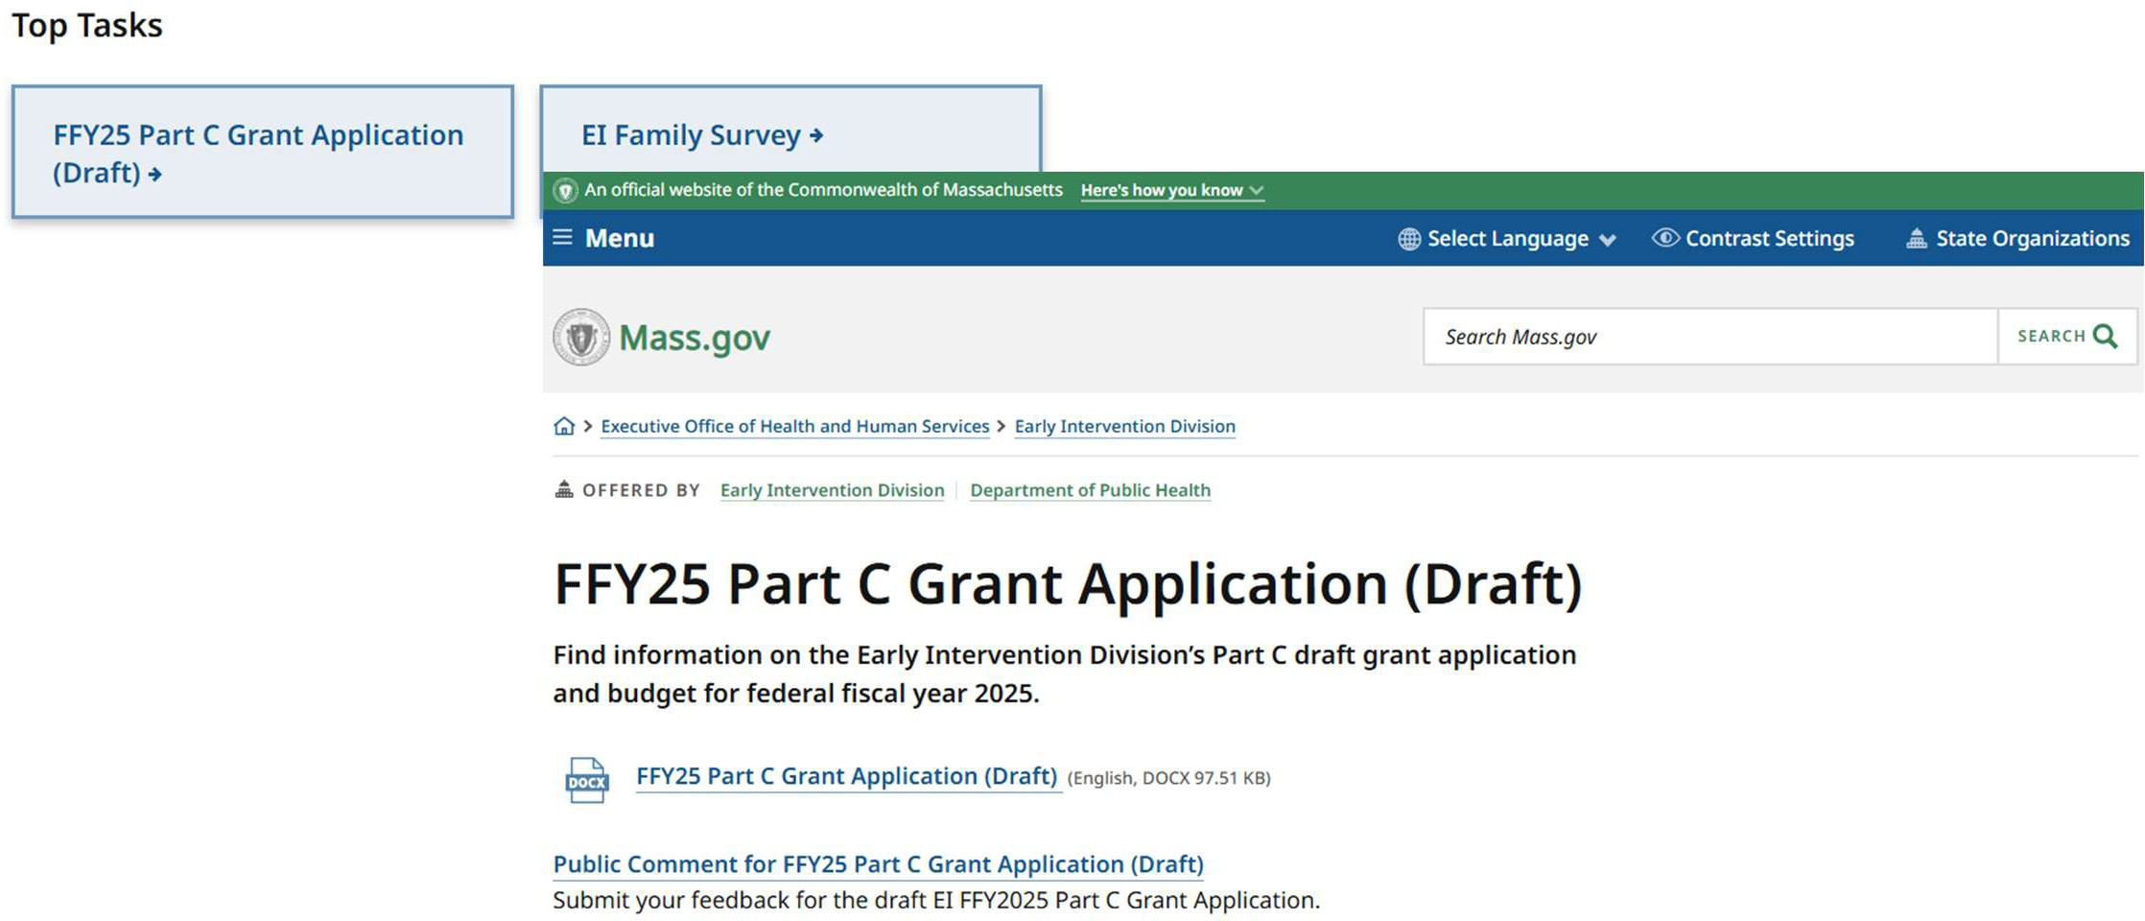

**FFY24’s Submission:**

**Comparing FFY24 to FFY25**

**FFY25’s Draft Submission:**

|  |  |  |
| --- | --- | --- |
| **Row No.** | **Section** | **Amount** |
| **Enter the subtotal amounts for Sub Sections A-E found in Section III of this application**. | | |
| 1. | III.A. | $3,762,685 |
| 2. | III.B. | $3,263,645 |
| 3. | III.C. | $2,135,480 |
| 4. | III.D. | $107,000 |
| 5. | III.E. | $100,000 |
| **Enter any Indirect Costs to be Charged** (See Section IV.B of this application.) | | |
| 6. | IV.B | $0 |
| **Total**  (Rows 1-6) |  | $9,368,810 |

|  |  |  |
| --- | --- | --- |
| **Row No.** | **Section** | **Amount** |
| **Enter the subtotal amounts for Sub Sections A-E found in Section III of this application**. | | |
| 1. | III.A. | $4,070,292 |
| 2. | III.B. | $3,126,112 |
| 3. | III.C. | $1,990,406 |
| 4. | III.D. | $82,000 |
| 5. | III.E. | $100,000 |
| **Enter any Indirect Costs to be Charged** (See Section IV.B of this application.) | | |
| 6. | IV.B | $0 |
| **Total**  (Rows 1-6) |  | $9,368,810 |

Early Intervention Division | Mass.gov

Direct Services

$1,990,406

Other State Agencies Activity

$82,000

### Total Budget

Key Changes from FFY24 to FFY25:

* Increased Personnel Costs due to State-mandated Increases
  + Reduction in EICS Spending
  + Reduction in Direct Services

Personnel

$4,070,292

Lead Agency Activities

**FFY25 Budget**

$3,126,112

At-Risk Identification

$100,000

### Personnel Budget

**FFY25 Budget, Section A: $4,070,292**

Total Budget

Personnel

RA

$864,348

Admin

$307,925

Finance

$563,660

Key Changes from FFY24 to

#### FFY25:

* Increased Personnel Costs due to state-mandated

increases

* + Reduced the number of 100% funded positions; increased the number of

<100% positions

PEO

$1,133,871

|  |  |  |  |
| --- | --- | --- | --- |
| **Positions Funded** | **Number of**  **Positions** | **% of Time Spent**  **on Part C** | **Salaries & Fringe**  **Benefits** |
| **Total 100% funded with**  **Part C** | ***24*** | ***100%*** | ***$3,409,988*** |
| ***Total Funded <100% Part***  ***C Funds*** | ***5*** | ***<100%*** | ***$352,697*** |
| ***Subtotal of amount under***  ***A:*** |  |  | ***$3,762,685*** |

FCE

$601,613

Operations

$291,266

#### FFY24

* + - 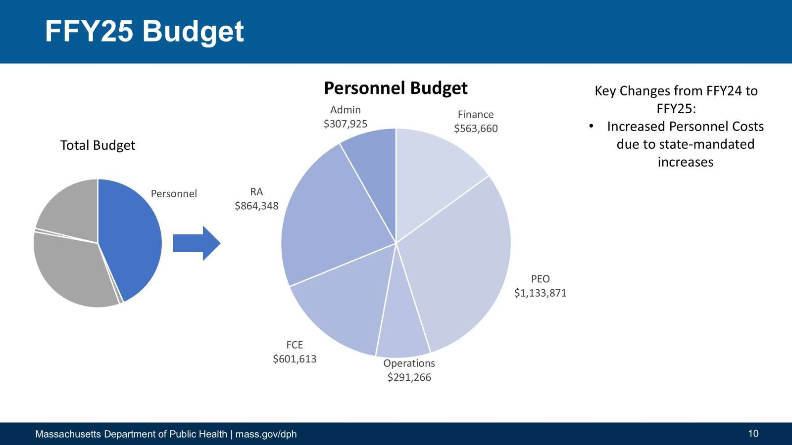What is needed for EICS Support Desk?

**We Need Your Advice & Assistance!**

### Lead Agency Activities Budget

**FFY25 Budget, Section 3B: $3,126,112**

Total Budget

EICS

$1,029,066

GSI

$300,000

Professional development

$250,000 NCSEAM

$55,000

CLAS

$775,500

Key Changes from FFY24 to

#### FFY25:

* Reduced EICS Costs
* Shifted Interpretation Support Costs from 3C
* Added $300K in General Supervision Incentives

Lead Agency Activities

Interpreter

Public

ICC meetings

$15,000

#### FFY24

support

$150,000

IT equipment

$28,546

Awareness

$523,000

**Major Activity/ Expense Subtotal of amount under**

**Part C Funds to be Spent**

**B: $3,263,645**

* + 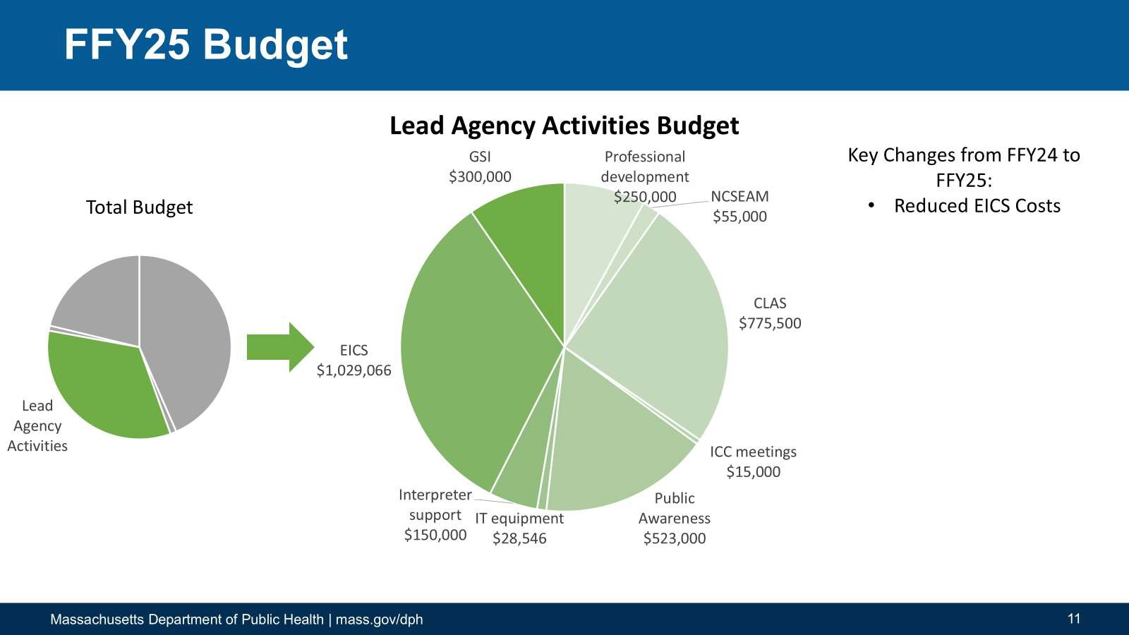What affects will these changes have on children and families?

**We Need Your Advice & Assistance!**

* + Can you foresee these changes affecting other state agencies or service systems?
  + What affects will these changes have on service providers?

### Direct Services Budget

**FFY25 Budget Section 3C: $1,990,406**

Direct Services

Total Budget

Transportation (for families)

$200,000

Social Work

$232,746

Psychological Services

$87,770

Family Coaching

$351,192

Respite,

Audiology, Vision, Nutrition

$18,139

Nursing

$154,403

Key Changes from FFY24 to FFY25:

* Reduced to reflect actuals charged to Part C Grant;
* Does not reflect a change in service delivery
  + Increased Transportation

Costs

Speech Language Pathology

Sign

Occupational Therapy

$274,446

#### FFY24

$296,136Language &

Cued Speech

$105,000

Physical Therapy

$244,740

Special Instruction

$25,836

|  |  |
| --- | --- |
| **Approximate Amount of Federal IDEA Part C Funds to be Spent on Each Direct Service** | |
| **Subtotal of amount**  **under C:** | **$2,135,480** |

* + - 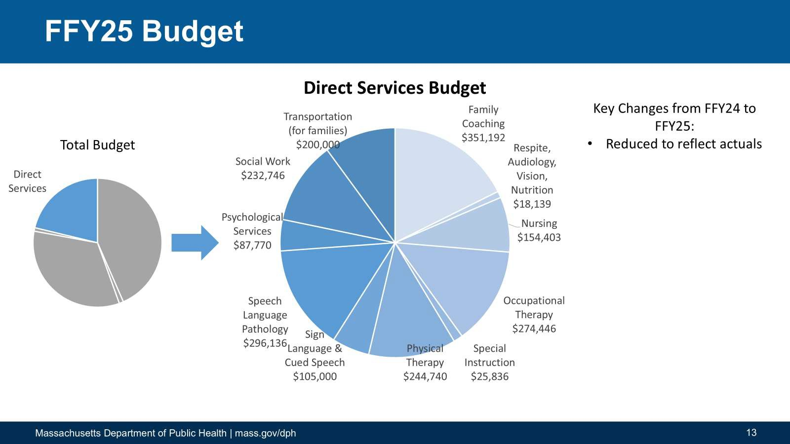What are the potential affects when MassHealth coverage is not maximized?

**We Need Your Advice & Assistance!**

* + - What’s the average latency from rendering services to submitting a claim to insurance? To MassHealth?



$250,,000.00

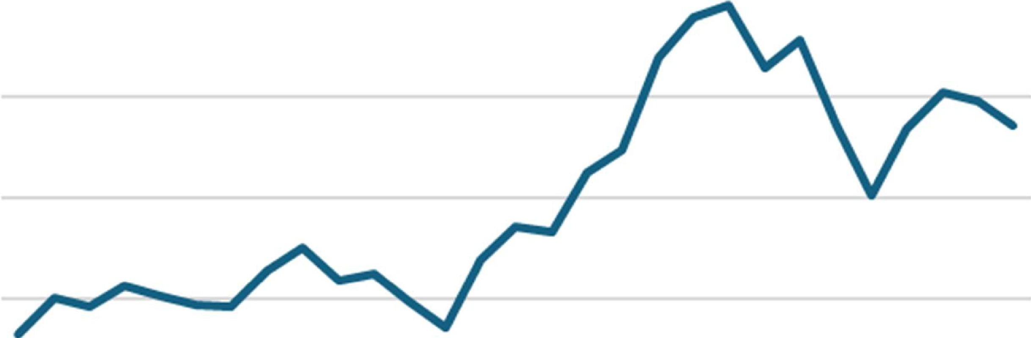

$200,000.00



$100.,,000.00

$50,,000.00

$-



* + - 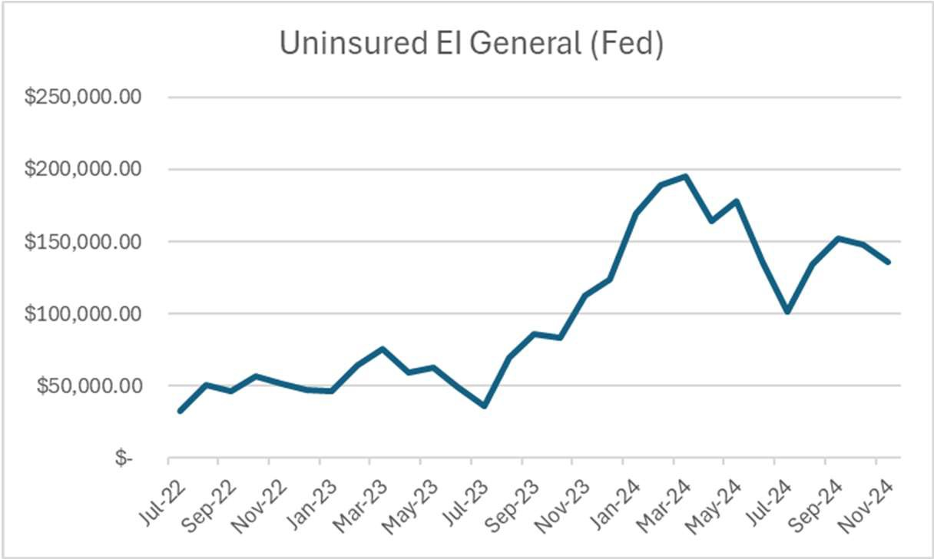What might account for the increase beginning in January 2024?

**We Need Your Advice & Assistance!**

Total Budget

### Other State Agencies Activities Budget

DALA

**FFY25 Budget: Section 3D: $82K**

$7,000

Key Changes from FFY24 to FFY25:

* Reduced ISA to Division of Administrative Law Appeals

Other State Agencies Activity

#### FFY24

DESE

|  |  |
| --- | --- |
| **State Agency**  **Receiving Funds** | **Amount of Funds** |
| **Subtotal of amount**  **under D:** | **$107,000** |

$75,000

* + 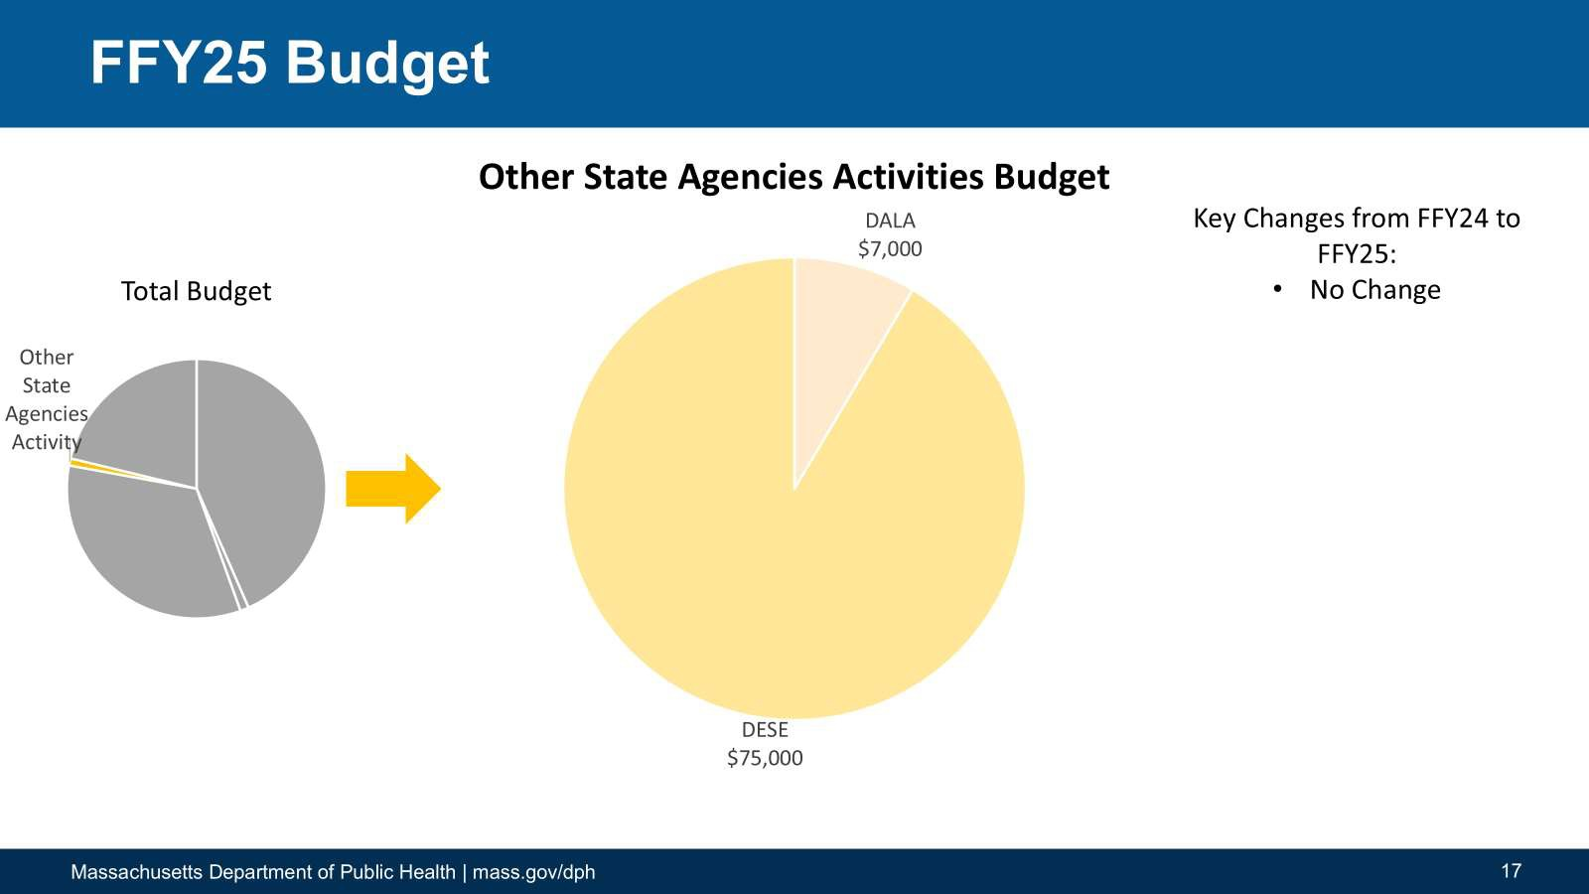How do these expenses impact children, families, and providers?

**We Need Your Advice & Assistance!**

Total Budget

### At-Risk Identification Budget

Key Changes from FFY24 to FFY25:

* No change from FFY24 to

#### FFY25

**FFY25 Budget, Section 3E: $100K**

At-Risk Identification

#### FFY24

Child Find

|  |  |
| --- | --- |
| **Major Activity** | **Part C Funds** |
| **Subtotal of amount**  **under E:** | **$100,000** |

$100,000

* + 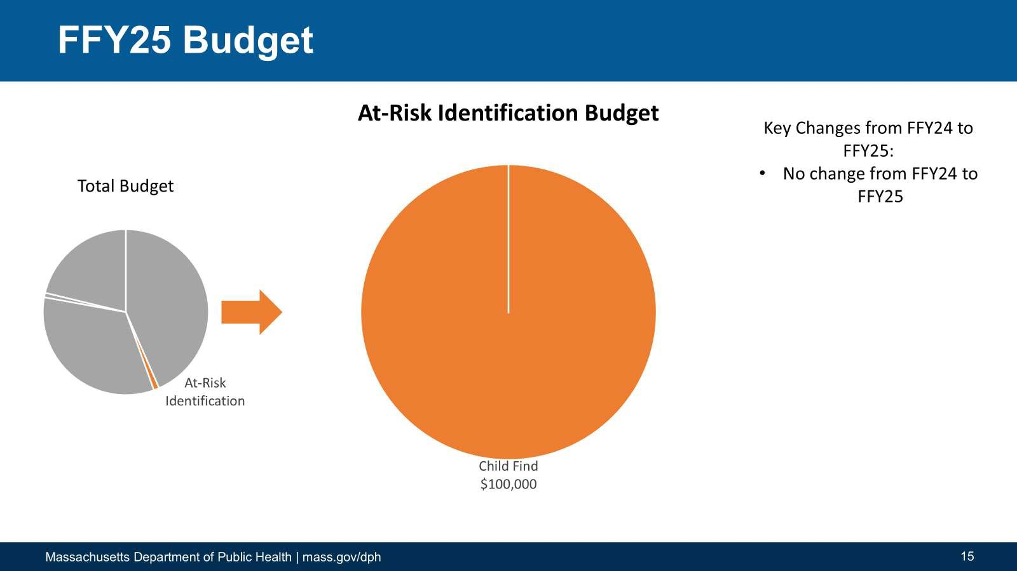What activities would be most helpful in identifying at-risk children?

**We Need Your Advice & Assistance!**

**ICC Fiscal Sub-Committee Schedule**

**Ongoing Business**

* **Feb 20th**

**Ask Away**

* + How to resubmit claims (voiding claims) and parental consent to bill insurance requirement

|  |  |  |
| --- | --- | --- |
| **FY 25 ICC Fiscal Sub Committee meeting schedule** | | |
| **August 8, 2024** | 2:00pm –  4:00pm | Introduction to the new finance  manager/initial review of policy |
| **September 12,**  **2024** | 2:00pm –  4:00pm | Reviewing Initial Fiscal  Report/Fiscal Auditing |
| **November 14,**  **2024** | 2:15pm –  3:00pm | Review of Fiscal Report and  Fiscal Auditing |
| **January 09,**  **2025** | 2:15pm –  3:00pm | ICC General Session follow up |
| **February 13,**  **2025** | 2:00pm –  4:00pm | Budget data review in preparation of Part C  application |
| **April 10, 2025** | 2:00pm –  4:00pm | Part C application review |
| **June 12, 2025** | 2:00pm –  4:00pm | FY 26 planning |

**th**

* **Mar 20**
  + Common error codes in EICS (How to resolve them)
* **Apr 17th**
  + Authorized Service Types/Procedure Codes (Do’s and Don’ts)
* **May 15th**
  + End of FY July 10 Deadline
* 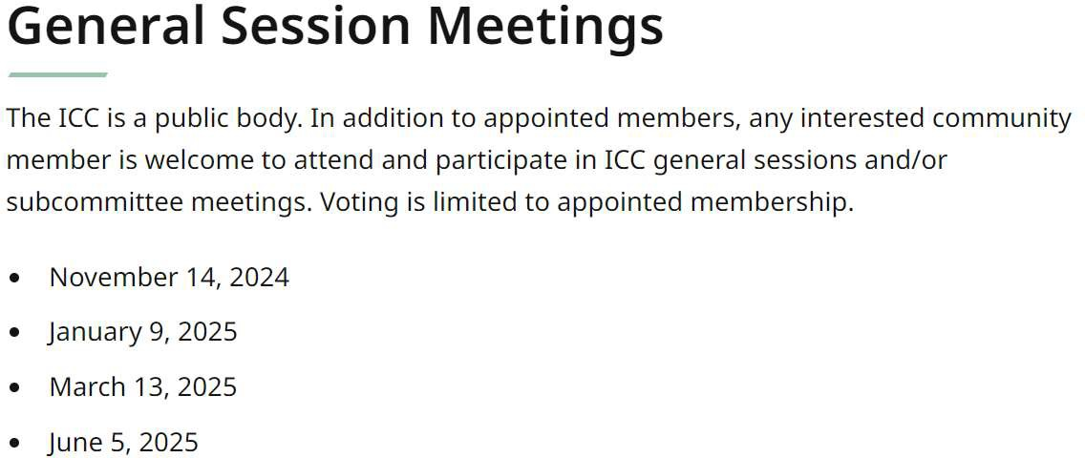**Jun 12th**
  + End of Year close out Report

**Massachusetts Department of Public Health**



# ICC Fiscal Subcommittee

April 10, 2025

**Emily White, PhD, BCBA-D, LABA Part C Coordinator**

**Director, Early Intervention Division**