Massachusetts Department of Public Health

Director’s Report

June 1, 2023

Emily White, PhD, BCBA-D, LABA Part C Coordinator
Director, Early Intervention Division

Overview

- Federal Updates
- State Updates

Federal Updates

- Federal Updates
  - FFY24 Appropriations
  - Proposed Changes in SPP/APR Reporting
  - DMS 2.0 Findings in Other States

Federal Updates: FFY24 Appropriations

FFY24 Appropriations includes funding for IDEA programs
  - Part C would be allocated at $932 million
  - Must be decided by midnight on September 30, 2023 or via CR

Federal Updates: OSEP Proposed Change in SPP/APR

Beginning in FFY23, SPP/APR Must Include:
  - Monitoring Schedule for EIS Programs
  - Description of Graduated & Progressive Actions for EIS Programs in Response to Noncompliance
  - Public Posting to State’s General Supervision Procedures &
Results
  - Listing Noncompliance by Program: Findings & Enforcement
  - Required to Account for Delays in Services (1,7,8)
  - Percentage of Findings of Noncompliance Corrected Timely

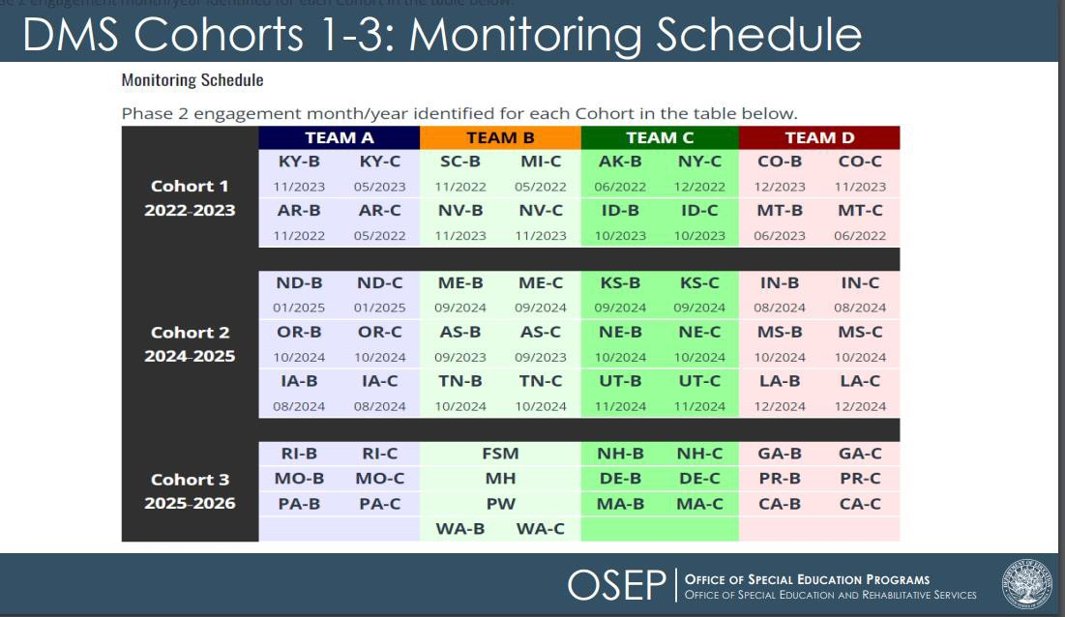
Federal Updates: DMS 2.0 Findings

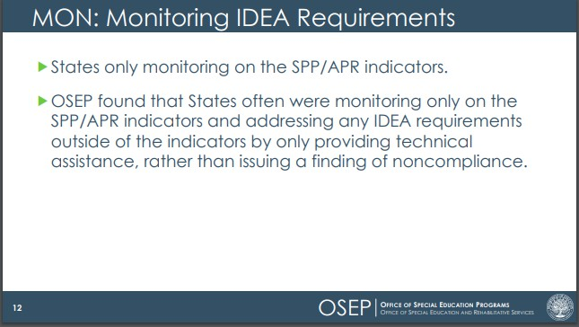
Federal Updates: DMS 2.0 Findings

Massachusetts Department of Public Health | mass.gov/dph 7

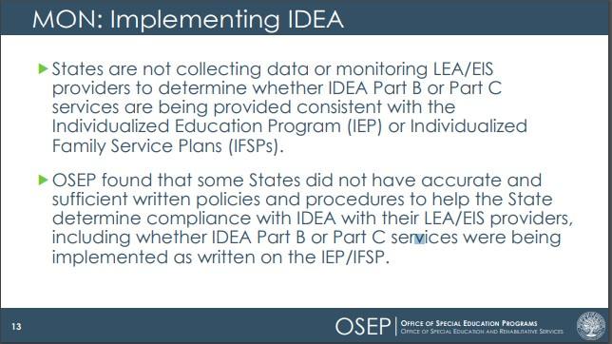
Federal Updates: DMS 2.0 Findings

Massachusetts Department of Public Health | mass.gov/dph 8

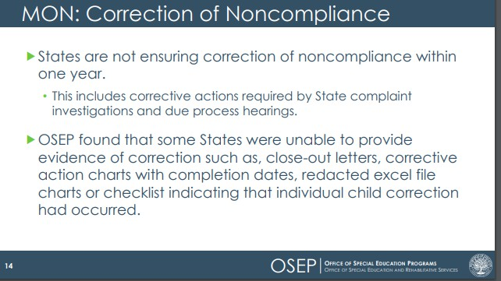
Federal Updates: DMS 2.0 Findings

Massachusetts Department of Public Health | mass.gov/dph 9

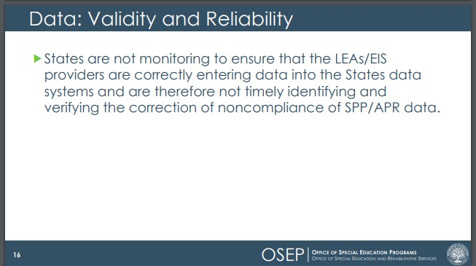
Federal Updates: DMS 2.0 Findings

Massachusetts Department of Public Health | mass.gov/dph 10

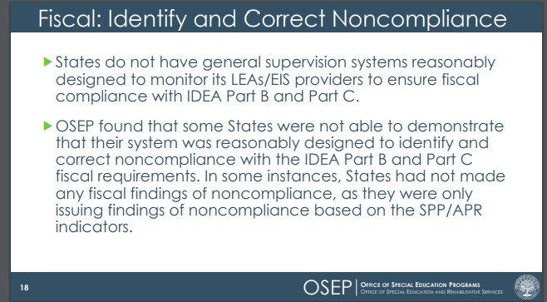
Federal Updates: DMS 2.0 Findings

Massachusetts Department of Public Health | mass.gov/dph 11

State Updates

- State Updates
  - Follow-Up Activities
  - New Initiatives
  - Data

State Updates: Follow-Up Actions

- State Updates
  - Follow-Up Activities
    - FFY21 State Performance Plan/Annual Performance Report
    - FY24 Procurement
    - CLAS Grant
    - DMS 2.0
    - NCSEAM Sampling Plan
    - Eligibility Instrument Change
    - EICS Updates

Announced Jan 2023 ICC Meeting;
Updated March 2023 ICC Meeting
State Performance Plan/Annual Performance Report (SPP/APR): Submitted clarified document to OSEP on April 25, 2023

Next Step: Determination in June 2023

State Updates: FFY21 SPP/APR
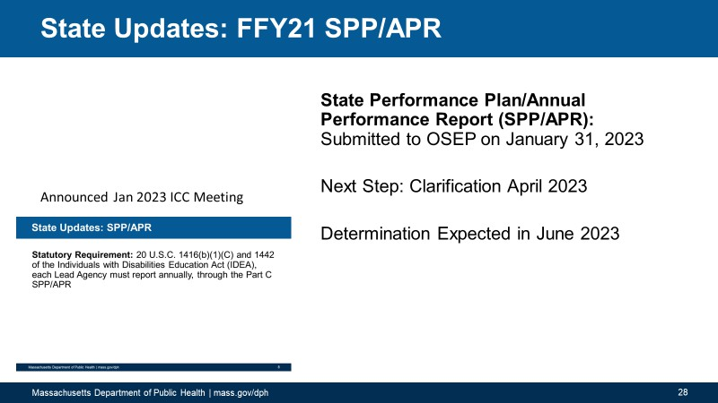

Number
What is measured
Starting
Point Recent Data for
(2005) Comparison
Current Data

Graph Depicting
Direction of Time
State Updates: FFY21 SPP/APR Data Display

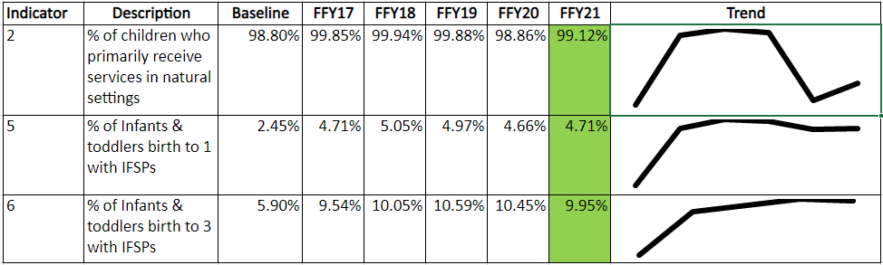

State Updates: FFY21 SPP/APR Data Display

Number
What is
measured
Starting
Point Recent Data for
(2005) Comparison
Current Data

Graph Depicting
Direction of Time

Number
State Updates: FFY21 SPP/APR Data Display

What is measured
Starting
Point Recent Data for
(2005) Comparison
Current Data

Graph Depicting
Direction of Time

Number
State Updates: FFY21 SPP/APR Data Display

What is measured
Starting
Recent Data for
Comparison
Current Data

Graph Depicting
Direction of Time
Point (2005)

Number
State Updates: FFY21 SPP/APR Data Display

What is measured

Starting Point (2005)
ent Data

Graph Depicting
Direction of Time
Curr

Recent Data for Comparison

Number
State Updates: FFY21 SPP/APR Data Display

What is measured

Starting Point (2005)

Recent Data for Comparison

Current Data
Graph Depicting
Direction of Time

Number

What is measured

Starting Point (2005)

Recent Data for Comparison

Current Data

State Updates: FFY21 SPP/APR Data Display
Graph Depicting
Direction of Time

Number

What is measured

Starting Point (2005)

Recent Data for Comparison

Current Data

Source: Date Range for Current Data
State Updates: FFY21 SPP/APR Data Display
Graph Depicting
Direction of Time

State Updates: Results Indicators 2, 5, 6

Source: 618 Data Collected 10/1/22

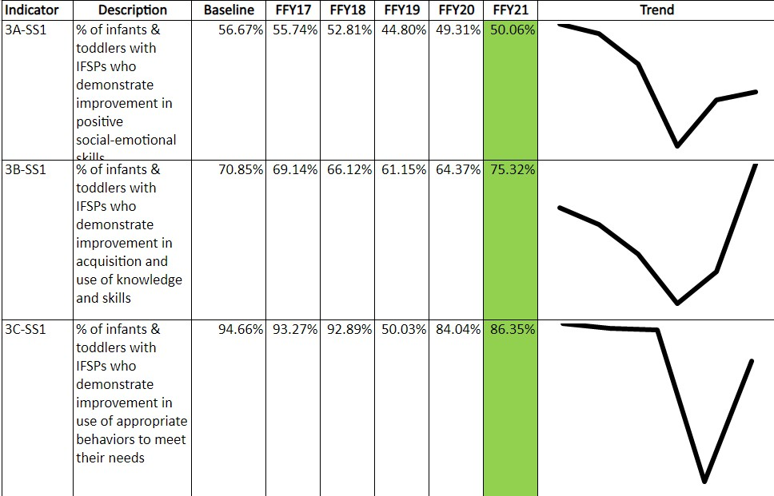
State Updates: Results Indicator 3 (Improvement)

Source: BDI-2 FFY22
(July 1,
2021-
June 30,
2022)

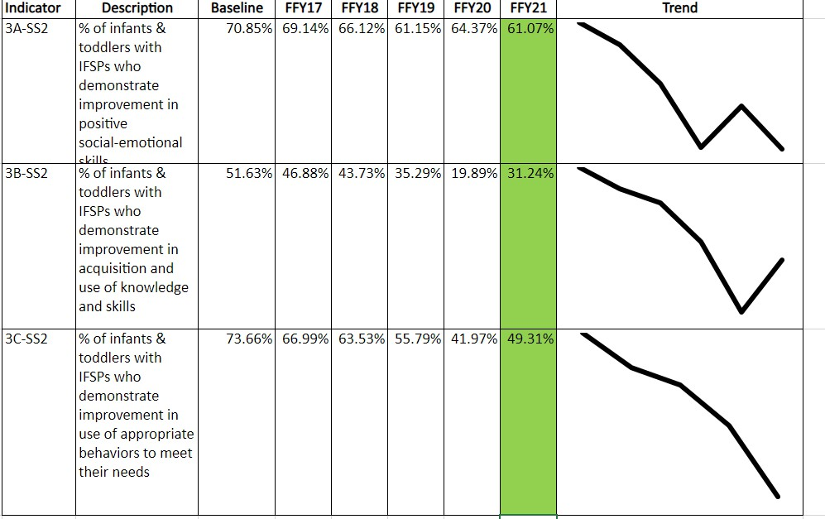
State Updates: Results Indicator 3 (Age-Expectations)

Source: BDI-2 7/1/21-

31.24
%

61.07
%
6/30/22

Massachusetts Department of Public Health | mass.gov/dph 25

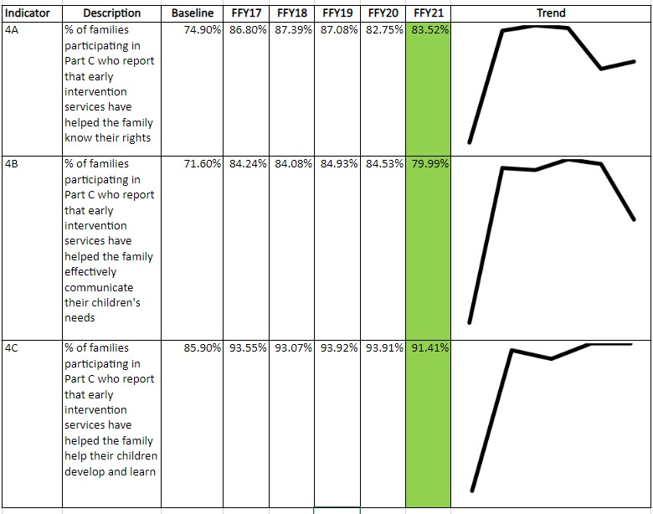
State Updates: Results Indicator 4

Source: NCSEAM
Family Survey Oct 2021
& March 2022

Massachusetts Department of Public Health | mass.gov/dph 26

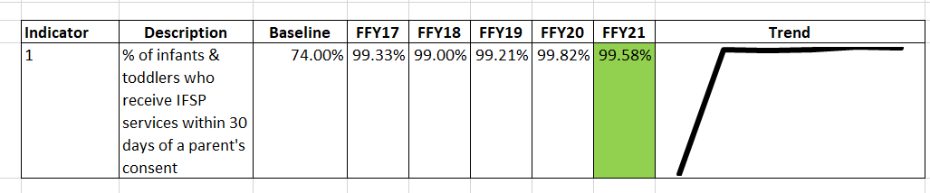
Source: FFY22Q4 (April 1 – June 30, 2022)
State Updates: Compliance Indicator 1

State Updates: Compliance Indicator 1

Source: FFY22Q4 (April 1 – June 30, 2022)

OSEP Responses

Indicator | OSEP Response | This Means | Action We Took
1 | OSEP notes the State reported "MA-C is continuing to work with its EIS programs to enter the undocumented reasons for delay into its state database and expects to further revise its reported FFY21 Quarter 4 data for Indicator 1 during the April 2023 clarification period." | We’re watching you MA-  C. We know you did this last year, too. | Revised Indicator data.
Massachusetts Department of Public Health | mass.gov/dph 29
1 The State reported "EIS programs were instructed to review the Intermittent Service isn’t Discussed we were
infants' and toddlers' records and correct any data entry errors an exceptional family referring to
or provide delay reasons, using the following categories: delay circumstance. intermittent internet attributable to exceptional family circumstances (e.g., family service for telehealth
problem scheduling appointment, family missed or cancelled an appt; removed
appointment, family delayed response or consent for an references to
appointment, intermittent service, weather or other emergency “intermittent
declared)". OSEP cannot determine whether delays caused due service.”
to an intermittent service were counted as an exceptional family circumstance, as defined in 34 CFR §303.310(b). The State must clarify

State Updates: Compliance Indicator 7

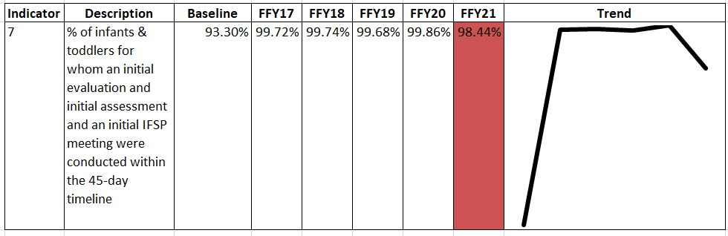
Source: FFY22 (July 1, 2021 – June 30, 2022)

State Updates: Compliance Indicator 8

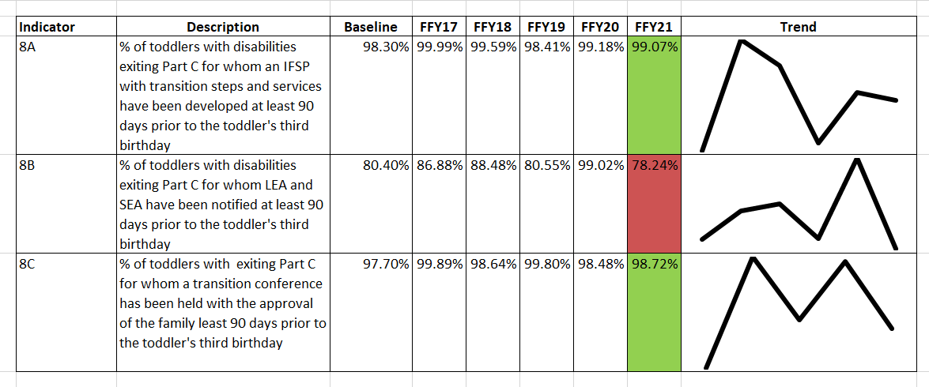
Source: FFY22 (July 1, 2021-June 30, 2022)

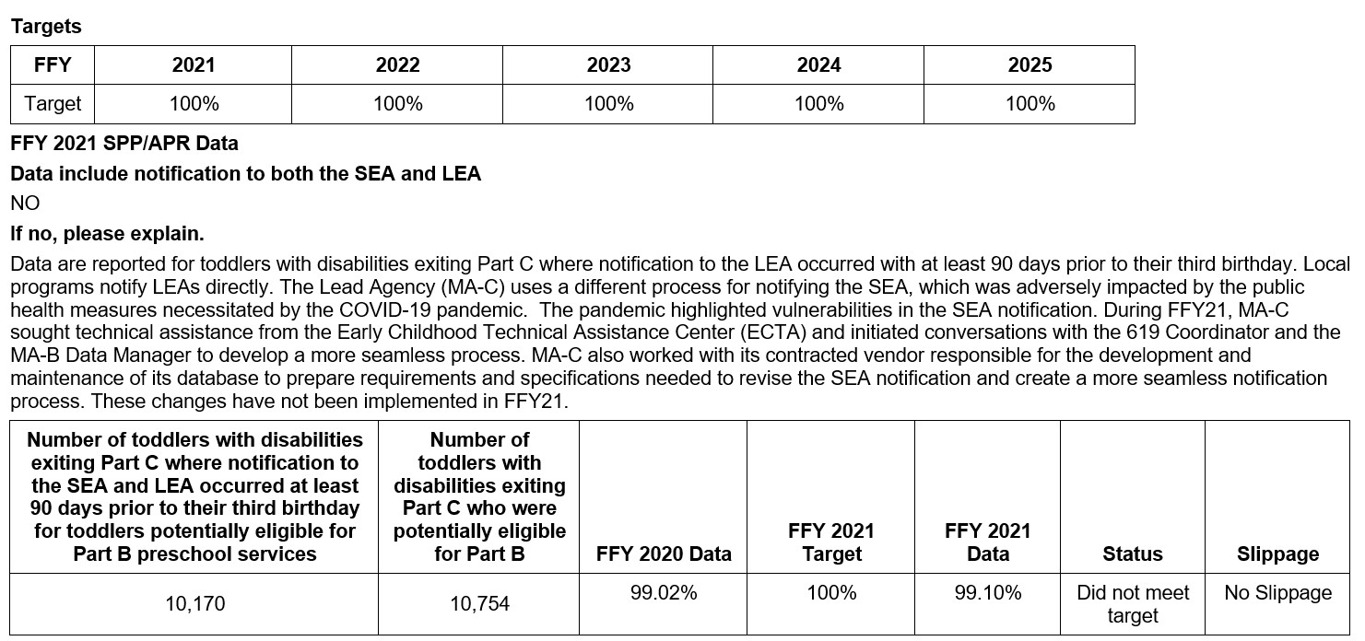
OSEP Responses

OSEP Responses

Indicator | OSEP Response | This Means | Action We Took
8B | The State did not provide valid and reliable data for this indicator. These data are not valid and reliable because the State's data does not include notification to both the SEA and LEA as required by the Measurement Table. Therefore, OSEP could not determine whether the State met its target. | Our data included only LEA notifications and it has to include LEA and SEA notifications. | Manually analyzed and calculated data to include SEA notifications.

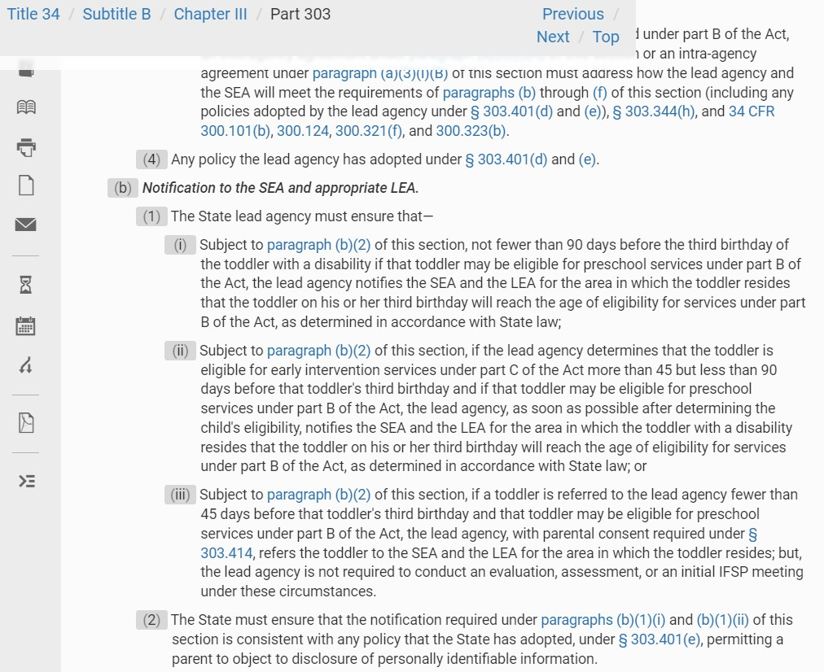
8B: LEA/SEA Notification

Massachusetts Department of Public Health | mass.gov/dph 34

8B: LEA/SEA Notification

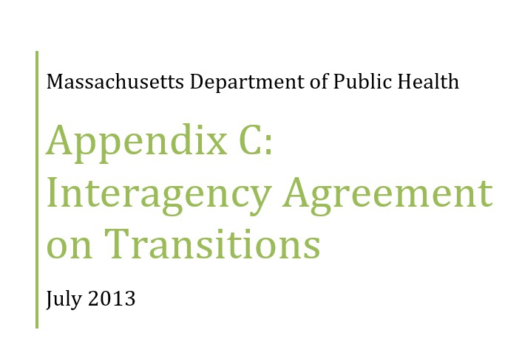

8B: LEA/SEA Notification

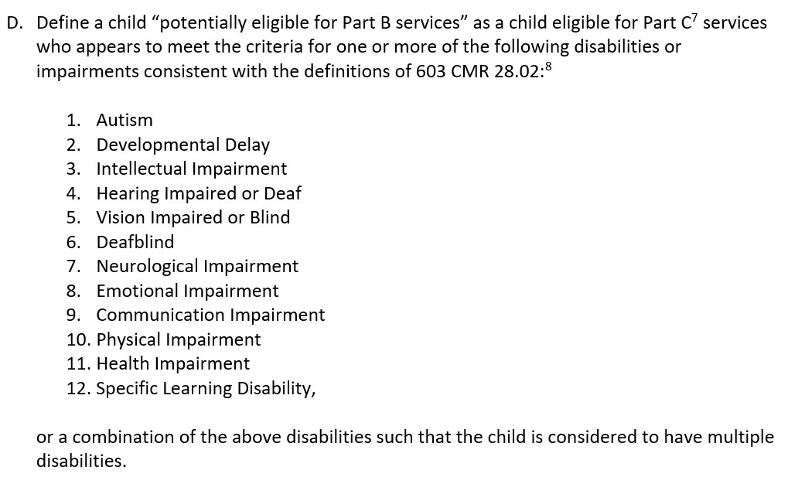

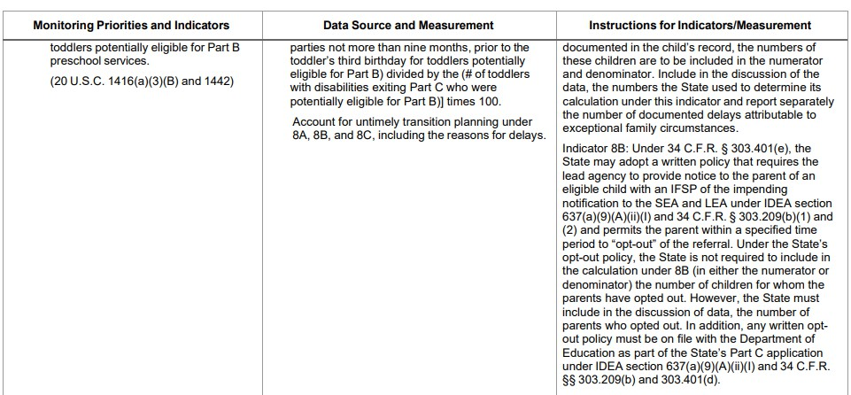
8B: LEA/SEA Notification

State Updates: Compliance Indicator 8

Source: FFY22 (July 1, 2021-June 30, 2022)

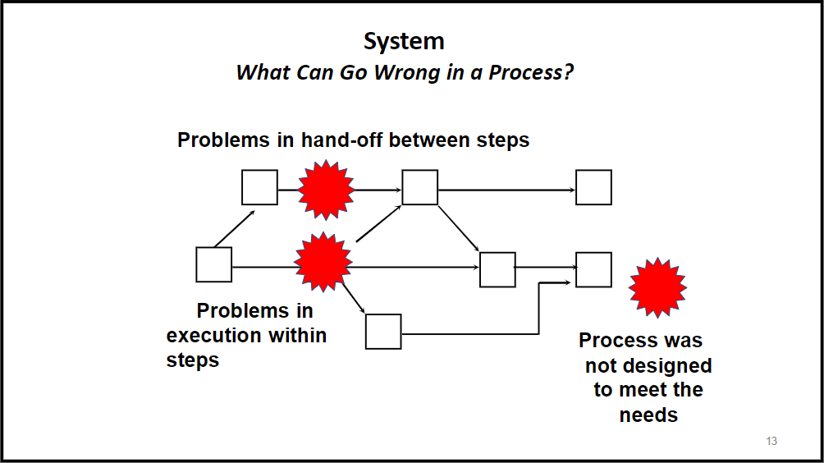
EIS notifies
LEA on time but enters data into EICS late
EICS creates
file daily (including weekends & holidays)
EICS
Business Rules don’t match Regs or MOU
8B: LEA/SEA Notification

8B: LEA/SEA Notification

- EICS Requirements Reviewed & Documented
- EICS Automation
- MOU Updates Initiated with DESE
- Training for EI Division Staff

FY24 General Early Intervention Services Procurement:
  - RFI Completed

Announced Nov 2022 ICC Meeting
Updated in March 2023 ICC Meeting
Next Step: Release Request for Response

State Updates: FY24 General EIS Procurement
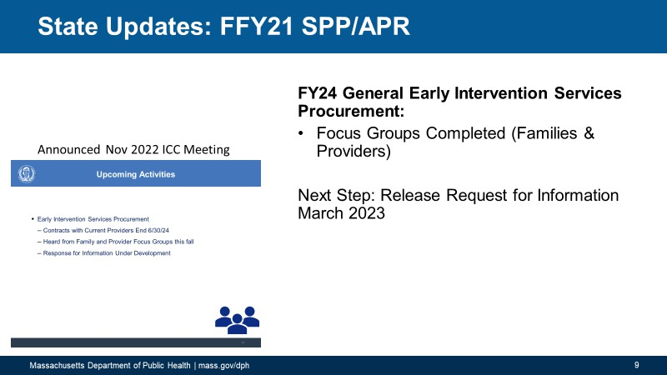

Written Responses
Overview of RFI Responses
Summary
- RFI open on COMMBUYS from 3/31/2023 – 04/21/2023
- RFI included 14 questions

Responses
- 9 responses
- Average number of questions
answered = 11

Verbal Responses
Summary
- Community Meeting held on 4/12/2023 from 1-2pm
- 2 questions were open for comment

Responses
- Question 1: 5 speakers
- Question 2: 3 speakers

Equity

What recommendations do you have for evaluating a bidder’s ability to use data to address racial
inequities within their program?

Require bidders to demonstrate a tracking system that evidences how the program will collect data to identify racial inequities and biases, as well as a process for improvement/ remediation in the event of findings
  - Data metrics could include identifying which populations should be accessing services or experiencing poorer outcomes for more targeted outreach, staff training, and support.

Bidders should be evaluated on whether the makeup of their clients reflects the community in which they provide services
  - Consider the % of staff that speak the native language of the children served, the program’s ability to translate reports into the native language, and the resources (funding) that goes into providing services in a means that aligns with the family’s culture.

Consider catchment-specific data and evaluate the efforts made by that program to meet the specific needs of their catchment area,
  - Homeless shelters, use of translators/language line and translation expenses, outreach initiatives
.

Equity

What recommendations do you have for evaluating a bidder’s ability to use data to plan, put in place,
and monitor the impact of interventions to address inequities?
- Utilize tools/strategies such as the Teacher Performance Rate and Accuracy Scale or other available tools that include social significance rating scales that would promote data/scores of effectiveness
Metrics should include:
- Demographic information
- Use of language demographic
- MassHealth/poverty statistics
- Community indicators of health
- Accurate IFSP data

A data work plan should include a system for:
- Data collection
- Entry
- Reporting
- Evaluation
- Planning
- Goals and benchmarks
- Responsible person
- Frequency of data collection
- The Division should share the current inequities in the system and evaluate bidders based on their ability to propose solutions
- A bidder should be able to demonstrate that there is a data evaluation system in place to analyze the demographics to identify disparities that exist
- Evaluate how bidders currently collect qualitative data (i.e. family
stories) to better understand the needs and inequities of the communities they serve

Family Engagement

Family engagement is a critical component of the IDEA Part C system. How do you suggest we evaluate a bidder’s commitment and ability to engage families across the EI continuum beginning with the referral and ending with discharge from EI?

The EI Division should evaluate a bidder’s…
- Approach to engaging families by asking about how they help overcome the challenges that the families are facing
- Ability to provide ongoing professional development to ensure staff are trained in multiple techniques for engaging families
- Approach to tailor outreach to non-English speaking families and those without access to the internet, smartphones, or other technology
- Ability to provide previous examples of successful partnerships, and relationships that highlight outcomes
- Commitment to their community, evident by hiring bilingual and racially diverse staff that represent their communities
- Commitment to a family-centered approach to service delivery by having a plan to evaluate family satisfaction with services
  - The Division should ask families and determine how well it aligns with Part C
- Commitment to engaging families through multiple communication opportunities, including written and verbal support, caregiver training, and caregiver groups, and plan for adapting these strategies based on data
- Approach to collecting qualitative feedback from families
- Ability to provide letters of support from partner agencies as part of the application package. If not a previous EI provider,
bidders should have a written plan for engaging families throughout the continuum.

Family Engagement

What are your recommendations for ensuring that bidders can find every child who is eligible for services in their area?

The EI Division should evaluate a bidder’ documented marketing and outreach abilities and relationships with key contacts such as primary care providers, daycares, WIC, housing authorities, DCF, etc. to increase awareness about the availability and importance of early intervention services.
  - Seek letters of support in the procurement process. Ask them to describe their outreach efforts, what community groups and boards they are members of, and their marketing plans.
  - Providers should be required to implement outreach activities in all communities in their catchment area
  - Outreach activities should be reported on a regular basis

Family Engagement

What recommendations do you have for connecting and more effectively engaging families, particularly from communities of color?
- Make trainings, community events, information sessions, and marketing materials free, readily available, and easily accessible. These should take a cultural humility lens and work to address stigma
- Go to families! Don’t assume that people are able to come to you. Transportation or babysitting is often an issue
- Share EI information with additional departments that are accessed by other communities
- Follow CLAS standards
- Hire diverse staff that share the language and cultural background and experiences of the families they serve
- Practice cultural humility and understand the family dynamics and cultures that impact family systems
- Utilize cultural brokers to make the healthcare system more accessible
  - Peer outreach workers with experience receiving services
  - Family Liaisons and EI staff familiar with resources to address social determinants of health (with a billable rate)
  - Offer translation services
- Take a community-driven approach with strong community partnerships, including faith-based organizations, preschools, and medical providers.
- DPH should create a definition of “effective engagement” so programs know what to work towards
- Empower parents through decision-making/goal-setting (especially during IFSP process)
- Use open-ended questions when asking about the child, family routines, and priorities

Contracting

How many EIS programs do you think should serve each community?

- Families should have a choice – at least 2 choices per region/catchment
- Do not over-concentrate catchment areas with too many options – this would make providers compete for fewer staff and would strain the EI system
- Focus should remain on supporting the current number of EIS programs
- The number of EIS programs needs to be dependent on the community and its population:
  - Assess population density, including census data, CDC statistics on developmental disabilities, and analysis of past data trends (including special ed data).
  - Survey current EI programs about whether they can meet each child’s needs, providing access to all supportive
and recommended treatment hours.
  - Review the number of pediatric offices and healthcare facilities within a catchment area to determine how many children may be within a region and qualify for services

Contracting

What are your ideas for evaluating companies that have not provided early intervention services in Massachusetts before?

The EI Division should evaluate a bidder’s…
- Ties to the community and ability to demonstrate established connections
- In-depth knowledge of EI service delivery system including an understanding of the fiscal model that funds EI (rate-setting process)
- Organizational structure to ensure it lends itself to providing EI services
- Long-term financial stability
- Ability to hire, train, and retain staff
- Physical space proposed for expansion to this service model
- Established history of providing evidence-based clinical services across disciplines
- Ability to collect and analyze data
- Policies and procedures in place that support and promote ethics, clinical service delivery, training and supervision, diversity and
inclusion
- History of effective home/community-based service delivery in Massachusetts outside of EI

The EI Division could consider…
- Funding pilot programs before offering multi-year contracts that require a prerequisite evaluation and site visit prior to making a multi- year contract
- Asking existing or past EI families what the most important factors are that played into their experiences. Use those responses to help
guide some questions for future providers

Contracting

What are your ideas for evaluating companies that are currently providing early intervention services in Massachusetts?

The EI Division should evaluate a bidder’s…
- Performance and compliance with EI Standards outcomes achieved, customer satisfaction, and adherence to program requirements, especially during the pandemic
- Ability to maintain services with the growth patterns of clients and staffing needs
- Local community-level connections needed to break silos and ensure community continuity of care.
- Staffing plan including how they establish caseload sizes for each employee/discipline based on factors such as the intensity and frequency of services needed, the complexity of the needs of the children served, and the ability to meet the needs of each child and review of service utilization rates
- Ability to use evidence-based interventions and plans for ongoing training and professional development
- Staffing patterns and review of potential staff turnover affecting family engagement and child outcomes
- Length of time providing EI services in Massachusetts
- Overall contributions to the statewide system and engagement/involvement in the EI community
- Ability to provide qualitative feedback from family regarding the services received

The EI Division could consider…
- Requiring that successful bidders submit to periodic on-site reviews, including a survey of partner agencies and parents for evaluating the quality of services. Expectations for programs should be clearly defined and agreed upon so that periodic reviews can assess programs against a clear rubric.
- That additional providers may likely further destabilize the existing crisis and workforce retention challenges.

High-Quality Service Delivery

How will we know if a bidder can provide research-based, high-quality services that produce effective outcomes for infants and toddlers with disabilities?

The EI Division should evaluate a bidder’s…
- Familiarity and utilization of evidence-based tools for data collection, questionnaires, and rating scales
- Ability to demonstrate a proven track record through an examination of their outcomes over time as well as their
ability to set goals and benchmarks for future performance
- Survey data showing that families and partners have positive experiences with the bidder
- Staffing plan that highlights the qualifications and resumes of existing staff. For staff to be hired through the RFP, job descriptions should be provided
- Vested in ongoing research, evaluation, and data analysis to ensure best practices are utilized, and optimal outcomes are achieved
- Demonstrated effective staff training and supervision processes and ongoing training of all staff that aids in effective outcomes for infants and toddlers with disabilities. The organization should also demonstrate a commitment to continuing education for staffing
- Commitment to fidelity to the PIWI model
- Commitment to hiring highly credentialed staff and ongoing professional development and education

High-Quality Service Delivery

What recommendations do you have for evaluating a bidder's ability to address workforce shortages or turnover with minimum disruption to services?

The EI Division should evaluate a bidder’s…
- Ability to produce data to assess current and future staffing needs, as well as staff tenure
- Recruitment plan with strategies that they’ve deployed to recruit new staff including partnerships with schools and
universities
- Workforce retention plan including their financial stability to offer competitive wages and growth, and an overall benefits package to reduce turnover
- Beliefs and policies for professional development and internal career growth
  - Does the program offer vital training programs that provide ongoing professional development, continuing education opportunities, and support for staff pursuing advanced degrees, and other support for staff to increase job satisfaction, reduce turnover and increase retention of qualified personnel?
  - Internal training program to make staff feel equipped to support the children and families enrolled in EI
- Organizational structure to support staff absences and staff turnover that reduces the number of disruptions to the
child’s services
- Interest in advocacy for statewide collaboration to address systemic issues that contribute to the current industry- wide workforce crisis including if a bidder has contributed to a system-wide, collaborative process for addressing the current workforce situation

Policies & Procedures

How will we know if a bidder is familiar with the Individuals with Disabilities Education Act (IDEA) Part C and other regulatory requirements?

The EI Division should evaluate a bidder’s…
- Level of understanding by asking them to provide examples of certain aspects of regulations that the
department finds to be critical
- Knowledge of the core frameworks of the EI system, including the regulatory requirements and be able to discuss what these requirements mean at the program level, the state level, and beyond
- Years of experience working in the system
- Ability to demonstrate activities that support IDEA Part C for each item in the regulation
- History of services provided, comprehensive policies and procedures that comply with regulations,
and training and self-monitoring systems established to ensure ongoing compliance
- Understanding of IDEA and part C and its impact on Early Intervention service delivery
- Ability to know where to find the regulatory requirements

Part C Policies & Procedures: Pop Quiz!

State Updates: CLAS Grant

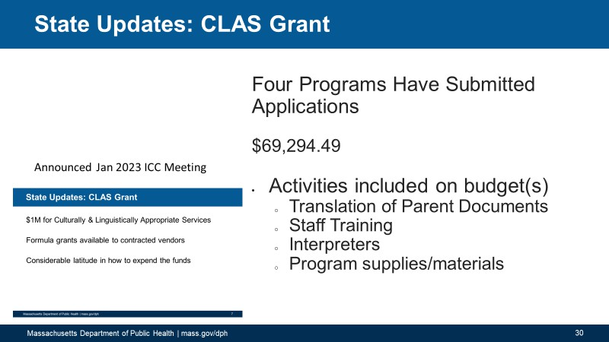
Announced Jan 2023 ICC Meeting Updated Mar 2023 ICC Meeting
24 Agencies Have Submitted Applications
$721,527.32
- Activities included on budget(s)
  - Translation of documents
  - Staff training for cultural competency
  - Interpreter services
  - Supplies/materials

Differential Monitoring & Support
2.0 (DMS):

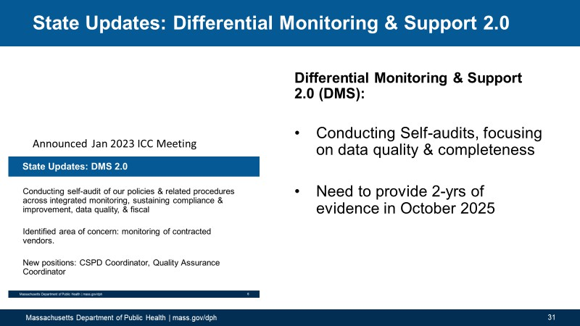
Announced Jan 2023 ICC Meeting Updated Mar 2023 ICC Meeting
State Updates: Differential Monitoring & Support 2.0
- Completed: Self-audits using DMS 2.0 Protocols

- Next Actions:
  - General Supervision &
Monitoring Manual
  - Revisions to Data Quality Reports

SPP/APR Indicator 4 Sampling Plan:
Submitted plan to OSEP to stop sampling in FFY24 (July 1, 2024)

Announced Mar 2023 ICC Meeting
Next Step: Awaiting Feedback

State Updates: Indicator 4 Sampling Plan
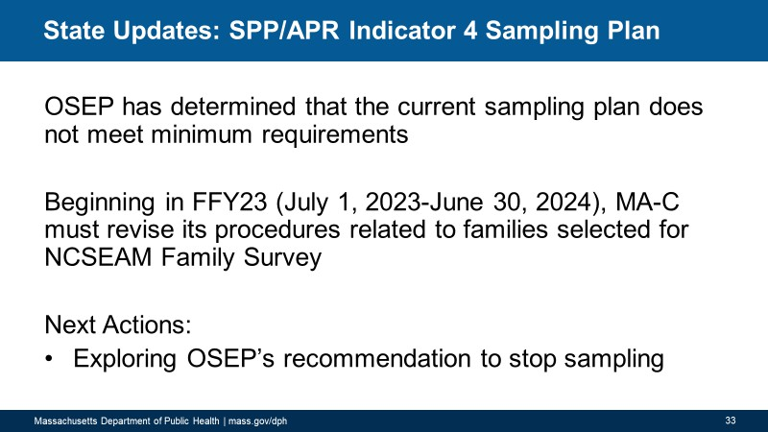

State Updates: Eligibility & Indicator 3 Instrument Change

Announced Mar 2023 ICC Meeting
Eligibility Instrument Change:
- Confirmed BDI-2 available through FY24
- OSEP approved change and future reset
of baseline
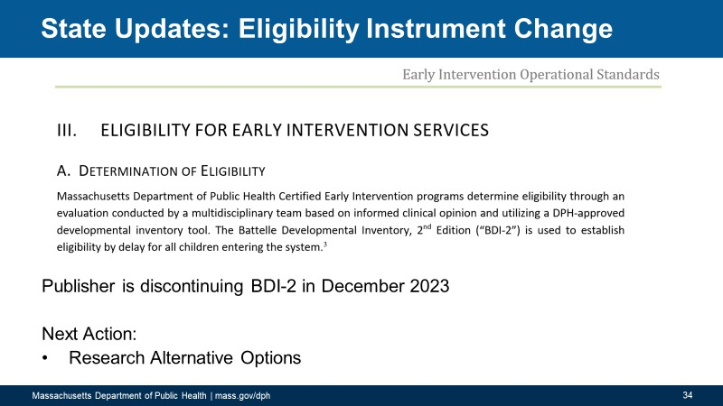
- Contractors reviewing available instruments

Next Step: Select instrument for use beginning July 1, 2024

State Updates: Early Intervention Client System

Announced Mar 2023 ICC Meeting
EICS Updates:
- Three Current User Groups have been launched
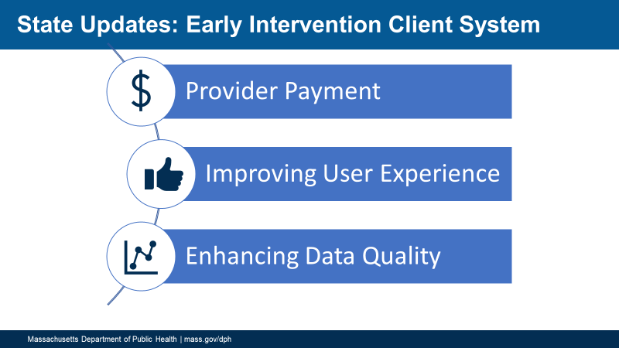
- EICS is being updated to reflect payor carveouts for behavioral health
- Programs have been informed the EICS will be updated with the latest MassHealth insurance plans

State Updates: New Initiatives

  - State Updates
    - New Initiatives
      - SPP/APR: Local Program Performance & Determinations
      - Workforce Survey

State Updates: FFY21 Local Program Determinations

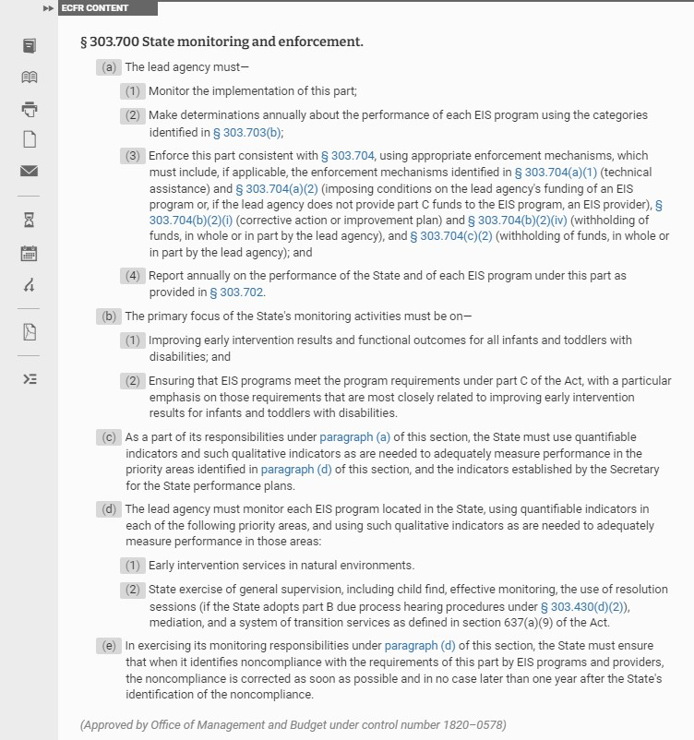
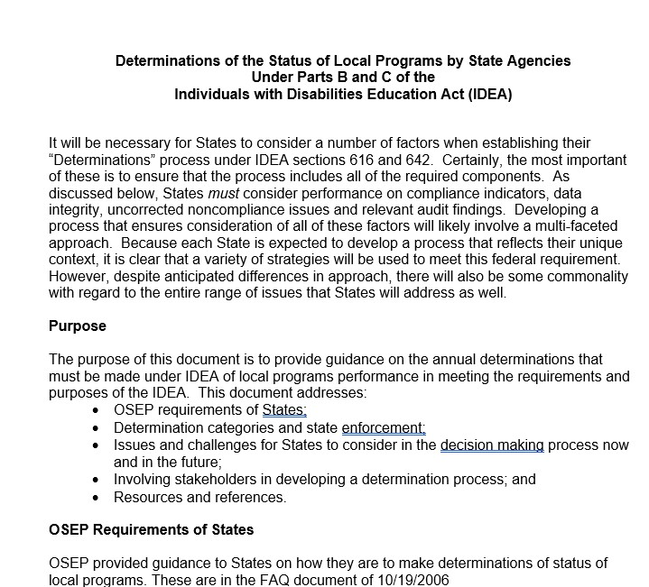
FFY 21 Local Performance Reports Posted
        - Local Determinations as required by 34 CFR 303.700
(1,7,8)
uality Reports)
          - Compliance Indicators
          - Data Quality
(Data Q n time)
(837 o
          - Fiscal
(4)
          - Results Indicator

State Updates: Workforce Survey

Survey Released in May to assess job satisfaction & burnout levels among direct-care staff

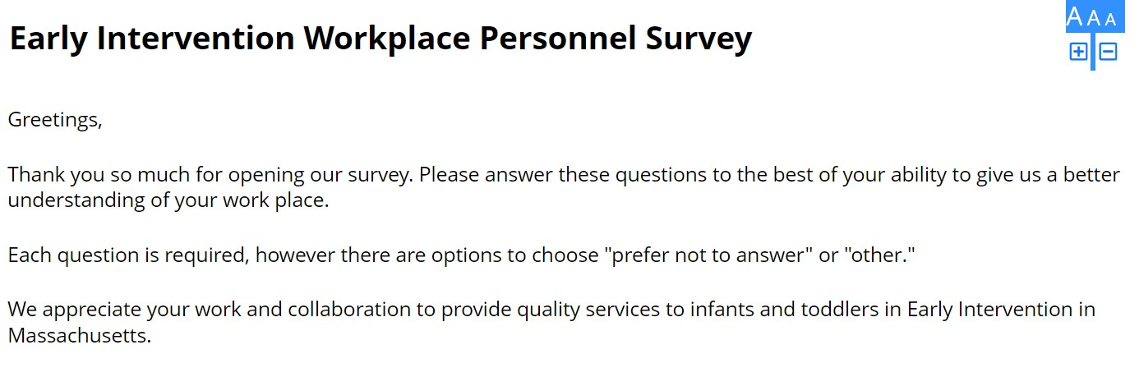

State Updates: Data

Data
    - FY23 Financials
    - FY20-FY23 Child Find

State Updates: Data

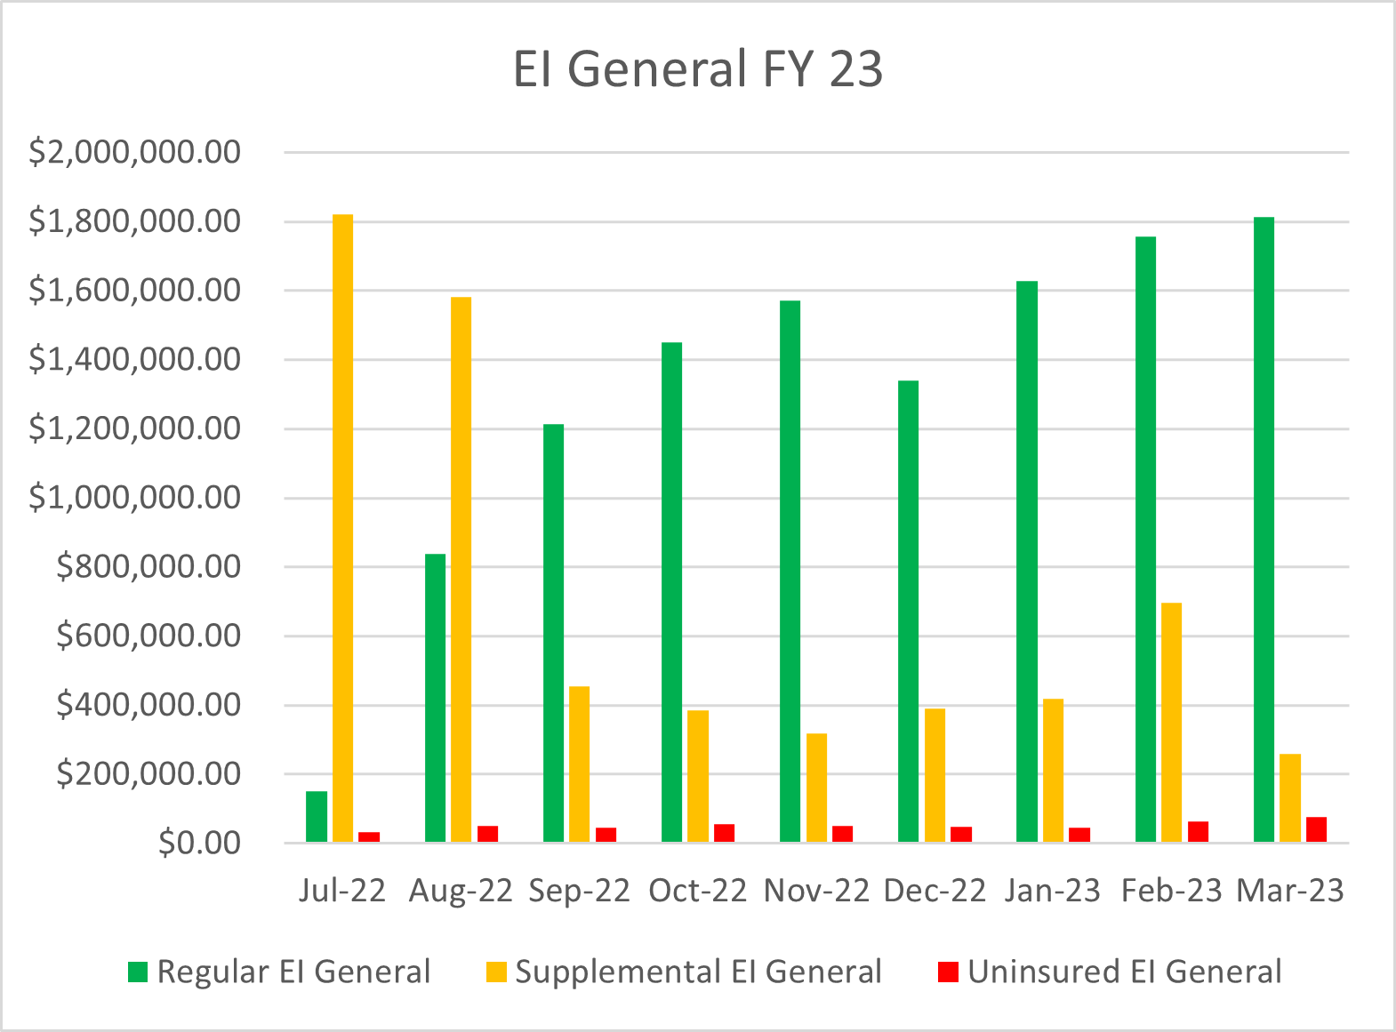

State Updates: Child Find Data

Child Find
    - Identify, locate, and evaluate all children who may need early intervention services
    - Mandated by IDEA
    - Monitored by OSEP

State Updates: Child Find Data FY20 (7/1/19-6/30/20)

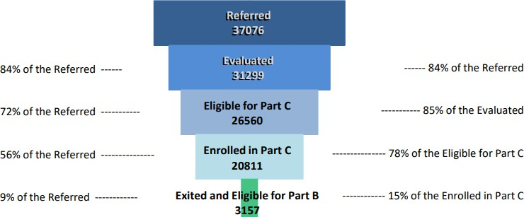

State Updates: Child Find Data FY21 (7/1/20-6/30/21)

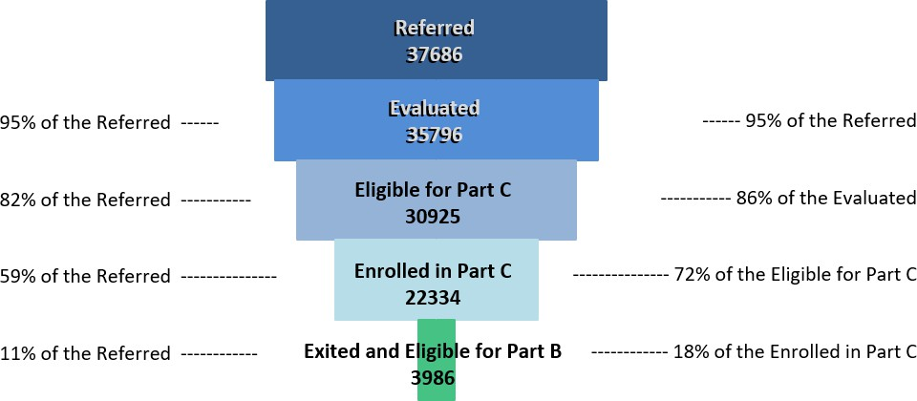

State Updates: Child Find Data FY22 (7/1/21-6/30/22)

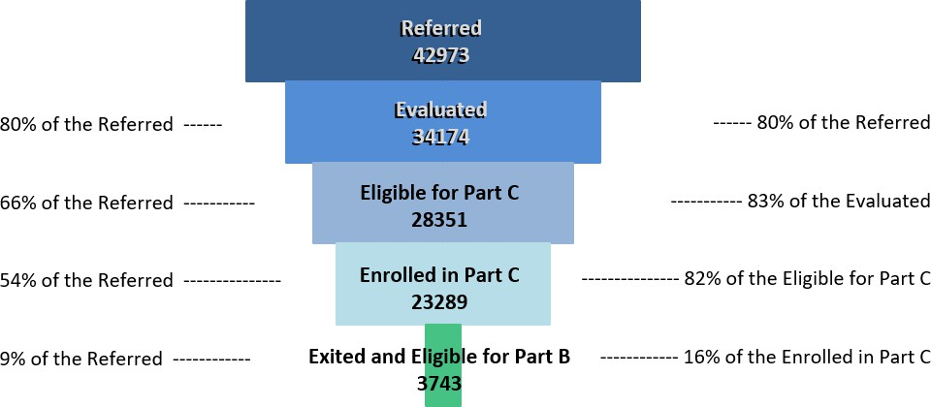

State Updates: Child Find Data FYTD23 (7/1/22-5/2/23)

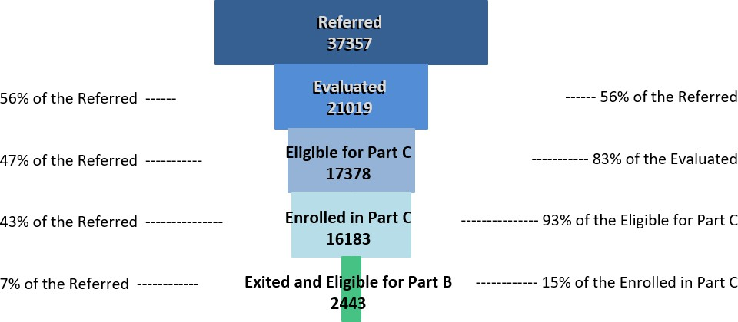

State Updates: Child Find Data

What do we See?
- The percentage of those evaluated has significantly reduced
- Eligibility for Part C remained stable between FY20 and FY23
- Enrollment rates in Part C were lower during COVID and then gradually increased in FY22 and FY23
- Rates of infants and toddlers exiting Part C and being eligible for Part B remained stable

State Updates: Child Find Data

What Does This Mean?
- Fewer children referred to EI are progressing through the care cascade
- Variability in evaluation rates among programs

State Updates: Child Find Data

What do we do Next?
- Mobilize resources to follow-up on referrals

Celebrating Michelle Grewal

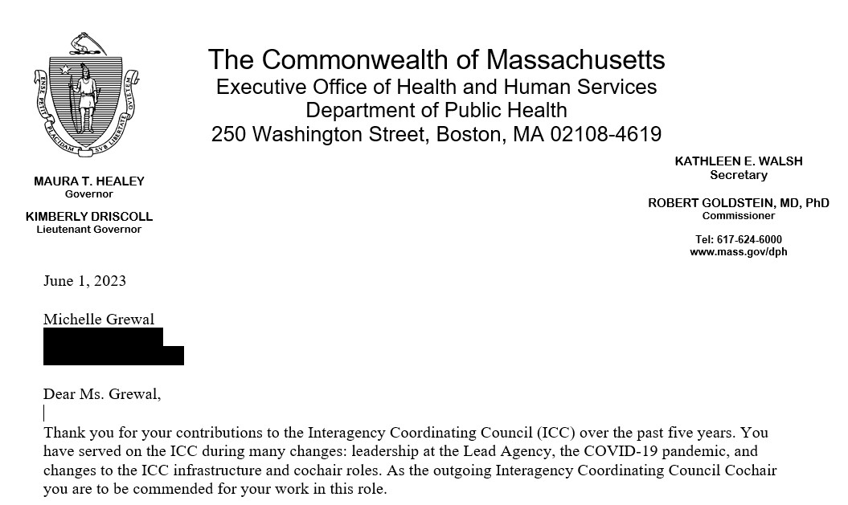

Massachusetts Department of Public Health

Director’s Report

June 1, 2023

Emily White, PhD, BCBA-D, LABA Part C Coordinator
Director, Early Intervention Division

