**Massachusetts Department of Public Health**



# FFY22 State Performance Plan/ Annual Performance Report

December 7, 2023

**Emily White, PhD, BCBA-D, LABA Part C Coordinator**

**Director, Early Intervention Division**

**Agenda**

* Share data from FFY22 State Performance Plan/Annual Performance Report
* Ask for your assistance to contextualize the data
* Ask for your advice for what the EI Division can do differently

**Why do we Submit an SPP/APR?**

**Statutory Requirement:** 20 U.S.C. 1416(b)(1)(C) and 1442 of the Individuals with Disabilities Education Act (IDEA), each Lead Agency must report annually, through the Part C SPP/APR

**What’s the Purpose of the SPP/APR?**

Evaluates the state's efforts to implement the requirements and purposes of Part C of the Individuals with Disabilities Education Act (IDEA)

Reports on progress in meeting the measurable and rigorous targets the state established as part of its State Performance Plan

**What Happens After we Submit the SPP/APR?**

Office of Special Education Programs (OSEP) designed for states to describe implementation and measurement of IDEA within the state system

Content and other state data inform OSEP determinations about whether the state “meets requirements” in implementing IDEA

Functions as a report for the state’s key representatives

**What’s Included in the SPP/APR?**

**Results Indicators** (2,3,4,5,9,10): focus on system and child and family outcomes; targets established by state

**Compliance Indicators** (1,7,8): 100% compliance is the requirement

**State Updates: SPP/APR**

**Determinations:** Based on the information provided in the state’s APR, information obtained through monitoring visits, and any other public information, the OSEP will determine if the state

* Meets Requirements
* Needs Assistance
* Needs Intervention
* Needs Substantial Intervention

Targets Met Not Met; No Slippage Not Met; Slippage

FFY18 FFY19 FFY20 FFY21 FFY22

**How are we Performing Across Time?**

Comparing FFY18 to FFY17

FFY22

FFY20

FFY18

Not Met;

Declined from Prior Year

Not Met but Improved or Maintained from Prior Year

Targets Met

**How are we Performing Across Time?**

Comparing

FFY19 to FFY18

FFY19

Comparing FFY20 to FFY19

Comparing

FFY21 to FFY20

FFY21

Comparing FFY22 to FFY21

FFY21

FFY22

FFY20

FFY19

FFY18

**How are we Performing Across Time?**

Targets Met

Comparing

FFY18 to FFY17

Comparing

FFY19 to FFY18

Comparing

FFY20 to FFY19

Comparing

FFY21 to FFY20

Comparing

FFY22 to FFY21

Not Met but Improved or Maintained From Prior Year

Targets Met

Comparing FFY18 to FFY17

FFY22

FFY20

FFY18

**How are we Performing Across Time?**

Comparing

FFY19 to FFY18

FFY19

Comparing FFY20 to FFY19

Comparing

FFY21 to FFY20

FFY21

Comparing FFY22 to FFY21

FFY18 = 7/1/18-

6/30/19

FFY19 = 7/1/19-

6/30/20

FFY20 = 7/1/20- 6/30/21

FFY21 = 7/1/21- 6/30/22

FFY22 = 7/1/22- 6/30/23

Not Met; Declined from Prior Year

Not Met but Improved or Maintained From Prior Year

Targets Met

FFY22

FFY20

Comparing FFY18 to FFY17

FFY18

**How are we Performing Across Time?**

Comparing

FFY19 to FFY18

FFY19

Comparing FFY20 to FFY19

Comparing

FFY21 to FFY20

FFY21

Comparing FFY22 to FFY21

**We Need Your Advice & Assistance!**

What happened in the field that created the improvement between July 1, 2022-June 30,

Comparing Comparing

FFY18 to FFY19 to

FFY17 FFY18

Comparing Comparing

FFY20 to FFY21 to

FFY19 FFY20

Comparing

FFY22 to

FFY21

2023?

FFY21

FFY22

FFY20

FFY19

FFY18

Number

What is measured

Starting

Point Recent Data for

(2005) Comparison

Current Data

Graph Depicting

Direction of Time

**SPP/APR Data Display**

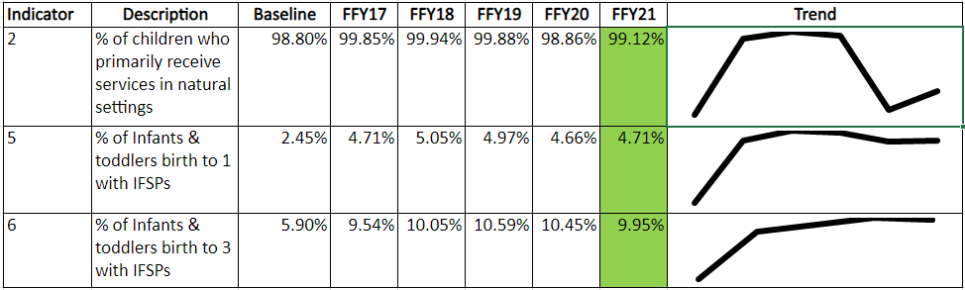

**Indicator Number**

Number

What is

measured

Starting

Point Recent Data for

(2005) Comparison

Current Data

Graph Depicting

Direction of Time



Number

**Indicator Description Provided by OSEP**



What is measured

Starting

Point Recent Data for

(2005) Comparison

Current Data

Graph Depicting

Direction of Time

Number

**Baseline Data**



What is measured

Starting

Recent Data for

Comparison

Current Data

Graph Depicting

Direction of Time

Point (2005)

Number

**Comparison Data**



What is measured

Starting Point (2005)

ent Data

Graph Depicting

Direction of Time

Curr

Recent Data for Comparison

Number

**FFY22 Data: July 1, 2022 – June 30, 2023**



What is measured

Starting Point (2005)

Recent Data for Comparison

Current Data

Graph Depicting

Direction of Time

Number



What is measured

Starting Point (2005)

Recent Data for Comparison

Current Data

**Trend Across Time**

Graph Depicting

Direction of Time

Number



What is measured

Starting Point (2005)

Recent Data for Comparison

Current Data

Source: Date Range for Current Data

**Source & Date Range**

Graph Depicting

Direction of Time

Targets Met

Not Met; No Slippage

Not Met; Slippage

**SPP/APR Slippage & Targets Met**

FFY22

FFY21

FFY20

FFY19

FFY18

**Indicator 2**

What Percentage of Children Primarily Receive Services in the Natural Environment (i.e., locations where children without disabilities spend time)?

**Services in the Natural Environment**

Source: 618 Data Collected 10/1/23

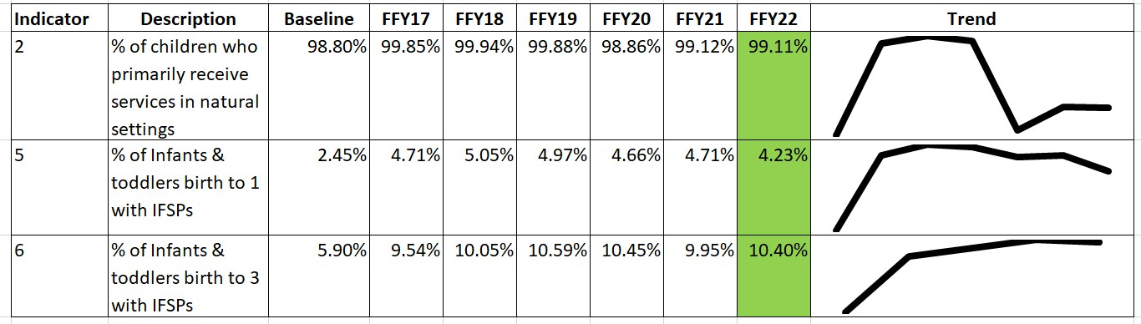

**Indicators 5 & 6**

What Percentage of Children (birth to 1; birth to 3) are Served?

**Infants Served**

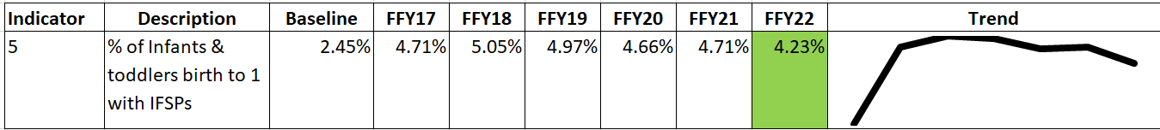

Source: 618 Data Collected 10/1/23

**We Need Your Advice & Assistance!**

What are some ideas for outreach to families with birth-1- year olds?



**Total Children Served**

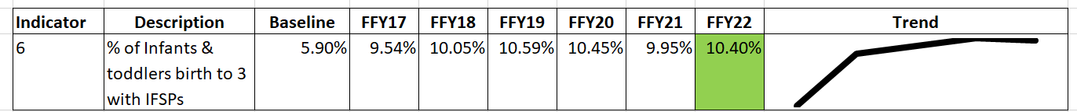

Source: 618 Data Collected 10/1/23

**We Need Your Advice & Assistance!**

We served 10.4% of all children in MA ages birth to three. Is this the right size for our system?

What makes you think that?

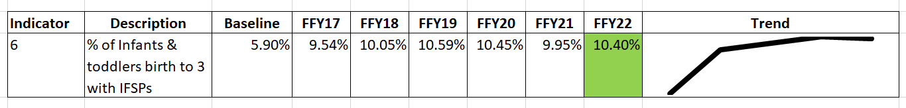

**Indicator 3, Summary Statement 1**

What Percentage of Children who Entered Below Age Expectations Exit Early Intervention with Substantial Improvements?

**Children who Entered Below Age-Expectations Making Substantial Improvements**

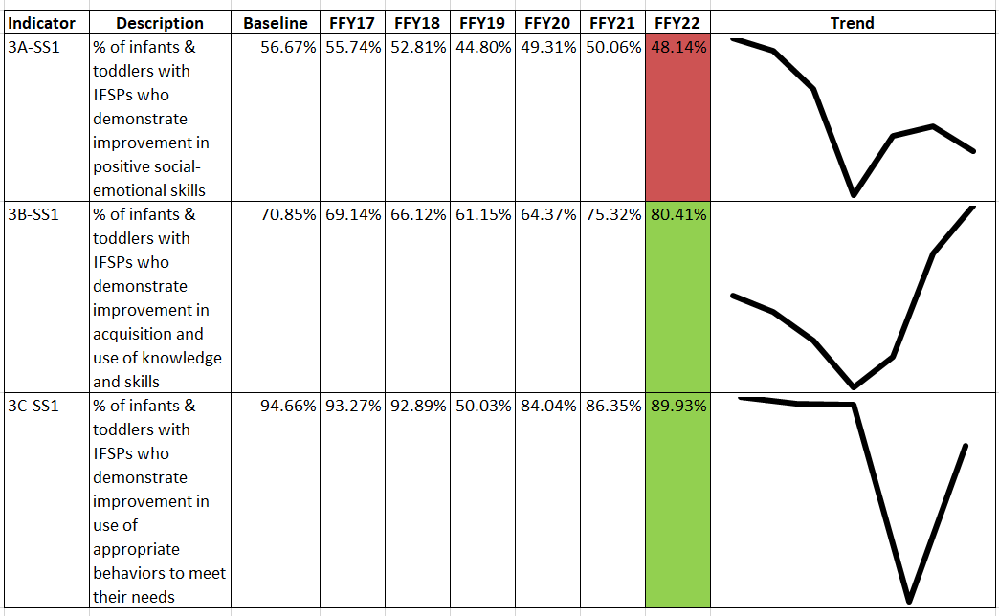

Source: Exited 7/1/22-

6/30/23

& had 2 BDI-2s

during EI

**We Need Your Advice & Assistance!**

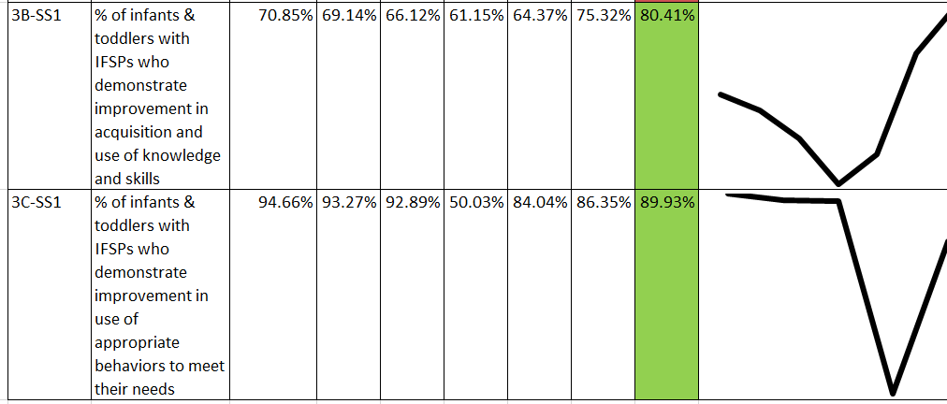

What made these improvements happen?

Massachusetts Department of Public Health | mass.gov/dph 32

**We Need Your Advice & Assistance!**

What ideas do you have for improving this result?

What steps do you recommend we take at the state-level to improve this outcome?

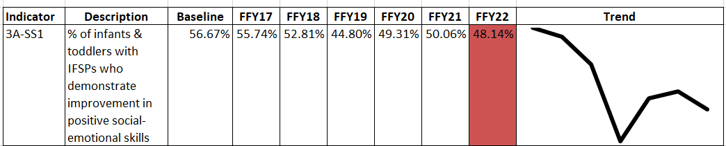

**Indicator 3, Summary Statement 2**

What Percentage of Children who Exit Early Intervention Meet Age Expectations?

## Children Meeting Age Expectations at Exit

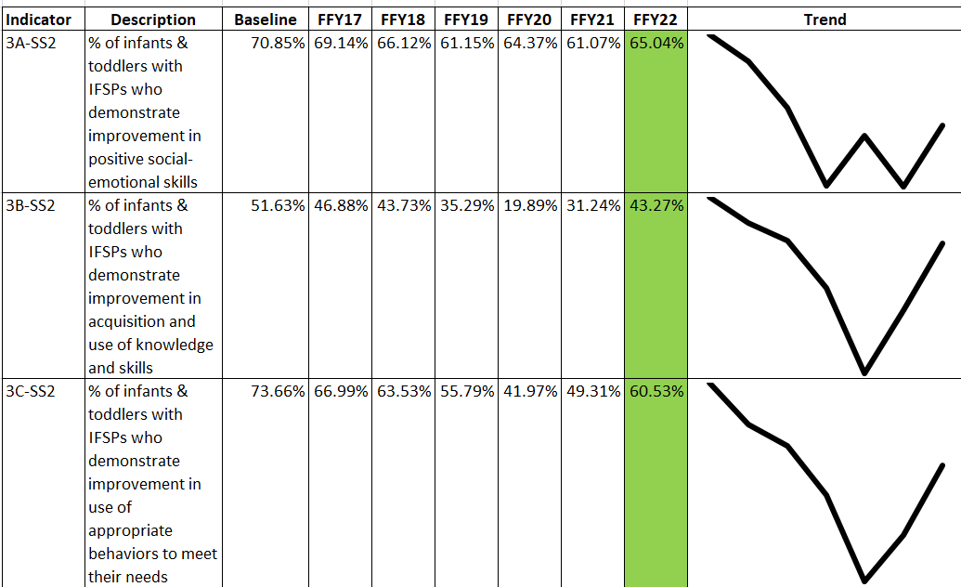

Source: Exited 7/1/22-

6/30/23

& had 2 BDI-2s

during EI

Massachusetts Department of Public Health | mass.gov/dph 35

## We Need Your Advice & Assistance!



What made these gains possible?

Massachusetts Department of Public Health | mass.gov/dph 36

**State Updates: Results Indicator 3**

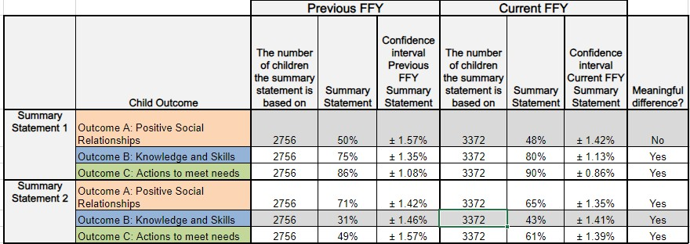

**Indicator 4**

What Percentage of Families Perceive Early Intervention to have Helped Their Family Know Their Rights, Effectively Communicate Their Child’s Needs, and Help Them Help Their Child Develop and Learn?

**Families Perception of Early Intervention Services**

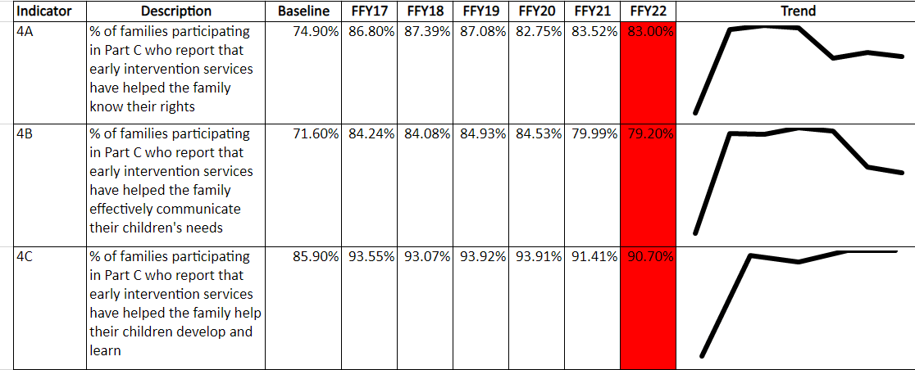

Source: NCSEAM Impacts on Family Survey July 1, 2022-May 30, 2023

40.00%

35.00% 33.40% 32.70%

31.22% 32.60%

30.00% 27.82%

25.00% 23.29%

20.00%

15.00%

10.00%

5.00%

0.00%

Boston

Central

Metro

Northeast

Southeast

West

Regional Response Rate State Response Rate

**FFY22 Response Rate by Region**

**We Need Your Advice & Assistance!**

What do you see in the field that might be causing this decline? What ideas do you have for improvement?

What can we at the state-level do to increase this performance?



**Massachusetts Department of Public Health**



# FFY22 State Performance Plan/ Annual Performance Report

January 10, 2024

**Emily White, PhD, BCBA-D, LABA Part C Coordinator**

**Director, Early Intervention Division**

**Indicator 7**

What Percentage of Children are Receiving an Initial Evaluation and IFSP Meeting within 45 days?

**45-day Evaluation & IFSP Meeting**

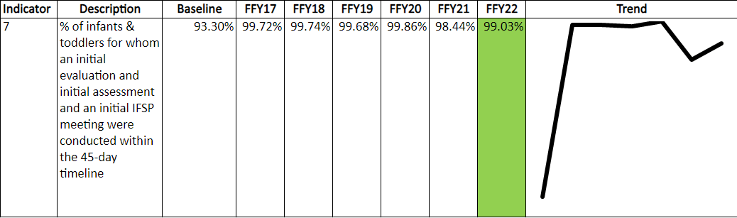

Source: FFY22 Quarter 3 (January 1, 2023 – March 30, 2023)

**We Need Your Advice & Assistance!**



What was changed last year to make this improvement?

What suggestions do you have supporting providers in correcting noncompliance?

Massachusetts Department of Public Health | mass.gov/dph 45

**Indicator 1**

What Percentage of Children are Receiving Services within 30

days of a Parent’s Consent?

**Services Within 30 days**

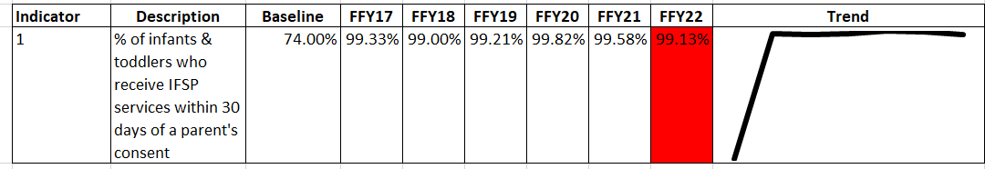

Source: FFY22 Quarter 3 (January 1, 2023 – March 30, 2023)

**We Need Your Advice & Assistance!**

What occurred in the field that contributed to this decline?

What do you recommend we do at the state level to improve timely delivery of services?



100%

90%

80%

70%

60%

50%

40%

30%

**11,767 Children**

8,685 Timely (30 days of Parent Consent) 2,061 Delays Attributable to Exceptional Family Circumstances

41 Delays Not Attributable to EFC

*980 Undocumented Delay*

**State Updates: Compliance Indicator 1**

20%

10%

0%

FFY22Q3

 Timely  Exceptional Family Circumstance

 Untimely  Undocumented Reason

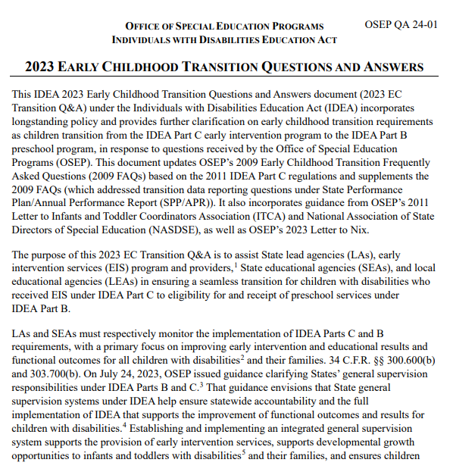

50

## Transition Plan Requirements

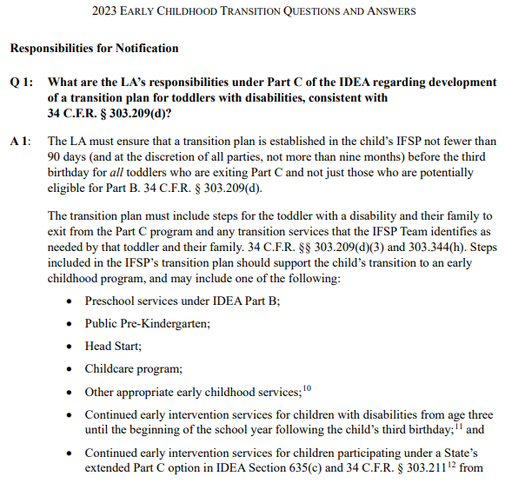

Every exiting toddler requires a transition plan

No later than 90 days before the toddler’s 3rd birthday, EIS programs must develop an IFSP with transition steps and services

Massachusetts Department of Public Health | mass.gov/dph 51

## Who is Potentially Eligible?

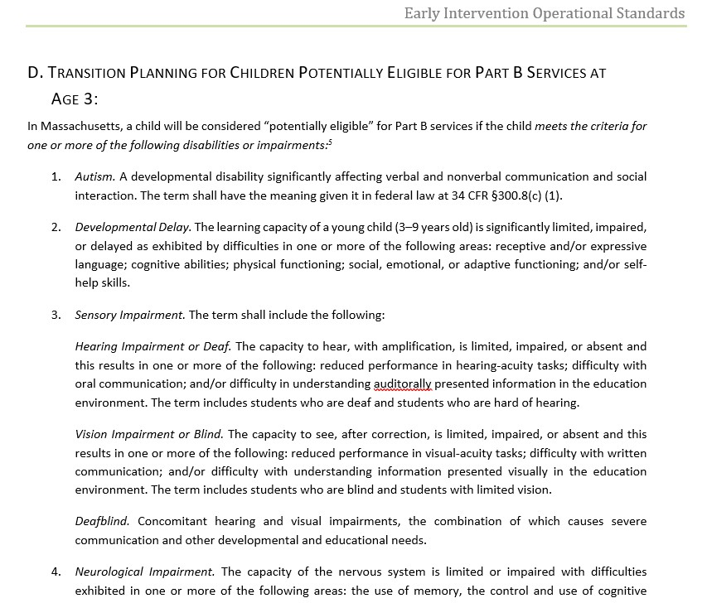

Potentially eligible is defined in the Early Intervention Operational Standards

Massachusetts Department of Public Health | mass.gov/dph 52

## LEA/SEA Notification Requirements



No Later Than 90 days before the child’s 3rd Birthday: for toddlers who are potentially eligible for Part B services

1. EIS programs must send notification to local education agency
2. EI Division must send notification to state education agency

Massachusetts Department of Public Health | mass.gov/dph 53

## Transition Conference Requirements

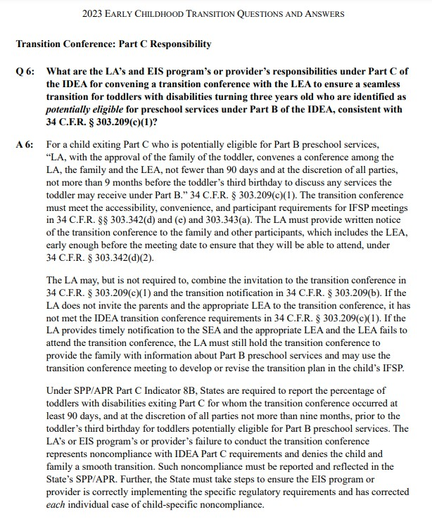

Transition Conference must occur even if LEA is unable to attend

Massachusetts Department of Public Health | mass.gov/dph 54

**Indicator 8A**

What Percentage of Children have an IFSP with Transition Steps and Services Developed no Later Than 90 days Before Their 3rd Birthday?

**Transition Plan Developed ≥ 90 days Before 3rd Birthday**

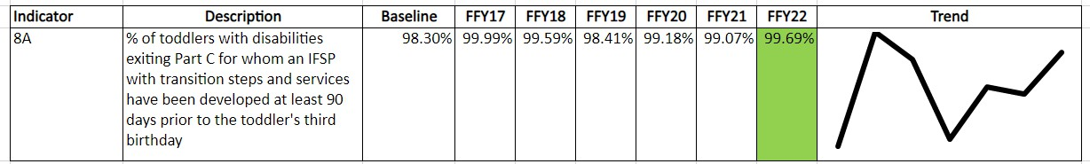

Source: FFY22 Quarter 3 (January 1, 2023 – March 30, 2023)

**We Need Your Advice & Assistance!**

What made this successful?

What helped us reverse the trend? What are the remaining barriers?



**Indicator 8B**

What Percentage of Potentially Eligible Children have Notification Sent to the Local Education Agency and the State Education Agency?

**How is SEA Notification Completed?**

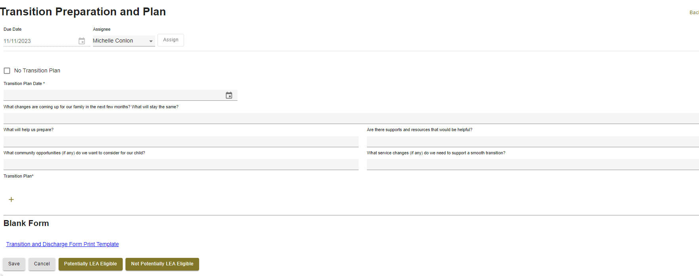

**LEA/SEA Notification ≥ 90 days Before 3rd Birthday**

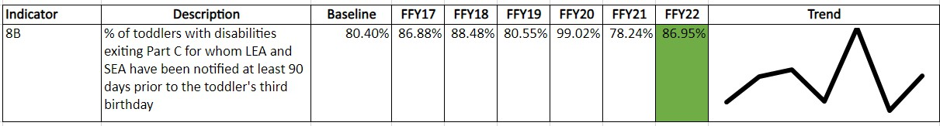

Source: FFY22 Quarter 3 (January 1, 2023 – March 30, 2023)

**We Need Your Advice & Assistance!**

What are the barriers to timely data entry?

What do you recommend we do at the state level for data entry? What are the barriers to timely LEA Notification?



**Indicator 8C**

What Percentage of Potentially Eligible Children have a Transition Conference no Later Than 90 days Before Their 3rd Birthday?

**Transition Conference ≥ 90 days Before 3rd Birthday**

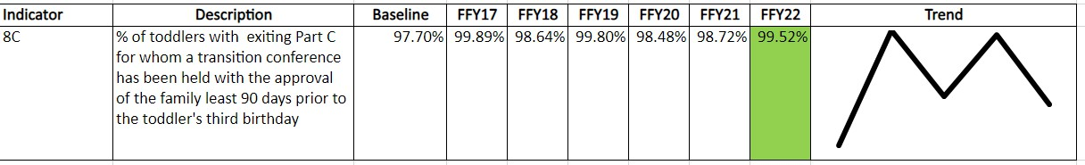

Source: FFY22 Quarter 3 (January 1, 2023 – March 30, 2023)

**We Need Your Advice & Assistance!**

What made this successful?

What helped us reverse the trend? What are the remaining barriers?



100%

90%

80%

70%

60%

50%

40%

**8,898 Children**

6,451 Timely

2,360 Delays Attributable to Exceptional Family Circumstances

43 Delays Not Attributable to EFC

*44 Missing Transition Plan Data*

**State Updates: Compliance Indicator 8A**

30%

20%

10%

100%

90%

80%

70%

60%

50%

40%

**9,183 Children**

6,372 Timely

2,593 Delays Attributable to Exceptional Family Circumstances

113 Delays Not Attributable to EFC

*105 Missing Transition Conference Date*

**State Updates: Compliance Indicator 8C**

30%

20%

10%

**Massachusetts Department of Public Health**



# FFY22 State Performance Plan/ Annual Performance Report

December 7, 2023

**Emily White, PhD, BCBA-D, LABA Part C Coordinator**

**Director, Early Intervention Division**