

**The Massachusetts Early Intervention**

**Interagency Coordinating Council (ICC) Handbook**

# About the Early Intervention ICC Handbook

The Massachusetts Interagency Coordinating Council (ICC) is a federally mandated statewide inter-agency group that advises and assists the Department of Public Health (DPH) on Early Intervention (EI). The purpose of this handbook is to outline the ICC operations to ensure a high-functioning Council.

# ICC Purpose & Governing Regulations

All states who receive federal money to implement Early Intervention (“Part C”) systems are required to have an ICC to advise and assist the Lead Agency (DPH) in the planning, development and provision of the statewide EI system. State ICCs are governed by [federal regulations](https://sites.ed.gov/idea/regs/c/g) through the Individuals with Disabilities Act (IDEA) Part C. *[Part 303 Subpart G]* The regulations direct how ICCs operate, including: membership composition and appointments, functions and authorized activities of the council, meeting structure, and use of funds.

# Massachusetts Open Meeting Law

The ICC is a public body and is subject to the Open Meeting Law (OML). The OML ensures transparency in the deliberations on which public policy is based. The law requires all meetings of public bodies be open to the public and establishes rules relative to the maintenance of meeting records. The Massachusetts Attorney General's (AG) Office holds responsibility for statewide enforcement of the OML. ICC-appointed members must review OML materials provided by the Attorney General's Office and sign a certificate of receipt verifying they have read and understand the requirements of the OML and the consequences of violating it. For questions, visit the Attorney General's Open Meeting Law website: <https://www.mass.gov/the-open-meeting-law>

# Vision, Mission, Core Principles

The Massachusetts ICC will advise and assist the DPH through active collaboration and engaged participation of all members in order to ensure and sustain a comprehensive birth-to-three system. As a result, the Commonwealth will have a community-based system of care that maximizes opportunities for all children and families. To achieve this vision, the ICC is based on the key principles of: family-centered, community-based, quality services, and sustainability. The following image depicts these values.

# Early Intervention ICC Vision & Mission

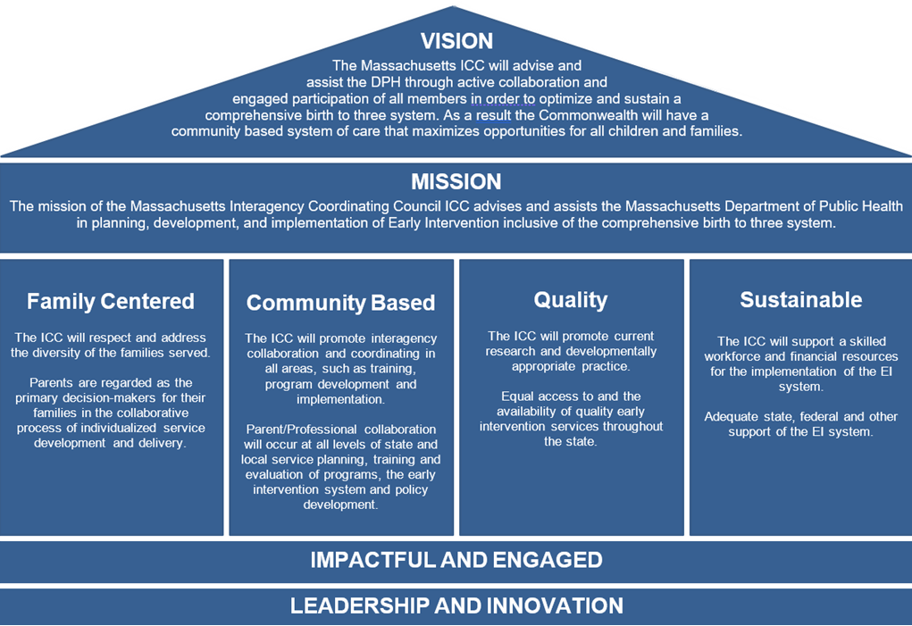

# Required Duties

Required Duties: Advise and assist the EI Division at the Department of Public Health in planning, development, and implementation of the EI system, including:

* Collaboration on Child Find activities and service delivery
* Transition from EI to preschool and other appropriate services
* Identification of fiscal and other supports for EI programs
* Preparation of application under IDEA Part C

# Core Functions

Additional functions of the council include:

* Supporting development and implementation of the **standards** and **policies** that constitute the EI statewide system.
* Engaging EI providers, parents and other key community partners to identify policies that serve as **barriers** to service delivery and **changes** to these policies.
* Gathering relevant **data** to inform effective implementation of the statewide EI system.
* Informed by these functions, the council sets **annual priorities** at the planning **retreat** held at the start of each ICC year in the fall.

# Membership

Federal and state regulations govern council membership to ensure the group reflects the perspectives of a diverse range of EI community partners. ICC members are appointed by the Commissioner of the Department of Public Health (DPH) on behalf of the Governor. Most members serve a 3-year term, except those who are filling a vacancy, as well as state agency representatives who serve at the pleasure of the Governor. All members may be re-appointed.

Note: The ICC is a public body. In addition to appointed members, any interested community member is welcome to attend and participate in ICC general sessions and/or committee meetings.

|  |
| --- |
| **ICC Membership** |
| 20% **parents** from diverse cultural backgrounds who have experience with EI system |
| 20% **providers** within the EI system, with representation from each region of the state and one provider from the MA EI Consortium |
| Representatives from **state agencies** that serve infants, toddlers and their families |
| A member of the **state legislature** |
| A representative from **higher education** |
| Representatives from **systems/sectors** that serve infants, toddlers and their families, including: physicians, Commissions for the Blind and Deaf and Hard of Hearing, federally recognized tribal council, and Massachusetts Developmental Disabilities Council |

# ICC Structure

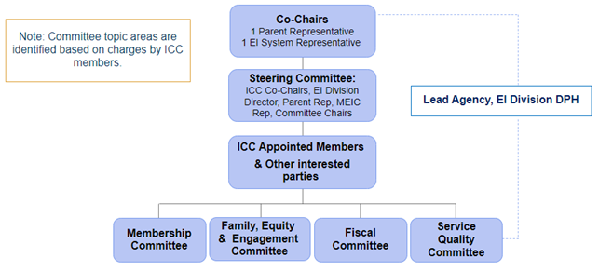

# ICC Member Roles: Co-Chairs

Co-chairs are elected by appointed members and serve a 2-year term. One co-chair must be a parent whose child has received EI services within the past 9 years and the second to be a provider from the EI system or a partnering agency. Responsibilities include:

* Call and preside over ICC General Session meetings
* Serve as the official spokesperson of the council
* Ensure that the required duties and functions of the council are fulfilled

# ICC Member Roles: Steering Committee

The Steering Committee is composed of the ICC co-chairs, an EI Division representative, a parent representative, the chairs of the committees, and a MA EI Consortium representative. Responsibilities include:

* Advise on agendas for council retreat and general sessions
* Review committee recommendations
* Develop and recommend planning strategies for the council, including committee charges

# ICC Member Roles: Appointed Members

* Attend and contribute ideas and perspectives in the planning retreat and general session meetings. Contact co-chairs and ICC coordinator if unable to attend to ensure there is a quorum of members present
* Vote on items raised before the council, including co-chair appointments, and committee recommendations
* Members are encouraged to join a committee, including serving a term as co-chair
* Participate in compliance with the Massachusetts Open Meeting (OML) and Conflict of Interest Laws (COI), including completing related training as provided by the EI Division

# ICC Member Roles: Interested Community Partners

The ICC is a public body and general session, and committee meetings are open to any interested community partner of the EI/Part C system in Massachusetts.

* Interested community partners are welcome to attend all general session and/orcommittee meetings and actively contribute their ideas and recommendations.
* Interested community partners are not appointed by the Department of Public Health and therefore are not voting members of the council.
* Interested community partners receive the same publicly available council information as appointed members through the ICC site on mass.gov, including meeting dates, agendas and minutes.

# Role of the Lead Agency, Early Intervention Division, DPH

* **Division Director**: provides reports at general session meetings, participates on Steering Committee, provides relevant data reports and responds to policy questions
* **ICC Coordinator**: primary point of contact for the Division and supports operations of the council, including logistics and support for the co-chairs and committee chairs
* **EI Division staff**: one Division staff participates on each committee to provide insight and answer questions on EI policies and practices, as appropriate, and to take meeting minutes

Support for ICC Parent Representatives: EI Parent Leadership Project (EIPLP)

* Recruit parents to serve as ICC representatives
* Provide orientation and training to new parent members
* Support parents in their roles as ICC members
* Connect parents with other leadership opportunities beyond the ICC

Contact Information: Kris Martone-Levine, EIPLP Statewide Coordinator, [Kris.Levine@mass.gov](mailto:kris.levine@mass.gov)

# ICC Meeting Schedule

The ICC year runs from July 1–June 30. The following meetings occur each ICC year:

* One planning meeting or retreat held in the fall
* Four General Sessions
* Committee meetings
* The Steering Committee meets in-between General Sessions

All ICC General Session and committee meeting information, including registration links, agendas, location details and minutes are posted on the [Interagency Coordinating Council](https://www.mass.gov/interagency-coordinating-council-icc) website on mass.gov.

## Appendix: Committee Meeting Guidance

Open Meeting Law: The ICC is a public body and is therefore subject to the MA Open Meeting Law (OML). The law requires all meetings of public bodies, including ICC General Sessions and committee meetings, be open to the public and puts forth requirements that guide meeting operations.

# ICC Committee Checklist

Committee meeting date/time, agenda, and log-in information needs to be posted on the ICC mass.gov website at least 48 hours in advance of the meeting date (note: the 48 hours excludes weekends and legal holidays)

In order for a meeting to be held, 51% of the members must be present (i.e. quorum). Attendance of members must be taken and documented at each meeting to establish the quorum.

Meeting minutes must be taken, approved by the members, and posted on the ICC mass.gov website

# ICC Committee Member Roles

Committee Chair(s):

* Develop agendas
* Take attendance and establish quorum
* Facilitate meeting
* Participate in ICC Steering Committee and provide committee updates at Steering Committee meetings
* Serve as committee point of contact for ICC Coordinator, ICC Co-Chairs, and other ICC community partners
* Manage committee membership list and coordinate membership tracking with ICC Membership Committee Chairs and ICC Coordinator

EI Division Representative:

* Serve as a resource and Division liaison by providing insight into relevant Division policies, practices and emerging issues to inform committee discussions and activities.
* Take meeting notes
* Log attendance in DPH tracking sheet

Committee Members:

* Participate in committee meetings and related activities by bringing unique perspectives and expertise
* Email chair(s) if unable to participate to ensure chairs can track quorum

ICC Coordinator:

* Scheduling and meeting logistics - creates zoom link for virtual meetings and facilitates scheduling at DPH offices for in-person meetings
* Posts meeting notices (i.e. dates, location/zoom link & agendas on mass.gov)
* Serves as a general support and liaison between ICC & EI Division

# Meeting Operations & Practices

Agenda:

* At least 7 business days prior to each meeting, the Chairs must send a final agenda to the ICC Coordinator to be posted online. This is done to ensure that DPH staff have enough time to post the agenda online at least 48 hours in advance of the meeting to be in accordance with the MA Open Meeting Law ([page 8](https://www.mass.gov/doc/open-meeting-law-guide-and-educational-materials-0/download))

Minutes:

* + The DPH Representative assigned to the Committee is responsible for taking meeting minutes.
  + Review [page 18](https://www.mass.gov/doc/open-meeting-law-guide-and-educational-materials-0/download) of the MA Open Meeting Law handbook to see what must be included in the minutes.
  + Prior to the next Committee meeting, the Chairs should send the meeting minutes along with the agenda for the next meeting to the committee for review. At the next meeting, the Chairs should hold a vote to approve the minutes. Only appointed members of that committee are included in the vote. Once approved, send the final meeting minutes to the ICC Coordinator to get posted online.

Quorum:

* At the start of each meeting, the chairs should take attendance to establish a quorum of appointed members to that committee (at least 51%). If there is no quorum, do not proceed with the meeting. Pause the meeting to reach out to those that are missing to determine if they plan to join. If after 10 minutes, there is still no quorum. Stop the meeting.

Note: Only appointed ICC members appointed to that Committee are included in the quorum. For example, if an appointed member of the general ICC attends the meeting but is not actually appointed to that committee specifically, they do not count towards the quorum.

Attendance Tracking (DPH Staff only):

* After each meeting, enter the attendance from that meeting into the Team’s tracking sheet. If you notice one member is consistently missing from meetings, let the committee chairs know.

**ICC Succession Planning**

This section of the ICC Member Handbook is in response to voting membership on the ICC. It addresses the need and timeline for succession planning on an annual basis.

The ICC is comprised of members that represent the following:

DPH

EI Providers

Families

State Agencies

EI Champions

Community Partners

|  |  |  |
| --- | --- | --- |
| **When** | **What** | **Who** |
| January | ICC Coordinator to send templated email to ICC members (with cc to Co-Chairs) to assess their interest in continuing and/or solicit new potential members. | ICC Coordinator |
| March | Potential new members attend general session alongside current member.  After the meeting, Membership Co-Chairs follow up to gauge interest and ICC Coordinator collects needed information | Appointed member and successor  Membership Co-Chairs  ICC Coordinator |
| April | DPH sends new potential member details and a resignation letter from the current member to the Commissioner’s office. | ICC Coordinator |

# Frequently Asked Questions:

* Do the Committee Chairs count towards quorum?
  + Yes.
* If there are two committee chairs (i.e. co-chairs), do they both need to be present to hold the meeting?
  + No. As long as one co-chair is present and there is a quorum the meeting may proceed.
* How do I log into Zoom to start the meeting?
  + The DPH Representative on your team will be responsible for Zoom and other IT issues. If you encounter problems, they can contact the ICC Coordinator via Teams chat.
* Will the ICC Coordinator attend committee meetings?
  + No, they will not attend unless they are the DPH representative on that committee.
* What happens if the Chair(s) make changes to the meeting schedule?
  + Chair(s) notify ICC Coordinator of changes to meeting schedule at least one week prior to meeting to make adjustments on mass.gov.