ICC Membership Subcommittee Meeting
Minutes
1.12.2024

In attendance: Nicole Constantino (v), Colleen O’Brien (v), Dina Tedeschi (v), Kathleen Amaral, Kris Martone-Levine; voting members absent: None. The meeting was held virtually.

Agenda:
- Review Charge
- Discussion
- Adjourn

Quorum met at 10:05 am. Colleen called to order at 10:06 am. 2 voting members for quorum.

A provider approached Colleen about joining the ICC. Colleen looped Nicole in and shared that Edith Benisty would like to join and represent MEIC. Nicole notified Kathleen, and as the DPH ICC Coordinator, Kathleen will follow up with the next steps. Colleen will email Kathleen Edith’s contact information.

Dina joined at 10:12am.

The proposed subcommittee charges need to be voted on. In the interim, we discussed the plan for creating a tool that includes, “What is your role?,” Kris will send what EIPLP uses with parents to the Membership Committee. Approved ICC Member Handbook at ICC meeting/retreat. Drafted letter to go to ICC membership to determine interest in continuing Attestation of current ICC membership having received and reviewed the ICC Member Handbook and that they understand their role and responsibilities. Locate the final version of the ICC Member Handbook to send out to ICC members. Need a list of members and their emails to send out the ICC Member Handbook.

Use Excel to determine quorum for quick determination at meetings.

Action Items:
Copy of handbook
List of members
Kris will send ICC materials EIPLP uses.
The phrasing of the proposed charge

Proposed charge: Membership will develop an onboarding process to orientate and initiate new members to the ICC.

Possible development of communications (i.e., Handbook language, review and maintain current role, etc.) to members. Clarity, refresher/reminder is needed because of changes and turnover. Opportunity to build connections and rapport with other members (challenge of in-person vs. virtual), which adds to membership retention.

We may be able to use EIPLP materials to build tools for membership orientation.

Should review pillars from Strategic Planning to make sure Membership’s charge aligns with the plan.

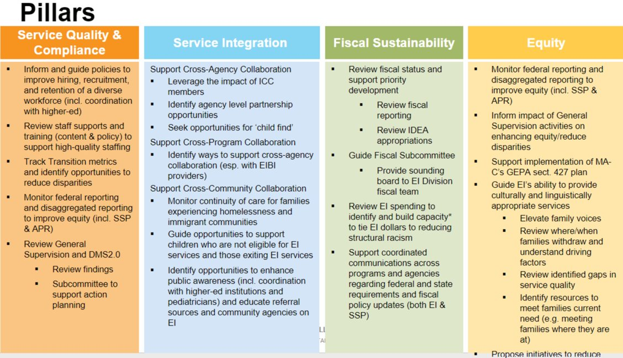
*Propose initiatives to reduce structural barriers impacting access to services.

Add ICC Org chart of roles from the slide deck.

Open Meeting Law – Minutes and meeting materials need to be shared within 10 days whether or not approved. Materials need to be available for use.

Whose role is it to recruit ICC members?
- EIPLP = parents, Providers = providers, DPH = state agency representation (i.e., DESE, DDS, etc.) and other roles (i.e., pediatrician, Tribal council, legislator, etc.)

How does information about being on the ICC get disseminated to various communities? Regional communication on who attends and any highlights to Program Directors > Program Staff. How is information shared and how can it be shared to the community and vice versa – raising concerns, etc. System for back-and-forth communication.

The meeting adjourned at 11:00am.

Respectfully submitted by Kris Martone-Levine

