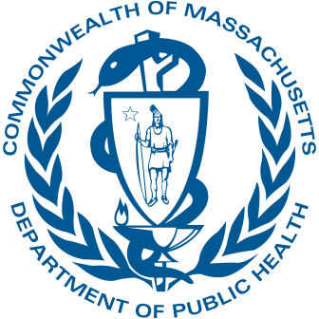
Massachusetts Department of Public Health

Special ICC Session
August 31, 2023

Early Intervention Division

Roll Call Attendance – Appointed Members
Massachusetts Department of Public Health | mass.gov/dph
2

Roll Call: Please verbally acknowledge your attendance by saying “Present”
when your name is called

To comply with the Open Meeting Law, a quorum of appointed members must
be established.

Quorum: A simple majority (51%) of the members of a public body, unless otherwise provided in a general or special law, executive order, or other authorizing provision. G.L. c. 30A, § 18

Agenda
Massachusetts Department of Public Health | mass.gov/dph
3

- Call to Order
- Review Nomination for Parent Representative Co-Chair
- Discussion
- Vote
- Closing

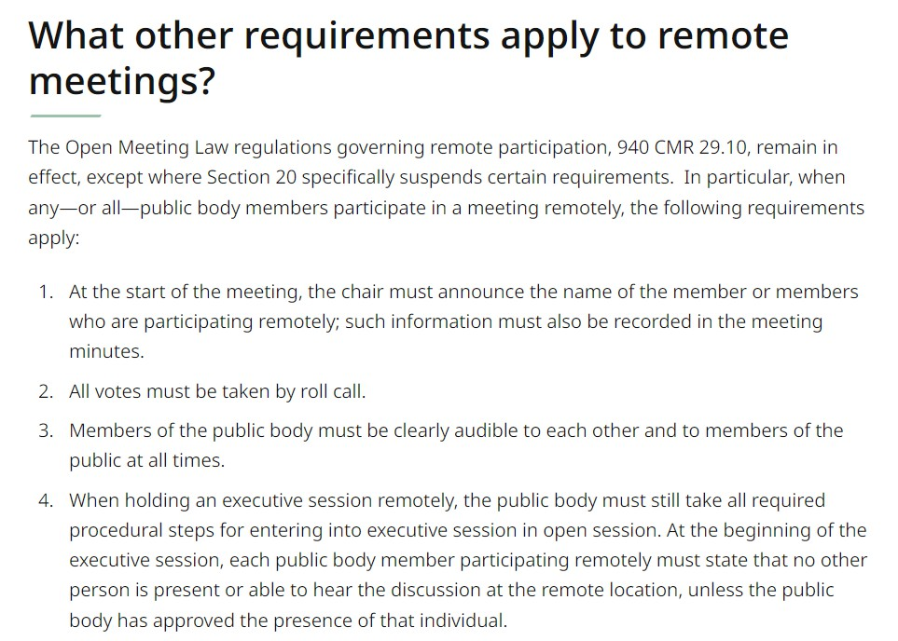
Roll Call Vote – Appointed Members

Roll Call: Please verbally acknowledge your vote by saying “Yes,” “No,” or
“Abstain” when your name is called
To comply with the Open Meeting Law, votes must be taken by roll call in virtual meetings.

Massachusetts Department of Public Health | mass.gov/dph 4

Meeting Close
Massachusetts Department of Public Health | mass.gov/dph
5

Thank you!

See you on October 19, 2023

