MassHealth
Transmittal Letter IDTF-15
July 2016

TO: Independent Diagnostic Testing Facilities Participating in MassHealth
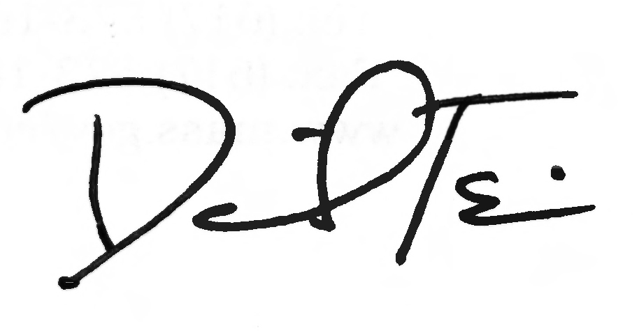
FROM: Daniel Tsai, Assistant Secretary for MassHealth

RE: Independent Diagnostic Testing Facility Manual (Subchapter 6 revisions)

This letter transmits revisions to the service codes in the Independent Diagnostic Testing Facility Manual. The Centers for Medicare & Medicaid Services (CMS) have revised the Healthcare Common Procedures Coding System (HCPCS) for 2016. MassHealth has updated Subchapter 6 to include new service codes effective for dates of service on or after January 1, 2016.

MassHealth providers must refer to the American Medical Association’s Current Procedural
Terminology (CPT) codebook or the HCPCS Level II codebook for service descriptions of the codes listed in Subchapter 6 of the Independent Diagnostic Testing Facility Manual.

If you wish to obtain a fee schedule, you may download the Executive Office of Health and Human Services regulations at no cost at www.mass.gov/eohhs. The regulation title for Radiology is 114.3 CMR 18.00 and the regulation title for Medicine is 101 CMR 317.00.

MassHealth Website

This transmittal letter and attached pages are available on the MassHealth website at www.mass.gov/masshealth.

Questions

If you have any questions about the information in this transmittal letter, please contact the
MassHealth Customer Services Center at 1-800-841-2900, e-mail your inquiry to providersupport@mahealth.net, or fax your inquiry to 617-988-8974.

NEW MATERIAL
(The pages listed here contain new or revised language.)

Independent Diagnostic Testing Manual

Pages vi and 6-1 through 6-6

OBSOLETE MATERIAL
(The pages listed here are no longer in effect.)

Independent Diagnostic Testing Facility Manual

Page vi — transmitted by Transmittal Letter IDTF-12

Pages 6-1 through 6-6 — transmitted by Transmittal Letter IDTF-14

6. Service Codes and Descriptions

Introduction 6-1
Portable X Ray: Radiology Service Codes 6-1
Freestanding Magnetic Resonance Imaging (FMRI): Radiology Service Codes 6-2
Diagnostic Imaging Centers: Radiology Service Codes …………………………………………. 6-2
Mobile Mammography Van: Radiology Service Codes 6-5
Sleep Centers: Radiology Service Codes 6-5
Modifiers 6-5

Appendix A. Directory A-1
Appendix B. Reserved B-1
Appendix C. Third-Party-Liability Codes C-1
Appendix U. DPH-Designated Serious Reportable Events That Are Not Provider
Preventable Conditions U-1
Appendix V. MassHealth Billing Instructions for Provider Preventable Conditions V-1
Appendix W. EPSDT Services: Medical and Dental Protocols and Periodicity Schedules W-1
Appendix X. Family Assistance Copayments and Deductibles X-1
Appendix Y. EVS Codes/Messages Y-1
Appendix Z. EPSDT/PPHSD Screening Services Codes Z-1

601 Introduction

MassHealth pays for the services represented by the codes listed in Subchapter 6 in effect at the time of service, subject to all conditions and limitations in MassHealth regulations at 130 CMR 431.000 and 450.000. MassHealth providers must refer to the American Medical Association’s Current Procedural Terminology (CPT) or the Health Care Procedure Code Set (HCPCS) Level II codebook for the service code and service descriptions when billing for services provided to MassHealth members.
An independent diagnostic testing facility (IDTF) may request prior authorization for any medically necessary service reimbursable under the federal Medicaid Act, in accordance with 130 CMR 450.144, 42 U.S.C. 1396d(a), and 42 U.S.C. 1396d(r)(5) for a MassHealth Standard or CommonHealth member younger than 21 years of age, even if it is not designated as covered or payable in Subchapter 6 of the Independent Diagnostic Testing Facility Manual.
“IC” indicates that the claim requires individual consideration. See 130 CMR 431.406 for more information. “PA” indicates that the service requires prior authorization. See 130 CMR 450.303 for more information.

602 Portable X-Ray: Radiology Service Codes

Service Code Service Code Service Code Service Code Service Code

70030
70100
70110
70120
70130
70134
70140
70150
70160
70190
70200
70210
70220
70240
70250
70260
70300
70310
70320
70328
70330
70332
70355
70360
70370
70371
70380

70390
71010
71015
71020
71021
71022
71023
71030
71034
71035
71100
71101
71110
71111
71120
71130
72020
72040
72050
72052
72070
72072
72074
72080
72081
72082
72083

72084
72100
72110
72114
72120
72170
72190
72200
72202
72220
72240
72255
72265
72270
72275
72285
72295
73000
73010
73020
73030
73040
73050
73060
73070
73080
73085

73090
73092
73100
73110
73115
73120
73130
73140
73501
73502
73503
73521
73522
73523
73525
73551
73552
73560
73562
73564
73565
73580
73590
73592
73600
73610
73615

73620
73630
73650
73660
74000
74010
74020
74022
74210
74220
74230
74235
74240
74241
74245
74246
74247
74249
74250
74251
74260
74270
74280
74290
74291
74300
74301

603 Freestanding Magnetic Resonance Imaging (FMRI): Radiology Service Codes

Service Code Service Code Service Code Service Code Service Code

70336 (PA)
70540
70542
70543
70544
70545
70546
70547
70548
70549
70551
70552
70553
70557
70558
70559
71550
71551
71555
72141
72142
72146
72147
72148
72149
72156
72157
72158
72195
72196
72197
73218
73219
73220
73221
73222
73223
73718
73719
73720
73721
73722
73723
73725
74181
74182
74183
74185
74301
74712
74713
75557
75559
75561
75563
75565
77021
77022
77058 (PA)
77059 (PA)
A4641
A9500 (IC)
A9502 (IC)
A9503 (IC)
A9505 (IC)
A9512 (IC)
A9537 (IC)

604 Diagnostic Imaging Centers: Radiology Service Codes

Service Code Service Code Service Code Service Code Service Code

59025
70030
70100
70110
70120
70130
70134
70140
70150
70160
70190
70200
70210
70220
70240
70250
70260
70300
70310
70320
70328
70330
70332
70336
70350
70355
70360
70370
70371
70380
70390
70450
70460
70470
70480
70481
70482
70486
70487
70488
70490
70491
70492
70540
70542
70543
70544
70545
70546
70547
70548
70549
70551
70552
70553
70554
70555
71010
71015
71020
71021
71022
71023
71030
71034
71035
71100
71101
71110
71111
71120
71130
71550
71551
71555
72020
72040
72050
72052
72070
72072
72074
72080
72081
72082
72083
72084
72100
72110
72114
72120
72125
72126
72127
72128
72129
72130
72131
72132
72133
72141
72142
72146
72147
72148
72149
72156
72157
72158
72170
72190
72192
72193
72194
72195
72196
72197
72200
72202
72220
72240
72255
72265
72270
72275
72285
72295
73000
73010
73020

73030
73040
73050
73060
73070
73080
73085
73090
73092
73100
73110
73115
73120
73130
73140
73200
73201
73202
73218
73219
73220
73221
73222
73223
73501
73502
73503
73521
73522
73523
73525
73551
73552
73560
73562
73564
73565
73580
73590
73592
73600
73610
73615
73620
73630
73650
73660
7370
73701
73702
73718
73719
73720
73721
73722
73723
73725
74000
74010
74020
74022
74150
74160
74170
74174
74176
74177
74178
74181
74182
74183
74185
74190
74210
74220
74230
74235
74240
74245
74246
74247
74249
74250
74251
74260
74261 (PA)
74262 (PA)
74270
74280
74283
74290
74291
74300
74301
74330
74340
74355
74400
74410
74415
74420
74425
74430
74440
74445
74450
74455
74470
74485
74710
74712
74713
74740
74742
74775
75557
75559
75561
75563
75565
75572
75573
75574
75600
75605
75625
75630
75658
75705
75710
75716
75726
75731
75733
75736
75741
75743
75746
75756
75774
75791
75801
75803
75805
75807
75809
75810
75820
75822
75825
75827
75831
75833
75840
75842
75860
75870
75872
75880
75885
75887
75889
75891
75893
75898
75901
75902
76000
76001
76010
76080
76098
76100
76101
76102
76120
76125
76376
76377
76380
76499 (IC)
76506
76510
76511
76512
76513
76514
76516
76519
76529
76536
76604
76641
76642
76700
76705
76770
76775
76776
76800
76801
76802
76805
76810
76811
76812
76813
76814
76815
76816
76817
76818
76820
76821
76825
76826
76827
76828
76830
76831
76856
76857
76870
76872
76873
76881
76882
76885
76886
76937

76942
76945
76946
76948
76965
76970
76977
76999 (IC)
77001
77002
77003
77011
77012
77013
77014
77021
77022
77051
77052
77053
77054
77055
77056
77057
77058 (PA)
77059 (PA)
77061
77062
77063
77071
77072
77073
77074
77075
77076
77077
77078
77080
77081
77085
77086
78012
78013
78014
78015
78016
78018
78020
78070
78071
78072
78075
78099 (IC)
78102
78103
78104
78110
78111
78120
78121
78122
78130
78135
78140
78185
78190
78191
78195
78199
78201
78202
78205
78206
78215
78216
78226
78227
78230
78231
78232
78258
78261
78262

78264
78265
78266
78270
78271
78272
78278
78282 (IC)
78290
78291
78299 (IC)
78300
78305
78306
78315
78320
78350
78399 (IC)
78414 (IC)
78428
78445
78451
78452
78453
78454
78456
78457
78458

78459
78466
78468
78469
78472
78473
78481
78483
78491
78492
78494
78496
78499 (IC)
78579
78580
78582
78597
78598
78599 (IC)

78600
78601
78605
78607
78608
78609
78610
78630
78635
78645
78647
78650
78660
78699 (IC)
78700
78701
78707
78708
78709
78710
78710 78725
78730
78740
78761
78799 (IC)

78800
78801
78802
78803
78804
78805
78806
78807
78808
78811
78812
78813
78814
78815
78816
78999 (IC)
93000
93005
93010
93015
93016
93017
93018
93024
93025
93040
93041
93042
93224
93225
93226
93227
93228 (IC)
93229 (IC)
93268
93270
93271
93272
93278
93303
93304
93306
93307
93308
93312
93313
93314
93315
93316
93317
93318
93320
93321
93325
93350
93351
93352
93724
93740
93745 (IC)
93784
93786
93788
93790
93797
93798
93799 (IC)
93880
93882
93886
93888
93890
93893
93922

93922
93923
93924
93925
93926
93930
93931
93965
93970
93971
93975
93976
93978
93979
93980
93981
93990
93998 (IC)
95950
95951
95953
95956
A4641 IC)
A9500 (IC)
A9502 (IC)
A9503 (IC)
A9505 (IC)
A9512 (IC)
A9537 (IC)
G0202
G0204
G0206
G0297

605 Mobile Mammography Van: Radiology Service Codes

Service Code Service Code Service Code Service Code Service Code

76641
76642
77051

77052
77053
77054

77055
77056
77057

77061
77062
77063

G0202
G0204
G0206

- Sleep Centers: Radiology Service Codes

Service Code Service Code Service Code Service Code Service Code

95782
95783
95800
95801
95805
95806
95807
95808
95810
95811

607 Modifiers

The following service code modifiers are allowed for billing under MassHealth.

Modifier Description

26 Professional Component
TC Technical Component

The following modifiers are for Provider Preventable Conditions (PPCs) that are National Coverage Determinations.

Modifier Description

PA Surgical or other invasive procedure on wrong body part
PB Surgical or other invasive procedure on wrong patient
PC Wrong surgery or other invasive procedure on patient

For more information on the use of these modifiers, see Appendix V of your provider manual.

This publication contains codes that are copyrighted by the American Medical Association. Certain terms used in the service descriptions for HCPCS codes are defined in the Current Procedural Terminology (CPT) codebook.

This page is reserved.

