INDIVIDUALIZED FAMILY SERVICE PLAN  
HANDBOOK

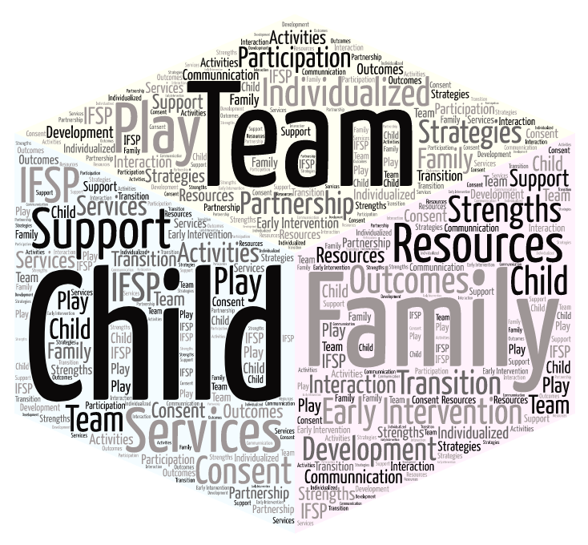

Special Thanks to the ICC IFSP Task Force for their hard work to create this document.

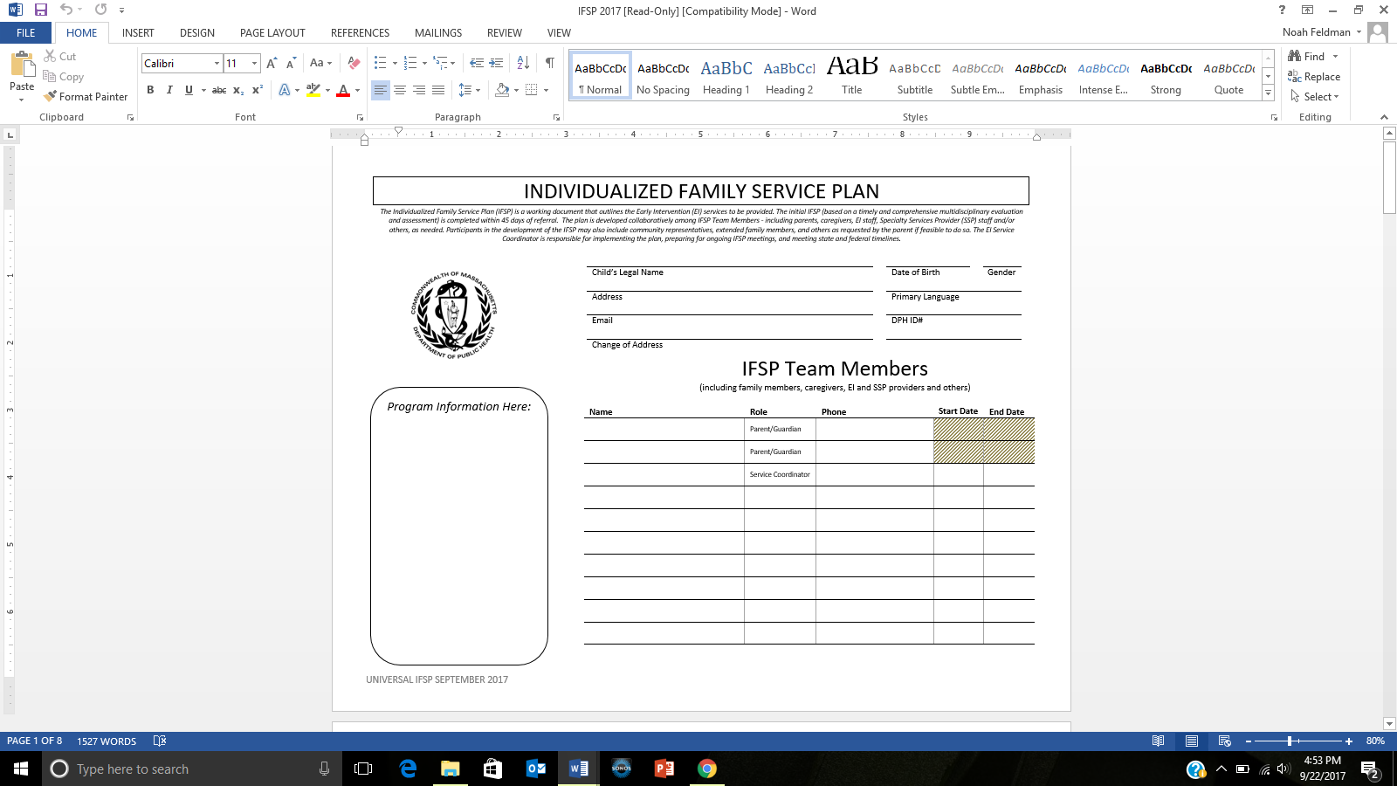

Along with caregivers, this list includes people important to the family that will be involved in supporting the IFSP (e.g. other members of the child’s family, child care provider, EI providers and SSPs) as well as EI providers that work with the family

Nicknames can be put in parentheses

This space can be used for program specific tracking info

*The Individualized Family Service Plan (IFSP) is a working document that outlines the Early Intervention (EI) services to be provided. The initial IFSP (based on a timely and comprehensive multidisciplinary evaluation and assessment) is completed within 45 days of referral. The plan is developed collaboratively among IFSP Team Members - including parents, caregivers, EI staff, Specialty Services Provider (SSP) staff and/or others, as needed. Participants in the development of the IFSP may also include community representatives, extended family members, and others as requested by the parent if feasible to do so. The EI Service Coordinator is responsible for implementing the plan, preparing for ongoing IFSP meetings, and meeting state and federal timelines.*

IFSP

COVER PAGE

**HOW IS IT USED?**

How do you fill it out?

The top section is dedicated to the information needed for team members about the child:

* Child’s legal name (nicknames may be included in parentheses) and primary address
* Email for primary parent/guardian
* Date of birth, gender, primary language, and DPH ID #
* Additional space for revising address if needed
* Blank line: can be used for program specific tracking information

How will this page benefit the family/team?

The bottom section is dedicated to list the entire IFSP Team

* Parent(s)/guardian(s)
* Service coordinator
* All other team members as they are identified

**For each person:**

Provide their full name, specific role (Physical Therapist, Developmental Specialist, Daycare Provider, etc.) and phone number

*There are many blank spaces provided to allow for multiple team members that may also include community representatives, extended family members and others.*

What do you do with it every day?

As team members change, fill in the date when a person is no longer a part of the team and then add each new person with relevant information.

*The blank space on the left of team listing is for EI programs to individualize contact information according to their needs such as program logo, program address and other program specific information.*

**SUMMARY**

The COVER PAGE is the one place that a parent or team member can go to for a quick reference for contact information. It can be used as a point of conversation to discuss what an IFSP Team looks like and who will be involved with this child/family to support the plan.

**WHY IS IT IMPORTANT?**

The introduction of this page is a good time to discuss the idea that the IFSP is supported by a number of people who each have an important role.

* Provides important demographics of the child and family
* Program contact information
* Outlines people\* that are involved in supporting the child/family toward meeting IFSP outcomes

*\*including the parents, caregivers, service coordinator, other EI program providers, SSPs and relevant community and extended family members (as designated by the family)*

The use of this cover page relies on its accuracy. As team members change it is important to revise and share with all team members for ongoing communication, planning, and understanding. With current and accurate information, this listing of team members can help families and providers when they need to share specifics such as appointment and meeting scheduling/cancellations.

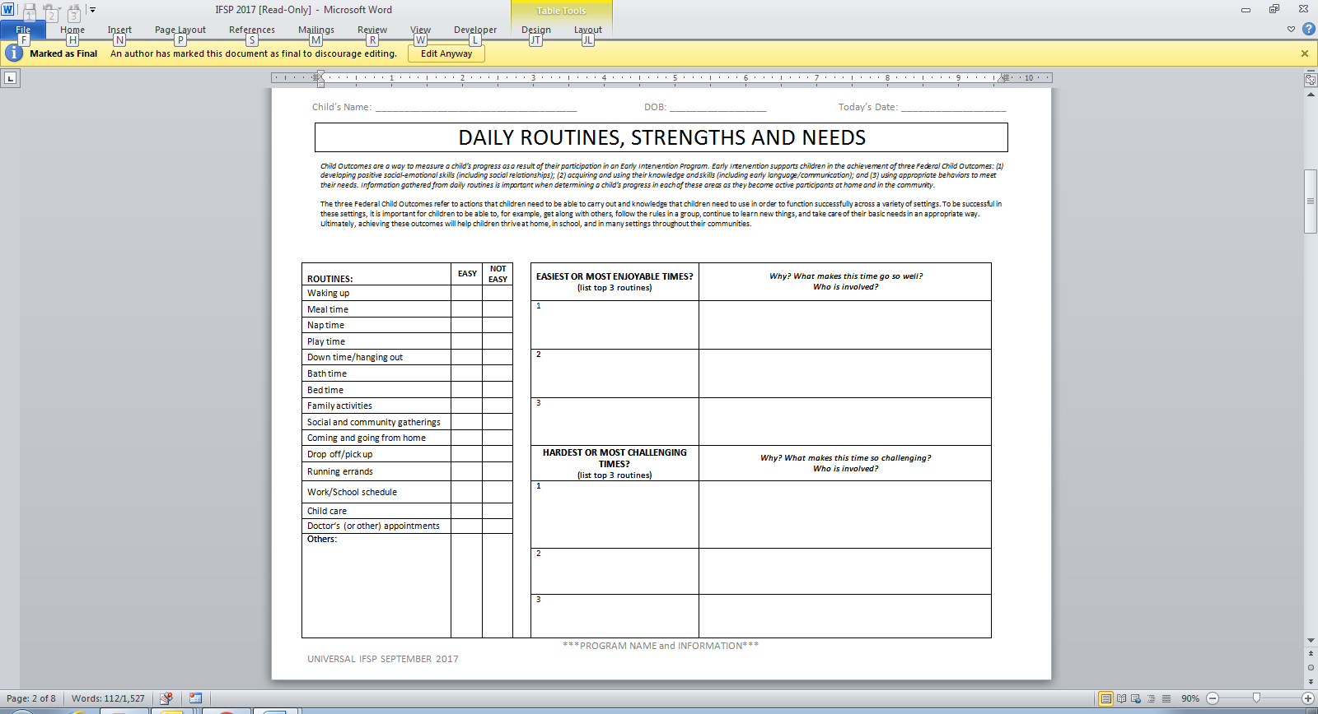

Discuss with the family to determine what to document here

Use this list to discuss and document times of the day that are significant to the family

This page should be a summary of the family’s routines and activities based on information gathered during the functional assessment

*Child Outcomes are a way to measure a child’s progress as a result of their participation in an Early Intervention Program. Early Intervention supports children in the achievement of three Federal Child Outcomes: (1) developing positive social-emotional skills (including social relationships); (2) acquiring and using their knowledge and skills (including early language/communication); and (3) using appropriate behaviors to meet their needs. Information gathered from daily routines is important when determining a child’s progress in each of these areas as they become active participants at home and in the community.*

The three Federal Child Outcomes refer to actions that children need to be able to carry out and knowledge that children need to use in order to function successfully across a variety of settings. To be successful in these settings, it is important for children to be able to, for example, get along with others, follow the rules in a group, continue to learn new things, and take care of their basic needs in an appropriate way. Ultimately, achieving these outcomes will help children thrive at home, in school, and in many settings throughout their communities.

DAILY ROUTINES, STRENGTHS AND NEEDS PAGE

**HOW IS IT USED?**

How do you fill it out?

1. Review daily routines as previously discussed with the family in order to identify specific areas that are working well and those that are more challenging.

* Consider your observations and information that the parent has shared with you about the child’s everyday routines and activities related to engagement and interest, independence and social relationships
* Use the list provided as a resource to probe for additional information

1. Discuss with the family what factors might contribute to the ease or difficulty of each of the top 3 routines.
2. Use this information when developing functional outcomes

* Routines and activities that are going well provide a way to identify and enhance learning opportunities to address family priorities
* Information about routines that are not going well may become priorities that the family wants to work on

How will this page benefit the family/team?

The routines inventory is not an expansive list of all routines within a day and not all routines may apply to all families. It is meant to be a suggested list to then work with the family to prioritize what may need to be included into the outcomes on this IFSP.

What do you do with it every day?

This page is completed during the development of the IFSP and should be reviewed regularly. When reviewing this information, a new page is used and added to the current IFSP.

**SUMMARY**

The DAILY ROUTINES, STRENGTHS AND NEEDS PAGE is a **summary** of the discussion and information gathering that occur as part of the evaluation and assessment process. This page should not be the start of the conversation with the family. It is not meant to be a checklist you go through at the IFSP meeting. The *family-directed assessment* is used to identify the families’ resources, priorities and concerns as well as the supports and services necessary to enhance the family’s capacity to meet the developmental needs of their infant or toddler. Each program is responsible for administering a *family-directed assessment* as part of the ongoing functional assessment in determining ongoing needs, concerns, and priorities.

This page is ***not*** a f*amily-directed assessment*.

**WHY IS IT IMPORTANT?**

Child and family focused outcomes can be generated from the important information summarized on this page.

According to research, children learn best in natural environments and within the context of their everyday lives. By identifying the child and family’s daily routines, we can help to identify times of day that can be used when incorporating new skills and addressing functional outcomes to ensure children get multiple opportunities to practice developing skills and to learn about routines that children may be struggling to participate in that are important to the family. The experiences summarized here are important when developing outcomes unique to each family situation.

* Routines that are difficult may be the focus of IFSP outcomes to support increased child or family participation
* Routines that are going well may offer opportunities for practicing developing skills

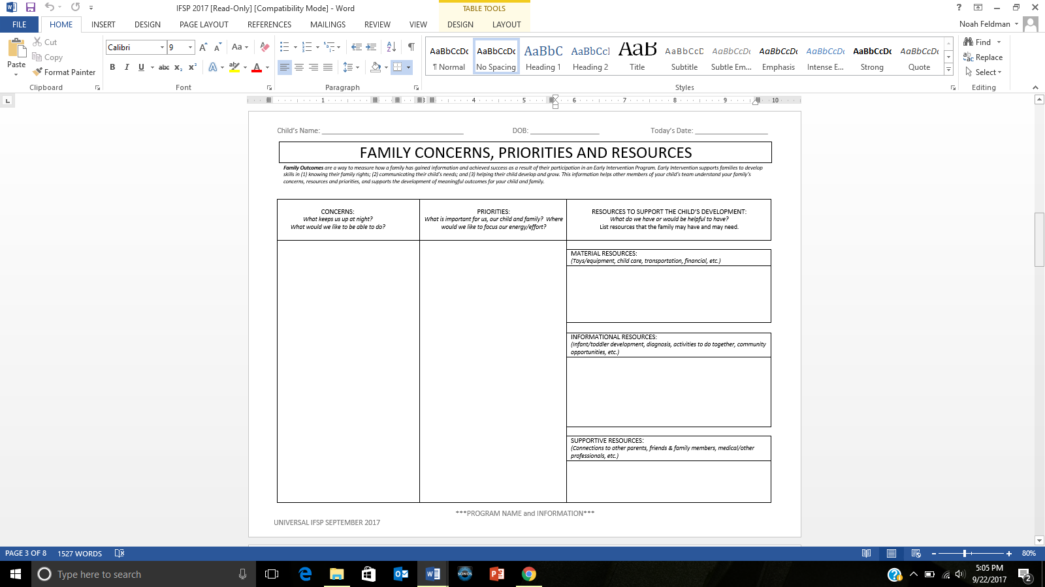

Functional assessment practices translate family concerns, such as:

* “She can’t let us know what she wants.”
* “He doesn’t sit at the table with us during meals.”

Into positive statements\*, such as:

* “I want her to be able to let others know what she wants.”
* “I want him to be able to sit with us during meals.”

\*These positive statements are probably the family priorities.

Fill in these boxes with the resources that are relevant to the family.

Use a separate Family-Directed Assessment to identify resources that are important to the family.

Actions toward obtaining these resources may be developed as family outcomes.

These could be opportunities to connect with other parents, spend time with friends/family or having time to themselves, or consult with other professionals.

Families could want to learn more about infant/toddler development, their child’s needs/condition, diagnosis, activities that they can do together, what is available in their community, what is available as their child transitions out of EI.

These could be resources for household expenses (food, utilities, and clothing), medical expenses (bills, medicine, special foods, equipment, transportation, child care, etc.

Information is gathered through conversations with the family throughout the IFSP process

***Family Outcomes*** *are a way to measure how a family has gained information and achieved success as a result of their participation in an Early Intervention Program. Early Intervention supports families to develop skills in (1) knowing their family rights; (2) communicating their child’s needs; and (3) helping their child develop and grow. This information helps other members of your child’s team understand your family’s concerns, resources and priorities, and supports the development of meaningful outcomes for your child and family.*

FAMILY CONCERNS, PRIORITIES AND RESOURCES

**SUMMARY**

This page is a **summary** of different conversations that have happened or taken place during the evaluation and functional assessment process. Child and family-focused outcomes can be generated from the important information gathered. As we know, family input is critical when determining what outcomes are included in the IFSP.

**HOW IS IT USED?**

How do you fill it out?

1. Complete each of the concerns and priorities sections by summarizing information collected through conversations with the family and the *family-directed assessment.*
2. Review each of the resource areas to help identify supports that the family may need. These resources are not necessarily linked to services by the EI Program and may or may not become outcomes completed by family members.

How will this page benefit the family/team?

Since completion of this page is voluntary, document if the family decides not to provide information (write “family chose not to complete” on page itself). A family situation can change and as you get to know a family better they may be more open to expressing their concerns and priorities.

What do you do with it every day?

This page is completed during the development of the IFSP and must be reviewed regularly during the IFSP process throughout the child’s enrollment. When reviewing this information, a new page is used and added to the current IFSP.

**WHY IS IT IMPORTANT?**

This is a place to capture family information with a focus on differentiating between concerns and priorities.

* Concerns are very important because they are what drive a parent to EI, and they are what might keep a parent up at night, worrying about their child. We must acknowledge these concerns, and record them on the IFSP, then dig deeper to find out about priorities
* Priorities reflect the family’s vision for the child’s development. Priorities are the foundation for individualized, functional IFSP outcomes. Starting with priorities reframes the discussion to become more individualized, more positive, and more functional.

*http://veipd.org/earlyintervention/2016/06/16/a-priority-or-a-concern-whats-the-difference-and-why-it-matters/*

Functional assessment practices translate family concerns, such as:

* “She can’t let us know what she wants.”
* “He doesn’t sit at the table with us during meals.”

Into positive statements, such as:

* “I want her to be able to let others know what she wants.”
* “I want him to be able to sit with us during meals.”

\*These positive statements are probably the family priorities.

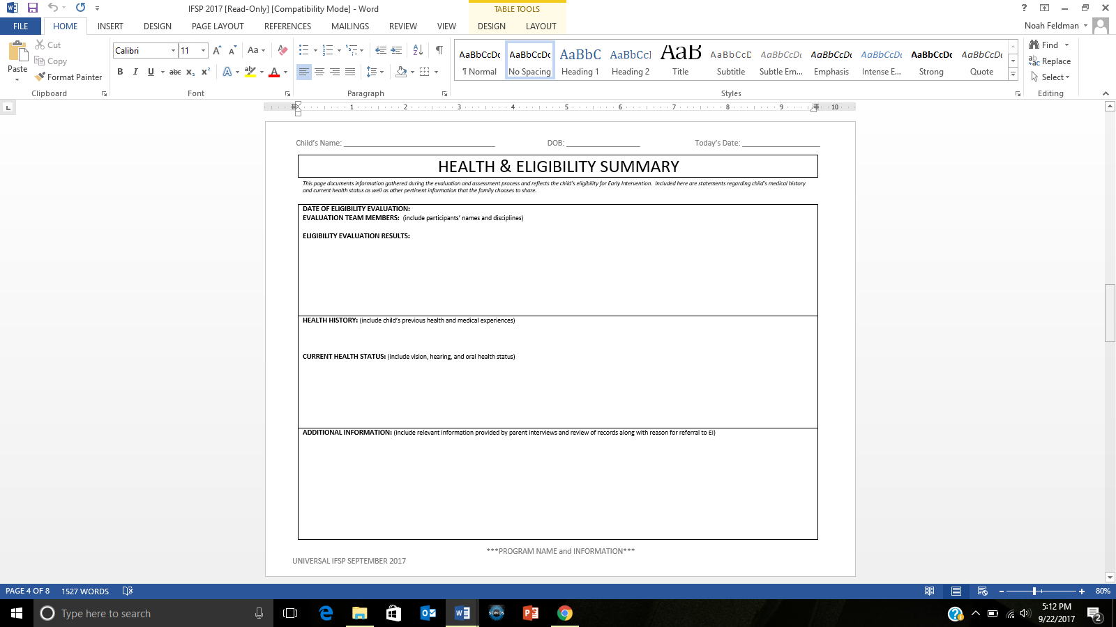

As part of the current health summary, include concerns related to vision, hearing and oral health along with any comprehensive exams that have been completed (with relevant dates, results and treatment).

**See Appendix A for additional information**

To complete the picture of the child and family, provide supplemental sources of information (e.g. daily life, concerns) as well as additional assessments that may have been used and the reason for EI referral.

Document those experiences that may have or are currently impacting the child’s and/or family’s participation in activities and routines.

Summarize the results of the evaluation process which includes eligibility status. This is also the place to record evaluation team participants.

*This page documents information gathered during the evaluation and assessment process and reflects the child’s eligibility for Early Intervention. Included here are statements regarding child’s medical history and current health status as well as other pertinent information that the family chooses to share.*

HEALTH AND ELIGIBILITY SUMMARY

**HOW IS IT USED?**

How do you fill it out?

1. Eligibility Evaluation Results:

* Date(s) of eligibility evaluation
* Names and disciplines of the multi-disciplinary evaluation team members
* Summary of the eligibility results including eligibility status

2. Health History/Current Health Status:

* Document relevant health and medical experiences related to participation in activities and routines
* Include statements about the child’s vision, hearing and oral health status \*See *Appendix A*

3. Additional Information:

* Summarize any additional information that may have been learned through the evaluation and functional assessment process that may be relevant in further development of the IFSP outcomes and service delivery plan
* This information may have been shared through parent interview, review of records, or other means. Include reason for referral here

How will this page benefit the family/team?

This page helps to give a clear picture of the child’s eligibility status to all team members. Health information provides details of any relevant medical issues as they relate to the child’s development.

What do you do with it every day?

Use all sources of information to complete this page of the IFSP. This includes the results from the BDI-2, information shared by parents and/or caregivers about the child and family daily life, additional assessment tools used, and review of records shared by the family.

Consider how the findings impact the child and family’s ability to participate in daily routines and activities.

**SUMMARY**

This page is designed to present relevant information that was learned through the evaluation and assessment process and will inform the on-going IFSP development. The multi-disciplinary team that determines eligibility summarizes the results of the eligibility evaluation and relevant health information.

**WHY IS IT IMPORTANT?**

The Health and Eligibility Summary page was developed to support teams to synthesize information learned through the evaluation and functional assessment process. This information should help inform the development of IFSP outcomes moving forward. Information related to on-going IFSP development should be documented here.

* ELIGIBILITY

The child’s eligibility status and reasons for meeting eligibility for EI services may have an impact on the on-going IFSP process. This may have in impact on the time frame for service eligibility.

* HEALTH

A child’s health status may be impacting his or her ability to participation in daily activities and routines.

* ADDITIONAL INFORMATION

A complete picture of the child and family through all functional assessment information including review of records is helpful to plan for participation in EI services.

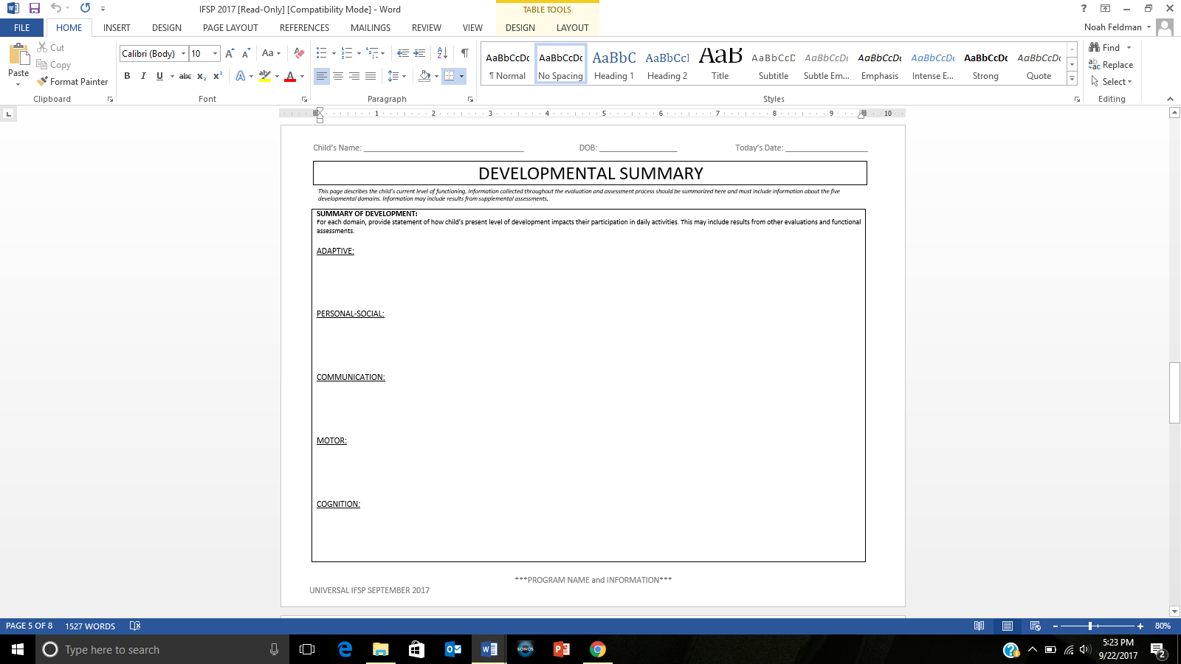

DEVELOPMENTALSUMMARY

*This page describes the child’s current level of functioning. Information collected throughout the evaluation and assessment process should be summarized here and must include information about the five developmental domains. Information may include results from supplemental assessments.*

**HOW IS IT USED?**

How do you fill it out?

Summary of Development

* This section is meant to be a synthesis of the information learned through the evaluation and assessment process that will help to inform the on-going IFSP development with the IFSP team
* For each domain, show how a child uses their skills when engaged in their daily routines and activities
* Note how the child participates in these routines and activities and whether there are developmental considerations that have an impact on participation

How will this page benefit the family/team?

This page helps to summarize the skills that the child has developed and allows the team to identify next steps for the child.

What do you do with it every day?

Apply knowledge of child development to determine next steps or skills to develop as part of the child and family’s IFSP outcomes.

Identify developmental skills that the child already consistently demonstrates and those that should develop next. This will help determine on-going strategies that will support the identification of practice opportunities for these developing skills.

**SUMMARY**

This page is designed to present relevant information that was learned through the evaluation and functional assessment process and will inform the on-going IFSP development. The multi-disciplinary team that determines eligibility summarizes how the child’s present level of development impacts their participation in daily activities.

**WHY IS IT IMPORTANT?**

The DEVELOPMENTAL SUMMARY PAGE was developed to support teams to synthesize information learned through the evaluation and functional assessment process.

* This information describes the child’s current functioning as well as how it impacts the day-to-day activities and routines for both the child and the family
* By doing this the EI team can show the family the relationship between the child’s developmental skills and the priorities that they have identified
* This process can support the development of high quality IFSP outcomes and the identification of opportunities in the family’s regular routine to support the child’s practice opportunities

__Kim______ will ____Eat     _
        who? Do what?
___________with her family at meal times______
   How well/How often?
_by eating the foods that they eat_____________
Condition required for outcome to be met?

   How well/How often?
_by eating the foods that they eat_____________
 Condition required for outcome to be met?
 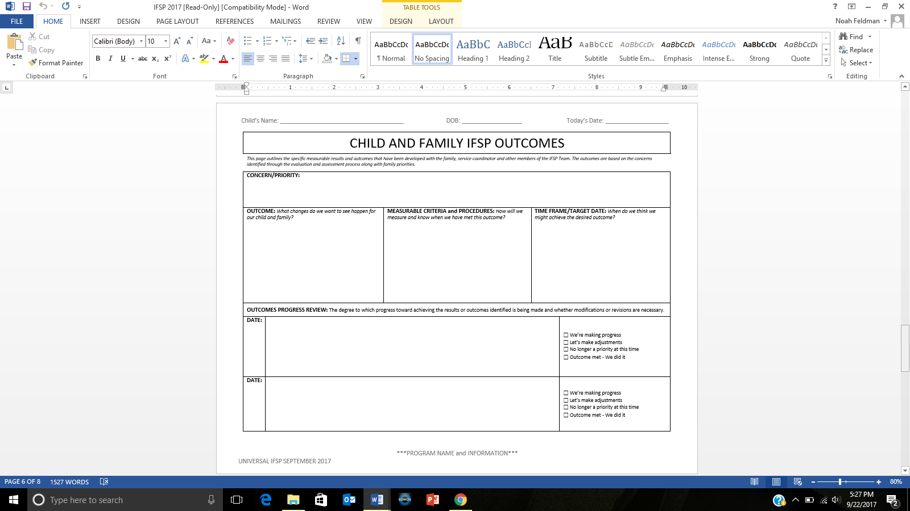

Use these spaces to document the degree of progress made when you are reviewing the IFSP

Outcomes should be functional, measurable and within the context of the family's everyday activities. Anyone who reads the outcome should be able to know when the outcome has been met.

What are the ways in which the family and team will work toward achieving this outcome?

Who will help and what will they do?

How will the team know what progress or achievement looks like or if revisions are needed to outcomes or services?

Start with the parent/caregiver *concerns/priorities* - what they hope for the child and family and what’s most important or meaningful to them.

Special focus should be placed on their desires related to participation in family and community activities.

This information may come from previous pages of the IFSP.

*This page outlines the specific measurable results and outcomes that have been developed with the family, service coordinator and other members of the IFSP Team. The outcomes are based on the concerns identified through the evaluation and assessment process along with family priorities.*

CHILD AND FAMILY IFSP OUTCOMES

**HOW IS IT USED?**

How do you fill it out?

1. The concern/priority section describes what’s most important and meaningful to the family and sets the stage for the identified IFSP outcome.

2. The outcome is a positive statement reflecting what the family hopes to achieve.

3. Measurable criteria/procedures are used to determine the degree to which progress toward achieving the outcome is being made, and whether modifications or revision of the expected outcome or services are necessary.

4. Target date is based on an estimate of time for when the child/family could possibly reach the outcome.

* *Outcomes should be realistic and achievable so that progress can be easily measured*

5. Progress review spaces are provided and allow for more than one review.

How will this page benefit the family/team?

It is these IFSP outcomes that should drive the on-going EI services that are provided. Children and families can have as many IFSP outcomes as needed to ensure that they are able to be active participants in their daily routines and activities 🡪 achieve the goal of Early Intervention. These outcomes are developed through the IFSP process by the IFSP team.

What do you do with it every day?

A review of the outcomes must occur at least every 6 months. If the estimated target date is less than 6 months, a review of progress should be made around that time frame.

Outcomes can be added, ended or modified whenever the team feels it is necessary or when new concerns and priorities are presented.

**SUMMARY**

This page should be used to document each outcome that EI services will focus on while the child and family are enrolled in EI. EI services should be determined once the outcomes are established.

**WHY IS IT IMPORTANT?**

This page should be completed after reviewing information gathered during the ongoing functional assessment throughout the IFSP process.

* Functional outcomes should include the information from the DAILY ROUTINES, STRENGTHS AND NEEDS and FAMILY CONCERNS, PRIORITIES AND RESOURCES pages of the IFSP
* Often IFSP child outcome statements are participation-based, focusing on the child’s interests and assets that will provide opportunities for learning and development
* Other times, IFSP outcome statements focus on the routines and activities that parents want or need to go more smoothly, such as mealtimes or bedtime routines

IFSP outcomes should:

* Start with parents’/caregivers’ priorities about child’s learning/development and/or family’s needs
* Consider what’s working and what’s challenging in everyday routines and activities
* Consider how the child’s developmental skills, needs and disability influence the child’s learning and participation in everyday routines and activities

Since strategies change frequently (based on the child/family’s needs in the moment as well as how well they are working week to week) they are not included on this page. This allows for individualized and specific strategies to be documented in real time on progress notes.

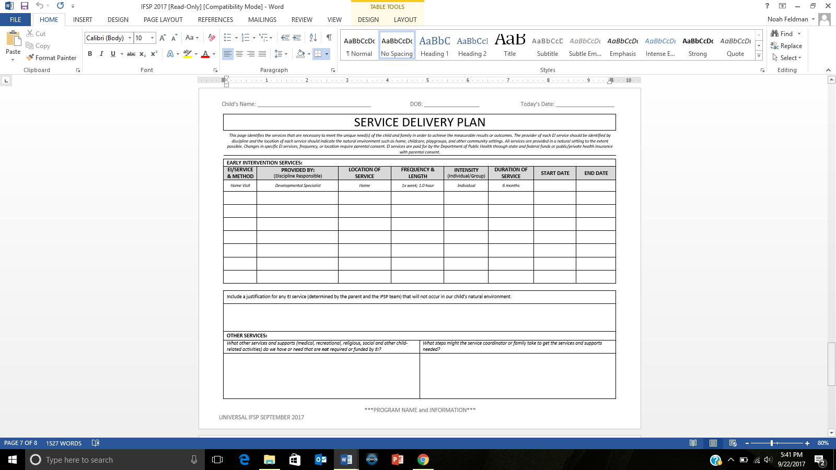

**NOTE**: Specialty Services provided by SSPs for vision loss and/or deaf and hard of hearing should be documented on this page as EI services.

Types of service include home visit, child group, co-treatment, parent group, center visit and transportation

These services must be agreed upon by the IFSP Team and should include a plan for transition to the child’s natural environment, when appropriate

Some services have an established duration and some services may continue after a timely review. Duration is an estimated timeline.

Services are reviewed to assess if the service will continue, end or be modified.

Duration of service can include: 1 time, 8 weeks, 3 months, etc.

Locations can include: home, childcare, EI center, etc.

This space is to identify the specific discipline that provides services.

This box can be used to record strategies for supporting the family in obtaining needed supports.

The *Family Concerns and Priorities* page may identify needed supports.

These services are documentation of what the family deems as important to include in the IFSP. The EI Program is not responsible for providing these services.

*This page identifies the services that are necessary to meet the unique need(s) of the child and family in order to achieve the measurable results or outcomes. The provider of each EI service should be identified by discipline and the location of each service should indicate the natural environment such as home, childcare, playgroups, and other community settings. All services are provided in a natural setting to the extent possible. Changes in specific EI services, frequency, or location require parental consent. EI services are paid for by the Department of Public Health through state and federal funds or public/private health insurance with parental consent.*

SERVICE DELIVERY

PLAN

**SUMMARY**

The SERVICE DELIVERY PLAN is designed to provide a clear location to document all services that are being provided to the child and/or family by Early Intervention. Both Federal language and DPH common terminology are used in several places throughout this page.

**HOW IS IT USED?**

How do you fill it out?

1. EI Service/Method: document the **type** of early intervention service being provided. (HV, Child Group, co-treatment, Parent Group, Center Visit, and Transportation)
2. Provided by: document the **discipline** of the professional providing the service
3. Location of Service: document **where** the service will take place.
4. Frequency & Length: document

* the expected frequency (**how often** will it happen)
* the expected length (**how long** will each instance last)

1. Intensity: document whether the service provided is an **individual** or **group** service
2. Duration of service: document an estimated timeline (**length of time**) you expect to provide the service. Some services have an established duration and some may continue after a timely review.
3. Start date: document the date that the service begins
4. End date: document the date the service ends
5. Justification for any services **not** provided in a child’s natural environment must be documented in the box below the service delivery grid
6. Other Services: this box is designed for documentation of other services or supports sought after or received by the family that are NOT required or funded by EI.

How will this page benefit the family/team?

This page allows for a clear understanding of what services EI will provide as agreed upon by the IFSP Team and outlines other services and steps that the family might be interested in and what support the family needs in obtaining these services.

What do you do with it every day?

Complete during the IFSP meeting and review regularly. New services can be added to the current page as space allows or add an additional page as needed.

**WHY IS IT IMPORTANT?**

Use this page to maintain accurate documentation of agreed upon services to be provided to the family by Early Intervention.

* This page should be updated as needed when changes to services occur
* Changes to Early Intervention services must be agreed upon by the IFSP Team
* Changes to services that require updating on this page include changes to any of the information in the service delivery grid
* **NOTE**: Specialty services provided by SSPs for children with vision loss and/or who are deaf/hard of hearing should be documented on this page as Early Intervention services

**NOTE**: Discipline of the provider is listed instead of individual provider name. This allows for the same service to take place in the event of a personnel change (For example: if Susie Smith, OT goes on a leave of absence and Molly Maple, OT begins providing the same service in her place, the service delivery grid does not need to be updated).

**Any provider change does however need to be reflected on the IFSP Cover Page.**

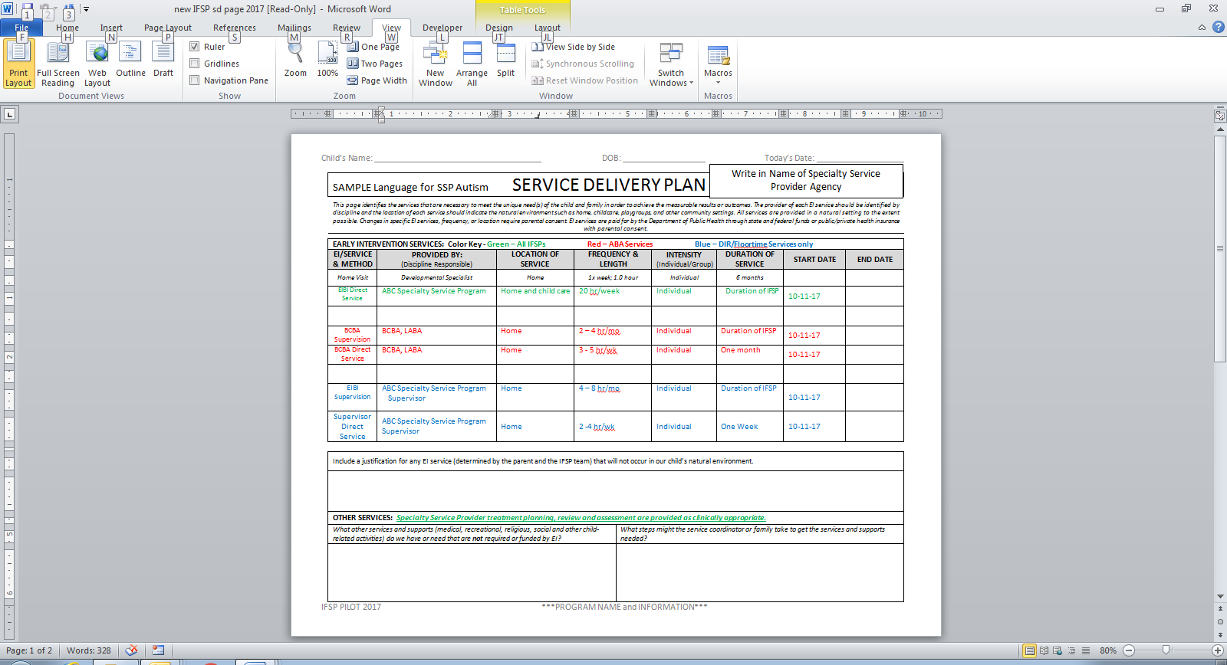

This statement below is to be written on IFSP when developing the Service Delivery Plan with the family.

A **NEW** Service Delivery Plan page should be added to document all Autism SSP services.

This is SAMPLE language for a SSP Autism Service Delivery Plan

*This page includes instructions for New IFSP Service Delivery Page – SSP Autism*

SSP SERVICE DELIVERY

PLAN

**Terms:**

EIBI - Early Intensive Behavioral Intervention

BCBA – Board Certified Behavior Analyst (Requires a MA license)

LABA – Licensed Applied Behavior Analyst

Supervisor – For DIR/Floortime programs only: A highly skilled but non-licensed supervisor designated by the SSP to provide direct supervision to a paraprofessional, provide treatment planning, review and assessment and may provide some direct services.

Paraprofessional – Direct Service provider trained by the SSP program. This individual is required to receive regular direct supervision from the SSP.

**Types of Service:**

**ABA Service Model**

* EIBI Direct Service – Direct service performed by the paraprofessional. Performed on site with child and caregiver present.
* BCBA Supervision– Supervision of paraprofessional. Performed on site with child present. Caregiver may be present.
* BCBA Direct Service – Direct service performed by BCBA. Performed on site with child and/or parent present. May include parent training.

**DIR/Floortime Service Model**

* EIBI Direct Service – Direct service performed by the paraprofessional. Performed on site with child and caregiver present.
* EIBI Supervision – Supervision of paraprofessional performed by a Supervisor designated by the SSP. Performed on site with child present. Caregiver may be present.
* Supervisor Direct Service – Direct service performed by Supervisor. Performed on site with child and/or parent present. May include parent training.

**Filling out IFSP Service Delivery Page:**

* EIBI Direct Service – Required on ALL IFSPs. If more than one direct service provider (paraprofessional), enter total hours provided per **week**.
* BCBA Supervision– For ABA – May enter frequency and length as range
* BCBA Direct Service – For ABA - May enter frequency and length as range
* EIBI Supervision – For DIR/Floortime - May enter frequency and length as range
* Supervisor Direct Service –For DIR/Floortime - May enter frequency and length as range

**IFSP Guidance:**

* The SSP Autism services will be on a separate Service Delivery page to be added to the IFSP.
* The name of the SSP Autism program will be written in on the top of the page.
* The IFSP team may pre-populate the EI Service/Method and Discipline section of the IFSP Service Delivery page prior to the IFSP meeting.
* During the development of the IFSP, the team will:
  + Write the following statement on the bottom of the Service Delivery page:

*“Specialty Service Provider treatment planning, review and assessment are provided as clinically appropriate.”*

* + Determine the location, frequency & length, intensity and duration sections for the IFSP Service Delivery page.
  + Complete the Natural Environment section at the bottom of the Service Delivery page if applicable.
  + Complete the Other Services section if applicable.

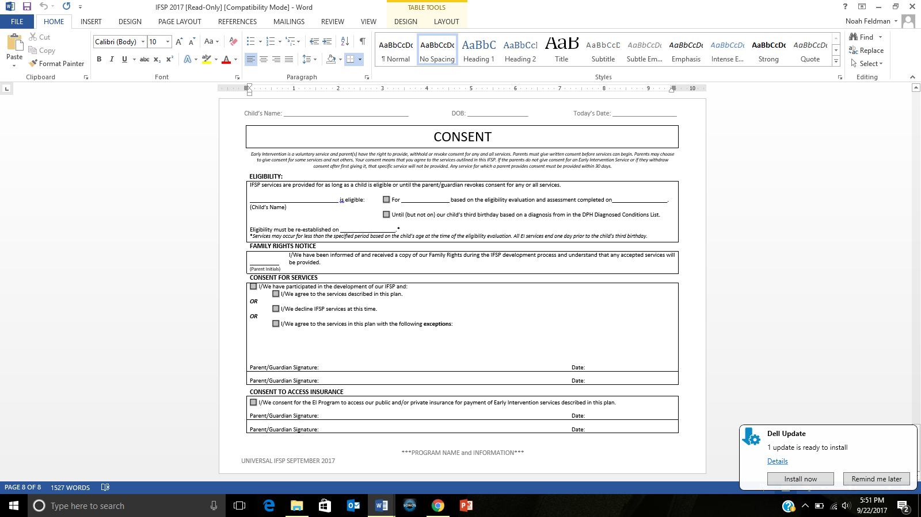

Parents also have the right to provide or decline to provide consent for the program to access their public or private insurance. A parent may decline access to insurance and still receive IFSP services.

Consent is voluntary and may be revoked at any time.

Not all children will be eligible until they turn 3 years old. This section identifies the duration of a child’s eligbility and reinforces the need to complete another eligibility evaluation/assessment for EI services to continue.

Review/Remind parents of their option to provide consent for some services and not others.

CONSENT

*Early Intervention is a voluntary service and parent(s) have the right to provide, withhold or revoke consent for any and all services. Parents must give written consent before services can begin. Parents may choose to give consent for some services and not others. Your consent means that you agree to the services outlined in this IFSP. If the parents do not give consent for an Early Intervention Service or if they withdraw consent after first giving it, that specific service will not be provided. Any service for which a parent provides consent must be provided within 30 days.*

**HOW IS IT USED?**

How do you fill it out?

1. Eligibility

* This section requires the Service Coordinator to explain eligibility thoroughly both for current eligibility and future eligibility requirements.

1. Consent

* A copy of the Family Rights must be provided and reviewed for understanding prior to requesting consent
* Family Rights are available in multiple languages as is the IFSP form
* Families must provide consent for services to begin. They also have the option to accept some of the services being proposed or decline services
* Consent must also be provided by the family in order for the EI Program to access public and/or private health insurance

How will this page benefit the family/team?

Parents/Guardians and EI staff all need to have timelines for service eligibility in order to best plan for required services, re-determination of eligibility and transition planning.

What do you do with it every day?

A new IFSP CONSENT PAGE is done each time a new IFSP is developed. Families should receive prior written notice of each IFSP meeting using the Prior Written Notice Form.

**SUMMARY**

This page is used to gain consent for services, to provide the opportunity for a family to decline some or all of the services that were discussed as well as to give the family specific details regarding their child’s eligibility for Early Intervention services. Families are only asked for consent when the IFSP is complete and contains all required elements (including evaluation/assessment results).

**WHY IS IT IMPORTANT?**

It is important that families understand the specific criteria used to determine eligibility for EI services and the timelines that those services will be provided. This is an opportunity for discussion regarding how their child and family meet those criteria utilizing functional assessment, interview, gathering additional information and informed clinical opinion.

A signature of consent is required for

* accepting all services/ partial acceptance of services/declining of services
* accessing insurance for payment of services

Families must also be made aware that their consent is voluntary as are EI services, and that they may revoke their consent at any time.

**ADDITIONAL IFSP PAGES:**

These pages can be added to the IFSP as needed

* CONSENT FOR SERVICE DELIVERY CHANGE

To be used to obtain consent for changes made to the SERVICE DELIVERY PAGE

* TRANSITION PREPARATION

To be used to prepare for all children and families when they plan to leave an EI program

* TRANSITION PLAN

To be used to plan for all children and families when they plan to leave an EI program

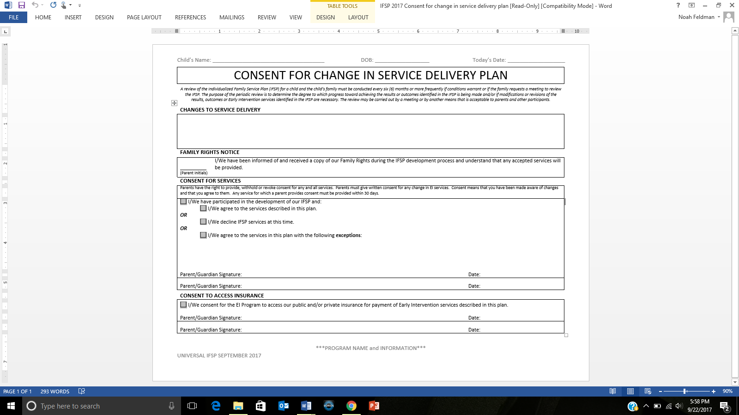

Review/Remind parents of their option to provide consent for some services and not others.

Document any changes in location, frequency, discipline of provider or duration.

CONSENT FOR CHANGE IN SERVICE DELIVERY PLAN

*A review of the Individualized Family Service Plan (IFSP) for a child and the child’s family must be conducted every six (6) months or more frequently if conditions warrant or if the family requests a meeting to review the IFSP. The purpose of the periodic review is to determine the degree to which progress toward achieving the results or outcomes identified in the IFSP is being made and/or if modifications or revisions of the results, outcomes or Early Intervention services identified in the IFSP are necessary. The review may be carried out by a meeting or by another means that is acceptable to parents and other participants.*

**SUMMARY**

This page is used to obtain consent for changes to the *Service Delivery Plan* on the IFSP.

**HOW IS IT USED?**

How do you fill it out?

Complete this page when a

* a change of service is made on the *Service Delivery Plan*

Parents must give written consent for any change in EI services. Consent means that you have been made aware of changes and that you agree to them. Any service for which a parent provides consent must be provided within 30 days.

How will this page benefit the family/team?

CONSENT FOR CHANGE IN SERVICE DELIVERY PLAN pages are added to the IFSP once completed. The CONSENT FOR CHANGE IN SERVICE DELIVERY PLAN page is utilized on an as-needed basis. Parents/guardians and EI staff all need to understand any changes within the IFSP in order to best plan for EI services. Parents have the right to provide, withhold or revoke consent for any and all services.

What do you do with it everyday?

IFSPs often have multiple CONSENT FOR CHANGE IN SERVICE DELIVERY PLAN pages throughout their duration. A CONSENT FOR CHANGE IN SERVICE DELIVERY PLAN page must also be completed if a parent requests to terminate services prior to the end of their eligibility period or when the parent and EI team decide services are no longer necessary.

**WHY IS IT IMPORTANT?**

IFSP Reviews require the participation of the EI Service Coordinator and parent whenever there is a **change in the service delivery plan**. Service changes for the child and family include changes in location, frequency, duration and/or discipline of provider. **NOTE**: Any time an outcome is reviewed (whether it is continued, met or changed) documentation must be on the CHILD AND FAMILY OUTCOMES PAGE.

The modification or addition of outcomes that do not affect specific services as noted on the IFSP Service Delivery Plan *do not require* written consent from the family.

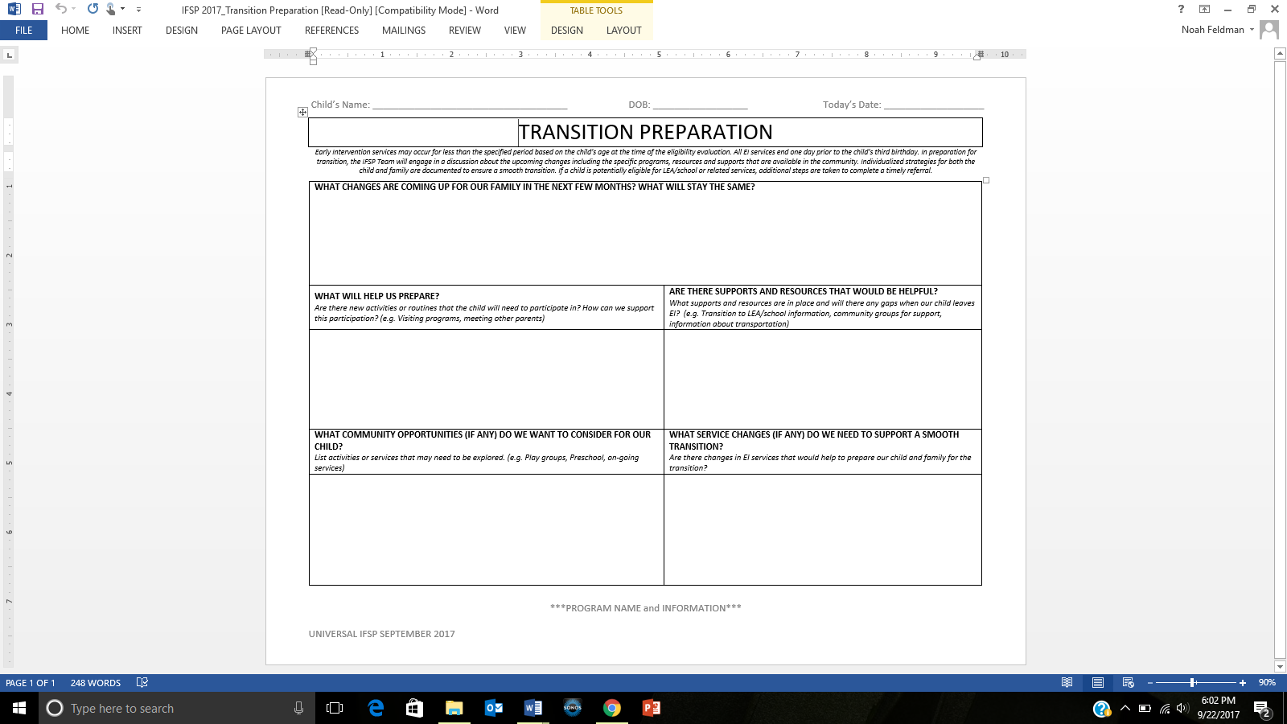

This page should be used for ALL children who are leaving an EI program.

Information gathered here reflects the upcoming changes for the child and family as they prepare to exit an Early Intervention Program.

**WHY IS IT IMPORTANT?**

This page is designed to be a planning document outlining the discussion of possible transition activities as the child and family are leaving their EI program (e.g. turning three, moving, ending services).

**HOW IS IT USED?**

How do you fill it out?

1. Each section should be filled out as necessary, with information specific and individualized to each child and family that answers the following questions:

* *What changes are coming up for our family in the next few months? What will stay the same?*
* *What will help us prepare?*
* *Are there supports and resources that would be helpful?*
* *What community opportunities (if any) do we want to consider for our child?*
* *What service changes (if any) do we need to support a smooth transition?*

1. The Service Coordinator’s responsibility is to outline the steps for transition and to ensure that the required timelines are met.
2. All team members can use this page - preparing the family for upcoming change does not fall solely on the service coordinator.

How will this page benefit the family/team?

By participating in and learning about local community options and program specific resources, the family will learn about what is available to them as they transition out of Early Intervention.

What do you do with it every day?

This page does not need to be used at an initial IFSP, but at the time transition will begin.  It is used only when a child and family are exiting from EI.  Any other types of transitions, such as attending a new daycare or starting preschool would not be documented here.  If you are helping a family with one of those types of transitions, this can be done as an outcome related to services.

**SUMMARY**

This page is used to accurately document a child and family’s transition out of the Early Intervention Program. Information gathered here reflects the upcoming changes for a child and family including the discussion of where the child is headed next along with strategies, supports and services the family and team deem appropriate.

TRANSITION PREPARATION

*Early Intervention services may occur for less than the specified period based on the child’s age at the time of the eligibility evaluation. All EI services end one day prior to the child’s third birthday. In preparation for transition, the IFSP Team will engage in a discussion about the upcoming changes including the specific programs, resources and supports that are available in the community. Individualized strategies for both the child and family are documented to ensure a smooth transition. If a child is potentially eligible for LEA/school or related services, additional steps are taken to complete a timely referral.*

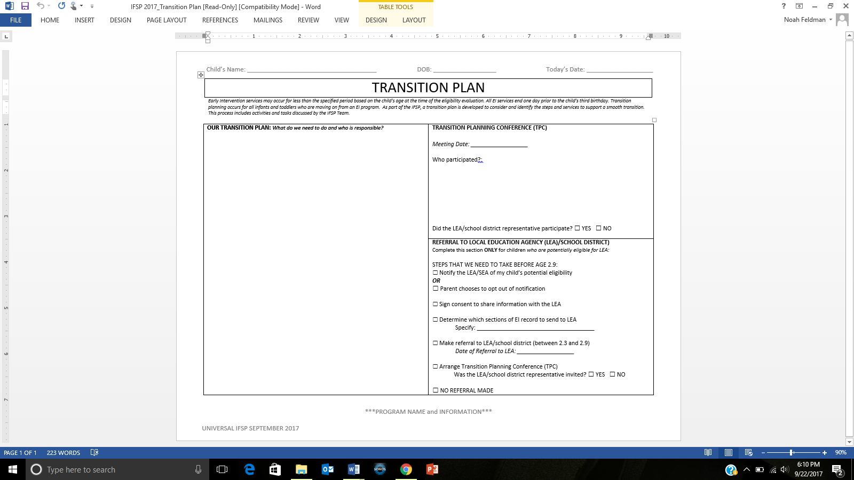

All children will have a Transition Planning Conference (TPC). Prior written notice is required before the meeting

This page is used for ALL children leaving an EI Program, not just those referred to LEA/School District

These action steps are required when referring a potentially eligible child to the LEA/School District

*Early Intervention services may occur for less than the specified period based on the child’s age at the time of the eligibility evaluation. All EI services end one day prior to the child’s third birthday. Transition planning occurs for all infants and toddlers who are moving on from an EI program. As part of the IFSP, a transition plan is developed to consider and identify the steps and services to support a smooth transition. This process includes activities and tasks discussed by the IFSP Team.*

TRANSITION PLAN

**SUMMARY**

The TRANSITION PLAN page provides ample space to highlight the importance of the discussions and documentation of who is responsible for all parts of the transition. All children and families will have a transition from Early Intervention which means every child and family should have a Transition Planning Conference regardless of where and why they are moving on. The Transition Planning Conference section is only one piece of the Transition Plan – that meeting is part of the action steps within the whole transition out of Early Intervention.

**HOW IS IT USED?**

How do you fill it out?

1. Our Transition Plan*: What do we need to do and who is responsible?*

Document the specific transition activities and the people who will complete them.

1. *Referral to LEA/School District:*

* Action steps that are required when referring a Part B, potentially eligible child to the public schools
* Check off as you complete each step

1. *Transition Planning Conference:*

Although all children are not referred to the LEA, all children will have a conference/meeting to discuss their transition out of EI. This meeting must take place with the family at least 90 days before the child turns 3 and depending on the transition, may include other people. If the child is being referred to the LEA (or another community program e.g. Head Start), individuals from those programs should be invited to participate.

How will this page benefit the family/team?

Documenting each activity as it pertains to the child and family’s transition provides team members (including the family) with their own responsibilities. Some steps may be completed by the service coordinator and others by the family (e.g. “Mom will call preschool to find out status of consent process.”)

What do you do with it every day?

This page is used for **ALL** children, not just those going to LEA/School District. Today’s date reflects the date transition activities are discussed with the family and documented. All children will have a Transition Planning Conference and prior written notice is required prior to this meeting.

**WHY IS IT IMPORTANT?**

This page can be viewed as a “to do list” or an “action plan” of ideas that the family and EI program would like to complete in order to prepare for transition.  It is a planning page – outlining the steps for each individual child and family as well as who will participate in or carryout each activity.  This is not intended to be completed at discharge but rather prior to transition as part of ongoing services.

**All children** will have a Transition Plan.

**All children** will have a Transition Planning Conference (TPC).

**Some children** will be referred to the LEA/School District.

**APPENDIX A**

*Health*

*Resources:*

*Vision*

*Hearing*

*Oral health*

VISION

*During a critical period in young childhood, interventions to support optimal vision development may be required (eyeglasses, patching, etc.). Many children with a vision problem have no signs or symptoms. Because of this, all children must have their vision and eye health assessed by their pediatrician, nurse practitioner and family physician as part of their newborn physical exam and all well checks throughout childhood.*

Questions to ask:

* Has the child had vision assessed by primary care provider during well visits?
* Has the child been referred for an eye exam?
* Is there a need for support in identifying an eye doctor who cares for young children and/or accepts required insurance?
* Has the child had a comprehensive eye exam?
* Has the child been prescribed eyeglasses? Has the eyeglass prescription been filled? Does the child wear the eyeglasses as prescribed?

A comprehensive eye exam is indicated when:

1. Child has signs/symptoms of a vision problem:

* Irritated/inflamed lids/eyes
* misaligned eye(s)
* drooping lid(s)
* rubbing eyes
* squinting/frowning
* avoiding eye contact when awake/alert
* holding objects close
* excessive blinking

2. Child has condition(s), risk factors known to be associated with vision problems:

* Neurodevelopmental Disorders
* Prematurity and/or Low Birth Weight
* Motor abnormalities such as Cerebral Palsy
* Juvenile Arthritis
* Down Syndrome
* Cognitive Impairment
* Hearing Impairment
* Speech and Language Delays
* Autism Spectrum Disorders
* Sibling with diagnosed vision condition as a young child
* Parent with history of vision problem as a young child
* High risk maternal behavior during pregnancy

1. Parent or health care provider/specialist is concerned that the child is having difficulties that may be related to vision

If child has signs/symptoms and risk factors as above, and/or there are concerns about how well the child can see, a comprehensive eye exam should be done as soon as possible.

*Over 99% of newborns in Massachusetts have hearing screenings soon after delivery. The system ensures that those who do not pass the screening are seen for timely diagnostic audiology appointments and referred on to Early Intervention if the hearing loss is confirmed. However, the newborn hearing screening is a snapshot in time. Some young children can have progressive or late onset hearing losses that are not identified by the newborn screening. Certain children are at higher risk for these types of hearing loss.*

HEARING

Questions to ask:

* Has the child ever seen an audiologist?
* Has the child ever had a hearing evaluation?
* Does the family (or others) have concerns about the child’s hearing?
* Is there a need for support in identifying a hearing specialist or making a referral?

Risk factors associated with permanent congenital, delayed-onset, or progressive hearing loss in childhood have been identified. Infants who pass the neonatal screening but have a risk factor should have at least 1 diagnostic audiology assessment by 24 to 30 months of age. Some risk factors for delayed onset hearing loss include but are not limited to:

* Caregiver concern regarding hearing, speech, language, or developmental delay.
* Family history of permanent childhood hearing loss.
* Neonatal intensive care requiring Extracorporeal membrane oxygenation (ECMO)
* In utero infections, such as Cytomegalovirus (CMV)
* Syndromes associated with hearing loss or progressive or late-onset hearing loss, such as neurofibromatosis, osteopetrosis, and Usher syndrome
* Neurodegenerative disorders, such as Hunter syndrome
* Postnatal infections associated with sensorineural hearing loss including confirmed bacterial and viral meningitis
* Head trauma
* Chemotherapy

A comprehensive hearing evaluation is indicated when:

1. Child has signs/symptoms of a hearing problem

2. Child has condition(s), risk factors known to be associated with hearing problems:

3. Parent or health care provider/specialist is concerned that the child is having difficulties that may be related to hearing

Any child who demonstrates delayed auditory and/or communication skills development, even if he or she passed the newborn hearing screening, should receive an audiological evaluation to rule out hearing loss.

*A growing body of research demonstrates the connection between oral health and overall health. This research indicates the need to engage children in oral health care early on to prevent chronic disease later in life. Yet there continues to be major disparities in oral health among children for a variety of reasons including barriers to access. Data shows that over 50% of children on MassHealth who have been to a doctor regularly have never been to a dentist.*

ORAL

HEALTH

Knowing that current research regarding the connection between oral health and overall health and development, program staff should gather information as part of the functional assessment regarding if the child has ever seen a dentist, date of last dental visit, need for support in identifying a dentist or making a referral to a dentist.  The section would be completed in the same way that staff collect information regarding vision and hearing status.

**Why is oral health important?**

A growing body of research demonstrates the connection between oral health and overall health indicating the need to engage children in oral health care early on to prevent chronic disease later in life. Yet there continue to be major disparities in oral health among children for a variety of reasons, including barriers to access. Data shows that over 50% of children on MassHealth who have been to a doctor regularly have never been to the dentist.

# Massachusetts Oral Health Practice Guidelines for Pregnancy and Early Childhood

This document builds on state and national efforts to educate healthcare providers across professions on oral healthcare for pregnant women and young children. Healthcare providers play an important role in educating, coordinating, and collaborating across professions to improve oral health care of all patients. These practice guidelines are consistent with guidance from professional organizations and provide specific oral health care recommendations and resources for healthcare professionals caring for pregnant women and pediatric population.

The Oral Health Practice Guidelines can be found at: [http://www.mass.gov/eohhs/docs/dph/com-health/data-translation/oral-health-guidelines.pdf](http://www.mass.gov/eohhs/docs/dph/com-health/data-translation/oral-health-guidelines.pdf%20)

To order hard copies of the oral health practice guidelines, go to: [www.massclearinghouse.ehs.state.ma.us/product/PP2837.html](http://massclearinghouse.ehs.state.ma.us/product/PP2837.html)

In 2000, the Surgeon General’s report, *Oral Health in America*, identified oral

diseases as the “silent epidemic” affecting millions of children and adults in the

United States. Since then, evidence of the effects of poor oral health on systemic

health, and social and economic well-being has accumulated. Universal access to

affordable dental care has been a priority for the Massachusetts Title V Maternal

and Child Health Program since 2010, which has led to several initiatives to

improve oral health among pregnant women and young children.

In 2013, the Title V Program, in collaboration with the Office of Oral Health at

the Massachusetts Department of Public Health (MDPH), convened a statewide

summit to lay a foundation for the integration of dental care into routine prenatal

care. The MDPH also endorsed efforts by Massachusetts Health Quality Partners

to include oral health in its 2013 Perinatal Care Recommendations. An Oral

Health Advisory Committee and work groups were subsequently convened by

MDPH to develop oral health care practice guidelines for providers who care for

pregnant women and young children.

**Questions to ask:**

Has the child ever seen a dentist?

Is there need for support in identifying a dentist or making a referral?

**APPENDIX B**

*Functional Assessment*