Executive Office of Housing and Livable Communities
IGX Grant Management System Guide

- Introduction to System and General Navigation ------------------- 2-3
  - Access to the system ------------------------------------------------- 3-4
  - Navigating the grant – Home Page and the Side Bar ----------- 4-7
- System Components
  - Activities – Administrative Accounts; Applicants;
Projects ------------------------------------------------------------------ 8-10
  - Amendments ----------------------------------------------------------- 10-12
  - Extensions --------------------------------------------------------------- 12-13
  - Davis-Bacon Reporting ------------------------------------------------ 13
  - Grant Reports ----------------------------------------------------------- 13
  - Performance Measures ----------------------------------------------- 14
  - Tools ----------------------------------------------------------------------- 14
  - Status Options ---------------------------------------------------------- 14
  - Related Documents – RFP, Grants, Claims, QPR --------------- 14-17
  - Transactions ------------------------------------------------------------ 18-19

Common Icons and Symbols Used in the System
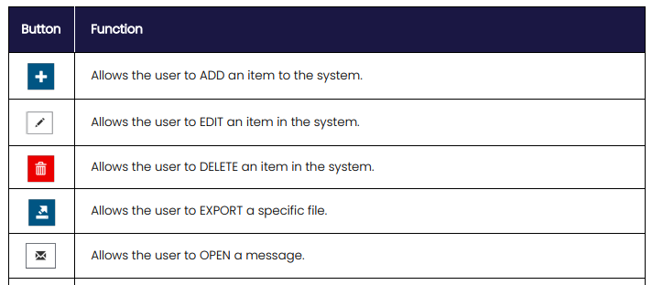

/8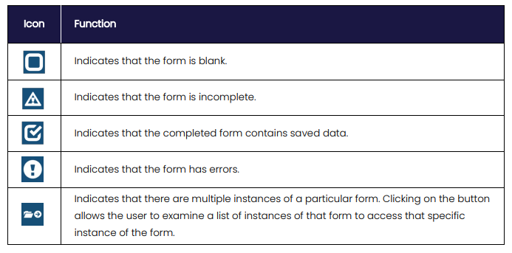

- Introduction to System and General Navigation
This is a step-by-step guide to the processes and procedures necessary to manage your CDBG grant. For those who are familiar with and may still be using our older Intelligrants Grant Management System many of the procedures will be the same while the process for carrying out the procedure may be different. In effect, you may be doing the same thing but in a different way. The biggest difference you will notice is that the bank account system is changed and hopefully the method for tracking expenditures and other transactions will be more straightforward, if not simpler. For those who have no experience with the old system, hopefully this one will be easy to grasp. With that said, we are still working on the system and there may be tweaks along the way. Any and all comments, questions and suggestions are welcome.
- Access to the System
The first step is to be able to access the system. The good news is that since you have successfully completed an application, you already have access. If for some reason you are unable to access the system with the credentials you established for the application, contact Mark Southard at mark.southard@mass.gov. If you have never used the system, you must first register and then be activated and assigned to the grant. To do this, click on the login link ( Login) and then click on the New User link and complete the registration. Once you have completed the registration contact Mark Southard at the above email address. You will then be activated and provided with additional instructions, if necessary. Already registered but forgot your login credentials? Click on the forgot username/password link on the Login page and provide the requested information.
When you log in, you will arrive at the Dashboard (aka Home Page). On the Home Page, you should have a My Opportunities panel and a My Tasks panel. My Opportunities is where you will find a link to create applications when they are available. (It should be blank currently). My Tasks should be blank as well; but this is where objects (grants etc.) appear when there has been a process change and some action needs to happen to the object. To access the grant, you will click on Searches in the blue ribbon at the top of page and select Grants. This will bring up a search box to find your grant. After the first time, use the recent documents link for quicker access.
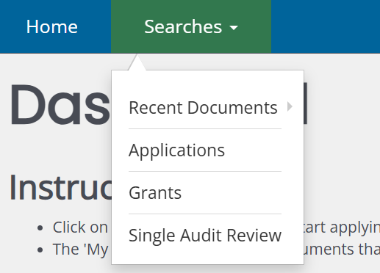
If you do not see the panels, click on the down arrow next to your name and select Edit Dashboard to be able to add the panels.
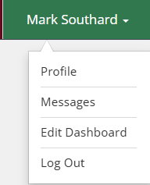
- Navigating the Grant
After finding your grant and clicking on it, you will be directed to the Home Page of the grant which will provide information on the grant and its status which at this point should be Grant Awarded.
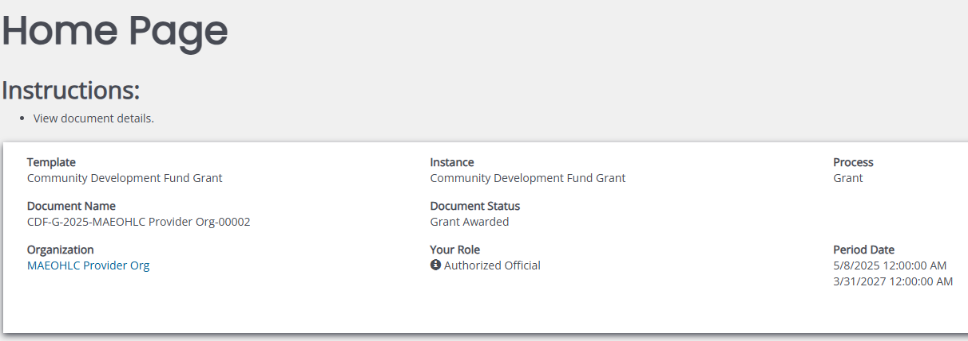
To the left of the Home Page, you will see the sidebar with several category headings. We will go through each of these in turn. Access to all forms and processes for the grant will be through the sidebar.
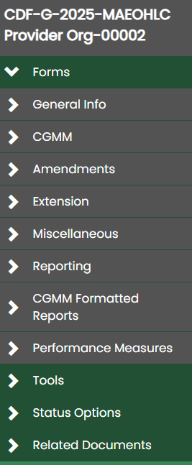
General Info
The first section on the sidebar is General Info which has forms related to the overall grant:
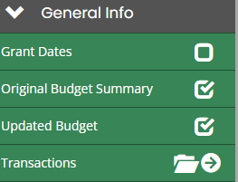
Grant Dates – This is just for recording dates on which some things happen. This will be handled by EOHLC staff.
Original Budget Summary – This is the budget summary from the application copied into the grant. A copy of it is part of the contract documents.
Updated Budget – This is a new form that expands the budget summary and will be used to track program income added, drawdowns (claims), expenses and amended budgets.
Transactions – This is where you will record bank account actions such as expenses initially.
Grant Activities
Main section for managing the grant and its activities.
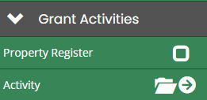
Property Register – Should you purchase anything with CDBG funds, you will need to provide information on the property and will do it here. Your fiscal rep can guide you on this.
Activity – This is where the activities that have been funded will exist. Clicking on the arrow next to the folder icon will bring up the list. Further information on accessing the activities and completing set up will be addressed later in this document.
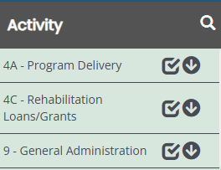
Amendments, Extensions, and Grant Close Out
This is where you will go to carry out these functions for the grant when necessary.
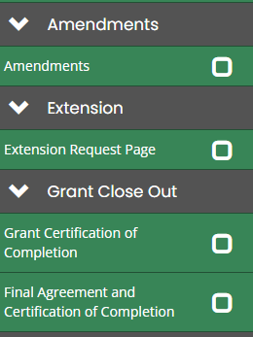
Miscellaneous, Davis-Bacon Reporting, Grant Reports and Performance Measures
- Miscellaneous is an attachment node where random documents can be uploaded, if needed.
- Davis-Bacon Reporting will be where you complete your six-month Davis Bacon reports, if required.
- Grant Reports are a number of reports that can be used to assist with grant management and the management of funds. More reports will appear as they are developed.
- Performance Measures are where you will enter this HUD required information for your activities as they are completed.
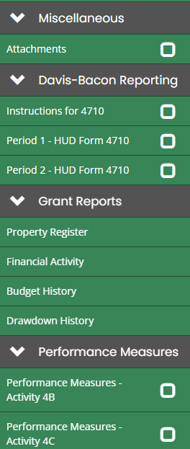
Tools
A variety of system tools to help you access certain functions or information such as adding or removing people from the grant or other related objects.
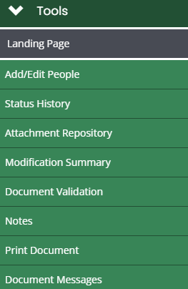
Status Options and Related Documents
- Status Options is where you will make status changes to carry out actions for the grant such as amendment and extension requests
- Related Documents is where you will create, find and manage documents which are related to your grant claims and quarterly reports.

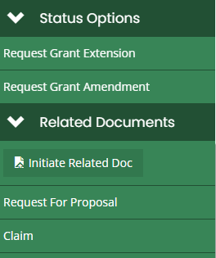

- System Components

- Activities – Administrative Accounts, Applicants, Project
On the side bar, you will see the link for Activity –

Click on either the word activity or the arrow to see the list of activities in the grant:
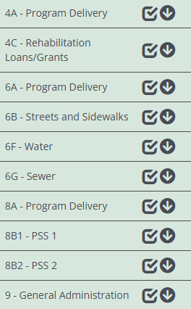
Click on the activity name to go to the activity page. This is an informational page that displays the activity along with budget information.
Click on the down arrow next to any activity and you will have access to three forms, Administrative Accounts, Project and Applicant. All three will show up for every activity though not every activity will use each of them.
Administrative Accounts – This page will only be used for the administrative activities (4A, 5A, 6A, 8A and 9). It is where you will set up your administrative accounts. Click on the Administrative Accounts link and you will come to the following page:
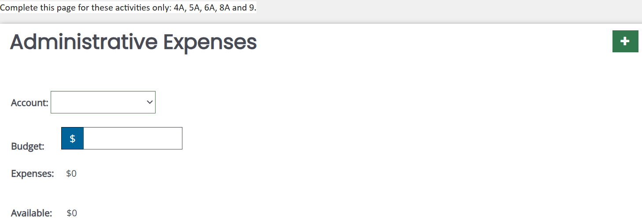

Click on the Account dropdown, select the appropriate account and enter the budget. Click Save in the upper right corner. If you do not see the account name you prefer, select Other and a text box will appear for you to enter a name. To add additional accounts, click on the green plus button.
Project – Each activity that is not an administrative activity must have at least one project. Some types of activities such as housing rehabilitation (4C) or commercial rehabilitation (5C) will have multiple projects as each home or building will be a separate project.
Select the Project link and complete the project page information, as needed. Don’t forget to Save.
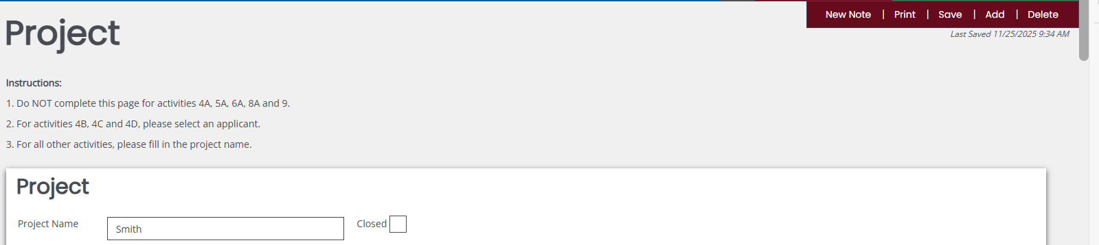
Please note that if you scroll down the Project page, you will find a section for Contractors as well as a section to add accomplishment (beneficiary) information.
If you have more than one project, you will use the Add button in the upper right of the page to create a blank project.
If a project has multiple contractors, you will use the green plus button to add additional contractors. A blank contractor form will be loaded below the one that you have already completed. You will use the same Save button in the upper right that you used for the project to save the contractors.
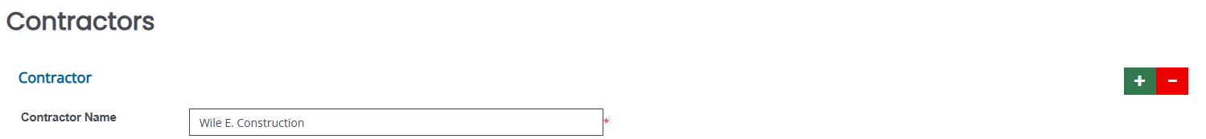
Each project will need to report accomplishment information based on the national objective that will be met by the project. Project Beneficiaries is where you will enter information for public service activities (coded 8B) and some commercial activities (coded 5…) along with other activities as directed by EOHLC staff.
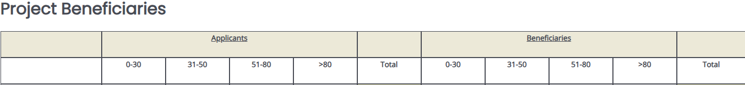
Project Beneficiaries Summary which follows is where you will enter information for most infrastructure activities (coded 6…) along with others as directed by EOHLC staff.
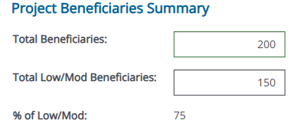

Applicant – The applicant link is used to enter accomplishment information for housing activities (4B, 4C, 4D). It is similar to the Project Beneficiaries page but also includes unit information. All housing projects must have an applicant associated with it. You will connect the applicant to the appropriate project using the dropdown in the second field of the project page. Click the dropdown, select the correct applicant and then click Save. The applicant link is used only for housing activities.
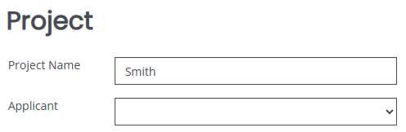

- Amendments – The amendment page will be used to make changes to the awarded grant from what was described in the approved application. Typically, this involves budgetary changes, moving funds from one activity to another and/or adding an activity or adding funds (program income) to a grant. Amendments can also be programmatic, a change to approach or focus or accomplishments for the grant.
An amendment begins with a status change to a grant. When in its active stage, a grant is in Grant Awarded status. In order to create an amendment, the grant needs to be moved out of Grant Awarded status to Amendment Status.
On the side bar, scroll down to Status Options and select Request Grant Amendment.
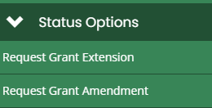
You will see a popup that is asking if you are sure you want to change the status. Click OK. The grant will now be in Grant in Amendment status.
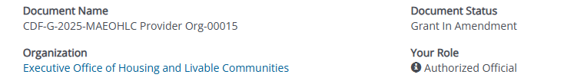
Please note that when the grant is in Amendment status, permissions (Save etc.) for other forms and objects may be limited so that changes cannot be made until the amendment is approved, rejected or cancelled.
With the grant in amendment status, on the side bar, scroll to the Amendments link
and click on the word amendments.
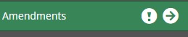

This will bring you to the amendments page. Complete the information on the page and save. Note that there is an attachment link on this page where you will be able to add any documents necessary for the amendment. Once you save, you will be able to click on the arrow to the right of the word amendments to access the remaining forms to complete the amendment. In addition, the amendment will now be identified by the date.
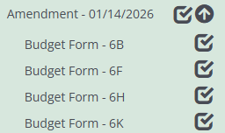
These forms include the Budget Form and a link to generate a signature form, along with a node to upload the signed document.

The Budget Form is where you will carry out budget transactions for moving funds within the grant. It is very important that the steps outlined on the page be completed as indicated. Select an activity, Click Save, Add the budget change for the activity (use a minus sign if for a reduction), Click Save. It is important that both saves be enacted and when asked for. Most amendments will include modifications to at least two activities. After completing the budget revision for the first activity, use the Add button in the upper right corner of the page to add additional activities.

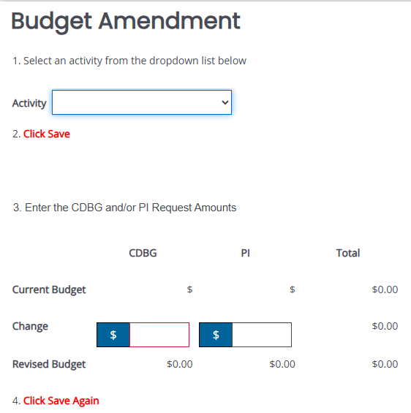

Once the amendment forms have been completed and the signed amendment form is uploaded, return to the Status Options section on the sidebar and select Submit Amendment Request.
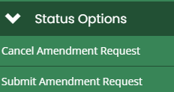

- Extensions – As with amendments, an extension request is initiated on the side bar by clicking on the Status Option, Request Grant Extension.
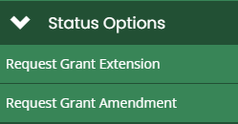
You will receive the popup asking to confirm that you want to go forward and the Document Status will be updated.
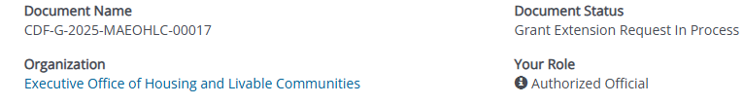
Scroll up to the Extension Section and click Extension Request Page. Complete the page and Save. As with amendments, there is an attachment node for uploading documents that support the extension request. The Extension Date Requested is the date that you want to extend to and should always be a quarter ending date.
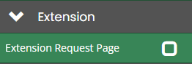

Once it is saved, the extension request will be identified by the quarter-end date you entered. Should you need to request another extension, you will click into the Extension Request Page and use the Add button in the upper right to add a blank page.

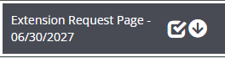

With the extension request completed, scroll down to the Status Option section on the side bar and select Submit Extension Request. You will receive the “Are you sure question”. Click OK and the extension request will be submitted.

- Davis-Bacon Reporting – Generally, construction projects that exceed $2,000 in cost require reporting for Davis-Bacon wage requirements. This is done every six months based on the calendar year. Instructions and forms to be completed online can be found in this section on the side bar. Please contact your program representative if you have questions.

- Grant Reports – This section contains formatted reports that provide information on financial activities. There are 4 reports listed – Property Register, Financial Activity, Budget History and Drawdown History.
- Property Register – Provides a list of any property entered on the property register link above.
- Financial Activity – this provides a look at the current balances in the system of Budget, Expenses, Committed and Drawdowns for all activities.
- Budget History – this provides a list of all the amendments that have taken place, showing changes that have been made to activities and the status of the amendment.
- Drawdown History – this provides a listing of all claims that have taken place with a running total of expenses, drawdowns and balance for all activities.
In order to generate a report simply click on it and a PDF will be offered for download.

- Performance Measures – this is HUD required reporting that must be completed for each activity at closeout. Provide the requested information, as appropriate, for each non-administrative activity and save it. Reach out to your program representative if you have any questions.

- Tools – A number of system tools that may be used for various actions or to provide information.
- Landing Page – This will take you back to the Home Page of the grant.
- Add/Edit People – Will provide a listing of persons associated with the grant, the role they have, when they were added to the grant and the person that added them. You may add or delete people here, as needed.
In order to add someone, click on the green plus button and complete the necessary information.
To delete someone or change their information, click on the edit icon 
- Status History – shows each status change that has taken place, the date and time that the change was completed and the person who completed it.
- Attachment Repository - a listing of all documents that have been uploaded to the system.
- Notes – A place to add and track notes in the system. EOHLC may develop this more in the future.
- Print Document – Allows you to print the entire grant or selected sections or forms of the grant.
- Document Messages – A method for sending, receiving or tracking messages within the system. EOHLC may develop this further in the future.

- Status Options – Status options are used to engage actions that the grant may need to undertake at times. Primarily, these involve extension or amendment requests as discussed above and will also be used during the grant close out period when activities have been completed. The current status of the grant, as displayed on the home page, will reflect these actions and the status options available will be related to the current status. Each time you select a status change, you will be asked to confirm that you want to make that change and will be able to add a note related to the change, if desired.

- Related Documents – RFP’s; Grants; Claims; Quarterly Reports – all of these can be related documents. When in a grant, the related documents are where you can access the application that resulted in this grant, claims and quarterly reports. You will use this section to initiate and store both claims and quarterly reports. Both of these processes will be described below.

- Claims – At the start of the grant, the Related Documents section will appear as in this screen shot:
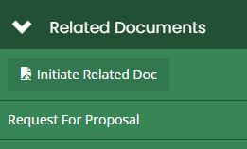
The Request for Proposal, or application, link will appear but there are no other documents until you create them. In order to do that, you will click on Initiate Related Document. This will bring up a screen that identifies the grant you are in and offers available documents to be created.
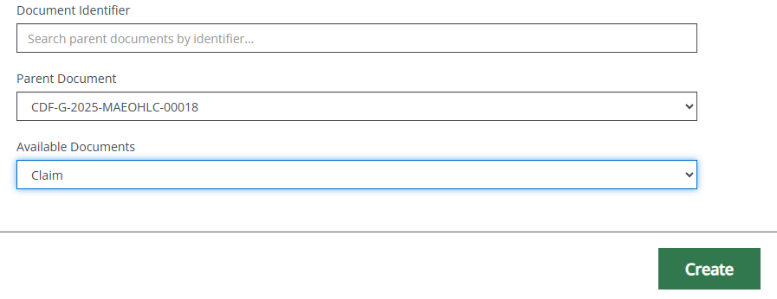
With claim selected, click on the Create button. A second screen will show which identifies what you are doing. Click on Proceed and the claim will be created. You will then be in the claim.
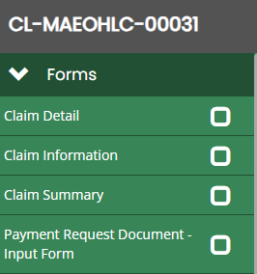
If you want to go back to the grant, scroll down to the Related Documents section and click Grant and a link will be provided to move you back to the grant.
Completing a Claim – The claim structure on the side bar is the same as for a grant. You will find the forms that need to be completed at the top. You will complete the Claim Detail and Claim Information forms. Please ignore the Claim Summary for now unless you need to record a comment as required by our fiscal staff. As needed, you will be able to generate the Payment Request Document which will need to be signed.
- Claim Detail Form – Click on this form to enter the activity(s) you want to draw funds from. There are two items to complete:
Activity selection – Use the dropdown to select the activity
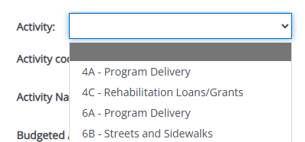

Current Request – Add in the $dollar amount requested for the activity. 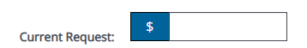
CLICK SAVE. The page will update with detailed information upon save. If you are intending to draw funds from more than one activity, there is a green + (plus) button on the upper right of the form. Click on it and a blank form will appear below the one you have just created. You may do this for as many activities as you want to draw from. You can verify your budget entries by creating the Claim Detail report which is located on the side bar below the Forms section.
Please note, there is a Program Income Activity section at the bottom of the claim form. You can ignore this for now.

- Claim Information Form – Click on this and complete the requested information.
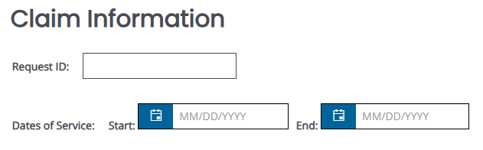

- Payment Request Document – Click on this and complete the information on the page. Select Physically for signature option as we have not developed the electronic signature format, at this point. Clicking Physically will open an Upload box for you to provide the signed document.
- Vendor Code – Grantees will need to enter the state issued vendor code for the Payment form. To have it load to the form, click on Profile under your name and select Organization Information on the side bar. Scroll down the page until you find the vendor code field and enter the 10-digit code. It will now load to the Payment Request Document when you create it.
When you have completed the claim, scroll to the Status Options section on the side bar and select Submit Claim. There is a Cancel Claim Option as well. Should you wish to go back to the grant, scroll to the Related Documents section and click on the Grant link.
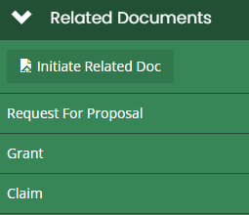
You can also access your claims using the Claim link which will be available in both the claim object and the grant.
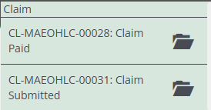

- Transactions – The Transactions link will be used to track expenditures that take place for the grant. As described in the CDBG Operations Manual, Chapter 11 Financial Management, “once a grant has been awarded, the community must establish a separate "designated bank account" for the receipt of Massachusetts CDBG funds”. Identifying this bank account in the grant is the first step in the transactions process. This is done through Organization Information which can be accessed by clicking on Profile in the dropdown next to your name.
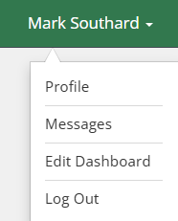

Select Bank Account Details and provide the required information.
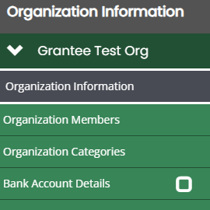
Expenses can be completed through the Transactions link once the bank account, administrative accounts, projects and contractors have been set up.
How to complete a transaction – the first step in completing a transaction is to click on the Transactions link on the side bar.
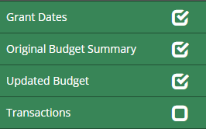
Select the bank account (Account Name) that you set up and then the activity that the expense is for. If this is a non-administrative activity, you will also select the relevant project name. Administrative activities (4A, 5A, 6A, 8A, 9) do not select projects.
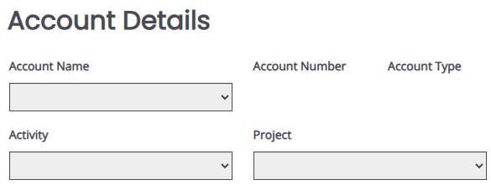
The next step is to complete the Transaction section. First select, transaction type and complete other transaction information. Be sure to include the Transaction Date and the Amount. You will need to Save the page prior to selecting the contractor or administrative account that the expense will be posted to. This will load the information unique to the activity and/or project that has been entered. Save the Page.
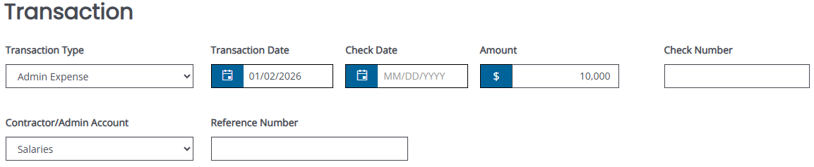
Note: At this time, we are only using Admin Expense and Contractor Expense. Though there are other options in the dropdown, they are not set up.
In order to add additional transactions, click on the Add button at the top right of the form and a blank form will be created.
Completed transactions will be tracked on the Updated Budget form in the last column. You may generate a report for transactions by selecting this link: Click here to view a list of all transactions. It will produce a spreadsheet of all saved transactions with an option to export to Excel.

