ILLEGAL TOBACCO TASK FORCE
Public Meeting #65 Minutes
Meeting Date: Wednesday, December 10, 2025
Meeting Time: 1:00 PM
Meeting Location: Via Zoom, dial (305) 224-1968, Meeting ID# 841 0897 1093, Passcode 794743
Board Attendance: John Hayes (DOR), Stephen McDonald (MSP), Jackie Doane (DPH), Molly Butler (DPH), Dan O’Neil (State Treasurer/Lottery), Nicholas Ogden (AGO), and Nicole Nixon (AGO).
Public Attendance: 26 attendees

Call to Order:
- Mr. Hayes called the meeting to order at 1:05 PM. Mr. Hayes informed all participants that this meeting will not be recorded by Zoom and that Cole Doherty-Crestin will take notes to complete the minutes which will be posted to the Task Force website.
Opening Remarks:
- Mr. Hayes welcomed Stephen McDonald (MSP). Stephen McDonald has recently been appointed as the co-chair of the Task Force. Mr. Hayes thanked everyone for attending and Task Force board members introduced themselves.
Approval of Minutes from Meeting #64 on February 25, 2025:
- Cole Doherty-Crestin emailed a copy of the minutes for Meeting #64 to Task Force board members prior to this meeting. Mr. Hayes asked members if there were any recommended edits to be made and hearing none, he asked for a motion. Dan O’Neil made a motion to approve the minutes, and Stephen McDonald seconded the motion. Mr. Hayes stated that with no objection, the minutes were approved and will be posted to the Task Force website.

Tobacco Product Waste Presentation
- Mr. Hayes introduced Carolina Saavedra and Zohal Khan from the Public Health Law Center. Mr. Hayes noted that with the disposal of tobacco product waste, especially for ENDS products, continuing to be an issue in the enforcement of the Commonwealth’s tobacco, revenue, and public health laws, the Task Force wanted to learn more about how some other parts of the country are handling issues surrounding the handling or disposal of tobacco product waste. Carolina and Zohal provided a presentation on Tobacco Product Waste. A copy of the presentation is attached at the end of this document. Mr. Hayes highlighted the high cost related to ENDS disposal.

Member Agency Updates
  - Mr. Hayes inquired whether board members had any agency updates. Board members did not provide any updates.

Other Business
  - Mr. Hayes stated that the annual report to the legislature is due March 1st. The Task Force will be having a meeting in early to mid-January to review previously proposed statutory or regulatory changes as well as to discuss any new proposals from board members or the public. Mr. Hayes reminded participants to email comments/proposals or to request to speak in advance so that they can be included during the meeting. The email for the task force can be found on the DOR task force web page. Mr. Hayes stated that two meetings are to be scheduled in February to review and approve the annual report.

Closing Remarks
- Mr. Hayes thanked Zohal and Carolina from the Public Health Law Center for their presentation and also thanked everyone for attending. Mr. Hayes reminded everyone to send in comments via email for inclusion in the next meeting. Mr. Hayes asked whether there was a motion to close the meeting. Dan O’Neil made a motion to close the meeting, and Stephen McDonald seconded the motion. Hearing no objections, Mr. Hayes adjourned the meeting at 1:57 PM.

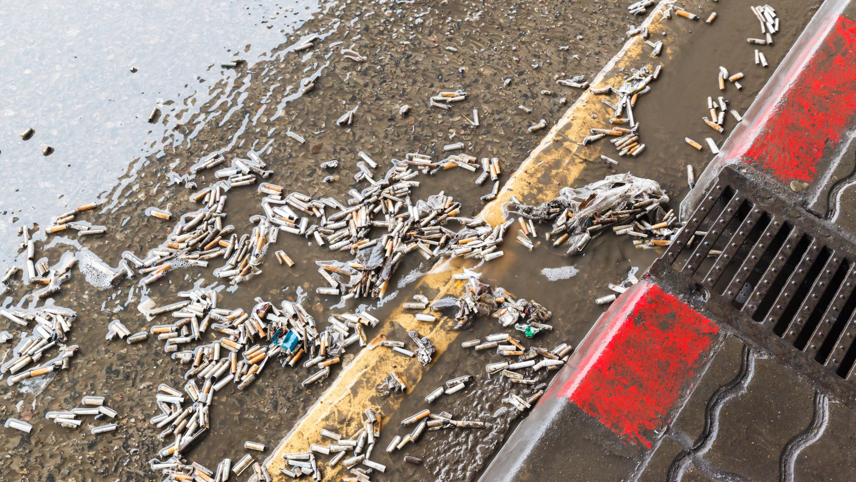












Tobacco Product Waste:
Problems and Solutions

THE PUBLIC HEALTH LAW CENTER

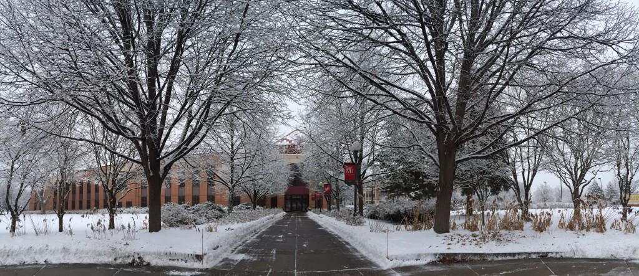

LAND ACKNOWLEDGMENT

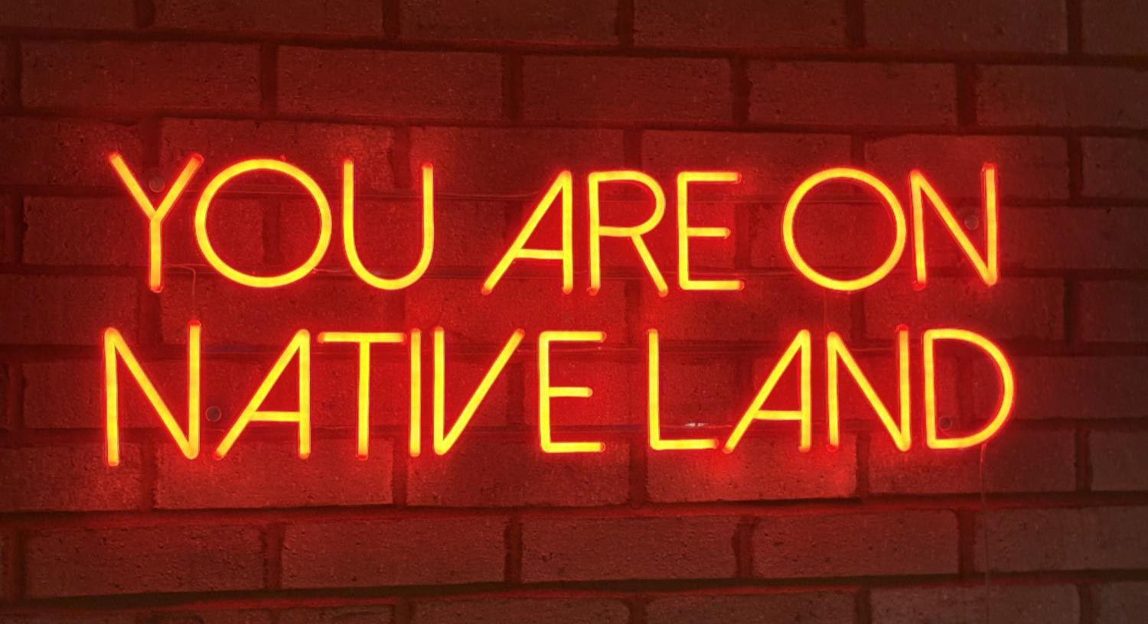
Photo taken at Owamni Restaurant - Minneapolis, MN


RESPECTING TRADITIONAL TOBACCO


Tobacco traditions have been passed down for generations. Tobacco plants are considered a sacred medicine for many Indigenous people. https://keepitsacred.itcmi.org/

https://www.glitc.org/publications/walking-toward-the-sacred-our-great-lakes-tobacco-story/

LEGAL TECHNICAL ASSISTANCE
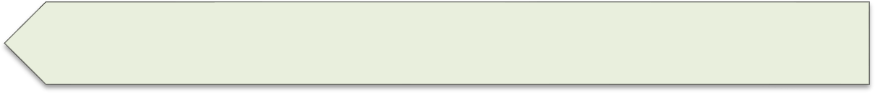




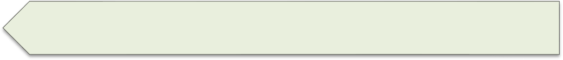






Legal Research
Policy Development, Implementation, Defense
Publications
Trainings
Direct Representation
Lobby

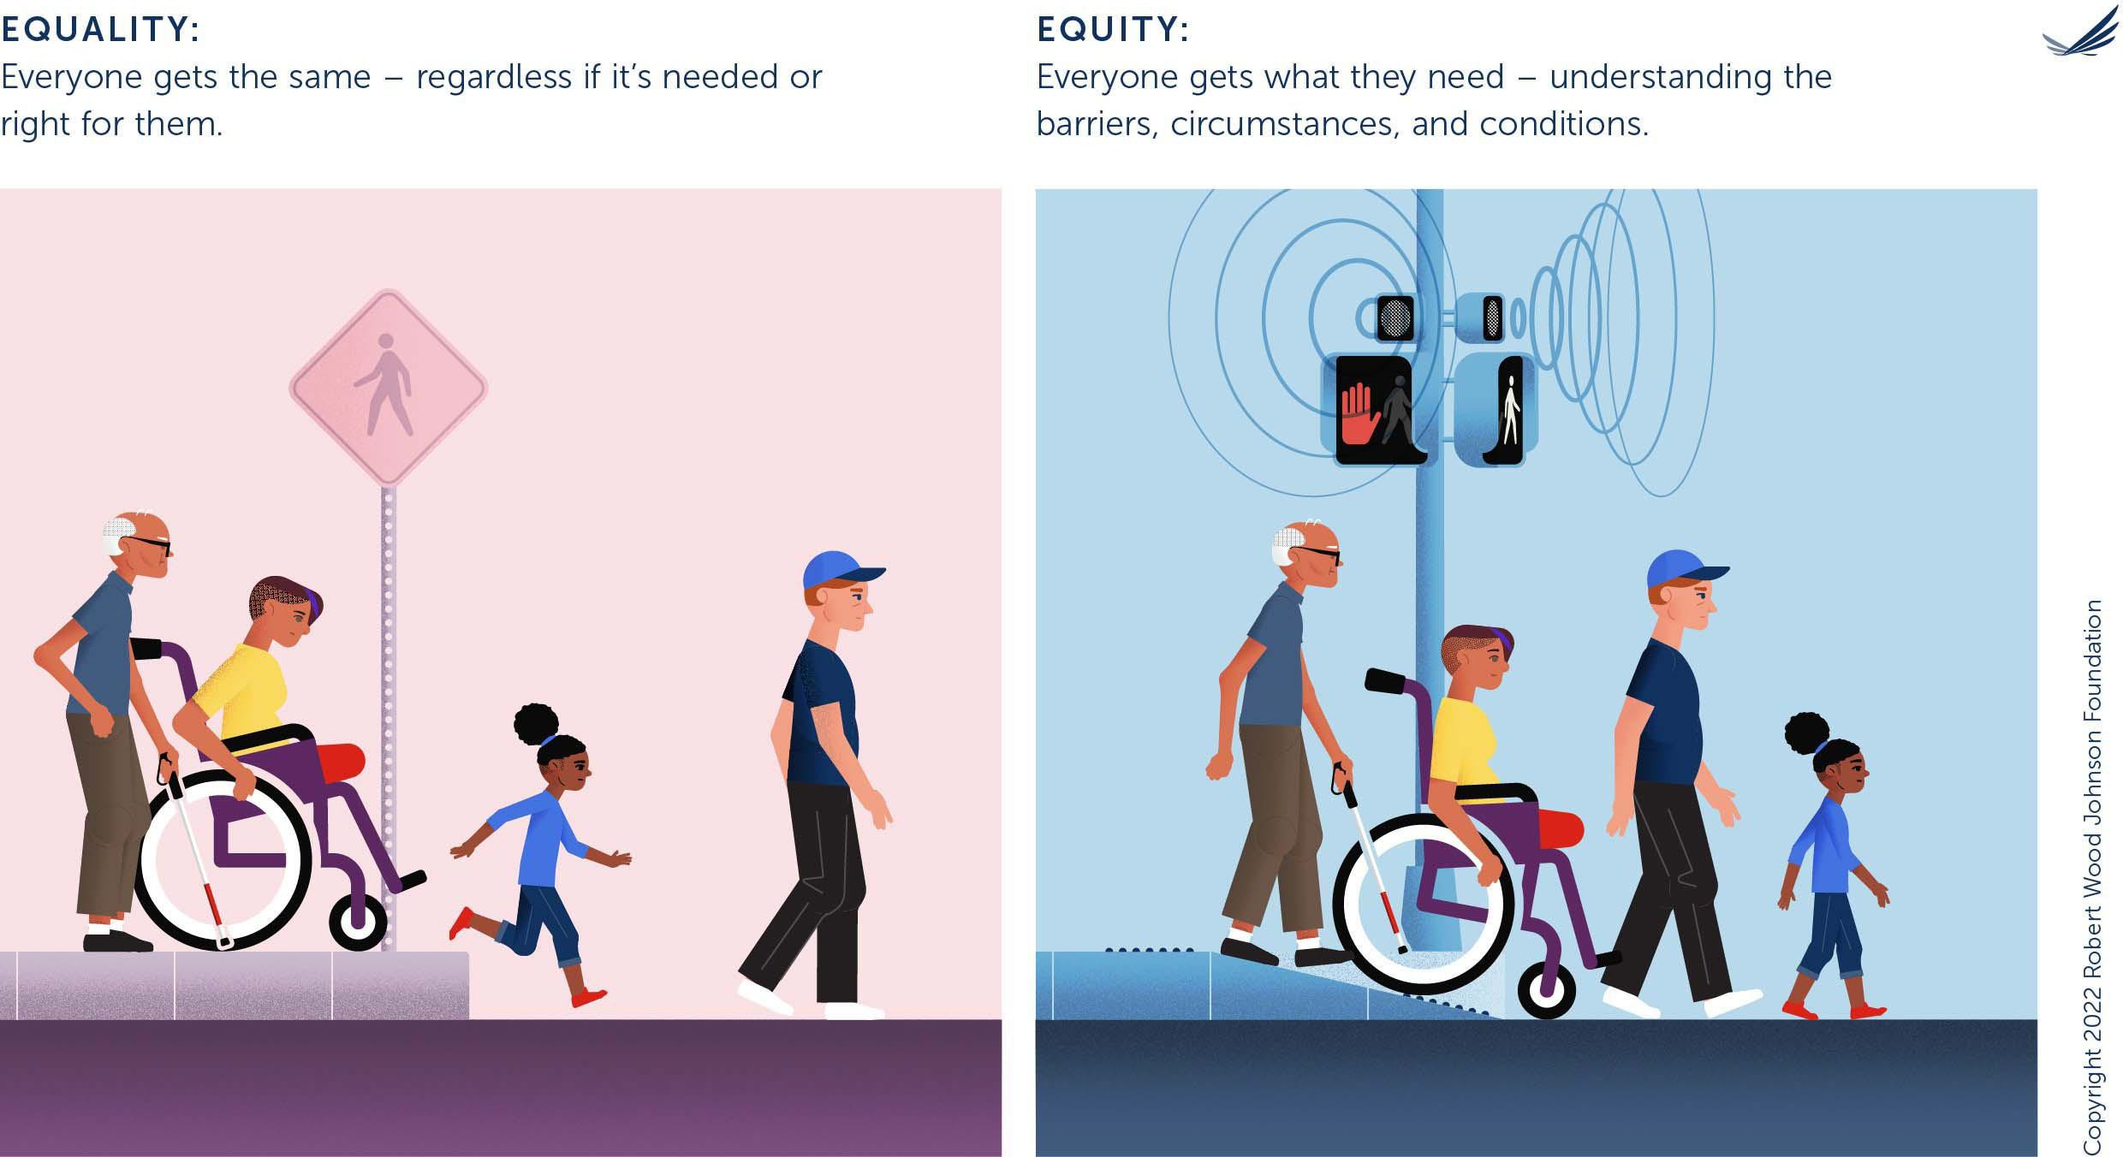

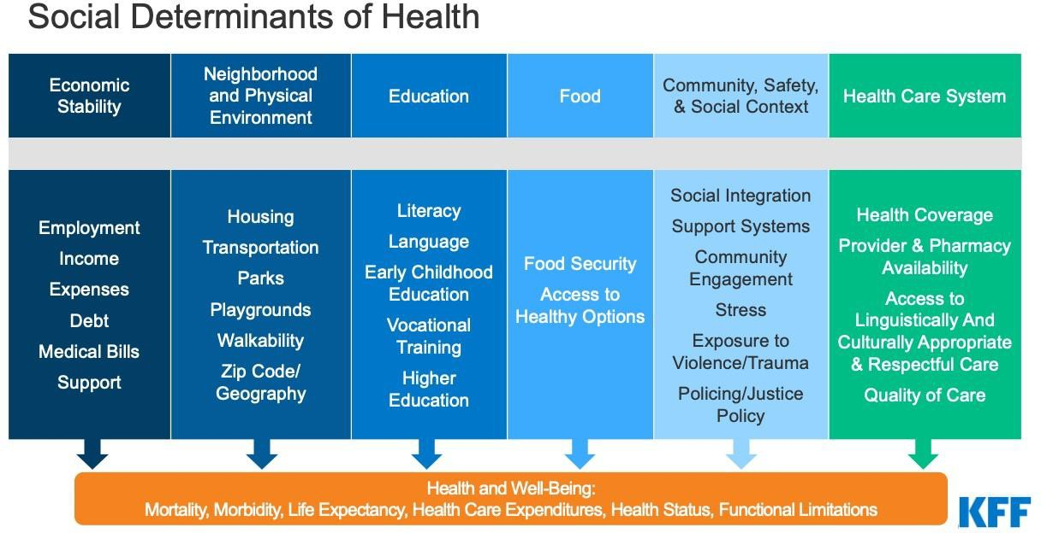

Source: Kaiser Family Foundation


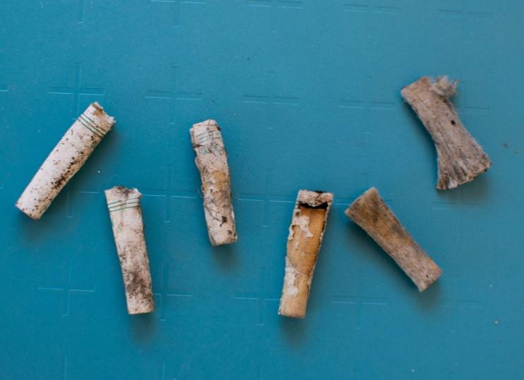
CIGARETTE BUTTS HAZARDOUS WASTE
Throwaway Culture
- Most commonly littered item
Cellulose Acetate
- Non-biodegradable; creates
microplastic
Toxic Chemicals & Metals
- Nicotine, lead, arsenic, etc.




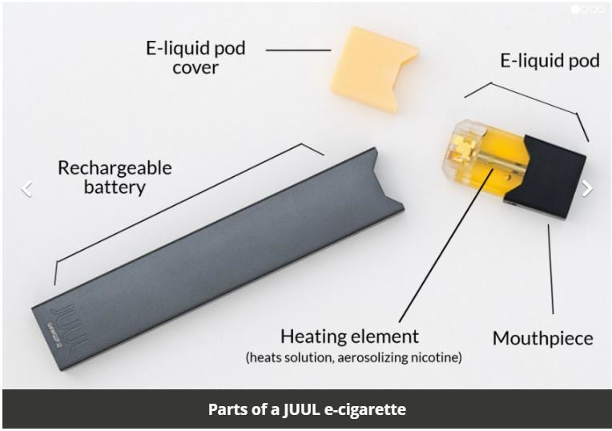
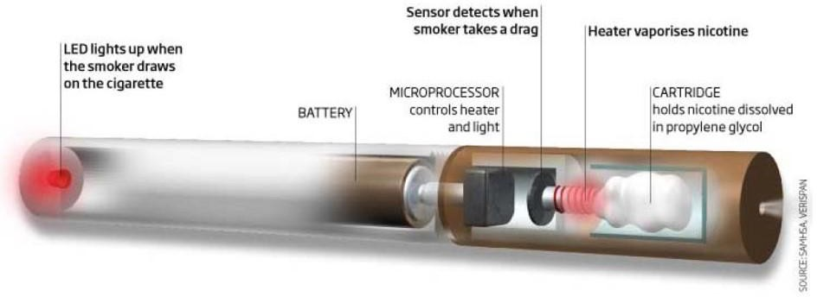
E-CIGARETTE/VAPES HAZARDOUS WASTE
Nicotine and nicotine salts
- Classified as an acute hazardous waste
Batteries
- Hazardous waste; fire/explosion risk
Metals
- Leach into ground and water


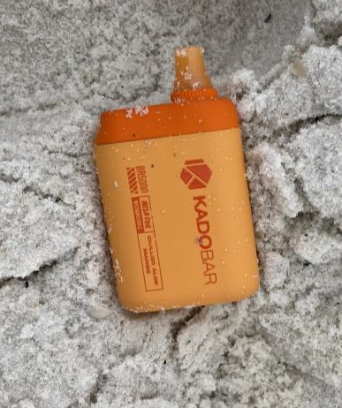

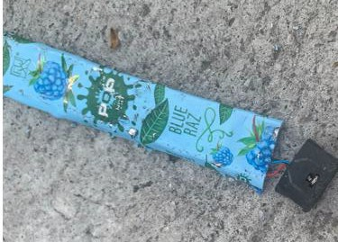

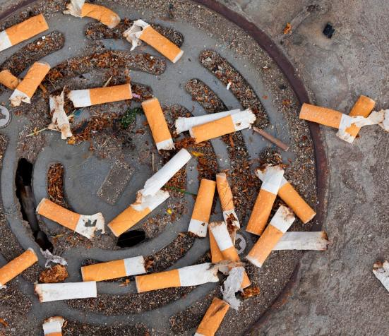

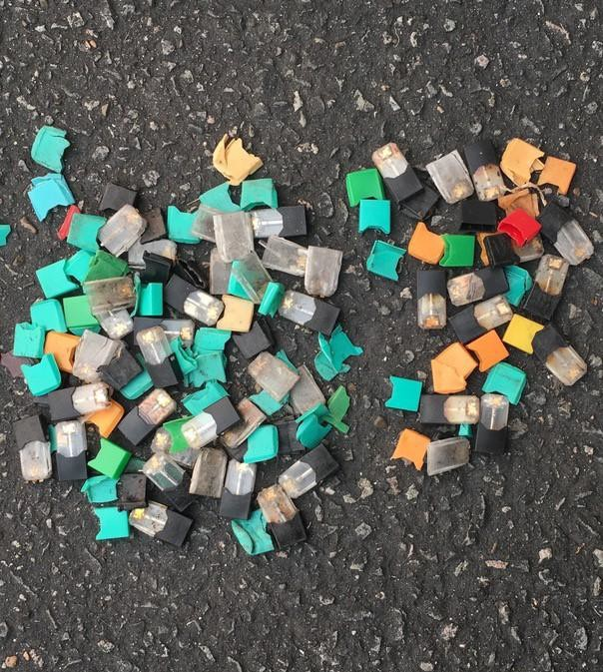
TPW: A KEY ISSUE
- Cessation – environment
> health

- Schools – dangerous and pervasive
- End game strategies
- Environmental Impact

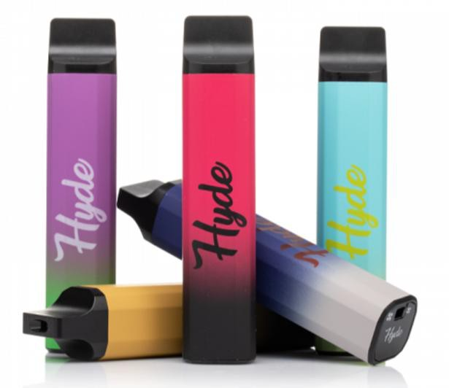
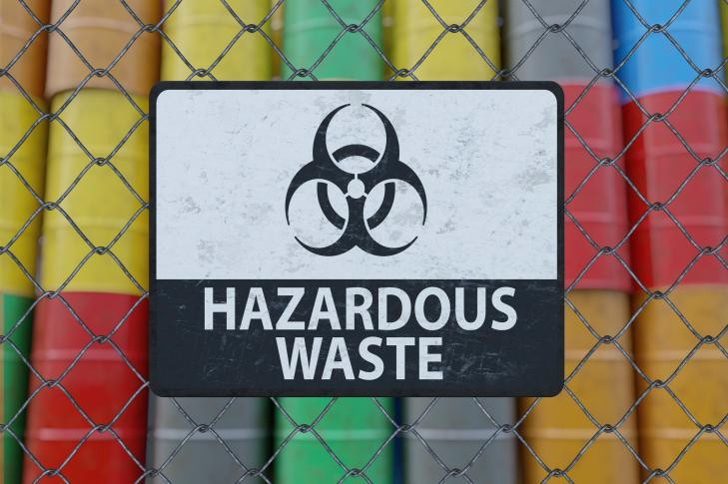
ADDRESSING TOBACCO PRODUCT WASTE

Whose responsibility?
  - Manufacturers?
  - Governments?
  - Schools?
  - Waste Facilities?

POLICY OPTIONS

Upstream: Politically difficult, but most efficient and equitable

Midstream: varying degrees of feasibility and effectiveness, require significant investment

Downstream: Politically feasible, but on their own least effective or equitable

UPSTREAM SOLUTIONS
SINGLE USE BANS AND SALES RESTRICTIONS
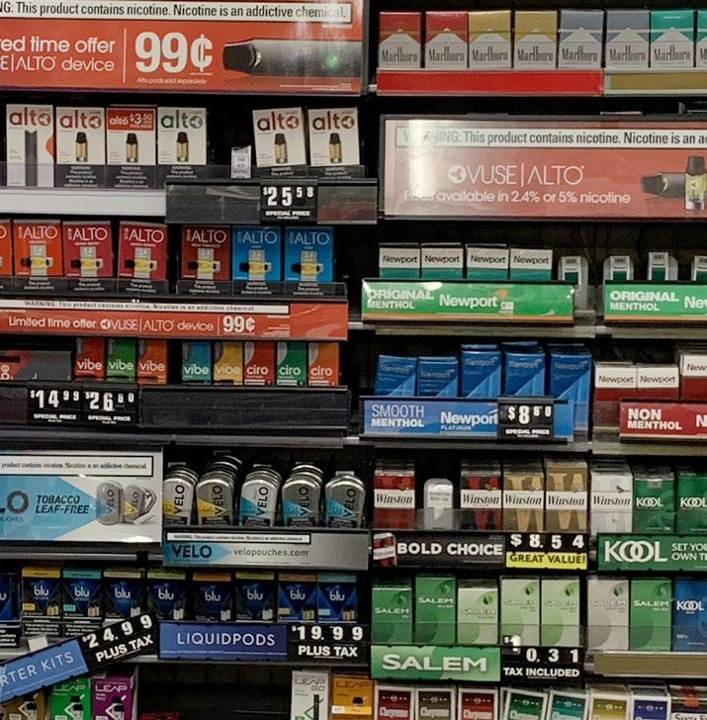


- Single-use tobacco product bans
  - CA localities ban sale of e-cigarettes
  - Ban on sale of partially inconsumable cigarettes
  - State level attempts
- CA localities ban the sale of all tobacco products
- Flavored tobacco product sales bans (California and
Massachussetts)
- Flavored e-cigarette sales bans (Massachusetts, NY, Maryland, Rhode Island, Utah)
- Nicotine Free Generation (Brookline)

MIDSTREAM SOLUTIONS
FACILITATING/FUNDING COLLECTION AND DISPOSAL
- Collaborative waste management – local governments, waste facilities, environmental departments, public health.
- Extended producer Responsibility:
- EPR laws should put the onus back on the manufacturer the end of life of the product – fronting the cost of disposal
- EPR legislation needs to be fully comprehensive - No industry self-reporting
- Beware of greenwashing

DOWNSTREAM SOLUTIONS
COLLECTION AND DISPOSAL PROGRAMS

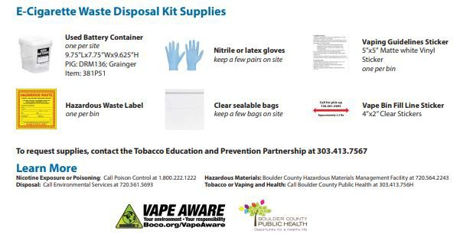
Downstream solutions mitigate, manage, or propose ways to clean up TPW after it has been created:

Credit: Boulder County, CO, Electronic Device Disposal Guide for Schools
  - Cleanups
  - Recycling
  - Penalties for littering
  - Vape disposal boxes
  - Contracting with hazardous waste companies for proper disposal

DOWNSTREAM SOLUTIONS
COLLECTION AND DISPOSAL PROGRAMS

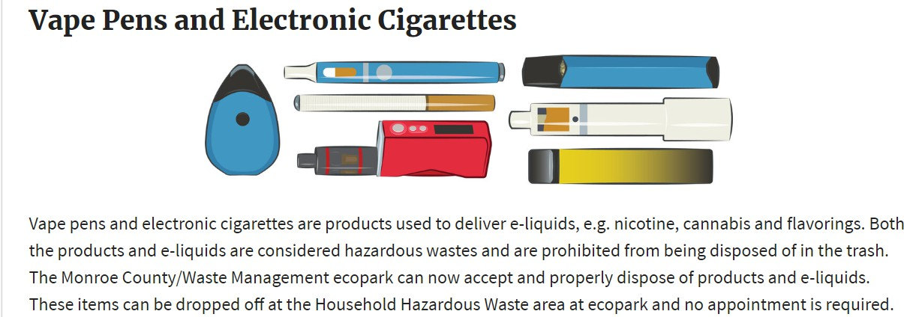
Credit: Monroe County, NY, Monroe County, NY - ecopark - Electronics/Cell Phone Recycling
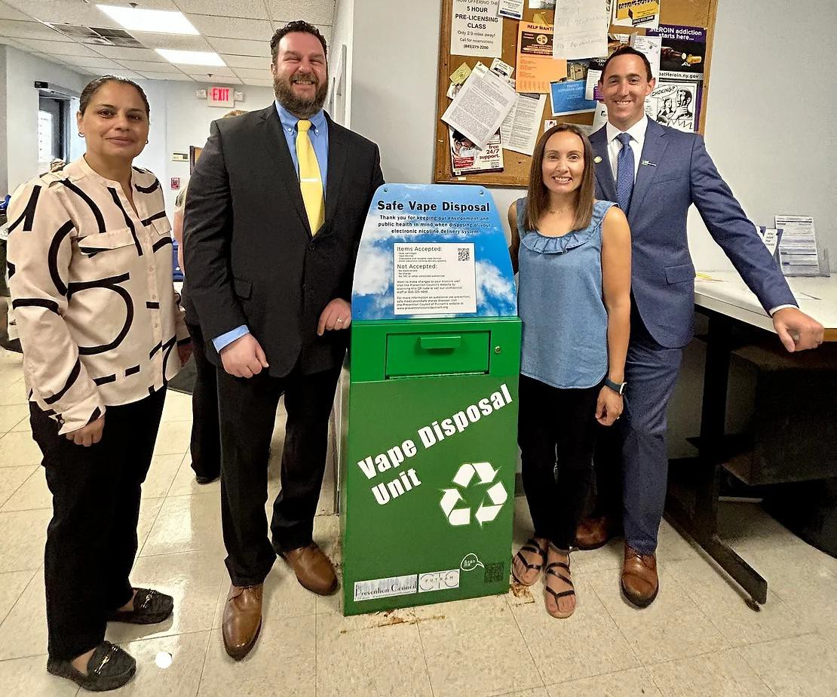
Putnam Press Times, Prevention Council, Prevention Council Launches Safe Vape Disposal Boxes (putnampresstimes.com)

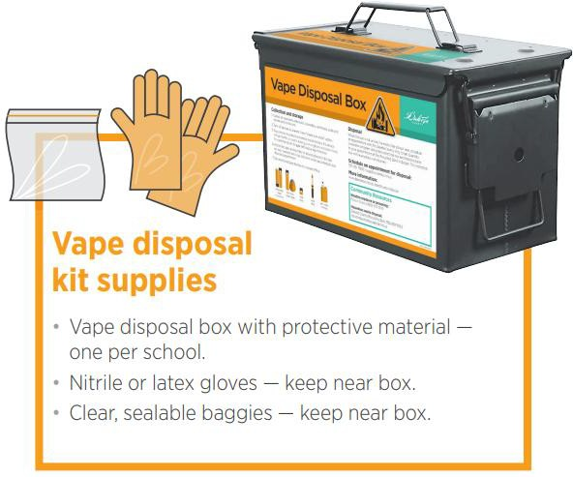

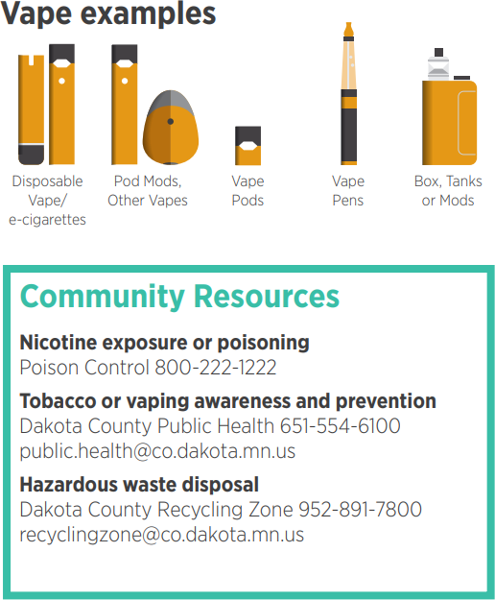
DOWNSTREAM SOLUTIONS
Dakota County, Minnesota
COLLECTION AND DISPOSAL PROGRAMS

STATE AND LOCAL OPTIONS

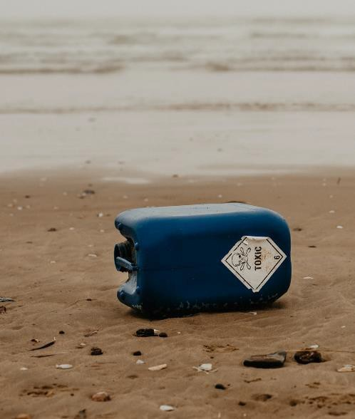

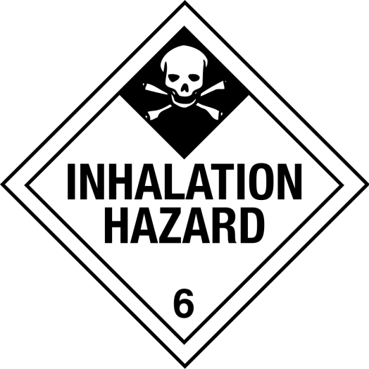
TO PREVENT HAZARDOUS WASTE DANGERS
- Jurisdictions may be able to go further to prevent
dangers
- Treat nicotine-containing consumer products as hazmat
– Leading to compliance costs and public awareness
about the real dangers of the products
- Hazardous materials sites maps for environmental emergencies/useful for fire officials

LITIGATION

  - TPW specific: Baltimore v. Philip Morris USA, Inc. et. al. – lawsuit targeting cigarette butt litter

  - E-Cigarette specific:
    - multi-state Juul settlements
    - state and city governments suing other vape manufacturers, distributors, and retailers over tobacco control violations

  - FDA authorized vape manufacturers suing unauthorized competitors

ENVIRONMENTAL JUSTICE
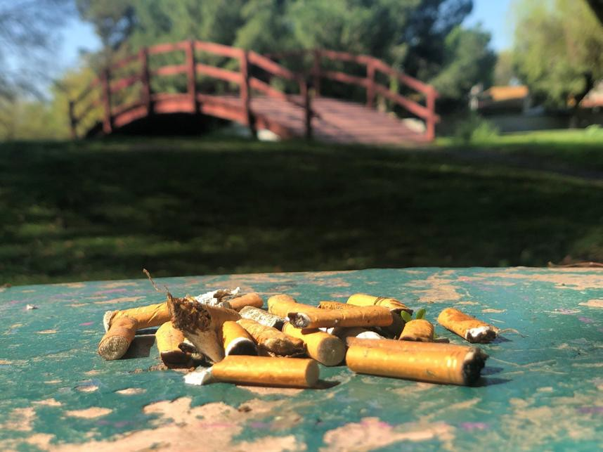
    - No environmetally neutral way to dispose of TPW

    - Disproportionate impact

    - 79% of municipal waste incinerators located near historically marginalized communities

    - Environmental impact assessments

TOBACCO PRODUCT WASTE MATERIALS
- PHLC Tobacco Product Waste Policy Toolkit and overview FAQ
- PHLC webinar Tobacco Product Waste: A Toxic Challenge
- Truth Initiative Report
- PIRG report on Vape Waste
- Tobacco Product Waste White Paper
- Boulder County Vape Aware Toolkit
- FDA best practices and guidance document for schools
- Utah schools guidance document and e-cigarette disposal for retailers pamphlet
- Tobacco Free Colorado-specific guidance

CONTACT US
651.290.7506

publichealthlawcenter@mitchellhamline.edu www.publichealthlawcenter.org

 facebook.com/publichealthlawcenter  @publichealthlawcenter
https://www.linkedin.com/company/public-health-
law-center-inc


�

MAURA T. HEALEY
GOVERNOR

KIMBERLEY DRISCOLL
LIEUTENANT GOVERNOR

SUSAN W. TERREY
INTERIM SECRETARY
The Commonwealth of Massachusetts Department of State Police
Office of the Superintendent 470 Worcester Road
Framingham, MA 01702
Telephone (508) 820-2350
October 6, 2025
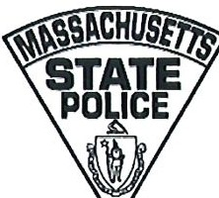

GEOFFREY D. NOBLE
COLONEL/SUPERINTENDENT

MARKO.CYR
DEPUTY SUPERINTENDENT

Commissioner Geoffrey E. Snyder Department of Revenue
100 Cambridge Street
P.O. Box 9550
Boston, MA 02114

Dear Commissioner Snyder,
Pursuant to the authority granted to the Colonel of the Massachusetts State Police under Section 40(a) of Chapter 64C of M.G.L., Multi-Agency Illegal Tobacco Task Force, it is my pleasure to designate Captain Stephen C. McDonald to serve on the Illegal Tobacco Task Force as my designee. Captain McDonald is replacing Major Jay Farley.

Captain McDonald can be contacted at stephen.c.mcdonald@pol.state.ma.us. Thank you. If you have any questions, please do not hesitate to contact me.

Respectfully,

CoIoneI Geoffrey D. Noble Superintendent Massachusetts State Police
cc: John H. Hayes, Director of the Criminal Investigations Bureau, DOR Captain Stephen C. McDonald, DIS

