MDPH Immunization Division Newsletter

Volume II, 2019/20 Fall/Winter

Inside this issue:

1
New Requirements and Recommendations
2
Vaccine Management
Updates

NEW REQUIREMENTS AND
RECOMMENDATIONS

New Meningococcal Vaccine
School Requirement

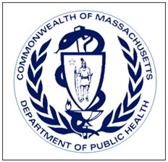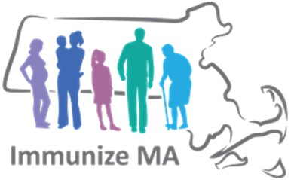
3
MIAP Conference

4
Immunization Bits
& Pieces

5
Important Upcoming Dates
In keeping with federal Advisory Committee on Immunization Practices (ACIP) routine recommendations, at
the start of the 2020-21 school year, students entering Grades 7 and 11 will be required to show evidence meningococcal conjugate vaccine protection against meningococcal strains A, C, W, and Y (MenACWY)
unless a religious or medical exemption applies.

Massachusetts has achieved high immunization rates with the first dose of MenACWY vaccine (over 90%), but rates for the booster dose both nationally and locally lag below 55%.

Please help ensure that you are vaccinating your adolescent patients according to ACIP recommendations so that they meet MA school immunization requirements.
The school immunization record will
need to demonstrate the following:

- Grade 7 entry: 1 dose of MenACWY for all students
- Grade 11 entry: 1 booster dose
of Men ACWY received on or after 16 years of age. (One or more doses of Men ACWY vaccine are acceptable as long as one dose was received on or after 16 years of age.)

Pneumococcal

The ACIP recently updated its pneumococcal vaccine recommendations for adults aged 65+. Read the MMWR article at:
www.cdc.gov/mmwr/volumes/68/wr/mm6846a5.htm

Fall/Winter 2019/20
Page 2

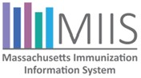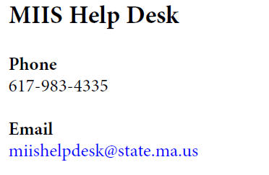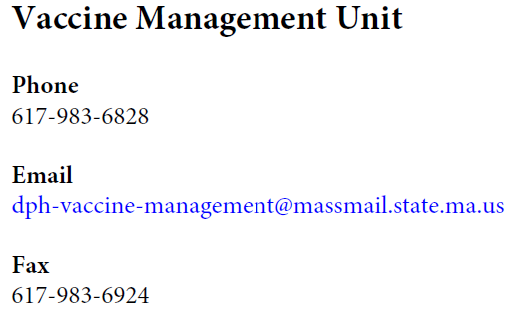

VACCINE MANAGEMENT UPDATES

FLU VACCINE

The 2019-2020 state-supplied flu vaccine is available for order.
If you have exceeded your flu vaccine ceiling limit and need more state-supplied flu vaccine, please call the Vaccine Unit.

IMPORTANT NOTE, REGARDING RE-ENROLLMENT

  - All sites receiving state-supplied vaccines are required to re-enroll annually
  - Please see our recent email announcing the beginning of re-enrollment o Re-enrollment must be complete by January 31, 2020
    - Sites must re-enroll directly through the MIIS
    - Sites that don't re-enroll by the deadline will not be able to order state-supplied vaccines

FOR MORE INFORMATION...

Resource Center
https://www.contactmiis.info/

Fall/Winter 2019/20
Page 3

24th ANNUAL MIAP PEDIATRIC IMMUNIZATION SKILLS-BUILDING CONFERENCE
Our 2019 edition took place on October 17 at the Sheraton Framingham Hotel & Conference Center, attracting 364 health care providers and advocates.

Plenary speakers included Dr. Ron Samuels and JoEllen Wolicki, RN

JoEllen Wolicki, Nurse Educator at CDC, provided a National Immunization Update.

Dr. Samuels presented, Now What? Resolving Challenging Immunization Scenarios. He is the Associate Director of the Primary Care Center, Boston Children's Hospital

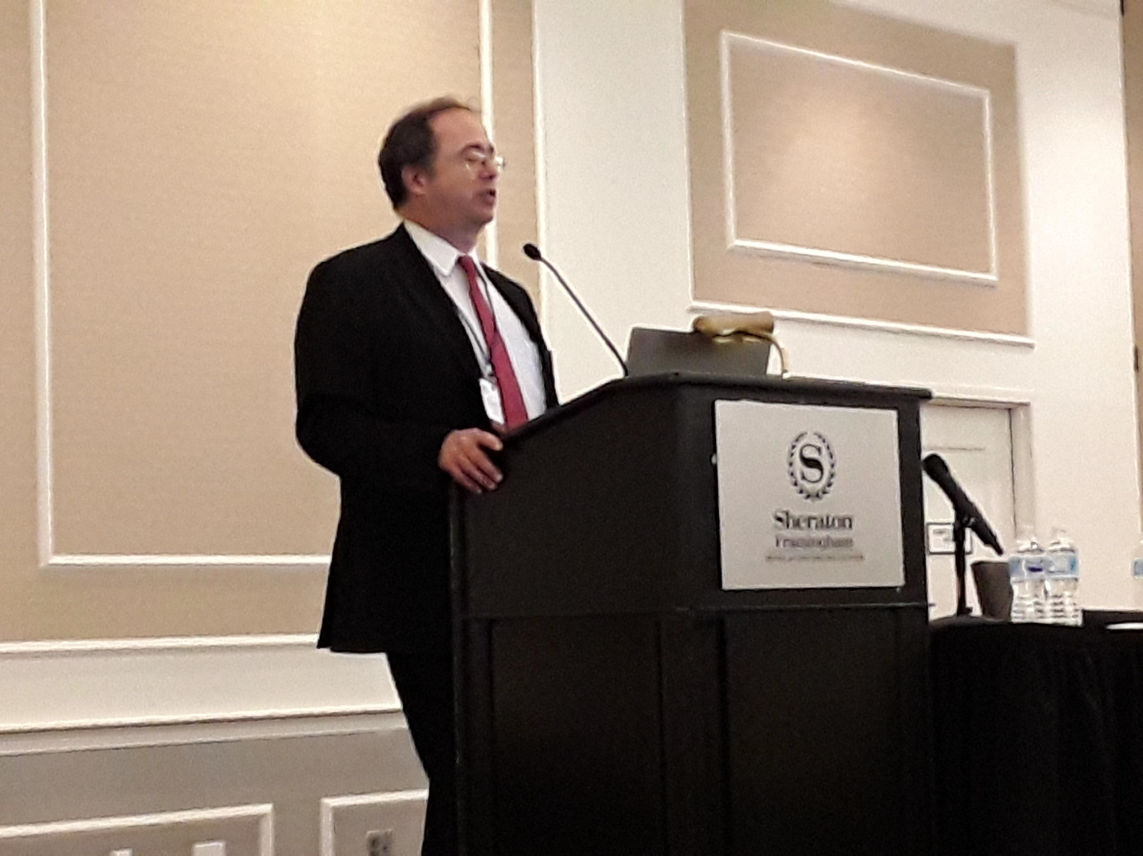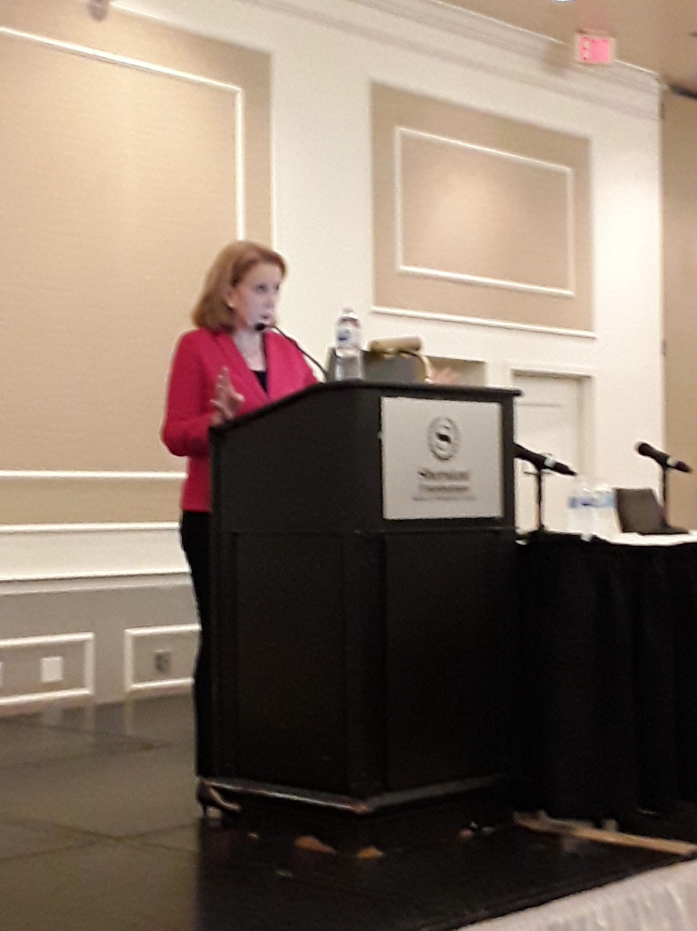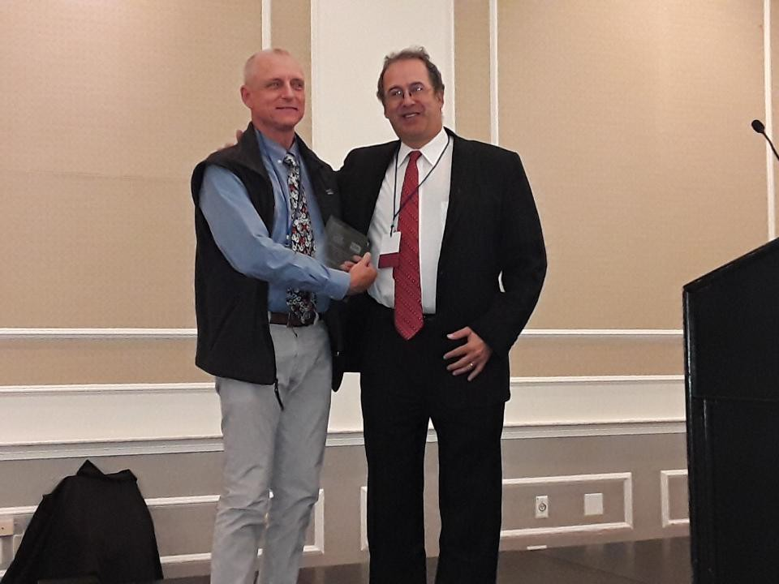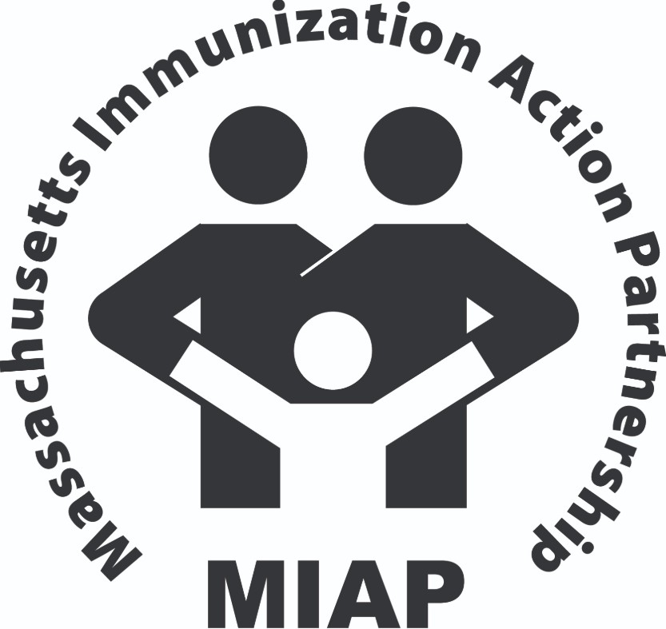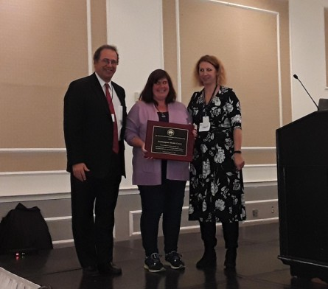In addition to the Plenary Sessions and State Immunization Update, MIAP
featured Breakout Sessions on:
- Vaccine Storage and Handling
& and VFC Compliance Training
- Intro to MIIS
- MIIS Reports and More
- Vaccine "101"
- VPD Epidemiology
- Pediatric Immunization Challenges in Immigrant/ Refugee Populations

We are in debt to our presenters: Joyce Cohen, Brendan Gallaher, Hillary Johnson, Julia Monturo Larson, Dr. Susan Lett, Béatrice Martin, Katie Reilly, Shumethia Seal, Pejman Talebian, and Sergut Wolde-Yohannes.

MIAP Conference Awards
MIAP honored the team at Easthampton Health Center for assessing vaccine coverage rates and implementing innovative strategies, which resulted in improved patient care and improved immunization rates.
David Norton, MD, FAAP, of Holyoke Pediatric Associates, was the 2019 Massachusetts recipient of the CDC’s Childhood Immunization Champion Award.

Deb Clark, LPN, of Easthampton Health Center (below, center), with Dr. Samuels and Sharon Leary, RN, of MDPH

Dr. Norton (above, left),
with Dr. Samuels

Fall/Winter 2019/20
Page 4

IMMUNIZATION BITS AND PIECES

HEPATITIS B BIRTH DOSE HONOR ROLL

The Immunization Action Coalition (IAC) recently recognized Lawrence General Hospital’s on the Hepatitis B Birth Dose Honor Roll. LGH reported a coverage rate of 97% for 2014 and 98% for 2019*.

Lawrence General was one of 13 hospitals in the Commonwealth awarded this honor in 2019, and one of only six honored nationally that achieved this mark over the last two years:

  - Community Hospital South, Indianapolis, IN (100%)
  - Franciscan Health Michigan City, Michigan City, IN (95%)
  - Good Samaritan Hospital, Vincennes, IN (96%)
  - Indiana University Health North Hospital, Carmel, IN (90%)

Lawrence General Hospital, Lawrence, MA (98%)
- St. Vincent Dunn Hospital, Bedford, IN (98%)
- The Women's Hospital, Newburgh, IN (95%)

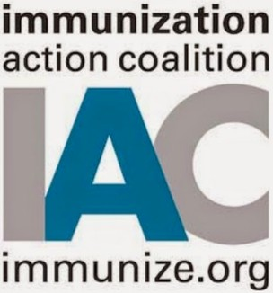Learn more about the IAC Hepatitis B Birth Dose Honor Roll:
https://www.immunize.org/honor-roll/birthdose/honorees.asp#ma

*From 12/1/2018 to 11/30/2019

KEEPING IN TOUCH

Chances are you're on our email list if you receive this Newsletter, but please forward this link <https://lp.constantcontact.com/su/mKGJjUc/imm> to friends and colleagues who may benefit from receiving the Immunization Division updates we send via Constant Contact.

The link below also directs to the email sign-up, in case you see it in
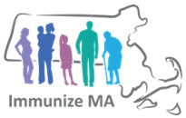MDPH email signatures.

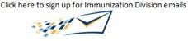

Follow MDPH on Twitter
https://twitter.com/MassDPH?ref_src=twsrc%5Egoogle%7Ctwcamp%5Eserp%7Ctwgr%5Eauthor

Fall/Winter 2019/20

WHAT'S ON TAP
Page 5

THANK YOU!
A huge and sincere Thank You to all who volunteered at the MIAP Conference in October, without whom it would not have been possible.

The Immunization Division will again provide training sessions in the spring
across the Commonweath and via webinar on:
- MIIS
- VFC Compliance/Vaccine Storage and Handling
- Immunization Schedules
- VPD Epidemiology
- Vaccine Confidence

If you need the VFC Certificate*, or just want to brush up on your skills, please join us at one of our in-person sessions, in Boston, Fall River, Haverhill, Holyoke, Pittsfield, West Barnstable, or Worcester. We'll announce the dates soon, and registration will open in March.

*For those Vaccine Coordinators whose certificates expire before the spring, you may earn your certificate via webinar. Click on the link for more information:
https://www.mass.gov/service-details/immunization-division-events

Massachusetts Department of Public Health Immunization Division

305 South Street
Jamaica Plain, MA 02130

Phone: 617-983-6800
Fax: 617-983-6840
Vaccine Unit: 617-983-6828 MIIS Help Desk:
617-983-4335

www.mass.gov/dph/imm

SAVE THE DATES

25th Annual MAIC! Massachusetts Adult Immunization Conference
Tuesday, April 14, 2020
Sheraton Framingham Hotel & Conference Center https://maic.jsi.com/

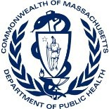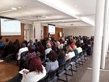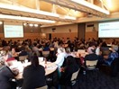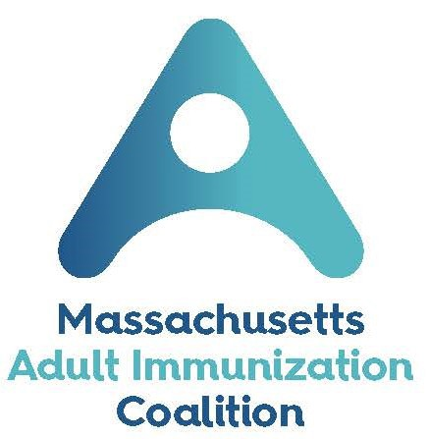

25th Annual MIAP Pediatric Immunization
Skills-Building Conference
October, 2020 (date TBA)
Updates will be posted as they become available at:
https://mcaap.org/immunization-initiative/immunization-cme/

