|  |  |
| --- | --- |
|  |  |
|  |  |

# MDPH Immunization

Divison Newsletter

#### Inside this issue:

**1**

Vaccine Management Updates

**Volume I, 2019 Spring/Summer**

**VACCINE MANAGEMENT UPDATES**

#### Hepatitis B Vaccine Shortage

2

Measles Outbreak

**3**

MAIC Conference

**4**

School Immunization Survey

5

Immunization Updates and VCP

Save the dates!

The national shortage of single- component pediatric hepatitis B (Hep B), vaccine is expected to continue through the end of 2019. Beginning October, 2018, the MDPH Immunization Division reduced all orders (except those from birth facilities) of single-component

pediatric hepatitis B vaccine by 25%. Please visit [https://www.mass.gov/clinical-](http://www.mass.gov/clinical-) advisory/pediatric-hepatitis-b-vaccine- [shortage-advisory-october-1-2018](https://www.mass.gov/clinical-advisory/pediatric-hepatitis-b-vaccine-shortage-advisory-october-1-2018)

to [access the Hepatitis B Advisory.](https://www.mass.gov/clinical-advisory/pediatric-hepatitis-b-vaccine-shortage-advisory-october-1-2018)

#### Vaccine Packaging

Packaging for pre-filled syringes is much larger than vials and can take up more space in your storage unit. As packaging for vaccines changes from single dose vials to pre-filled syringes, please consider your storage unit capacity when ordering vaccines.

#### State-Supplied Data Loggers

State-supplied data loggers have been replaced as of March, 2019.

#### Meningitis B

As outlined in the MDPH Childhood Vaccine Availability Table on the Vaccine Management page, (https:// [www.mass.gov/service-details/](http://www.mass.gov/service-details/) vaccine-management) MDPH supplies meningitis B vaccine to

high-risk children, 10-18 years of age, regardless of insurance status, and healthy children, 16-18 years of age, who are VFC-eligible. Full and part-time students, 18 and under, that attend one of the schools in the Five College Consortium are no longer considered high risk.

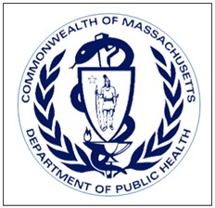

If you have any questions about vaccine supply, or storage or handling, please contact the Vaccine Unit at 617-983-6828.

**Volume I, 2019**

## MEASLES OUTBREAK 2019

**Page 2**

### MAKE SURE YOUR PATIENTS AND [STAFF ARE](http://www.mass.gov/flu) UP-TO-DATE!

From January 1 to June 6, 2019, 1,022*

individual cases of measles have been confirmed in 28 states, including [Massachusetts](https://www.mass.gov/service-details/school-immunizations)**. This is the greatest number of cases r[eported in the](https://www.mass.gov/info-details/highlights-for-the-2018-2019-flu-season)

U.S. since 1992, and since measles was eliminated in 2000. It already far exceeds the total number of cases reported nationally for all of 2018 (372 cases). The U.S. outbreak is taking [place in the context of a](https://www.mass.gov/service-details/flu-information-for-healthcare-and-public-health-professionals) large international [outbreak of measles.](https://www.mass.gov/service-details/flu-information-for-healthcare-and-public-health-professionals) According to the World Health Organization, there has been a 300% increase in measles this year compared to last year.

*\**

The states that have reported cases to CDC are

Arizona, California, Colorado, Connecticut, Florida, Georgia, Idaho, Illinois, Indiana, Iowa, Kentucky, Maine, Maryland, Massachusetts (two confirmed cases as of 6/6/2019), Michigan, Missouri, Nevada, New Hampshire, New Jersey, New Mexico, New York, [Oklahoma, Oregon, Pennsylvania, Texas, Tennessee, Virginia, and Washington. Source: https://www.cdc.gov/measles/cases-](https://www.cdc.gov/measles/cases-outbreaks.html) outbreaks.html

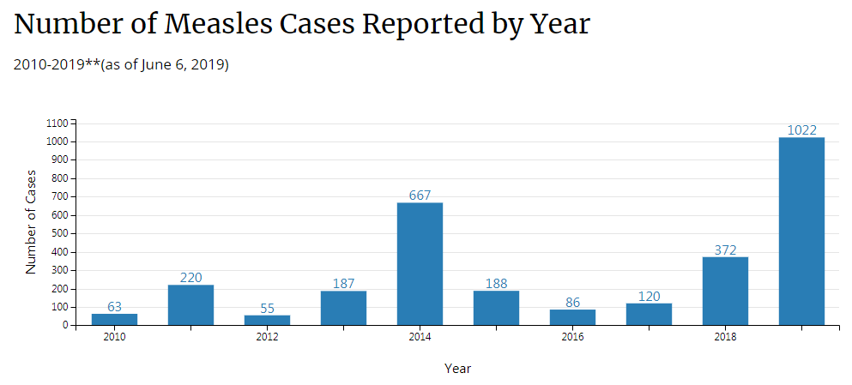

*Cases as of June 6, 2019. Case count is preliminary and subject to change.

**MA cases as of June 6, 2019. Case count is preliminary and subject to change.

What can providers do? Make sure that all of your eligible patients, and all of your staff, are up-to- date with MMR vaccine. This includes MMR vaccination prior to travel for children 6 to 11 months of age.

For more information about who should receive MMR, go to CDC’s *Measles Mumps and Rubella Vaccination: What Everyone Should Know* web page - [https://www.cdc.gov/vaccines/vpd/mmr/](https://www.cdc.gov/vaccines/vpd/mmr/public/index.html) public/index.html. For the most recent MDPH clinical guidance see the Clinical Measles Alert

from April 17, 2019. An updated measles fact sheet is available at [https://www.mass.gov/service-](http://www.mass.gov/service-) details/measles. For questions please call the Division of Immunization at 617-983-6800.

#### Maintaining high [coverage with MMR](https://www.mass.gov/clinical-advisory/pediatric-hepatitis-b-vaccine-shortage-advisory-october-1-2018) vaccination remains the most effective way to prevent outbreaks and limit them if they occur.

**Volume I, 2019**

**Page 3**

## TWENTY-FOURTH ANNUAL MASSACHUSETTS ADULT IMMUNIZATION CONFERENCE

The 2019 MAIC Conference took place on April 2 at the Sheraton Framingham Hotel & Conference Center, [attracting 331 healthcare](https://www.contactmiis.info/FileSystem/Draft/MIIS%20v18.1%20Release%20Notes.pdf) providers and advocates.

*Dr. David Kim explores the new Adult Immunization Schedule.*

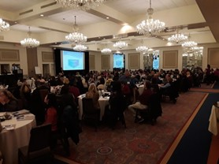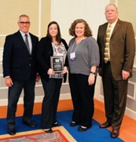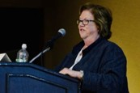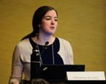

#### Afternoon Sessions

The four breakout sessions included [presentations on the Epidemiology of](https://www.mass.gov/lists/massachusetts-department-of-public-health-immunization-program-advisories-and-alerts) Vaccine-Preventable Diseases (presented by Lindsay Bouton and Nancy Harrington), Intro to MIIS (Christine Bradley), Adult Immunization 101 (Katie Reilly), and Refugee Health Care on the Continuum (Sergut Wolde-Yohannes and Zakaria Ahmed-Gas).

*Nancy Harrington Christine Bradley*

*Dr. Elisa Choi discusses how improving immunization coverage can reduce health disparities.*

The 2019 Massachusetts Adult Immunization Champion Award went to Brianna Messina, LPN, RN, for her collaboration and leadership in responding to the [hepatitis A outbreak in the Essex](https://www.mass.gov/lists/massachusetts-department-of-public-health-immunization-program-advisories-and-alerts) County House of Corrections.

*Ms. Messina (second from left), flanked by her colleagues Mark Cassolla (far left), and William Gerke (at right), receives the award from Katie Reilly.*

## SCHOOL IMMUNIZATION SURVEY



The analysis of the School Immunization Survey 2018-19 is now complete!

The summary documents, including immunization coverage and exemption rates by school, will be posted on our Immunization Division website ([https://www.mass.gov/service-details/](http://www.mass.gov/service-details/) school-immunizations).

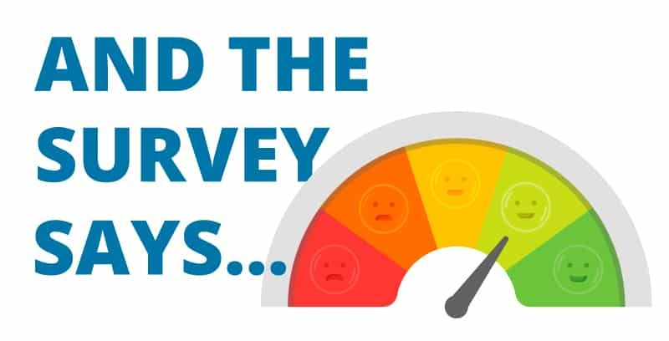

Overall, we see similar patterns this year as in previous years, namely that taken as a whole, Massachusetts enjoys high immunization coverage rates and low exemption rates.

Having a population nearly completely immunized against measles is the best prevention against the highly infectious measles virus. Of note, not all regions of the state have uniform immunization patterns. We observe higher exemption rates in western Mass., and the Cape and Islands, and, by association, higher rates of unimmunized children in the same regions.

We are working actively in communities across the state to increase compliance with the school vaccine requirements and participation in the School Immunization Survey. This fall, we’ll roll out an entirely new school module in the MIIS, which will

support school nurse data entry for the survey every year.

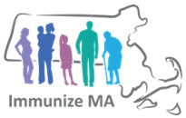

## IMMUNIZATION UPDATES

**Page 5**

**THANK YOU!**

A huge and sincere Thank You to all the presenters and volunteers without whom the MAIC Conference and Immunization Updates

would not have been possible.

The Immunization Division provided seven in-person training sessions across the Commonweath, on the topics of MIIS, Vaccine Storage and Handling, the new Immunization [Schedules, and Epidemiology of](https://mcaap.org/immunization-cme/) VPDs. A total of 524 people attended the sessions. Webinars take place in June.

In addition to the venues noted, we visited West Barnstable,

Do you know someone interested in receiving this

***Holyoke Pittsfield Fall River Haverhill***

Worcester, and the State Lab.

newsletter?

Please email [ashley.romero@state.ma.us](mailto:ashley.romero@state.ma.us) for additions to the distribution list.

**VACCINE CONFIDENCE PROJECT (VCP)**

Following the Holyoke and Pittsfield sessions, we convened a VCP meeting with providers. After Ashley Romero's recap of the Project, Dr. Lett gave an overview of resources for providers and their patients. We then opened to floor to discussion on common barriers to vaccination and potential solutions. Keep an eye out for updates on the VCP as we move forward.

**Massachusetts Department of Public Health Immunization Division**

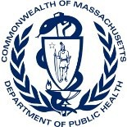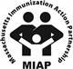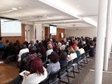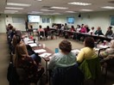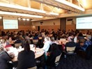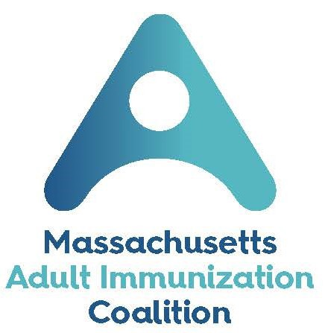

**305 South Street**

**Jamaica Plain, MA 02130**

[**Phone: 617-983-6800**](http://www.mass.gov/dph/imm)

**Fax: 617-983-6840**

**Vaccine Unit:**

**617-983-6828 MIIS Help**

**Desk: 617-983-4335**

[www.mass.gov/dph/imm](http://www.mass.gov/dph/imm)

## SAVE THE DATES!

### 24th Annual MIAP Pediatric Immunization

**Skills Building Conference**

Thursday, October 17, 2019

Sheraton Framingham Hotel & Conference Center https:// mcaap.org/immunization-initiative/immunization-cme/

### 2[5th Annual!](https://maic.jsi.com/) Massachusetts Adult Immunization Conference

Tuesday, April 14, 2020

Sheraton Framingham Hotel & Conference Center https:// maic.jsi.com/