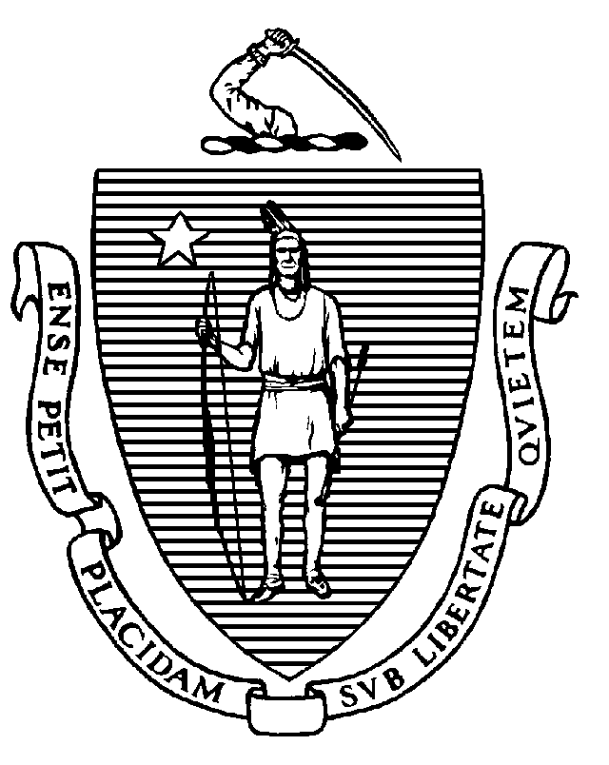
Executive Office of Health and Human Services
Department of Public Health
Bureau of Health Care Safety and Quality
67 Forest Street, Marlborough, MA 01752
CHARLES D. BAKER
Governor
KARYN E. POLITO
Lieutenant Governor
MARYLOU SUDDERS
Secretary
MARGRET R. COOKE
Acting Commissioner

Tel: 617-624-6000
www.mass.gov/dph

Memorandum

TO: Licensed Out-of-Hospital Dialysis Units

FROM: Elizabeth D. Kelley, MPH, MBA, Director
Bureau of Health Care Safety and Quality

SUBJECT: Implementation of Order of the Commissioner of Public Health Regarding Staffing at Out-of-Hospital Dialysis Units

DATE: January 31, 2022

The Massachusetts Department of Public Health (Department) continues to work with state, federal, and local partners on the outbreak of Coronavirus Disease 2019 (COVID-19), caused by the virus SARS-CoV-2, and we continue to appreciate the essential role you have in responding to this evolving situation.

This memorandum is to provide guidance to licensed out-of-hospital dialysis units on the implementation of the Order of the Commissioner of Public Health, issued on January 14, 2022, regarding staffing at out-of-hospital dialysis units.

The statutory requirement for an out-of-hospital dialysis unit to have at least one direct patient care staff member to every three patients undergoing dialysis is waived, provided that the out-of-hospital dialysis unit otherwise ensures that sufficient direct care staff, who are trained in dialysis care, are available to meet the needs of patients undergoing dialysis.

“Direct Care Staff” means registered nurses, licensed practical nurses, and trained dialysis technicians who provide direct care to patients undergoing dialysis in the unit. Direct care staff may include charge nurses, but does not include the nurse manager, nurses assigned to dialysis training, or technicians assigned to dialyzer preparation or reuse, equipment maintenance, and water testing and purification.

All other statutory and regulatory staffing requirements remain in effect.

