The Commonwealth of Massachusetts
Executive Office of Health and Human Services
Department of Public Health
Bureau of Infectious Disease and Laboratory Sciences
305 South Street, Jamaica Plain, MA 02130

MARYLOU SUDDERS
Secretary
MONICA BHAREL, MD, MPH Commissioner

Tel: 617-624-6000
www.mass.gov/dph

Division of STD Prevention
Tel: (617) 983-6940
Fax: (617) 983-6962
www.mass.gov/dph/cdc/std

CHARLES D. BAKER
Governor
KARYN E. POLITO
Lieutenant Governor

Clinical Advisory: Increases in Syphilis and Gonorrhea Cases
April 23, 2018
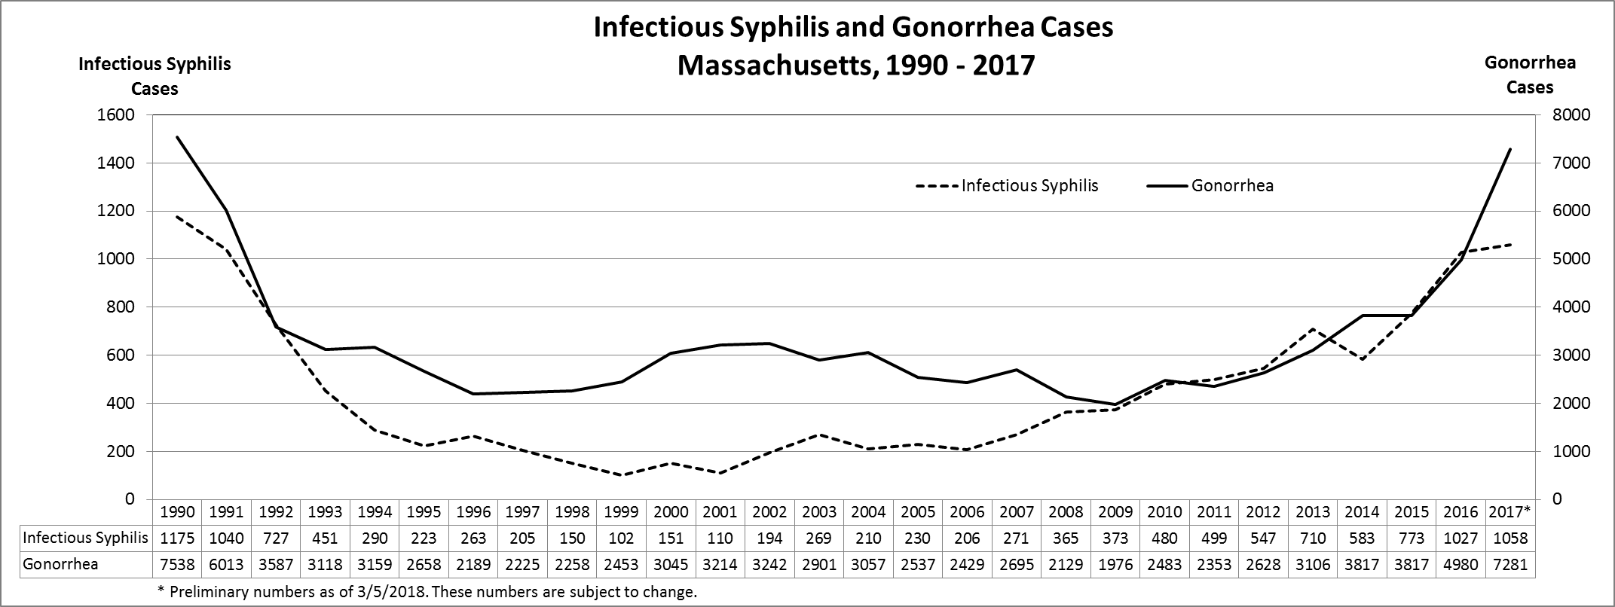
Cases of infectious (primary, secondary, and early latent) syphilis and gonorrhea reported in Massachusetts have increased and now approach levels not seen since the early 1990s. This rise has coincided with increasing reports of serious complications (ocular, otologic, and other forms of neurosyphilis, syphilitic aortitis, congenital syphilis, and gonococcal opthalmia neonatorum) in Massachusetts. Men who have sex with men (MSM) bear a disproportionate burden of both infections (estimated 74% of infectious syphilis and 21% of gonorrhea cases), but women of child-bearing age (15-44 years) also represent a growing proportion of both infections (currently 5% and 30%).
Review of surveillance data on Massachusetts 13-65 year olds (N = 4,847,510) reveals that only 1% were reported with a bacterial sexually transmitted infection (STI) over 2 years and 0.1% accounted for 28% of all reported bacterial STIs (infectious syphilis, gonorrhea, and chlamydia infections. This is consistent with earlier observations that bacterial STIs remain relatively concentrated in certain sexual networks and that reductions in morbidity can be achieved through focused intensive screening and treatment efforts.
MDPH Division of STD Prevention (DSTDP) recommends the following actions to Massachusetts clinicians:
- Screen more frequently -- this reduces carriage and prolonged infectiousness, thereby reducing transmission
  - In those with a prior STI diagnosis, re-screen for STI in 3 months.
  - MSM at high risk should be screened for HIV and syphilis, and gonorrhea and chlamydia infection at exposed mucosal surfaces (using urine, rectal and oropharyngeal swabs) every 3 months.2

- Treat as quickly as possible, with recommended regimens.
  - STI syndromes, symptomatic patients, and contacts of STI cases can be treated presumptively in accordance with CDC STD Treatment Guidelines, to reduce morbidity and likelihood of complications, and render them non-infectious.2
  - Asymptomatic patients, once positive STI test results are back, should also be treated rapidly, to minimize carriage and transmission.2
  - Offer pre-exposure prophylaxis (PrEP) to prevent HIV infection in men who test positive for syphilis or rectal STIs and other patients at risk for acquiring HIV.

- Vaccinate cases with no prior history of STI vaccines. Indications for HPV, hepatitis A, and hepatitis B vaccination extend across age groups, and recommendations for vaccines are provided by the CDC Advisory Committee on Immunization Practices.

- Contact MDPH DSTDP for
- Clinical consultation on complex cases, available through the STD Clinical Consultation Network.
- Record searches on prior syphilis test titers and treatment history.
- Partner services – contact tracing and notification is automatically performed for acute HIV infection and infectious syphilis cases, but is not routinely provided for other STIs unless a clinician requests it.
- Technical assistance on expedited partner therapy (EPT) for chlamydia infection, which is permissible under Massachusetts law.
  - Case reporting - clinician-completed MDPH DSTDP Case Report Forms are required, and provide details on case characteristics and treatment not automatically reported, unless your clinical organization participates in ESPNet.

- Help MDPH DSTDP to
- Collect clinical samples for public health purposes.
    - Samples (whole blood, primary/moist secondary lesions, cerebrospinal or ocular fluid) from ocular syphilis cases.
    - Gonococcal culture should be performed on:
      - Symptomatic cases who do not respond to the recommended treatment regimen.
      - All cases not treated with the recommended treatment regimen, where oropharyngeal infection is suspected.
  - Encourage partner services to reduce reinfection. Allay patient concerns and ask for patient cooperation should they be contacted by DSTDP.
  - Follow up on pregnant women with syphilis and pregnancy outcomes to eliminate congenital syphilis. Our congenital syphilis prevention program includes obstetric, perinatal, and newborn follow-up to ensure appropriate work-up and treatment.

Hsu KK, Molotnikov LE, Roosevelt KA, Elder HR, Klevens RM, DeMaria Jr A, Aral SO. Clinical Infectious Diseases, 2018.
2015 CDC STD Treatment Guidelines, available as an app for Apple and Android devices, www.cdc.gov/std/tg2015/default.htm.
MDPH HIV PrEP Information for Providers, www.mass.gov/service-details/hiv-pre-exposure-prophylaxis-prep-information-for-providers.
CDC ACIP Vaccine Recommendations and Guidelines, www.cdc.gov/vaccines/hcp/acip-recs/index.html.
National Network of STD Clinical Prevention Training Centers STD Clinical Consultation Network, www.stdccn.org.
MDPH Expedited Partner Therapy for Chlamydia Infection, www.mass.gov/eohhs/gov/departments/dph/programs/id/std/public-health-cdc-std-clinical-advisories.html.
MDPH STD Case Report Forms, www.mass.gov/eohhs/gov/departments/dph/programs/id/std/case-report-forms.html.
Electronic medical record Support for Public health, www.esphealth.org.
CDC Clinical Advisory: Ocular Syphilis in the United States, www.cdc.gov/std/syphilis/clinicaladvisoryos2015.htm.

