INDOOR AIR QUALITY ASSESSMENT

Indian Brook Elementary School
Modular Classroom Wing
1181 State Road, Plymouth, Massachusetts

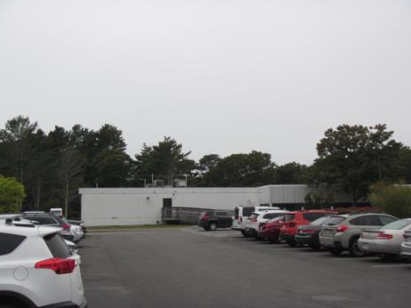

Prepared by:
Massachusetts Department of Public Health
Bureau of Environmental Health
Indoor Air Quality Program
October 2018

BACKGROUND
Building: | Indian Brook Elementary School (IBES)
Address: | 1181 State Road, Plymouth, Massachusetts
Assessment Requested by: | Arthur Montrond, Director of Facilities, Plymouth Public Schools
Reason for Request: | General indoor air quality (IAQ) concerns, with a focus on water damage/mold in the modular wing.
Date of Assessment: | September 25, 2018
Massachusetts Department of Public Health/Bureau of Environmental Health (MDPH/BEH) Staff Conducting Assessment: | Cory Holmes, Environmental Analyst/Inspector IAQ Program
Date of Building Construction: | The modular wing has been in use at the IBES for approximately 17 years.
Building Description: | The modular wing consists of 6 general classrooms connected to the main building by a hallway.
Windows: | Openable

METHODS
Please refer to the IAQ Manual and appendices for methods, sampling procedures, and interpretation of results (MDPH, 2015).

RESULTS and DISCUSSION
The following is a summary of indoor air testing results (Table 1).
- Carbon dioxide levels were slightly above the MDPH recommended level of 800 parts per million (ppm) in half the areas surveyed, which can indicate a lack of air exchange at the time of assessment. It is likely that fresh air intake was limited by the air conditioning (AC) system due to an unseasonably warm/humid stretch of weather during/prior to the assessment.
- Temperature was within or very close to the MDPH recommended range of 70°F to 78°F in areas tested.
- Relative humidity was above the MDPH recommended range of 40 to 60% in all areas tested and reflective of outdoor conditions (100% humidity).
- Carbon monoxide levels were non-detectable (ND) in all areas tested.
- Particulate matter (PM2.5) concentrations measured were below the National Ambient Air Quality (NAAQS) level of 35 μg/m³ in all areas tested.

Ventilation
The heating, ventilation and air conditioning (HVAC) system consists of rooftop air handling units (AHUs, Picture 1) controlled by a computerized system. Conditioned air is delivered to classrooms via ceiling vents (Picture 2). Air is drawn into the above ceiling plenum through grates (Picture 3) and exhausted out of the building through louvered vents (Picture 4).
The HVAC system controls include a carbon dioxide sensor system to control the amount of fresh air into the building. The system has reportedly been in use for approximately 5 years, and the controls are set for 800 ppm, which is recommended by MDPH. However, it is important to note that these systems need to be regularly maintained/calibrated in accordance with manufacturer’s instructions to ensure proper function. It was not known at the time of assessment, how often the carbon dioxide sensors need to be calibrated or replaced.
The rooftop AHUs contain pleated filters where fresh air is drawn into the system (Picture 5). The MDPH recommend that AHUs be outfitted with filters of a Minimum Efficiency Reporting Value (MERV) of 8, which are adequate in filtering out pollen and mold spores (ASHRAE, 2012). In addition, filters should be changed 2-4 times a year or in accordance with the manufacture’s recommendations. The filters observed at IBES are MERV 8 and are reportedly changed 2-4 times per year. In addition, filter media is installed in the grates of return vents, for extra filtration.

Microbial/Moisture Concerns
It was reported that over the summer, mold growth was visible on a number of both porous and non-porous materials due to a stretch of elevated relative humidity. It was also reported that non-porous (e.g., hard/smooth) materials were cleaned, whereas porous materials (e.g., area rugs, pillows, cushions) that are difficult to clean, were discarded, which is recommended by MDPH. At the time of assessment, no current water damage and or visible mold growth was observed on classroom items or building materials in the space, with the exception of one stained tile (Picture 6) in classroom P-4. This tile was reportedly damaged by a roof leak that has since been repaired.
A few rooms utilize dehumidifiers. Dehumidifiers contain a reservoir with standing water, therefore should be cleaned as per the manufacture’s recommendations to avoid scale/bacteria growth and associated odors. In addition, some units contain filters, which should also be cleaned/changed as per the manufacture’s recommendations.
Although no visible signs of water infiltration were noted inside the modular classrooms, with the exception of the stained ceiling tile, MDPH/IAQ staff noted several issues along the exterior that should be addressed, including:
- Damaged siding/paneling (Pictures 7 through 10);
- Clogged downspouts that empty close to the building (Pictures 11 and 12); and
- Trees/plant growth adjacent to building (Picture 13).
All of these issues can create conditions where excess moisture can enter the building. Gaps in siding and damage to the foundation can also allow pests entry.

Other Conditions
Other conditions that can affect IAQ were observed during the assessment. Most classrooms contain area carpets (Table 1). Carpets should be cleaned annually (or semi-annually in soiled/high traffic areas) in accordance with Institute of Inspection, Cleaning and Restoration Certification (IICRC) recommendations, (IICRC, 2012). Regular cleaning with a high efficiency particulate air (HEPA) filtered vacuum in combination with an annual cleaning will help to reduce accumulation and potential aerosolization of materials from carpeting. Area carpets too worn to be effectively cleaned should be replaced.
Exposure to low levels of total volatile organic compounds (TVOCs) may produce eye, nose, throat, and/or respiratory irritation in some sensitive individuals. To determine if VOCs were present, BEH/IAQ staff examined rooms for products containing VOCs. BEH/IAQ staff noted hand sanitizers, cleaners and dry erase materials in use within the building (Table 1). These products have the potential to be irritants to the eyes, nose, throat, and respiratory system of sensitive individuals.
Finally, MDPH/IAQ staff noted missing joint/wall paneling in the corners of classrooms P-1 and P-2 (Pictures 14 and 15), from which air movement was detected. These breaches can provide a source of odors, drafts, moisture and particulates from the wall cavity/exterior into occupied areas. In addition, they can also serve as a pathway for pest migration.

CONCLUSIONS and RECOMMENDATIONS
In view of the findings at the time of the visit, the following recommendations are made:
- Contact the HVAC manufacturer to ensure a regular program/preventative maintenance system is instituted to ensure carbon dioxide sensor calibration/integrity and proper HVAC operation.
- The MDPH recommends adopting a balancing schedule of every 5 years for all mechanical ventilation systems, as recommended by ventilation industrial standards (SMACNA, 1994).
- Continue to change filters in HVAC units two to four times per year (e.g., between heating/cooling seasons/vacations) or per the manufacturer’s instructions.
- For buildings in New England, periods of low relative humidity during the winter are often unavoidable. Therefore, scrupulous cleaning practices should be adopted to minimize common indoor air contaminants whose irritant effects can be enhanced when the relative humidity is low. To control for dusts, a high efficiency particulate arrestance (HEPA) filter equipped vacuum cleaner in conjunction with wet wiping of all surfaces is recommended. Avoid the use of feather dusters. Drinking water during the day can help ease some symptoms associated with a dry environment (throat and sinus irritation).
- Replace water-damaged ceiling tiles after leaks are discovered and repaired.
- During summer months closely monitor conditions of excess relative humidity (e.g., > 70% for extended periods of time) to prevent condensation/mold growth. Operate AC systems/dehumidifiers as needed.
- Ensure dehumidifiers are emptied/maintained on a regular basis to avoid scale/bacterial growth and associated odors.
- Make repairs to wall corners in classrooms P-1 and P-2.
- Clean out gutters/downspouts periodically to ensure proper drainage, consider extending downspouts further away from building to prevent pooling/damage to foundation/siding.
- Make repairs to breaches in siding/paneling of modular wing to maintain watertight integrity and prevent infiltration/damage to interior building components.
- Remove trees/plant growth in close proximity to the building.
- Clean supply, return and exhaust vents periodically of accumulated dust.
- Clean area carpets annually or semi-annually in soiled high traffic areas as per the recommendations of the Institute of Inspection, Cleaning and Restoration Certification (IICRC, 2012). Replace those with excessive wear.
- Consider reducing the use of hand sanitizers, air deodorizers, and other scented materials in use within the office since these products have the potential to be irritants to the eyes, nose, throat, and respiratory system of sensitive individuals.
- Refer to resource manual and other related indoor air quality documents located on the MDPH’s website for further building-wide evaluations and advice on maintaining public buildings. These documents are available at http://mass.gov/dph/iaq.

REFERENCES
ASHRAE. 2012. American Society of Heating, Refrigeration and Air Conditioning Engineers (ASHRAE) Standard 52.2-2012 -- Method of Testing General Ventilation Air-Cleaning Devices for Removal Efficiency by Particle Size (ANSI Approved). 2012.
IICRC. 2012. Institute of Inspection, Cleaning and Restoration Certification. Carpet Cleaning: FAQ.
MDPH. 2015. Massachusetts Department of Public Health. Indoor Air Quality Manual: Chapters I-III. Available at: http://www.mass.gov/eohhs/gov/departments/dph/programs/environmental-health/exposure-topics/iaq/iaq-manual/.
SMACNA. 1994. HVAC Systems Commissioning Manual. 1st ed. Sheet Metal and Air Conditioning Contractors’ National Association, Inc., Chantilly, VA.
Picture 1
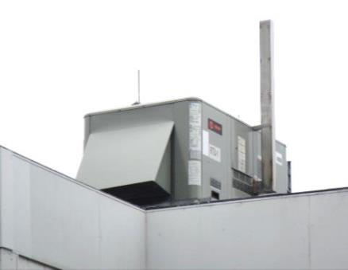
Rooftop air handling unit
Picture 2
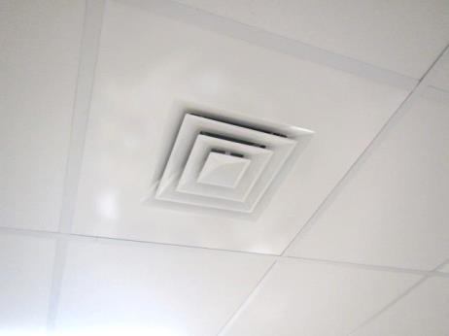
Ceiling-mounted supply diffuser
Picture 3
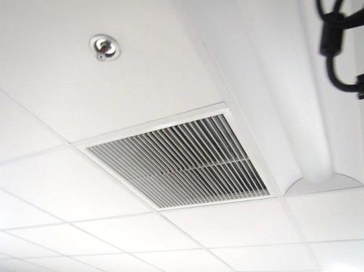
Exhaust vent
Picture 4
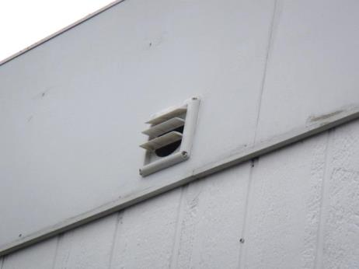
Louvered exhaust vent
Picture 5
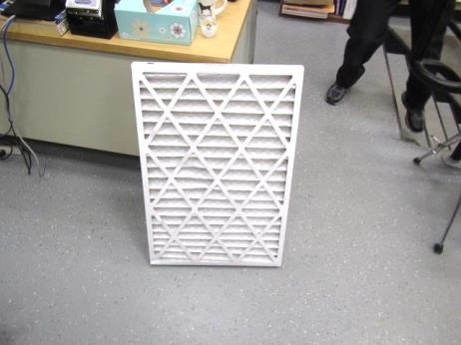
Pleated MERV 8 filter
Picture 6
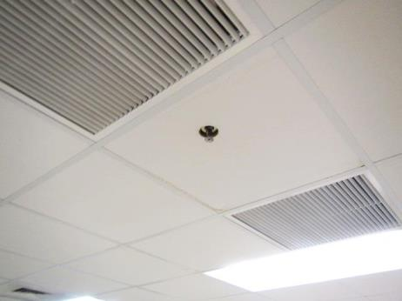
Slightly stained ceiling tile in room P-4
Picture 7
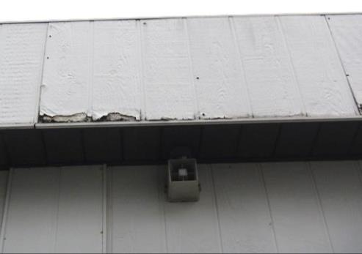
Damaged siding
Picture 8
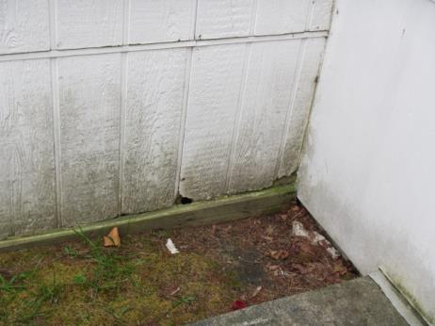
Damaged siding, note staining/moss growth indicating chronic water exposure
Picture 9
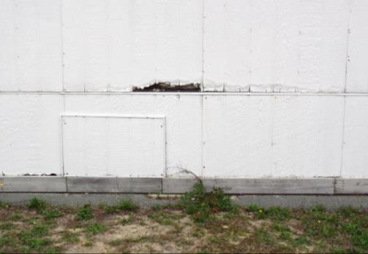
Damaged siding
Picture 10
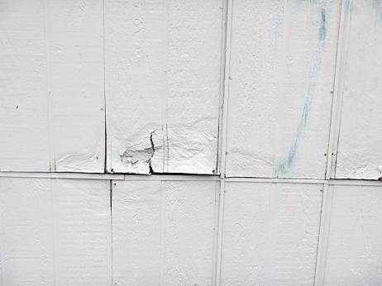
Damaged siding
Picture 11
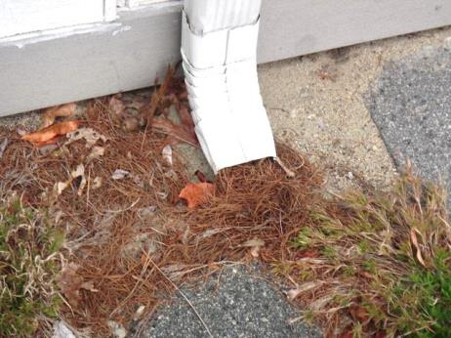
Clogged downspout emptying close to the building
Picture 12
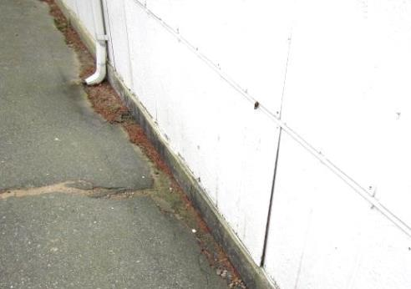
Downspout emptying close to the building
Picture 13
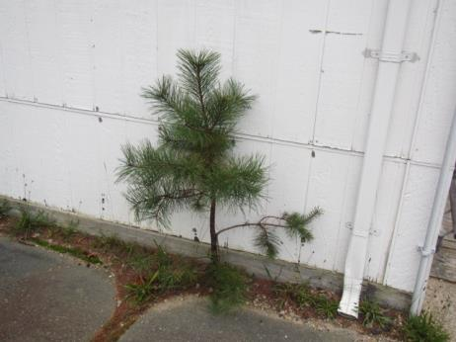
Tree/plant growth adjacent to building
Picture 14
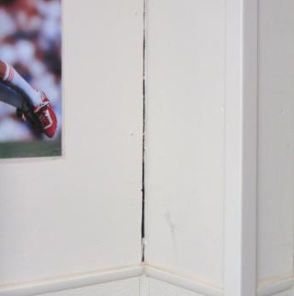
Space/breach/missing corner siding
Picture 15
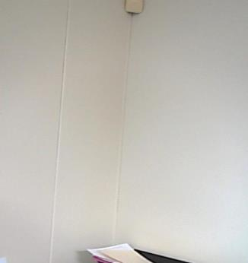
Corner with intact siding

Location | Carbon  Dioxide  (ppm) | Carbon Monoxide  (ppm) | Temp  (°F) | Relative  Humidity  (%) | PM2.5  (µg/m³) | Occupants  in Room | Windows  Openable | Ventilation |  | Remarks
 |  |  |  |  |  |  |  | Supply | Exhaust
Background | 414 | ND | 60 | 100 | 8 |  |  |  |  | Cloudy, rainy
P-1 | 879 | ND | 72 | 64 | 3 | 26 | Y | Y | Y | Area carpet, DO, corner wall space-air movement, dehumidifier
P-2 | 745 | ND | 71 | 64 | 4 | 25 | Y | Y | Y | Area carpet, DEM, dehumidifier, space in corner wall
P-3 | 811 | ND | 71 | 64 | 1 | 22 | Y | Y | Y | Area carpet, DO, HS
P-4 | 659 | ND | 71 | 66 | 2 | 21 | Y | Y | Y | DO, WD CT-roof repaired, area carpets
P-5 | 760 | ND | 69 | 72 | 2 | 23 | Y | Y | Y | Area carpets, HS, DO, DEM
P-6 | 907 | ND | 71 | 67 | 5 | 21 | Y | Y | Y | DO, area carpets, DEM, HS

