Massachusetts Department of Public Health
Bureau of Environmental Health | INDOOR AIR QUALITY PROGRAM

Indoor Plants and Indoor Air Quality
Purpose: This document provides guidance on the use and care of indoor plants in schools and office buildings to protect indoor air quality (IAQ).
Concern: Indoor plants are used to increase the visual appeal of a space. They may also have educational value, for example in a biology class. There is some literature suggesting that indoor plants can “clean” the air of various toxic constituents such as formaldehyde; however, these claims have not been well documented in real-world situations (Wolverton et al., 1989).
The Bureau of Environmental Health’s IAQ Program has observed excessive, improperly-located, or poorly maintained plants in a variety of indoor environments. Plants and potting soil can be a source of odors, mold, pollen, and other allergens, and improper care of plants can lead to water damage in building materials.
An issue that frequently occurs as a result of poorly maintained indoor and improperly located plants is fungus gnat infestation. Often misidentified as fruit flies, fungal gnats reproduce in potting soil of plants. If plants are over-watered, fungus gnats can proliferate and become a nuisance. In order combat this problem, building occupants have been known to use store-purchased pesticides. The use of pesticides in this manner is forbidden in schools (MGL. c. 132B) and state offices (E.O. No. 403).
The following are examples of improperly maintained plants inside buildings:
- Placing plants in the airstream of heating, ventilation, and air conditioning (HVAC) equipment, which can distribute odors, mold, and pollen throughout an occupied space.

(a) 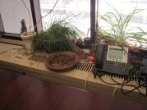 | (b) 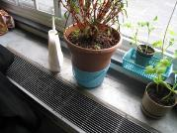 | (c) 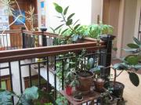
Plants placed in the airstream of (a) a unit heater in an office and (b) a unit ventilator in a school. (c) Pollen and mold from plants placed in a hallway/atrium can be aerosolized when air moves through the building.

- Placing plants on porous materials, including paper, cardboard, wood, and carpeting, can lead to water damage and microbial growth.

(a) 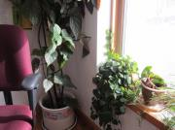 | (b) 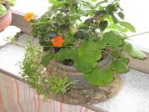 | (c)
Plants on porous material such as (a) wooden windowsill and carpeting (b) wooden windowsill, dripping onto cloth covering, and (c) carpeting.
- Improperly maintained plants, plant debris, and excessive number of plants.

(a) 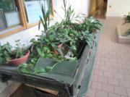 | (b) 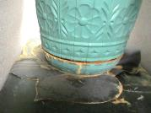 | (c) 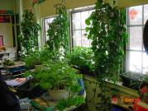
Poor maintaining is evidenced by (a) the large number of plants sitting in a trough with excess water and debris, (b) damage to materials under a plant due to overwatering, and (c) the excessive number of plants.

Guidance: Plants should be kept on non-porous drip pans and away from any sources of heat, air conditioning, or air movement (e.g., fans). Plants should be well maintained, including avoidance of overwatering, removal of debris and periodic cleaning of drip pans and the nearby area using soap and water, as well as disinfectant if needed. Plants should not be placed on or near any porous materials. Flowering plants may be a particular source of pollen, odors, and debris. Excessive plants create conditions where overwatering, water damage, and debris become hard to avoid and detect, which may lead to IAQ concerns. If plants cannot be properly maintained in an office environment, they should be removed.
Plants can be a nice addition to an office or classroom, but care is required to keep them from becoming a source of degradation to IAQ.

References
Wolverton, BC; Douglas, WL; Bounds, K. 1989. A study of interior landscape plants for indoor air pollution abatement (Report). NASA. NASA-TM-108061.

For more information, contact:

Indoor Air Quality Program
Bureau of Environmental Health
Massachusetts Department of Public Health
250 Washington Street, 7th Floor
Boston, MA 02108
Phone: 617-624-5757 | Fax: 617-624-5183 | TTY: 617-624-5286
www.mass.gov/dph/iaq

