Erosion prevention, sediment control, and runoff management

Where soils are exposed to water, wind, or ice, erosion can result.

Typical non-structural BMPs that can be implemented to limit erosion and control sediment include:
• Leaving as much vegetation onsite as possible
• Minimizing the length of time bare soil is exposed
• Diverting or preventing runoff from flowing across exposed areas
• Stabilizing disturbed soils as soon as possible

Dust control

Dust comes from smokestacks and vents, stockpiles, cleared ground, gravel roads, and open areas.

Non-structural methods to control dust include:
• Storing all materials, products, and waste inside the facility
• Routine cleaning of vents and filters
• Spraying controlled amounts of uncontaminated stormwater to dampen dust-generating areas
• Regular sweeping

Eliminating unauthorized non-stormwater discharges (illicit discharges)

Your site’s stormwater system is designed to handle stormwater, but is not designed to handle illicit discharges like sewage and septic flows, washwater, spills and other dumped materials.

Non-structural BMPs for non-stormwater discharges include:
• Inspecting and testing floor drains, sinks, and process drains; eliminating connections to storm sewers, surface or subsurface drains
• Preventing mixing of non-stormwater and stormwater discharges; once mixed, the discharge cannot be managed as stormwater and requires different permits. Illicit discharges are not authorized under the industrial stormwater permit.

Brought to you by the Town of


STORMWATER POLLUTION PREVENTION FOR INDUSTRIAL SITES

Contaminated stormwater is a source of pollutants in many of our ponds, lakes, rivers and streams.

Storm drains carry runoff from streets, urban centers, and industrial sites, and
open spaces into streams, creeks, and rivers.

Industrial operations are only one contributor to this problem, but they are known to be a source of heavy metals,
oily wastes, and other substances.

Reducing or eliminating the exposure of industrial operations to rainfall and runoff is a proven way to reduce pollution into our surface waters.

What Is a Stormwater Pollution Prevention Plan?
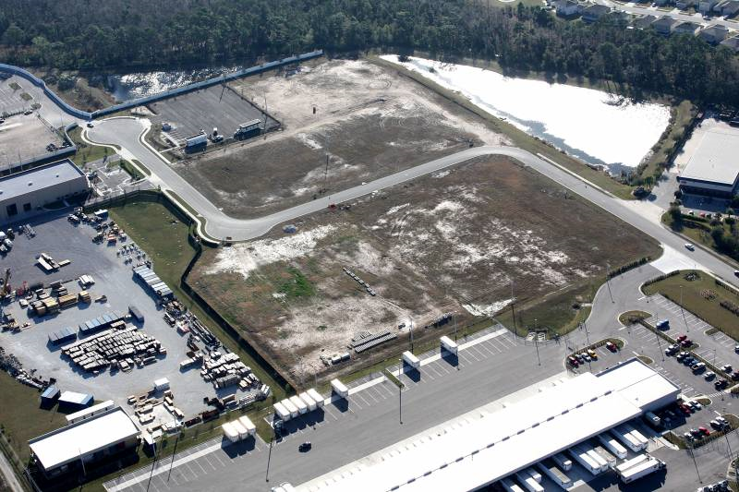

A Stormwater Pollution Prevention Plan (SWPPP) describes how you are going to reduce or eliminate stormwater pollution from your industrial operations.

Federal stormwater regulations require many kinds of industrial facilities to take steps to prevent storm water pollution.

Based upon SIC codes and stormwater exposure, your facility may need to be covered under the Multi Sector General Permit (MSGP.)

If so, you need to prepare a SWPPP that is in part a collection of Best Management Practices (pollution control measures) like the ones described in this brochure.

For more information on coverage under the Multi Sector General Permit, see https://www.epa.gov/npdes/stormwater-discharges-industrial-activities#msgp.

How Do I Prevent Stormwater Pollution at My Industrial Operations?

Salt Storage

Any facility using salt must manage it to prevent contact with stormwater.

Usual BMPs include covering salt piles and placing an impervious pad under salt storage and work areas.

Additional BMPs to manage salt storage:
• Use environmentally-friendly de-icing products
• Apply de-icing products sparingly
• Sweep up salt that is tracked out of the storage area
• Train employees about proper salt application and storage

Employee training program

Employee training is crucial to making sure these BMPS actually reduce pollution. Training should occur at least once a year and can be achieved by through formal classes, in-house training sessions, webinars, and on-the-job training.

Spill prevention and response procedure

A spill prevention and response procedure enables your staff to quickly and consistently respond to any spills that may occur.

Typical spill prevention and response procedures include:
• Identifying potential discharge locations
• Identifying monitoring locations or surface waters that may be impacted by emergency firefighting techniques
• Training employees in proper prevention and response techniques
• Developing and implementing proper material handling, storage, and cleanup procedures
• Posting contact information for all individuals who need to be notified in the event of a spill
• Promptly reporting and documenting any spills or leaks to appropriate individuals

