 | Massachusetts Department of Environmental Protection  Industrial Wastewater Holding Tank  Return to Compliance Plan |  |  | DEP Assigned Facility ID or Facility Name  Holding Tank ID (If any)
Important: When filling out forms on the computer, use only the tab key to move your cursor - do not use the return key.  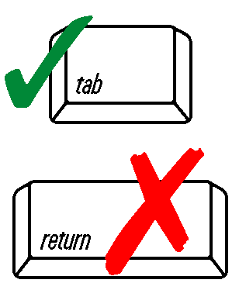 | Instructions
1. Complete a separate Return to Compliance Plan for each compliance question answer that requires one. (Make extra copies of this form if necessary)

2. Only submit the Return to Compliance Plan(s) for violation(s) that you were unable to correct before the required submittal date.

3. Completing this form does not relieve the facility of its responsibility to operate in compliance with applicable regulations. Failure to operate in full compliance with the applicable regulations may result in enforcement actions that may include fines or penalties.
 | Return to Compliance Plan
 | 1. What is the Compliance Question number for which you are reporting non-compliance?
 | Question number
 | 2. What is the specific non-compliance problem?
 | Brief Description of the Problem
 | 3. What corrective action will you take to return to compliance?
 | Describe Corrective Action
 | 4. What is the anticipated return to compliance date?
 | MM/DD/YYYY
 |  |  | Responsible Official's Signature

