Executive Offices of Health and Human Services
Health Safety Net

INET BD Evidence Collection User Guide

INET BD Evidence Collection User Guide

05/18/2026

Version 1.05

Chloen Systems, Inc.

Table of Contents
- Document Revisions 3
- Application Overview 4
- How to Access the Bad Debt Evidence Collection Application 5
- Batch Upload 6
  - ...Evidence File Specification 7
- Create New BDEC Evidence 8
- Edit Saved BDEC Evidence 10
- Submit Saved BDEC Evidence 12
- View Submitted 13
- Evidence Dates Validation 14
- Reopen Requests 14
- Bad Debt Policy 14

Document Revisions

Date | Version Number | Document Changes
04/15/2026 | 1.01 | Initial release of INET BD Evidence Collection User Guide
04/23/2026 | 1.02 | Initial Review (GPT)
04/25/2026 | 1.03 | Updated text, added screenshots, edited layout, etc. for better readability (JQT)
04/25/2026 | 1.04 | Update of Application Overview
04/25/2026 | 1.04 | Review and approval
05/18/2026 | 1.05 | Updated via CA# 3840918

Application Overview
The Health Safety Net INET Provider Portal (HSNPP) is a web-based application providing an interface for Providers, Billing Intermediaries, etc. to submit reports and filings to the Health Safety Net, as well as download provider reports from the Health Safety Net. The purpose of this document is to help users of the application to upload, create, search & edit saved, submit, search & view submitted, and request to reopen submitted Hospital Emergent and CHC Urgent Bad Debt Evidence Collection filings for Organization(s) assigned access to by the HSN Help Desk.
Bad Debt Evidence Collection (BDEC), is a web-based application accessible within the HSN INET Provider Portal, and allows for submitting Bad Debt Evidence Collection filings to the HSN as outlined in 101 CMR 613.00: Health Safety Net Eligible Services | Mass.gov .
All current users who submit 837 claims will also be able to submit collection evidence. Providers may register separate users if they wish to do so by registering them as Web HSN Claim submitters (collection evidence is considered part of the claim).

How to Access the Bad Debt Evidence Collection Application
The HSN INET Provider Portal is a subscription site and requires registration with the Health Safety Net prior to accessing. All users must sign a User Agreement form provided by the HSN Help Desk, with whom can be contacted at hsnhelpdesk@massmail.state.ma.us or by calling 1-800-609-7232.
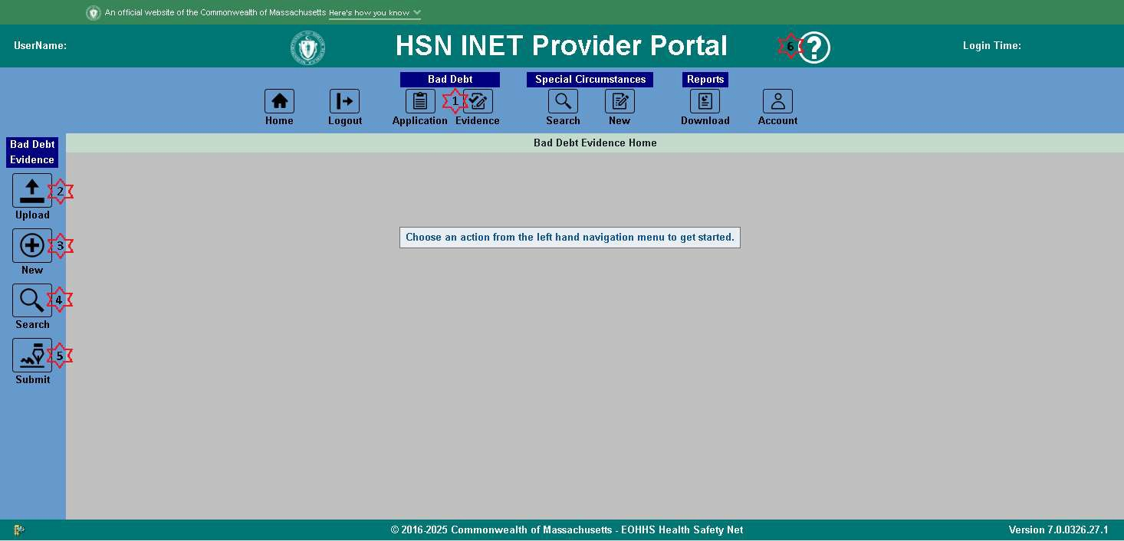
- Click the “Evidence” icon found under the Bad Debt heading on the top navigation bar. You will be brought to the Bad Debt Evidence Collection home page, and the Bad Debt Evidence Collection side navigation bar will appear.
- Click the “Upload” icon on the side navigation bar to access the Bad Debt Evidence Collection upload page.
- Click the “New” icon on the side navigation bar to start a new Bad Debt Evidence Collection application.
- Click the “Search” icon on the side navigation bar to access the Bad Debt Evidence Collection search page where you can search for, locate, and edit saved or view submitted Bad Debt Evidence Collection applications.
- Click the “Submit” icon on the side navigation bar to access the submit page, where you can select and submit any saved Bad Debt Evidence Collection applications.
- Click the “Help” icon on the top navigation bar to view this user guide in your browser. You will then be able to save this user guide from your browser’s PDF viewer.
Once you are on the BDEC home page you can:
  - Batch upload applications.
  - Create a new application.
  - Search for an existing application to edit.
  - Submit application(s).
  - Search for submitted applications, and Export applications to a CSV file.

Batch Upload
- Prepare a CSV file containing the Bad Debt Evidence applications to be uploaded based on the Evidence File Specification Batch File CSV File Format.
- Log into the HSN INET Provider Portal and navigate to the Bad Debt Evidence Collection application as described above in Application Access.
- Click on Batch File “Upload” icon on the left hand navigation bar.
- Click on the “Click here to select file for upload.” button and browse to the Bad Debt Evidence CSV file on your system that you created in step 1, or drag and drop that same file into the upload drop zone that states “Drag and drop files here”.
- The INET application automatically processes the file.
- BDEC reads and validates the CSV file. When errors are detected BDEC displays those errors in the results. Correct the problems and attempt to upload the CSV file again.
Example of upload with errors:
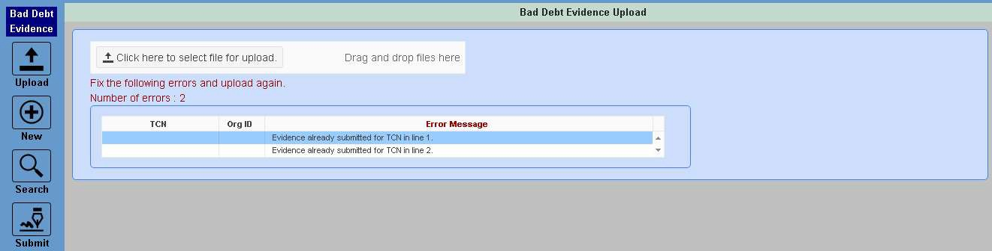
Example of successful upload:
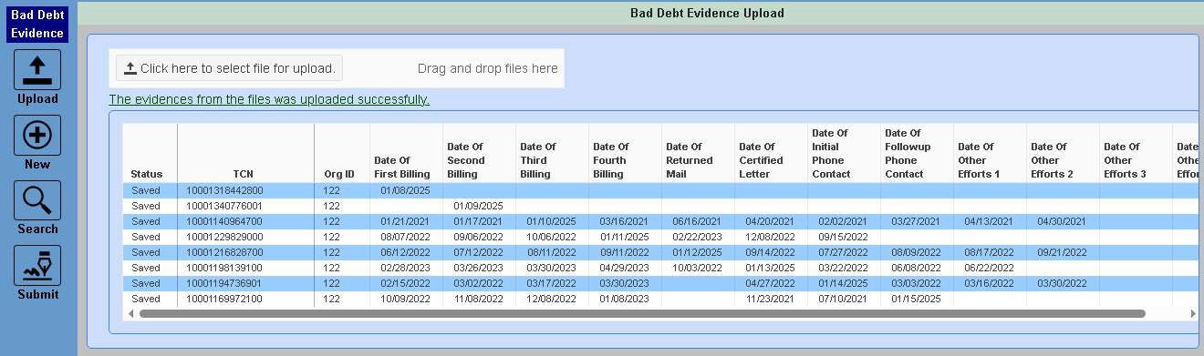
- BDEC validates the collection dates per the Evidence Dates Validation section below.
- When no errors are detected BDEC saves the Bad Debt evidence applications and displays those applications in the results.

Evidence File Specification
Evidence records will be matched to submitted BDEC Claims records using the provider’s HSN Org ID# and the provider’s TCN for the claim. This process will be required for all Hospital Inpatient Emergency Room Bad Debt claims, and CHC Urgent Care Bad Debt claims per HSN regulations. Evidence for outpatient hospital emergent bad debt must be submitted upon request of the Health Safety Net (HSN).

Claims must be submitted within 90 days of write-off. Please note that submission of the claim and evidence are not submitted simultaneously. After a claim is submitted, it must be processed, and posted to INET before evidence may be submitted.

EBDEC evidence must be submitted via the Health Safety Net (HSN) INET Provider Portal web application; either by manual entry, or alternatively by uploading a batch file of evidence records, as specified below.

Note: The BDEC INET application will be available to all currently registered HSN (837) Claim Web submitters. Registration will be an automatic process requiring no action on the part of providers, unless the provider wishes to add new users to that existing list.

Fields | Description
Field 1 | TCN – Matching the claim
Field 2 | Organization ID# (number assigned by HSN)
Field 3 | Date of Initial Bill
Field 4 | Date of Second Bill
Field 5 | Date of Third Bill
Field 6 | Date of Fourth Bill
Field 7 | Date of Returned Mail
Field 8 | Date of Certified Letter
Field 9 | Date of Initial Phone Contact
Field 10 | Date of Follow up Phone Contact
Field 11 | Date Other Effort
Field 12 | Date Other Effort
Field 13 | Date Other Effort
Field 14 | Date Other Effort
Required File Format - CSV (comma separated)
Instructions for file format when provider chooses to upload evidence data
- Fields are separated by commas.
- The last field on the line is not followed by a comma.
- Null fields are represented by two commas in a row.
- Leading and trailing spaces are ignored for all fields.
- Date formats are all mm/dd/yyyy. Dates will also be subject to restrictions (edits) as described in the HSNO regulation defining evidence requirements.
- Each line must end normally with a single carriage return and line feed (CtrLf). Examples:
NVAP234,3644,02/02/2000,03/02/2000,04/02/2000,05/02/2000, 06/02/2000,07/02/2000,08/02/2007,09/02/2000,10/02/2000,11/02/2000,12/01/2000,01/01/2001 NVAP452,3644,02/02/2000, , , ,06/02/2000, ,08/02/2000, ,10/02/2000,,,

Create New BDEC Evidence
If there are any TCNs found for any Organization(s) you have access to that are available for entering and submitting Bad Debt Evidence Collection, that aren’t yet in saved or submitted status, you can locate and begin the editing process by using the following steps.
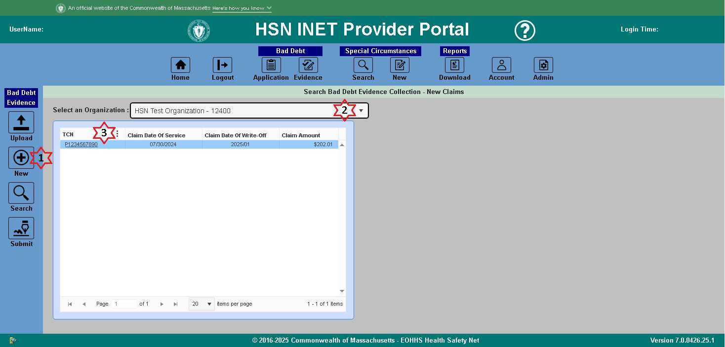
- Click the “New” Evidence icon on the left hand navigation bar.
- Select the Organization that you want to enter new evidence for any available TCN(s).
- Once the list of available TCNs loads, locate the and click the TCN that you want to enter new evidence for.
  - The TCN, Date of Service, Write Off Date, etc. will be loaded into the BDEC Edit form where you can enter the evidence dates.
Refer to the Evidence Dates Validation for rules on what is required for the evidence to pass.

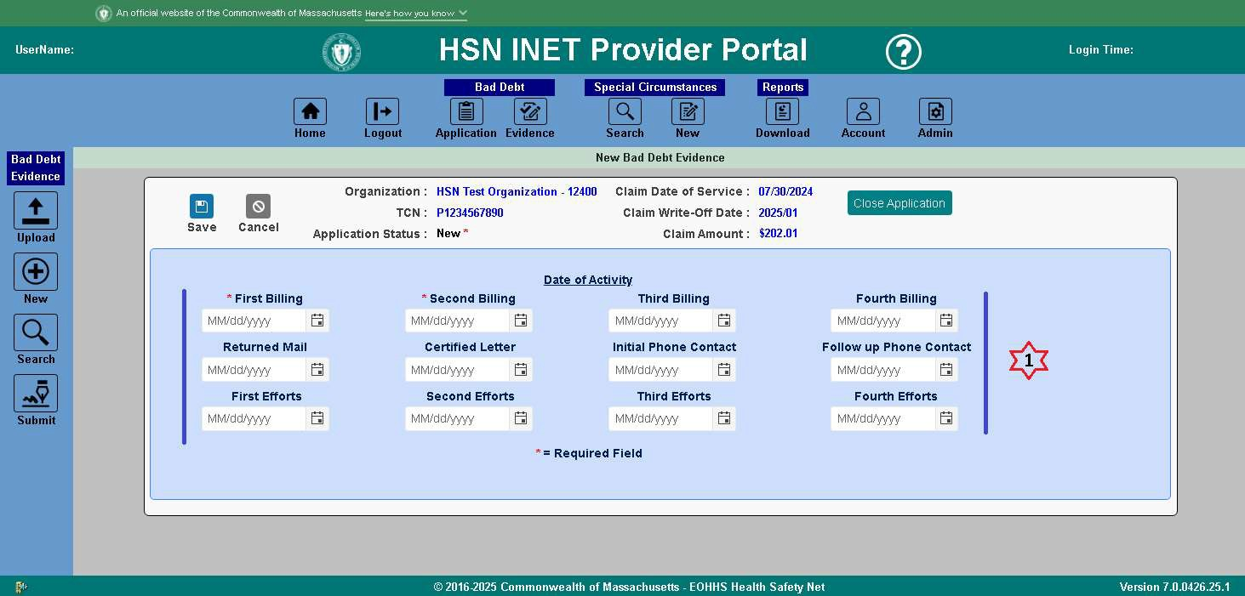
- You will need to enter the dates of evidence, and when finished, click the Save button.
  - If you need to start over and clear the form, click the Cancel button.
If you get any validation errors upon saving the evidence, you will need to review and correct those dates before you can successfully save the evidence. Refer to the Evidence Dates Validation for rules on what is required for the evidence to pass.
Once you have successfully saved the evidence, you can edit it further by referring to Edit Saved BDEC Evidence, or you can submit it by referring to Submit Saved BDEC Evidence.

Edit Saved BDEC Evidence
If there are any saved evidences you need to edit before submitting, use the following steps.
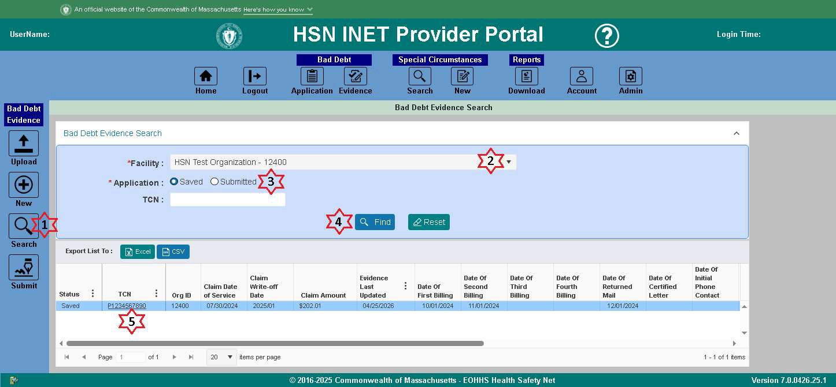
- Click the “Search” Evidence icon on the left hand navigation bar.
- Select the Organization that you want to edit saved evidence for.
- The “Saved” radio button is selected by default, and you can also specify an exact TCN if applicable, or leave it blank to get all Saved evidences available.
- Click the Find button, and the list of saved evidences for that Organization will be loaded into the results.
- Locate and click the TCN that you want to edit the saved evidence for.
The TCN, Date of Service, Write Off Date, etc. will be loaded into the BDEC Edit form where you can edit the evidence dates.
Refer to the Evidence Dates Validation for rules on what is required for the evidence to pass.

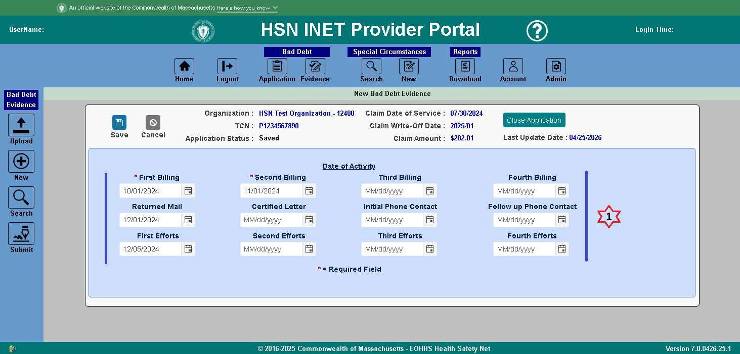
- You will need to enter the dates of evidence, and when finished, click the Save button.
  - If you need to start over and clear the form, click the Cancel button.
If you get any validation errors upon saving the evidence, you will need to review and correct those dates before you can successfully save the evidence. Refer to the Evidence Dates Validation for rules on what is required for the evidence to pass.
Once you have successfully saved the evidence, you can edit it further by referring to Edit Saved BDEC Evidence, or you can submit it by referring to Submit Saved BDEC Evidence.

Submit Saved BDEC Evidence
If there are any saved evidences you want to submit, use the following steps.
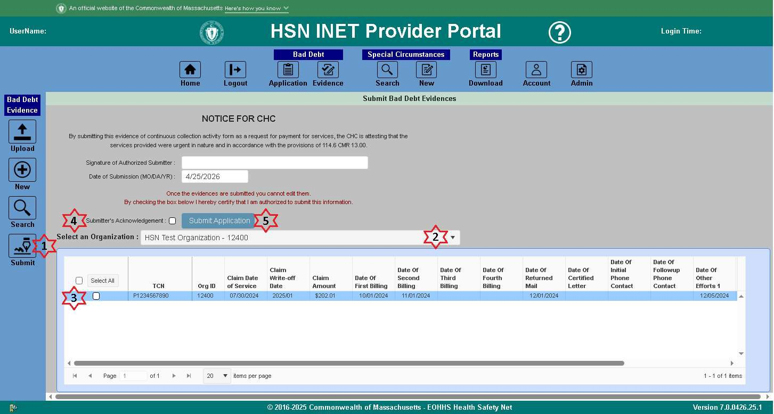
- Click the “Submit” Evidence icon on the left hand navigation bar.
- Select the Organization that you want to submit the saved evidence for.
  - The Signature of Authorized Submitter and Date of Submission are filled in automatically and are not editable.
- Select any TCN(s) to submit by clicking the individual checkbox for that TCN, or to submit all click the Select All button.
- Once you have selected your TCN(s) to submit, check off the Submitter’s Acknowledgement checkbox.
- Click the Submit Application button to submit the application(s) and review the submission status for.
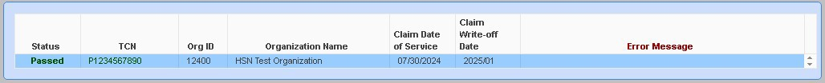
You will get a list of the TCNs you submitted evidence for, along with their Pass/Fail status (Green for Passed / Red for Failed).

View Submitted
If at any time, you would like to view the list of TCNs and their submitted evidence, use the following steps. You will also have the ability to export that list to an Excel / CSV file.
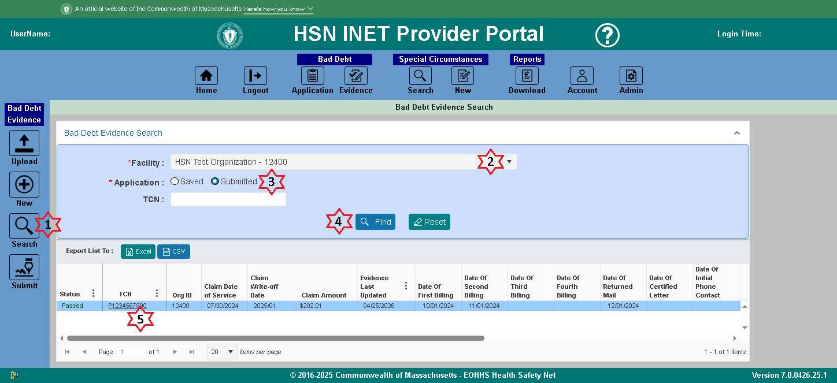
- Click the “Search” Evidence icon on the left hand navigation bar.
- Select the Organization that you want to view submitted evidence for.
- Select the “Submitted” radio button, and you can also specify an exact TCN if applicable, or leave it blank to get all Submitted evidences available.
- Click the Find button, and the list of submitted evidences for that Organization will be loaded into the results.
  - If you want to export the list of submitted evidences to an Excel or CSV file, click the “Excel” or “CSV” buttons and the file will be downloaded to your default downloads folder.
- Locate and click the TCN that you want to view the submitted evidence for.
The TCN, Date of Service, Write Off Date, etc. will be loaded into the BDEC Edit form where you can view the evidence dates.

Evidence Dates Validation
The following validation is applied when saving or submitting an application:
- All dates must be on or after the claim Date of Service.
- All dates must be before the claim Write Off date.
- When there is less than 365 days between the claim Date of Service and the Write Off date:
  - The amount of days between dates must be less than 120 days.
  - The most recent date must be less than 120 days before the claim Write Off date.
- Billing dates must be in chronological order.
- Effort dates must be in chronological order.
- Billing dates can’t be the same date as another billing date.
- Effort dates can’t be the same date as another effort date.
- If there is no Return Mail date:
  - The Certified Letter date is required for claim amounts greater than $1000.
  - At least 3 dates are required.
- If there is a Return Mail date:
  - The First Billing date is required.
  - The Returned Mail date must be on or after the First Billing date.
- If there is a Return Mail Date there must be an Effort Date.

Reopen Requests
Once you have submitted your evidence, it is possible that the evidence did not meet the regulatory requirements for sufficient collection effort. In this case the status of the evidence submission will be “Failed”, and the associated claim will be denied. If you have made a mistake in your data entry, or think the system has erroneously denied your evidence submission, you may contact HSN to request (if appropriate) that the HSN “reopen” the evidence collection submission, for editing and/or resubmission.

Reopen requests will be reviewed and the HSN may request additional documentation to be sent by fax or other means.

Evidence collection reopen requests must be filed with HSN staff within 30 days of the “Failed” evidence submission.

Contact for reopen requests: Health Safety Net Helpdesk 1-800-609-7232 or by email:
hsnhelpdesk@massmail.state.ma.us

Bad Debt Policy

Please refer to the Health Safety Net Regulations 101 CMR 613.00
Please keep in mind that collection efforts must be consistent, with no time frame greater than 120 days between efforts. If the facility uses a collection agency, the facility should either send HSN the Bad Debt claim prior to sending to the agency, or be prepared to document all collection agency efforts to be certain the time between efforts is no greater than 120 days.

