Executive Offices of Health and Human Services
Health Safety Net

INET Bad Debt User Guide

INET Bad Debt User Guide
05/18/2026
Version 1.05

Chloen Systems, Inc.

Table of Contents
- Document Revisions 3
- Application Overview 4
- How to Prepare for Application Submission 4
  - ...Determine Residency and Availability of Patient Information 4
    - Screenshot of Options 4
  - ...Collect Required Information 5
  - ...Determine Whether Patient has an MMIS ID / Check for MMIS ID 5
  - ...Collection Period Verification 6
    - Example 6
- How to Access the Bad Debt Application 7
- New Bad Debt Applications 8
  - ...How to Manually Submit an Application 9
  - ...How to Enter Applications for Non-U.S. Residents 11
  - ...How to Enter Applications with Insufficient Information 12
  - ...Validation 13
    - Form Level Validation 13
    - MMIS Id Validation 13
    - Duplicate Validation 13
- How to Batch Upload Applications 14
- Bad Debt Search page 16
- How to Export Applications 17
- How to Search and View Applications 17
- Batch Upload File CSV Format 18
  - .Batch File Upload Columns 19
  - .Example Batch Upload CSV File 20
  - .Races 20
  - .States 21

Document Revisions

Date | Version Number | Document Changes
04/15/2026 | 1.01 | Initial release of INET Bad Debt User Guide
04/23/2026 | 1.02 | Initial Review (GPT)
04/25/2026 | 1.03 | Updated text, added screenshots, edited layout, etc. for better readability (JQT)
04/25/2026 | 1.04 | Updated iNet to INET, Grammar
04/25/2026 | 1.04 | Reviewed and Approved
05/18/2026 | 1.05 | Updated via CA# 3840918

Application Overview
The Health Safety Net INET Provider Portal (HSNPP) is a web-based application providing an interface for Providers, Billing Intermediaries, etc. to submit reports and filings to the Health Safety Net, as well as download provider reports from the Health Safety Net. The purpose of this document is to help users of the application to upload, create & submit, and search & view submitted Bad Debt filings for Organization(s) assigned access to by the HSN Help Desk.
Bad Debt is a web-based application accessible within the HSN INET Provider Portal, and allows for submitting Bad Debt filings to the HSN as outlined in 101 CMR 613.00: Health Safety Net Eligible Services | Mass.gov .

How to Prepare for Application Submission
- Determine residency and availability of patient information.
- Collect required information.
- Determine whether patient has an assigned MMIS ID.

Determine Residency and Availability of Patient Information
When you enter a Bad Debt application you must indicate whether you have all patient information and whether the patient resides in the US.

Bad Debt displays three options:
- “By selecting this option, provider affirms that they have exhausted all efforts and have been unable to capture patient information.”
This option should be selected when a provider does not have patient information as noted in No Patient Information below.

- “By selecting this option, provider affirms that patient is not a resident of the United States.”

This option should be selected when a provider is submitting a bad debt application for a patient who is not a resident of the United States (please refer to Non-US Residents below).

- “None of the above”

This button should be selected when a provider has all required information (as noted in Collect Required Information) for an individual residing in the United States.
    - Screenshot of Options
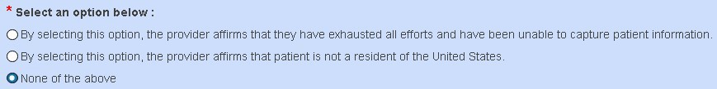

Collect Required Information
Based on the option you selected in the previous section you must collect the following information about the patient:

Information | Required for Option 1?  No Patient Information | Required for Option 2?  Non-US Resident | Required for Option 3?  US Resident
First Name | Auto-Filled | Yes | Yes
Middle Initial | Optional | Optional | Optional
Last Name | Auto-Filled | Yes | Yes
SSN | Auto-Filled | Yes, or 000000000 or 999999999 | Yes, or 000000000 or 999999999
Birth Date | Yes, estimated | Yes | Yes
Gender | Yes | Yes | Yes
MMIS Id | See MMIS ID Verification | See MMIS ID Verification | See MMIS ID Verification
MMIS ID Checked | See MMIS ID Verification | See MMIS ID Verification | See MMIS ID Verification
Street Address | Auto-Filled | Auto-Filled | Yes
City | Auto-Filled | Auto-Filled | Yes
State | Auto-Filled | Auto-Filled | Yes
Zip | Auto-Filled | Auto-Filled | Yes
Race | Yes | Yes | Yes

Determine Whether Patient has an MMIS ID / Check for MMIS ID
You must check whether a patient has an MMIS ID by searching the MMIS Provider Online Service Center (POSC) before you enter an application for the patient.
You must perform this check when you have full information about the patient. When you enter a new application for a patient you will need to:
- Enter the patient’s MMIS Id;
- Or; specify you have checked for an MMIS ID for this patient. To prepare for application submission:
- Obtain the patient’s first name, last name, and DOB.
- Search MMIS POSC by the patient’s first name, last name, and DOB.
- When you find a patient in MMIS POSC note the exact spelling of the first and last name and record the MMIS ID.

Collection Period Verification
Bad Debt now checks whether the new application you are entering is within or beyond the collection period since the last application was entered for the same patient.

The current collection period is 120 days.
You may enter additional applications for the same patient after 120 days of the previous application.

    - Example
Suppose you enter an application for Mary Test on January 1, 2019. Then you attempt to enter a second application for Mary on the dates in the table below:

App Entry Date | Description
February 1st, 2019 | Bad Debt detects the second application is within the 120 day collection period.  Bad Debt prevents you from entering the second application.
May 1st, 2019 | Bad Debt detects the second application is beyond the 120 day collection period.  Bad Debt saves the new second application (assuming all other patient information is valid).

How to Access the Bad Debt Application
You must register with the HSN INET Provider Portal system to enter Bad Debt applications. The HSN INET Provider Portal is a subscription site and requires registration with the Health Safety Net prior to accessing. All users must sign a User Agreement form provided by the HSN Help Desk, with whom can be contacted at hsnhelpdesk@massmail.state.ma.us or by calling 1-800-609-7232.
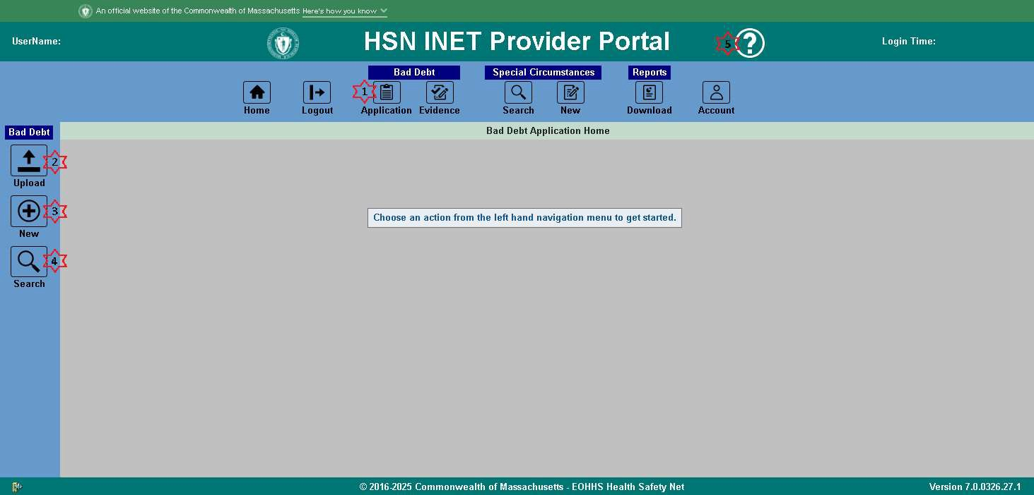
- Click the “Application” icon found under the Bad Debt heading on the top navigation bar. You will be brought to the Bad Debt home page, and the Bad Debt side navigation bar will appear.
- Click the “Upload” icon on the side navigation bar to access the Bad Debt upload page.
- Click the “New” icon on the side navigation bar to enter a new Bad Debt application.
- Click the “Search” icon on the side navigation bar to access the Bad Debt search page where you can search for, locate, and view submitted Bad Debt applications.
- Click the “Help” icon on the top navigation bar to view this user guide in your browser. You will then be able to save this user guide from your browser’s PDF viewer.
Once you are on the Bad Debt home page you can:
  - Batch upload applications.
  - Submit a new application.
  - View existing applications, and Export applications to a CSV file.

New Bad Debt Applications
New Bad Debt application form:
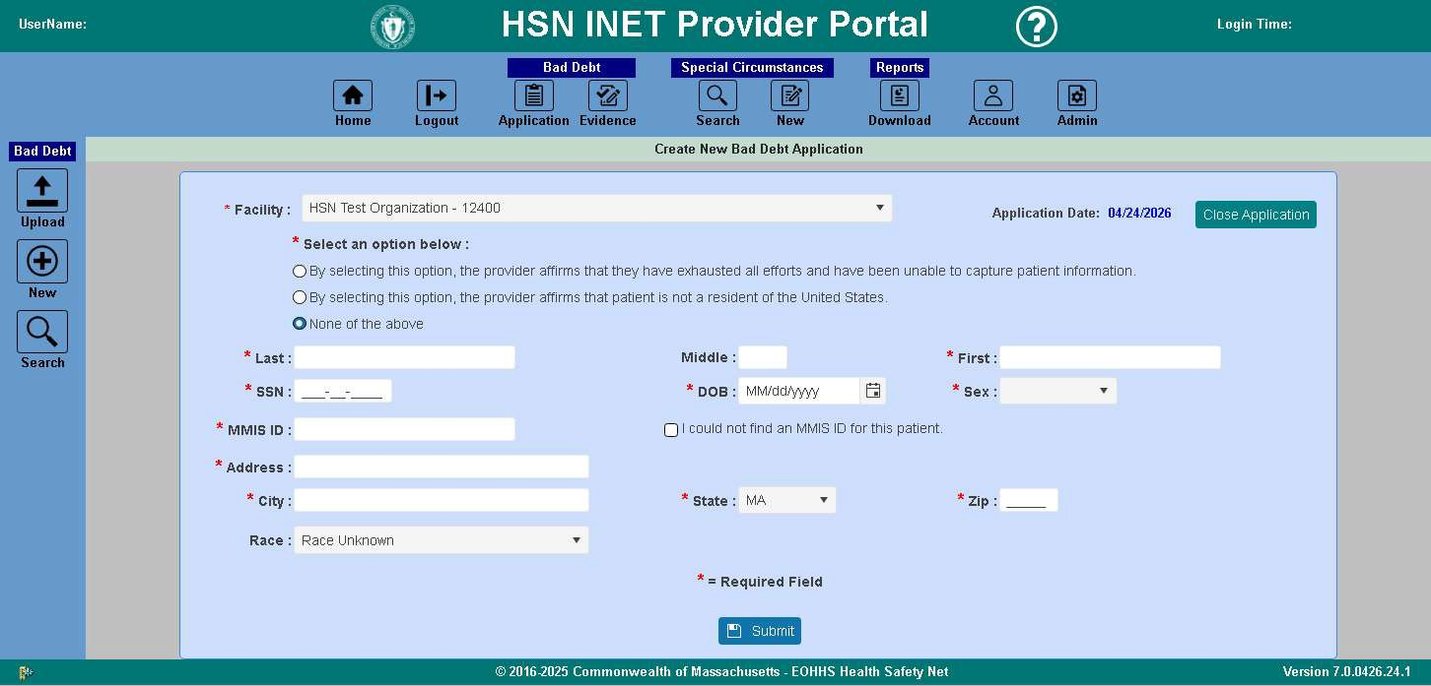

After a new application is submitted successfully, you will get a notification in upper left corner:

How to Manually Submit an Application
This section describes how to enter bad debt applications manually.
This submission process is for patients for which you have all patient information. For patients who reside outside the U.S. or patients for whom you don’t have all information see the later sections.
You should prepare to enter an application by following the instructions provided in “How to Prepare for Submitting Applications.

Once you have collected all required patient information, providers can enter the application following these steps:
- Log into the HSN INET Provider Portal and navigate to the Bad Debt application as described in How to Access the Bad Debt Application.
- Click on the “New” Application icon on the left hand navigation bar.
- Bad Debt displays the New Application page.
- Select the provider you want to use for this application.
- Bad Debt automatically fills in the current date for the application date.
- Since you have all patient information leave the option “None of the above” selected.

When you don’t have all patient information go to “How to Enter Applications When You’re Lacking Information”.

When the patient is a non-U.S. resident go to “How to Enter Applications for Non-U.S. Residents”.
- Enter the patient’s information into the form.
  - Enter birth date in the format mm/dd/yyyy.
  - Enter SSN in the format 000000000.
- When you determined the patient has an MMIS ID:
  - Enter the patient’s MMIS Id;
  - and; leave the “I could not find an MMIS ID for this patient.” checkbox unchecked
- When you determined the patient does not have an MMIS ID:
  - Leave the MMIS Id field blank;
  - and; check the “I could not find an MMIS ID for this patient.” checkbox.
- Enter the patient’s street address, city, state, and 5-digit zip code.
- Click on the Submit button.
- Bad Debt validates patient information. If errors are detected, Bad Debt highlights the fields with the color red that are invalid.

See Validation below for more information.

- Correct these errors and then click on the Submit button again.
- Bad Debt matches the patient data you entered to the MMIS Provider Online Service Center (POSC) patient data when you key in an MMIS ID. Bad Debt matches these fields:
  - First name
  - Last name
  - DOB
  - Gender

- When the items you entered does not match the MMIS Provider Online Service Center (POSC) patient data, Bad Debt displays errors indicating which things don’t match.
- Bad Debt checks for duplicate applications by comparing application you entered to existing applications in Bad Debt. When a duplicate application is detected Bad Debt displays an error message. Update the application and attempt to submit it again. See Duplicate Applications below for more information.
- When the patient information is valid, Bad Debt saves the patient information and displays a confirmation message indicating the information was successfully saved and displays the application id.

You may want to save the Bad Debt application id for future reference.
- Providers needing to enter more applications can repeat the process, since the form clears to a New state after successfully submitting each application.

How to Enter Applications for Non-U.S. Residents
There may be cases where a patient has a non-U.S. (foreign) address. For these cases only, providers should perform the following steps.
- Log into HSN INET Provider Portal and navigate to the Bad Debt application as described in How to Access the Bad Debt Application.
- Click on the “New” Application icon on the left hand navigation bar.
- Bad Debt displays the New Application page.
- Select the provider you want to use for this application.
- Bad Debt automatically fills in the current date for the application date.
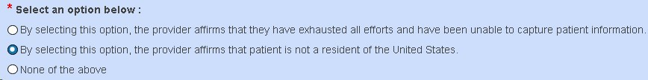
- Select option 2: “By selecting this option, provider affirms that patient is not a resident of the United States.”

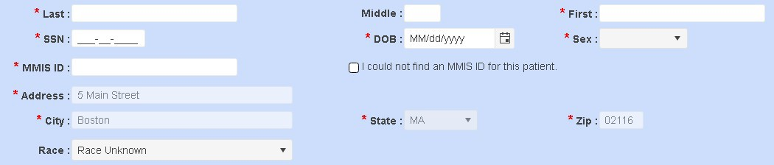
- The system populates the address, city, state and zip code fields with the provider’s address information.

NOTE: HSN staff may, at any time, request written proof from a provider verifying that a patient is not a resident of the United States.
- Enter the patient’s name, SSN and birth date. When the patient doesn’t have an SSN enter 000000000.
- Select the gender of the patient.
- Select the race of the patient.
- Click Submit.
- Bad Debt validates the information you entered. If any patient information is invalid, Bad Debt highlights the fields with the color red that are invalid.

See Validation below for more information.
- Correct these errors and then click on the Submit button again.
- When the patient information is valid, Bad Debt saves the patient information and displays a confirmation message indicating the information was successfully saved and displays the application id.

You may want to save the Bad Debt application id for future reference.

How to Enter Applications with Insufficient Information
There may be cases where you do not have full patient information to submit a Bad Debt application. These cases should be rare and occur after you have performed due diligence and exhausted all available means of trying to collect patient information. For these cases only, providers should complete the following steps.
- Log into HSN INET Provider Portal and navigate to the Bad Debt application as described in How to Access the Bad Debt Application.
- Click on the “New” Application icon on the left hand navigation bar.
- Bad Debt displays the New Application page.
- Select the provider you want to use for this application.
- Bad Debt automatically fills in the current date for the application date.
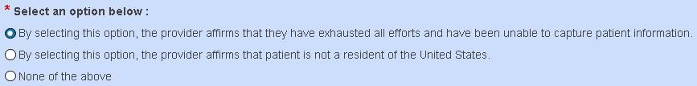
- Select option 1: “By selecting this option, provider affirms that they have exhausted all efforts and have been unable to capture patient information.”

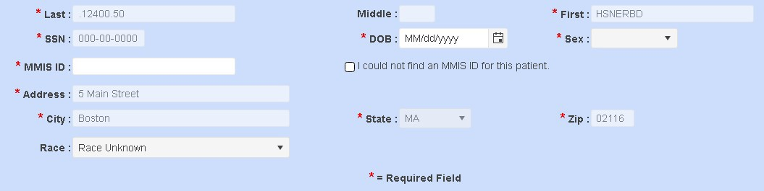
- Bad Debt fills in the first name, last name, street address, city, state, and zip code with the name and address of the provider you selected.

- Bad Debt fills in 000000000 for the SSN.
- Enter the estimated birth date of the patient.
- Select the gender of the patient.
- Select the race of the patient.
- Click Submit.
- Bad Debt validates the information you entered. If any patient information is invalid, Bad Debt highlights the fields with the color red that are invalid.

See Validation below for more information.

- When the patient information is valid, Bad Debt saves the patient information and displays a confirmation message indicating the information was successfully saved and displays the application id.
You may want to save the Bad Debt application id for future reference.

HSN BAD DEBT CLAIMS FOR THE CASES ABOVE (WHERE PATIENT INFORMATION IS NOT AVAILABLE) SHOULD NEVER BE SUBMITTED UNLESS A PROVIDER HAS SUBMITTED A BAD DEBT APPLICATION AS NOTED ABOVE.

Validation
When you click on the Submit button to submit an application Bad Debt validates the patient information as follows:
- Form Level Validation
- MMIS ID Validation
- Duplicate Validation
    - Form Level Validation
Bad Debt validates the individual fields first as follows:

Field | Validation Description
First name Last name Street Address  City | Bad Debt validates that these fields contain a value.
SSN | The SSN is nine digit value
Birth Date | The birth date is a valid date and is not in the future.
MMIS Id | The MMIS Id is a 12-digit value.
Zip | The Zip is a five digit value.
Bad Debt displays errors when any of the above validations fail. Correct the problems and click Submit again.

    - MMIS Id Validation
Bad Debt performs the next level of validation once the first level validation succeeds.

“I could not find an MMIS ID for the patient” checkbox | Validation Action
Checked | Bad Debt performs Duplicate Validation.
Unchecked | Bad Debt matches the patient’s first name, last name, and DOB with the patient information available in our systems.  When this validation fails Bad Debt displays a list of patient data items which do not match our patient information.

    - Duplicate Validation
Bad Debt checks for duplicate applications by comparing the application you entered to existing applications. When a duplicate application is detected Bad Debt displays an error message.

Update the application and attempt to submit it again.

How to Batch Upload Applications
This section describes how to batch upload multiple applications.
- Prepare a CSV file containing the Bad Debt applications to be uploaded based on the table titled Batch File CSV File Format.
- Log into the HSN INET Provider Portal and navigate to the Bad Debt application as described in How to Access the Bad Debt Application.
- Click on Batch File “Upload” icon on the left hand navigation bar.
- Select the provider for these applications.
- Click on the “Click here to select file for upload.” button and browse to the Bad Debt CSV file on your system that you created in step 1, or drag and drop that same file into the upload drop zone that states “Drag and drop files here”.
- The application automatically processes the file.
- Bad Debt reads and validates the CSV file. When errors are detected Bad Debt displays those errors at the bottom of the page. Correct the problems and attempt to upload the CSV file again. You can export the list of errors to CSV or Excel by clicking the Export List To “Excel” / “CSV” button above the errors list. The file will be downloaded to your default Downloads folder.

Example of upload with errors:
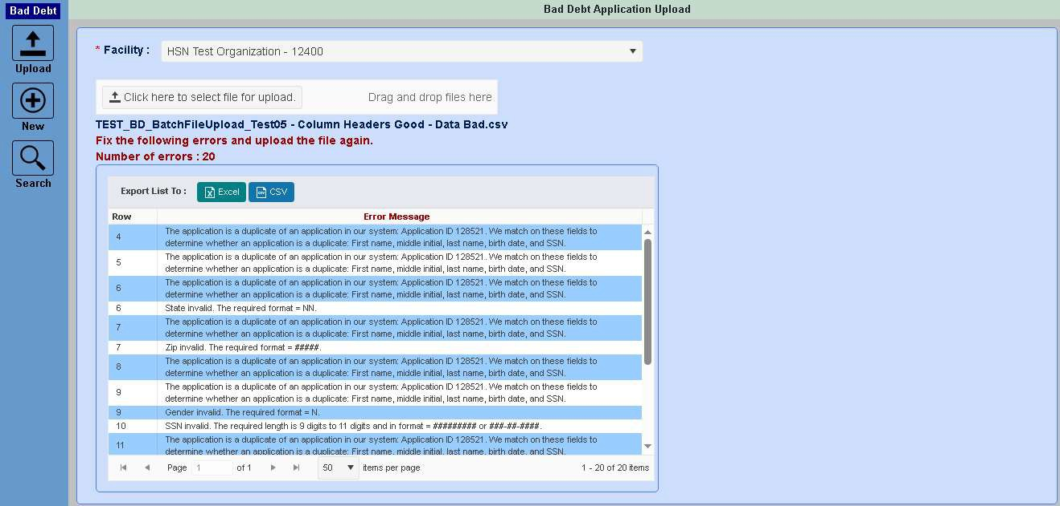

Example of successful upload:
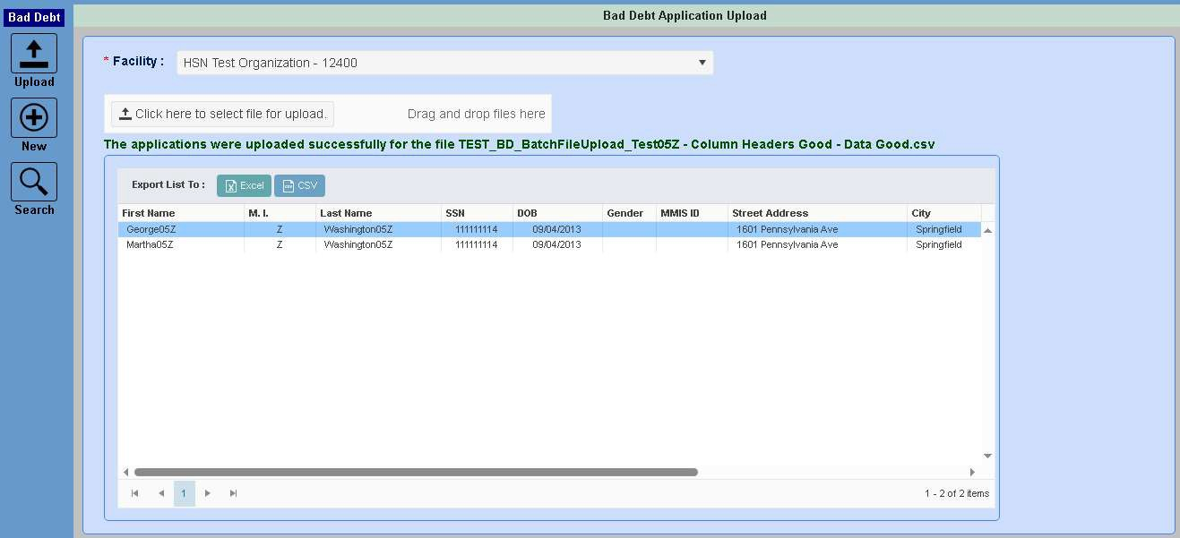
- Bad Debt validates the patient information per the Validation section above.
- When no errors are detected Bad Debt saves the Bad Debt applications and displays a message indicating the number of applications read from the CSV file and saved successfully.
- NOTE: Batch upload applications cannot be submitted for cases where no patient information is available or for patients with a foreign address.

Bad Debt Search page
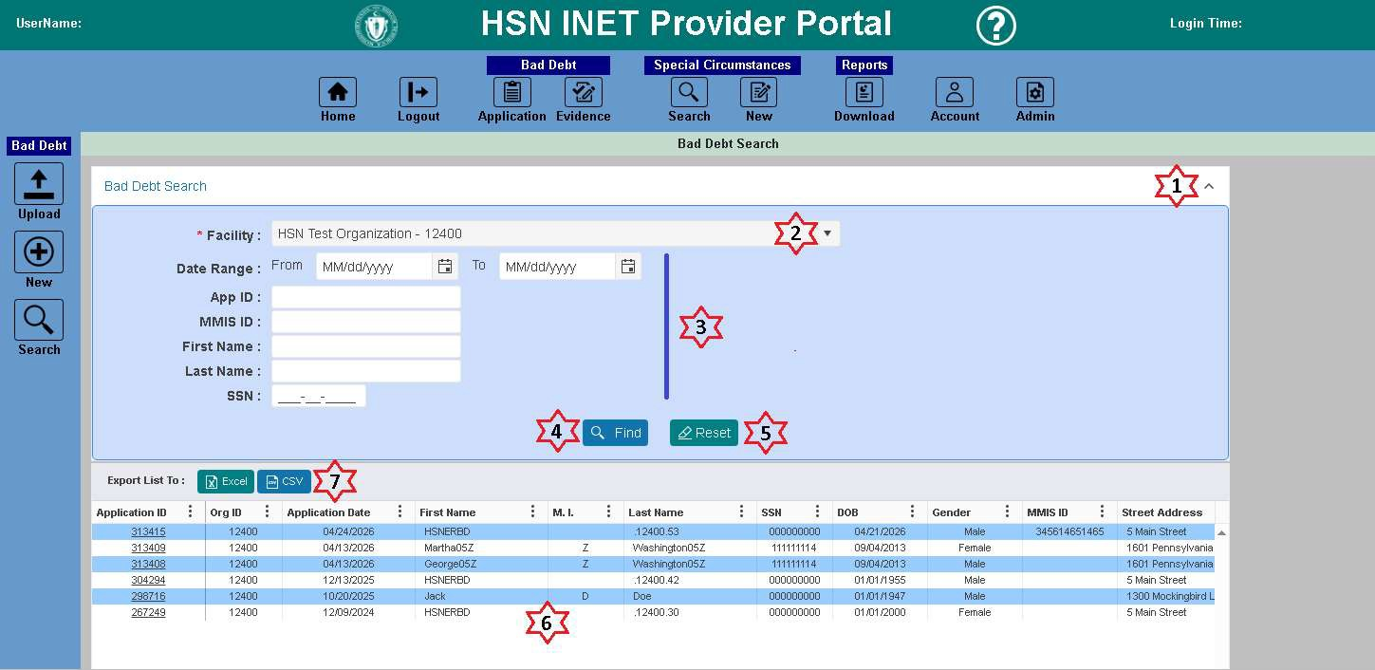
- Click Up/Down arrow to collapse/expand the search criteria panel.
- Select the Organization you want to search Bad Debt applications for. This will only contain Organizations that you have access to.
- Other search criteria fields (Optional) are:
  - Date Range (From Date and To Date)
  - Bad Debt Application ID
  - MMIS ID
  - First Name
  - Last Name
  - SSN/TIN
- Click the Find button to retrieve the list of Bad Debt applications that matched the search criteria.
- Click the Reset button to clear the fields to their default values.
- The Bad Debt applications that matched the search criteria will display in the search results grid. Clicking the Application ID for a record will open the Bad Debt application in View Only mode.
- Click the “Excel” or “CSV” buttons to export the search results to an Excel or CSV file, which will be downloaded to your default Downloads folder.

How to Export Applications
- Log into the HSN INET Provider Portal and navigate to the Bad Debt application as described in How to Access the Bad Debt Application.
- Click on the “Search” BD Applications icon on the left hand navigation bar.
- Select the provider that you want to export the list of applications for.
- Select the search criteria, if any, and click the Find button. You can search for applications by Date Range, Application ID, MMIS ID, First Name, Last Name, and/or SSN.
- You will see all results returned for the search criteria.
- To export the list of applications to an Excel or CSV file, click the Export List To : “Excel” or “CSV” button above the search results list.
- The file will be downloaded to your default Downloads folder.

How to Search and View Applications
- Log into the HSN INET Provider Portal and navigate to the Bad Debt application as described in How to Access the Bad Debt Application.
- Click on the “Search” icon on the left hand navigation bar.
- Select the provider that you want to export the list of applications for.
- Select the search criteria, if any, and click the Find button. You can search for applications by Date Range, Application ID, MMIS ID, First Name, Last Name, and/or SSN.
- You will see all results returned for the search criteria.
- To view an application, click the Application ID for the application you want to view.
- The application will be loaded in view only mode.
- Once finished reviewing, click the “Close Application” button to return to the Search page.

Batch Upload File CSV Format
You must follow these rules when creating a CSV Batch Upload File:
- Create the CSV file using a text editor like notepad, or you may generate the CSV using a software program.
- The first record in the CSV must contain the column headers as shown in the table below.
- Separate the column header names with a comma.
- Spell the column header names precisely as shown in the table below.
- Write the column header names in the case exactly as shown in the table below. For example, for “last name” the name must be “Last Name”.
- List the column headers in the order shown in the table below.
- The 2nd and subsequent records must contain the patient records you want to submit to HSN as Bad Debt applications.
- You must create separate CSV batch files for each provider you are submitting Bad Debt applications for.
- The number of characters in each data item must be less than or equal to the maximum length of the field as listed in the Length column in the table below.
- You must separate data items with a comma.
- You must surround each data item with double quotes.
- You can put as many Bad Debt application records as possible into the CSV file if they are for one provider.
- Name the file as desired.
- The file extension must be “csv”. Example: BadDebts.csv.

Batch File Upload Columns
This table describes the Batch File Upload columns:

Column | Column Header | Length | Required? | Description
A | Last Name | 20 | Yes | The patient’s last name.
B | First Name | 15 | Yes | The patient’s first name.
C | Middle Initial | 1 | No | The patient’s middle initial.
D | Street Address | 30 | Yes | The patient’s street address.
E | City | 30 | Yes | The patient’s city.
F | State | 2 | Yes | Two-letter state abbreviation. Use Code from States table below.
G | Zip | 5 | Yes | 5-digit zip code.
H | Birth Date | 8 | Yes | Format YYYY-MM-DD.  Example: If the person was born on May 12, 1956, the birth date is formatted like 1956-05-12.  The birth date must be equal to or greater than January 1, 1912.
I | Gender | 1 | Yes | M or F.
J | SSN | 9 | Yes | You may leave out hyphens between the number groups, or you may use hyphens:  Examples: 000000000  000-00-0000
K | Race | 6 | Yes | Use the Code from the Races table below. Example: When the patient is Caucasian put WHITE into this column.
L | MMIS Id | 12 | Maybe | The 12-digit MMIS Id.  See MMIS ID Verification for detailed instructions on how to fill in this column.
M | MMISID_Checked | 1 | Maybe | T or F.  See MMIS ID Verification for detailed instructions on how to fill in this column.

Example Batch Upload CSV File
Your Batch Upload File should look something like this:

Races
Use these codes for the Races column in the Batch Upload CSV File.

Description | Code
Race Unknown | UNKNOW
Asian or Pacific Islander | ASIAN
Black-Not of Hispanic Origin | BLACK
Hispanic | HISPAN
American Indian or Alaskan American | INDIAN
Interracial | INTER
Caucasian | WHITE

States
Use these codes for the State column in the Batch Upload CSV file.
Full State Name | Code
Alaska | AK
Alabama | AL
Arkansas | AR
Arizona | AR
California | CA
Colorado | CO
Connecticut | CT
District of Columbia | DC
Delaware | DE
Florida | FL
Georgia | GA
Guam | GU
Hawaii | HI
Iowa | IA
Illinois | IL
Indiana | IN
Kansas | KS
Kentucky | KY
Louisiana | LA
Massachusetts | MA
Maryland | MD
Maine | ME
Michigan | MI
Minnesota | MN
Missouri | MO
Mississippi | MS

Montana | MT
North Carolina | NC
North Dakota | ND
Nebraska | NB
New Hampshire | NH
New Jersey | NJ
New Mexico | NM
Nevada | NV
New York | NY
Ohio | OH
Oklahoma | OK
Oregon | OR
Pennsylvania | PA
Puerto Rico | PR
Rhode Island | RI
South Carolina | SC
South Dakota | SD
Tennessee | TN
Texas | TX
Utah | UT
Virginia | VA
Virgin Islands | VI
Vermont | VT
Washington | WA
Wisconsin | WI
West Virginia | WV
Wyoming | WY

