Executive Offices of Health and Human Services
Health Safety Net

INET Provider Portal User Guide

INET Provider Portal User Guide
05/18/2026
Version 1.03

Chloen Systems, Inc.

Table of Contents
- Document Revisions 3
- Application Overview 4
- Application Access 5
  - ...Logging In 5
  - ...Updating your Password 6
  - ...Logged In 6
  - ...Logging Out 6
- Home Page 7
- How to Access the Bad Debt User’s Guide 8
- How to Access the Bad Debt Evidence Collection User’s Guide 9
- How to Access the Special Circumstances User’s Guide 10
- How to Download Reports 11
  - ...How to Access 11
  - ...How to Download 11

Document Revisions

Date | Version Number | Document Changes
04/15/2026 | 1.01 | Initial release of INET Prov Portal User Guide
04/25/2026 | 1.02 | Update iNET to INET, Reviewed and Approved
05/18/2026 | 1.03 | Updated via CA# 3840918

Application Overview
The Health Safety Net INET Provider Portal (HSNPP) is a web-based application providing an interface for Providers, Billing Intermediaries, etc. to submit reports and filings to the Health Safety Net, as well as download provider reports from the Health Safety Net. The purpose of this document is to help users of the application to do the following:
- Download Provider Reports
- Upload, Create, Edit, Submit, and Search
  - Bad Debt Filings
  - Bad Debt Evidence Collection Reporting
- Create, Edit, Submit, and Search
  - Special Circumstances Applications, consisting of the following application types :
    - Confidential Minors
    - Domestic Violence
    - Medical Hardship
- Update User Password

Application Access
The HSN INET Provider Portal is a subscription site and requires registration with the Health Safety Net prior to accessing. All users must sign a User Agreement form provided by the HSN Help Desk, with whom can be contacted at hsnhelpdesk@massmail.state.ma.us or by calling 1-800-609-7232.

Logging In
Once you have obtained your credentials for accessing the HSN INET Provider Portal, the first time signing in you will need to :
    - Log in using your INET Username and temporary password.
    - Set your new password.
    - Login again using your INET Username and new password.
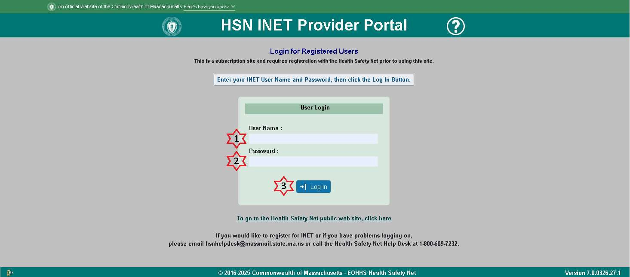
Fig 1.a
To log in to the HSN INET Provider Portal, from the login page as shown in fig 1.a, use the following steps :
- Enter your INET Username.
- Enter your password.
- Click the Log In button.

Updating your Password
Whether setting your new password for the first time or updating your password, from the User Account page as shown in fig 1.b, use the following steps to update your password :
    - Enter your current password.
    - Enter your new password.
    - Confirm your new password.
    - Click the Save button.
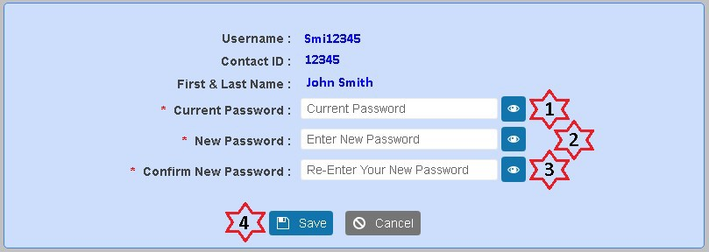
Fig 1.b
Upon successfully setting your new password, you will be returned to the Login screen as shown in fig 1.a in order to log in again using your new password.

Logged In
Once you are successfully logged in, and have set your new password (if applicable), you will see the Home page as shown in fig 1.c.

Logging Out
To log out of the HSN INET Provider Portal, click the Logout button as marked #7 in fig 1.c. You will be brought back to the login page as shown in fig 1.a.

Home Page
From the Home page, you can access the following by clicking the menu navigation item as marked in Fig 1.c :
- Bad Debt
  - See Section 5 “How to Access the Bad Debt User’s Guide”
- Bad Debt Evidence Collection
  - See Section 6 “How to Access the Bad Debt Evidence Collection User’s Guide”
- Special Circumstances Applications
  - See Section 7 “How to Access the Special Circumstances User’s Guide”
- Download Reports
  - See Section 8 “Download Reports”
- User Account
  - See Section 3.2 “Updating Your Password”
- User’s Guide
  - Launches this document in a new browser tab
- Logout
  - See Section 3.4 “Logging Out”
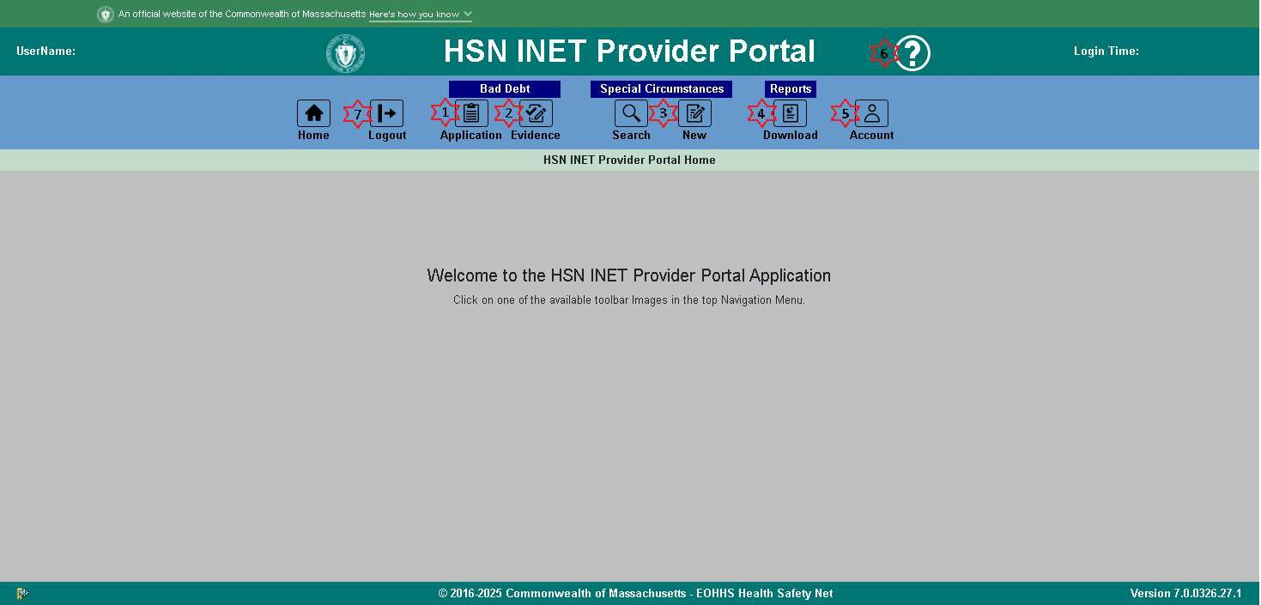
Fig 1.c

How to Access the Bad Debt User’s Guide
While in the context of the Bad Debt Application as marked #’s 1-4in fig 2.a, the Help Button marked #5 in fig 2.a will launch the Bad Debt User’s Guide in a new browser tab. You can save/download the Bad Debt User’s Guide for future reference, if needed. Fig 2.b shows an example of what the Bad Debt User’s Guide will look like.
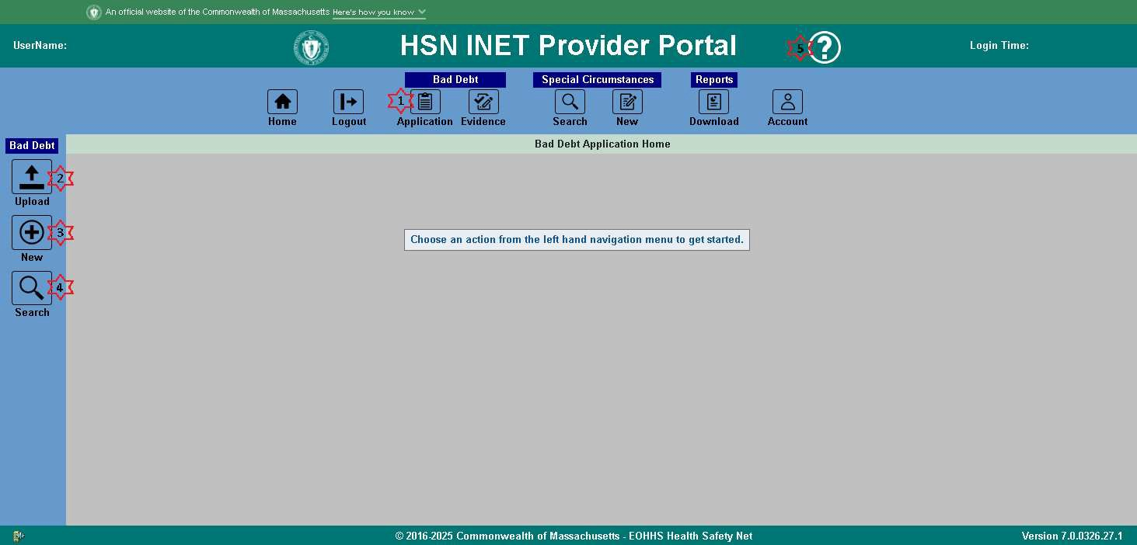
Fig 2.a
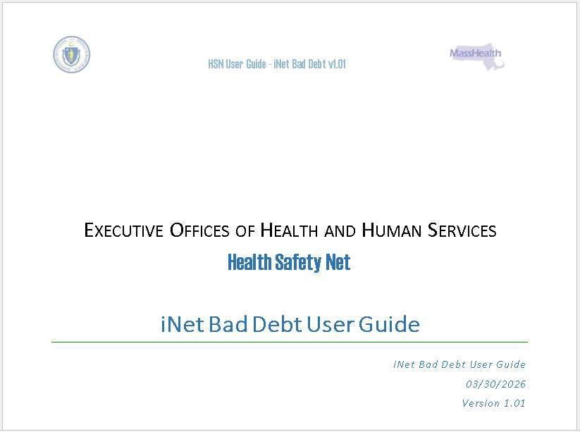
Fig 2.b

How to Access the Bad Debt Evidence Collection User’s Guide
While in the context of the Bad Debt Evidence Collection Application as marked #’s 1-5in fig 3.a, the Help Button marked #6 in fig 3.a will launch the Bad Debt Evidence Collection User’s Guide in a new browser tab. You can save/download the Bad Debt Evidence Collection User’s Guide for future reference, if needed. Fig 3.b shows an example of what the Bad Debt Evidence Collection User’s Guide will look like.
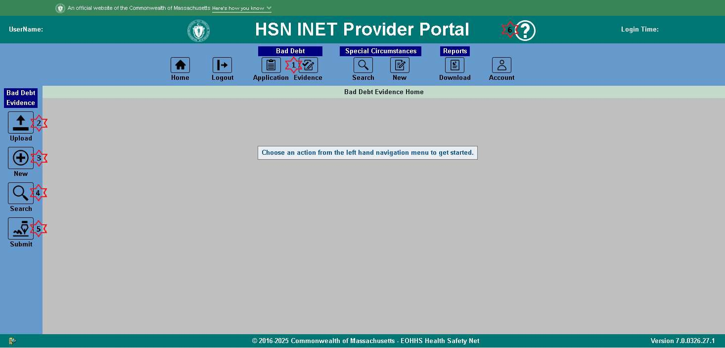
Fig 3.a
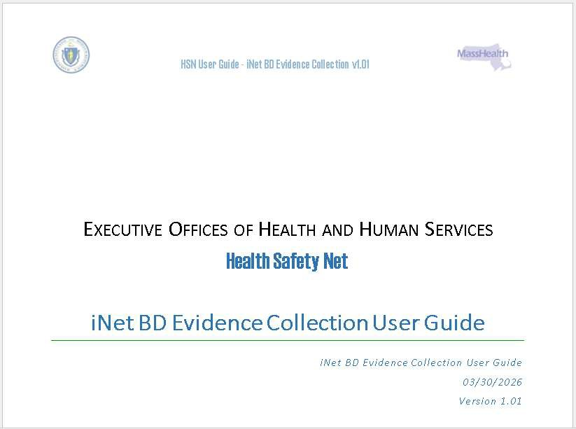

How to Access the Special Circumstances User’s Guide
While in the context of the Special Circumstances Application as marked # 1in fig 4.a, the Help Button marked #2 in fig 4.a will launch the Special Circumstances User’s Guide in a new browser tab. You can save/download the Special Circumstances User’s Guide for future reference, if needed. Fig 4.b shows an example of what the Special Circumstances User’s Guide will look like.
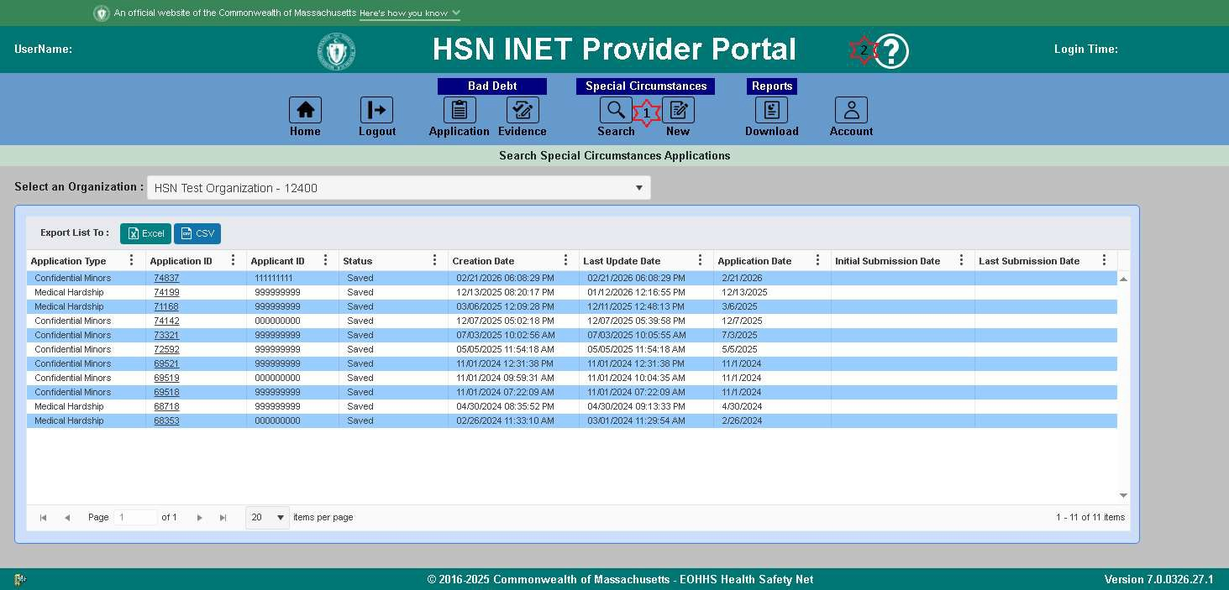
Fig 4.a
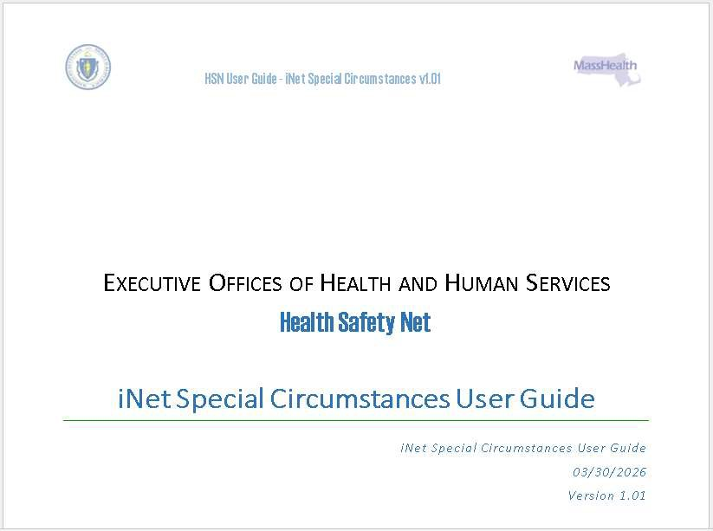

How to Download Reports

How to Access
To access the Download Reports page, click the Download button as highlighted red in fig 5.a.
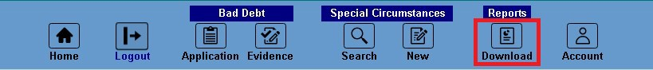
Fig 5.a

How to Download
While on the Download Reports page :
To see a list of files available for download for a specific Organization, select the Organization from the dropdown list marked #1 in fig 5.b. The reports available for download will be shown in a grid similar to #2 in fig
5.b. Once you’ve located a report you would like to download, click on the Report Name of that report and the report file will be downloaded to your Downloads folder.
To view 20/30/40/50 or All available reports per page in the grid, select the Items per page from the dropdown list marked #3 in fig 5.b.
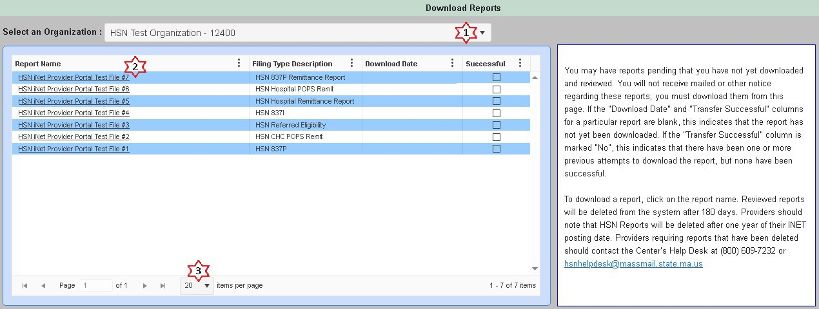
Fig 5.b

