Executive Offices of Health and Human Services
Health Safety Net

INET Special Circumstances User Guide

INET Special Circumstances User Guide
04/25/2026
Version 1.04

Chloen Systems, Inc.

Table of Contents

- Document Revisions 4
- Application Overview 5
- How to Access the Special Circumstances Application 5
- Application Types 6
  - ...Medical Hardship (MH) 6
  - ...Confidential Minors (CM) 6
  - ...Domestic Violence (Battered/Abused) (DV) 6
- Creating a New Application 7
- Editing and Submitting a Saved Application 8
  - ...Applicant Information & Tabs Overview 8
    - Applicant Tab 9
    - Family Members Tab (Displayed only for Medical Hardship and Domestic Violence) 10
    - Income Tab 11
    - Medical Expenses Tab (Displayed only for Medical Hardship) 12
    - Additional Info Tab 12
    - Eligibility Verification Tab 13
    - Facility Calculation Tab 14
    - Submit Application Tab 15
  - ...Family Members (Displayed only for Medical Hardship and Domestic Violence) 17
  - ...Income 18
    - Earned Income 18
    - Unearned Income 19
    - No Income 19
  - ...Medical Expenses (Displayed only for Medical Hardship) 20
  - ...Additional Information 20
  - ...Eligibility Verification 21
    - General Information 21
    - Residency Documentation 21
    - General Documentation 21
  - ...Facility Calculation 22
    - General Information 22
    - Applicant Eligibility Summary & Eligibility Message Area 22
    - Eligibility Period (Displayed only for Confidential Minors and Domestic Violence) 22
  - ...Submit Application 23
- Reopen Requests 24

Document Revisions

Date | Version Number | Document Changes
04/23/2026 | 1.01 | Initial release of INET Special Circumstances User Guide
04/23/2026 | 1.02 | Initial Review (GPT)
04/25/2026 | 1.03 | Updated text, added screenshots, edited layout, etc. for better readability (JQT)
04/25/2026 | 1.04 | Reviewed and Approved

Application Overview
The Health Safety Net INET Provider Portal (HSNPP) is a web-based application providing an interface for Providers, Billing Intermediaries, etc. to submit reports and filings to the Health Safety Net, as well as download provider reports from the Health Safety Net. The purpose of this document is to help users of the application to create, search & edit saved, submit, search & view submitted, and request to reopen submitted Special Circumstances filings (Confidential Minors, Domestic Violence, and Medical Hardship) for Organization(s) assigned access to by the HSN Help Desk.
Special Circumstances Applications is a web-based application accessible within the HSN INET Provider Portal, and allows for submitting Special Circumstances filings to the HSN as outlined in 101 CMR 613.00: Health Safety Net Eligible Services | Mass.gov .
Questions involving the submission of a special circumstances application or bad debt application should be directed to HSN’s Help Desk at (800) 609-7232 or hsnhelpdesk@massmail.state.ma.us.

How to Access the Special Circumstances Application
The HSN INET Provider Portal is a subscription site and requires registration with the Health Safety Net prior to accessing. All users must sign a User Agreement form provided by the HSN Help Desk, with whom can be contacted at hsnhelpdesk@massmail.state.ma.us or by calling 1-800-609-7232.
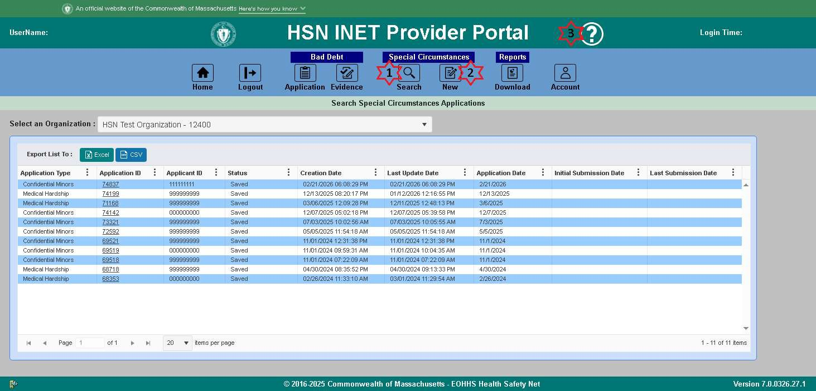
- Click the “Search” icon found under the Special Circumstances heading on the top navigation bar to access the search page for locating and accessing all saved and submitted Special Circumstances applications.
  - Click the Application ID in the search results grid for the Special Circumstances application you want to continue editing, or view if already submitted.
- Click the “New” icon found under the Special Circumstances heading on the top navigation bar to start a new Special Circumstances application.
- Click the “Help” icon on the top navigation bar to view this user guide in your browser. You will then be able to save this user guide from your browser’s PDF viewer.

Application Types

Medical Hardship (MH)
Please refer to the 101 CMR 613.00: Health Safety Net Eligible Services | Mass.gov for a complete definition and outline regarding Medical Hardship applications.

Confidential Minors (CM)
Please refer to the 101 CMR 613.00: Health Safety Net Eligible Services | Mass.gov for a complete definition and outline regarding Confidential Minor applications.

Domestic Violence (Battered/Abused) (DV)
Please refer to the 101 CMR 613.00: Health Safety Net Eligible Services | Mass.gov for a complete definition and outline regarding Domestic Violence applications.

Creating a New Application
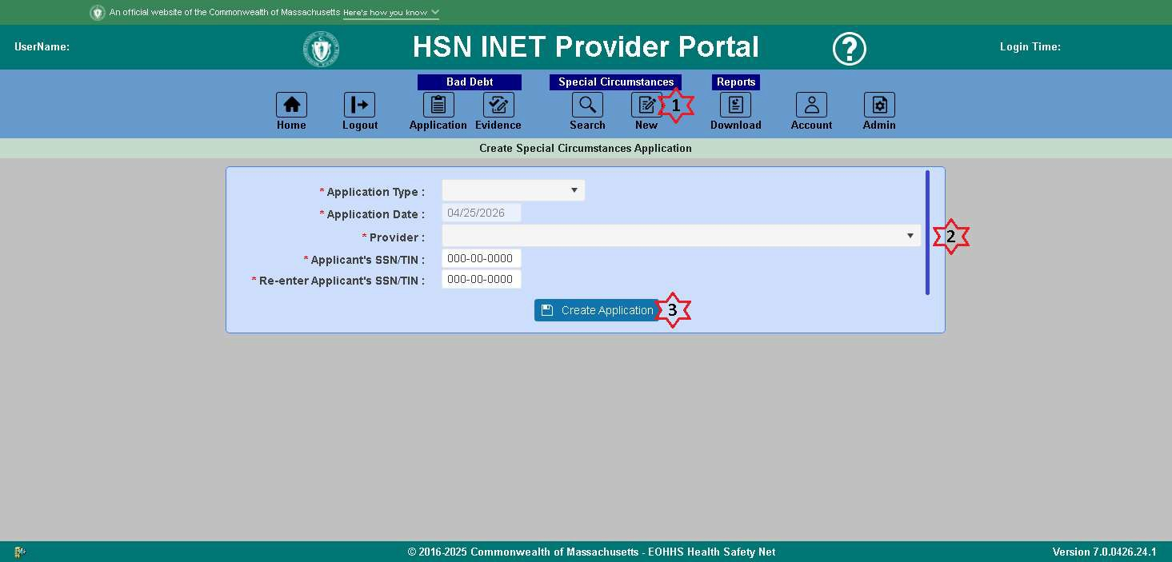
To file a new Special Circumstances (MH/CM/DV) application, use the following steps.
- Click the Special Circumstances “New” icon on the top navigation bar.
- Fill out the Application Type, select the Provider, and enter/confirm the applicant’s SSN/TIN.
  - Select the application type; Medical Hardship, Confidential Minors, or Domestic Violence.
  - Select the provider that is submitting the application.
  - Enter the applicant’s SSN, and if unknown, leave as 000-00-0000.
  - Confirm the applicant’s SSN, and again, if unknown, leave as 000-00-0000.
- Click the “Create Application” button.
  - The application is now in saved status, and can be searched for and accessed at any time from the Special Circumstances “Search” icon on the top navigation bar.
The application will then be loaded into the Special Circumstances edit page so you can edit and submit your application. See Editing a Saved Application for next steps.

Editing and Submitting a Saved Application
To edit a saved application, either create a new application, or search for and open a saved application.
Regardless of the application type (MH/CM/DV), the Applicant Information, found under the Applicant tab, is required to be filled out before you can work on any other parts of the application such as entering/editing income, additional information, residency documentation, running facility calculations, etc.
Use the following steps and guidelines to complete the application process.

Applicant Information & Tabs Overview
- The following fields are required when entering the Applicant Information:
  - First Name
  - Last Name
  - SSN/TIN (Social Security Number or Tax ID Number)
  - Date of Birth (DOB)
  - Sex (Gender)
  - Pregnant (If Sex is Female)
  - Number of Babies (If Pregnant is Yes)
  - Home Phone (If Application Type is Medical Hardship or Domestic Violence)
  - Street Address
  - City
  - State
  - Zip
  - Race
  - Ethnicity
  - Has Insurance (If Application Type is Medical Hardship)
  - Insurance Company Name (If Has Insurance is Yes)
- When you have completed filling out the applicant information, click the Save button.
- If there were any validation errors, fix the errors, and try Saving again. The fields that are required but not filled out correctly will be highlighted in red.
- If there were no errors and the save was successful, the other tabs will be available for editing/viewing.
  - The “Family Members” tab is available for both Medical Hardship and Dometic Violence application types.
  - The “Medical Expenses” tab is only available Medical Hardship applications.
- Enter any other information pertaining to this application found under each tab.

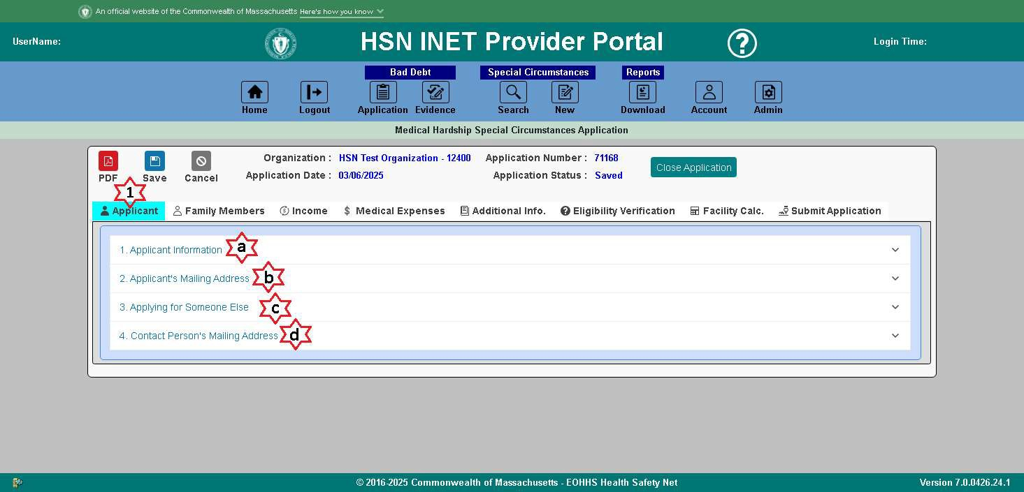
    - Applicant Tab
      - Click the Applicant tab.

        - Applicant Information
          - Required to be filled out without errors before being able to access any other tab areas of the application.
        - Mailing Address
          - If not the same as the address provided in the Applicant Information section.
        - Applying for Someone Else
          - Complete this section as the contact person.
        - Contact Person’s Mailing Address
          - Complete this section if the mailing address is not the same as entered in the Applying for Someone Else section.

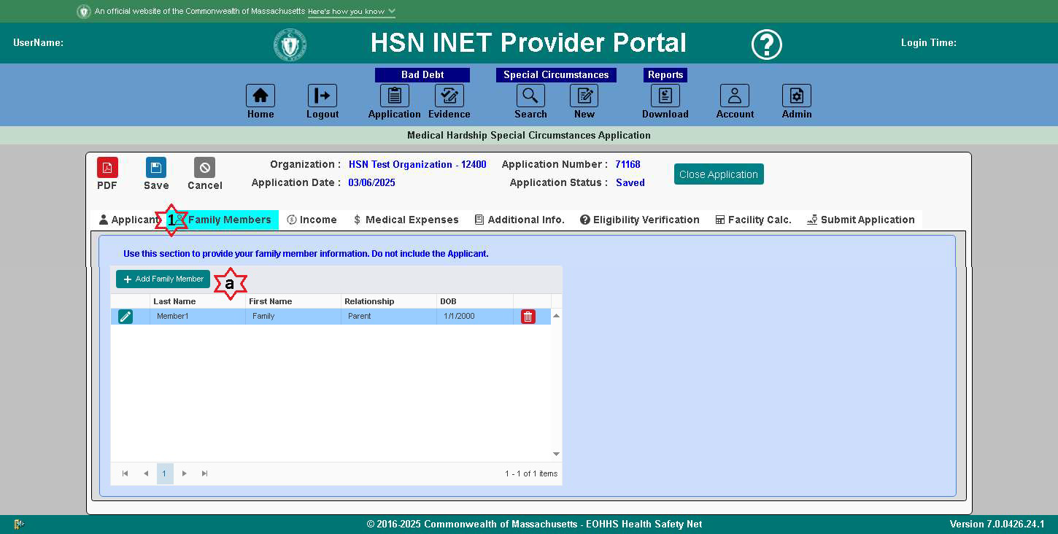
    - Family Members Tab (Displayed only for Medical Hardship and Domestic Violence)
      - Click the Family Members tab.

        - Use this section to provide information about any family members.
          - Do not include the Applicant.

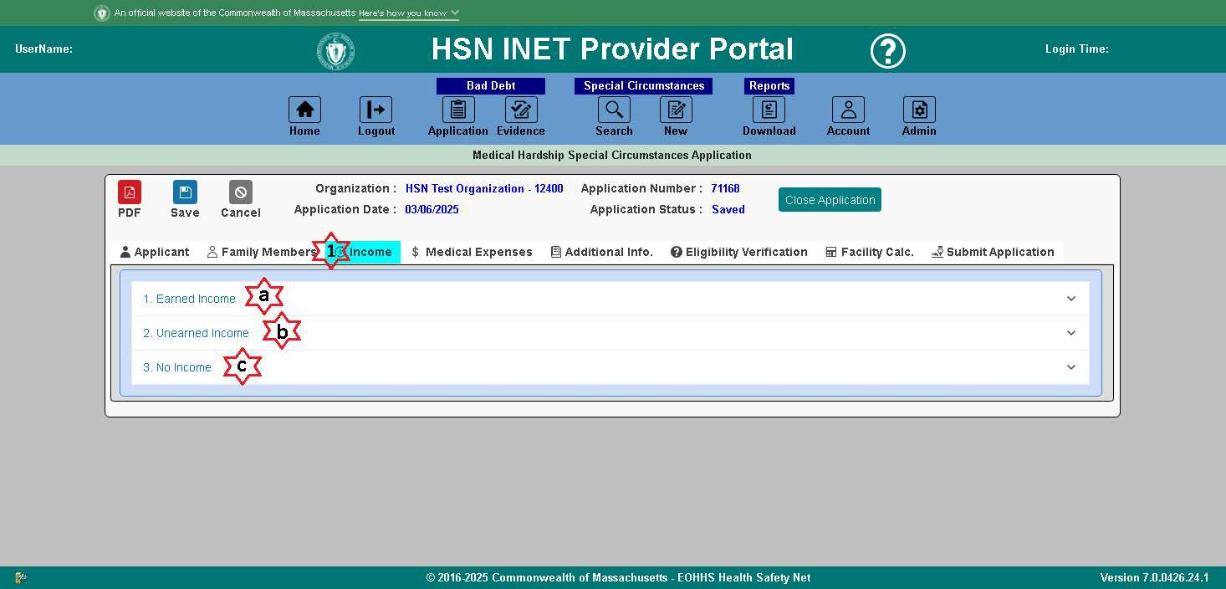
    - Income Tab
      - Click the Income tab.

        - Earned Income
          - Use this section to provide earned income information for the applicant and, if applicable, any family members.
        - Unearned Income
          - Use this section to provide unearned income information for the applicant and, if applicable, any family members.
        - No Income
          - Use this section to indicate that the applicant or family members have no income.
          - In order to check off the “No Income” checkbox, there can’t be any earned or unearned income listed. If there is, you must delete them before being able to check off “No Income”.
          - If the “No Income” checkbox is checked off, then Handwritten affidavits are required.

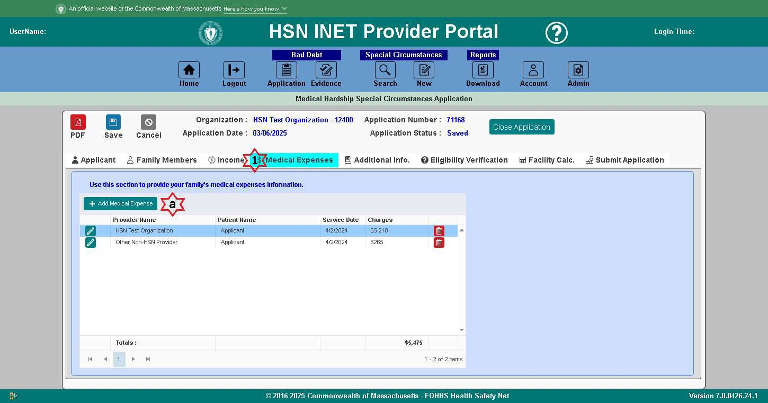
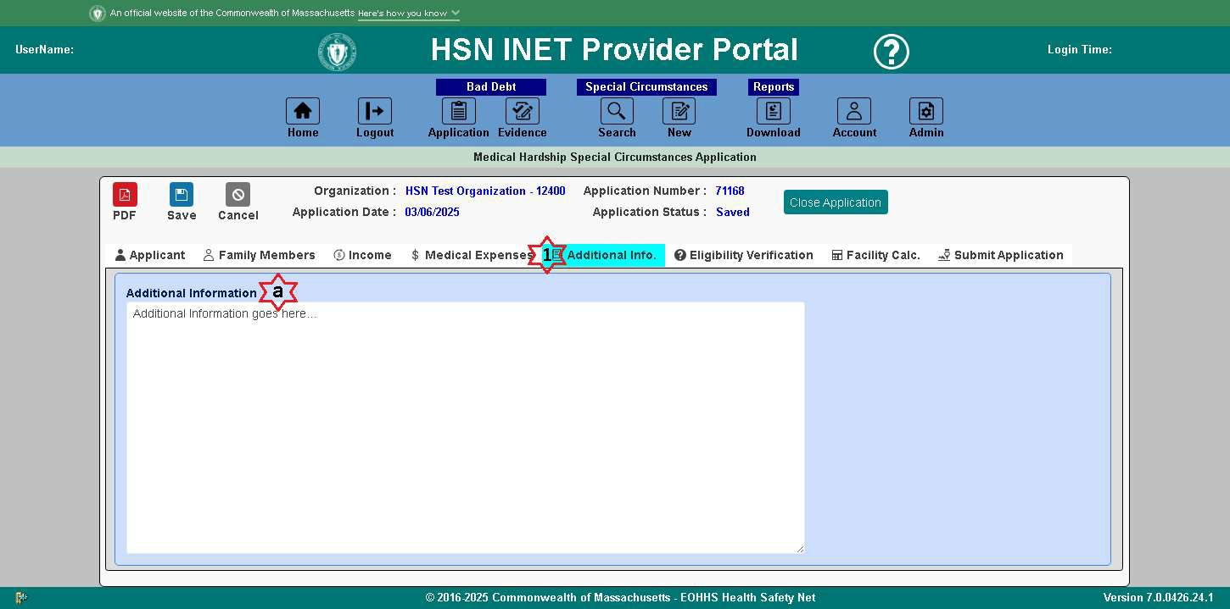
    - Medical Expenses Tab (Displayed only for Medical Hardship)
      - Click the Medical Expenses tab.

        - Use this section to provide information about the applicant and/or family member’s medical expenses.
    - Additional Info Tab
      - Click the Additional Info tab.

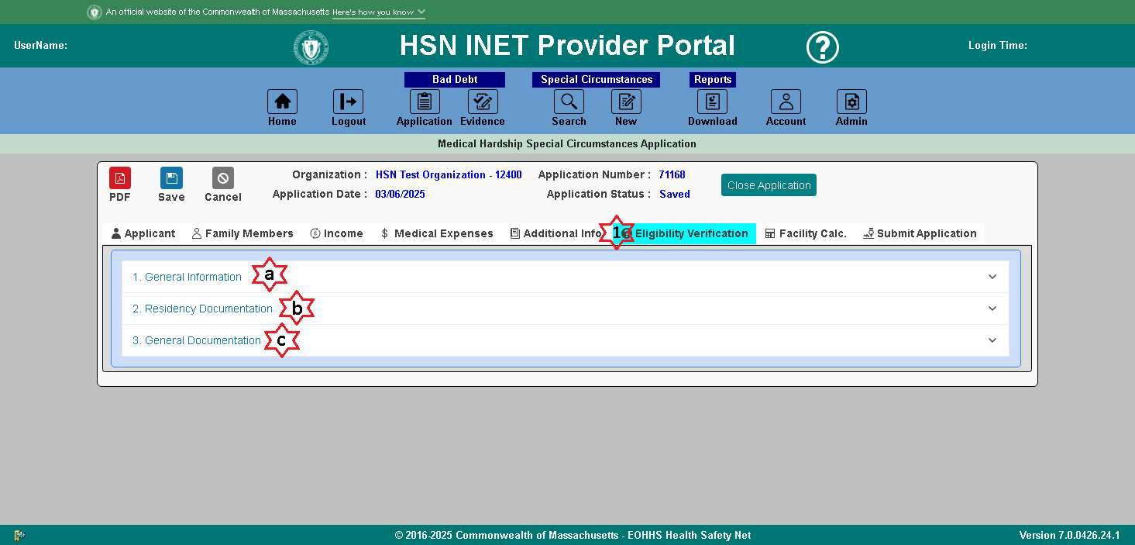
        - Use this section to provide additional information about this applicant. This section is required when the Eligibility Verification Residency Documentation selected type is “Other”.
    - Eligibility Verification Tab
      - Click the Eligibility Verification tab.

        - General Information
          - This section is View only, and contains a summary of the applicant information.
        - Residency Documentation
          - This section is to indicate the documentation being used to verify residency.
        - General Documentation
          - This section is View only, and contains the date the application was received by the HSN.

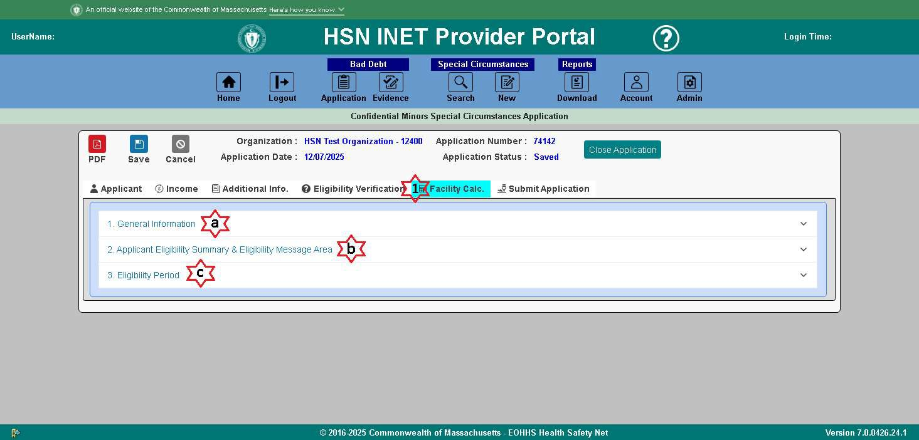
    - Facility Calculation Tab
      - Click the Facility Calculations tab.

        - General Information
          - This section is View only, and contains a summary of the applicant information.
        - Applicant Eligibility Summary & Eligibility Message Area
          - Click the “Calculate” button to update the Applicant Eligibility after information on the application has changed since the last time the calculations were ran.
        - Eligibility Period (Only Displays for Confidential Minors and Domestic Violence applications)
          - This section is View only, and displays the Eligibility Period dates for Submit, Determination, Eligibility Begin, and Eligibility End.

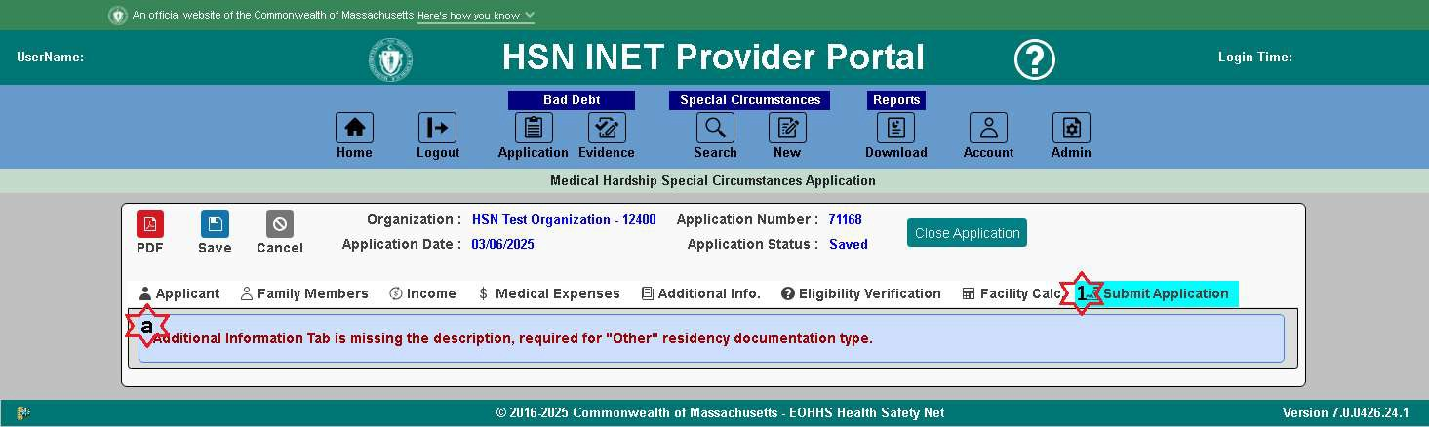
    - Submit Application Tab
      - Click the Submit Application tab.

        - If there are required parts of the application that are incomplete, this tab may contain any of the following error messages.
          - Income Information Tab is missing required income data.
          - Medical Expenses Tab is missing required medical expenses data.
          - Eligibility Verification Tab is missing required residency documentation type.
          - Additional Information Tab is missing the description, required for "Other" residency documentation type.
          - Facility Calculations Tab needs calculations ran.
You must complete all the required information that is incomplete, to be able to access the “Acknowledge and Submit functionality” for the application.
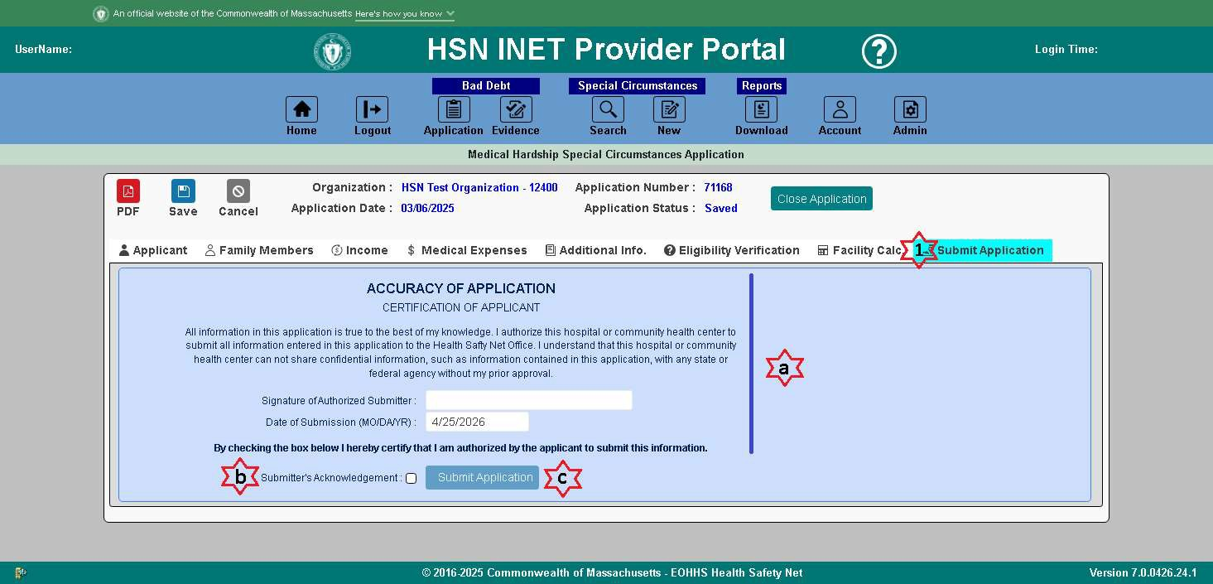
- If all required information of the application is complete, you will be able to “Acknowledge and Submit” the application.
- Check the Submitter’s Acknowledgement checkbox, and the “Submit Application” button becomes enabled.

- Click the Submit Application button to submit the application, and you will get the following message:

Family Members (Displayed only for Medical Hardship and Domestic Violence)
Click the Family Members tab to access the family members list for the application being worked on. If the Family Members tab is inaccessible, the Applicant Information is not yet filled out.
To add a family member, click the Add Family Member button and a dialog will appear.
- Enter all required information:
  - First Name
  - Last Name
  - SSN/TIN
  - Relationship
  - DOB
  - Sex (Gender)
  - Pregnant (If Sex is Female)
  - Number of Babies (If Pregnant is Yes)
  - Has Insurance (If Application Type is Medical Hardship)
  - Insurance Company Name (If Has Insurance is Yes)
- Click the OK button to save the family member.
  - If there were any validation errors, or missing fields, the fields will highlight red to let you know which fields are incomplete.
- The family member will be added to the family members list.
- Repeat for any additional family members to be added.
- Click the Save button to save the family members list.
To edit a family member, click the pencil icon next to the family member you want to edit and a dialog will appear.
- Make any adjustments as needed.
- Click the OK button to save the family member.
  - If there were any validation errors, or missing fields, the fields will highlight red to let you know which fields are incomplete.
- The family member will be updated in the family members list.
- Repeat for any additional family members to be edited.
- Click the Save button to save the family members list.
To delete a family member, click the trash icon next to the family member you want to delete.
- A confirmation message will appear confirming that you want to delete the family member.
  - Click Yes to delete the family member.
  - Click No to cancel this action.
- The family member will be deleted from the family members list.
- Repeat for any additional family members to be deleted.
- Click the Save button to save the family members list.

Income
Click the Income tab to access the earned incomes list, the unearned incomes list, and the no income checkbox, for the application being worked on. If the Income tab is inaccessible, the Applicant Information is not yet filled out.
Under the No Income section, there is a checkbox for “No Income”. You can only check the No Income checkbox if there are no earned/unearned incomes listed. Once checked, the Earned/Unearned Incomes become inaccessible, unless the No Income checkbox is then unchecked.
    - Earned Income
To add an earned income, expand the Earned Income panel, then click the Add Earned Income button and a dialog will appear.
      - Enter all required information:
        - Family Member Name
        - Employer Name
        - Employer Address
        - Earned Amount
        - Payment Frequency
        - Income Type
        - Documentation
      - Click the OK button to save the earned income.
        - If there were any validation errors, or missing fields, the fields will highlight red to let you know which fields are incomplete.
      - The earned income will be added to the earned incomes list.
      - Repeat for any additional earned incomes to be added.
      - Click the Save button to save the earned incomes list.
To edit an earned income, click the pencil icon next to the earned income you want to edit and a dialog will appear.
- Make any adjustments as needed.
- Click the OK button to save the earned income.
  - If there were any validation errors, or missing fields, the fields will highlight red to let you know which fields are incomplete.
- The earned income will be updated in the earned incomes list.
- Repeat for any additional earned incomes to be edited.
- Click the Save button to save the earned incomes list.
To delete an earned income, click the trash icon next to the earned income you want to delete.
- A confirmation message will appear confirming that you want to delete the earned income.
  - Click Yes to delete the earned income.
  - Click No to cancel this action.
- The earned income will be deleted from the earned incomes list.
- Repeat for any additional earned incomes to be deleted. Click the Save button to save the earned incomes list.

    - Unearned Income
To add an unearned income, expand the Unearned Income panel, then click the Add Unearned Income button and a dialog will appear.
      - Enter all required information:
        - Family Member Name
        - Income Type
        - Unearned Income Name
        - Unearned Amount
        - Payment Frequency
        - Documentation
      - Click the OK button to save the unearned income.
        - If there were any validation errors, or missing fields, the fields will highlight red to let you know which fields are incomplete.
      - The unearned income will be added to the unearned incomes list.
      - Repeat for any additional unearned incomes to be added.
      - Click the Save button to save the unearned incomes list.
To edit an unearned income, click the pencil icon next to the unearned income you want to edit and a dialog will appear.
- Make any adjustments as needed.
- Click the OK button to save the unearned income.
  - If there were any validation errors, or missing fields, the fields will highlight red to let you know which fields are incomplete.
- The unearned income will be updated in the unearned incomes list.
- Repeat for any additional unearned incomes to be edited.
- Click the Save button to save the unearned incomes list.
To delete an unearned income, click the trash icon next to the unearned income you want to delete.
- A confirmation message will appear confirming that you want to delete the unearned income.
  - Click Yes to delete the unearned income.
  - Click No to cancel this action.
- The unearned income will be deleted from the unearned incomes list.
- Repeat for any additional unearned incomes to be deleted. Click the Save button to save the unearned incomes list.
    - No Income
Use this section to indicate that you and your family have no income. Check the No Income checkbox to indicate that the applicant has no income. If the applicant has no income, then one or more adult family members did not report income. In this case, handwritten affidavits are required.
Please Note: You can only check the No Income checkbox if there are no earned/unearned incomes listed. Once checked, the Earned/Unearned Incomes become inaccessible, unless the No Income checkbox is then unchecked.

Medical Expenses (Displayed only for Medical Hardship)
Click the Medical Expenses tab to access the medical expenses list for the application being worked on. If the Medical Expenses tab is inaccessible, the Applicant Information is not yet filled out.
To add a medical expense, click the Add Medical Expense button and a dialog will appear.
- Enter all required information:
  - Healthcare Provider Name
  - Patient Name
  - Type of Service
  - Charges
  - Date of Service
- Click the OK button to save the medical expense.
  - If there were any validation errors, or missing fields, the fields will highlight red to let you know which fields are incomplete.
- The medical expense will be added to the medical expenses list.
- Repeat for any additional medical expenses to be added.
- Click the Save button to save the medical expenses list.
To edit a medical expense, click the pencil icon next to the medical expense you want to edit and a dialog will appear.
- Make any adjustments as needed.
- Click the OK button to save the medical expense.
  - If there were any validation errors, or missing fields, the fields will highlight red to let you know which fields are incomplete.
- The medical expense will be updated in the medical expenses list.
- Repeat for any additional medical expenses to be edited.
- Click the Save button to save the medical expenses list.
To delete a medical expense, click the trash icon next to the medical expense you want to delete.
- A confirmation message will appear confirming that you want to delete the medical expense.
  - Click Yes to delete the medical expense.
  - Click No to cancel this action.
- The medical expense will be deleted from the medical expenses list.
- Repeat for any additional medical expenses to be deleted. Click the Save button to save the medical expenses list.

Additional Information
Click the Additional Information tab to access the Additional Information textbox for the application being worked on. If the Additional Information tab is inaccessible, the Applicant Information is not yet filled out.
Fill out any additional information you would like to be attached to this application. This section is required when the Residency Documentation, found under the Eligibility Verification tab, is selected as “Other”. In this case, you would need to provide a detailed description about the "Other" type.

Eligibility Verification
Click the Eligibility Verification tab to access the general information, the Residency Documentation list, and the general documentation, for the application being worked on. If the Eligibility Verification tab is inaccessible, the Applicant Information is not yet filled out.
    - General Information
To view the General Information for the Applicant, expand the General Information panel. This displays the following fields in View Only Mode:
      - First Name
      - Middle Initial
      - Last Name
      - SSN/TIN
      - Date of Birth
      - Sex (Gender)
      - Home Phone
      - Work Phone
      - Work Phone Extension
    - Residency Documentation
To indicate the Residency Documentation being used to verify residency, expand the Residency Documentation panel. Select one of the following values from the Residency Documentation:
      - Driver’s License
      - State Income Tax
      - Real Estate/Utility Bill
      - Other
        - If you select "Other" type of residency document, you need to use the "Additional Information" Tab to provide a detailed description about the "Other" type.
    - General Documentation
To view the General Documentation for the Applicant, expand the General Documentation panel. This displays the following fields in View Only Mode:
      - Date Application Received

Facility Calculation
Click the Facility Calculation tab to access the general information, the Facility Calculations, and the application date, for the application being worked on. If the Eligibility Verification tab is inaccessible, the Applicant Information is not yet filled out.
    - General Information
To view the General Information for the Applicant, expand the General Information panel. This displays the following fields in View Only Mode:
      - First Name
      - Middle Initial
      - Last Name
      - SSN/TIN
      - Date of Birth
      - Sex (Gender)
      - Home Phone
      - Work Phone
      - Work Phone Extension
    - Applicant Eligibility Summary & Eligibility Message Area
To calculate/recalculate the FPL, expand the Applicant Eligibility Summary & Eligibility Message Area. This displays the following fields in View Only Mode:
      - Family Size
      - Family Income
      - % of FPL
      - Eligibility Message Area
        - Medical Hardship applications
          - Based on the calculations, this section contains a message area that details if the application may be submitted to the HSN for review, or if the family is not eligible for medical hardship.
        - Confidential Minor or Domestic Violence applications
          - Based on the calculations, this section contains a message area that details if the applicant is eligible for HSN Primary, HSN Partial, or not eligible for HSN.
          - Based on the calculations, this section also contains an Approved/Denied status.
      - Calculate button
        - The calculations are automatically run when the tab is selected. You can click the Calculate button if there were changes made to the application that haven’t yet been reflected in the family size, family income, or FPL %. Click the Save button after running the calculations.
    - Eligibility Period (Displayed only for Confidential Minors and Domestic Violence)
To view the Eligibility Period for the application, expand the Eligibility Period panel. This displays the following fields in View Only Mode:
      - Submit Date
      - Determination Date
      - Eligibility Begin Date
      - Eligibility End Date

Submit Application
Click the Submit Application tab to acknowledge and submit the application being worked on. If the Submit Application tab is inaccessible, the Applicant Information is not yet filled out. If you don’t see the Submit Application tab, then the application has already been submitted.
If there are any sections of the application that are required and aren’t yet filled out, you will see a list of error message(s) with a description of the required information needed to be filled out. Those errors can be one or more of the following:
- Income Information Tab is missing required income data.
- Medical Expenses Tab is missing required medical expenses data.
  - Only displays for Medical Hardship applications.
- Eligibility Verification Tab is missing required residency documentation type.
- Additional Information Tab is missing the description, required for "Other" residency documentation type.
- Facility Calculations Tab needs calculations ran.
If there are no errors on the application, you will see an accuracy of application section containing the certification of applicant. To submit the application, you must check off the Submitter’s Acknowledgment checkbox, therefore certifying that you are authorized by the applicant to submit this information. Once checked, the Submit Application button will be enabled. Click the Submit Application button to submit the application to the HSN. You will receive a confirmation message once the application has been submitted.

Reopen Requests
If you need to request that a submitted application, be reopened for a specific reason, you must click the Reopen button (which only displays if the application has been submitted). A dialog will appear, where you can enter the reason for the reopen request. Click the Submit Request button to submit the request, or the cancel button to cancel the request. If you chose to submit the reopen request, the reopen request will then be submitted to the HSN for review.
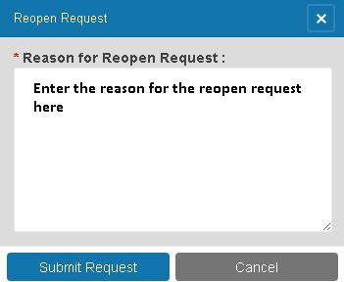

You will see the Reopen Request History for the application you are viewing under the Reopen Request History tab. This tab only displays if the application is submitted. This will contain a list of reopen requests that were made for this application and the outcome of those requests.
