Health Safety Net (HSN)

An INET Web Application User Guide to:

Hospital Emergent and CHC Urgent Care Bad Debt
Evidence Collection

I. User Guide Overview

A. Introduction
B. Evidence File Specification
C. Step by Step Process
D. Reopen Request
E. FAQ

II. User Guide Screen Shots

- Login
- Reporting data
- Submitting

Revision History
Date | Version | Description | Author
November 14, 2007 | 1.0 | Initial version | DHCFP IT
November 23, 2007 | 1.1 | Revised, Re-open functionality | DHCFP IT
May 29, 2008 | 1.2 | Revised, CHC Urgent Care Bad Debt | DHCFP IT
Oct 6,2013 | 1.3 | Updated | CHIA IT
February 4, 2016 | 1.4 | Update | HSN Operations

I. User Guide Overview.

This is a basic guide to filing Hospital Emergent and CHC Urgent Bad Debt collection evidence by means of the Health Safety Net (HSN)’s INET Web site. The name of the link as it appears on the INET main menu is:

Hospital Emergent and CHC Urgent Bad Debt Evidence

- Introduction.

Providers must connect to the Health Safety Net “INET” web site at: https://dhcfpinet.hcf.state.ma.us to submit collections evidence.

All current users who submit 837 claims will also be able to submit collection evidence. Providers may register separate users if they wish to do so by registering them as Web HSN Claim submitters (collection evidence is considered part of the claim).

For referencing forward in this document, the application “Hospital Emergent and CHC Urgent Bad Debt Evidence” will be abbreviated as “EBDEC”.

- EBDEC Evidence File Specification.

Evidence records will be matched to submitted EBDEC Claims records using the provider’s HSN Org ID# and the provider’s TCN for the claim. This process will be required for all Hospital Inpatient Emergency Room Bad Debt claims, and CHC Urgent Care Bad Debt claims per HSNO regulations. Evidence for outpatient hospital emergent bad debt must be submitted upon request of the Health Safety Net (HSN).
Claims must be submitted within 90 days of write-off. Please note that submission of the claim and evidence are not submitted simultaneously. After a claim is submitted, it must be processed, and posted to INET before evidence may be submitted.
EBDEC evidence must be submitted via the Health Safety Net (HSN) INET web application; either by manual entry, or alternatively by uploading a batch file of evidence records, as specified below.
Note: The EBDEC INET application will be available to all currently registered HSNO (837) Claim Web submitters. Registration will be an automatic process requiring no action on the part of providers, unless the provider wishes to add new users to that existing list.
Fields | Description
Field 1 | TCN – Matching the claim
Field 2 | Organization ID# (number assigned by HSN)
Field 3 | Date of Initial Bill
Field 4 | Date of Second Bill
Field 5 | Date of Third Bill
Field 6 | Date of Fourth Bill
Field 7 | Date of Returned Mail
Field 8 | Date of Certified Letter
Field 9 | Date of Initial Phone Contact
Field 10 | Date of Follow up Phone Contact
Field 11 | Date Other Effort
Field 12 | Date Other Effort
Field 13 | Date Other Effort
Field 14 | Date Other Effort

Required File Format - CSV (comma separated)
Instructions for file format when provider chooses to upload evidence data
- Fields are separated by commas.
- The last field on the line is not followed by a comma.
- Null fields are represented by two commas in a row.
- Leading and trailing spaces are ignored for all fields.
- Date formats are all mm/dd/yyyy. Dates will also be subject to restrictions (edits) as described in the HSNO regulation defining evidence requirements.
- Each line must end normally with a single carriage return and line feed (CtrLf).
Examples:
NVAP234,3644,02/02/2000,03/02/2000,04/02/2000,05/02/2000, 06/02/2000,07/02/2000,08/02/2007,09/02/2000,10/02/2000,11/02/2000,12/01/2000,01/01/2001
NVAP452,3644,02/02/2000, , , ,06/02/2000, ,08/02/2000, ,10/02/2000,,,

- Step by Step Process.

The following describes all the necessary steps to complete and successfully evidence data electronically:

- Register your users for INET.

If necessary - register the user who will upload and submit the collection evidence data. Once processed by the HSN, the registered user will receive a Login ID via email.

- Submit relevant EBDEC related claims.

- Assemble required information for your evidence submission.

This would include the comma delimited file for a batch upload, and/or other records of evidence collection efforts specific to your process.

Note that there will be a lag between the time you submit the claim and the time when that claim (TCN) appears in the EBDEC application.

- Log into INET (https://dhcfpinet.hcf.state.ma.us), using the Login ID provided to you by the HSN in Step 1.

a. Select menu option:
Hospital Emergent and CHC Urgent Bad Debt Evidence

b. Click on View, and then Show Claims:

  - This will show you all passed claims that have been processed and are eligible for matching with evidence. You can only enter evidence once the claim has been processed and appears in this list.

c. Click on Evidence

If you want to upload evidence from a batch file:

  - Select “Upload Evidence” from the left side navigation pane
  - Use the Browse command button to select your upload file
  - Click on the Upload command button to import the evidence file
  - Success or Fail messages will be presented after importing
    - If the upload fails – note that one bad record can fail the batch – remove the offending record and retry

If you want to enter evidence directly into a form:

  - Select ”Create New Evidence” from the left side navigation pane
  - Select the claim record from the grid, for which you will enter evidence data
  - Enter the evidence collection data into the form provided
  - Save by clicking on the blue “Save” button.

- Caution... Inactivity for 20 minutes will cause the internet session to Time-Out, and you will lose any unsaved data!

Whether you upload a batch file or enter it through the form, you can edit an evidence record once it is saved:

  - Select ”Edit Evidence” from the left side navigation pane
  - Select the evidence record from the grid list
  - Edit the evidence collection data using the form provided
  - Save by clicking on the blue “Save” button.

- Submit the evidence.

Your evidence is not filed until you have successfully submitted your data.

Once you are satisfied that you have entered all your evidence detail, and are ready to submit it as part of the claim: Click on the “Submit Evidence” link in the left Navigation pane.

On the next form:
Select all or some of the evidences to be submitted
Check the box to certify your authorization
Click the command button “Submit Selected Evidences”

A confirmation of submitted evidence records will be displayed on the screen. The submission may include records that passed edits, and evidence records that failed to meet regulatory requirements for sufficient collection efforts. The status column indicates whether the evidence passed or failed to meet requirements.

You may view, save or print a PDF file of submitted evidences using the navigation menu options - Select View, and then Submitted Evidences.

Note: Once submitted – the Report is officially filed, and the data is frozen. It can no longer be modified unless enabled by HSN staff – See section “D. Reopen Requests”.

- Reopen Requests:
Once you have submitted your evidence, it is possible that the evidence did not meet the regulatory requirements for sufficient collection effort. In this case the status of the evidence submission will be “Failed”, and the associated claim will be denied. If you have made a mistake in your data entry, or think the system has erroneously denied your evidence submission, you may contact HSN to request (if appropriate) that the HSN “reopen” the evidence collection submission, for editing and/or resubmission.
Reopen requests will be reviewed and the HSN may request additional documentation to be sent by fax or other means.
Evidence collection reopen requests must be filed with HSN staff within 30 days of the “Failed” evidence submission.
Contact for reopen requests: Health Safety Net Helpdesk 1-800-609-7232 or by email: hsnhelpdesk@state.ma.us
- Bad Debt Policy

Please refer to the Health Safety Net Regulations 101 CMR 613.00

Please keep in mind that collection efforts must be consistent, with no time frame greater than 120 days between efforts. If the facility uses a collection agency, the facility should either send HSN the Bad Debt claim prior to sending to the agency, or be prepared to document all collection agency efforts to be certain the time between efforts is no greater than 120 days.

II. User Guide Screen Shots.

This section presents screen shots from the Health Safety Net INET Web site. They should be used along with section “I. User Guide Overview”, as a basic guide to filing “evidence of collection effort” data for Hospital Emergent and CHC Urgent care claims under the HSN regulation.

- Login Screens.

A.1 Log in to the INET Web Site

Use this URL to access the INET Login page: https://dhcfpinet.hcf.state.ma.us

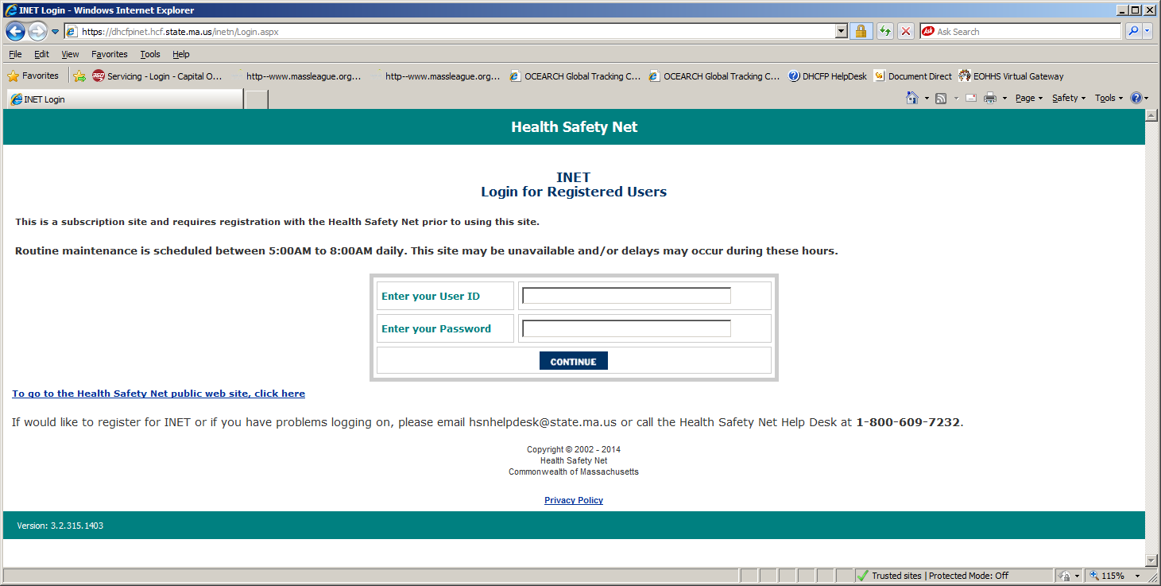

Login
Enter Your User ID – assigned by HSN when you register as a user.
Enter Your Password – determined by you.

Click on the “Continue” button.

If you need your password reset or if you have any questions concerning the content of the Evidence Collection efforts, contact the HSN Help Desk at (800) 609-7232.
A.2 Select the application you wish to run.

The list of applications presented to you on the Main Menu depends on which applications you specifically are registered for in INET.* To file either Hospital Emergent or CHC Urgent Bad Debt Evidence, click on the following link visible on the main menu page:

Click on “Hospital Emergent and CHC Urgent Bad Debt Evidence”

from the Main Menu list…
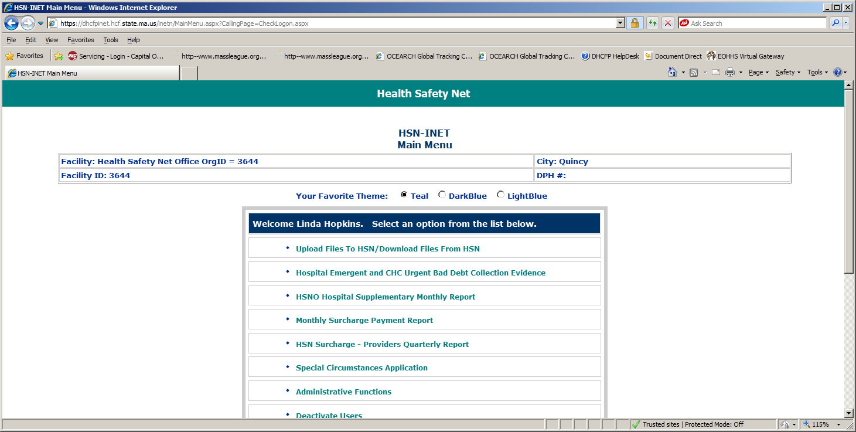

Clicking on this link brings you to the Hospital Emergent and CHC Urgent Bad Debt Evidence Web application.

*Note that the menu options you see when logging in to INET are specific to you. Only those applications that you are signed up for in INET will be displayed. You must be registered as a Web HSNO Claims submitter to see the Hospital Emergent and CHC Urgent Bad Debt Evidence Collection link.

B. Reporting data.

B.1 All reporting functions can be selected from the Main page.

This is the EBDEC Web application’s main or “Home” page.

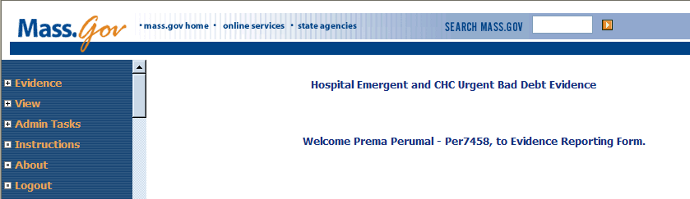

Functions are listed down the left side “navigation pane”. Click on the itemized links in the navigation pane to select the function you want:

Navigation pane
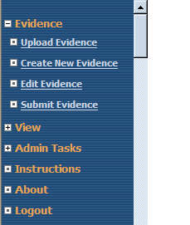

Clicking on Evidence expands to show four link options:
Upload Evidence – upload a batch evidence file (See batch filing specification document)
Create New Evidence – to enter individual claim evidence data via a web form
Edit Evidence – Select this to edit evidence partially saved or fix errors
Submit Evidence – Select this to submit evidence once it has been saved

Most users will first select Upload Evidence to upload a comma separated text file of evidence data for previously submitted Emergent, or Urgent care claims.

Note that at times you may need to select your facility name from a drop down box. This is necessary because some users may be registered filers for more than one facility or campus location.
B.2 Uploading evidence from a batch file.

Following step “3.b” in the “I. User Guide Overview section B. Step by Step Process” select Evidence and then click on Upload Evidence from the navigation pane.

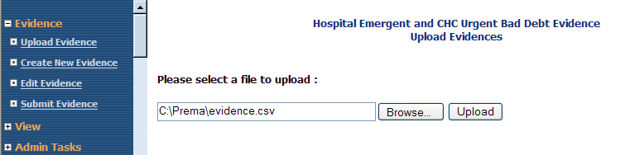

Use the Browse button to select your “csv” file, and then click Upload to load your evidence collection data into the EBDEC database.

Here is the message received for a successful upload of evidence data:

Once evidence records have been uploaded, click on Edit Evidence to view saved evidence records. From the grid you can also modify an evidence record by clicking on the
Edit button in the row.

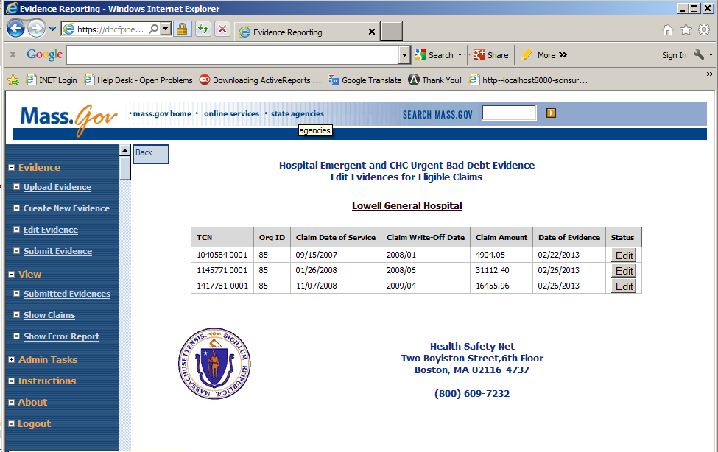

Note: If your evidence file is improperly formatted or the TCN’s on the evidence file do not match the TCN’s found on your EBDEC claim records, you will get a list of Error messages such as that shown below:

The upload is all or none, so you will have to correct all errors cited for your source file, and upload again. The system will not save any data from a file with an invalid TCN.

You can edit uploaded evidence before it has been submitted by clicking on Edit Evidence. You will get a list of uploaded evidence records from which to select. Alternatively, you can enter new evidence directly into forms by clicking on Create New Evidence:

Both edit and create evidence links ultimately take you to this edit form:

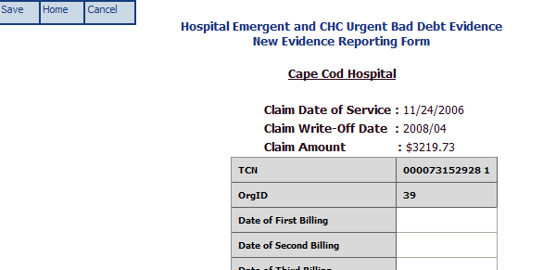
This is the “floating” tool bar

Enter or change your data, then click the (save) button on the floating tool bar.
C. Submitting.

Once you have saved and reviewed your evidence records you are now ready to Submit the evidence for the final step in the EBDEC claims submission process.

Select Submit Evidence from the navigation pane.

Select some or all evidence records to be submitted by clicking on the “Submitter’s acknowledgement” checkbox to commit and confirm your authorization.

Then click on the Submit Selected Evidences command button.

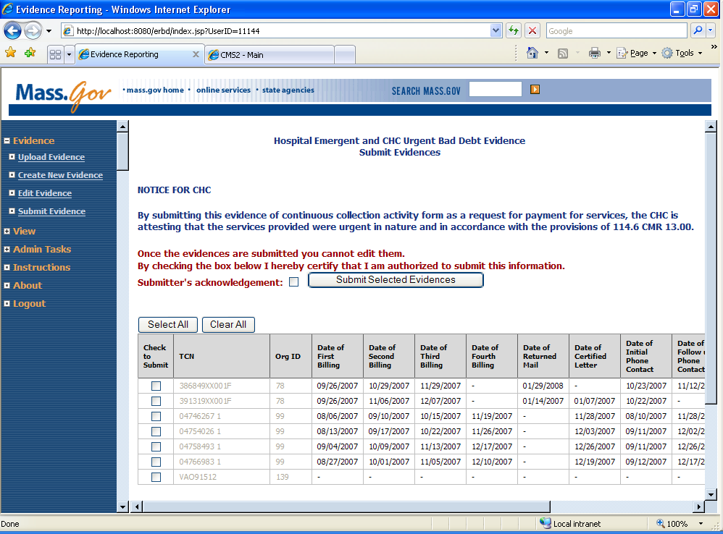

Once evidence records have been submitted, they may be viewed using the View/Submitted Evidences link in the left navigation pane.

Note that the evidence can no longer be edited. The claim submission is considered complete. Claims with failed evidence will be denied.

Results – Submitted evidence:

You can review passed and failed evidence submissions by using navigation pane links.

a. View Submitted Evidences – click PDF to print submitted Evidence records:

b. Show Error Report - View submitted Evidences with Errors:

