LEAD POISONING
Call for free: 1-800-532-9571
Assistance available in other languages.

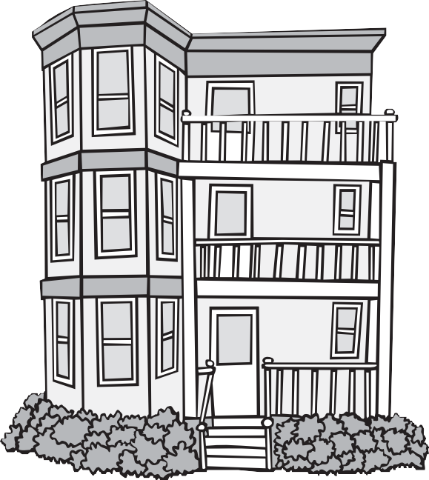
Information for Property Owners

Lead poisons children. Most children get lead poisoning from lead dust and lead paint in old homes. As a property owner, you must protect children from lead poisoning.

The Massachusetts Lead Law
The Lead Law says owners must remove or cover lead paint hazards in homes built before 1978 if a child under 6 lives there. Lead paint hazards include loose paint and lead paint on windows or other places that children can reach.
The only way to know if you have lead in your home is to have it tested by a licensed inspector. Go to www.mass.gov/dph/clppp to find a licensed lead inspector near you.
If there is lead in your home, you must remove or cover it. There are different ways to do this. Call CLPPP to learn more. http://tinyurl.com/maleadinfo

Who can remove or cover the lead?
Removing or covering lead is called deleading. Some work must be done by a licensed deleader. But you can do most deleading work yourself if you get trained and authorized. You may need to help tenants find a place to stay (at your expense) until the work is done. To learn more, call CLPPP and ask for a copy of the Deleading Book.

What about money?
There is money to help property owners pay for deleading. Encourage property owners to call the Get the Lead Out program at 1-617-854-1000.

Owners may be eligible for a state income tax credit of up to $3,000 if they delead their home. http://tinyurl.com/malead-financial-help

Before You Rent or Sell
What You Need to Know

Tenant Notification and Certification
When you rent a home built before 1978, you must give tenants these papers before they sign a rental agreement, even if they do not have children:

Tenant Lead Law Notification and Certification form
- A copy of the most recent lead inspection report, if it exists
- A copy of any Letter of Compliance or Letter of Interim Control, if it exists
- Any information about lead in the home.

Property Transfer Lead Paint Notification
When a buyer is about to purchase a home built before 1978, you must give them:
- Property Transfer Lead Paint Notification form
- A signed Property Transfer Lead Paint Certification form
- Any information about lead in the home
- A copy of any lead inspection report, Letter of Compliance, or Letter of Interim Control
- A 10 day period to have the home inspected for lead at the buyer’s expense before the Purchase and Sale.

All Notification and Certification forms are available at www.mass.gov/dph/clppp

Penalties and Liability
You cannot evict or refuse to rent to someone because of lead paint. This is discrimination. It is illegal. If a child is poisoned by lead, you are responsible. Complying with the Lead Law is the best protection you have from liability. If you do not comply with the law, you could face civil and criminal penalties.

Childhood Lead Poisoning
Prevention Program (CLPPP)
Call: 1-800-532-9571 or 1-617-624-5757
TTY: 1-617-624-5286
Email: clppp@state.ma.us
On the web: www.mass.gov/dph/clppp

Massachusetts Department of Public Health Bureau of Environmental Health

www.mass.gov/dph/clppp

2015

