LEAD POISONING

Information for Real Estate Agents

Lead poisons children. Most children get lead poisoning from lead dust and lead paint in old homes. As a real estate agent, you can help protect children from lead poisoning.

The Massachusetts Lead Law
The Lead Law says an owner must remove or cover lead paint hazards in homes built before 1978 if a child under 6 lives there. Lead paint hazards include loose paint and lead paint on windows and in other places that children can reach.

The only way to know if there is lead in a home is to have it tested by a licensed inspector.
If there is lead in the home, the owner must remove or cover it. There are different ways to do this. Some work can only be done by a licensed deleader. But proper ty owners can do most deleading work themselves
if they get trained and authorized. Call CLPPP to learn more.

What about money?
There is money to help property owners pay for deleading. Encourage property owners to call the Get the Lead Out program at 1-617-854-1000.

http://tinyurl.com/ma-lead-out-loans

Owners may be eligible for a state income tax credit of up to $3,000 if they delead their home.

Call for free: 1-800-532-9571

Tenant and Property Transfer Notification

What You Need to Know
Real estate agents and owners must comply with these Lead Paint Notification requirements:

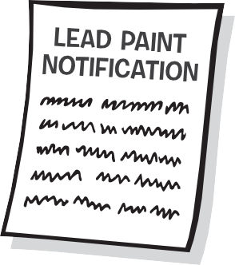
Tenant Notification and Certification
You must disclose the presence of known lead paint if you are renting a home built before 1978. You must give the tenant these papers before they sign a rental agreement, even if the tenant does not have children:
- A Tenant Notification and Certification form
- A copy of the most recent lead inspection report, if it exists
- A copy of any Letter of Compliance or Letter of Interim Control, if they exist
- Any information about lead in the home.

Property Transfer Lead Paint Notification
When a buyer is about to purchase a home built before 1978, you must give them the following:
- A Property Transfer Lead Paint Notification form
- A signed Property Transfer Certification form
- Any information the owner has regarding lead in the home
- A copy of any inspection report, Letter of Compliance, or Letter of Interim Control
- A 10 day period to have the home inspected for lead at the buyer’s expense before the Purchase and Sale.
All Notification and Certification forms are online at www.mass.gov/dph/clppp

Penalties
Real estate agents and sellers who do not comply with the law could face civil and criminal penalties. You could lose your real estate license.

Childhood Lead Poisoning
Prevention Program ( CLPPP) Call for free: 1-800-532-9571
On the web: www.mass.gov/dph/clppp

Massachusetts Department of Public Health
Bureau of Environmental Health
2015

