The Commonwealth of Massachusetts
Executive Office of Health and Human Services
Department of Public Health
250 Washington Street, Boston, MA 02108-4619

MARYLOU SUDDERS
Secretary
MONICA BHAREL, MD, MPH Commissioner

Tel: 617-624-6000
www.mass.gov/dph

CHARLES D. BAKER
Governor
KARYN E. POLITO
Lieutenant Governor

Date: December 8, 2020

Subject: RCP Information Notice 20-01 December 2020, “Gonadal/Fetal Shielding

Dear Radiation Professionals:
Several professional radiological societies have recently provided industry recommendations related to gonadal/fetal shielding changes. The American College of Radiology, Health Physics Society, the Image Gently campaign and the American Association of Physicists in Medicine have put out statements and/or recommendations to cease gonadal and fetal shielding during X-ray exams. The Massachusetts Department of Public Health Radiation Control Program (RCP) is reviewing these recommendations for a future regulation revision. In the interim, the following guidance is provided:
The current regulation 105 CMR 120.403(A)(1)(f) states: “Gonadal shielding of no less than 0.5 millimeter lead equivalent shall be used for patients, who have not passed the reproductive age, during radiographic procedures in which the gonads are in the useful beam, except for cases in which this would interfere with the diagnostic procedure.”

RCP interprets this regulation to allow the decision to use gonadal/fetal shielding to be at the discretion of the attending radiologists as they are most qualified to determine the potential impact upon diagnosis as a result of the patient’s anatomy versus any potential benefit of shielding the gonads from radiation.

If you have any concerns or desire to make recommendations regarding future regulations, please contact me directly.

Regards,
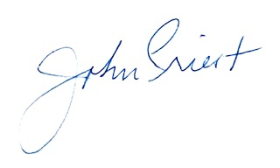

John M. Priest Jr., Director
MDPH/BEH Radiation Control Program
529 Main St. Suite 1M2A, Charlestown, MA 02129
617-242-3035 ext 2001
https://www.mass.gov/radiation-control

